Pal, Gargi (Cognizant)

Set up

This document gives the overview of how to set up the application in the local machine for the development.

Project manager

Contents

Introduction 2

Software Requirements and Technology details 2

Required Software 2

Technology Details 2

Setting up the application 2

Taking checkout 2

Folder Structure 3

Client 4

Server 4

Database 4

Running the application 4

# Introduction

This document describes the setup of the application “**Project Manager**” in the local machine for development and debugging purpose.

# Software Requirements and Technology details

## Required Software

These are the list of the software installed in the system to debug/develop and run the application:

1. Visual Studio 2017
2. Visual Studio Code (preferable latest version)
3. SQL Server Management Studio 2017
4. Google Chrome
5. Node JS v 8.12.0
6. GIT BASH and GIT UI (for connecting to the repository)

## Technology Details

These are the list of the technologies used in the application:

1. Angular 4 (UI)
2. HTML (UI)
3. CSS3 and BOOTSTRAP (UI)
4. .NET Framework
5. Web API 2.0 (C#)
6. Entity Framework (C#)
7. SQL (C#)

# Setting up the application

## Taking checkout

1. Visit the URL <https://github.com/Gargi263/FSE_IIHT_SBA_Project> where the code is checked in.
2. Click on the “**Clone or download**” button.  
     
   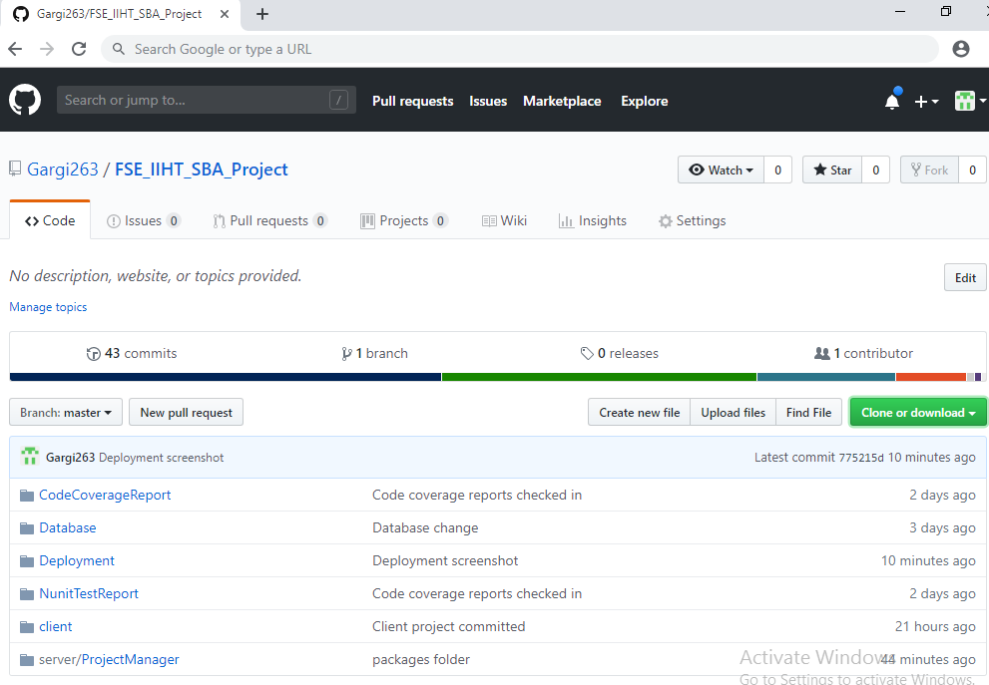
3. Once a small pop-up opens, click on the “**Download ZIP**” button.  
   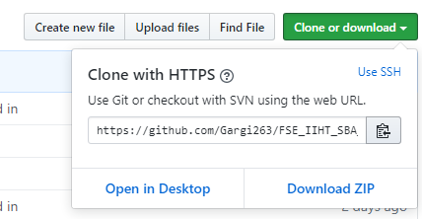
4. Open the downloaded file and extract the folder (**FSE_IIHT_SBA_Project**) to some path on the system.

## Folder Structure

In the main folder **FSE_IIHT_SBA_Project** there are two folders.

1. Client:   
   This folder contains the angular part of the code.
2. Server:   
   This folder contains the C# part of the code.

### Client

1. Go to the path **FSE_IIHT_SBA_Project/client** where you can see the file ***angular.json***
2. Open command prompt
3. Copy the path from Step No. 1
4. Traverse to the path of Step 1 in the command prompt
5. Once you are in this path, run this command “npm install –g -f @angular/cli”
6. After this installation is done, run this command “npm install -f”
7. Let all the npm packages install in the project
8. Once the installation is done you will be able to see a folder “*node_modules*” in your system
9. Don’t close the command window yet

### Server

1. Open the folder **FSE_IIHT_SBA_Project/server**/**ProjectManager**
2. Open the file “**ProjectManager.sln**” in Visual Studio 2017
3. Build the application
4. Don’t close the Visual Studio 2017 yet

### Database

1. Open the SQL Server Management Studio
2. Run the script “**CreateDatabase_Script.sql**”
3. Run the script “**CreateTables_Script.sql**”

# Running the application

Once the build is succeeded:

1. Open the command prompt and run the command “npm start”
2. Open the visual studio 2017 and select the “**ProjectManager**” project as startup project and press “**Start**” to run the application
3. Once the node modules are built after the step 1, open Google Chrome and enter the URL “**localhost:4200**”