Walmart Sales Forecasting
Streamlit Dashboard — UI Output Reference

1. Overview
This document records what the Streamlit dashboard (Sales_forcast.py) renders once the data layer and HistGradientBoostingRegressor model finish running. Every number and table below was produced by executing the app's actual data-preparation, training, and forecasting functions against the uploaded train.csv, test.csv, features.csv, and stores.csv files — it is not placeholder text.
The underlying dataset covers 45 stores and 81 departments, with weekly sales history from 05 Feb 2010 to 26 Oct 2012 (421,570 training rows) and an unlabeled forecast horizon from 02 Nov 2012 to 26 Jul 2013 (115,064 rows to predict).

2. Page Header
The main panel opens with the app title and a one-line caption, set via st.title and st.caption:
📈 Walmart Sales Forecasting
A practical weekly demand view for 45 stores and their departments

3. Sidebar Filters
Two dropdown controls appear in the left sidebar (st.sidebar.selectbox) and drive every other element on the page:
Sidebar control | Options shown
Store | “All stores”, plus each of the 45 individual store IDs (1–45)
Department | “All departments”, plus each of the 81 department codes present in the data

Selecting a specific store and/or department filters the historical data, the forecast, the four summary metrics, the trend chart, and the forecast-detail table all at once — nothing is cached per filter, so each change recomputes the filtered views from the already-trained model's output.

4. Summary Metrics — “All stores / All departments” (default view)
Four st.metric cards sit in a row beneath the header. With no filters applied, they read:
Historical sales | Forecast horizon | Model holdout MAE | Latest history
$6,737,218,987 | $1,631,831,136 | $3,909.72 | 26 Oct 2012

The holdout MAE of $3,909.72 comes from a chronological validation split: the model is fit on all rows before 31 Aug 2012 (394,879 rows) and evaluated on the final 8 weeks (26,691 rows) before being refit on the full training set for the actual forecast.

5. Weekly Sales Trend Chart
A Plotly line chart (px.line) plots historical weekly sales in green (#1f6f5b) against the forecast in orange (#d36b3c), with a unified hover tooltip. Aggregated across all stores and departments, it looks like this:
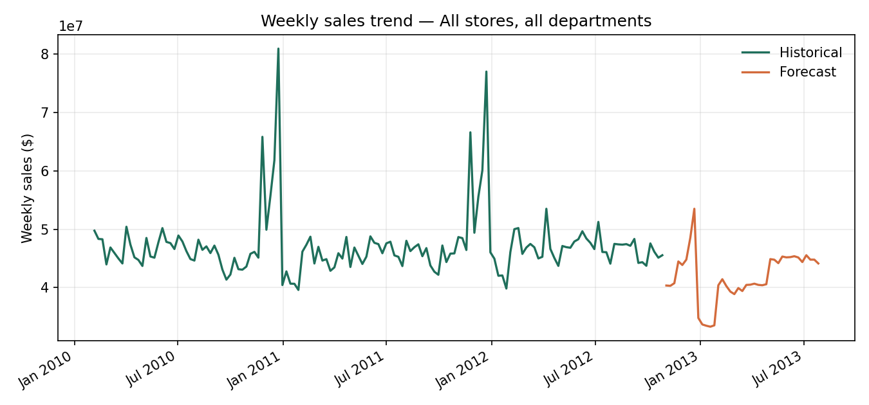
Weekly sales trend — All stores, all departments
The recurring spikes each late November / December are the Thanksgiving and Christmas holiday weeks flagged by IsHoliday; the forecast segment picks up the same seasonal shape for the 2012 holiday period before easing into 2013.

6. Forecast Detail Table
Below the chart, st.dataframe lists every forecast row for the current filter, sorted by date with the forecast formatted as currency. For Store 1 / Department 1, the first rows of that table are:
Store | Dept | Date | Forecast
1 | 1 | 02 Nov 2012 | $20,952.29
1 | 1 | 09 Nov 2012 | $20,494.22
1 | 1 | 16 Nov 2012 | $20,927.38
1 | 1 | 23 Nov 2012 | $24,066.61
1 | 1 | 30 Nov 2012 | $23,659.39
1 | 1 | 07 Dec 2012 | $23,437.23
1 | 1 | 14 Dec 2012 | $27,826.28
1 | 1 | 21 Dec 2012 | $30,291.75

With no filters applied this table holds all 115,064 forecast rows; narrowing to one store/department (as above) reduces it to that combination's weekly rows only — 39 weeks for Store 1, Dept 1.

7. Download Control
A st.download_button at the bottom of the page exports the full, unfiltered forecast (all stores and departments, 115,064 rows) as walmart_sales_forecast.csv, with columns Store, Dept, Date, Forecast — independent of whatever sidebar filter is currently applied.

8. Example of a Filtered View — Store 1, Department 1
Choosing Store = 1 and Department = 1 in the sidebar updates every element above. The summary metrics become:
Historical sales | Forecast horizon | Model holdout MAE | Latest history
$3,219,405 | $853,099 | $3,909.72 | 26 Oct 2012

...and the trend chart narrows to that single store/department series:
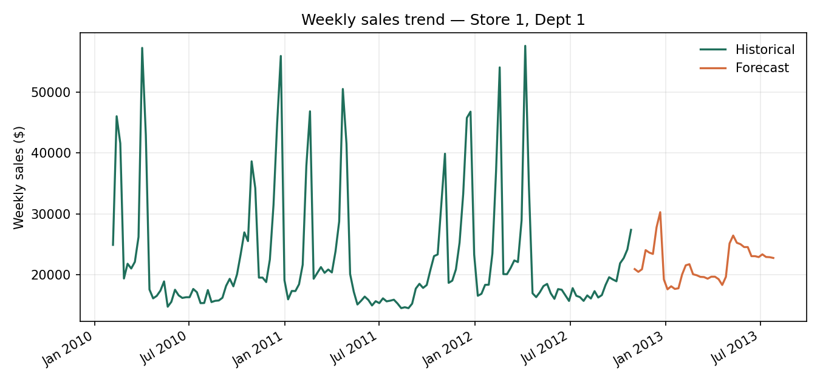
Weekly sales trend — Store 1, Dept 1

9. Notes
- Values are deterministic for a given data snapshot: the model uses random_state=42, so re-running the app against the same four CSVs reproduces the same MAE and forecasts shown here.
- MarkDown1–5 are heavily missing before Nov 2011 and are filled with 0 rather than imputed, which the README already flags as a candidate follow-up.
- The chart images above were rendered outside Streamlit (matplotlib, same colors and series) to document the output without a running server; the live app renders the equivalent as an interactive Plotly chart.

