Project Synopsis — Submission Template
HCLTech Career Shaper Programme | III Year Industry Project | 2025-26

Field | Details (Learner to complete)
Project Title | Personalized Movie Recommendation System Using Collaborative Filtering
Project No. | 28
Domain | Digital-Data-AI / AIML
Difficulty | Intermediate
Duration | 4 Weeks
Format | Individual Project
Learner Name | [FILL IN]
Roll Number | [FILL IN]
College / Campus | [FILL IN]
Mentor Name | [FILL IN]
Submission Date | [FILL IN]

1. Problem Statement
Streaming viewers face catalogues too large to browse, and popularity lists bury regional-language films, which lowers engagement and traps viewers in a filter bubble. This project builds collaborative-filtering recommenders (user-based, item-based and SVD), evaluates them with RMSE and precision@K, and audits them for diversity and fairness so that suggestions are both relevant and varied.

2. Proposed Solution & Approach
I built a Python recommender with user-based and item-based collaborative filtering and SVD matrix factorisation (Surprise), compared against mean, bias and popularity baselines on a leakage-free, per-user chronological split. The deployed model (item-based CF blended with popularity) is served through a Flask REST API (recommend, similar, history, explain) and a Streamlit dashboard, with a popularity fallback for new users. A diversity re-ranker (MMR with an exposure penalty) counters filter bubbles, and every result states that the data is synthetic. Everything is reproducible from fixed seeds and covered by 56 automated tests.

3. System Architecture
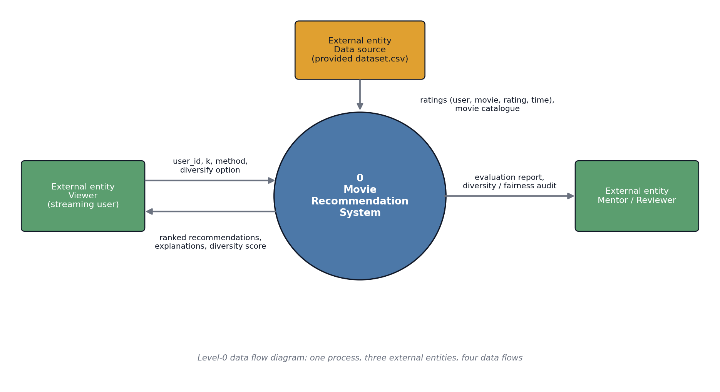
Figure 1: Level-0 data flow diagram
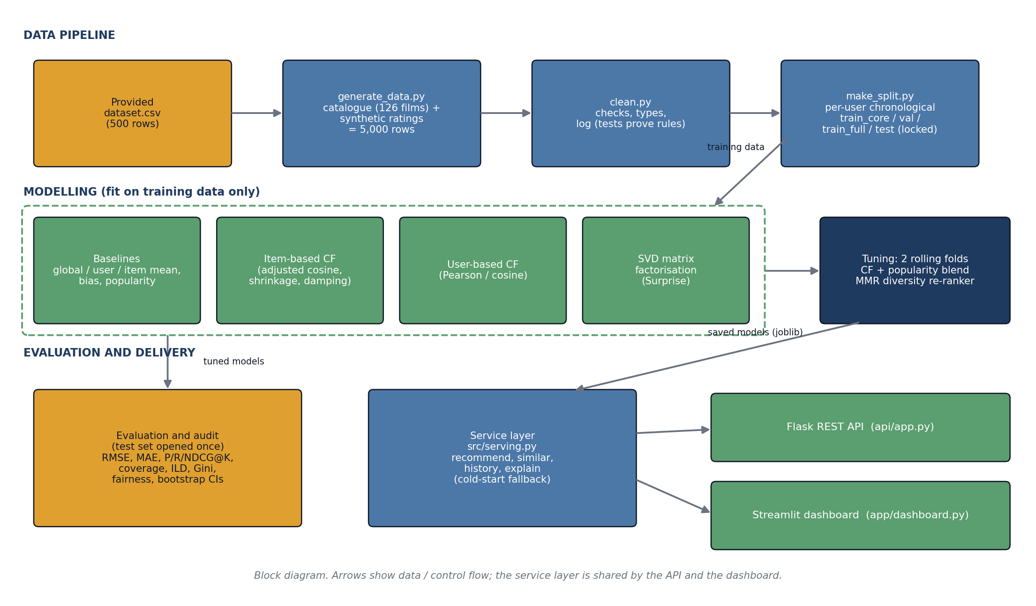
Figure 2: System block diagram (data pipeline, models, evaluation and delivery)

4. Technology Stack
Frontend / UI: Streamlit dashboard (plus a JSON REST API for other clients)
Backend / Logic: Python 3.12, Flask REST API, shared service layer (src/serving.py)
Database: None: data is stored as CSV files; no database server or SQL was needed
AI/ML Framework: Surprise (SVD); own NumPy implementations of item-based and user-based CF; pandas, SciPy
Visualisation: matplotlib and seaborn (EDA notebook), Streamlit charts
Hardware: Standard laptop CPU, no GPU needed (median API response 3.0 ms)

5. Dataset Used
Dataset file name: dataset.csv (provided in project folder; cleaned version delivered)
Number of rows: 5,000 (473 from the provided file + 4,527 synthetic)
Number of columns: 9 (the 7 provided columns + movie_id + is_original)
Key columns (list 5): user_id, movie_id, rating, timestamp, genre (also language, release_year)
Any additional data collected: Yes: 4,527 synthetic ratings and a 126-film catalogue, generated by a seeded script (src/generate_data.py) because the provided file had only 8 movies and about 1.6 ratings per user. Assumptions are documented in docs/data_source.md; no real MovieLens rows were used.

6. Key Results & Metrics
Metric 1: Test RMSE (item-based CF) 0.7224 vs 0.7576 for the item-mean baseline (difference -0.0352 (95% CI -0.0562 to -0.0154)); no gain over a user-bias + movie-bias baseline (0.7234).
Metric 2: Precision@10 and coverage P@10 0.0796 for the deployed CF + popularity blend vs 0.0792 for plain popularity (a tie). Catalogue coverage@10 rises from 15.9% to 31.0% with the diversity re-ranker (P@10 0.0775, 2.7% lower).
Metric 3: API response time median 3.0 ms, 95th percentile 4.7 ms (300 real HTTP requests); 56 automated tests pass.
Business value achieved: A working, tested recommender with a diversity control and an honest evaluation. It shows where collaborative filtering helps (beats item averages), where it does not (no gain over simple biases on sparse data) and how to reduce the filter-bubble effect. Results come from synthetic data and are not findings about real viewers.

7. Challenges Faced & How Resolved
Challenge 1: the provided dataset had only 8 movies, about 1.6 ratings per user and random genre/language per row, so collaborative filtering was impossible. → Resolution: built a consistent 126-film catalogue and a documented, seeded synthetic extension to 5,000 ratings, kept the original rows flagged (is_original), and stated in every deliverable that results concern synthetic data.
Challenge 2: collaborative filtering barely beat simple baselines, popularity beat pure CF, and a blend that looked better on validation only tied popularity on the test set. → Resolution: added a bias baseline, tuned on rolling time-respecting folds, used bootstrap confidence intervals, opened the test set once and reported the result honestly; added a diversity re-ranker (coverage 15.9% → 31.0%) against filter bubbles.

8. References
1. Harper, F. M. and Konstan, J. A. (2015). The MovieLens Datasets: History and Context. ACM Transactions on Interactive Intelligent Systems, 5(4), Article 19. https://grouplens.org/datasets/movielens/
2. Koren, Y., Bell, R. and Volinsky, C. (2009). Matrix Factorization Techniques for Recommender Systems. Computer, 42(8), 30-37.
3. Hug, N. (2020). Surprise: A Python library for recommender systems. Journal of Open Source Software, 5(52), 2174.
4. Sarwar, B., Karypis, G., Konstan, J. and Riedl, J. (2001). Item-based collaborative filtering recommendation algorithms. Proceedings of the 10th International Conference on World Wide Web, 285-295.
5. Carbonell, J. and Goldstein, J. (1998). The use of MMR, diversity-based reranking for reordering documents and producing summaries. Proceedings of SIGIR 1998, 335-336.
6. HCLTech Career Shaper Programme: Project Brief (Project 28), Dataset Generation Prompt and Programme Guidelines (provided by the Programme Coordinator).

9. Ethical Compliance Declaration
I confirm that:
☐ All dataset usage complies with the source licence.
☐ No personally identifiable information (PII) is stored without consent.
☐ AI tools used for code/writing are disclosed in the Appendix.
☐ This project complies with the DPDP Act 2023 where applicable.
Learner Signature: _________________________ Date: ________________

[To be read, ticked and signed by the learner. Not completed by the AI assistant. AI-tool use is disclosed in Appendix A of the project report.]
Submit this file as 'Project_Synopsis_[YourName]_[RollNo].docx' | HCLTech Career Shaper Programme 2025-26

