**Project Proposal**

**Project participants and email addresses**

Gargi Darade. gargi.darade@laverne.edu

**Problem Statement:** Develop software to keep track of books in a small library

Following features has to implement.

1 - Add a Book

2 - Edit a Book

3 - Search a Book, based on author or title of book

4 - Delete a Book

5 - Check out a Book

6 – Check in a Book

7 - Auto save data on Exit and load on application start

8-GUI should be user friendly

**Design**

To solve issue of friendly GUI, this application is developed as a windows application, since it is for small library, XML file is used to store library data, context menu is provided for the required features.

Following features are provided by “library Management System”

If the user selects option **– Add** a Book, then the program will ask the user to enter the name of the book and the author of the book, number of copies, and if it is checked out, then the name of person. Once this information submitted it will be displayed as new entry in the collection of books, this information will get saved on exit of application

If the user selects option **– Edit** a Book, then the program will show information of the selected book like name, author, no. of copies and names of person who has checked out. User can edit required information and then submit it to see the changes, which will be displayed in the collection of books

If the user selects option **– Search** a Book, then the program will ask the user to select search criteria like to search based on title of book or to search based on author of book or just display all books in the library, note that the word entered by user will also be search as sub string and will be case sensitive.

If the user selects option – **Delete** a Book, then the program will ask about confirmation and then remove entry form the library, selection of book is done by selecting row and then right click to select, delete option from the context menu

If the user selects option**– Check out** a Book, then the program will ask the user to enter the name of the person who is checking out the book, selection of book is done by selecting row and then right click to select , Check out option from the context menu, on success the name of the person will be displayed against the book in the checkout by column.

If the user selects option – **Check in** a Book, then the program will ask the user to enter the name of the person who is checking in the book, selection of book is done by selecting row and then right click to select , Check in option from the context menu, on success the name of the person will be removed from the checkout by column.

**Intended audiences** are librarian and library user.

How to run the app

First you have to compile this project with help of Microsoft visual studio (2022), then use executable file to launch the application.

**Tools/technologies used**

Object oriented programing technic is used; project is implement by using C# as a windows application. XML is used at backend to store data used by this library management system. Microsoft Visual studio is used to develop this application.

**System architecture and implementation details**

Three tier architecture is used, front end as GUI, middle tier for processing and back end to store data to the XML file.

Back end

Data

Middle tier

processing

Front end

GUI

**Block diagram of the library management system**

|  |
| --- |
| BookCollection |
| -Booklist: List<Book>  -FileName: string |
| +totalBooks():int  +addBook(Book book):int  +editBook(Book book, string title):int  +checkOutBook(Book book,string personName):int  +checkInBook(Book book, string personName):int  +deleteBook(string bookInfo, int +deleteOnType):int  +searchBook(ref Book resBook, string bookInfo, int searchType):int  +searchBook(string bookInfo, int searchType, ref int foundCount): List<Book>  +saveCollection(string fileName):int  +loadCollection(string fileName):int  +WriteToXmlFile<T>(string filePath, T objectToWrite, bool append):Void  +ReadFromXmlFile<T>(string filePath):T |

|  |
| --- |
| Book |
| -Title: string  - Author: string  -Copies: int  -CheckoutNameList:  List<string> |
|  |

**Class diagram of the library management system**

These two classes were design develop and tested as a console application then they are used in the development of library management system. Since it is windows app it is interactive and intuitive, user can quickly select option and execute it.

**Screenshots of the user interface or a prototype (if any).**

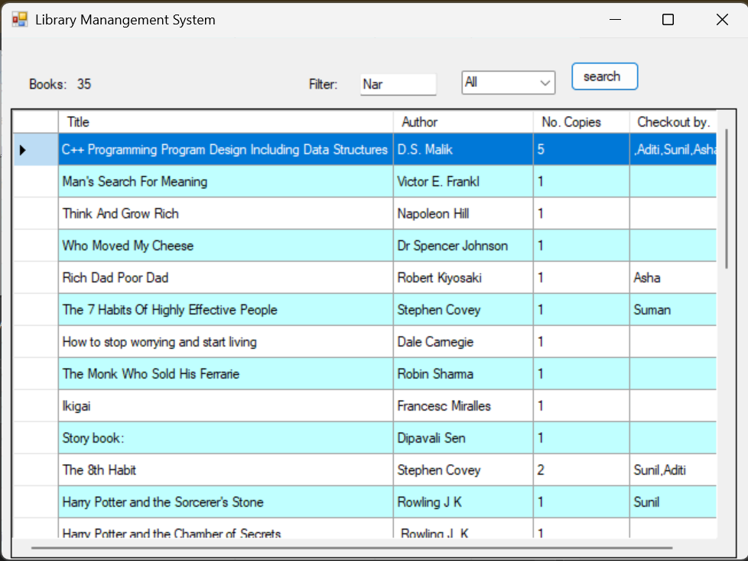

Output of different use cases is stored in **librayOutPut.docx/pdf** file.

Future enhancement:

Can provide sorting based on title, author, and checkout person name. Data base can be used to store large number of books and user data. Can provide web support for larger audiences and users