**Screenshots**

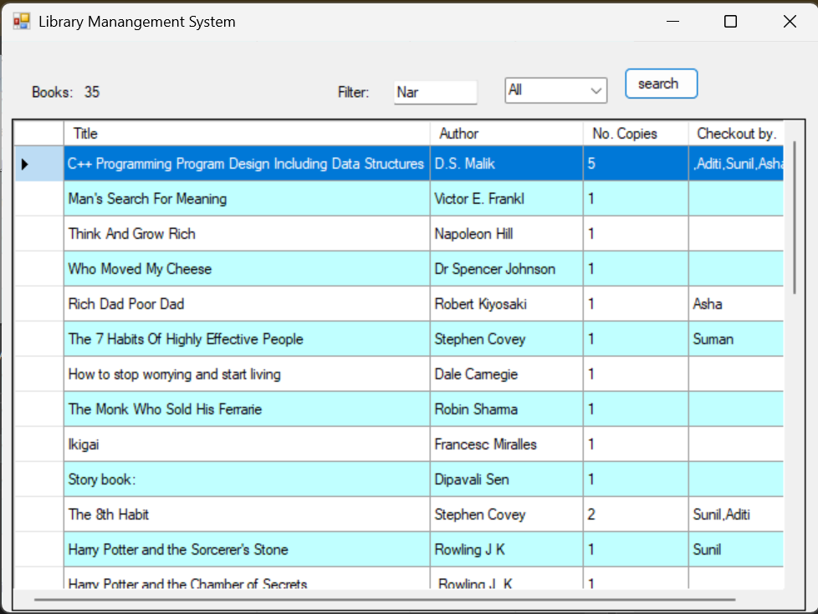

**Screenshots of the user interface** of the “library Management System”

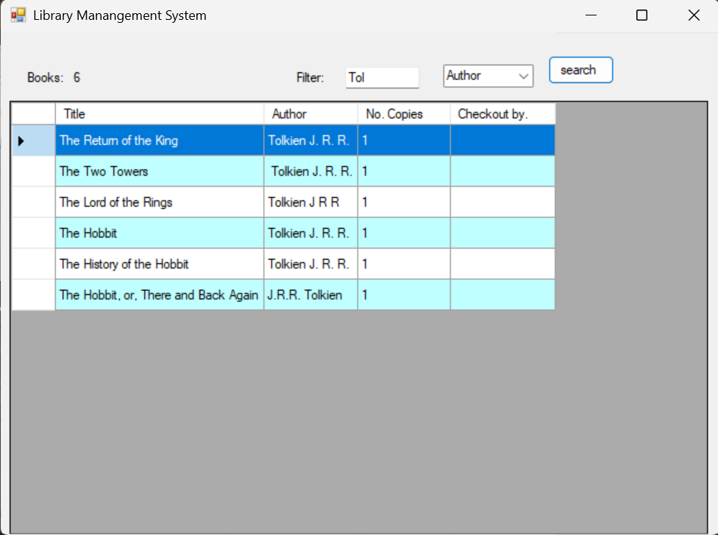

**Screenshots of the search based on author**

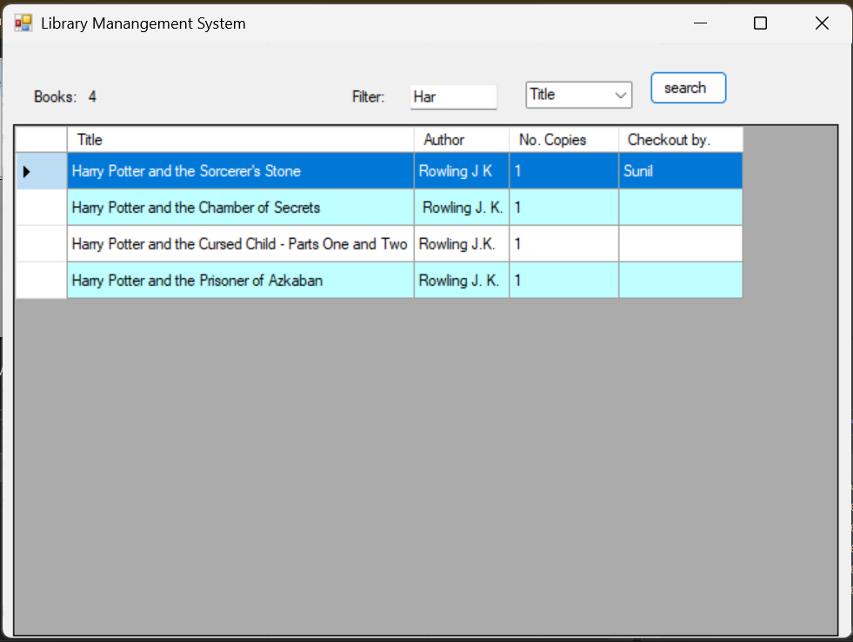

**Screenshots of the search based on title of the book**

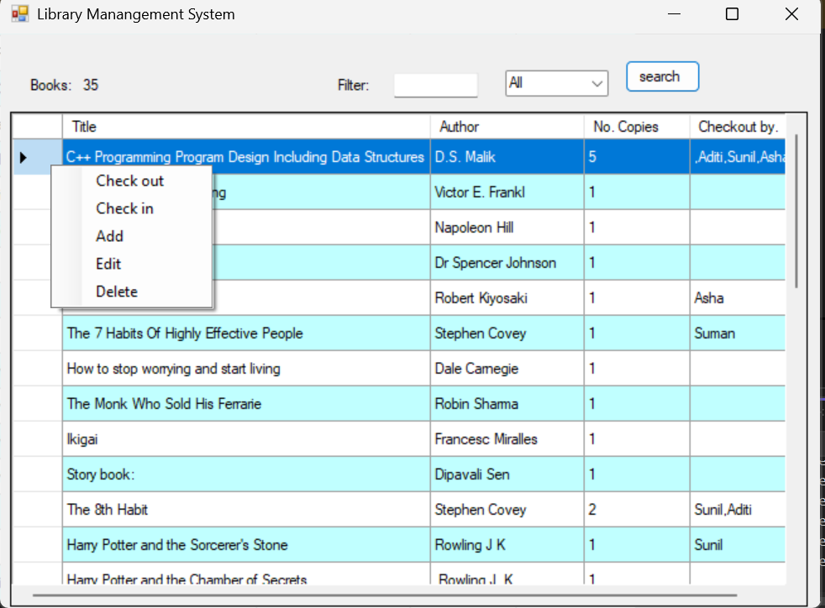

**Right click context menu and options it provides**

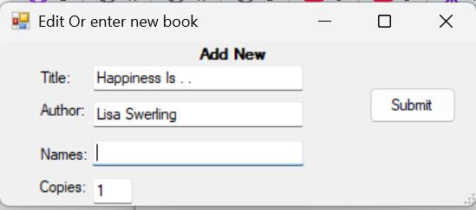

**Add new book to the library**

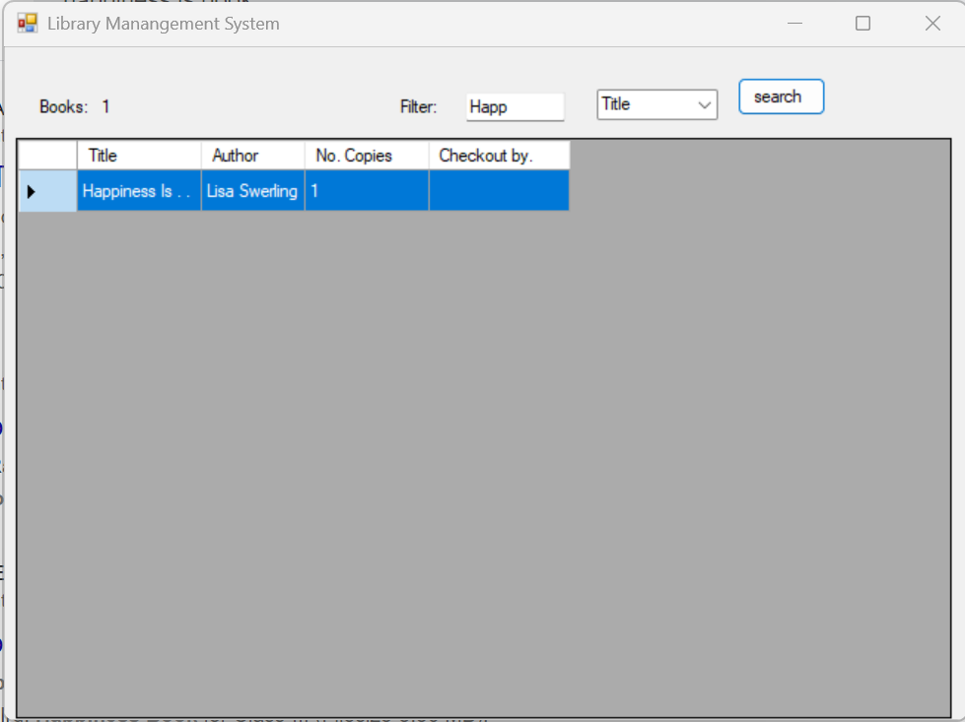

**Can see the entry of added new book to the library**

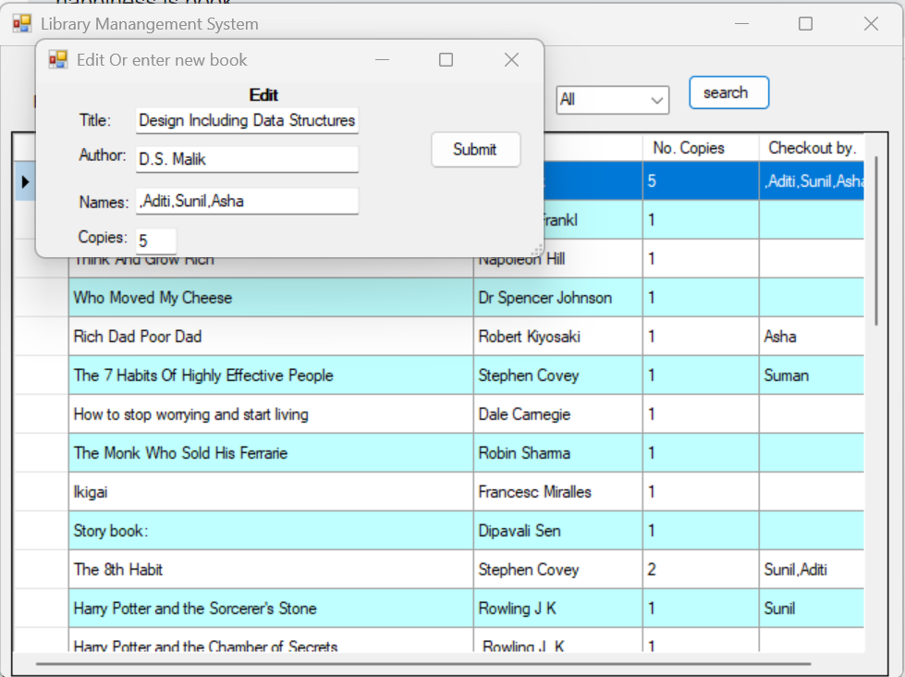

**Editing information of book in the library.**

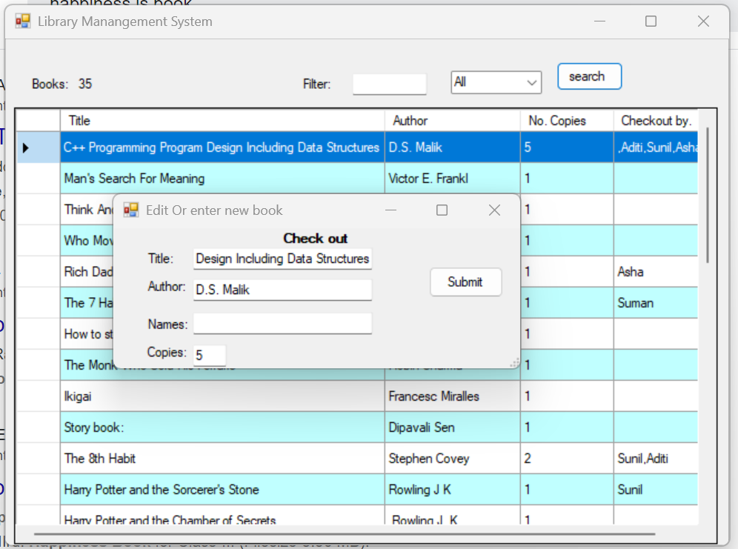

**Checkout book from the library.**

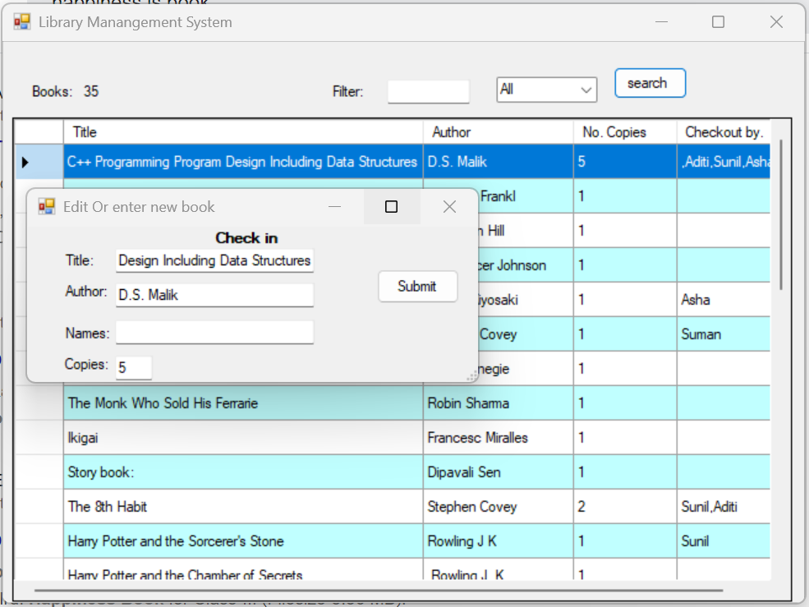

**Checkin book from the library.**

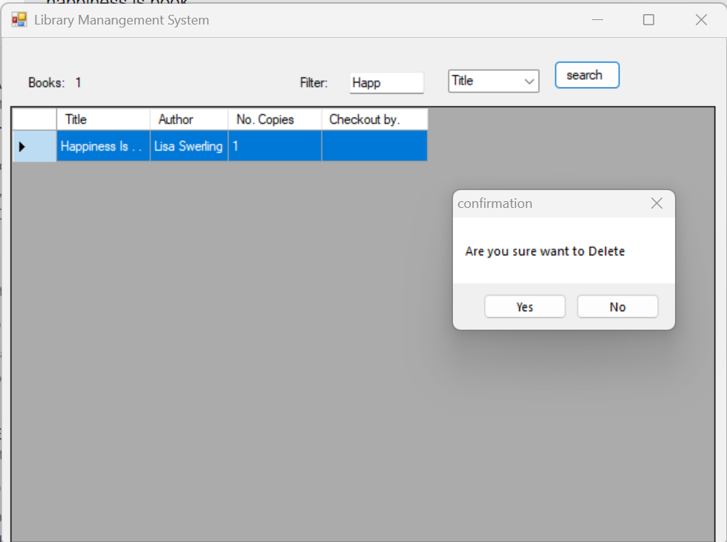

**When you select delete option from context menu it asks for the confirmation.**

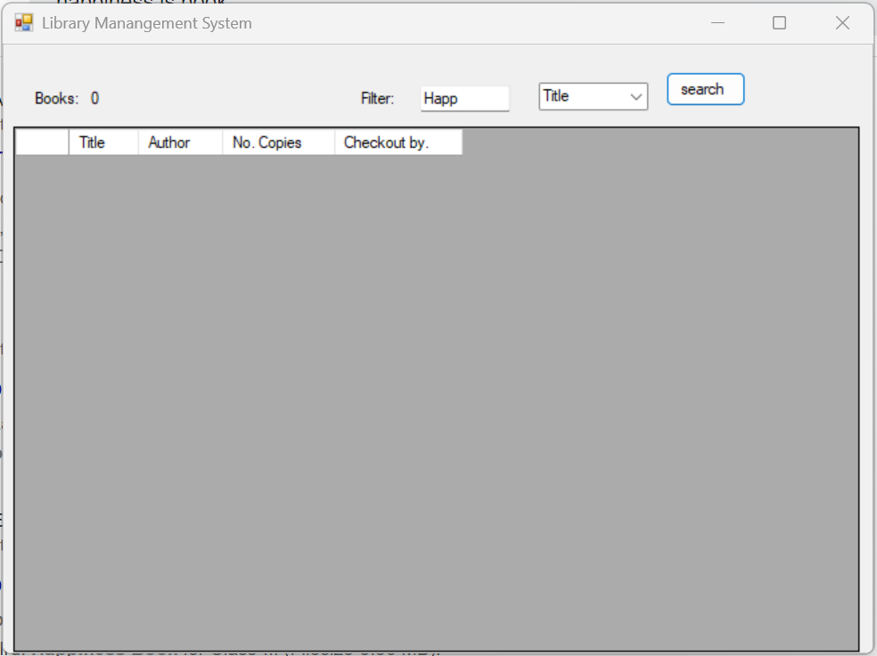

**Book is deleted form the library system.**