**Code and output screenshots from python notebook**

# implementation of basic K-means clustering algorithm using Python in jupyter notebook

# Student Name: Gargi Darade

# Subject/Class: CMPS 451 Artificial Intelligence

#Step 1:- Import the required libraries

#Numpy for statistical computations

#Matplotlib to plot the graph

#make_blobs from sklearn.datasets

import numpy as np

import matplotlib.pyplot as plt

from sklearn.datasets import make_blobs

#Step 2:- Create the custom test dataset with make_blobs and plot it

X,y = make_blobs(n_samples = 550,n_features = 2,centers = 3,random_state = 23)

fig = plt.figure(0)

plt.grid(True)

plt.scatter(X[:,0],X[:,1])

plt.title("Random test blob dataset")

plt.show()

#output of above code

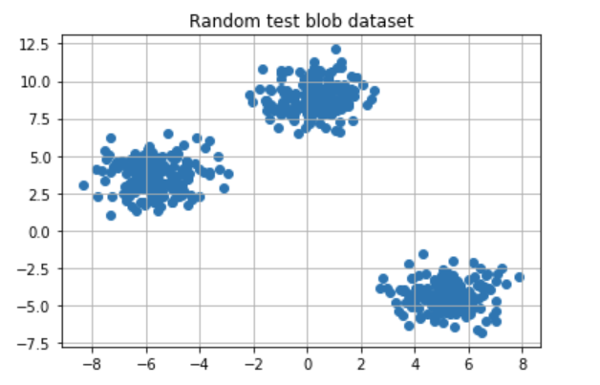

#Step 3: Initialize the random centroids

#initializes 3 clusters for K-means

#sets a random seed

#generates random cluster centers within a specified range

#creates an empty list of points for each cluster.

k = 3

clusters = {}

np.random.seed(23)

for idx in range(k):

center = 2*(2*np.random.random((X.shape[1],))-1)

points = []

cluster = {

'center' : center,

'points' : []

}

clusters[idx] = cluster

clusters

# output of above code

{0: {'center': array([0.06919154, 1.78785042]), 'points': []},

1: {'center': array([ 1.06183904, -0.87041662]), 'points': []},

2: {'center': array([-1.11581855, 0.74488834]), 'points': []}}

#Step 4: Plot the random initialize center with data points

plt.scatter(X[:,0],X[:,1])

plt.grid(True)

for i in clusters:

center = clusters[i]['center']

plt.scatter(center[0],center[1],marker = '*',c = 'red')

plt.title("Initial cluster centers (red stars)")

plt.show()

#output of above code

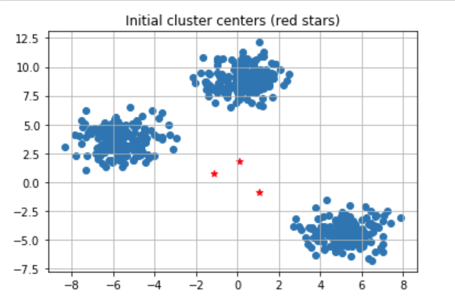

#Step 5: Define Euclidean distance

def distance(p1,p2):

return np.sqrt(np.sum((p1-p2)**2))

#Step 6: the function to Assign and Update the cluster center

#This step assigns data points to the nearest cluster center,

# and the M-step updates cluster centers based on the mean of assigned points in K-means clustering.

def assign_clusters(X, clusters):

for idx in range(X.shape[0]):

dist = []

curr_x = X[idx]

for i in range(k):

dis = distance(curr_x,clusters[i]['center'])

dist.append(dis)

curr_cluster = np.argmin(dist)

clusters[curr_cluster]['points'].append(curr_x)

return clusters

def update_clusters(X, clusters):

for i in range(k):

points = np.array(clusters[i]['points'])

if points.shape[0] > 0:

new_center = points.mean(axis =0)

clusters[i]['center'] = new_center

clusters[i]['points'] = []

return clusters

#Step 7: the function to Predict the cluster for the datapoints

def pred_cluster(X, clusters):

pred = []

for i in range(X.shape[0]):

dist = []

for j in range(k):

dist.append(distance(X[i],clusters[j]['center']))

pred.append(np.argmin(dist))

return pred

#Step 8: Assign, Update, and predict the cluster center

clusters = assign_clusters(X,clusters)

clusters = update_clusters(X,clusters)

pred = pred_cluster(X,clusters)

#Step 9: Plot the data points with their predicted cluster center

plt.scatter(X[:,0],X[:,1],c = pred)

for i in clusters:

center = clusters[i]['center']

plt.scatter(center[0],center[1],marker = '^',c = 'red')

plt.title("Red markers represent the updated cluster centers")

plt.show()

#output of above code

