**Implementation of a CNN model to identify the disease of plant leaf, using Python in jupyter notebook.**

**Student Name: Gargi Darade.**

**Subject/Class: CMPS 451 Artificial Intelligence.**

#Import the required libraries

import os

import matplotlib.image as mpimg

import matplotlib.pyplot as plt

from tensorflow.keras.preprocessing.image import ImageDataGenerator

from tensorflow.keras import layers, models

import numpy as np

from PIL import Image

#current_path = os.getcwd()

#print(current_path)

Number of Classes.

# Dataset Path

base_dir = 'plantvillage'

print("Number of Classes:"+str(len(os.listdir(base_dir))))

img_classes=os.listdir(base_dir)

print("Image classes:")

print(img_classes)

Number of Classes:15

Image classes:

['Pepper__bell___Bacterial_spot', 'Pepper__bell___healthy', 'Potato___Early_blight', 'Potato___healthy', 'Potato___Late_blight', 'Tomato_Bacterial_spot', 'Tomato_Early_blight', 'Tomato_healthy', 'Tomato_Late_blight', 'Tomato_Leaf_Mold', 'Tomato_Septoria_leaf_spot', 'Tomato_Spider_mites_Two_spotted_spider_mite', 'Tomato__Target_Spot', 'Tomato__Tomato_mosaic_virus', 'Tomato__Tomato_YellowLeaf__Curl_Virus']

**Sample images from all classes**

flCnt=1

for img_class in img_classes:

print("Image class:"+img_class)

tmp_file=os.listdir(base_dir+"/"+img_class)[:1]

image_path =base_dir+"/"+img_class+"/"+ tmp_file[0]

print("Image path:"+image_path)

# Read the image

img = mpimg.imread(image_path)

print("Image shape:"+str(img.shape))

# Display the image

plt.imshow(img)

plt.axis('off') # Turn off axis numbers

plt.savefig("clsRepImg" + str(flCnt) +".png")

flCnt=flCnt+1

plt.show()

Image class:Pepper__bell___Bacterial_spot

Image path:plantvillage/Pepper__bell___Bacterial_spot/0022d6b7-d47c-4ee2-ae9a-392a53f48647___JR_B.Spot 8964.JPG

Image shape:(256, 256, 3)

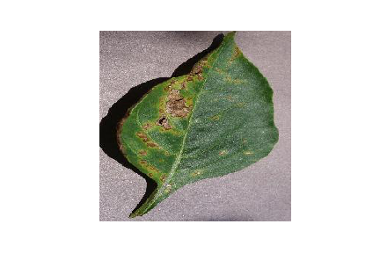

Image class:Pepper__bell___healthy

Image path:plantvillage/Pepper__bell___healthy/00100ffa-095e-4881-aebf-61fe5af7226e___JR_HL 7886.JPG

Image shape:(256, 256, 3)

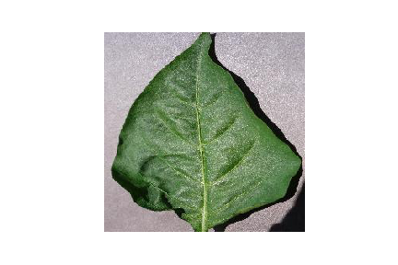

Image class:Potato___Early_blight

Image path:plantvillage/Potato___Early_blight/001187a0-57ab-4329-baff-e7246a9edeb0___RS_Early.B 8178.JPG

Image shape:(256, 256, 3)

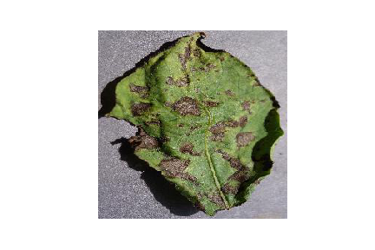

Image class:Potato___healthy

Image path:plantvillage/Potato___healthy/00fc2ee5-729f-4757-8aeb-65c3355874f2___RS_HL 1864.JPG

Image shape:(256, 256, 3)

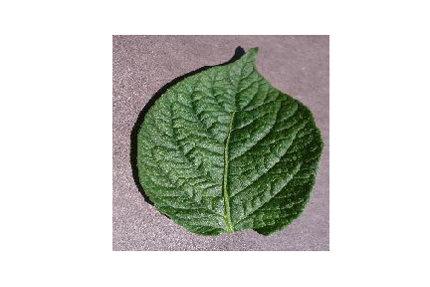

Image class:Potato___Late_blight

Image path:plantvillage/Potato___Late_blight/0051e5e8-d1c4-4a84-bf3a-a426cdad6285___RS_LB 4640.JPG

Image shape:(256, 256, 3)

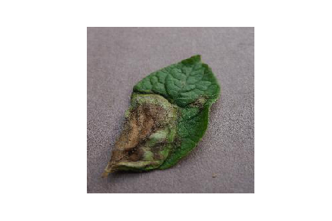

Image class:Tomato_Bacterial_spot

Image path:plantvillage/Tomato_Bacterial_spot/00416648-be6e-4bd4-bc8d-82f43f8a7240___GCREC_Bact.Sp 3110.JPG

Image shape:(256, 256, 3)

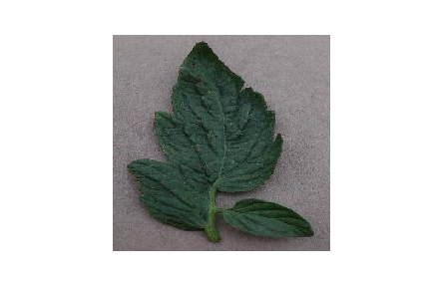

Image class:Tomato_Early_blight

Image path:plantvillage/Tomato_Early_blight/0012b9d2-2130-4a06-a834-b1f3af34f57e___RS_Erly.B 8389.JPG

Image shape:(256, 256, 3)

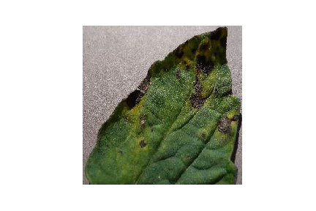

Image class:Tomato_healthy

Image path:plantvillage/Tomato_healthy/000146ff-92a4-4db6-90ad-8fce2ae4fddd___GH_HL Leaf 259.1.JPG

Image shape:(256, 256, 3)

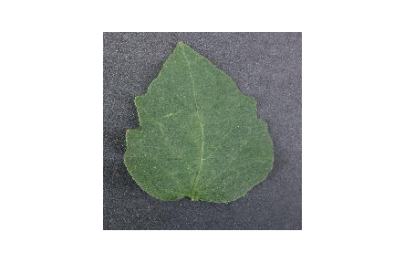

Image class:Tomato_Late_blight

Image path:plantvillage/Tomato_Late_blight/0003faa8-4b27-4c65-bf42-6d9e352ca1a5___RS_Late.B 4946.JPG

Image shape:(256, 256, 3)

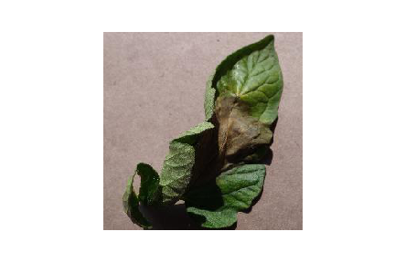

Image class:Tomato_Leaf_Mold

Image path:plantvillage/Tomato_Leaf_Mold/00694db7-3327-45e0-b4da-a8bb7ab6a4b7___Crnl_L.Mold 6923.JPG

Image shape:(256, 256, 3)

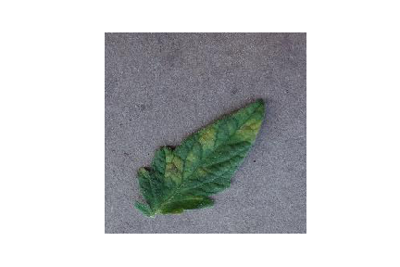

Image class:Tomato_Septoria_leaf_spot

Image path:plantvillage/Tomato_Septoria_leaf_spot/002533c1-722b-44e5-9d2e-91f7747b2543___Keller.St_CG 1831.JPG

Image shape:(256, 256, 3)

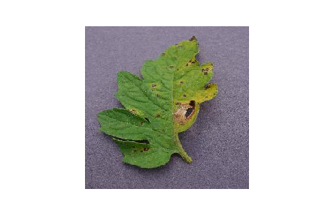

Image class:Tomato_Spider_mites_Two_spotted_spider_mite

Image path:plantvillage/Tomato_Spider_mites_Two_spotted_spider_mite/002835d1-c18e-4471-aa6e-8d8c29585e9b___Com.G_SpM_FL 8584.JPG

Image shape:(256, 256, 3)

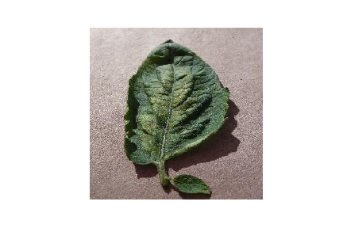

Image class:Tomato__Target_Spot

Image path:plantvillage/Tomato__Target_Spot/002213fb-b620-4593-b9ac-6a6cc119b100___Com.G_TgS_FL 8360.JPG

Image shape:(256, 256, 3)

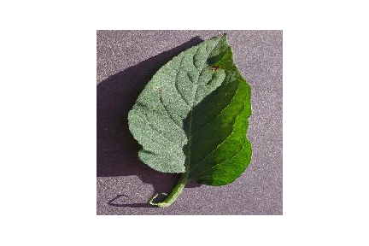

Image class:Tomato__Tomato_mosaic_virus

Image path:plantvillage/Tomato__Tomato_mosaic_virus/000ec6ea-9063-4c33-8abe-d58ca8a88878___PSU_CG 2169.JPG

Image shape:(256, 256, 3)

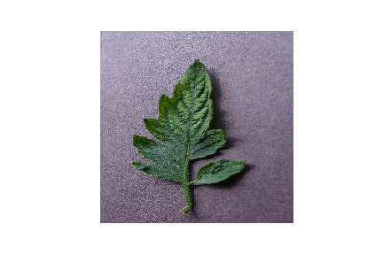

Image class:Tomato__Tomato_YellowLeaf__Curl_Virus

Image path:plantvillage/Tomato__Tomato_YellowLeaf__Curl_Virus/00139ae8-d881-4edb-925f-46584b0bd68c___YLCV_NREC 2944.JPG

Image shape:(256, 256, 3)

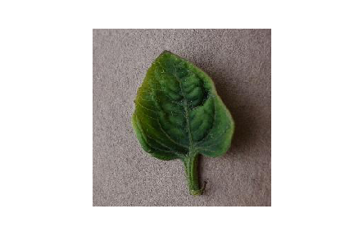

# Image Parameters

img_size = 224

batch_size = 32

**Train Test Split**

# Image Data Generators

data_gen = ImageDataGenerator(

rescale=1./255,

validation_split=0.2 # Use 20% of data for validation

)

# Train Generator

train_generator = data_gen.flow_from_directory(

base_dir,

target_size=(img_size, img_size),

batch_size=batch_size,

subset='training',

class_mode='categorical'

)

Found 16516 images belonging to 15 classes.

# Validation Generator

validation_generator = data_gen.flow_from_directory(

base_dir,

target_size=(img_size, img_size),

batch_size=batch_size,

subset='validation',

class_mode='categorical'

)

Found 4122 images belonging to 15 classes.

### Convolutional Neural Network

# Model Definition

model = models.Sequential()

model.add(layers.Conv2D(32, (3, 3), activation='relu', input_shape=(img_size, img_size, 3)))

model.add(layers.MaxPooling2D(2, 2))

model.add(layers.Conv2D(64, (3, 3), activation='relu'))

model.add(layers.MaxPooling2D(2, 2))

model.add(layers.Flatten())

model.add(layers.Dense(256, activation='relu'))

model.add(layers.Dense(train_generator.num_classes, activation='softmax'))

# model summary

model.summary()

Model: "sequential_1"

_________________________________________________________________

Layer (type) Output Shape Param #

=================================================================

conv2d_2 (Conv2D) (None, 222, 222, 32) 896

max_pooling2d_2 (MaxPooling (None, 111, 111, 32) 0

2D)

conv2d_3 (Conv2D) (None, 109, 109, 64) 18496

max_pooling2d_3 (MaxPooling (None, 54, 54, 64) 0

2D)

flatten_1 (Flatten) (None, 186624) 0

dense_2 (Dense) (None, 256) 47776000

dense_3 (Dense) (None, 15) 3855

=================================================================

Total params: 47,799,247

Trainable params: 47,799,247

Non-trainable params: 0

_________________________________________________________________

#### Model training

# Training the Model

history = model.fit(

train_generator,

steps_per_epoch=train_generator.samples // batch_size, # Number of steps per epoch

epochs=10, # Number of epochs

validation_data=validation_generator,

validation_steps=validation_generator.samples // batch_size # Validation steps

)

Epoch 1/10

516/516 [==============================] - 585s 1s/step - loss: 1.1255 - accuracy: 0.6690 - val_loss: 0.5227 - val_accuracy: 0.8262

Epoch 2/10

516/516 [==============================] - 583s 1s/step - loss: 0.3572 - accuracy: 0.8829 - val_loss: 0.4483 - val_accuracy: 0.8452

Epoch 3/10

516/516 [==============================] - 584s 1s/step - loss: 0.1372 - accuracy: 0.9547 - val_loss: 0.4470 - val_accuracy: 0.8613

Epoch 4/10

516/516 [==============================] - 583s 1s/step - loss: 0.0767 - accuracy: 0.9756 - val_loss: 0.5408 - val_accuracy: 0.8660

Epoch 5/10

516/516 [==============================] - 583s 1s/step - loss: 0.0619 - accuracy: 0.9811 - val_loss: 0.6105 - val_accuracy: 0.8401

Epoch 6/10

516/516 [==============================] - 583s 1s/step - loss: 0.0478 - accuracy: 0.9849 - val_loss: 0.6552 - val_accuracy: 0.8430

Epoch 7/10

516/516 [==============================] - 583s 1s/step - loss: 0.0568 - accuracy: 0.9817 - val_loss: 1.0894 - val_accuracy: 0.7869

Epoch 8/10

516/516 [==============================] - 582s 1s/step - loss: 0.0331 - accuracy: 0.9888 - val_loss: 0.7412 - val_accuracy: 0.8433

Epoch 9/10

516/516 [==============================] - 582s 1s/step - loss: 0.0471 - accuracy: 0.9864 - val_loss: 0.7312 - val_accuracy: 0.8552

Epoch 10/10

516/516 [==============================] - 582s 1s/step - loss: 0.0207 - accuracy: 0.9930 - val_loss: 0.7479 - val_accuracy: 0.8633

#### Model Evaluation

# Model Evaluation

print("Evaluating model...")

val_loss, val_accuracy = model.evaluate(validation_generator, steps=validation_generator.samples // batch_size)

print(f"Validation Accuracy: {val_accuracy * 100:.2f}%")

Evaluating model...

128/128 [==============================] - 27s 211ms/step - loss: 0.7465 - accuracy: 0.8643

Validation Accuracy: 86.43%

# Plot training & validation accuracy values

plt.plot(history.history['accuracy'])

plt.plot(history.history['val_accuracy'])

plt.title('Model accuracy')

plt.ylabel('Accuracy')

plt.xlabel('Epoch')

plt.legend(['Train', 'Test'], loc='upper left')

plt.savefig("ModelAccuracy.png")

plt.show()

# Plot training & validation loss values

plt.plot(history.history['loss'])

plt.plot(history.history['val_loss'])

plt.title('Model loss')

plt.ylabel('Loss')

plt.xlabel('Epoch')

plt.legend(['Train', 'Test'], loc='upper left')

plt.savefig("ModelLoss.png")

plt.show()

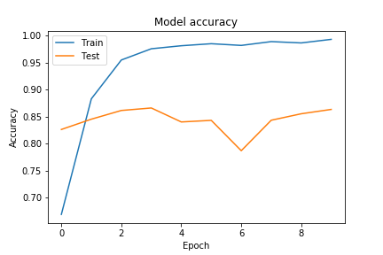

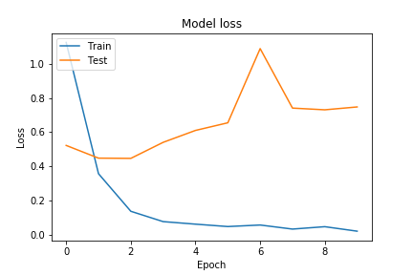

#### Building a Predictive System

# Function to Load and Preprocess the Image using Pillow

def load_and_preprocess_image(image_path, target_size=(224, 224)):

# Load the image

img = Image.open(image_path)

# Resize the image

img = img.resize(target_size)

# Convert the image to a numpy array

img_array = np.array(img)

# Add batch dimension

img_array = np.expand_dims(img_array, axis=0)

# Scale the image values to [0, 1]

img_array = img_array.astype('float32') / 255.

return img_array

# Function to Predict the Class of an Image

def predict_image_class(model, image_path, class_indices):

preprocessed_img = load_and_preprocess_image(image_path)

predictions = model.predict(preprocessed_img)

predicted_class_index = np.argmax(predictions, axis=1)[0]

predicted_class_name = class_indices[predicted_class_index]

return predicted_class_name

# Create a mapping from class indices to class names

class_indices = {v: k for k, v in train_generator.class_indices.items()}

class_indices

{0: 'Pepper__bell___Bacterial_spot',

1: 'Pepper__bell___healthy',

2: 'Potato___Early_blight',

3: 'Potato___Late_blight',

4: 'Potato___healthy',

5: 'Tomato_Bacterial_spot',

6: 'Tomato_Early_blight',

7: 'Tomato_Late_blight',

8: 'Tomato_Leaf_Mold',

9: 'Tomato_Septoria_leaf_spot',

10: 'Tomato_Spider_mites_Two_spotted_spider_mite',

11: 'Tomato__Target_Spot',

12: 'Tomato__Tomato_YellowLeaf__Curl_Virus',

13: 'Tomato__Tomato_mosaic_virus',

14: 'Tomato_healthy'}

# Example Usage

image_path = 'test_images/test_potato_early_blight.jpg'

predicted_class_name = predict_image_class(model, image_path, class_indices)

# Output the result

print("Predicted Class Name:", predicted_class_name)

1/1 [==============================] - 0s 83ms/step

Predicted Class Name: Potato___Early_blight

#### Save the model to local drive

model.save('PlantDiseasePredictionCNNModel.h5')