**Implementation of Regression Model to confirm if there is a relationship between the two sets of columns, (1) “age” and “bmi” and (2) “age” and “charges” from the given data, using Python in jupyter notebook.**

**Student Name: Gargi Darade.**

**Subject/Class: CMPS 451 Artificial Intelligence.**

#Step 1:- Import the required libraries

#Numpy for statistical computations

#Matplotlib to plot the graph

#make_blobs from sklearn.datasets

import pandas as pd

import numpy as np

import matplotlib.pyplot as plt

import seaborn as sns

#from sklearn.datasets import make_blobs

from sklearn.model_selection import train_test_split

from sklearn.preprocessing import MinMaxScaler

#!pip install tensorflow

import tensorflow as tf

#load data from csv file

data_path = 'insurance.csv'

# create pandas dataframe

df = pd.read_csv(data_path)

# remove spaces on the column

df.columns = df.columns.str.lstrip()

df.columns = df.columns.str.rstrip()

# print out sample dataset

print("Total records:",len(df))

df.shape

df.head()

Total records: 1338

Out[86]:

|  | **age** | **sex** | **bmi** | **children** | **smoker** | **region** | **charges** |
| --- | --- | --- | --- | --- | --- | --- | --- |
| 0 | 19 | female | 27.900 | 0 | yes | southwest | 16884.92400 |
| 1 | 18 | male | 33.770 | 1 | no | southeast | 1725.55230 |
| 2 | 28 | male | 33.000 | 3 | no | southeast | 4449.46200 |
| 3 | 33 | male | 22.705 | 0 | no | northwest | 21984.47061 |
| 4 | 32 | male | 28.880 | 0 | no | northwest | 3866.85520 |

# filter the columns by only the required_columns

required_cols = ['age', 'bmi', 'charges']

df = df[required_cols]

df.head()

# check number of nan values in dataframe

df.isna().sum()

age 0

bmi 0

charges 0

dtype: int64

#to check relation plot scatter plot

plt.scatter('age', 'bmi', data=df);

plt.title('Age vs BMI', fontsize=16)

plt.xlabel('Age', fontsize=12)

plt.ylabel('BMI', fontsize=12)

plt.savefig("AgeVsBMI.png")

plt.show()

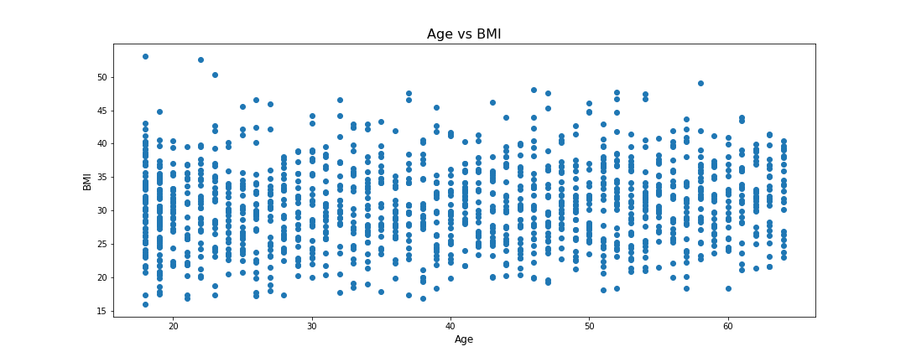

from numpy.polynomial.polynomial import polyfit

# Fit with polyfit

# Sample data

x = df['age']

y = df['bmi']

b, m = polyfit(x,y , 1)

plt.plot(x, y, '.')

plt.plot(x, b + m * x, '-')

plt.savefig("AgeVsBMIFt.png")

plt.show()

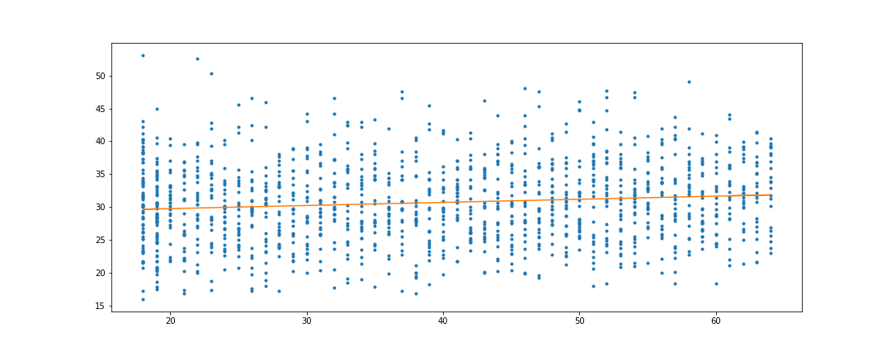

## The above plots proves no relation between Age and BMI (slope is zero)

plt.scatter('age', 'charges', data=df);

plt.title('Age vs Charges', fontsize=16)

plt.xlabel('Age', fontsize=12)

plt.ylabel('Charges', fontsize=12)

plt.savefig("AgeVsCharges.png")

plt.show()

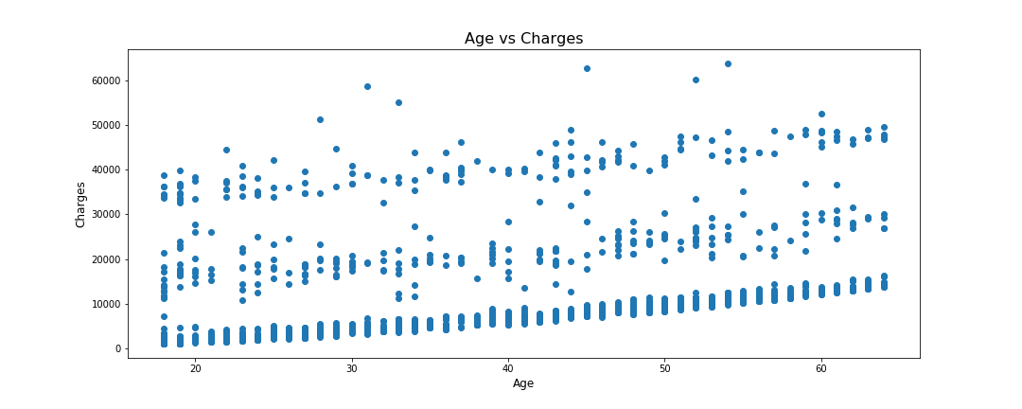

from numpy.polynomial.polynomial import polyfit

# Fit with polyfit

# Sample data

x = df['age']

y = df['charges']

#sns.regplot(x=x, y=y)

b, m = polyfit(x,y , 1)

plt.plot(x, y, '.')

plt.plot(x, b + m * x, '-')

plt.savefig("AgeVsChargesFt.png")

plt.show()

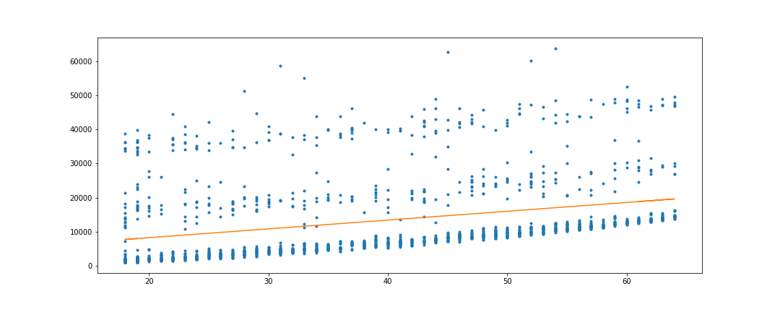

## The above plots proves weak relation between Age and Charges.

**calculate the Pearson's correlation between two variables**

**The positive correlation between the two variables is strong, if it surpasses the 0.5 threshold and approaches 1.0**

from scipy.stats import pearsonr

corr, _ = pearsonr(df['age'], df['bmi'])

print('Pearsons correlation between Age and BMI: %.3f' % corr)

corr, _ = pearsonr(df['age'], df['charges'])

print('Pearsons correlation between Age and Charges: %.3f' % corr)

Pearsons correlation between Age and BMI: 0.109

Pearsons correlation between Age and Charges: 0.299

**If you are unsure of the distribution and possible relationships between two variables, the Spearman correlation coefficient is a good tool to use.**

from scipy.stats import spearmanr

corr, pvalue = spearmanr(df['age'], df['bmi'])

print('Spearman’s correlation between Age and BMI: %.3f' % corr)

#print(f"P-value: {pvalue}")

corr, pvalue = spearmanr(df['age'], df['charges'])

print('Spearman’s correlation between Age and Charges: %.3f' % corr)

#print(f"P-value: {pvalue}")

Spearman’s correlation between Age and BMI: 0.108

Spearman’s correlation between Age and Charges: 0.534

### Better than pearsons but not that strong.

# What if we use log transformation on Charges

x = df['age']

y = df['charges']

slope, intercept = np.polyfit(x, np.log(y), 1)

plt.figure()

plt.scatter(x, np.log(y))

plt.plot(x, (slope*x)+intercept)

plt.savefig("AgeVsLogChargesFt.png")

plt.show()

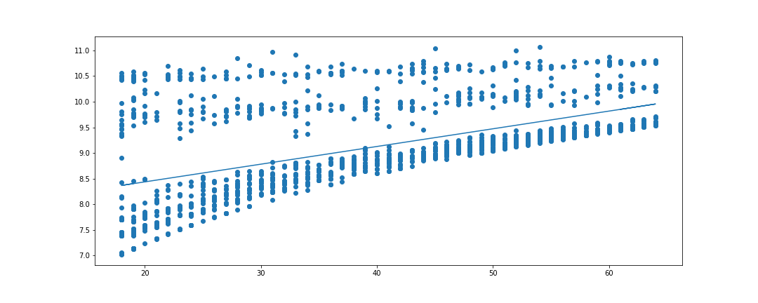

from scipy.stats import spearmanr

corr, pvalue = spearmanr(df['age'], df['charges'])

print('Spearman’s correlation between Age and charges: %.3f' % corr)

#print(f"P-value: {pvalue}")

corr, pvalue = spearmanr(df['age'], np.log(df['charges']))

print('Spearman’s correlation between Age and Log Charges: %.3f' % corr)

#print(f"P-value: {pvalue}")

Spearman’s correlation between Age and charges: 0.534

Spearman’s correlation between Age and Log Charges: 0.534

**Ordinary least squares (OLS) regression is an optimization strategy used in linear regression models**

**that finds a straight line that fits as close as possible to the data points, in order to help estimate the relationship between a dependent variable and one or more independent variables**

import statsmodels.api as sm

import numpy as np

import matplotlib.pyplot as plt

x = df['age']

y = df['charges']

results = sm.OLS(y,sm.add_constant(x)).fit()

print(results.params)

print(results.summary())

mn=np.min(x)

mx=np.max(x)

x1=np.linspace(mn,mx,500)

y1=results.params[1]*x1+results.params[0]

plt.plot(x,y,'ob')

plt.plot(x1,y1,'-r')

plt.savefig("OLSRegAgeVsChargesFt.png")

plt.show()

const 3165.885006

age 257.722619

dtype: float64

OLS Regression Results

==============================================================================

Dep. Variable: charges R-squared: 0.089

Model: OLS Adj. R-squared: 0.089

Method: Least Squares F-statistic: 131.2

Date: Mon, 07 Apr 2025 Prob (F-statistic): 4.89e-29

Time: 14:20:24 Log-Likelihood: -14415.

No. Observations: 1338 AIC: 2.883e+04

Df Residuals: 1336 BIC: 2.884e+04

Df Model: 1

Covariance Type: nonrobust

==============================================================================

coef std err t P>|t| [0.025 0.975]

------------------------------------------------------------------------------

const 3165.8850 937.149 3.378 0.001 1327.440 5004.330

age 257.7226 22.502 11.453 0.000 213.579 301.866

==============================================================================

Omnibus: 399.600 Durbin-Watson: 2.033

Prob(Omnibus): 0.000 Jarque-Bera (JB): 864.239

Skew: 1.733 Prob(JB): 2.15e-188

Kurtosis: 4.869 Cond. No. 124.

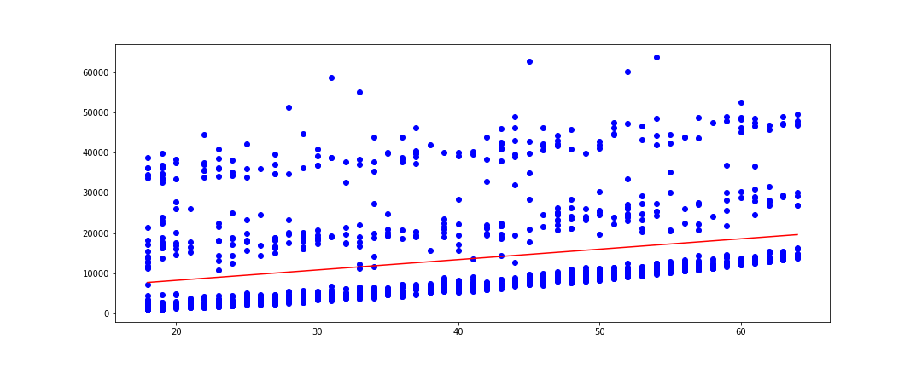

## Ordinary least squares (OLS) regression using log transformation on Charges

import statsmodels.api as sm

import numpy as np

import matplotlib.pyplot as plt

x = df['age']

y = np.log(df['charges'])

results = sm.OLS(y,sm.add_constant(x)).fit()

print(results.params)

print(results.summary())

mn=np.min(x)

mx=np.max(x)

x1=np.linspace(mn,mx,500)

y1=results.params[1]*x1+results.params[0]

plt.plot(x,y,'ob')

plt.plot(x1,y1,'-r')

plt.savefig("OLSRegAgeVsLogChargesFt.png")

plt.show()

const 7.744247

age 0.034545

dtype: float64

OLS Regression Results

==============================================================================

Dep. Variable: charges R-squared: 0.279

Model: OLS Adj. R-squared: 0.278

Method: Least Squares F-statistic: 516.0

Date: Mon, 07 Apr 2025 Prob (F-statistic): 7.48e-97

Time: 16:04:14 Log-Likelihood: -1567.3

No. Observations: 1338 AIC: 3139.

Df Residuals: 1336 BIC: 3149.

Df Model: 1

Covariance Type: nonrobust

==============================================================================

coef std err t P>|t| [0.025 0.975]

------------------------------------------------------------------------------

const 7.7442 0.063 122.272 0.000 7.620 7.868

age 0.0345 0.002 22.715 0.000 0.032 0.038

==============================================================================

Omnibus: 179.280 Durbin-Watson: 2.029

Prob(Omnibus): 0.000 Jarque-Bera (JB): 256.341

Skew: 1.067 Prob(JB): 2.17e-56

Kurtosis: 3.206 Cond. No. 124.

==============================================================================

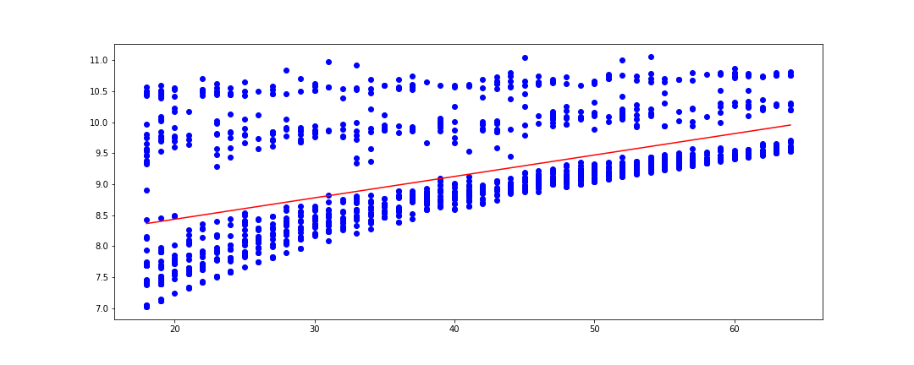

### R-squared is 0.089 when charges are used as is, becomes R-squared 0.279 when log transformation is used on charges

import matplotlib.pyplot as plt

from scipy import stats

x = df['age']

y = np.log(df['charges'])

slope, intercept, r, p, std_err = stats.linregress(x, y)

def modelYval(x):

return slope * x + intercept

mymodel = list(map(modelYval, x))

print("slope:",slope)

print("intercept:",intercept)

print("r:",r)

print("p:",p)

print("std_err:",std_err)

plt.scatter(x, y)

plt.plot(x, mymodel)

plt.savefig("LinRegAgeVsLogChargesFt.png")

plt.show()

slope: 0.03454513080663117

intercept: 7.744246908060742

r: 0.5278340489394343

p: 7.477385218968553e-97

std_err: 0.0015207983609832536



import matplotlib.pyplot as plt

from scipy import stats

x = df['age']

y = df['charges']

slope, intercept, r, p, std_err = stats.linregress(x, y)

def modelYval(x):

return slope * x + intercept

mymodel = list(map(modelYval, x))

print("slope:",slope)

print("intercept:",intercept)

print("r:",r)

print("p:",p)

print("std_err:",std_err)

plt.scatter(x, y)

plt.plot(x, mymodel)

plt.savefig("LinRegAgeVsLogChargesFt.png")

plt.show()

slope: 257.7226186668956

intercept: 3165.885006063023

r: 0.29900819333064776

p: 4.886693331718281e-29

std_err: 22.5023892867703

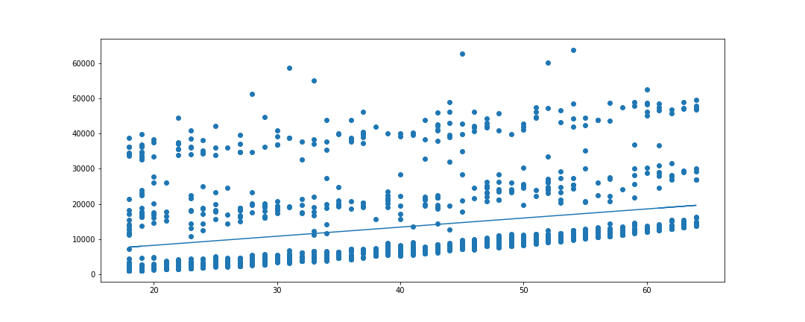

## Conclusion: from above regression analysis we can conclude that there is no relation between Age and BMI, but there is some weak relation between Age and charges.