We have a planar 6-DOF (base- 3DOF x,y,yaw and arm 3DOF -3 revolute joints) free-floating SMS. The SMS has one arm with three links and the base. Due to dynamic coupling if we move the arm the base also moves.

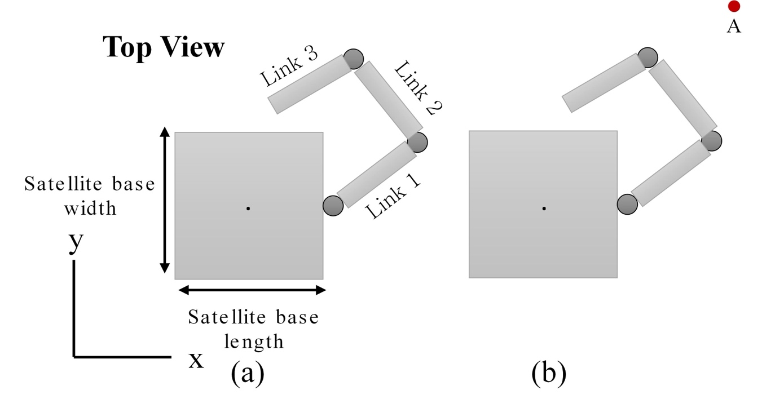

The idea is to design the MuJoCo Simulation Model and then control the SMS. The following steps are followed:
- Create an .xml file for the SMS.
- Test the .xml model with forward kinematics.
- Design a PID controller to move the end-effector from point A to point B.
- Design an MPC controller to move the end-effector from point A to point B.
- Design a RL-based controller to move the end-effector from point A to point B.

- Step -1: Create an .xml file for the SMS
The .xml file is the robot description file. In MuJoCo the physical properties like link length, mass, inertia, joint type, base dimensions, geometry are usually defined in an XML file. The XML tells MuJoCo:
"This is my mechanical system. Build the multibody model and compute all dynamics automatically."
The .xml file for the system is as follows:
<?xml version="1.0"?>
<mujoco model="planar_ffsms_com">
<compiler angle="radian" inertiafromgeom="true" />
<!-- option integrator="RK4" timestep="0.002" gravity="0 0 0" /-->
<option timestep="0.002" gravity="0 0 0" integrator="RK4" />

<default>
<geom conaffinity="1" contype="1" friction="0.0 0.0 0.0" density="1000"/>
<joint limited="false"/>
</default>

<worldbody>
<!-- Large plane behind the model for background -->
<body name="bg_plane" pos="0 0 -5">
<geom type="plane" size="10 10 0.1" rgba="0.95 0.95 0.95 1"/>
</body>
<!-- Overhead directional light -->
<light diffuse="0.1 0.1 0.1" ambient="0.1 0.1 0.1"
pos="0 0 50" dir="0 0 -1"/>

<!-- Fill lights >
<light diffuse=".3 .3 .3" pos="5 5 5"/>
<light diffuse=".3 .3 .3" pos="-5 -5 5"/-->
<!--
World origin is the INERTIAL FRAME = WHOLE-SYSTEM CENTER OF MASS.
The base body is positioned at the base COM (N_r_b) computed
for q = [0,0,0] and placed here so the world origin sits at system COM.
-->
<!--body name="base" pos="-0.05735208 0 0"-->
<body name="base" pos="-0.0522 -0.0193 0">
<!-- Planar floating base joints (restrict motion to plane: tx, ty, yaw) -->
<joint name="base_tx" type="slide" axis="1 0 0" />
<joint name="base_ty" type="slide" axis="0 1 0" />
<joint name="base_yaw" type="hinge" axis="0 0 1" />

<!-- Base geometry: box sized to lb/2 in x and y half-sizes -->
<geom name="base_geom" type="box" pos="0 0 0" size="0.232 0.232 0.2415" mass="33.015" rgba="1 1 0.2 1"/>

<!-- Mounting point B_M_b is at +lb/2 along base x in base frame -->
<body name="mount_point" pos="0.232 0 0">
<!-- Joint 1: hinge about z (rotation q1) -->
<joint name="joint1" type="hinge" axis="0 0 1" pos="0 0 0" damping="0.0" />
<!-- Link1: capsule from joint1 origin to l1 along +x -->
<body name="link1" pos="0 0 0">
<geom name="link1_geom" type="box" size="0.19 0.019 0.019" pos="0.19 0 0" mass="1.2" rgba="0.8 0.3 0.3 1"/>
<!-- joint2 located at the end of link1 (x = l1) -->
<body name="joint2_mount" pos="0.38 0 0">
<joint name="joint2" type="hinge" axis="0 0 1" pos="0 0 0" damping="0.0" />
<body name="link2" pos="0 0 0">
<geom name="link2_geom" type="box" size="0.19 0.019 0.019" pos="0.19 0 0" mass="1.2" rgba="0.3 0.8 0.3 1"/>
<!-- joint3 located at end of link2 -->
<body name="joint3_mount" pos="0.38 0 0">
<joint name="joint3" type="hinge" axis="0 0 1" pos="0 0 0" damping="0.0" />
<body name="link3" pos="0 0 0">
<geom name="link3_geom" type="box" size="0.19 0.019 0.019" pos="0.19 0 0" mass="0.5" rgba="0.3 0.3 0.8 1"/>
<site name="ee_site" pos="0.38 0 0" size="0.01" type="sphere" rgba="1 0 0 1"/>
</body>
</body>
</body>
</body>
</body>
</body>

</body>
</worldbody>

<actuator>
<!-- torque actuators on the manipulator joints -->
<motor joint="joint1" gear="1"/>
<motor joint="joint2" gear="1"/>
<motor joint="joint3" gear="1"/>
</actuator>

<sensor>
<jointpos joint="joint1" name="q1"/>
<jointpos joint="joint2" name="q2"/>
<jointpos joint="joint3" name="q3"/>

<jointpos joint="base_tx" name="base_x"/>
<jointpos joint="base_ty" name="base_y"/>
<jointpos joint="base_yaw" name="base_yaw"/>

<!-- Correct way to get end-effector site position -->
<framepos objtype="site" objname="ee_site" name="ee_pos"/>
</sensor>

<keyframe>
<key name="home" qpos="0 0 0 0 0 0"/>
<!-- <key name="home" qpos="0 0 0 0.523599 0 0"/> -->
</keyframe>

</mujoco>
The SMS model looks like:
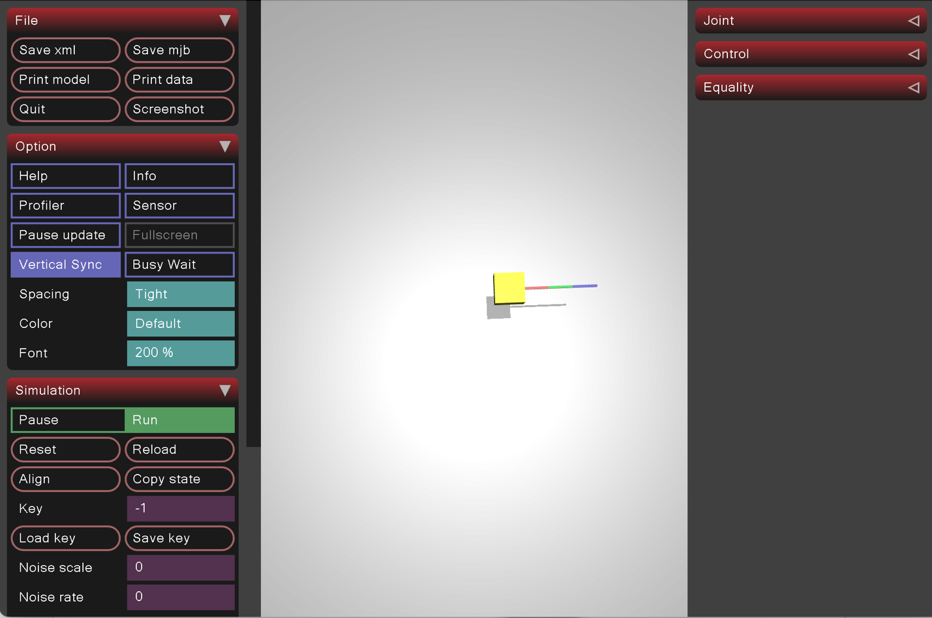

- Step -2: Test the .xml file for the SMS using Forward Kinematics
Forward kinematics is the process of determining the end-effector pose (position and orientation) from the given joint angles. In our current planar Space Manipulator System (SMS), we are primarily interested in calculating the end-effector position in the x-y plane, while the z-coordinate remains constant.
We need to write a separate python file, where we calculate the forward kinematics. A small snippet of the code is:
while (data.time - time_prev < 1.0/60.0):
#mj.mj_step(model, data) # step gives you only dynamics
data.time += 0.2;
data.qpos = key_qpos.copy(). # You can either get the joint angle values from the .xml file
#data.qpos = np.array([1.5707, -1.5707, 1.5707]) # You can also define the joint angles here

mj.mj_forward(model, data) # only forward kinematics
mj_end_eff_pos = data.site("ee_site").xpos
print(mj_end_eff_pos)

Let us test our forward kinematics code with two different initial joint angles. Before that the link lengths are: l1 = l2 = l3 = 0.38m and the mounting point of the arm from the base’s com was 0.232m. Each link COM position vector is [0.19; 0.019; 0.019].

With initial q1=q2=q3 =0 the end-effector position is: [ 1.3198 -0.0193 0. ]
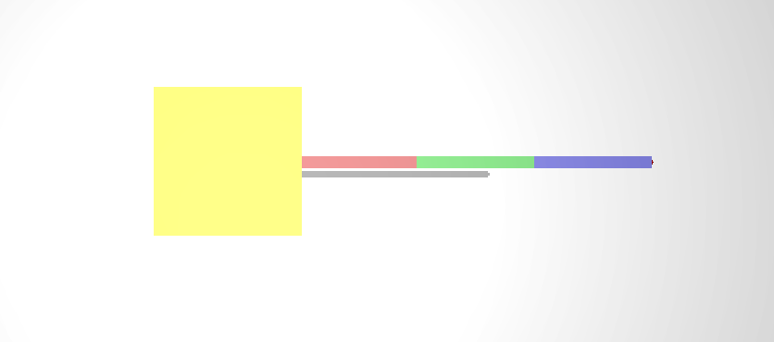

% Calcualte end-effector position
N_r_e = N_r_b + N_L_b + R_N1 * L_l_1 + R_N2 * L_l_2 + R_N3 * L_l_3;

B_L_b = [lb/2; 0; 0]; % B_M_b in body frame
N_L_b = R_NB * B_L_b; % N_M_b in inertial frame
N_l_1 = R_N1 * L_l_1;
N_l_2 = R_N2 * L_l_2;
N_l_3 = R_N3 * L_l_3;
% Calculate the base position w.r.t inertial frame
N_r_b =-(((m_1+m_2+m_3) * N_L_b)+ ((0.5 *m_1 + m_2 +m_3)* N_l_1) + ...
((0.5 *m_2 +m_3)* N_l_2) + (0.5* m_3 * N_l_3))/(m_b + m_1 + m_2 + m_3);

Now let us check the forward kinematics with q1 = 30 deg, q2 = q3 =0, the end-effector position is: [1.16706883 0.55070022 0. ]
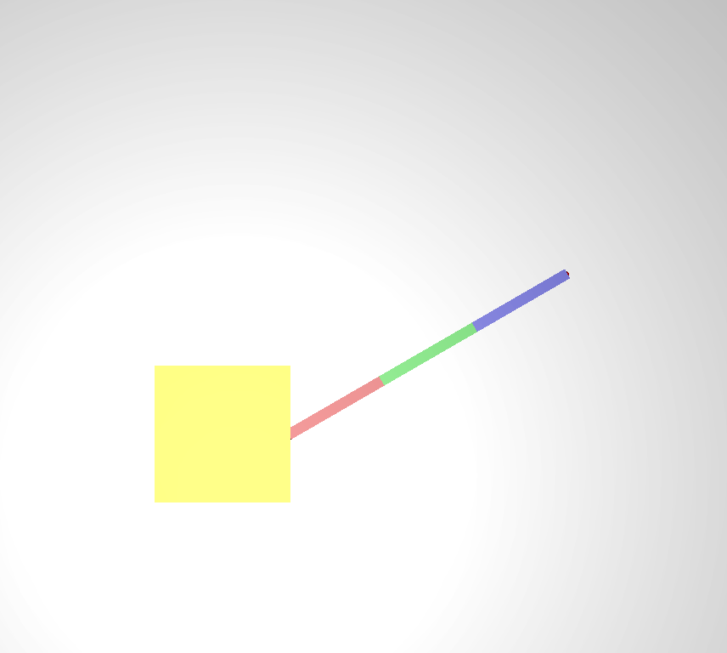

- Step -3: Design a PID controller to move the end-effector from point A to point B
For ease of understanding we will consider all joint angles 0 as point A and joint 1 = 30 deg as point B. So from the above two images, first image ee is at point A and and second image ee is the desired ee-position, i.e. point B.

B
A

We can solve this problem in two ways, 1. Joint-space control: where we can directly control the joint angle using PID. We know initial joint angles and the desired joint angles, we can easily calculate the errors and design the PID.
The control law is simply:
$$e=q_{d}-q \\ τ=K_{p}e+K_{d}\dot{e}+K_{i}∫e dt$$
No Jacobian required.
2. Task (Cartesian) space control: End-effector position control using Jacobian transpos. You know the initial and desired end-effector position.
desired end-effector position: xd​
Compute: $e_{x}=x_{d}-x$
and use the Jacobian
$$\dot{q}=J^{-1}Ke_{x}$$
or
$$τ=J^{T}Ke_{x}$$
This introduces:
- Jacobians
- singularities
- Cartesian control
First, we will do the joint-space control:
For joint space control we have desired q_des and current q. We designed a PD control. We made a code named “mj_FreeFloating_Joint_Space_PID_Planar.py”. We made few changes in the .xml file:
- Increased base mass to 100.015kg, increased joint damping from 0 to 0.3.
- In the Controller code: we kept the gains as:
Kp = np.array([5.0, 5.0, 5.0])
Ki = np.array([0.0, 0.0, 0.0])
Kd = np.array([2.0, 2.0, 2.0])

# Actuator output saturation [Nm]
TORQUE_LIMIT = 5.0
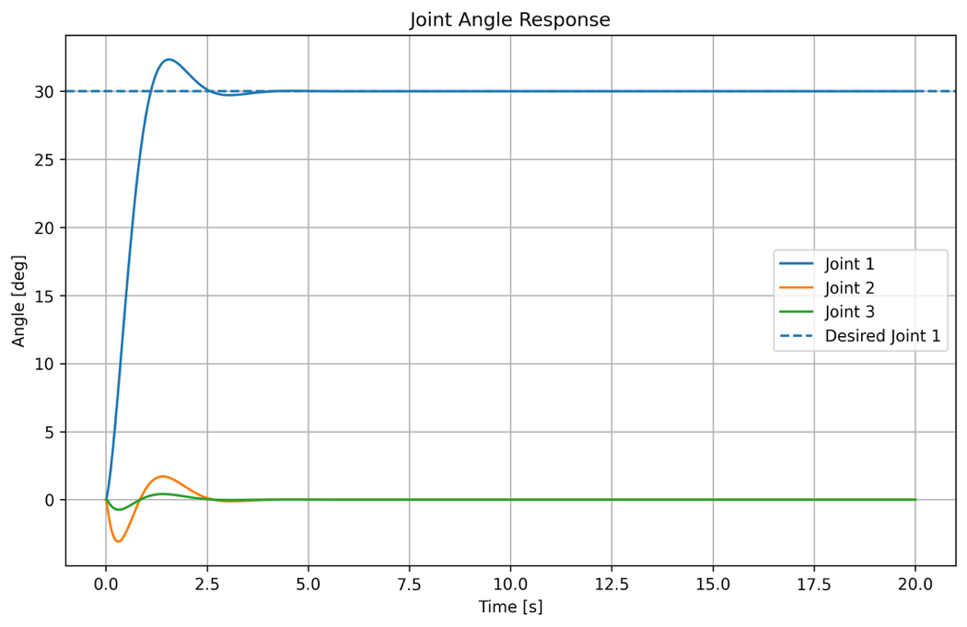
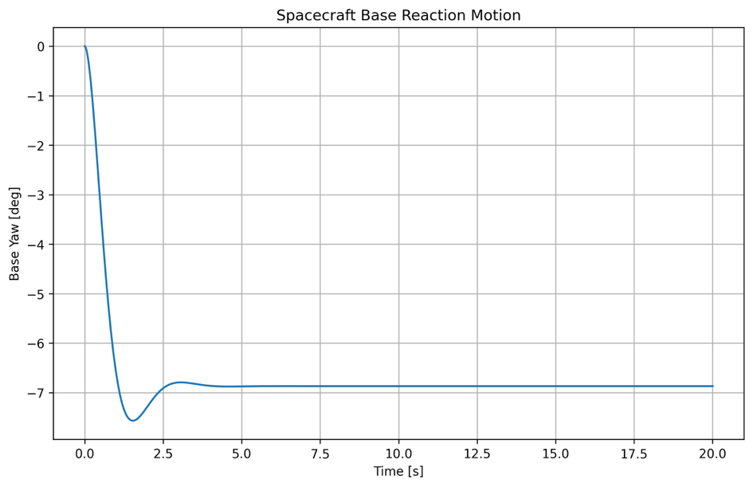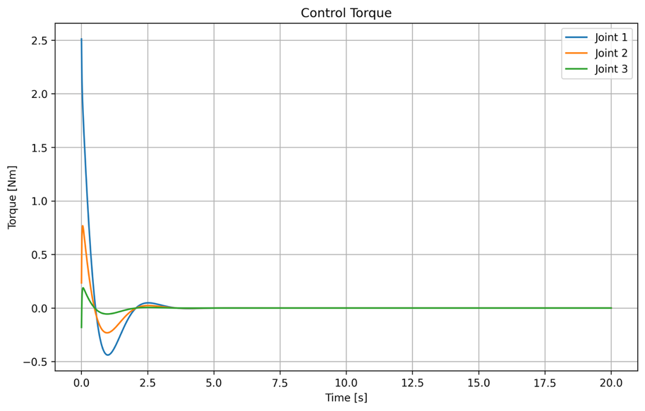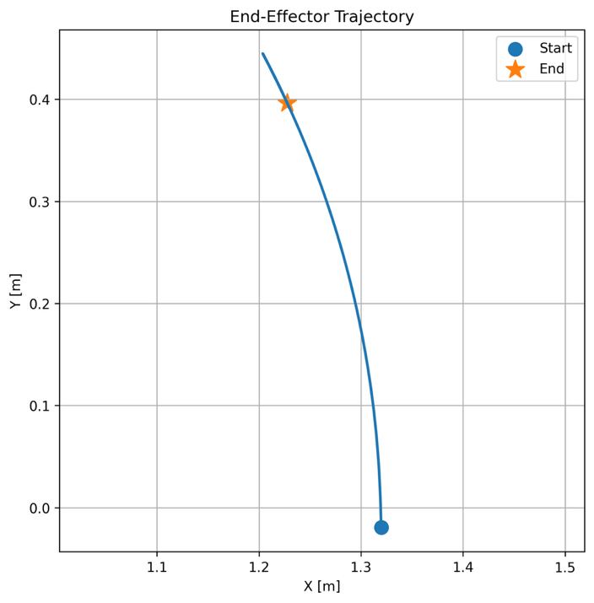
Now, Task space control:

