**Name: GARGI GHOSAL**

**Class Roll No.: 301911001004**

**Department: B.E Information Technology**

**Year of study: 4th Year**

**Semester: 1st Sem**

**Subject name: Machine Learning Lab (Subject Code: IT/PC/B/S/411)**

**Git link:** [**https://github.com/GargiGhosal/MachineLearning_Lab.git**](https://github.com/GargiGhosal/MachineLearning_Lab.git)

**Solutions::**

**Q1. Datasets used :**

1. Wine Dataset: <https://archive.ics.uci.edu/ml/datasets/wine>
2. Ionosphere Dataset: <https://archive.ics.uci.edu/ml/datasets/Ionosphere>

**Q1. Answers::**

# WINE DATASET

# SVM(Without Tuning)[70-30 split]

import pandas as pd

import numpy as np

# Dataset Preparation

df = pd.read_csv("wine.data",header=None)

col_name = ['Class','Alcohol','Malic acid','Ash','Alcalinity of ash','Magnesium','Total phenols','Flavanoids',

'Nonflavanoid phenols','Proanthocyanins','Color intensity','Hue','OD280/OD315 of diluted wines','Proline']

df.columns = col_name

X = df.drop(['Class'], axis=1)

y = df['Class']

from sklearn.model_selection import train_test_split

X_train, X_test, y_train, y_test = train_test_split(X,y,train_size=0.7,test_size=0.3,random_state=10)

# Feature Scaling

from sklearn.preprocessing import StandardScaler

sc = StandardScaler()

X_train = sc.fit_transform(X_train)

X_test = sc.transform(X_test)

# Classification

from sklearn.svm import SVC

classifier = SVC()

classifier.fit(X_train,y_train)

y_pred = classifier.predict(X_test)

from sklearn.metrics import classification_report, confusion_matrix, accuracy_score

print("Confusion Matrix:")

print(confusion_matrix(y_test, y_pred))

print("--------------------------------------------------")

print("--------------------------------------------------")

print("Performance Evaluation")

print(classification_report(y_test, y_pred))

print("--------------------------------------------------")

print("--------------------------------------------------")

print("Accuracy:")

print(accuracy_score(y_test, y_pred))

import matplotlib.pyplot as plt

from sklearn.metrics import plot_confusion_matrix

plot_confusion_matrix(classifier, X_test, y_test)

plt.show()

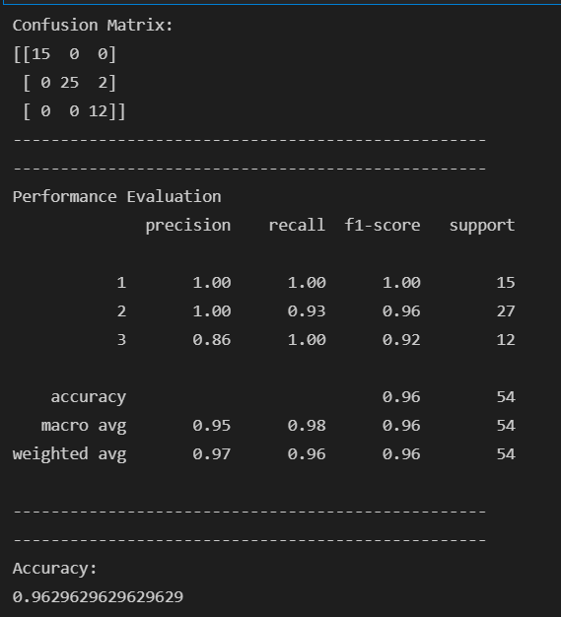 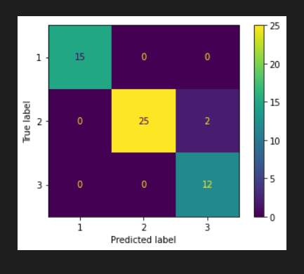

# WINE DATASET

# SVM(Without Tuning)[60-40 split]

import pandas as pd

import numpy as np

# Dataset Preparation

df = pd.read_csv("wine.data",header=None)

col_name = ['Class','Alcohol','Malic acid','Ash','Alcalinity of ash','Magnesium','Total phenols','Flavanoids',

'Nonflavanoid phenols','Proanthocyanins','Color intensity','Hue','OD280/OD315 of diluted wines','Proline']

df.columns = col_name

X = df.drop(['Class'], axis=1)

y = df['Class']

from sklearn.model_selection import train_test_split

X_train, X_test, y_train, y_test = train_test_split(X,y,train_size=0.6,test_size=0.4,random_state=10)

# Feature Scaling

from sklearn.preprocessing import StandardScaler

sc = StandardScaler()

X_train = sc.fit_transform(X_train)

X_test = sc.transform(X_test)

# Classification

from sklearn.svm import SVC

classifier = SVC()

classifier.fit(X_train,y_train)

y_pred = classifier.predict(X_test)

from sklearn.metrics import classification_report, confusion_matrix, accuracy_score

print("Confusion Matrix:")

print(confusion_matrix(y_test, y_pred))

print("--------------------------------------------------")

print("--------------------------------------------------")

print("Performance Evaluation")

print(classification_report(y_test, y_pred))

print("--------------------------------------------------")

print("--------------------------------------------------")

print("Accuracy:")

print(accuracy_score(y_test, y_pred))

import matplotlib.pyplot as plt

from sklearn.metrics import plot_confusion_matrix

plot_confusion_matrix(classifier, X_test, y_test)

plt.show()

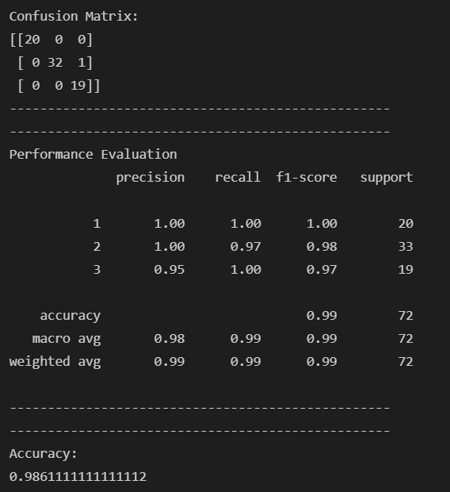 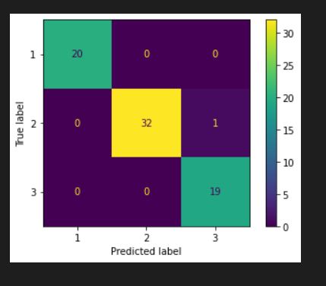

# WINE DATASET

# SVM(Without Tuning)[40-60 split]

import pandas as pd

import numpy as np

# Dataset Preparation

df = pd.read_csv("wine.data",header=None)

col_name = ['Class','Alcohol','Malic acid','Ash','Alcalinity of ash','Magnesium','Total phenols','Flavanoids',

'Nonflavanoid phenols','Proanthocyanins','Color intensity','Hue','OD280/OD315 of diluted wines','Proline']

df.columns = col_name

X = df.drop(['Class'], axis=1)

y = df['Class']

from sklearn.model_selection import train_test_split

X_train, X_test, y_train, y_test = train_test_split(X,y,train_size=0.4,test_size=0.6,random_state=10)

# Feature Scaling

from sklearn.preprocessing import StandardScaler

sc = StandardScaler()

X_train = sc.fit_transform(X_train)

X_test = sc.transform(X_test)

# Classification

from sklearn.svm import SVC

classifier = SVC()

classifier.fit(X_train,y_train)

y_pred = classifier.predict(X_test)

from sklearn.metrics import classification_report, confusion_matrix, accuracy_score

print("Confusion Matrix:")

print(confusion_matrix(y_test, y_pred))

print("--------------------------------------------------")

print("--------------------------------------------------")

print("Performance Evaluation")

print(classification_report(y_test, y_pred))

print("--------------------------------------------------")

print("--------------------------------------------------")

print("Accuracy:")

print(accuracy_score(y_test, y_pred))

import matplotlib.pyplot as plt

from sklearn.metrics import plot_confusion_matrix

plot_confusion_matrix(classifier, X_test, y_test)

plt.show()

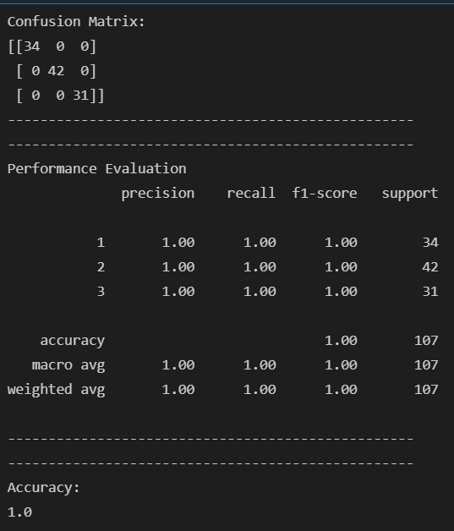 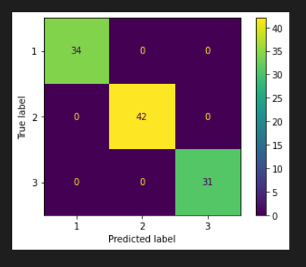

# WINE DATASET

# SVM(With Tuning)[40-60 split]

import pandas as pd

import numpy as np

# Dataset Preparation

df = pd.read_csv("wine.data",header=None)

col_name = ['Class','Alcohol','Malic acid','Ash','Alcalinity of ash','Magnesium','Total phenols','Flavanoids',

'Nonflavanoid phenols','Proanthocyanins','Color intensity','Hue','OD280/OD315 of diluted wines','Proline']

df.columns = col_name

X = df.drop(['Class'], axis=1)

y = df['Class']

from sklearn.model_selection import train_test_split

X_train, X_test, y_train, y_test = train_test_split(X,y,train_size=0.4,test_size=0.6,random_state=10)

# Feature Scaling

from sklearn.preprocessing import StandardScaler

sc = StandardScaler()

X_train = sc.fit_transform(X_train)

X_test = sc.transform(X_test)

# Classification

from sklearn.svm import SVC

classifier = SVC()

############################################################################

# Showing all the parameters

from pprint import pprint

# Look at parameters used by our current forest

print('Parameters currently in use:\n')

pprint(classifier.get_params())

############################################################################

# Creating a set of important sample features

param_grid = {'C': [0.1,1, 10, 100], 'gamma': [1,0.1,0.01,0.001],'kernel': ['rbf', 'poly', 'sigmoid']}

pprint(param_grid)

############################################################################

from sklearn.model_selection import GridSearchCV

# Use the random grid to search for best hyperparameters

# First create the base model to tune

classifier = SVC()

# Random search of parameters, using 3 fold cross validation,

# search across 100 different combinations, and use all available cores

rf_random = GridSearchCV(SVC(), param_grid, refit=True, verbose=2)

rf_random.fit(X_train, y_train)

y_pred = rf_random.predict(X_test)

from sklearn.metrics import classification_report, confusion_matrix, accuracy_score

print("Confusion Matrix:")

print(confusion_matrix(y_test, y_pred))

print("--------------------------------------------------")

print("--------------------------------------------------")

print("Performance Evaluation")

print(classification_report(y_test, y_pred))

print("--------------------------------------------------")

print("--------------------------------------------------")

print("Accuracy:")

print(accuracy_score(y_test, y_pred))

import matplotlib.pyplot as plt

from sklearn.metrics import plot_confusion_matrix

plot_confusion_matrix(rf_random, X_test, y_test)

plt.show()

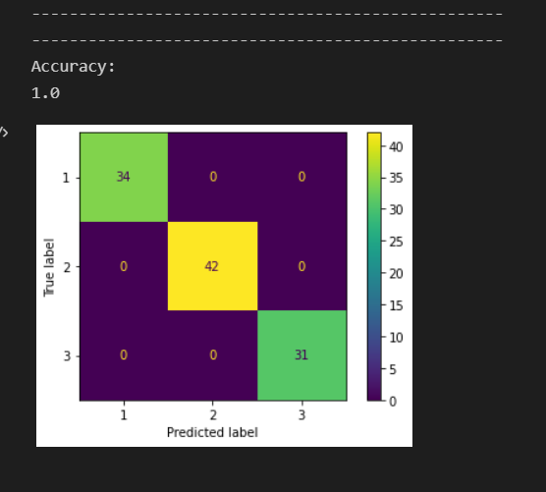

# WINE DATASET

# Decision Tree (Without Tuning)[70-30 split]

import pandas as pd

import numpy as np

# Dataset Preparation

df = pd.read_csv("wine.data",header=None)

col_name = ['Class','Alcohol','Malic acid','Ash','Alcalinity of ash','Magnesium','Total phenols','Flavanoids',

'Nonflavanoid phenols','Proanthocyanins','Color intensity','Hue','OD280/OD315 of diluted wines','Proline']

df.columns = col_name

X = df.drop(['Class'], axis=1)

y = df['Class']

from sklearn.model_selection import train_test_split

X_train, X_test, y_train, y_test = train_test_split(X,y,train_size=0.7,test_size=0.3,random_state=10)

# Feature Scaling

from sklearn.preprocessing import StandardScaler

sc = StandardScaler()

X_train = sc.fit_transform(X_train)

X_test = sc.transform(X_test)

# Classification

from sklearn.tree import DecisionTreeClassifier

classifier = DecisionTreeClassifier().fit(X_train,y_train)

classifier.fit(X_train,y_train)

y_pred=classifier.predict(X_test)

from sklearn.metrics import classification_report, confusion_matrix, accuracy_score

print("Confusion Matrix:")

print(confusion_matrix(y_test, y_pred))

print("--------------------------------------------------")

print("--------------------------------------------------")

print("Performance Evaluation")

print(classification_report(y_test, y_pred))

print("--------------------------------------------------")

print("--------------------------------------------------")

print("Accuracy:")

print(accuracy_score(y_test, y_pred))

import matplotlib.pyplot as plt

from sklearn.metrics import plot_confusion_matrix

plot_confusion_matrix(classifier, X_test, y_test)

plt.show()

from sklearn import tree

text_representation = tree.export_text(classifier)

print(text_representation)

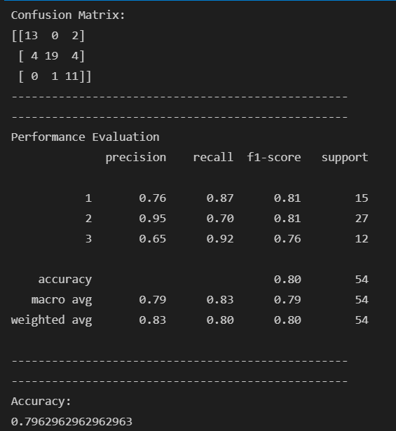 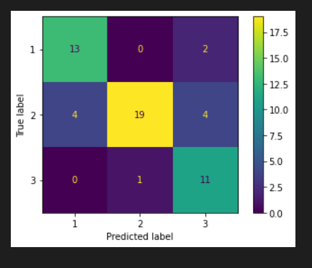

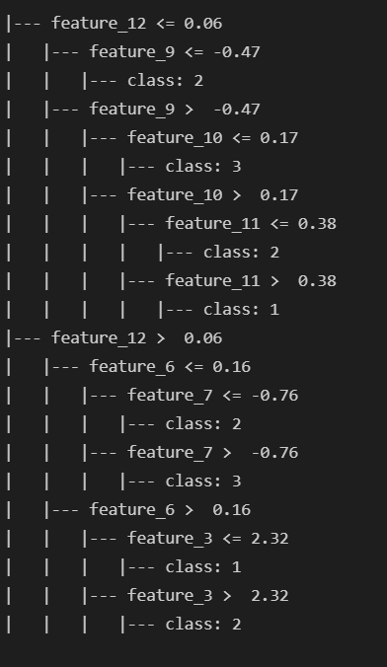

# WINE DATASET

# Decision Tree (With Tuning)[70-30 split]

import pandas as pd

import numpy as np

# Dataset Preparation

df = pd.read_csv("wine.data",header=None)

col_name = ['Class','Alcohol','Malic acid','Ash','Alcalinity of ash','Magnesium','Total phenols','Flavanoids',

'Nonflavanoid phenols','Proanthocyanins','Color intensity','Hue','OD280/OD315 of diluted wines','Proline']

df.columns = col_name

X = df.drop(['Class'], axis=1)

y = df['Class']

from sklearn.model_selection import train_test_split

X_train, X_test, y_train, y_test = train_test_split(X,y,train_size=0.7,test_size=0.3,random_state=10)

# Feature Scaling

from sklearn.preprocessing import StandardScaler

sc = StandardScaler()

X_train = sc.fit_transform(X_train)

X_test = sc.transform(X_test)

# Classification

from sklearn.tree import DecisionTreeClassifier

classifier = DecisionTreeClassifier(criterion="entropy",max_depth=20).fit(X_train,y_train)

classifier.fit(X_train,y_train)

y_pred=classifier.predict(X_test)

from sklearn.metrics import classification_report, confusion_matrix, accuracy_score

print("Confusion Matrix:")

print(confusion_matrix(y_test, y_pred))

print("--------------------------------------------------")

print("--------------------------------------------------")

print("Performance Evaluation")

print(classification_report(y_test, y_pred))

print("--------------------------------------------------")

print("--------------------------------------------------")

print("Accuracy:")

print(accuracy_score(y_test, y_pred))

import matplotlib.pyplot as plt

from sklearn.metrics import plot_confusion_matrix

plot_confusion_matrix(classifier, X_test, y_test)

plt.show()

from sklearn import tree

text_representation = tree.export_text(classifier)

print(text_representation)

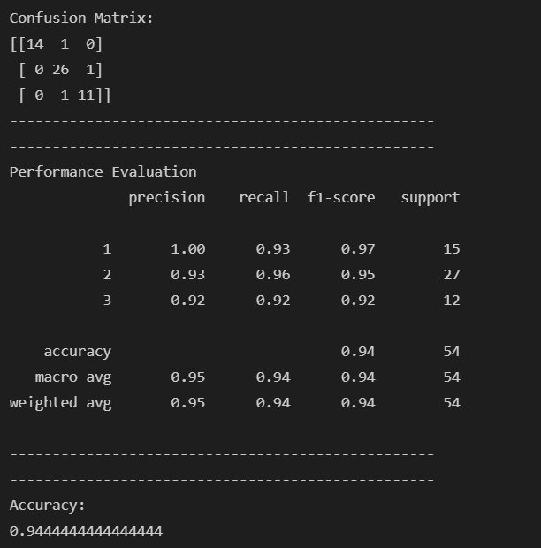 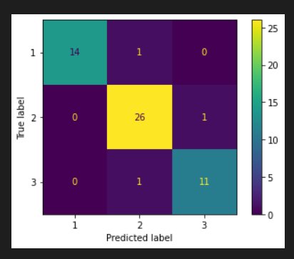

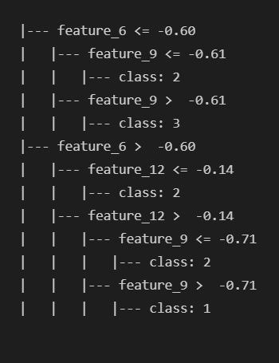

# WINE DATASET

# Random Forest Classifier(Without Tuning)[70-30 split]

import pandas as pd

import numpy as np

# Dataset Preparation

df = pd.read_csv("wine.data",header=None)

col_name = ['Class','Alcohol','Malic acid','Ash','Alcalinity of ash','Magnesium','Total phenols','Flavanoids',

'Nonflavanoid phenols','Proanthocyanins','Color intensity','Hue','OD280/OD315 of diluted wines','Proline']

df.columns = col_name

X = df.drop(['Class'], axis=1)

y = df['Class']

from sklearn.model_selection import train_test_split

X_train, X_test, y_train, y_test = train_test_split(X,y,train_size=0.7,test_size=0.3,random_state=10)

# Feature Scaling

from sklearn.preprocessing import StandardScaler

sc = StandardScaler()

X_train = sc.fit_transform(X_train)

X_test = sc.transform(X_test)

# Classification

from sklearn.ensemble import RandomForestClassifier

classifier = RandomForestClassifier(n_estimators=20, random_state=0)

classifier.fit(X_train,y_train)

y_pred = classifier.predict(X_test)

from sklearn.metrics import classification_report, confusion_matrix, accuracy_score

print("Confusion Matrix:")

print(confusion_matrix(y_test, y_pred))

print("--------------------------------------------------")

print("--------------------------------------------------")

print("Performance Evaluation")

print(classification_report(y_test, y_pred))

print("--------------------------------------------------")

print("--------------------------------------------------")

print("Accuracy:")

print(accuracy_score(y_test, y_pred))

import matplotlib.pyplot as plt

from sklearn.metrics import plot_confusion_matrix

plot_confusion_matrix(classifier, X_test, y_test)

plt.show()

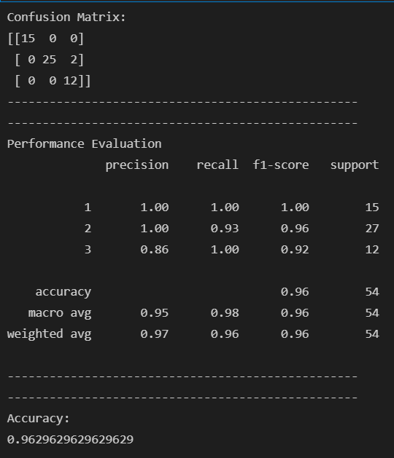 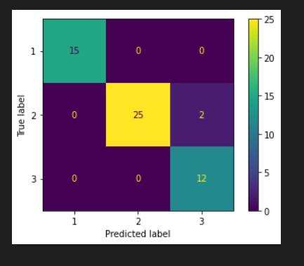

# WINE DATASET

# Random Forest Classifier(With Tuning)[70-30 split]

import pandas as pd

import numpy as np

# Dataset Preparation

df = pd.read_csv("wine.data",header=None)

col_name = ['Class','Alcohol','Malic acid','Ash','Alcalinity of ash','Magnesium','Total phenols','Flavanoids',

'Nonflavanoid phenols','Proanthocyanins','Color intensity','Hue','OD280/OD315 of diluted wines','Proline']

df.columns = col_name

X = df.drop(['Class'], axis=1)

y = df['Class']

from sklearn.model_selection import train_test_split

X_train, X_test, y_train, y_test = train_test_split(X,y,train_size=0.7,test_size=0.30,random_state=10)

# Feature Scaling

from sklearn.preprocessing import StandardScaler

sc = StandardScaler()

X_train = sc.fit_transform(X_train)

X_test = sc.transform(X_test)

# Classification

from sklearn.ensemble import RandomForestClassifier

classifier = RandomForestClassifier()

############################################################################

# Showing all the parameters

from pprint import pprint

# Look at parameters used by our current forest

print('Parameters currently in use:\n')

pprint(classifier.get_params())

############################################################################

# Creating a set of important sample features

from sklearn.model_selection import RandomizedSearchCV

# Number of trees in random forest

n_estimators = [int(x) for x in np.linspace(start = 200, stop = 2000, num = 10)]

# Number of features to consider at every split

max_features = ['auto', 'sqrt']

# Maximum number of levels in tree

max_depth = [int(x) for x in np.linspace(10, 110, num = 11)]

max_depth.append(None)

# Minimum number of samples required to split a node

min_samples_split = [2, 5, 10]

# Minimum number of samples required at each leaf node

min_samples_leaf = [1, 2, 4]

# Method of selecting samples for training each tree

bootstrap = [True, False]

# Create the random grid

random_grid = {'n_estimators': n_estimators,

'max_features': max_features,

'max_depth': max_depth,

'min_samples_split': min_samples_split,

'min_samples_leaf': min_samples_leaf,

'bootstrap': bootstrap}

pprint(random_grid)

############################################################################

# Use the random grid to search for best hyperparameters

# First create the base model to tune

classifier = RandomForestClassifier()

# Random search of parameters, using 3 fold cross validation,

# search across 100 different combinations, and use all available cores

rf_random = RandomizedSearchCV(estimator = classifier, param_distributions = random_grid, n_iter = 100, cv = 3, verbose=2, random_state=42, n_jobs = -1)

# Fit the random search model

rf_random.fit(X_train, y_train)

y_pred = rf_random.predict(X_test)

from sklearn.metrics import classification_report, confusion_matrix, accuracy_score

print("Confusion Matrix:")

print(confusion_matrix(y_test, y_pred))

print("--------------------------------------------------")

print("--------------------------------------------------")

print("Performance Evaluation")

print(classification_report(y_test, y_pred))

print("--------------------------------------------------")

print("--------------------------------------------------")

print("Accuracy:")

print(accuracy_score(y_test, y_pred))

import matplotlib.pyplot as plt

from sklearn.metrics import plot_confusion_matrix

plot_confusion_matrix(rf_random, X_test, y_test)

plt.show()

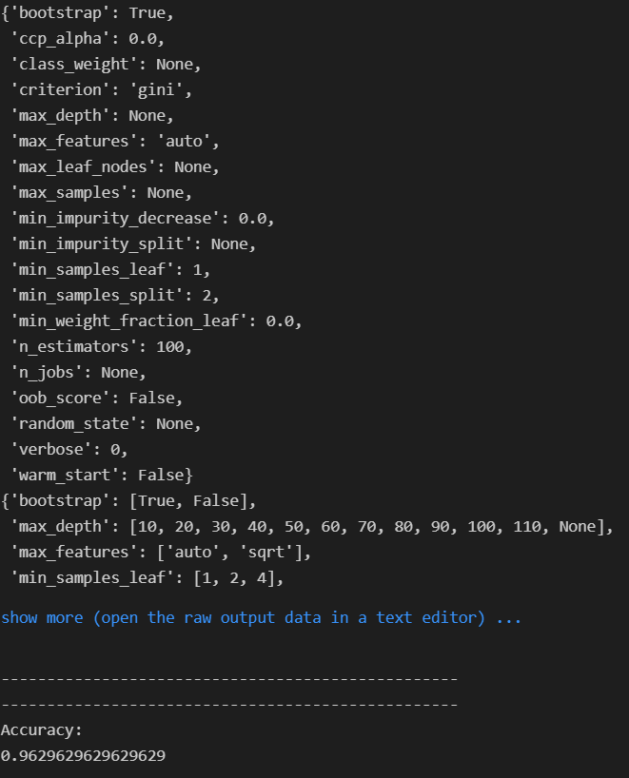 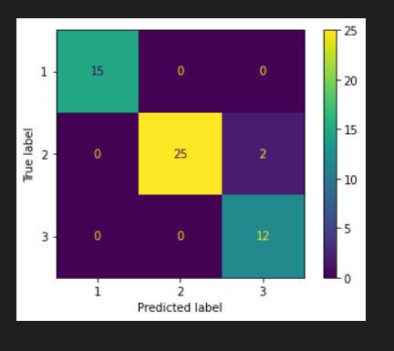

# WINE DATASET

# Gaussian Naive Bayes (Without Tuning)[70-30 split]

import pandas as pd

import numpy as np

# Dataset Preparation

df = pd.read_csv("wine.data",header=None)

col_name = ['Class','Alcohol','Malic acid','Ash','Alcalinity of ash','Magnesium','Total phenols','Flavanoids',

'Nonflavanoid phenols','Proanthocyanins','Color intensity','Hue','OD280/OD315 of diluted wines','Proline']

df.columns = col_name

X = df.drop(['Class'], axis=1)

y = df['Class']

from sklearn.model_selection import train_test_split

X_train, X_test, y_train, y_test = train_test_split(X,y,train_size=0.7,test_size=0.3,random_state=10)

# Feature Scaling

from sklearn.preprocessing import StandardScaler

sc = StandardScaler()

X_train = sc.fit_transform(X_train)

X_test = sc.transform(X_test)

# Classification

from sklearn.naive_bayes import GaussianNB

classifier = GaussianNB().fit(X_train,y_train)

classifier.fit(X_train,y_train)

y_pred=classifier.predict(X_test)

from sklearn.metrics import classification_report, confusion_matrix, accuracy_score

print("Confusion Matrix:")

print(confusion_matrix(y_test, y_pred))

print("--------------------------------------------------")

print("--------------------------------------------------")

print("Performance Evaluation")

print(classification_report(y_test, y_pred))

print("--------------------------------------------------")

print("--------------------------------------------------")

print("Accuracy:")

print(accuracy_score(y_test, y_pred))

import matplotlib.pyplot as plt

from sklearn.metrics import plot_confusion_matrix

plot_confusion_matrix(classifier, X_test, y_test)

plt.show()

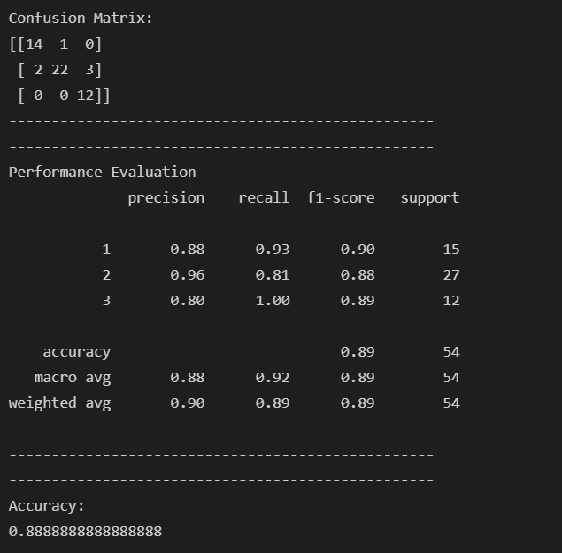 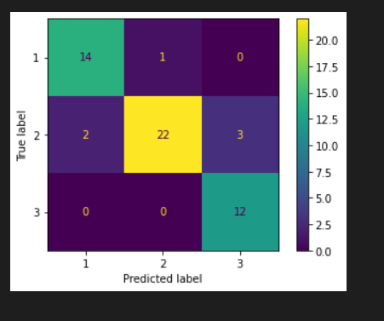

# WINE DATASET

# Gaussian Naive Bayes (With Tuning)[70-30 split]

import pandas as pd

import numpy as np

# Dataset Preparation

df = pd.read_csv("wine.data",header=None)

col_name = ['Class','Alcohol','Malic acid','Ash','Alcalinity of ash','Magnesium','Total phenols','Flavanoids',

'Nonflavanoid phenols','Proanthocyanins','Color intensity','Hue','OD280/OD315 of diluted wines','Proline']

df.columns = col_name

X = df.drop(['Class'], axis=1)

y = df['Class']

from sklearn.model_selection import train_test_split

X_train, X_test, y_train, y_test = train_test_split(X,y,train_size=0.7,test_size=0.3,random_state=10)

# Feature Scaling

from sklearn.preprocessing import StandardScaler

sc = StandardScaler()

X_train = sc.fit_transform(X_train)

X_test = sc.transform(X_test)

# Classification

from sklearn.naive_bayes import GaussianNB

classifier = GaussianNB(priors=None,var_smoothing=1e-5).fit(X_train,y_train)

classifier.fit(X_train,y_train)

y_pred=classifier.predict(X_test)

from sklearn.metrics import classification_report, confusion_matrix, accuracy_score

print("Confusion Matrix:")

print(confusion_matrix(y_test, y_pred))

print("--------------------------------------------------")

print("--------------------------------------------------")

print("Performance Evaluation")

print(classification_report(y_test, y_pred))

print("--------------------------------------------------")

print("--------------------------------------------------")

print("Accuracy:")

print(accuracy_score(y_test, y_pred))

import matplotlib.pyplot as plt

from sklearn.metrics import plot_confusion_matrix

plot_confusion_matrix(classifier, X_test, y_test)

plt.show()

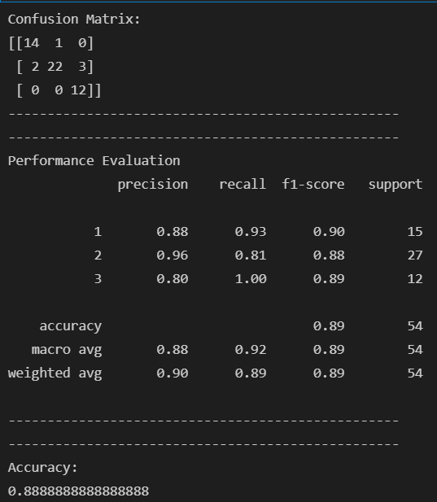 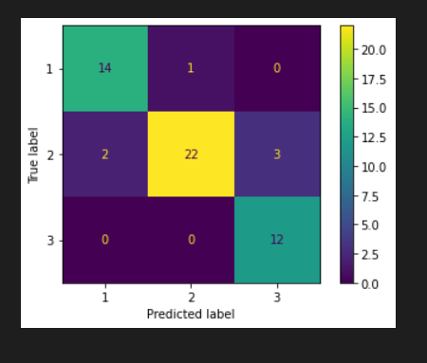

# IONOSPHERE DATASET

# SVM(Without Tuning)[70-30 split]

import pandas as pd

import numpy as np

# Dataset Preparation

df = pd.read_csv("ionosphere.data",header=None)

col_name = ['1','2','3','4','5','6','7','8','9','10','11','12','13','14','15','16','17','18','19'

,'20','21','22','23','24','25','26','27','28','29','30','31','32','33','34','Class']

df.columns = col_name

X = df.drop(['Class'], axis=1)

y = df['Class']

from sklearn.model_selection import train_test_split

X_train, X_test, y_train, y_test = train_test_split(X,y,train_size=0.7,test_size=0.3,random_state=10)

# Feature Scaling

from sklearn.preprocessing import StandardScaler

sc = StandardScaler()

X_train = sc.fit_transform(X_train)

X_test = sc.transform(X_test)

# Classification

from sklearn.svm import SVC

classifier = SVC()

classifier.fit(X_train,y_train)

y_pred = classifier.predict(X_test)

from sklearn.metrics import classification_report, confusion_matrix, accuracy_score

print("Confusion Matrix:")

print(confusion_matrix(y_test, y_pred))

print("--------------------------------------------------")

print("--------------------------------------------------")

print("Performance Evaluation")

print(classification_report(y_test, y_pred))

print("--------------------------------------------------")

print("--------------------------------------------------")

print("Accuracy:")

print(accuracy_score(y_test, y_pred))

import matplotlib.pyplot as plt

from sklearn.metrics import plot_confusion_matrix

plot_confusion_matrix(classifier, X_test, y_test)

plt.show()

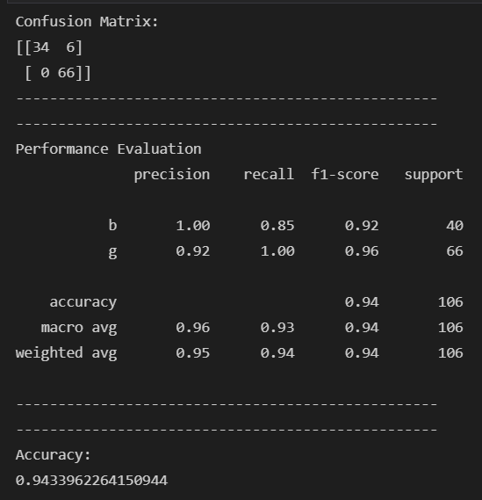 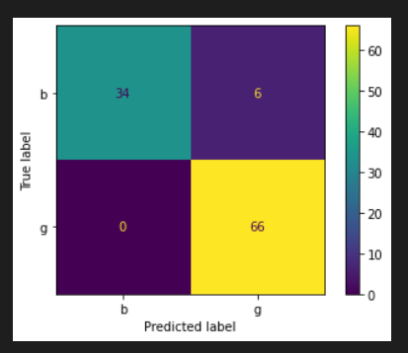

# IONOSPHERE DATASET

# SVM(With Tuning)[70-30 split]

import pandas as pd

import numpy as np

# Dataset Preparation

df = pd.read_csv("ionosphere.data",header=None)

col_name = ['1','2','3','4','5','6','7','8','9','10','11','12','13','14','15','16','17','18','19'

,'20','21','22','23','24','25','26','27','28','29','30','31','32','33','34','Class']

df.columns = col_name

X = df.drop(['Class'], axis=1)

y = df['Class']

from sklearn.model_selection import train_test_split

X_train, X_test, y_train, y_test = train_test_split(X,y,train_size=0.7,test_size=0.3,random_state=10)

# Feature Scaling

from sklearn.preprocessing import StandardScaler

sc = StandardScaler()

X_train = sc.fit_transform(X_train)

X_test = sc.transform(X_test)

# Classification

from sklearn.svm import SVC

classifier = SVC()

############################################################################

# Showing all the parameters

from pprint import pprint

# Look at parameters used by our current forest

print('Parameters currently in use:\n')

pprint(classifier.get_params())

############################################################################

# Creating a set of important sample features

param_grid = {'C': [0.1,1, 10, 100], 'gamma': [1,0.1,0.01,0.001],'kernel': ['rbf', 'poly', 'sigmoid']}

pprint(param_grid)

############################################################################

from sklearn.model_selection import GridSearchCV

# Use the random grid to search for best hyperparameters

# First create the base model to tune

classifier = SVC()

# Random search of parameters, using 3 fold cross validation,

# search across 100 different combinations, and use all available cores

rf_random = GridSearchCV(SVC(), param_grid, refit=True, verbose=2)

rf_random.fit(X_train, y_train)

y_pred = rf_random.predict(X_test)

from sklearn.metrics import classification_report, confusion_matrix, accuracy_score

print("Confusion Matrix:")

print(confusion_matrix(y_test, y_pred))

print("--------------------------------------------------")

print("--------------------------------------------------")

print("Performance Evaluation")

print(classification_report(y_test, y_pred))

print("--------------------------------------------------")

print("--------------------------------------------------")

print("Accuracy:")

print(accuracy_score(y_test, y_pred))

import matplotlib.pyplot as plt

from sklearn.metrics import plot_confusion_matrix

plot_confusion_matrix(rf_random, X_test, y_test)

plt.show()

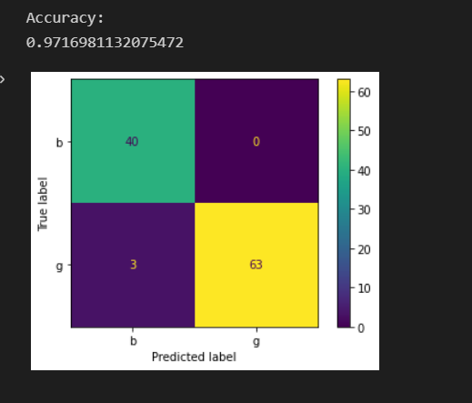

# Ionosphere DATASET

# Decision Tree (Without Tuning)[70-30 split]

import pandas as pd

import numpy as np

# Dataset Preparation

df = pd.read_csv("ionosphere.data",header=None)

col_name = ['1','2','3','4','5','6','7','8','9','10','11','12','13','14','15','16','17','18','19'

,'20','21','22','23','24','25','26','27','28','29','30','31','32','33','34','Class']

df.columns = col_name

X = df.drop(['Class'], axis=1)

y = df['Class']

from sklearn.model_selection import train_test_split

X_train, X_test, y_train, y_test = train_test_split(X,y,train_size=0.7,test_size=0.3,random_state=10)

# Feature Scaling

from sklearn.preprocessing import StandardScaler

sc = StandardScaler()

X_train = sc.fit_transform(X_train)

X_test = sc.transform(X_test)

# Classification

from sklearn.tree import DecisionTreeClassifier

classifier = DecisionTreeClassifier().fit(X_train,y_train)

classifier.fit(X_train,y_train)

y_pred=classifier.predict(X_test)

from sklearn.metrics import classification_report, confusion_matrix, accuracy_score

print("Confusion Matrix:")

print(confusion_matrix(y_test, y_pred))

print("--------------------------------------------------")

print("--------------------------------------------------")

print("Performance Evaluation")

print(classification_report(y_test, y_pred))

print("--------------------------------------------------")

print("--------------------------------------------------")

print("Accuracy:")

print(accuracy_score(y_test, y_pred))

import matplotlib.pyplot as plt

from sklearn.metrics import plot_confusion_matrix

plot_confusion_matrix(classifier, X_test, y_test)

plt.show()

from sklearn import tree

text_representation = tree.export_text(classifier)

print(text_representation)

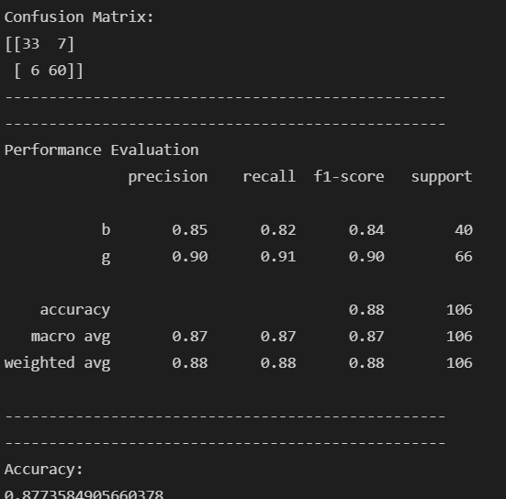 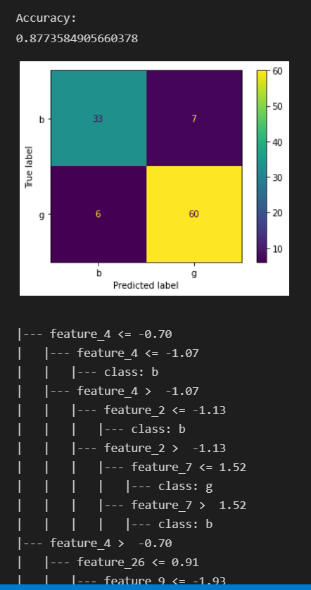

# Ionosphere DATASET

# Decision Tree (With Tuning)[70-30 split]

import pandas as pd

import numpy as np

# Dataset Preparation

df = pd.read_csv("ionosphere.data",header=None)

col_name = ['1','2','3','4','5','6','7','8','9','10','11','12','13','14','15','16','17','18','19'

,'20','21','22','23','24','25','26','27','28','29','30','31','32','33','34','Class']

df.columns = col_name

X = df.drop(['Class'], axis=1)

y = df['Class']

from sklearn.model_selection import train_test_split

X_train, X_test, y_train, y_test = train_test_split(X,y,train_size=0.7,test_size=0.3,random_state=10)

# Feature Scaling

from sklearn.preprocessing import StandardScaler

sc = StandardScaler()

X_train = sc.fit_transform(X_train)

X_test = sc.transform(X_test)

# Classification

from sklearn.tree import DecisionTreeClassifier

classifier = DecisionTreeClassifier(criterion="entropy",max_depth=20).fit(X_train,y_train)

classifier.fit(X_train,y_train)

y_pred=classifier.predict(X_test)

from sklearn.metrics import classification_report, confusion_matrix, accuracy_score

print("Confusion Matrix:")

print(confusion_matrix(y_test, y_pred))

print("--------------------------------------------------")

print("--------------------------------------------------")

print("Performance Evaluation")

print(classification_report(y_test, y_pred))

print("--------------------------------------------------")

print("--------------------------------------------------")

print("Accuracy:")

print(accuracy_score(y_test, y_pred))

import matplotlib.pyplot as plt

from sklearn.metrics import plot_confusion_matrix

plot_confusion_matrix(classifier, X_test, y_test)

plt.show()

from sklearn import tree

text_representation = tree.export_text(classifier)

print(text_representation)

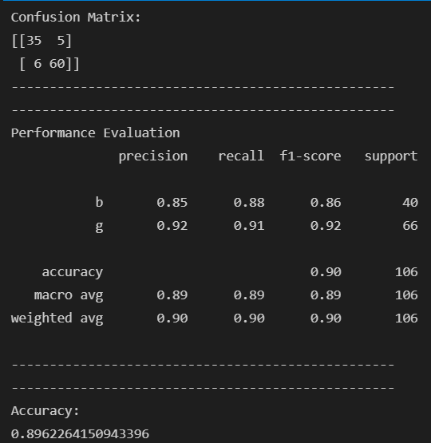 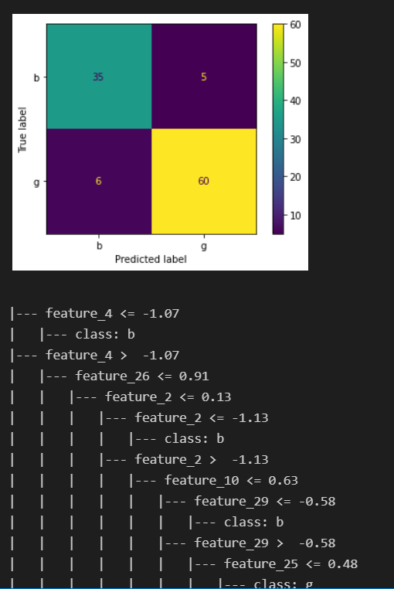

# IONOSPHERE DATASET

# Random Forest Classifier(Without Tuning)[70-30 split]

import pandas as pd

import numpy as np

# Dataset Preparation

df = pd.read_csv("ionosphere.data",header=None)

col_name = ['1','2','3','4','5','6','7','8','9','10','11','12','13','14','15','16','17','18','19'

,'20','21','22','23','24','25','26','27','28','29','30','31','32','33','34','Class']

df.columns = col_name

X = df.drop(['Class'], axis=1)

y = df['Class']

from sklearn.model_selection import train_test_split

X_train, X_test, y_train, y_test = train_test_split(X,y,train_size=0.7,test_size=0.30,random_state=10)

# Feature Scaling

from sklearn.preprocessing import StandardScaler

sc = StandardScaler()

X_train = sc.fit_transform(X_train)

X_test = sc.transform(X_test)

# Classification

from sklearn.ensemble import RandomForestClassifier

classifier = RandomForestClassifier(n_estimators=20, random_state=0)

classifier.fit(X_train,y_train)

y_pred = classifier.predict(X_test)

from sklearn.metrics import classification_report, confusion_matrix, accuracy_score

print("Confusion Matrix:")

print(confusion_matrix(y_test, y_pred))

print("--------------------------------------------------")

print("--------------------------------------------------")

print("Performance Evaluation")

print(classification_report(y_test, y_pred))

print("--------------------------------------------------")

print("--------------------------------------------------")

print("Accuracy:")

print(accuracy_score(y_test, y_pred))

import matplotlib.pyplot as plt

from sklearn.metrics import plot_confusion_matrix

plot_confusion_matrix(classifier, X_test, y_test)

plt.show()

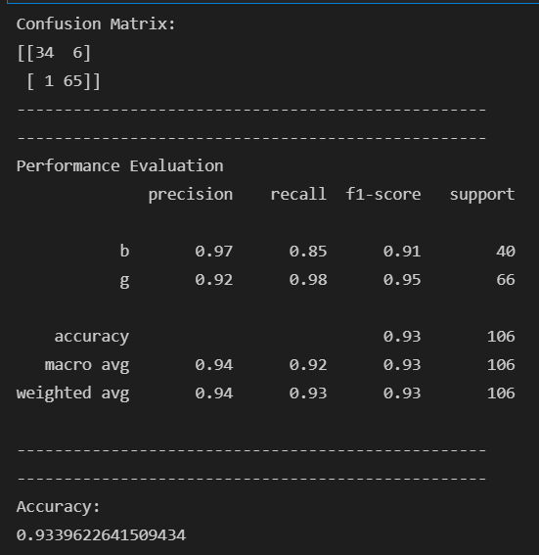

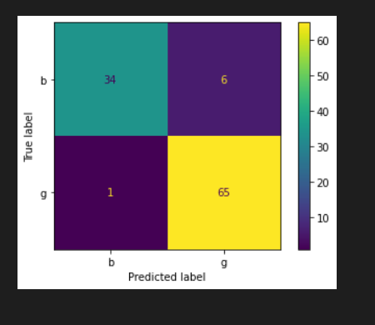

# IONOSPHERE DATASET

# Random Forest Classifier(With Tuning)[70-30 split]

import pandas as pd

import numpy as np

# Dataset Preparation

df = pd.read_csv("ionosphere.data",header=None)

col_name = ['1','2','3','4','5','6','7','8','9','10','11','12','13','14','15','16','17','18','19'

,'20','21','22','23','24','25','26','27','28','29','30','31','32','33','34','Class']

df.columns = col_name

X = df.drop(['Class'], axis=1)

y = df['Class']

from sklearn.model_selection import train_test_split

X_train, X_test, y_train, y_test = train_test_split(X,y,train_size=0.7,test_size=0.3,random_state=10)

# Feature Scaling

from sklearn.preprocessing import StandardScaler

sc = StandardScaler()

X_train = sc.fit_transform(X_train)

X_test = sc.transform(X_test)

# Classification

from sklearn.ensemble import RandomForestClassifier

classifier = RandomForestClassifier()

############################################################################

# Showing all the parameters

from pprint import pprint

# Look at parameters used by our current forest

print('Parameters currently in use:\n')

pprint(classifier.get_params())

############################################################################

# Creating a set of important sample features

from sklearn.model_selection import RandomizedSearchCV

# Number of trees in random forest

n_estimators = [int(x) for x in np.linspace(start = 200, stop = 2000, num = 10)]

# Number of features to consider at every split

max_features = ['auto', 'sqrt']

# Maximum number of levels in tree

max_depth = [int(x) for x in np.linspace(10, 110, num = 11)]

max_depth.append(None)

# Minimum number of samples required to split a node

min_samples_split = [2, 5, 10]

# Minimum number of samples required at each leaf node

min_samples_leaf = [1, 2, 4]

# Method of selecting samples for training each tree

bootstrap = [True, False]

# Create the random grid

random_grid = {'n_estimators': n_estimators,

'max_features': max_features,

'max_depth': max_depth,

'min_samples_split': min_samples_split,

'min_samples_leaf': min_samples_leaf,

'bootstrap': bootstrap}

pprint(random_grid)

############################################################################

# Use the random grid to search for best hyperparameters

# First create the base model to tune

classifier = RandomForestClassifier()

# Random search of parameters, using 3 fold cross validation,

# search across 100 different combinations, and use all available cores

rf_random = RandomizedSearchCV(estimator = classifier, param_distributions = random_grid, n_iter = 100, cv = 3, verbose=2, random_state=42, n_jobs = -1)

# Fit the random search model

rf_random.fit(X_train, y_train)

y_pred = rf_random.predict(X_test)

from sklearn.metrics import classification_report, confusion_matrix, accuracy_score

print("Confusion Matrix:")

print(confusion_matrix(y_test, y_pred))

print("--------------------------------------------------")

print("--------------------------------------------------")

print("Performance Evaluation")

print(classification_report(y_test, y_pred))

print("--------------------------------------------------")

print("--------------------------------------------------")

print("Accuracy:")

print(accuracy_score(y_test, y_pred))

import matplotlib.pyplot as plt

from sklearn.metrics import plot_confusion_matrix

plot_confusion_matrix(rf_random, X_test, y_test)

plt.show()

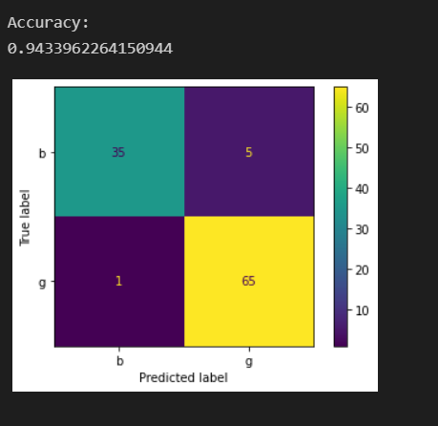

# Ionosphere DATASET

# Gaussian Naive Bayes (Without Tuning)[70-30 split]

import pandas as pd

import numpy as np

# Dataset Preparation

df = pd.read_csv("ionosphere.data",header=None)

col_name = ['1','2','3','4','5','6','7','8','9','10','11','12','13','14','15','16','17','18','19'

,'20','21','22','23','24','25','26','27','28','29','30','31','32','33','34','Class']

df.columns = col_name

X = df.drop(['Class'], axis=1)

y = df['Class']

from sklearn.model_selection import train_test_split

X_train, X_test, y_train, y_test = train_test_split(X,y,train_size=0.7,test_size=0.3,random_state=10)

# Feature Scaling

from sklearn.preprocessing import StandardScaler

sc = StandardScaler()

X_train = sc.fit_transform(X_train)

X_test = sc.transform(X_test)

# Classification

from sklearn.naive_bayes import GaussianNB

classifier = GaussianNB().fit(X_train,y_train)

classifier.fit(X_train,y_train)

y_pred=classifier.predict(X_test)

from sklearn.metrics import classification_report, confusion_matrix, accuracy_score

print("Confusion Matrix:")

print(confusion_matrix(y_test, y_pred))

print("--------------------------------------------------")

print("--------------------------------------------------")

print("Performance Evaluation")

print(classification_report(y_test, y_pred))

print("--------------------------------------------------")

print("--------------------------------------------------")

print("Accuracy:")

print(accuracy_score(y_test, y_pred))

import matplotlib.pyplot as plt

from sklearn.metrics import plot_confusion_matrix

plot_confusion_matrix(classifier, X_test, y_test)

plt.show()

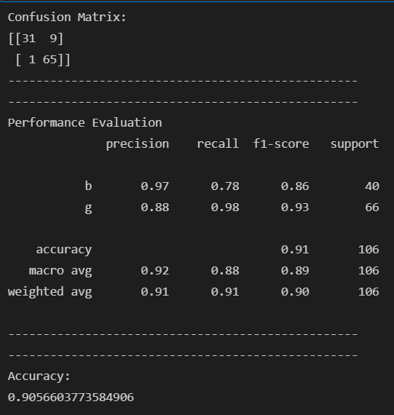 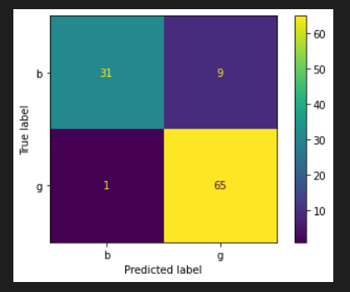

Q3. Used datasets

1. Iris plants dataset: <https://archive.ics.uci.edu/ml/datasets/Iris/>
2. Diabetes dataset: <https://www4.stat.ncsu.edu/~boos/var.select/diabetes.html>

# IONOSPHERE DATASET

# GaussianHMM(Without Tuning)[70-30 split]

print("Split: 70-30")

import pandas as pd

import numpy as np

# Dataset Preparation

df = pd.read_csv("ionosphere.data",header=None)

col_name = ['1','2','3','4','5','6','7','8','9','10','11','12','13','14','15','16','17','18','19'

,'20','21','22','23','24','25','26','27','28','29','30','31','32','33','34','Class']

df.columns = col_name

X = df.drop(['1','2','Class'], axis=1)

y = df['Class']

from sklearn.model_selection import train_test_split

X_train, X_test, y_train, y_test = train_test_split(X,y,train_size=0.7,test_size=0.3,random_state=10)

# Feature Scaling

from sklearn.preprocessing import StandardScaler

sc = StandardScaler()

X_train = sc.fit_transform(X_train)

X_test = sc.transform(X_test)

# Classification

from hmmlearn import hmm

classifier = hmm.GaussianHMM(n_components=2, covariance_type="full")

classifier.fit(X_train)

y_pred = classifier.predict(X_test)

size = len(y_pred)

strings = np.empty(size, np.unicode_)

for i in range (size):

if y_pred[i] == 1:

strings[i] = ("g")

else:

strings[i] = ("b")

strings

from sklearn.metrics import classification_report, confusion_matrix, accuracy_score

print("Confusion Matrix:")

print(confusion_matrix(y_test, strings))

print("--------------------------------------------------")

print("--------------------------------------------------")

print("Performance Evaluation")

print(classification_report(y_test, strings))

print("--------------------------------------------------")

print("--------------------------------------------------")

print("Accuracy:")

print(accuracy_score(y_test, strings))

import matplotlib.pyplot as plt

import seaborn as sns

cm = confusion_matrix(y_test, strings)

sns.heatmap(cm, annot=True, fmt="d",cmap='Blues')

plt.show()

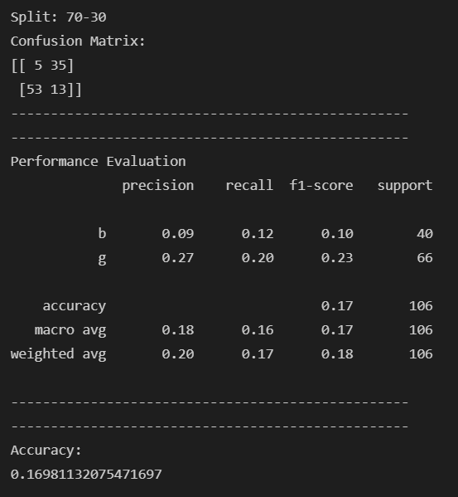

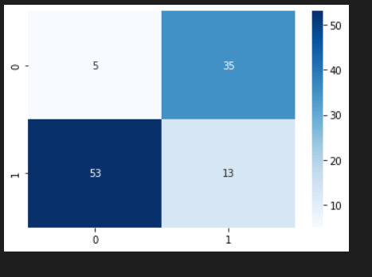

# IONOSPHERE DATASET

# GaussianHMM(With Tuning)[70-30 split]

import pandas as pd

import numpy as np

# Dataset Preparation

df = pd.read_csv("ionosphere.data",header=None)

col_name = ['1','2','3','4','5','6','7','8','9','10','11','12','13','14','15','16','17','18','19'

,'20','21','22','23','24','25','26','27','28','29','30','31','32','33','34','Class']

df.columns = col_name

X = df.drop(['1','2','Class'], axis=1)

y = df['Class']

from sklearn.model_selection import train_test_split

X_train, X_test, y_train, y_test = train_test_split(X,y,train_size=0.7,test_size=0.3,random_state=10)

# Feature Scaling

from sklearn.preprocessing import StandardScaler

sc = StandardScaler()

X_train = sc.fit_transform(X_train)

X_test = sc.transform(X_test)

# Classification

from hmmlearn import hmm

classifier = hmm.GaussianHMM(n_components=2, covariance_type="full",n_iter=5,algorithm='viterbi',verbose=False)

classifier.fit(X_train)

y_pred = classifier.predict(X_test)

size = len(y_pred)

strings = np.empty(size, np.unicode_)

for i in range (size):

if y_pred[i] == 1:

strings[i] = ("g")

else:

strings[i] = ("b")

strings

from sklearn.metrics import classification_report, confusion_matrix, accuracy_score

print("Confusion Matrix:")

print(confusion_matrix(y_test, strings))

print("--------------------------------------------------")

print("--------------------------------------------------")

print("Performance Evaluation")

print(classification_report(y_test, strings))

print("--------------------------------------------------")

print("--------------------------------------------------")

print("Accuracy:")

print(accuracy_score(y_test, strings))

import matplotlib.pyplot as plt

import seaborn as sns

cm = confusion_matrix(y_test, strings)

sns.heatmap(cm, annot=True, fmt="d",cmap='Blues')

plt.show()

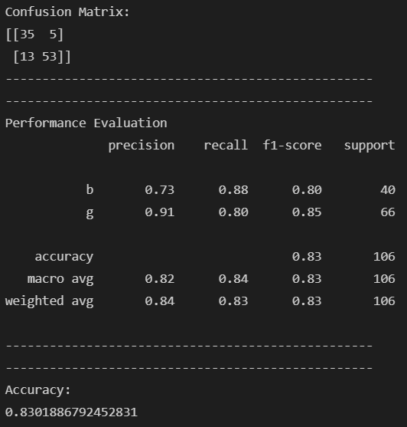 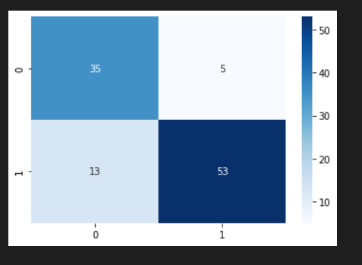

# IONOSPHERE DATASET

# GMMHMM(Without Tuning)[60-40 split]

print("Split: 60-40")

import pandas as pd

import numpy as np

# Dataset Preparation

df = pd.read_csv("ionosphere.data",header=None)

col_name = ['1','2','3','4','5','6','7','8','9','10','11','12','13','14','15','16','17','18','19'

,'20','21','22','23','24','25','26','27','28','29','30','31','32','33','34','Class']

df.columns = col_name

X = df.drop(['1','2','Class'], axis=1)

y = df['Class']

from sklearn.model_selection import train_test_split

X_train, X_test, y_train, y_test = train_test_split(X,y,train_size=0.6,test_size=0.4,random_state=10)

# Feature Scaling

from sklearn.preprocessing import StandardScaler

sc = StandardScaler()

X_train = sc.fit_transform(X_train)

X_test = sc.transform(X_test)

# Classification

# from hmmlearn import hmm

import hmmlearn

classifier = hmmlearn.hmm.GMMHMM(n_components=2, random_state=10,covariance_type='full',algorithm='viterbi',n_iter=10)

classifier.fit(X_train)

y_pred = classifier.predict(X_test)

size = len(y_pred)

strings = np.empty(size, np.unicode_)

for i in range (size):

if y_pred[i] == 1:

strings[i] = ("g")

else:

strings[i] = ("b")

strings

from sklearn.metrics import classification_report, confusion_matrix, accuracy_score

print("Confusion Matrix:")

print(confusion_matrix(y_test, strings))

print("--------------------------------------------------")

print("--------------------------------------------------")

print("Performance Evaluation")

print(classification_report(y_test, strings))

print("--------------------------------------------------")

print("--------------------------------------------------")

print("Accuracy:")

print(accuracy_score(y_test, strings))

import matplotlib.pyplot as plt

import seaborn as sns

cm = confusion_matrix(y_test, strings)

sns.heatmap(cm, annot=True, fmt="d",cmap='Blues')

plt.show()

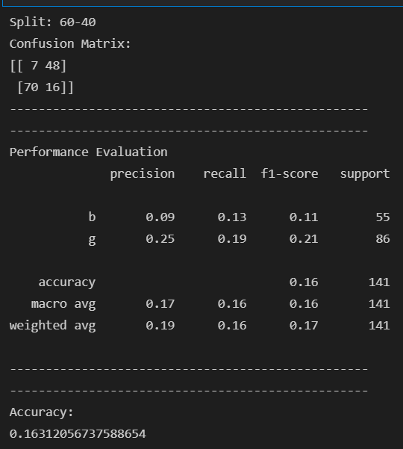 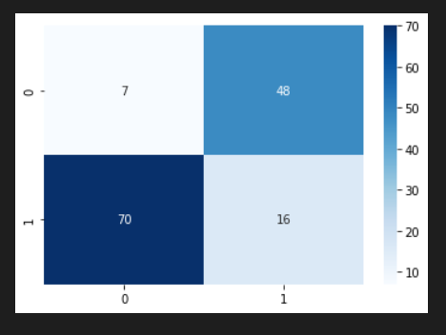

# IONOSPHERE DATASET

# GMMHMM(With Tuning)[60-40 split]

print("Split size: 60-40")

import pandas as pd

import numpy as np

# Dataset Preparation

df = pd.read_csv("ionosphere.data",header=None)

col_name = ['1','2','3','4','5','6','7','8','9','10','11','12','13','14','15','16','17','18','19'

,'20','21','22','23','24','25','26','27','28','29','30','31','32','33','34','Class']

df.columns = col_name

X = df.drop(['1','2','Class'], axis=1)

y = df['Class']

from sklearn.model_selection import train_test_split

X_train, X_test, y_train, y_test = train_test_split(X,y,train_size=0.6,test_size=0.4,random_state=10)

# Feature Scaling

from sklearn.preprocessing import StandardScaler

sc = StandardScaler()

X_train = sc.fit_transform(X_train)

X_test = sc.transform(X_test)

# Classification

# from hmmlearn import hmm

import hmmlearn

classifier = hmmlearn.hmm.GMMHMM(n_components=2, random_state=10,covariance_type='full',algorithm='viterbi',n_iter=10)

classifier.fit(X_train)

y_pred = classifier.predict(X_test)

size = len(y_pred)

strings = np.empty(size, np.unicode_)

for i in range (size):

if y_pred[i] == 1:

strings[i] = ("g")

else:

strings[i] = ("b")

strings

from sklearn.metrics import classification_report, confusion_matrix, accuracy_score

print("Confusion Matrix:")

print(confusion_matrix(y_test, strings))

print("--------------------------------------------------")

print("--------------------------------------------------")

print("Performance Evaluation")

print(classification_report(y_test, strings))

print("--------------------------------------------------")

print("--------------------------------------------------")

print("Accuracy:")

print(accuracy_score(y_test, strings))

import matplotlib.pyplot as plt

import seaborn as sns

cm = confusion_matrix(y_test, strings)

sns.heatmap(cm, annot=True, fmt="d",cmap='Blues')

plt.show()

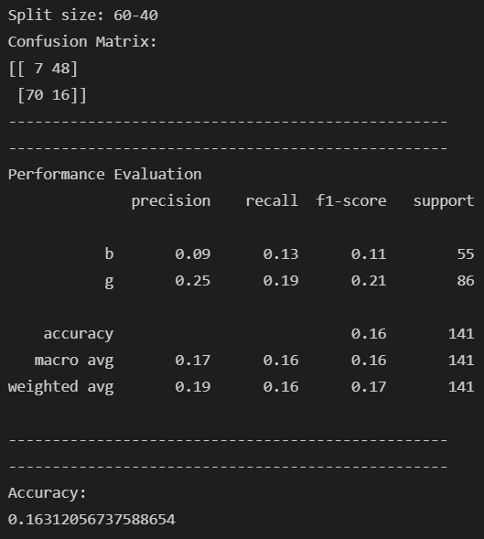 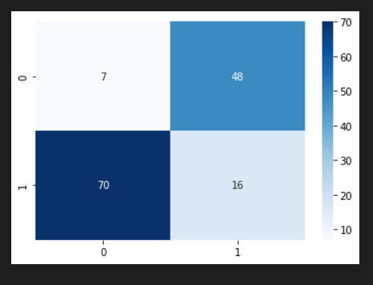

# IONOSPHERE DATASET

# MultinomialHMM(Without Tuning)[40-60 split]

print("Split: 40-60")

import pandas as pd

import numpy as np

# Dataset Preparation

col_name = ['1','2','3','4','5','6','7','8','9','10','11','12','13','14','15','16','17','18','19'

,'20','21','22','23','24','25','26','27','28','29','30','31','32','33','34','Class']

df.columns = col_name

X = df.drop(['1','2','Class'], axis=1)

y = df['Class']

X = df.drop(['1','Class'], axis=1)

y = df['Class']

from sklearn.model_selection import train_test_split

X_train, X_test, y_train, y_test = train_test_split(X,y,train_size=0.4,test_size=0.6,random_state=10)

# Feature Scaling

from sklearn.preprocessing import StandardScaler

sc = StandardScaler()

X_train = sc.fit_transform(X_train)

X_test = sc.transform(X_test)

# Classification

# from hmmlearn import hmm

import hmmlearn

classifier = hmmlearn.hmm.MultinomialHMM(n_components=4, random_state=15,n_iter=10,algorithm='viterbi',params='ste')

import math

row = len(X_train)

col = len(X_train[0])

new = [1] * 33

for i in range(row):

for j in range(col):

X_train[i][j] = X_train[i][j]*10

X_train[i][j] = math.floor(X_train[i][j])

x = X_train[i].astype(int)

new = np.vstack([new,x])

y = new

y = np.absolute(y)

X_train = y

import math

row = len(X_test)

col = len(X_test[0])

new

for i in range(row):

for j in range(col):

X_test[i][j] = X_test[i][j]*10

X_test[i][j] = math.floor(X_test[i][j])

x = X_test[i].astype(int)

new = np.vstack([new,x])

y = new

y = np.absolute(y)

X_test = y

classifier.fit(X_train)

y_pred = classifier.predict(X_test)

size = len(y_pred)

strings = np.empty(size, np.unicode_)

for i in range (size):

if y_pred[i] == 1:

strings[i] = ("b")

else:

strings[i] = ("g")

strings

strings = strings[0:211]

from sklearn.metrics import classification_report, confusion_matrix, accuracy_score

print("Confusion Matrix:")

print(confusion_matrix(y_test, strings))

print("--------------------------------------------------")

print("--------------------------------------------------")

print("Performance Evaluation")

print(classification_report(y_test, strings))

print("--------------------------------------------------")

print("--------------------------------------------------")

print("Accuracy:")

print(accuracy_score(y_test, strings))

import matplotlib.pyplot as plt

import seaborn as sns

cm = confusion_matrix(y_test, strings)

sns.heatmap(cm, annot=True, fmt="d",cmap='Blues')

plt.show()

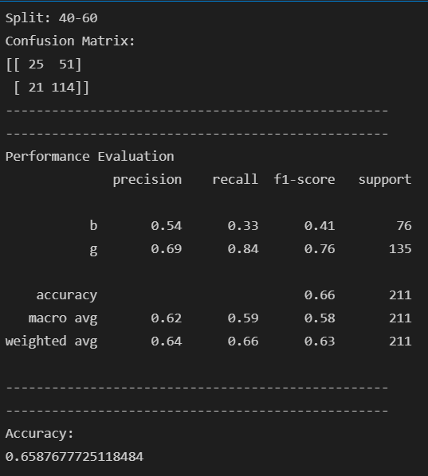 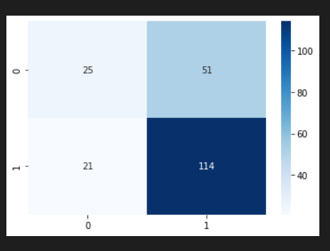

# Irish DATASET

# GaussianHMM(Without Tuning)[30-70 split]

print("Split: 30-70")

import pandas as pd

import numpy as np

import sklearn

from sklearn import datasets

iris = datasets.load_iris()

X=iris.data

y=iris.target

from sklearn.model_selection import train_test_split

X_train, X_test, y_train, y_test = train_test_split(X,y,train_size=0.3,test_size=0.7,random_state=10)

# Feature Scaling

from sklearn.preprocessing import StandardScaler

sc = StandardScaler()

X_train = sc.fit_transform(X_train)

X_test = sc.transform(X_test)

# Classification

from hmmlearn import hmm

classifier = hmm.GaussianHMM(n_components=2, covariance_type="full")

classifier.fit(X_train)

y_pred = classifier.predict(X_test)

from sklearn.metrics import classification_report, confusion_matrix, accuracy_score

print("Confusion Matrix:")

print(confusion_matrix(y_test, y_pred))

print("--------------------------------------------------")

print("--------------------------------------------------")

print("Performance Evaluation")

print(classification_report(y_test, y_pred))

print("--------------------------------------------------")

print("--------------------------------------------------")

print("Accuracy:")

print(accuracy_score(y_test, y_pred))

import matplotlib.pyplot as plt

import seaborn as sns

cm = confusion_matrix(y_test, y_pred)

sns.heatmap(cm, annot=True, fmt="d",cmap='Blues')

plt.show()

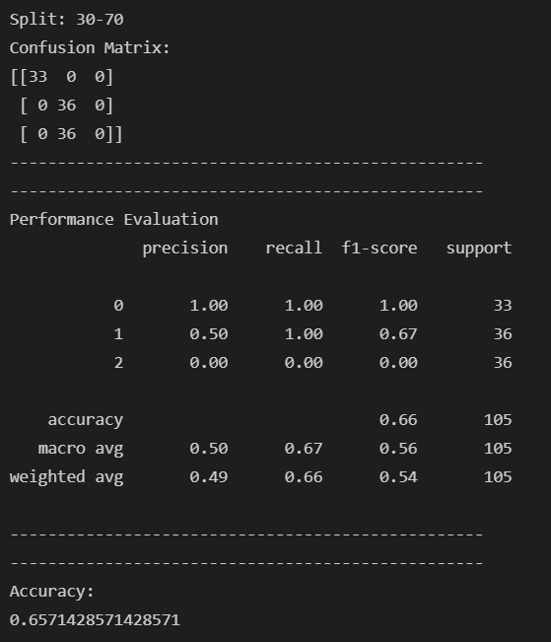 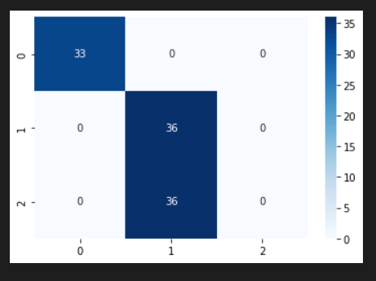

# Irish DATASET

# GaussianHMM(With Tuning)[70-30 split]

print("Split: 70-30")

import pandas as pd

import numpy as np

import sklearn

from sklearn import datasets

iris = datasets.load_iris()

X=iris.data

y=iris.target

from sklearn.model_selection import train_test_split

X_train, X_test, y_train, y_test = train_test_split(X,y,train_size=0.7,test_size=0.3,random_state=10)

# Feature Scaling

from sklearn.preprocessing import StandardScaler

sc = StandardScaler()

X_train = sc.fit_transform(X_train)

X_test = sc.transform(X_test)

# Classification

from hmmlearn import hmm

classifier = hmm.GaussianHMM(n_components=2, covariance_type="full",n_iter=5,algorithm='viterbi',verbose=False)

classifier.fit(X_train)

y_pred = classifier.predict(X_test)

from sklearn.metrics import classification_report, confusion_matrix, accuracy_score

print("Confusion Matrix:")

print(confusion_matrix(y_test, y_pred))

print("--------------------------------------------------")

print("--------------------------------------------------")

print("Performance Evaluation")

print(classification_report(y_test, y_pred))

print("--------------------------------------------------")

print("--------------------------------------------------")

print("Accuracy:")

print(accuracy_score(y_test, y_pred))

import matplotlib.pyplot as plt

import seaborn as sns

cm = confusion_matrix(y_test, y_pred)

sns.heatmap(cm, annot=True, fmt="d",cmap='Blues')

plt.show()

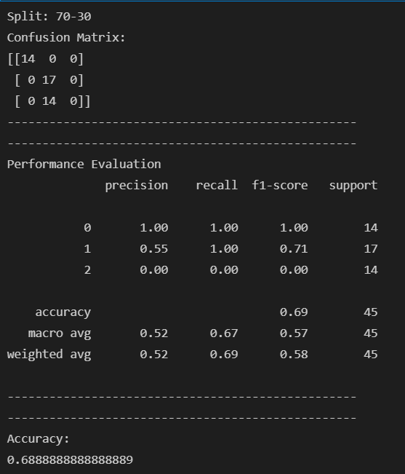 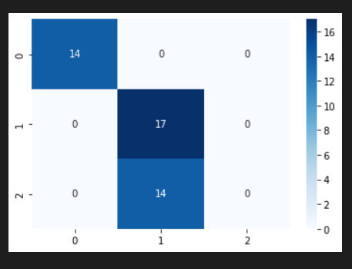

# Irish DATASET

# GMMHMM(With Tuning)[30-70 split]

print("Split: 30-70")

import pandas as pd

import numpy as np

import sklearn

from sklearn import datasets

iris = datasets.load_iris()

X=iris.data

y=iris.target

from sklearn.model_selection import train_test_split

X_train, X_test, y_train, y_test = train_test_split(X,y,train_size=0.3,test_size=0.7,random_state=10)

# Feature Scaling

from sklearn.preprocessing import StandardScaler

sc = StandardScaler()

X_train = sc.fit_transform(X_train)

X_test = sc.transform(X_test)

# Classification

import hmmlearn

classifier = hmmlearn.hmm.GMMHMM(n_components=2, random_state=10,covariance_type='full',algorithm='viterbi',n_iter=10)

classifier.fit(X_train)

y_pred = classifier.predict(X_test)

from sklearn.metrics import classification_report, confusion_matrix, accuracy_score

print("Confusion Matrix:")

print(confusion_matrix(y_test, y_pred))

print("--------------------------------------------------")

print("--------------------------------------------------")

print("Performance Evaluation")

print(classification_report(y_test, y_pred))

print("--------------------------------------------------")

print("--------------------------------------------------")

print("Accuracy:")

print(accuracy_score(y_test, y_pred))

import matplotlib.pyplot as plt

import seaborn as sns

cm = confusion_matrix(y_test, y_pred)

sns.heatmap(cm, annot=True, fmt="d",cmap='Blues')

plt.show()

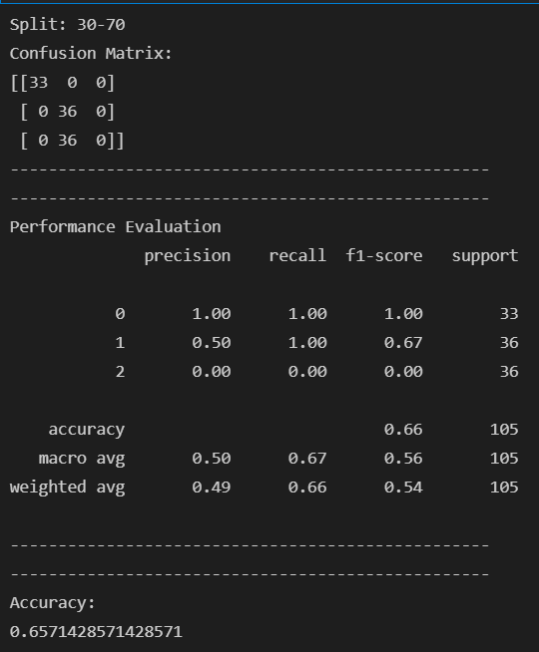 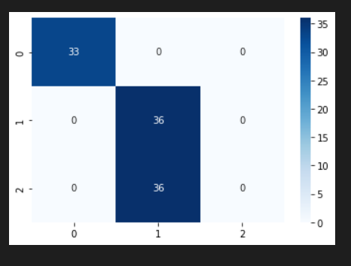

Q5. Used Dataset

Wine Dataset: <https://archive.ics.uci.edu/ml/datasets/wine>

Kmeans vs Kmedoids

#importing libraries

import numpy as np

import pandas as pd

import sklearn as sk

import matplotlib.pyplot as plt

%matplotlib inline

from sklearn.cluster import KMeans

from sklearn.datasets import load_wine

wine=load_wine() #loading iris dataset from sklearn.datasets

x=wine.data

df=pd.DataFrame(data=wine.data, columns=['alcohol',

'malic_acid',

'ash',

'alcalinity_of_ash',

'magnesium',

'total_phenols',

'flavanoids',

'nonflavanoid_phenols',

'proanthocyanins',

'color_intensity',

'hue',

'od280/od315_of_diluted_wines',

'proline'])

plt.scatter(x=df['alcohol'], y=df['malic_acid'] ,c=wine.target, cmap='gist_rainbow') #try using cmap='rainbow'

plt.xlabel('alcohol', fontsize=18)

plt.ylabel('malic_acid', fontsize=18)

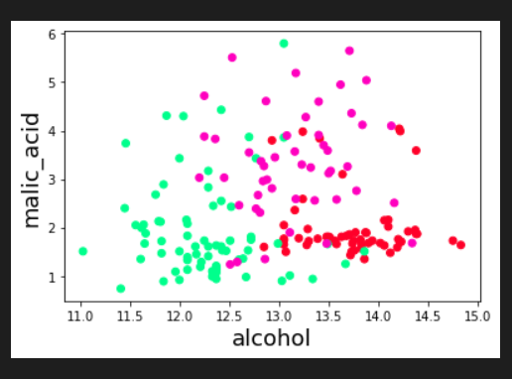

kmeans = KMeans(init="random", n_clusters=3, n_init=10, max_iter=300, random_state=42)

y = kmeans.fit_predict(x)

print("K-Means Cluster Centers")

print(kmeans.cluster_centers_)

print("Cluster Labels")

print(kmeans.labels_)

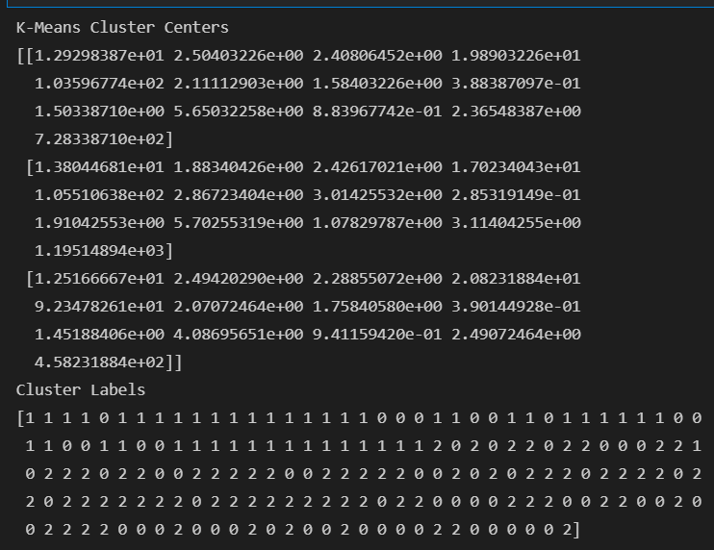

plt.scatter(x=df['alcohol'], y=df['malic_acid'] ,c=kmeans.labels_, cmap='rainbow') #try using cmap='rainbow'

plt.show()

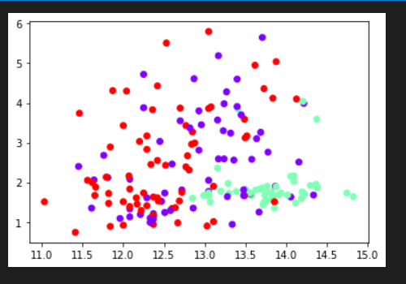

fig, axes = plt.subplots(1, 2, figsize=(14,6))

axes[0].scatter(x=df['alcohol'], y=df['malic_acid'], c=y, cmap='rainbow',edgecolor='k', s=150) #you can also try cmap='rainbow'

axes[1].scatter(x=df['alcohol'], y=df['malic_acid'], c=wine.target, cmap='jet',edgecolor='k', s=150)

axes[0].set_xlabel('alcohol', fontsize=18)

axes[0].set_ylabel('malic_acid', fontsize=18)

axes[1].set_xlabel('alcohol', fontsize=18)

axes[1].set_ylabel('malic_acid', fontsize=18)

axes[0].tick_params(direction='in', length=10, width=5, colors='k', labelsize=20)

axes[1].tick_params(direction='in', length=10, width=5, colors='k', labelsize=20)

axes[0].set_title('Actual', fontsize=18)

axes[1].set_title('Predicted', fontsize=18)

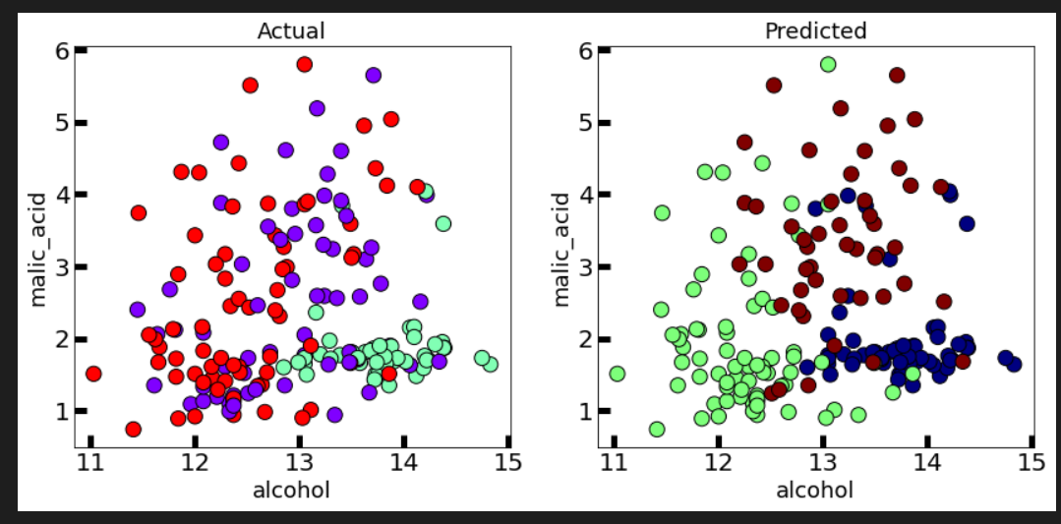

from sklearn.metrics import silhouette_score

print("The silhouette score is :")

silhouette_score(x, kmeans.labels_)

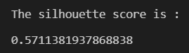

from sklearn.metrics import calinski_harabasz_score

print("The calinski harabasz score is :")

calinski_harabasz_score(x, kmeans.labels_)

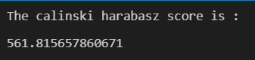

from sklearn.metrics import davies_bouldin_score

print("The davies bouldin score is :")

davies_bouldin_score(x, kmeans.labels_) 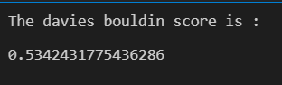

#importing libraries

import numpy as np

import pandas as pd

import sklearn as sk

import matplotlib.pyplot as plt

%matplotlib inline

from sklearn_extra.cluster import KMedoids

from sklearn.datasets import load_wine

wine=load_wine() #loading iris dataset from sklearn.datasets

x=wine.data

df=pd.DataFrame(data=wine.data, columns=['alcohol',

'malic_acid',

'ash',

'alcalinity_of_ash',

'magnesium',

'total_phenols',

'flavanoids',

'nonflavanoid_phenols',

'proanthocyanins',

'color_intensity',

'hue',

'od280/od315_of_diluted_wines',

'proline'])

plt.scatter(x=df['alcohol'], y=df['malic_acid'] ,c=wine.target, cmap='gist_rainbow') #try using cmap='rainbow'

plt.xlabel('alcohol', fontsize=18)

plt.ylabel('malic_acid', fontsize=18)

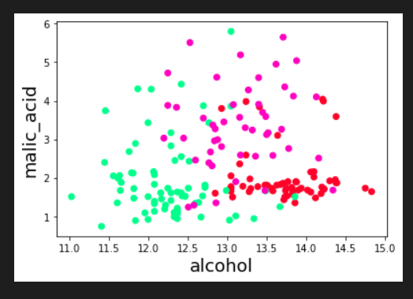

kmedoid = KMedoids(init="heuristic", n_clusters=3, max_iter=300, random_state=42)

y = kmedoid.fit_predict(x)

print("K-Medoids Cluster Centers")

print(kmedoid.cluster_centers_)

print("Cluster Labels")

print(kmedoid.labels_) 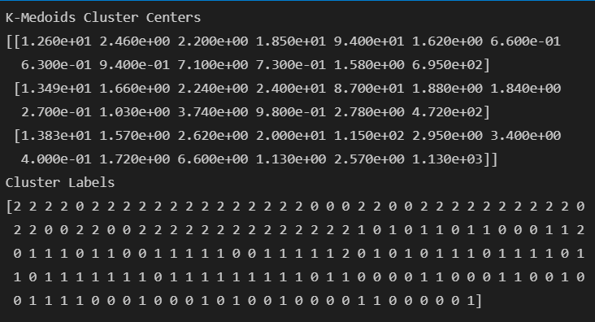

plt.scatter(x=df['alcohol'], y=df['malic_acid'] ,c=kmedoid.labels_, cmap='rainbow') #try using cmap='rainbow'

plt.show()

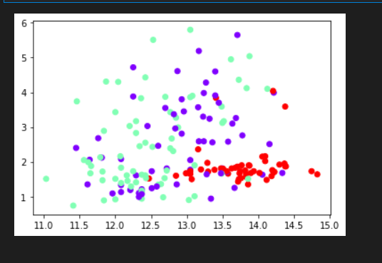

fig, axes = plt.subplots(1, 2, figsize=(14,6))

axes[0].scatter(x=df['alcohol'], y=df['malic_acid'], c=y, cmap='rainbow',edgecolor='k', s=150) #you can also try cmap='rainbow'

axes[1].scatter(x=df['alcohol'], y=df['malic_acid'], c=wine.target, cmap='jet',edgecolor='k', s=150)

axes[0].set_xlabel('alcohol', fontsize=18)

axes[0].set_ylabel('malic_acid', fontsize=18)

axes[1].set_xlabel('alcohol', fontsize=18)

axes[1].set_ylabel('malic_acid', fontsize=18)

axes[0].tick_params(direction='in', length=10, width=5, colors='k', labelsize=20)

axes[1].tick_params(direction='in', length=10, width=5, colors='k', labelsize=20)

axes[0].set_title('Actual', fontsize=18)

axes[1].set_title('Predicted', fontsize=18)

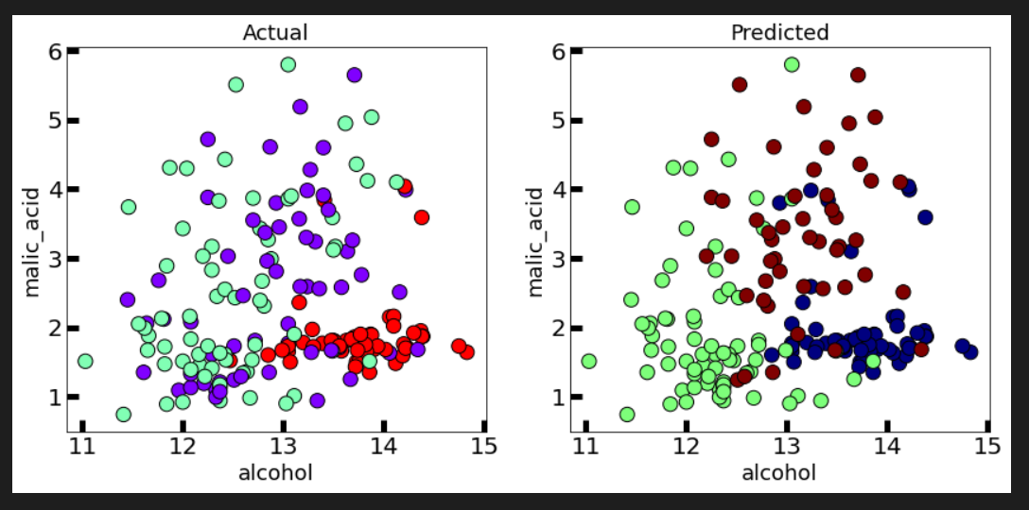

from sklearn.metrics import silhouette_score

print("The silhouette score is :")

silhouette_score(x, kmedoid.labels_)

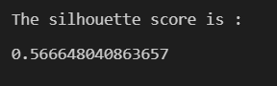

from sklearn.metrics import calinski_harabasz_score

print("The calinski harabasz score is :")

calinski_harabasz_score(x, kmedoid.labels_)

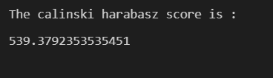

from sklearn.metrics import davies_bouldin_score

print("The davies bouldin score is :")

davies_bouldin_score(x, kmedoid.labels_)

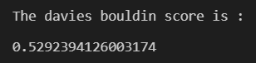

#importing libraries

import numpy as np

import pandas as pd

import sklearn as sk

import matplotlib.pyplot as plt

%matplotlib inline

from sklearn.cluster import KMeans

from sklearn.datasets import load_wine

wine=load_wine()   #loading iris dataset from sklearn.datasets

x=wine.data

df=pd.DataFrame(data=wine.data, columns=['alcohol',

  'malic_acid',

  'ash',

  'alcalinity_of_ash',

  'magnesium',

  'total_phenols',

  'flavanoids',

  'nonflavanoid_phenols',

  'proanthocyanins',

  'color_intensity',

  'hue',

  'od280/od315_of_diluted_wines',

  'proline'])

plt.scatter(x=df['alcohol'], y=df['malic_acid'] ,c=wine.target, cmap='gist_rainbow') #try using cmap='rainbow'

plt.xlabel('alcohol', fontsize=18)

plt.ylabel('malic_acid', fontsize=18)

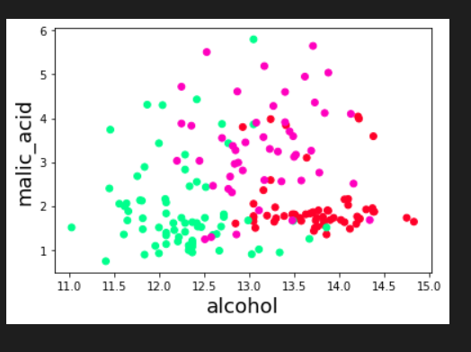

from sklearn.cluster import DBSCAN

dbscan = DBSCAN(eps=35, algorithm='auto', metric='euclidean')

y = dbscan.fit_predict(x)

print("Cluster Labels")

print(dbscan.labels_)

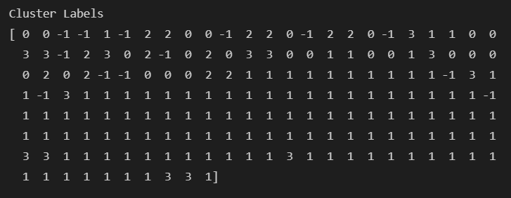

plt.scatter(x=df['alcohol'], y=df['malic_acid'] ,c=dbscan.labels_, cmap='rainbow') #try using cmap='rainbow'

plt.show()

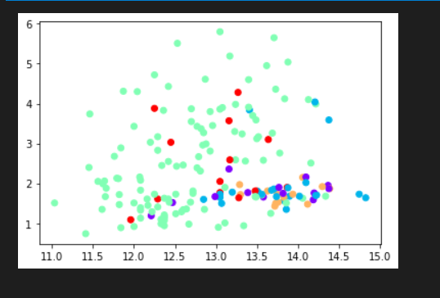

fig, axes = plt.subplots(1, 2, figsize=(14,6))

axes[0].scatter(x=df['alcohol'], y=df['malic_acid'], c=y, cmap='rainbow',edgecolor='k', s=150) #you can also try cmap='rainbow'

axes[1].scatter(x=df['alcohol'], y=df['malic_acid'], c=wine.target, cmap='jet',edgecolor='k', s=150)

axes[0].set_xlabel('alcohol', fontsize=18)

axes[0].set_ylabel('malic_acid', fontsize=18)

axes[1].set_xlabel('alcohol', fontsize=18)

axes[1].set_ylabel('malic_acid', fontsize=18)

axes[0].tick_params(direction='in', length=10, width=5, colors='k', labelsize=20)

axes[1].tick_params(direction='in', length=10, width=5, colors='k', labelsize=20)

axes[0].set_title('Actual', fontsize=18)

axes[1].set_title('Predicted', fontsize=18)

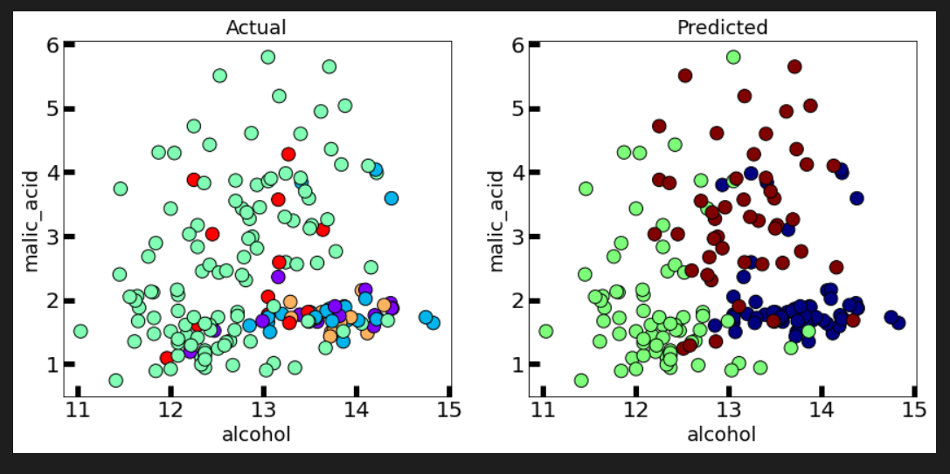

from sklearn.metrics import silhouette_score

print("The silhouette score is :")

silhouette_score(x, dbscan.labels_)

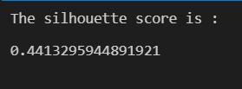

from sklearn.metrics import calinski_harabasz_score

print("The calinski harabasz score is :")

calinski_harabasz_score(x, dbscan.labels_)

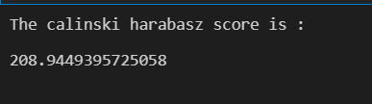

from sklearn.metrics import davies_bouldin_score

print("The davies bouldin score is :")

davies_bouldin_score(x, dbscan.labels_)

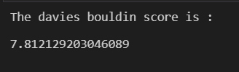

#importing libraries

import numpy as np

import pandas as pd

import sklearn as sk

import matplotlib.pyplot as plt

%matplotlib inline

from sklearn.cluster import KMeans

from sklearn.datasets import load_wine

wine=load_wine()   #loading iris dataset from sklearn.datasets

x=wine.data

df=pd.DataFrame(data=wine.data, columns=['alcohol',

  'malic_acid',

  'ash',

  'alcalinity_of_ash',

  'magnesium',

  'total_phenols',

  'flavanoids',

  'nonflavanoid_phenols',

  'proanthocyanins',

  'color_intensity',

  'hue',

  'od280/od315_of_diluted_wines',

  'proline'])

plt.scatter(x=df['alcohol'], y=df['malic_acid'] ,c=wine.target, cmap='gist_rainbow') #try using cmap='rainbow'

plt.xlabel('alcohol', fontsize=18)

plt.ylabel('malic_acid', fontsize=18)

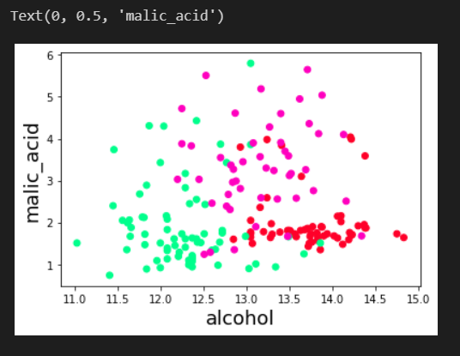

from sklearn.cluster import OPTICS

optics = OPTICS(min_samples=13)

y = optics.fit_predict(x)

print("Cluster Labels")

print(optics.labels_)

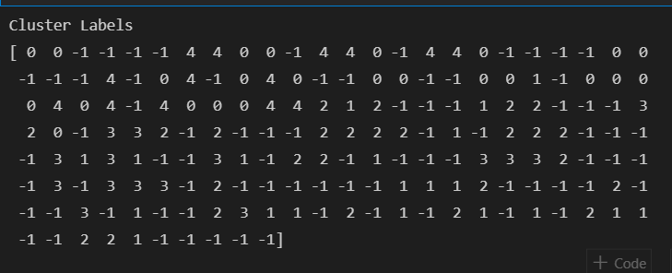

plt.scatter(x=df['alcohol'], y=df['malic_acid'] ,c=optics.labels_, cmap='rainbow') #try using cmap='rainbow'

plt.show()

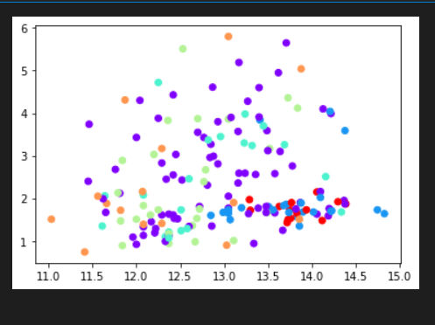

fig, axes = plt.subplots(1, 2, figsize=(14,6))

axes[0].scatter(x=df['alcohol'], y=df['malic_acid'], c=y, cmap='rainbow',edgecolor='k', s=150) #you can also try cmap='rainbow'

axes[1].scatter(x=df['alcohol'], y=df['malic_acid'], c=wine.target, cmap='jet',edgecolor='k', s=150)

axes[0].set_xlabel('alcohol', fontsize=18)

axes[0].set_ylabel('malic_acid', fontsize=18)

axes[1].set_xlabel('alcohol', fontsize=18)

axes[1].set_ylabel('malic_acid', fontsize=18)

axes[0].tick_params(direction='in', length=10, width=5, colors='k', labelsize=20)

axes[1].tick_params(direction='in', length=10, width=5, colors='k', labelsize=20)

axes[0].set_title('Actual', fontsize=18)

axes[1].set_title('Predicted', fontsize=18)

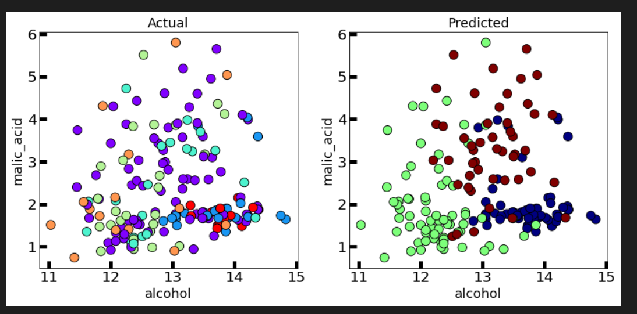

from sklearn.metrics import silhouette_score

print("The silhouette score is :")

silhouette_score(x, optics.labels_)

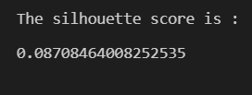

from sklearn.metrics import calinski_harabasz_score

print("The calinski harabasz score is :")

calinski_harabasz_score(x, optics.labels_)

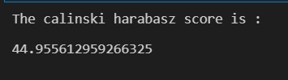

from sklearn.metrics import davies_bouldin_score

print("The davies bouldin score is :")

davies_bouldin_score(x, optics.labels_)

