

**PlyPluse**

**INTERNSHIP REPORT ON**

**"WEB TECHNOLOGY Internship"**

Submitted in partial fulfilment of requirements to CSE

**-Digital Form of Music**

**Submitted by:**

**G RAGHU BABU**

**22KQ1A0544**

**III B. Tech CSE-A**

**PACE INSTITUTE OF TECHNOLOGY AND SCIENCE**

**JUNE 2025**

**PACE INSTITUTE OF TECHNOLOGY AND SCIENCE**

****DEPARTMENT OF CSE

**CERTIFICATE**

This is to certify that this internship report **"WEB TECHNOLOGY Internship"** is the Bonafide work of **"G RAGHU BABU (22KQ1A0544)"** who has carried out the work under my supervision and submitted in partial fulfilment for the award of **WEB TECHNOLOGY** Internship during the year 2025 (May) - 2025 (June).

**Signature of External Trainer Signature of Internal Trainer**

**Prof. & HOD**

**ACKNOWLEDGEMENT**

I would like to express my sincere gratitude to all those who supported and guided me throughout my internship journey titled **"WEB TECHNOLOGY Internship."**

First and foremost, I extend my heartfelt thanks to **Dr. G.V.S. Murthy**, Principal of **PACE Institute of Technology and Science**, for providing me with an encouraging environment and the opportunity to undertake this internship.

I am deeply grateful to **Dr.** **Giri Babu**, Head of the CSE, for paving the path and supporting me with all the necessary resources and guidance required to complete this internship.

My sincere thanks to **Mr. P. Dharan Kumar**, Internship In-charge, for his valuable suggestions, constant encouragement, and insightful feedback that played a significant role in the successful completion of this internship.

I would like to place on record my sincere appreciation and gratitude to **CodeTantra**, the organization where I had the opportunity to pursue my internship. I am thankful for the exposure, technical learning, and real-time insights into web development, including **HTML,CSS, JavaScript, and MongoDB**, that I gained during this period.

Finally, I am immensely thankful to my friends and family for their unwavering moral support throughout this journey.

**G RAGHU BABU**

**(22KQ1A0544)**

**Table of Contents**

|  |  |
| --- | --- |
| S.NO | Name of the Topics |
| 1. | Abstract |
| 2. | Objectives |
| 3. | Scope of the Project |
| 4. | Technologies Used |
| 5. | Project Categorization |
| 6. | Problem Statement: Interactive Music Visualization |
| 7. | Real-World Scenarios and Analysis |
| 8. | Explanation of Project |
| 9. | Learnings and Skills Gained |
| 10. | Challenges Faced |
| 11. | Suggestions and Future Enhancements |
| 12. | Conclusion |
| 13. | References |

**1. Abstract**

This project focuses on developing an **Interactive Music Visualization** website, leveraging fundamental web technologies: HTML for structure, CSS for styling, JavaScript for interactivity, and MongoDB for data persistence (if implemented for features like user preferences or music library management). The core of the project involves creating dynamic visual representations that respond to audio input, enhancing the user's music listening experience. This includes implementing various visualization types (e.g., bar graphs, waveforms, particle effects) that synchronize with audio frequencies and amplitudes.

The project aims to bridge academic learning with practical web development skills. By tackling a real-world inspired problem like interactive visualization, the internship strengthens foundational knowledge in front-end development, user experience design, and potentially back-end integration. Moreover, it fosters independent thinking, encourages clean code practices, and introduces basic software design strategies for web applications.

**2. Objectives**

* To apply HTML for structuring dynamic web content.
* To utilize CSS for creating visually appealing and responsive layouts.
* To implement JavaScript for client-side interactivity and audio processing.
* To understand and apply Web Audio API for analyzing audio data.
* To design and develop various real-time music visualization effects.
* To potentially integrate MongoDB for user-specific data storage (e.g., preferred visualizations, uploaded music).
* To develop problem-solving skills required for front-end and full-stack web development.
* To gain confidence in building interactive and media-rich web applications.
* To learn the process of designing, testing, and documenting web projects.

**3. Scope of the Project**

This project involves implementing an **Interactive Music Visualization** website based on a unique problem statement simulating real-world use cases. It includes:

* A front-end built with HTML, CSS, and JavaScript to create a user interface for music playback and visualization selection.
* Integration with the Web Audio API to capture and analyze audio data from a playing music source.
* Development of multiple visualization algorithms (e.g., frequency bars, waveform, circular visualizers) that dynamically react to audio properties.
* Responsive design to ensure optimal viewing and interaction across various devices (desktop, tablet, mobile).
* Potential back-end integration using Node.js and MongoDB for features like storing user playlists, visualization preferences, or user-uploaded music metadata.

Each solution aspect includes detailed input/output expectations, edge case considerations, code explanation, and test examples. This project strengthens practical web development skills and introduces structured thinking for building interactive web applications.

The project highlights different aspects of web programming:

1. Front-end structure and styling (HTML/CSS).
2. Client-side scripting, audio processing, and dynamic content generation (JavaScript/Web Audio API).
3. (Optional) Data persistence and back-end integration (MongoDB).

The scope also includes edge case handling and comprehensive code documentation.

**4. Technologies Used**

* **Front-end Languages:**
  + HTML5 (for semantic structure)
  + CSS3 (for styling and responsiveness)
  + JavaScript (ES6+) (for interactivity, audio processing, and DOM manipulation)
* **JavaScript APIs/Libraries:**
  + Web Audio API (for audio input, analysis, and processing)
  + Canvas API (for drawing dynamic visualizations)
  + (Optional) D3.js or Three.js (for more complex visualizations, if applicable)
* **Back-end (Optional, for data persistence):**
  + Node.js (for server-side logic)
  + Express.js (for building RESTful APIs)
  + MongoDB (NoSQL database for data storage)
  + Mongoose (ODM for MongoDB in Node.js)
* **Development Tools:**
  + IDE: VS Code
  + Browser Developer Tools (for debugging)
  + Version Control: Git/GitHub

**5. Project Categorization**

|  |  |  |
| --- | --- | --- |
| **Aspect** | **Category** | **Key Concepts** |
| **HTML/CSS** | Front-end Development | Semantic HTML, CSS Flexbox/Grid, Responsive Design, CSS Animations/Transitions |
| **JavaScript** | Client-side Scripting / Audio Processing | DOM Manipulation, Event Handling, Asynchronous Programming (Promises/Async-Await), Web Audio API, Canvas API, Data Visualization Algorithms |
| **MongoDB** | Database Management / Back-end Development (Optional) | NoSQL Database, CRUD Operations, Data Modelling, Mongoose Schema, RESTful APIs |

This project maps directly to foundational topics in modern web development and interactive media.

* Interactive visualization resembles digital signal processing and real-time graphics.
* Front-end development reinforces user experience (UX) and user interface (UI) principles.
* Database integration (if included) models data management for web applications.

**6. Project: Interactive Music Visualization**

**6.1 Problem Statement**

Develop a web application that provides interactive visual feedback to playing music. The application should allow users to upload or select music files and display dynamic visualizations that respond to the audio's frequency and amplitude changes in real-time. The solution should be responsive, aesthetically pleasing, and offer various visualization options.

**6.2 Input Format**

* User interaction via web interface (e.g., button clicks for play/pause, slider for volume).
* Music file input (e.g., audio element for pre-selected tracks, file input for user uploads).
* User selection of visualization type (e.g., dropdown, radio buttons).

**6.3 Output Format**

* Real-time graphical visualizations drawn on an HTML <canvas> element.
* Audio playback.
* User interface elements for control (play/pause button, volume slider, visualization selector).

**6.4 Constraints**

* Visualizations must be generated in real-time and synchronize accurately with the audio.
* The application should be responsive and function well on various screen sizes.
* Performance should be optimized to prevent lag or stuttering during visualization.
* Cross-browser compatibility is desired.
* (If MongoDB is used) Secure handling of user data and efficient database queries.

**6.5 Sample Interface/Features (Inspired by plypluse.rf.gd)**

* **Music Selection:** Ability to load different music tracks.
* **Playback Controls:** Play, pause, volume.
* **Visualization Modes:**
  + **Bar Graph:** Vertical bars reacting to frequency bands.
  + **Waveform:** Line drawing of the audio's amplitude over time.
  + **Circular/Radial:** Visuals expanding from a canter point.
  + **Particle Effects:** Abstract shapes or particles moving with the music.
* **Customization:** (Optional) Color schemes, intensity controls for visualizations.

**6.6 Algorithm Used (General)**

1. **Audio Source Loading:** Load an audio file (e.g., MP3, WAV) into an HTML <audio> element or via FileReader for user uploads.
2. **Web Audio API Context:** Create an AudioContext to process audio.
3. **Source Node:** Create an AudioBufferSourceNode (for loaded audio) or MediaElementSourceNode (for HTML audio element) and connect it to the AudioContext.
4. **Analyzer Node:** Create an AnalyserNode to retrieve frequency and time-domain data. Configure its FFT size and smoothing time constant.
5. **Data Retrieval:** Continuously fetch frequency data (e.g., getByteFrequencyData()) or waveform data (e.g., getByteTimeDomainData()) from the AnalyserNode in an animation loop (requestAnimationFrame).
6. **Canvas Drawing:** Use the HTML Canvas 2D API to clear the canvas and draw dynamic visual elements (lines, rectangles, circles, particles) based on the retrieved audio data.
7. **Looping:** The animation loop calls itself repeatedly, ensuring smooth and continuous visualization.

**6.7 Time & Space Complexity**

* **Time Complexity:** Predominantly O(N) per frame, where N is the FFT size/sample count from the AnalyserNode. Drawing operations on canvas also contribute. Optimized rendering is crucial for smooth performance.
* **Space Complexity:** O(N) for storing audio data arrays (frequency/time domain data) and potentially O(M) for visualization elements or particles on canvas, where M is the number of elements.

**6.8 Solution and Criteria**

A valid solution should:

* Successfully load and play music.
* Render real-time visualizations that accurately reflect audio characteristics.
* Provide a user-friendly interface for music control and visualization selection.
* Be responsive and performant across devices.
* (If MongoDB is used) Store and retrieve data reliably.

**6.9 Solution Design and Implementation**

* **HTML:** Minimal and semantic structure for audio element, canvas, and controls.
* **CSS:** Styling for layout, responsive design using media queries, and potentially CSS animations for UI elements.
* **JavaScript:**
  + **AudioManager module/class:** Handles audio loading, playback, Web Audio API setup, and analyzer node creation.
  + **VisualizationManager module/class:** Manages different visualization types. Each visualization type could be its own class/function.
  + **CanvasRenderer module/class:** Handles drawing operations on the canvas.
  + **Main App script:** Orchestrates interactions between AudioManager, VisualizationManager, and UI elements.
  + **Event Listeners:** For play/pause, volume change, visualization type selection.
  + **(Optional) Backend API:** Node.js/Express.js routes for handling music file uploads, user preferences, and MongoDB interactions.

**6.10 Error Handling and Edge Cases**

* **Audio Loading Errors:** Handle cases where audio files fail to load (e.g., network issues, unsupported format).
* **Web Audio API Support:** Check for browser compatibility of Web Audio API.
* **User Input Validation:** Ensure valid music file types are uploaded.
* **Empty Audio:** Gracefully handle scenarios where no music is playing.
* **Performance Degradation:** Implement safeguards or optimizations if performance drops (e.g., reduce visualization complexity).
* **(If MongoDB is used):** Database connection errors, invalid data writes/reads, schema validation.

**6.11 Limitations**

* Reliance on Web Audio API, which might have minor browser inconsistencies.
* Complexity of advanced visualizations can lead to performance issues on low-end devices.
* Copyright considerations for distributing music files for testing/demo.
* (If MongoDB is used) Requires server-side infrastructure.
* Limited to browser-supported audio formats.

**6.12 Code Optimization Techniques**

* **Efficient Canvas Drawing:** Minimize redraws, use requestAnimationFrame, avoid complex calculations in the drawing loop.
* **Web Audio API Optimization:** Reuse AudioContext, AnalyserNode.
* **CSS Optimizations:** Use hardware-accelerated CSS properties (e.g., transform, opacity).
* **JavaScript Performance:** Cache DOM elements, avoid unnecessary reflows/repaints, optimize loops.
* **(If MongoDB is used):** Indexing for faster queries, efficient data modeling to reduce document size.

**6.13 Methodology / Code (Conceptual)**

// Example JavaScript structure (simplified)

// 1. Audio Manager

class AudioManager {

constructor(audioElement) {

this.audioElement = audioElement;

this.audioContext = new (window.AudioContext || window.webkitAudioContext)();

this.sourceNode = this.audioContext.createMediaElementSource(this.audioElement);

this.analyser = this.audioContext.createAnalyser();

this.sourceNode.connect(this.analyser);

this.analyser.connect(this.audioContext.destination);

this.analyser.fftSize = 2048; // Adjust for desired frequency resolution

this.bufferLength = this.analyser.frequencyBinCount;

this.dataArray = new Uint8Array(this.bufferLength);

}

play() {

if (this.audioContext.state === 'suspended') {

this.audioContext.resume();

}

this.audioElement.play();

}

pause() {

this.audioElement.pause();

}

getFrequencyData() {

this.analyser.getByteFrequencyData(this.dataArray);

return this.dataArray;

}

getWaveformData() {

this.analyser.getByteTimeDomainData(this.dataArray);

return this.dataArray;

}

}

// 2. Visualization Renderer (example for bar graph)

class BarVisualization {

constructor(canvas, audioManager) {

this.canvas = canvas;

this.ctx = canvas.getContext('2d');

this.audioManager = audioManager;

this.WIDTH = canvas.width;

this.HEIGHT = canvas.height;

}

draw() {

requestAnimationFrame(() => this.draw()); // Loop for continuous animation

const dataArray = this.audioManager.getFrequencyData();

this.ctx.clearRect(0, 0, this.WIDTH, this.HEIGHT); // Clear canvas

const barWidth = (this.WIDTH / dataArray.length) * 2.5; // Adjust for spacing

let x = 0;

for (let i = 0; i < dataArray.length; i++) {

const barHeight = dataArray[i]; // Value from 0-255

this.ctx.fillStyle = `rgb(${barHeight + 100}, 50, 50)`; // Example color

this.ctx.fillRect(x, this.HEIGHT - barHeight / 2, barWidth, barHeight / 2); // Draw bars

x += barWidth + 1; // Spacing

}

}

}

// 3. Main Application Logic

document.addEventListener('DOMContentLoaded', () => {

const audioElement = document.getElementById('audioPlayer');

const playPauseBtn = document.getElementById('playPauseBtn');

const canvas = document.getElementById('visualizerCanvas');

const audioManager = new AudioManager(audioElement);

const barViz = new BarVisualization(canvas, audioManager);

playPauseBtn.addEventListener('click', () => {

if (audioElement.paused) {

audioManager.play();

playPauseBtn.textContent = 'Pause';

barViz.draw(); // Start visualization

} else {

audioManager.pause();

playPauseBtn.textContent = 'Play';

}

});

// Load initial music

audioElement.src = 'path/to/your/music.mp3';

});

// HTML Structure (simplified)

/*

<audio id="audioPlayer" controls></audio>

<button id="playPauseBtn">Play</button>

<canvas id="visualizerCanvas" width="800" height="400"></canvas>

*/

**6.14 Final Output (Conceptual)**

The final output would be a fully functional web page that, upon loading, displays a music player interface. When a song is played, a dynamic visualization (e.g., frequency bars or waveform) appears on the canvas, reacting in real-time to the music.

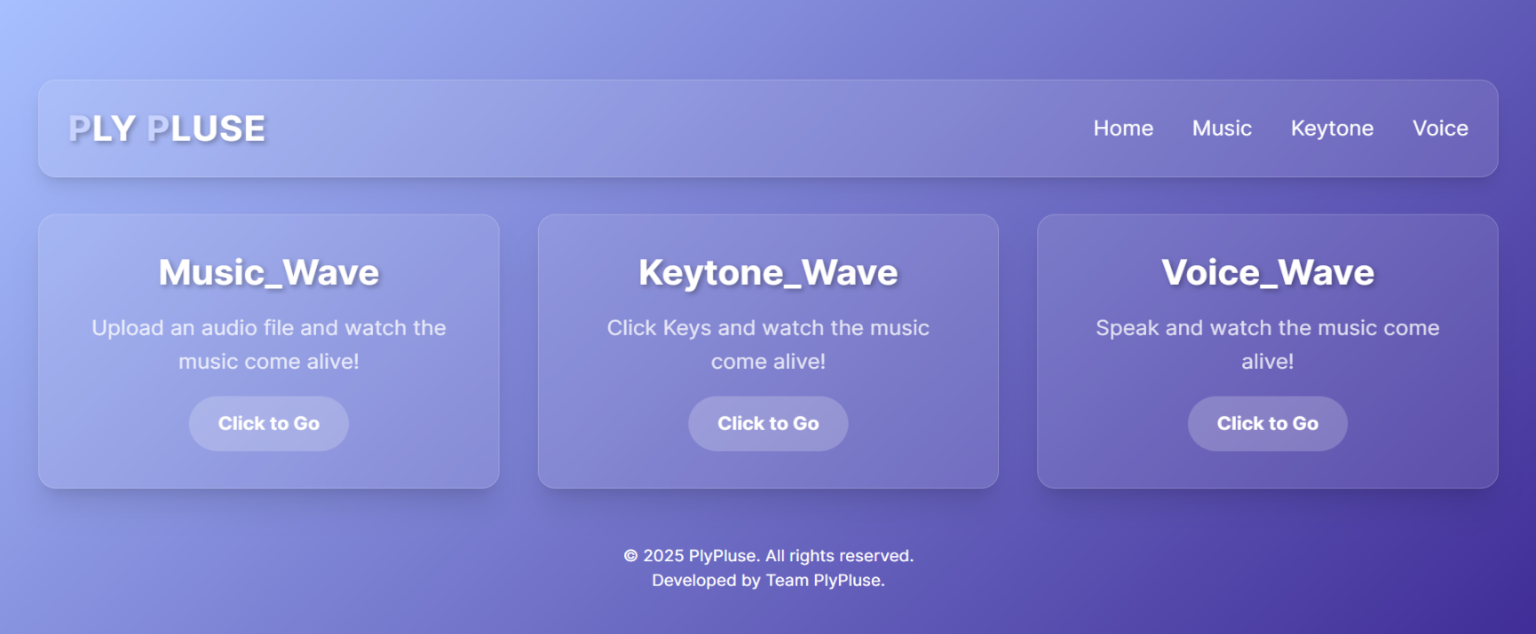

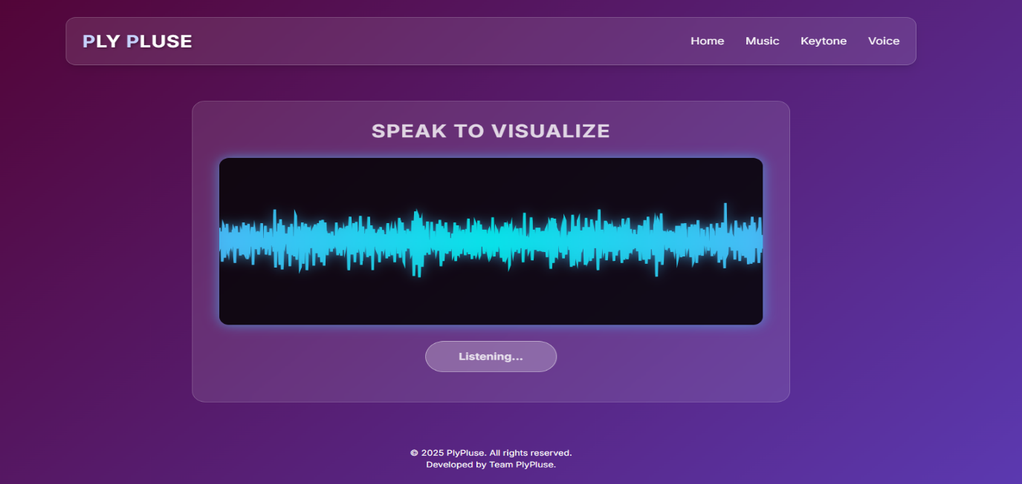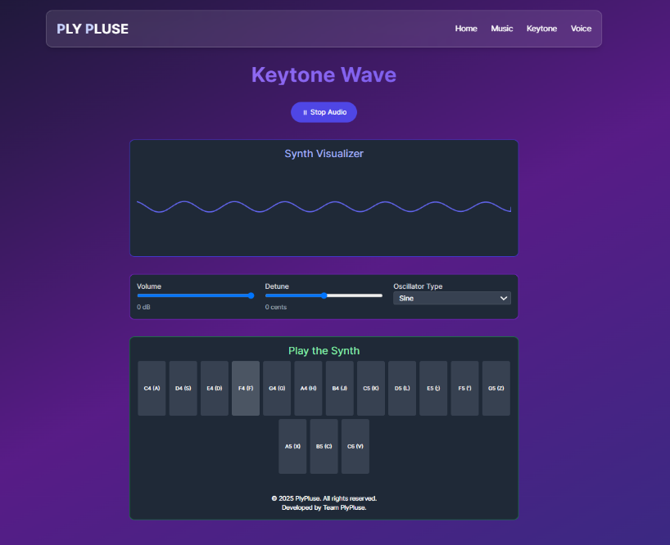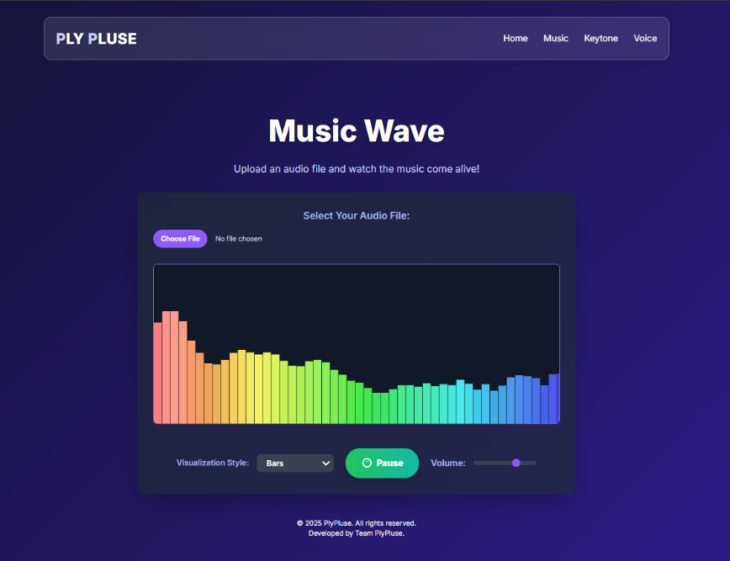**6.15 Explanation of the Problem**

The **Interactive Music Visualization** project involves translating abstract audio data into engaging visual experiences. It utilizes the power of the Web Audio API to tap into the raw sound information (frequencies, amplitudes) and the HTML Canvas API to render dynamic graphics. This project demonstrates how front-end technologies can be combined to create rich, interactive multimedia applications, reflecting real-world use cases in media players, live event visualizers, and educational tools for sound analysis. It emphasizes the importance of performance optimization and creative design in web development.

**6.16 Objective**

* To implement a fully functional interactive music visualization website.
* To gain a deep understanding of the Web Audio API and HTML Canvas for real-time graphics.
* To enhance problem-solving skills in integrating different web technologies.
* To develop a portfolio-worthy project demonstrating proficiency in front-end development.

**7. Real-World Scenarios and Analysis**

**7.1 Interactive Music Visualization**

In real-world applications, interactive music visualization is used in various contexts to enhance the user's audio experience, provide entertainment, or even for analytical purposes.

**Use Case Examples:**

* **Music Streaming Platforms:** Services like Spotify or Apple Music could integrate advanced visualizers to provide a more immersive listening experience, especially for premium users or during curated playlists.
* **Live Performance Visuals:** DJs and music producers use real-time visualizers during concerts and online streams to create dynamic backdrops that synchronize with their music, enhancing audience engagement.
* **Educational Tools:** Applications that teach audio engineering or music theory can use visualizers to help students understand concepts like frequency spectrum, amplitude, and waveforms.
* **Gaming:** Background music in games could be visually represented, adding to the atmosphere and player immersion.
* **Accessibility:** Visualizations can offer an alternative way for hearing-impaired individuals to "experience" music.

Preprocessing audio data for visualization is a fundamental task in multimedia applications and digital signal processing.

**8. Explanation of Project**

The **Interactive Music Visualization** project touches on several key areas of web development:

**HTML & CSS (Structure & Style)**

The project leverages HTML to define the core structure of the web page, including the audio player, control buttons, and the <canvas> element where visualizations are rendered. CSS is used extensively to style these elements, ensuring a responsive layout that adapts to different screen sizes (using Flexbox, Grid, and Media Queries) and providing an aesthetically pleasing user interface. This foundation is crucial for any modern web application, ensuring usability and visual appeal.

**Learning Highlights:**

* Demonstrates how semantic HTML creates a clear and accessible page structure.
* Reinforces responsive design principles for cross-device compatibility.
* Encourages creative CSS styling to enhance user experience.

**JavaScript & Web Audio API (Interactivity & Audio Processing)**

This is the core of the project. JavaScript is responsible for all client-side interactivity, including handling music playback (play/pause, volume), managing different visualization modes, and, most importantly, interacting with the Web Audio API. The Web Audio API allows direct access to audio data (frequencies, waveforms) in real-time. An AnalyserNode is used to capture this data, which is then passed to drawing functions that render the visualizations on the HTML <canvas> element using the Canvas 2D API. The use of requestAnimationFrame ensures smooth, browser-optimized animation loops.

**Learning Highlights:**

* Teaches real-time audio processing and analysis using the Web Audio API.
* Reinforces dynamic content generation and drawing on the HTML Canvas.
* Simulates principles of digital signal processing and interactive graphics.
* Encourages asynchronous programming and event-driven architecture.

**MongoDB (Optional - Data Persistence)**

While not strictly required for basic visualization, integrating MongoDB (via Node.js/Express.js backend) would elevate the project to a full-stack application. It would allow for features like:

* **User Profiles:** Storing user preferences for visualizations.
* **Music Library Management:** Enabling users to upload their own music files and storing metadata (artist, title, album).
* **Playlists:** Creating and saving custom playlists.

**Learning Highlights (if implemented):**

* Introduces server-side development with Node.js and Express.js.
* Teaches NoSQL database concepts and CRUD operations with MongoDB.
* Reinforces API design and full-stack application architecture.

**9. Learnings and Skills Gained**

* **1. Front-end Development Mastery:** Proficient in HTML5, CSS3, and JavaScript for building responsive and interactive web interfaces.
* **2. Real-time Audio Processing:** Acquired in-depth knowledge and practical experience with the Web Audio API for analyzing and visualizing audio data.
* **3. Dynamic Graphics Rendering:** Developed skills in using the HTML Canvas API to create complex, animated, and data-driven visualizations.
* **4. User Experience (UX) Design:** Learned to design intuitive interfaces and create engaging visual feedback for users.
* **5. Performance Optimization:** Understood techniques to ensure smooth and efficient real-time animations in web browsers.
* **6. (Optional) Full-Stack Integration:** Gained experience in connecting front-end applications with back-end services (Node.js/Express.js) and databases (MongoDB) for data persistence.
* **7. Problem Decomposition & Debugging:** Improved ability to break down complex problems into manageable components and systematically debug web applications.

**Additional Soft Skills Gained:**

* **Analytical Thinking:** Breaking down the process of audio visualization into distinct technical steps.
* **Creative Problem Solving:** Designing various visual effects that effectively represent audio properties.
* **Attention to Detail:** Ensuring synchronization, responsiveness, and aesthetic consistency across the application.
* **Technical Communication:** Clearly explaining the project's architecture, implementation, and future potential in documentation.

**10. Challenges Faced**

During the development of this project, we encountered a range of technical and logical challenges that contributed significantly to our learning experience.

* **Web Audio API Complexity:**
  + Understanding the audio graph, connecting nodes (source, analyser, destination), and correctly extracting frequency/time domain data proved challenging initially.
  + Synchronizing visualizations precisely with audio playback required careful timing and use of requestAnimationFrame.
* **Real-time Canvas Drawing:**
  + Optimizing canvas rendering for smooth performance across different devices, especially for complex visualizations, was a significant hurdle. Avoiding redraw flickers and ensuring efficient drawing operations required careful planning.
  + Implementing various visual patterns (e.g., bars, waveforms, particles) and mapping audio data to visual attributes required creative algorithmic thinking.
* **Cross-Browser Compatibility:**
  + Ensuring the Web Audio API and Canvas operations behaved consistently across different browsers sometimes led to unexpected issues.
* **Responsive Design:**
  + Making the visualizations and the UI elements adapt seamlessly to various screen sizes and orientations, especially for dynamic canvas elements, required meticulous CSS and JavaScript adjustments.
* **(If MongoDB was used):**
  + Setting up the Node.js server and connecting to MongoDB, understanding schema design, and implementing secure API endpoints.
  + Handling asynchronous operations and error handling in the back-end.

**General Challenges:**

* Debugging issues across the front-end (HTML, CSS, JavaScript) and potentially the back-end.
* Ensuring code readability, modularity, and maintainability for a growing codebase.
* Aligning the technical implementation with the desired user experience and visual appeal.

**11. Suggestions and Future Enhancements**

To further improve and expand the capabilities of the Interactive Music Visualization project, the following suggestions are proposed:

* **Enhanced Visualization Library:**
  + Integrate popular JavaScript visualization libraries like p5.js, D3.js, or Three.js for more sophisticated and diverse visual effects (e.g., 3D visualizations, interactive particle systems).
  + Add user-customizable parameters for visualizations (e.g., color gradients, intensity, shape variations, responsiveness to different frequency ranges).
* **User Account & Personalization (with MongoDB):**
  + Implement user authentication and profiles.
  + Allow users to save their preferred visualization settings, upload their own music, and create custom playlists stored in MongoDB.
* **Microphone Input:**
  + Extend the application to visualize audio input from the user's microphone, turning it into a real-time audio analysis tool.
* **External Music Source Integration:**
  + Explore integration with external music APIs (e.g., Spotify API) to stream music directly and visualize it (subject to API terms of service and authorization).
* **Export Options:**
  + Enable users to capture screenshots or short video clips of their favorite visualizations.
* **Performance Monitoring & Optimization:**
  + Integrate tools to monitor real-time performance and provide feedback or automatically adjust visualization complexity based on device capabilities.
* **Web Workers for Heavy Processing:**
  + Offload heavy audio analysis or complex visualization calculations to Web Workers to keep the main thread free and improve responsiveness.

**12. Conclusion**

This internship has provided hands-on exposure to building, debugging, and documenting a complete web solution for **Interactive Music Visualization**. The project reinforced fundamental web development skills in HTML, CSS, and JavaScript, while deeply exploring advanced browser APIs like the Web Audio API and HTML Canvas. It also encouraged systematic problem decomposition, emphasized the importance of code clarity, reusability, and maintainability, and introduced concepts of real-time data processing and interactive graphics. This experience has been invaluable in bridging theoretical knowledge with practical application in modern web development.

**13. References**

* **MDN Web Docs:** For comprehensive documentation on HTML, CSS, JavaScript, Web Audio API, and Canvas API.
  + <https://developer.mozilla.org/en-US/docs/Web/HTML>
  + <https://developer.mozilla.org/en-US/docs/Web/CSS>
  + <https://developer.mozilla.org/en-US/docs/Web/JavaScript>
  + <https://developer.mozilla.org/en-US/docs/Web/API/Web_Audio_API>
  + <https://developer.mozilla.org/en-US/docs/Web/API/Canvas_API>
* **(If MongoDB used) MongoDB Official Documentation:** For understanding database concepts and Mongoose.
  + <https://docs.mongodb.com/>
  + <https://mongoosejs.com/>
* **Stack Overflow & GitHub:** For troubleshooting specific implementation challenges and exploring open-source examples.
* [**https://plypluse.rf.gd**](https://plypluse.rf.gd)**:** Reference for interactive music visualization concepts and design inspiration.