HTML NOTES

==================

->The abbrevation of HTML is Hyper Text Markup Language.

->In 1991 Tim Berners Lee introduced html1.

->In 1995 he published html2.

->In 1999 he published html4.

->Html5 came into the picture in the year 2014.

->Html is used to structure the web page.

->Basic structure of html

---------------------------

<HTML>

<HEAD>

<TITLE>

</TITLE>

</HEAD>

<BODY>

</BODY>

</HTML>

->Tags

-----------

It is the keyword or reserved word enclosed within a angular bracket.

Ex-<html>,<head>,<body>,etc...

It is used to give instructions to the browser.

->There are 2 types of tags

a)Paired tag

b)Unpaired tag

a)Paired tag ->It contains both start and end tag.It is also called as Container tag.

Ex-<html>.....</html>

b)Unpaired tag ->It contains only start tag.It is also called as Empty tag/Self closing tag.

Ex-<br>,<img>,etc.

->Elements

--------------

The content within opening and closing tag are called as elements.

Ex- <p>Friends Forever</p>

->Basic tags

---------------

Tag Description

<!DOCTYPE> Defines the document type

<html> Defines an HTML document

<head> Defines information about the document

<title> Defines a title for the document

<body> Defines the document's body

<h1>to<h6> Defines HTML headings

<p> Defines a paragraph

<br> Inserts a single line break

<!--...--> Defines a comment

->Attributes

---------------

It provides additional information about an element.

They are always specified in the start tag.

Attributes usually comes in name/value pair.

Ex-<p align="left>.....</p>

There are 4 types of attributes:

a)id =Specifies a unique id for an element.

Ex-<p id="idname">........</p>

b)title=Specifies extra information about an element.

Ex- <p title="Html notes">.............</p>

c)class=Specifies one or more classnames for an element (refers to a class in a style sheet).

Ex-<p class="classname1 classname2 classname3">.......</p>

d)style=The style attribute is used to specify the styling of an element, like color, font, size etc.

Ex- <p style="color:red">........</p>

->Grouping Elements

---------------------

Block-Level Elements

A block-level element always starts on a new line and takes up the full width available(stretches out to the left and right as far as it can).

The <div> element is a block-level element.

The <div> element is often used as a container for other HTML elements.

The <div> tag takes up the entire width of the screen.

Ex-<div>Hello World</div>.

Inline Elements

An inline element does not start on a new line and only takes up as much width as necessary.

This is an inline <span> element inside a paragraph.

The <span> element is often used as a container for some text.

The <span> tag conforms to the width of whatever element it contains.

Ex-<span>Hello World</span>.

->Lists

----------

Each list item starts with the <li> tag.

There are 4 types of lists in html

a)Ordered List

b)Unordered List

c)Definition List

d)Nested List

a)Ordered List

----------------

An ordered list starts with the <ol> tag.

Type Description

type="1" The list items will be numbered with numbers(default).

type="A" The list items will be numbered with uppercase letters.

type="a" The list items will be numbered with lowercase letters.

type="I" The list items will be numbered with uppercase roman numbers.

type="i" The list items will be numbered with lowercase roman numbers.

b)Unordered List

------------------

An unordered list starts with the <ul> tag.

Type Description

disc Sets the list item marker to a bullet(default).

circle Sets the list item marker to a circle.

square Sets the list item marker to a square.

none The list items will not be marked.

c)Definition List

------------------

Type Description

<dl> defines start of the list.

<dt> definition term.

<dd> defining defination.

d)Nested List

------------------

A nested list is a list within a list.

->Anchors and Hyperlinks

----------------------------

* Anchor tag

Html uses the <a>(anchor) tag to create a link to another document.

An anchor tag can point to any resource on the Web.

Syntax-<a href="url">.....</a>

* Href Attribute

It is used to address the document to link to,and the content between the open and close of the anchor tag will be displayed as a hyperlink.

->Image Handling

------------------

<img src = "image-file.jpg">

where img=name

src=Attribute

image-file.jpg=value

->Tables

----------

The html tables allows us to arrange the data into rows and columns.

Html tables are created using the <table> tag.

Table row is definied using <tr> tag.

Table header is defined using <th> tag.

Table data/cell is definedusing <td> tag.

->Forms

----------

The <form> tag is used to create an HTML form for user input.

The <form> element can contain one or more of the following form elements:

<input>,<textarea>,<button>,<select>,<option>,<optgroup>,<fieldset>,<label>,<output>

Syntax-<form action="Script URL" method="GET/POST">......</form>

->Form Controls

------------------

There are different types of form controls that you can use to collect data using HTML form −

1.Text Input Controls

2.Checkboxes Controls

3.Radio Box Controls

4.Select Box Controls

5.File Select boxes

6.Hidden Controls

7.Clickable Buttons

8.Submit and Reset Button

->Form input types

--------------------------

Here are the different input types you can use in HTML:

1.<input type="button"> defines a button.

2.<input type="checkbox"> defines a checkbox.Checkboxes let a user select ZERO or MORE options of a limited number of choices.

3.<input type="color"> is used for input fields that should contain a color.

4.<input type="date"> is used for input fields that should contain a date.

5.<input type="datetime-local"> specifies a date and time input field, with no time zone.

6.<input type="email"> is used for input fields that should contain an e-mail address.

7.<input type="file"> defines a file-select field and a "Browse" button for file uploads.

8.<input type="month"> allows the user to select a month and year.

9.<input type="number"> defines a numeric input field.

10.<input type="password"> defines a password field.

11.<input type="radio"> defines a radio button.Radio buttons let a user select ONLY ONE of a limited number of choices.

12.<input type="range"> defines a control for entering a number whose exact value is not important (like a slider control).Default range is 0 to 100. However, you can set restrictions on what numbers are accepted with the min, max, and step attributes.

13.<input type="reset"> defines a reset button that will reset all form values to their default values.

14.<input type="search"> is used for search fields (a search field behaves like a regular text field).

15.<input type="submit"> defines a button for submitting form data to a form-handler.

16.<input type="tel"> is used for input fields that should contain a telephone number.

17.<input type="text"> defines a single-line text input field.

18.<input type="time"> allows the user to select a time (no time zone).

19.<input type="url"> is used for input fields that should contain a URL address.

20.<input type="week"> allows the user to select a week and year.

CSS(Cascading style sheets)

===============================

1.It is a style sheet language which is used to describe the look

and formatting of a document written in markup language.

2.It is generally used with HTML to change the style of web

pages and user interfaces

selectors:

CSS selectors are used to "find" (or select) the HTML elements you want to style.

We can divide CSS selectors into five categories:

+++Simple selectors (select elements based on name, id, class)

+++Combinator selectors (select elements based on a specific relationship between them)

+++Pseudo-class selectors (select elements based on a certain state)

+++Pseudo-elements selectors (select and style a part of an element)

+++Attribute selectors (select elements based on an attribute or attribute value)

syntax:

selector{

property : value;

}

Element Selector

Universal Selector

Attribute Selector

Class Selector

Id Selector

Pseudo Classes

WAYS TO ADD CSS:

====================

There are three ways to add css to HTML

1 Inline Styles

Inline CSS is used to apply CSS on a single line or element.

For example:

<p style="color : blue">Hello CSS</p>

2 Head Styles / Internal Styles

Internal CSS is used to apply CSS on a single document or page. It can affect all the elements of the page.

It is written inside the style tag within head section of html.

<style>

p{color:blue}

</style>

3 External Styles

External CSS is used to apply CSS on multiple pages or all pages. Here,

we write all the CSS code in a css file.

BOOTSTRAP

===========

Bootstrap is an open source toolkit for developing with HTML, CSS, and JS.

It is a free and opensource css framework used to build responsive mobile first web-pages.

Bootsrap grid system:

----------------------

The screen is basically divided in to 12 parts

classes based on device size:

1.col-12 -----> extra small devices <576px

2.col-sm-12----->small devices >=576px

3.col-md-12 ----->medium device >=768px

4.col-lg-12 ----->large device >=992px

5.xol-xl-12 ------> extra large device >=1200px

in bootstrap 3 col-xs-12 ---> col-12 in BS4.

Display: inline-block allows to set height and width of the element ,top and margins are respected.

float:left floats elements to left of the container.

float:right floats elements to the right of container.

Ways of dividing:

4 4 4

3 6 3

6 3 3

2 8 2

8 2 2

3 3 3 3

and so on.

Internally the bootstrap classes has some css.(check by inspecting in browser)

Color codes:

----------------

success – green

danger - red

warning – orange

primary – blue

info - blue(variant)

secondary – gray

dark – black

light -white

how to apply ---> bg-code_name,text-code_name,link-code_name

e.g bg-success

extensions to install in vscode ----> bs3 snippets,bs4 snippets

GO THROUGH BOOTSTRAP DOCUMENTATIONS.

Files to linked ---> link bootstrap.min.css(for css),2 scripts(for js)(Ref to code)

GIT

================

GIT is a version control system.(VCS)

It is used to track the changes in files and folders.

To collaborate in teams.

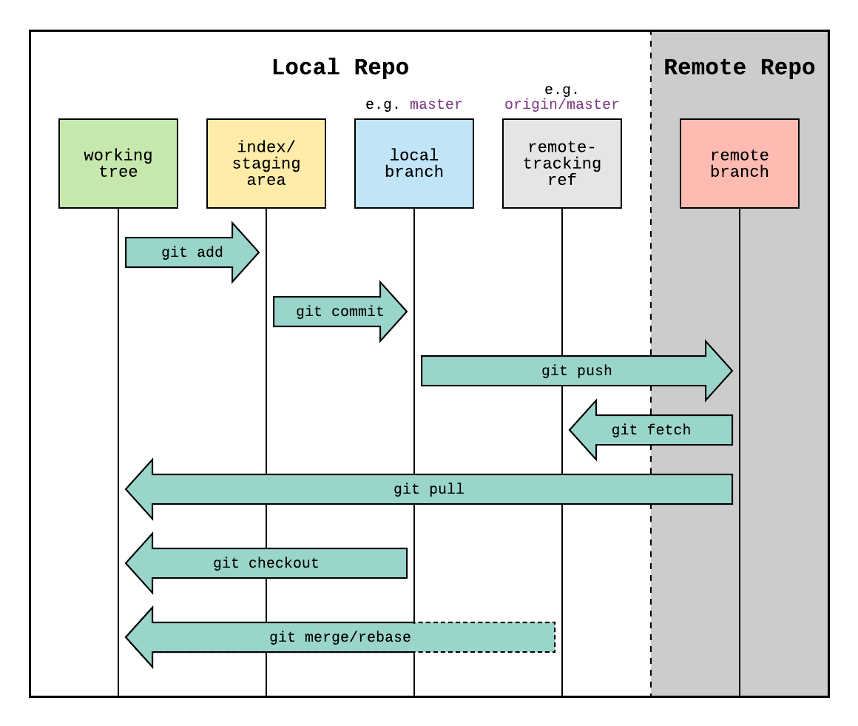

Types of VCS:

1.centralised

2.Distributed

1.centralised

here everyone should always be connected to the server.

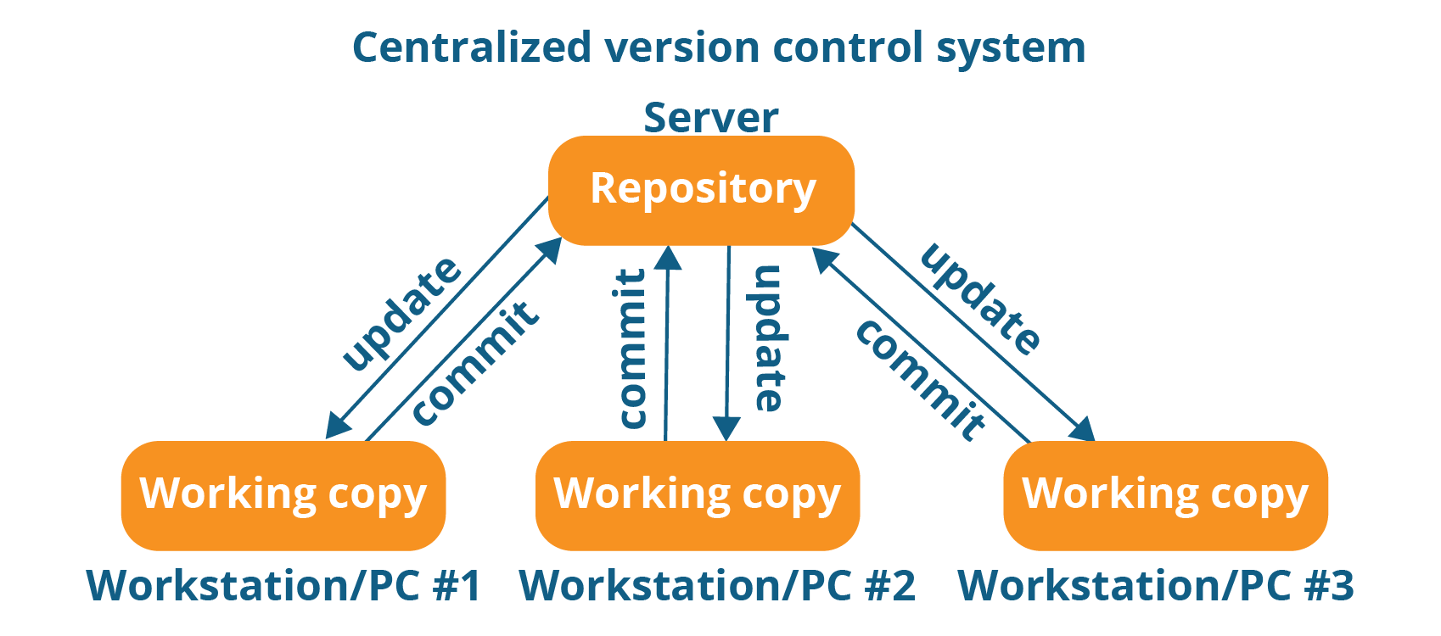

2.distributed

need to be connected only when pushing and pulling.

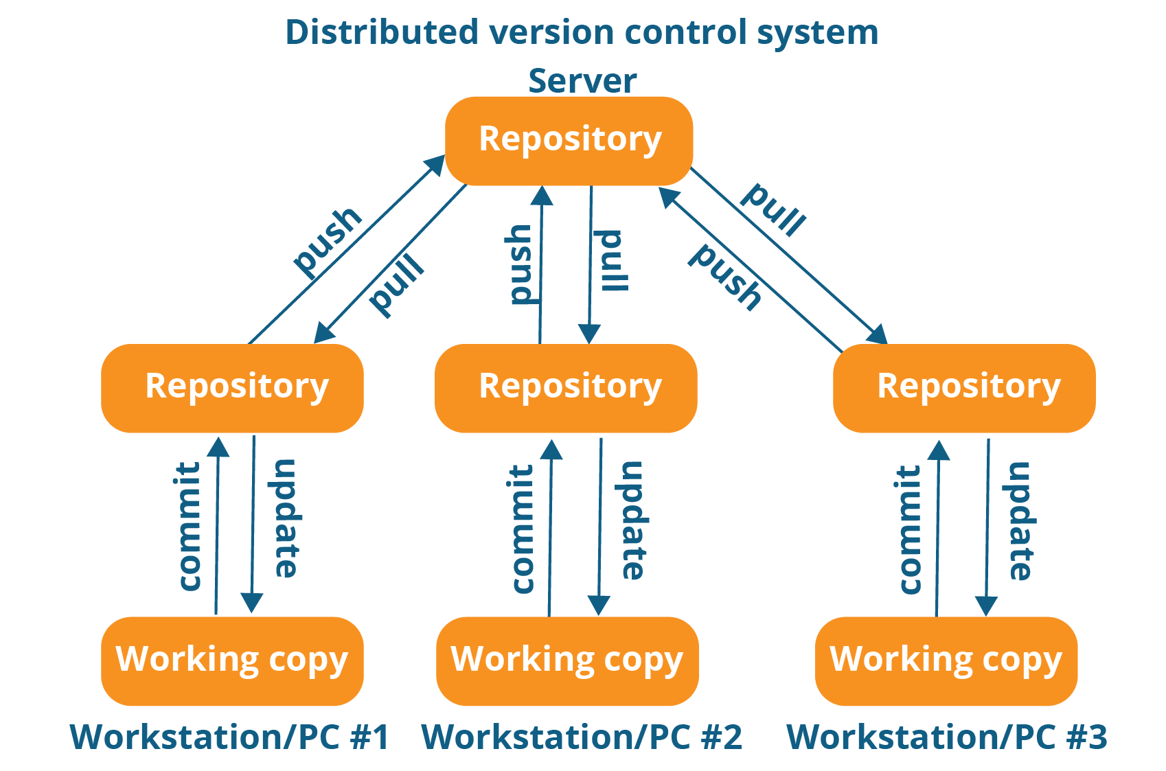

GITHUB:

it is a website to upload the repositories online.

---->it provides backup

---->provides visual interface to repo

---->makes collaboration easier.

GIT IS NOT RELATED TO GITHUB.

GIT COMMANDS:

=============

git init

git status

git add

git commit -m ‘message’

GIT is a combination of both centralised and distributed vcs.

SDLC

=============

start ------> stages/phases------->End

|

v

dedicated functionality

SDLC is unidirectional

1.Requirement analysis

BRD (Business requirement document)

2.design  
 functional design

FSD(functional design document)

technical design

TSD(Technical Design document)

3.development

4.unit testing

5.application testing

6.deployment

7.support

UNIT Testing is done by the developer.

Application testing

Tester comes in to picture

1.functionality testing

2.non-functionality testing

3.user acceptance testing

4.crowd beta testing(TY spec)

learn -----> WaterFall Method , Agile Method.

POSTGRESQL

=============

DATA:

A Data is a Raw fact which defines the attribute of an entity.

DATABASE:

A Database is the place where we can store data in an organized and systematic approach.

APPLICATION:

1. It is an Interface between user and operating system.

2. Every Application has its own dedicated functionallity.

3. Every Application has its own File Extension.

4. It is Platform dependant.

DBMS:

1. DBMS stands for Database management System.

2. The DBMS manages incoming data, organizes it, and provides ways for the data to be modified or extracted by users or other programs.

3. Some DBMS examples include MySQL, PostgreSQL, Microsoft Access, SQL Server, FileMaker, Oracle.

TYPES OF DBMS:

1. Hierarchical DBMS

2. Network DBMS

3. Relational DBMS

4. Object DBMS-(Data Stored in the form of Objects)

RELATIONAL DBMS:

1. A DBMS which organises and store the data by following relational model is known as RDBMS.

2. Similarly, The DBMS which follow the E.F.CODD rule is known as RDBMS.

3. In RDBMS, the data sholuld be stored in the form of tables.

TABLES:

It is the logical representation of data which consists of row and column.

COLUMN:

It is used to represent all the properties of the entities.

ROW:

It is also called as Record/Tuples and it is used to represent all the properties of individual entities.

CELL:

It is the smallest unit of table, which is used to store the data.

CONSTRAINTS:

1. Constraints are used to enforce some rules on columns of the table.

2. It is used to limit the type of data that can go into the table.

3. This ensures the accuracy of data in the table.

NOT NULL:

It ensures that it should have some value or in the other word this constraint is used to specify that the data is mandatory.

UNIQUE:

It is used to avoid duplicacy of values into the column.

CHECK:

It is an extra validation given to a column with a condition.

PRIMARY KEY:

1. It is the combination of unique and notnull.

2. It is used to identify a record uniquely.

3. In a table, we can have only one primary key.

4. It is not mandatory to have a primary key in a table. But, it is highly recommended.

FOREIGN KEY:

1. It is used to establish the relationship between two tables.

2. We can have more than one foreign key in a table and it can be duplicate and null.

3. Foreign key is a key in the child table which is the primary key of its parent table.

CHARACTERISTICS:

1. A table in which foreign key is present is known as child table.

2. A table in which it actually belongs is known as parent table.

3. Foreign Key must and should declare as primary key in the parent table.

4. We cannot insert a value in a column defined as a foreign key, which is not present in the table.

5. So, Foreign key is also called as referential integrity.

DATA TYPES:

1. Numeric

2. Date and Time

3. String Data types

E.F.CODD Rules:

1. The data entered into the cell should be single valued or atomic data.

2. We can store the data in multiple tables, if needed we can establish connection between two tables by using key attributes.

3. Data stored in the tables can be validated in two steps

i] By assigning Datatypes

ii] By assigning Constraints

4. Everything in the database should be stored in table fortmat.

5. A database can only be addressed using a language having linear syntax that supports data definition, data manipulation and data transaction management operations.

6. The data stored in the database must be independent of applications that access the database.

7. All viwes that are theorytically updatable are also updatable by the system.

8. The capability of handling a base or derived relation as a single operand applies not only to the retrieval, but also to insertion, update and deletion of data.

9. All information in the database is represented explicitely at logical level and in exactly one way.

10. Each and every data in database should be accessible by combination of table name, primary key value and column name.

11. Null values are supported in for representing Missing data, inapplicablr information and independent of data.

12. The end user must not able to see that the data is distributed over various locations.

SQL:

1. SQL stands for Structured Query Language.

2. SQL is a language used to interact with the database.

3. According to ANSI (American National Standards Institute), it is the standard language for relational database management systems.

SQL HISTORY:

1. IBM was the first company to develop DBMS which follow Relational model and is also called as System R.

2. IBM developed a language to communicate with system R which is known as SEQUEL.

3. SEQUEL stands for Simple English Query Language.

4. Then, ANSI (American National Standards Institute) took SEQUEL and made some modifications and recommend it as SQL.

5. SQL is the standard language for all the RDBMS Applications.

6. SQL commands are case insesnsitive.

ORDBMS:

An ORDBMS is a relational DBMS that allows developer to integrate the database with their own datatypes and method.

a] ORDBMS -> RDBMS + ODBMS

b] In ORDBMS, we can have our own datatypes.

POSTGRES (or) POSTGRESQL:

a] It is an open source object oriented Database.

b] It is the worlds most advanced open source RDBMS.

SQL COMMANDS:

1] Data Definition Language(DDL)

a] It deals with database or table structure.

b] It helps us to define the structure.

DDL Commands are,

a] Create

b] Alter

c] Drop

d] Rename

e] Truncate

2] Data Manipulation Language(DML)

a] It deals with data in the database.

DML Commands are,

a] Insert

b] Update

c] Delete

3] Data Control Language(DCL)

a] Grant

b] Revoke

4] Transaction Control Language(TCL)

a] Commit

b] rollback

c] savepoint

5] Data Query Language (DQL)

a] select

Q.1) Write a query to select the version.

Syntax --> select version();

Q.2) Write a query to check the list of database.

Syntax --> \l

Q.3) Write a query to connect the desired database.

Syntax --> \c database_name

DDL:

Create:

Q.4) Write a query to create a database.

Syntax --> create database database_name;

Example --> Create database test;

Alter:

Q.5) Write a query to add the column to the table.

Syntax --> Alter table table_name add column column_name datatype;

Example --> Alter table person add column age int;

Drop:

Q.6) Write a query to drop the table.

Syntax --> Drop table table_name;

Example --> Drop table person;

Rename:

Q.7) Write a query to rename the table.

Syntax --> Alter table table_name rename to t_name;

Example --> Alter table person rename to emp;

DML:

Insert:

Q.8) Write a query to insert the values in the table.

Syntax --> Insert into table_name values(value1,......value_n);

Example --> Insert into person values(1,'Name');

DQL:

Select --> It helps us to retrieve the data.

In three different ways we can retrieve the data from the table

1.Projection --> if we want to get only rows or columns we use this.

Ex --> select column_name from table_name;

2.Selection --> if we want to get the whole table.

Ex --> select * from table_name;

3.Join:

Syntax --> SELECT */[DISTINCT] COLUMN_NAME/EXPRESSION [ALIAS] FROM TABLE_NAME;

Here *- Special character that selects/retrieves all the data present in the table at the time of execution.

Q.9) Write a query to check all the data inserted in the table.

Syntax --> select * from table_name;

Ex --> Select * from employee;

Order of execution --> 1.from

2.where

3.select

Q.10)Write a query to display ename,deptno and hiredate.

Syntax --> select ename,deptNo,hiredate from table_name;

Ex --> select ename,deptNo,hiredate from employee;

DML:

Update-

Q.11)Query to Update the table.

Syntax -->update table_name set column_name;

Delete-

Q.12)Query to delete the record from the table.

Syntax -->delete from table_name;

WHERE clause -->helps to filter the record.

Used to extract only those values which satisfy the particular condition.

NOTE-It will execute row by row if the condition does not matches then it will reject the row and proceed to next row and their if condition matches it will execute the query.

Syntax -->SELECT * FROM table_name WHERE condition;

Q.13)Write a query to udate the salary of the employee having empid=104.

Query -->update employee set salary=30000.00 where empid=104;

Q.14)Write a query to delete the record of the employee having empid=104.

Query -->delete from employee where empid=104;

Expression- Statement which helps us to give the result.

It consits of operators and operand.

Operands- On which operation has to be performed.

It is divided into 2 types.

1.column_name-It is an attribute.

2.literals-the direct value or real value used in the SQL Statement.

Literals are further divided in to two types

2.1.Number-the direct values used for number values is known as number literals.

2.2.Character-if the direct value we are passing in string type is known as character literal.(Ex-'garima')

2.3.Date-Ex-'1997-12-06'.

Operators-operators are the symbols that represent specific task/operation.

It is of 4 types

1.Airthmetic operators-(+,-,/,*,%)

2.Comparison operators-

3.Logical operators-

4.Special operators-

Q.15)Write a query to give increment of 5% to the salary.

Expression- incrementSalary=sal+500

Alias-used to give a table or column in a table a temperory name.

Syntax- select column_name AS alias_name from table_name AS alias_name.

OR select column_name alias_name from table_name alias_name.

Q.16)Write a query to alias the name of the column designation as job_type.

Query --> select designation as job_type from employee;

Q.17)Write a query to obtain employee name with his current salary and new salary with a hike of 5% of all employee.

Query --> select ename,salary,salary+salary*1/4 as hiked_sal from employee;

Q.18)W.A.Q to display all the record of employees incremented with 500rs to each employee.

Query --> select * ,salary+500 as Incremented_sal from employee;

OR update employee set salary=salary + 500;

Q.19)W.A.Q to display all the record of employees decremented with 500rs to each employee.

Query --> select * ,salary-500 as Decremented_sal from employee;

OR update employee set salary=salary - 500;

Q.20)W.A.Q to display name salary and annual salary of all the employee.

Query --> select ename,salary,salary*12 as annual_sal from employee;

Q.21)W.A.Q to display per day salary of all employee.

Query -->select salary/30 as sal_perday from employee;

Distinct-used to eliminate the duplicate row for the result set.

Syntax -->select distinct column_name from table_name;

Ex- select distinct ename from employee;

Q.22)W.A.Q to display the distinct values from the enaqme and deptNo column.

Query --> select distinct ename,deptNo from employee;

NOTE-if we are passing single arrguments with distinct it will remove the duplicate value and if we pass more than one arrguments it will remove the combination of duplicate value will be removed and

unique combination will be given in result set.

Comparison Operators- used to compare between two arrguments.

Ex --> =,<,>,>=,<=,(!=,<>)same

Q.23)W.A.Q to display the record of the employee who is working in deptNo=10.

Query --> select * from employee where deptNo=10;

Q.24)W.A.Q to display the record of the employee whose salary is greater than 25000.

Query --> select * from employee where salary>25000;

Q.25)W.A.Q to display the record of the employee whose salary is greater than or equal to 25000.

Query --> select * from employee where salary>=25000;

Q.26)W.A.Q to display the record of the employee whose salary is less than 25000.

Query --> select * from employee where salary<25000;

Q.27)W.A.Q to display the record of the employee whose salary is less than or equal to 25000.

Query --> select * from employee where salary<=25000;

Q.28)W.A.Q to display the record of the employee whose salary is not equal to 25000.

Query --> select * from employee where salary!=25000;

OR select * from employee where salary<>25000;

Logical Operator

They are of three types:

1.AND

When both condition are true then only it give output.

We can have more than two conditions.

Input Output

A B C

0 0 0

0 1 0

1 0 0

1 1 1

Syntax-SELECT * FROM table_name WHERE condition1 AND condition2.

Q.29)W.A.Q to display all the employees who is working as hr in dept 40.

Query -->select * from employee where designation ='HR' and deptNo=40;

Q.30)W.A.Q to display all the record of the employee who is working as salesman and hired after 2016.

Query -->select * from employee where designation='salesman' and hiredate > '2016-12-31';

Q.31)W.A.Q to display who is working as hr in deptno 20 only if salary is greater than 25000.

Query -->select * from employee where designation='hr' and deptNo=20 and salary > 25000;

2.OR

When anyone of the condition is true the result will be true.

We can have more than two conditions.

TRUTH TABLE

Input Output

A B C

0 0 0

0 1 1

1 0 1

1 1 1

Syntax-SELECT * FROM table_name WHERE condition1 OR condition2.

Q.32)W.A.Q to display employee working in dept 10 or 20.

Query -->select * from employee where deptNo=10 or deptNo=20;

Q.33)W.A.Q to display name,salary,deptno who is working as tester or whose salary=15000.

Query --> select ename,salary,deptNo from employee where designation='Tester' or salary=15000;

Q.34)W.A.Q to display name of all employee working as a tester as well as working in dept 30 or working as a clerk whose salary is greater than 15000.

Query -->select ename from employee where (designation='tester' and deptNo=30) or (designation='clerk' and salary >15000);

3.NOT

It will display the records if condition is not true.

TRUTH TABLE

Input Output

A B

0 1

1 0

Syntax-SELECT *FROM table_name where NOT condition

Q.35)W.A.Q to display all the employees except who is working in dept 20.

Query -->select * from employee where not deptNo=10;

NOTE-If all the logical operator are in same query then the order of execution is NOT,AND,OR.

Q.36)W.A.Q to display all the record of employee excluding hr who is working in dept 30.

Query -->select * from employee where not(designation='hr' and deptNo=30);

Q.37)W.A.Q to display all the employees who has hired after jan 2015 working as tester in dept 20 or display all the who were hired before 2015.

Query -->select * from employee where (hiredate>'2015-01-30'and designation='tester'and deptNo=20)or hiredate<'2015-01-01';

Q.38)W.A.Q to display all the record of the employee who is working in deptNo 10 or 20 or 30 or 40 or 50.

Query -->select * from employee where deptNo=10 or deptNo=20 or deptNo=30 or deptNo=40;

Special Operator-

1.IN-It is a type of special operator where it excepts multiple values of same column name.

Syntax-SELECT * FROM table_name WHERE column_name IN (value1,value2,value3,....value n);

Q.39)W.A.Q to display all the record of the employee who is working in deptNo 10 or 20 or 30 or 40 or 50.

Query -->select * from employee where deptNo IN (10,20,30,40);

Q.40)W.A.Q to display all the record of the employee who is working as salesman,manager or admin.

Query -->select * from employee where designation IN('salesman','manager','admin');

NOT IN-If we want to neglect any value we use not in operator

Syntax-SELECT * FROM table_name WHERE column_name NOT IN (value1,value2,value3,....value n);

Q.41)W.A.Q to display all the details of employee who is working in dept 50,30,40,excluding salesman and hr.

Query -->select * from employee where deptNo IN(50,30,40) and designation NOT IN('salesman','hr');

2.BETWEEN-

Syntax-SELECT *FROM table_name WHERE column_name BETWEEN value1 AND value2;

Q.42)W.A.Q to display all the record of the employee whose salary range is within 20,00 to 40,000.

Query -->select * from employee where salary>20000 and salary<40000;

Q.43)W.A.Q to display the details of the employee who were hired during 2014.

Query -->select * from employee where hiredate between ('2014-01-01' and '2014-12-31');

Q.44)W.A.Q to display ename salary working in dept 10,20 and their annual salary between 40000 to 50000.

Query -->select * from employee where deptNo IN (10,20) and salary*12 between 40000 and 50000;

NOT BETWEEN-

Syntax-SELECT *FROM table_name WHERE column_name NOT BETWEEN value1 AND value2;

Q.45)to dispaly all the records of employee excluding those who are hired in 2017.

Query -->select * from employee where hiredate not between'2017-01-01' and '2017-12-31';

NOTE- Null=no value(it represents missing value).It is not zero nor empty string or space

Ex-a+null=null

3.IS-It is used to check only the null value.

Syntax-SELECT * FROM table_name WHERE column_name IS NULL;

IS NOT

Syntax-SELECT * FROM table_name WHERE column_name IS NOT NULL;

Character-It is divided in to two:

1.Ordinary character-which do not have special behaviour (a-z, A-Z, 0-9).

2.Special character-which have special behaviour or meaning (*,_,%).

*-gives all the record present in table.

%-if we dont know the the fixed length we use %.

_-it is limited to one character or it has fixed length.

4.LIKE-used for pattern matching.

Percentage(%)-if we dont know the the fixed length we use %.

Underscore(_)-it is limited to one character or it has fixed length.

Syntax-SELECT * FROM table_name WHERE column_name LIKE '%/_';

Q.46)W.A.Q to find all the record of the employee whose name starts with r.

Query -->select * from employee where ename LIKE 'R%';

Q.47)W.A.Q to display all the record of employee whose name have only 3 character.

Query -->select * from employee where ename LIKE '___';

Q.48)W.A.Q to display all the record of the employee who has atleast 2 L in their name.

Query -->select * from employee where ename LIKE '%l%l%';

Q.49)W.A.Q to dispaly all the records of employee whose name start with s and end with p.

Query -->select* from employee where ename LIKE 's%p';

Q.50)W.A.Q to dispaly all the record of employee whose name length 5 and start with s and l should be the second last character.

Query -->select * from employee where ename LIKE 's__l_';

Q.51)W.A.Q to display all the records of the employee if the employee name start with s or a.

Query -->select * from employee where ename like 's%' or ename like 'a%';

Q.52)W.A.Q to display all the records of the employee excluding employee name start with z and p.

Query -->select * from employee where ename not like 'Z%' and ename not like 'P%';