**Dashboard:**

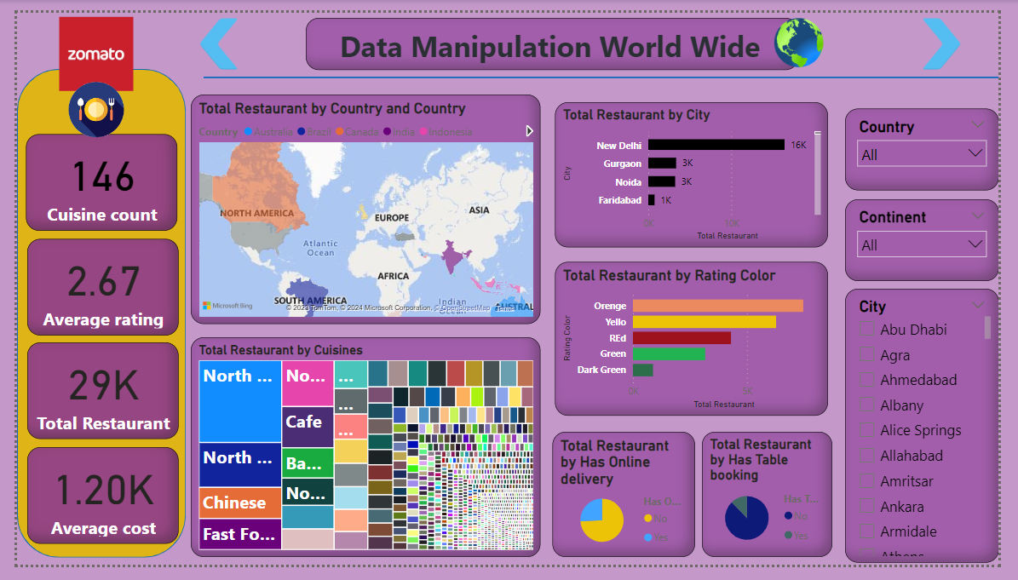

**Source Code:**

