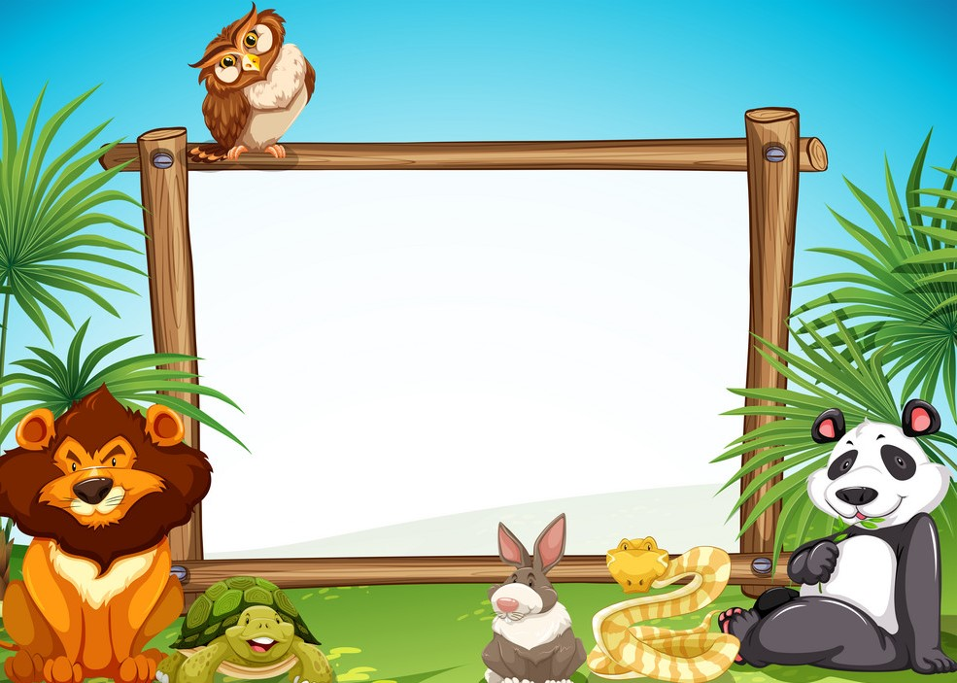

Name: Garima Sharma
Student Id: 300343374
Course: CSIS-1280 S-004

Wildlife

Table of Contents:

- Introduction 2
- Description 2
- Sitemap 4
- Wireframes
- Home 5
- Species 7
- News 10
- Threat 11
- References 14

Introduction

Wildlife is a precious gift of God to this planet. The term ‘wildlife’ not only caters to wild animals but also considers all undomesticated lifeforms including birds, insects, plants, fungi, and even microscopic organisms. For maintaining a healthy ecological balance on this earth, animals, plants, and marine species are as important as humans. Each organism on this earth has a unique place in food chain that helps contribute to the ecosystem in its own special way. But, sadly today, many of the animals and birds are getting endangered. The natural habitats of animals and plants are being destroyed for land development and farming by humans. Poaching and hunting of animals for fur, jewelry, meat, and leather are other great factors contributing to wildlife extinction. If soon, no stringent steps are taken to save wildlife, it would not be long when they will find a place only on the list of extinct species. And that would not be all! The extinction of wildlife species will certainly have a fatal impact on human race as well. So, for us as humans, it becomes a great responsibility to save the wildlife, our planet and most importantly, our own selves.

In this project, I tried to cover the information about wild animals, their species, news regarding them as well as threats to their life.

Description

In this project, I made four webpages. They are home, species, news, and threat to wildlife. Each page has its own layout and features. I tried to express my thoughts and feelings regarding wild animals using different pictures. These pictures helped me a lot to describe the true nature and emotions of these animals. I provided the information regarding the species under my species web page. I also covered the content regarding the threat to these animals. How animals are killed for their fur. The way they are tortured by human activities such as illegal trading.

In home page, I provided the basic information regarding wildlife. Animals living in the forests suffer from so many problems. These problems can be either natural such as starvation, dehydration, disease, injury, and extreme weather conditions or due to human activities. In home page, I created four navigational links such as home, species, news, and threat. Under navigational links, I used rollover effect on the images. In the aside section if user is interested to give donation for the animals. I asked for the first name, last name, and favorite number from the user. Once user provide that information then on clicking the “Click Me!!” button, an email id is generated for the user using its “first_name.favorite_numberLast_name@donation.ca” along with the contact information of donation foundation. Users can contact us at that address to know more details about donation. After this, I provided two videos under aside section. These videos help to see the true nature of animals. It helps to provide the original view of animals. In the main section, I provided the brief information on wildlife as well as harms. I also applied responsive designs according to tablet and mobile display.

In species web page, navigational links are on the left-hand side. When you click on the these, it will lead to that web page. I tried to cover the different species and provided the information regarding them. To make it clearer to understand, I added the pictures as well. On clicking any picture mentioned under the navigational links, it will lead you to that animal details within the page. I covered the terrestrial and aquatic animals. I also applied the rollover effect on the images. Tablet and mobile display designs are also applied.

In news web page, navigational links are on the left-hand side. When you click on the these, it will lead to that web page. Information regarding the cruel treatment and killing in wild is provided. Then in form, headlines for the news are provided. When you select any headline, it will lead you to the text area along with the description of that selected headline. Tablet and mobile display designs are also applied.

In threat web page, navigational links are on the left-hand side. When you click on the these, it will lead to that web page. In the aside section, I added two buttons: “click me!!” and “reset”. When you click on that button, it will provide you a message and when you click reset button, it will clear that message. Then I added some pictures. After this, I also provided reasons for their habitat loss. In the main section, I covered three topics such as killing due to fur, bycatch, and illegal trading. I also applied responsive designs according to tablet and mobile display.

Project Sitemap

Project Sitemap

Threat
News
Species
Home

Wireframe
Structure of Home web page: 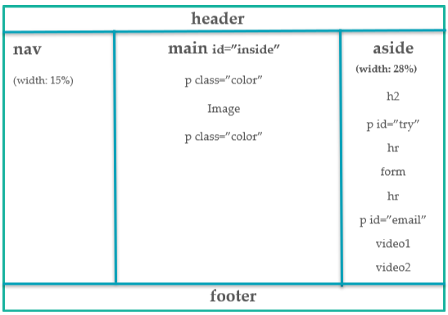
Structure of Home web page – Tablet display (max-width: 1024px):
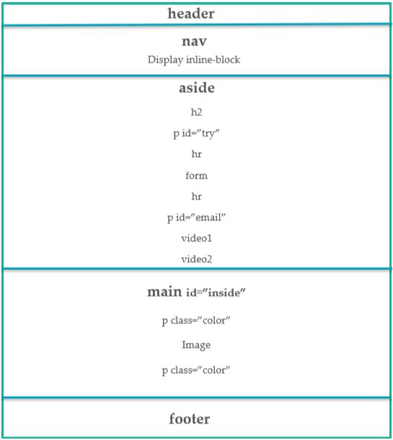
Structure of Home web page – Mobile display (max-width: 768px):
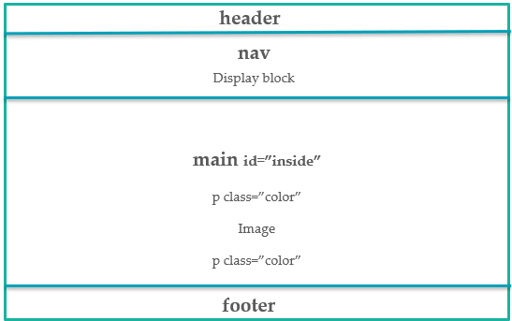

Structure of Species web page:
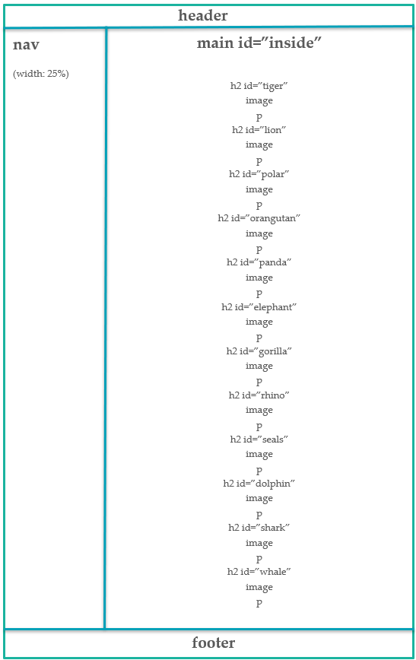
Structure of Species web page – Tablet display (max-width: 1024px):
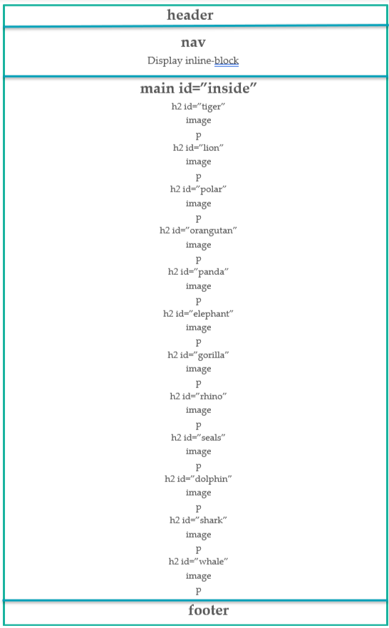
Structure of Species web page – Mobile display (max-width: 768px):
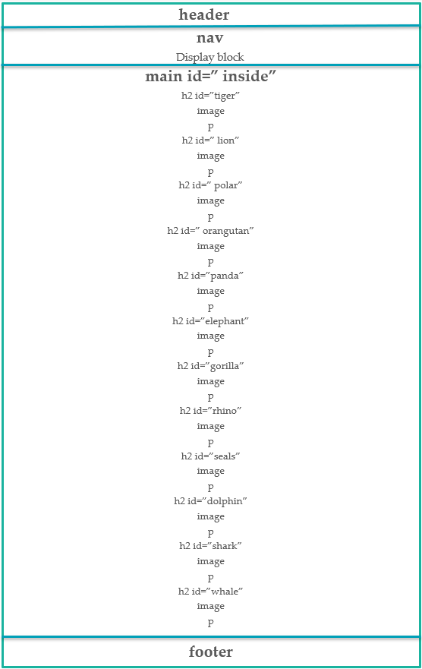
Structure of News web page:
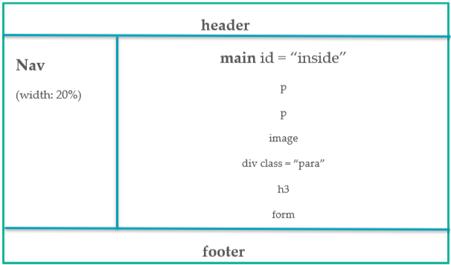
Structure of News web page – Tablet display (max-width: 1024px):
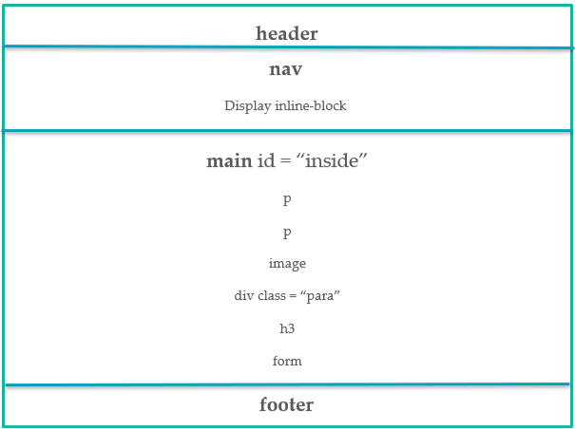
Structure of News web page – Mobile display (max-width: 768px):
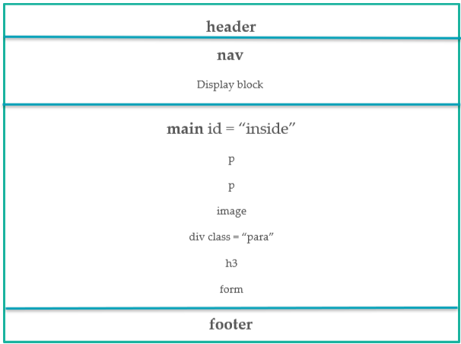

Structure of threat web page: 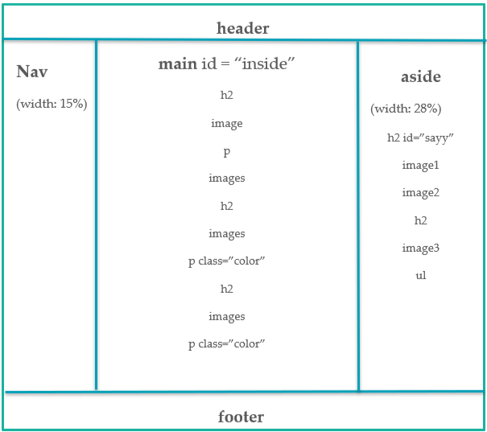

Structure of Threat web page – Tablet display (max-width: 1024px):
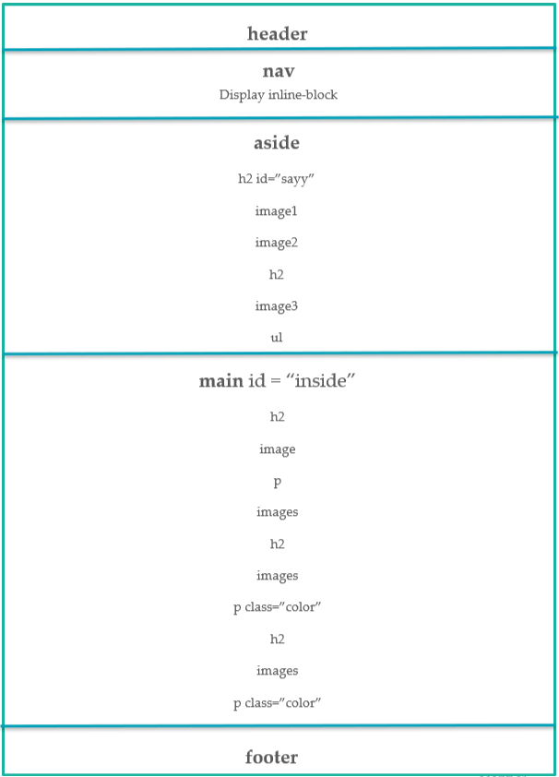

Structure of Threat web page – Mobile display (max-width: 768px):
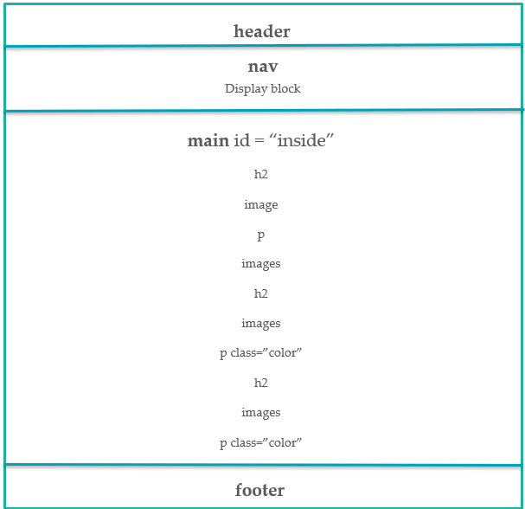

References
Home:
https://en.wikipedia.org/wiki/Wildlife
Species:
https://www.worldwildlife.org/species/shark
https://www.nationalgeographic.com/animals/mammals/facts/whale-facts
https://www.worldwildlife.org/
https://www.worldwildlife.org/species
News:
https://www.nationalgeographic.com/animals/article/wildlife-wins-good-news-stories-2020
https://news.mongabay.com/list/wildlife/
Threat:
https://www.worldwildlife.org/threats/bycatch
https://www.nwf.org/Educational-Resources/Wildlife-Guide/Threats-to-Wildlife/Habitat-Loss

