📱 AI-Powered Telegram Bot (AWS + DynamoDB + Lambda + OpenAI)
This project is a fully serverless Telegram bot built on AWS Lambda, API Gateway, and DynamoDB, with optional OpenAI integration for AI responses.
It supports:
- Saving and retrieving your own data
- Searching your message history
- Key/value personal notes
- AI question answering
- DynamoDB-backed storage
- Clean, simple command-based UX

🚀 Features
Core Commands
Command | Description
/start | Welcome message + full command list
/hello | Simple greeting
/help | Show all commands
/echo <text> | Echo back any text
/save <key> <value> | Save a key/value pair
/get <key> | Retrieve a saved value
/list | List all saved keys
/getid <message_id> | Retrieve a stored message by ID
/search <keyword> | Full-text search across user messages
/latest | Show latest saved message
/history | Show last 5 saved messages
/ask <question> | Get an AI answer (OpenAI)
/menu | Show full text-based help menu

🗂 Architecture Overview
This bot is completely serverless.
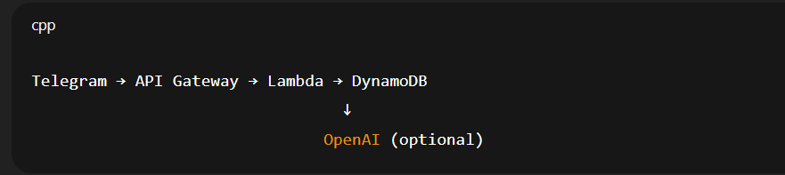
AWS Components
- API Gateway (HTTP API)
Receives webhook updates from Telegram.
- Lambda Function
  - Parses commands
  - Saves/reads from DynamoDB
  - Calls OpenAI for /ask responses
- DynamoDB Table
  - Partition key: user_id
  - Sort key: sort_key
  - Stores notes, key/value pairs, and message history.
- IAM Role / Policies
Lambda permissions for DynamoDB and logs.

📦 Project Structure
/
├── main.tf # Terraform infra
├── handler.py # AWS Lambda bot logic
├── terraform.tfvars # Bot token + OpenAI key
└── README.md # This file

🔧 Deployment Instructions
1. Clone the repository
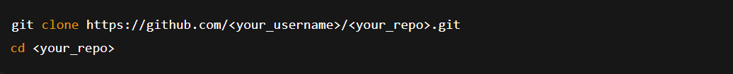
2. Add environment variables (Terraform)
Create a file named:
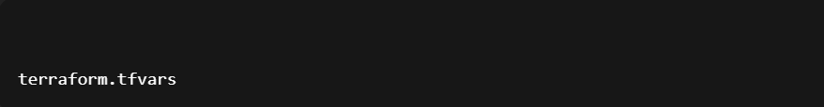
Add:
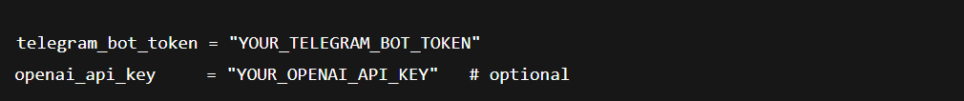
3. Build the Lambda package
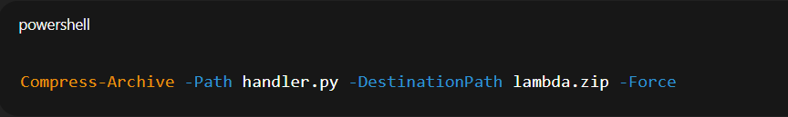

4. Deploy with Terraform
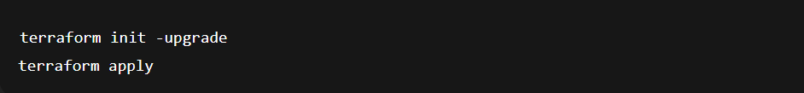
Terraform outputs the webhook URL.

5. Set the Telegram webhook
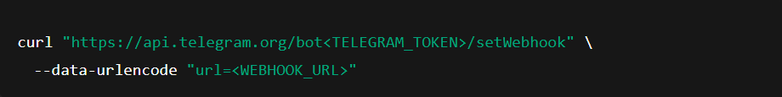
🤖 OpenAI Integration
The /ask command supports OpenAI’s API via:
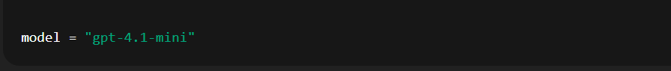
If you don't want AI:
- remove the OPENAI_API_KEY var
- /ask will respond with a friendly fallback message
If you get:
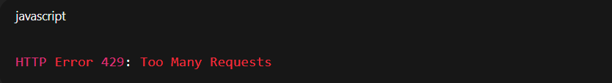
Add a payment method or increase your usage limits at:
https://platform.openai.com/account/billing/limits

📜 DynamoDB Schema
Key/value items
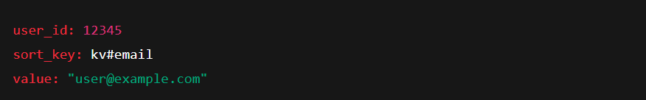
Message history items
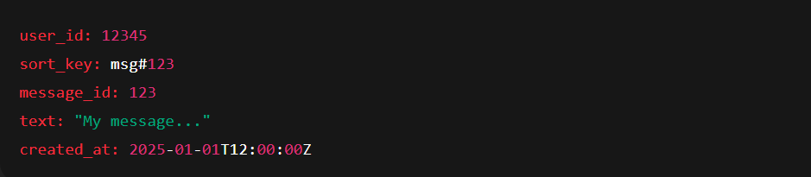
This allows fast:
- /search
- /history
- /latest
- /getid

🛠 Useful Commands
Rebuild Lambda:
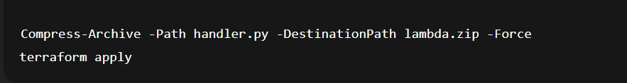

Check logs:
AWS Console → CloudWatch → /aws/lambda/<function_name>

🧪 Example Usage
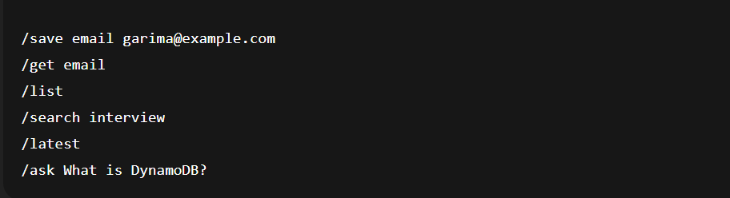
💡 Future Enhancements
- Add user authentication
- Add job-matching features
- Add document parsing (PDF/CV -> skills extraction)
- Add analytics dashboard in Streamlit
- Add multi-step guided flows

🧩 License
MIT License — free to use and modify.

