**Image Colorization Results**

**Team:**

Ahmet Gizik(ag7739)

Garima Chaudhary(gc2505)

Fangzhou Cheng(fc2147)

**Description:**

In this project, our aim is to turn black and white images into colorized images. We tried to implement and compare the result of different models. We also used 2 different color space, RGB and LAB, to see with color model work best to certain model.

**Dataset:**

The CIFAR-10 dataset consists of 60000 32x32 color images. There are 50000 training images and 10000 test images.

**Lasso Regression:**

Grayscale

Image

Original

Image

Predicted

Image

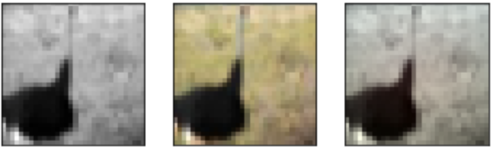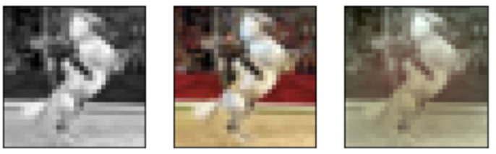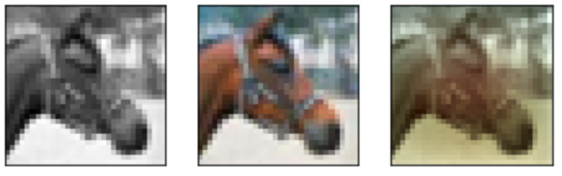

Accuracy: 0.9001

**Ridge Regression:**

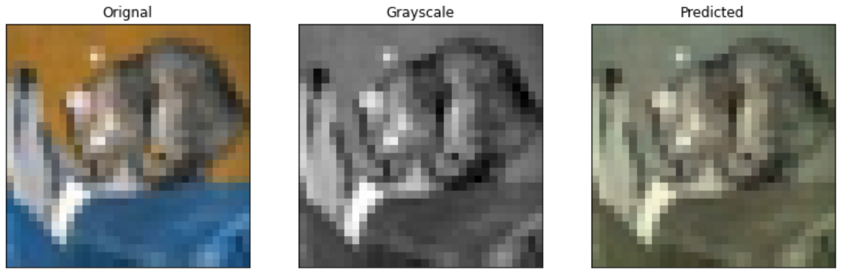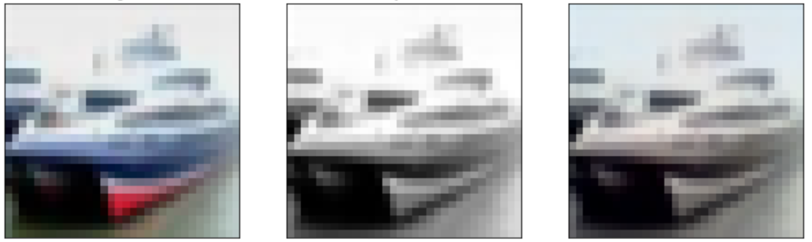

**CNN with Lab color space:**

For CNN we used Lab color space with two optimizers:

1. Adam optimizer with learning rate 0.001. The loss we get with the test images is 0.0026.

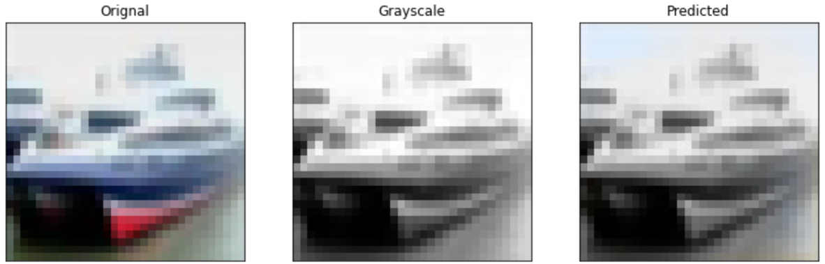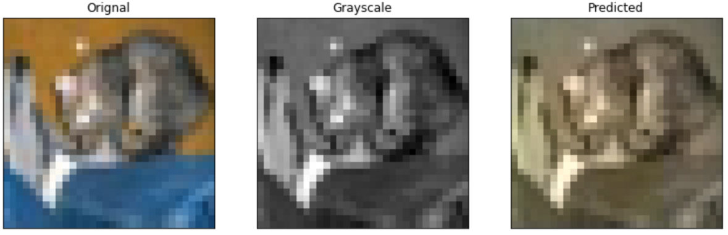

2. Rmsprop Optimizer: the loss is 0.0025 with the test images. Though the loss is decrease but it’s not a significate decrease.

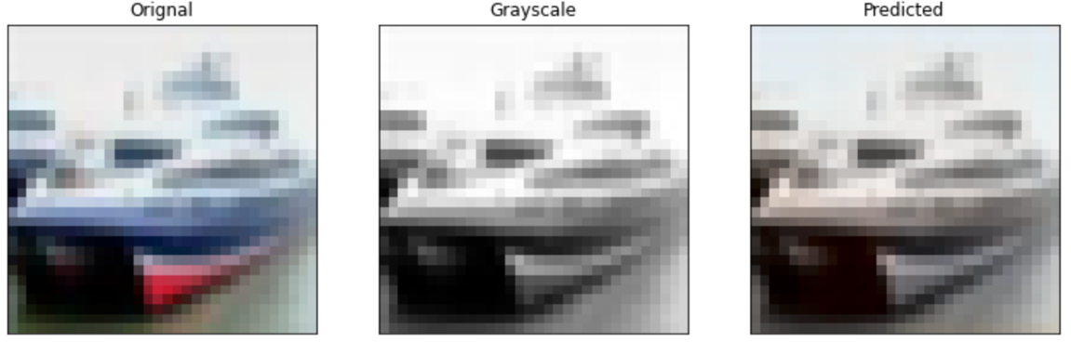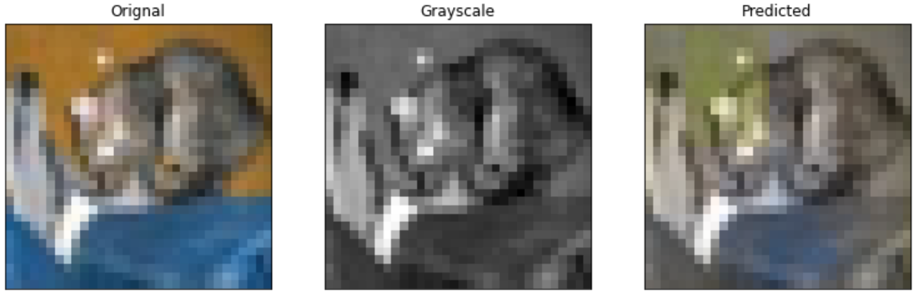

References:

[1] Richard Zhang, Phillip Isola, Alexei A. Efros, Colorful Image Colorization

<https://arxiv.org/pdf/1603.08511.pdf>

[2] <https://medium.com/towards-artificial-intelligence/colorizing-images-with-deep-learning-a34d11587643>

[3] Patricia Vitoria, Lara Raad and Coloma Ballester, ChromaGAN: Adversarial Picture Colorization with Semantic Class Distribution