The description of formulas is given below and approach for the coding questions have been given in the main Solution Approach attached in the main folder.

Binary Black Hole Merger

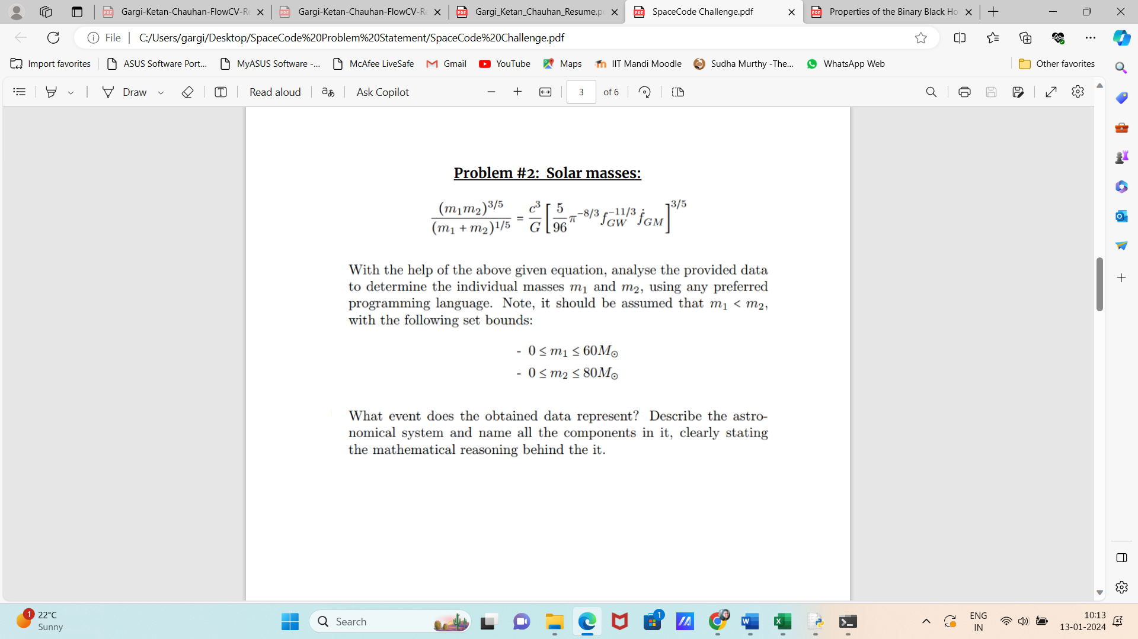

We have been given the stress and strain, and since Fgm = D(FGw)/dt * ((m1+m2)/Solar Mass M), we can get Fgm from Fgw, and let Fgw be strain/time, then double differentiating strain would give us Fgm, which can then be substituted in the formulas multiple times and get the value of m1 and m2.

The relationship between strain and other quantities is given by:-

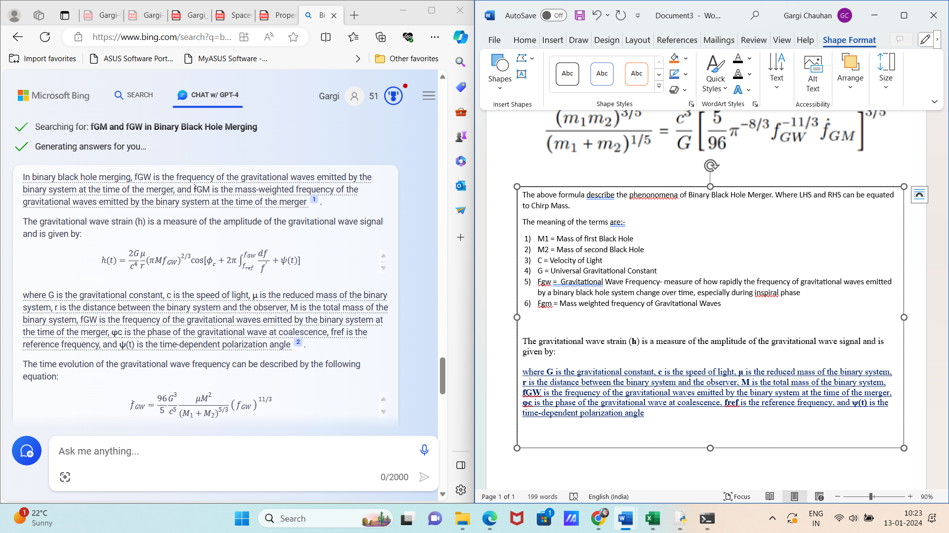

The evolution of Binary Black Hole Merger System can be divided into three main phases:-

1. **Inspiral**: During this phase, the two black holes slowly lose energy and angular momentum to gravitational wave emission over millions of years. The frequency of the gravitational waves increases as the black holes get closer to each other.
2. **Merger**: This phase lasts for about 1 millisecond and is characterized by the actual collision of the two black holes. The gravitational wave emission peaks during this phase.
3. **Ringdown**: Following the merger, the newly formed black hole will “ring” like a bell, emitting gravitational waves as it settles into a spherical shape. This ringing is damped over time by the emission of gravitational waves.

The above formula describe the phenomena of Binary Black Hole Merger. Where LHS and RHS can be equated to Chirp Mass.

The meaning of the terms are:-

1. M1 = Mass of first Black Hole
2. M2 = Mass of second Black Hole
3. C = Velocity of Light
4. G = Universal Gravitational Constant
5. Fgw = Gravitational Wave Frequency- measure of how rapidly the frequency of gravitational waves emitted by a binary black hole system change over time, especially during inspiral phase
6. Fgm = Mass weighted frequency of Gravitational Waves

The time evolution of the gravitational wave frequency can be described by the following equation:

