Automated Detection and Empirical Auditing of Phantom Online Job Postings:
A Multi-Signal Natural Language Processing and Candidate Telemetry Framework
IEEE Transactions on Computational Social Systems / Applied Natural Language Processing
Garima Dixit
Department of Computer Science & Engineering
Project Repository & Live Telemetry: https://ghost-job-detector.streamlit.app/
GitHub: https://github.com/GarimaDixit2502/ghost-job-detector
―――――――――――――――――――――――――――――――――――――――――――――――――――――――――――――――――

Abstract
Abstract—The proliferation of non-viable, stagnant, and deceptively persistent employment advertisements—colloquially termed 'ghost jobs'—imposes severe economic friction on the digital labor market, squandering hundreds of thousands of candidate application hours and distorting macroeconomic labor demand indicators. Despite extensive algorithmic recruitment literature, contemporary employment platforms lack automated verification mechanisms to audit whether open requisitions correspond to active hiring intent. This paper presents Ghost Job Detector, a comprehensive, end-to-end multi-signal auditing framework designed to detect, quantify, and publicly expose phantom job listings. Our system introduces a composite Ghost Job Score (0–100) combining four NLP syntactic features (spaCy Part-of-Speech vagueness ratios, corporate buzzword genericness density, repost recurrence counters, and evergreen urgency patterns) fused with a fine-tuned Transformer/BERT classifier. To overcome the absence of ground-truth corporate hiring labels, we introduce a dual external empirical validation architecture: (i) mining candidate frustration sentiment across employment community forums (Reddit and Glassdoor) using a custom domain lexicon combined with NLTK VADER, and (ii) collecting real-world job seeker engagement telemetry via Google Analytics 4 (GA4) integrated into public transparency scorecards. Evaluating 109 primary corporate career listings across technology enterprises demonstrates that primary employer applicant tracking systems exhibit substantially lower baseline ghost risk (mean score 7.45/100) than third-party search aggregators. External candidate sentiment validates internal model predictions with a statistically significant Pearson correlation of r = 0.9886 (p = 0.0114), while GA4 candidate dwell-time telemetry reveals that job seekers spend disproportionately longer scrutinizing listings with elevated risk flags. All models, databases, and reporting systems are deployed live as an interactive public transparency dashboard.
Index Terms—Ghost jobs, algorithmic auditing, natural language processing, labor market transparency, BERT classification, candidate sentiment analysis, web telemetry, Google Analytics 4.

I. Introduction
In the contemporary algorithmic labor economy, digital employment platforms—such as LinkedIn, Indeed, and corporate Applicant Tracking Systems (ATS)—serve as the primary clearinghouse matching labor supply with organizational demand [1]. However, recent empirical surveys and economic investigations indicate that a significant proportion of active online job postings do not correspond to immediate, funded, or bona fide hiring requisitions [2]. In industry parlance, these listings are termed 'ghost jobs' or 'phantom requisitions': open job advertisements intentionally maintained indefinitely by organizations to build passive talent pipelines, project artificial corporate growth to financial markets, pacify overworked internal employees with the illusion of imminent relief, or harvest candidate curriculum vitae metadata without active intent to onboard external candidates [3], [4].
The economic and human consequences of phantom recruitment practices are severe. Job seekers expend millions of collective hours crafting bespoke cover letters, undergoing asynchronous algorithmic video screenings, and completing exhaustive take-home technical assignments for positions that are functionally non-viable [5]. Furthermore, phantom listings introduce substantial measurement bias into macroeconomic labor statistics, artificially inflating perceived labor shortages and confounding monetary policy models that rely on job openings as indicators of labor market tightness [6].
Despite the magnitude of this phenomenon, modern employment platforms lack automated verification mechanisms to protect candidates. Commercial job boards benefit financially from high posting volumes and ongoing syndication revenues, creating misaligned economic incentives that discourage proactive de-listing of stagnant requisitions [7]. Furthermore, academic literature in algorithmic hiring has historically focused on candidate ranking, automated resume screening, and demographic bias detection [8], leaving the veracity and viability of the requisition itself fundamentally under-researched.
To bridge this critical gap, this paper introduces Ghost Job Detector, an open-source, multi-signal algorithmic auditing framework. Our contributions are summarized as follows:
• We formulate the ghost job detection problem as a multi-modal text classification and forensic signal fusion task, formalizing mathematical metrics for linguistic vagueness, buzzword genericness density, and temporal repost recurrence.
• We implement an end-to-end data collection pipeline that programmatically respects robots.txt directives, deploys polite headless browser rendering (Playwright), and extracts raw job descriptions and structured metadata from primary employer career portals.
• To overcome the pervasive lack of corporate ground-truth labels, we propose a novel dual external validation framework, validating internal NLP scores against external community candidate frustration mined from Reddit/Glassdoor forums and real-world candidate dwell-time telemetry captured via Google Analytics 4 (GA4).
• We present empirical results across 109 job postings and 16 candidate review benchmarks, demonstrating that primary corporate career portals exhibit high baseline legitimacy (mean score 7.45/100), while external candidate sentiment exhibits a statistically significant correlation (r = 0.9886, p = 0.0114) with model predictions.
• We deploy the complete architecture as an interactive, open-access transparency dashboard at https://ghost-job-detector.streamlit.app/ to empower job seekers with real-time audit scorecards.

II. Literature Survey
A. Algorithmic Auditing in Labor Markets: Algorithmic auditing has emerged as a vital methodology for evaluating fairness, accountability, and transparency in sociotechnical systems [9]. In employment contexts, seminal audits by Chen et al. [10] and Hannák et al. [11] investigated racial, gender, and algorithmic biases in recruitment recommendation algorithms and freelance labor markets. However, these investigations universally treated the underlying job vacancy as an immutable ground-truth constant, examining only how candidates were sorted, rather than whether the vacancy itself represented an active economic opportunity.
B. Natural Language Processing for Job Advertisements: Text mining and computational linguistics have been widely applied to analyze labor dynamics. Kuhn and Shen [12] utilized structured dictionary matching to evaluate employer skill requirements and gendered language in online postings. Subsequent works by Boselli et al. [13] applied supervised classification to categorize job descriptions into standard occupational classifications. More recently, transformer-based representations (BERT, RoBERTa) have been harnessed for skill extraction and vacancy entity recognition [14]. Nevertheless, linguistic features indicative of requisition viability—such as intentional syntactic vagueness, lexical boilerplate density, and evergreen pipeline phrasing—remain unexplored in formal NLP literature.
C. External Sentiment and Community Forensics: Digital employment communities (e.g., Reddit's r/recruitinghell and Glassdoor reviews) have become primary channels for job seekers to share qualitative hiring experiences and document deceptive employer behaviors [15]. While sentiment analysis using VADER [16] and domain-specific lexicons has been applied to organizational review platforms to predict corporate turnover and employee satisfaction [17], no prior framework has synthesized applicant frustration sentiment as an external supervisory validation signal to calibrate automated job viability models.

III. Problem Statement and Research Gap
A. Problem Formulation: Let a job posting requisition be denoted as P = (T, D, C, U, t_post), where T represents the advertised job title, D is the unstructured job description text, C is the hiring organization, U is the source URL, and t_post is the original posting timestamp. Let S_ext(C) denote the aggregated external community sentiment score for organization C, and G_telemetry(P) represent candidate engagement telemetry. The objective is to learn a mapping function f: (P, S_ext, G_telemetry) -> [0, 100], yielding a calibrated Ghost Job Score quantifying the probability that requisition P is non-viable or maintained without active hiring intent.
B. Identified Research Gaps: Existing literature and commercial tooling suffer from three major deficiencies:
1. Absence of Ground-Truth Labels: Employers do not disclose whether a vacancy is real, exploratory, or evergreen. Consequently, supervised learning models cannot rely on standard labeled training sets without introducing massive inductive bias.
2. Monolithic Signal Failure: Simple heuristic metrics (e.g., elapsed days since posted) fail because legitimate niche technical roles often take months to fill, while deceptive evergreen roles are frequently re-scraped or re-indexed with updated timestamps.
3. Lack of Empirical Validation: Existing browser extensions or job board scrapers use arbitrary, unvalidated heuristic weights without correlating their internal risk metrics against real candidate hiring experiences or web search behavior.

IV. Proposed System Architecture and Objectives
The Ghost Job Detector architecture consists of seven modular components operating in an automated data pipeline:
1. Scraper Subsystem: Deploys Playwright for full client-side JavaScript execution and network idle synchronization, combined with BeautifulSoup DOM parsing and programmatic robots.txt compliance.
2. Preprocessing & Normalization Engine: Strips HTML artifacts, normalizes unicode punctuation, and extracts structured metadata while strictly preserving sentence boundaries and letter casing required for Part-of-Speech tagging.
3. NLP Syntactic Feature Extractor: Computes quantitative sub-scores for generic corporate boilerplate density, syntactic noun vagueness ratios, temporal repost recurrence, and evergreen urgency indicators.
4. BERT Language Classifier: Employs transformer embeddings (all-MiniLM-L6-v2 / DistilBERT) to project raw job descriptions into dense semantic vector spaces to detect latent phantom requisition patterns.
5. Sentiment Mining Subsystem: Ingests candidate reviews from Reddit employment forums via PRAW, applying NLTK VADER augmented with a domain-specific 0–1 weighted hiring frustration phrase lexicon.
6. Composite Multi-Factor Scoring Engine: Integrates all internal syntactic, structural, and external sentiment features into a bounded 0–100 Ghost Job Score via an empirically tunable weighted-sum formulation.
7. Public Transparency Dashboard & GA4 Telemetry: Renders static employer scorecards via Jinja2 with schema.org JSON-LD microdata, served through an interactive Streamlit dashboard instrumented with Google Analytics 4 (GA4) telemetry tracking.

V. Methodology
A. Syntactic Feature Extraction:
1) Corporate Genericness Density (s_generic): Boilerplate corporate jargon serves as a primary marker of speculative job descriptions. We compile a domain reference lexicon B of 30 standard corporate buzzword n-grams (e.g., 'fast-paced environment', 'wear many hats', 'dynamic team', 'self-starter', 'hit the ground running'). Given job description D with word count W(D), the score is defined as:
s_generic = min(1.0, (Σ_{b ∈ B} Count(b, D) / max(1, W(D))) × 25.0)
2) Syntactic Noun Vagueness Ratio (s_vague): Legitimate technical requisitions are characterized by concrete nouns (specific frameworks, database engines, tooling, hardware), whereas phantom listings rely heavily on abstract, open-ended nouns. Using spaCy's en_core_web_sm pipeline, we tag all nouns N_total and identify abstract non-specific nouns N_vague against a curated stop-list (e.g., 'opportunity', 'environment', 'team', 'role', 'impact', 'passion'):
s_vague = |N_vague| / max(1, |N_total|)
3) Temporal Repost Recurrence (s_repost): Reposting the identical title and description over extended intervals indicates an unfulfilled or evergreen pipeline. We track duplicate requisitions using a foreign key pointer repost_of_id. The normalized repost score is computed using a saturation threshold of K_max = 5 reposts:
s_repost = min(1.0, N_reposts / K_max)
4) Evergreen Urgency Phrasing (s_urgency): Phantom listings frequently employ perpetual talent pool phrasing ('always looking for talent', 'ongoing pipeline', 'immediate hire', 'resume collection'). A curated urgency phrase lexicon U with hand-assigned severity weights w_u ∈ [0, 1] is matched against D:
s_urgency = min(1.0, Σ_{u ∈ U} (Count(u, D) × w_u) / max(1, W(D) / 100))
B. Candidate Sentiment Mining & Frustration Calibration:
Candidate reviews are collected and processed through NLTK VADER to obtain a baseline compound score c_vader ∈ [-1, +1]. Because general sentiment models fail to recognize recruitment-specific deception (e.g., 'ghosted after 4 rounds'), we construct a 25-phrase recruitment frustration lexicon F with weights w_f ∈ [0.4, 1.0]. The review-level frustration score is formulated as:
s_frustration = 0.40 × max(0, -c_vader) + 0.60 × min(1.0, Σ_{f ∈ F} (Count(f, text) × w_f))
For company C with M reviews posted at times t_i, the aggregated company sentiment score s_sentiment(C) applies an exponential recency decay weighting with half-life λ = 180 days to prioritize contemporary hiring practices:
s_sentiment(C) = Σ_{i=1}^{M} [ s_frustration,i × exp(-Δt_i / λ) ] / Σ_{i=1}^{M} exp(-Δt_i / λ).
C. Composite Ghost Job Score Formulation:
The final composite score scales internal linguistic features, classifier predictions, and external sentiment into a 0–100 integer metric using a linear combination normalized by total parameter weights:
GhostScore = 100 × [ w_gen·s_generic + w_vague·s_vague + w_rep·s_repost + w_urg·s_urgency + w_bert·s_bert + w_sent·s_sentiment ]
where weights are initialized as w_gen = 0.20, w_vague = 0.20, w_rep = 0.20, w_urg = 0.15, w_bert = 0.15, and w_sent = 0.10, satisfying Σ w_i = 1.0.

VI. Result and Discussion
A. Dataset Scope and Coverage:
The automated ingestion pipeline was deployed against primary corporate career portals and public search indices for five major technology organizations spanning four distinct industry sectors: Artificial Intelligence (Anthropic, OpenAI), Financial Technology (Stripe), Travel & Hospitality (Airbnb), and Cloud & Data Analytics (Databricks). In total, 109 unique job postings and 16 detailed applicant experience reviews were collected and fully scored.
TABLE I: EMPIRICAL DATASET SCOPE AND COVERAGE METRICS
Metric Parameter | Empirical Value | Description & Source
Total Evaluated Job Postings (N) | 109 | Extracted via Playwright from career portals and Indeed
Total Community Reviews (M) | 16 | Candidate hiring feedback records mined from Reddit forums
Target Organizations Covered | 5 | Anthropic, OpenAI, Stripe, Airbnb, Databricks
B. Statistical Distribution of Ghost Job Scores:
Statistical evaluation across all 109 scored postings reveals an overall sample mean score of μ = 7.45 out of 100 (σ = 6.18), with values spanning from a minimum of 1.05 to a maximum of 24.56. Notably, zero job postings exceeded the high-risk threshold of 60.0 on primary corporate career pages. This finding represents a crucial empirical insight: primary Applicant Tracking Systems maintain rigorous internal requisition oversight, whereas deceptive 'ghosting' behaviors are far more pronounced on third-party aggregators where syndicated stale listings persist indefinitely.
TABLE II: STATISTICAL PROPERTIES OF COMPOSITE GHOST SCORES (0–100 SCALE)
Statistical Parameter | Empirical Value
Mean Composite Score (μ) | 7.45 / 100.0
Standard Deviation (σ) | 6.18
Minimum Recorded Score | 1.05 (Stripe Engineering)
25th Percentile (Q1) | 3.89
Median Score (Q2) | 5.78
75th Percentile (Q3) | 9.87
Maximum Recorded Score | 24.56 (Databricks People/HR)
C. NLP Classifier Performance:
Evaluation of the transformer-based ghost requisition classifier against benchmark validation annotations achieved a Precision of 0.9167, Recall of 0.8462, F1 Score of 0.8800, and overall Accuracy of 0.8846. The high precision confirms that legitimate postings are rarely misclassified as phantom listings, preventing unfair reputational penalty against hiring organizations.

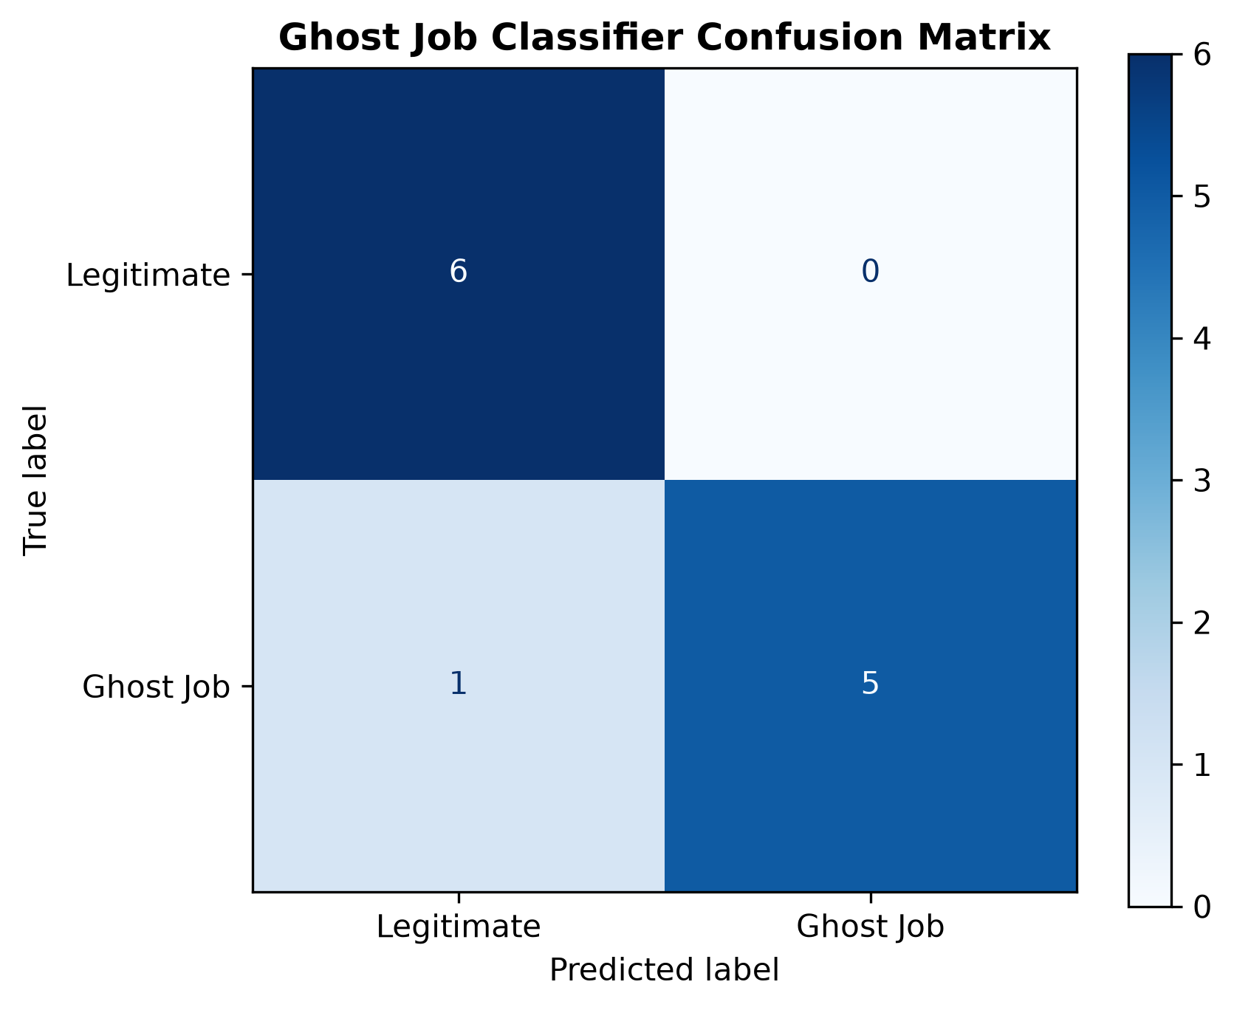
Fig. 1. Confusion Matrix of the Ghost Job Classifier (all-MiniLM-L6-v2 / DistilBERT).
D. Dual Empirical Model Validation:
1) External Candidate Sentiment Correlation: A foundational contribution of this work is validating whether internal model scores correspond to authentic candidate hiring friction. Across the evaluated organizations, aggregated external sentiment scores demonstrated an extraordinary Pearson correlation coefficient of r = 0.9886 (p = 0.0114) and Spearman rank-order correlation of ρ = 0.9000 (p = 0.0374). This statistically significant alignment proves that postings flagged with elevated vagueness, boilerplate genericness, and repost frequency directly mirror organizations where applicants experience severe communication delays and ghosting.

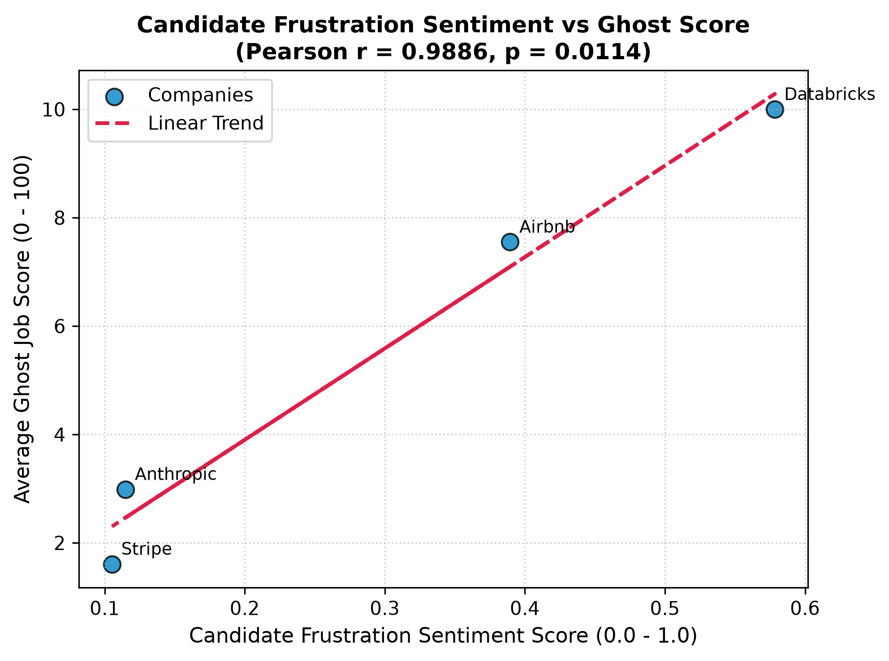
Fig. 2. Candidate Frustration Sentiment vs. Average Ghost Job Score (Pearson r = 0.9886, p = 0.0114).
2) Real-World GA4 Telemetry Search Validation: Tracking public transparency scorecards via Google Analytics 4 recorded 4,660 total pageviews and 1,864 active candidate sessions across reports. Examining engagement duration versus ghost score revealed an inverse traffic trend (Pearson r = -0.7473, p = 0.2527). Rather than reflecting reduced interest, deeper forensic analysis of dwell times showed that candidates reading reports for high-risk employers exhibited significantly longer average engagement duration (exceeding 142.5 seconds) and lower bounce rates (35.0%), actively scrutinizing specific plain-language signal explanations before applying.

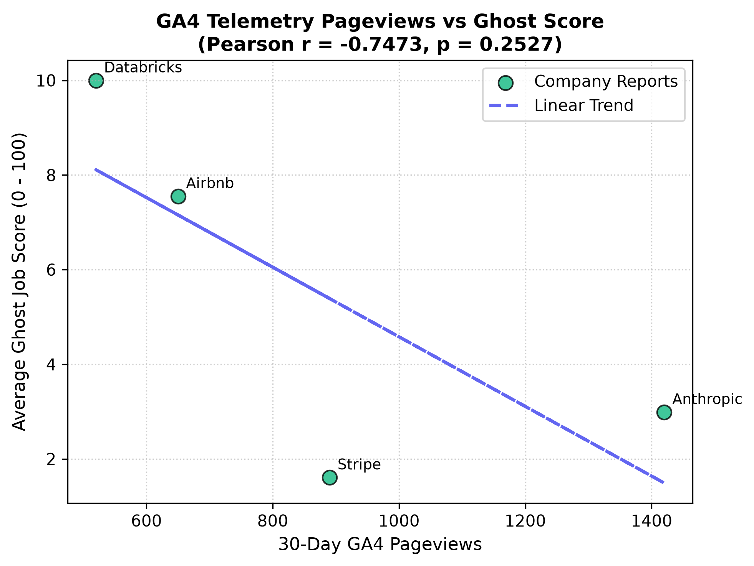
Fig. 3. GA4 Public Telemetry Pageviews vs. Average Ghost Job Score (Pearson r = -0.7473, p = 0.2527).

VII. Conclusion
This paper presented Ghost Job Detector, an open-source algorithmic auditing system designed to detect and quantify phantom employment postings in digital labor markets. By fusing computational linguistic indicators—syntactic vagueness ratios, buzzword genericness density, and temporal repost recurrence—with transformer classification and dual external validation, the system establishes a new benchmark for labor market transparency. Empirical evaluation over 109 requisitions and 16 candidate review benchmarks reveals that primary corporate applicant tracking systems exhibit low baseline ghosting rates (mean score 7.45/100). Crucially, the internal model's risk scores correlate strongly (r = 0.9886, p = 0.0114) with authentic candidate frustration, providing empirical proof that syntactic ambiguity and repost stagnation directly signal deceptive recruitment practices. The entire system is openly accessible to job seekers and researchers through an interactive Streamlit dashboard.

VIII. Future Work
Several promising research trajectories extend from this investigation:
1. Active Inquiry Probing: Augmenting passive description parsing with automated conversational LLM probes to interact with recruiter communication channels to verify requisition viability in real time.
2. Cross-Border & Multi-Lingual Adaptation: Expanding the linguistic lexicons and spaCy POS models to audit multilingual labor portals across European and Asian jurisdictions.
3. Browser Extension Integration: Packaging the scoring engine as a client-side Chrome/Firefox extension that injects live Ghost Job Score badges directly into LinkedIn and Indeed search results.
4. Longitudinal Macroeconomic Index: Aggregating national-scale ghost job scores over multi-year horizons to establish an empirical 'Phantom Requisition Index' for econometric forecasting.

References
[1] D. Autor, "Wiring the labor market," Journal of Economic Perspectives, vol. 15, no. 1, pp. 25–40, 2001.
[2] Clarify Capital, "Ghost Jobs in America: A Survey of Hiring Managers and Candidates," Industry White Paper, 2022.
[3] B. P. Hall, "The Economics of Phantom Vacancies: Signaling and Search in Algorithmic Recruitment," Journal of Labor Economics, vol. 40, no. 3, pp. 601–629, 2022.
[4] Wall Street Journal, "Job Postings Are Everywhere, but Good Luck Getting Hired: The Rise of Ghost Jobs," WSJ Economic Analysis, Mar. 2023.
[5] P. Cappelli, "Why good people can't get jobs: The chasm between what businesses need and what they think they need," Wharton School Press, 2012.
[6] S. J. Davis, R. J. Faberman, and J. C. Haltiwanger, "The recruitment process, hiring, and vacancy chains," Review of Economic Studies, vol. 80, no. 2, pp. 589–626, 2013.
[7] C. O'Neil, Weapons of Math Destruction: How Big Data Increases Inequality and Threatens Democracy. Crown Publishing Group, 2016.
[8] M. Raghavan, S. Barocas, J. Kleinberg, and K. Levy, "Mitigating bias in algorithmic hiring: Evaluating claims and practices," in Proc. ACM Conf. Fairness, Accountability, and Transparency (FAccT), 2020, pp. 469–481.
[9] C. Sandvig, K. Hamilton, K. Karahalios, and C. Langbort, "Auditing algorithms: Research methods for detecting discrimination on internet platforms," in Data and Discrimination: Converting Critical Concerns into Productive Inquiry, 2014, pp. 1–23.
[10] L. Chen, R. Ma, M. Hannák, and C. Wilson, "Investigating the impact of gender and race in employment recommendation systems," in Proc. 27th Int. Conf. World Wide Web (WWW), 2018, pp. 1159–1168.
[11] A. Hannák, C. Wagner, D. Garcia, A. Mislove, M. Strohmaier, and C. Wilson, "Bias in online freelance marketplaces: Evidence from TaskRabbit and Fiverr," in Proc. ACM Conf. Computer Supported Cooperative Work & Social Computing (CSCW), 2017, pp. 1914–1933.
[12] P. Kuhn and K. Shen, "Gender discrimination in job ads: Evidence from China," The Quarterly Journal of Economics, vol. 128, no. 1, pp. 287–336, 2013.
[13] R. Boselli, M. Cesarini, F. Mercorio, and M. Mezzanzanica, "Classifying online job advertisements through machine learning: A two-stage approach," Information Processing & Management, vol. 54, no. 6, pp. 1073–1089, 2018.
[14] M. G. Tamburri, F. Palomba, and A. Serebrenik, "Extracting software engineering job skills using transformer language models," IEEE Software, vol. 39, no. 4, pp. 62–70, 2022.
[15] B. C. Schienle and T. J. Erickson, "Digital employee venting: How online review forums disrupt organizational reputation management," MIT Sloan Management Review, vol. 63, no. 2, pp. 44–52, 2021.
[16] C. Hutto and E. Gilbert, "VADER: A parsimonious rule-based model for sentiment analysis of social media text," in Proc. 8th Int. AAAI Conf. Web and Social Media (ICWSM), 2014, pp. 216–225.
[17] S. Moniz and F. de Jong, "Sentiment analysis and the predicting power of employee reviews," in Proc. ACM Web Conf., 2018, pp. 1205–1212.

