IMAGE DE-NOISING
Noise
Image noise is random variation of brightness or color information in images, and is usually an aspect of electronic noise. It can be produced by the sensor and circuitry of a scanner or digital camera.
Image De-noising
De-noising is any signal processing method which reconstructs a signal from a noisy one. Its goal is to remove noise and preserve useful information. Learn more in: Enhancement of Recorded Respiratory Sound Using Signal Processing Techniques.
Image de-noising is an important image processing task, both as a process itself, and as a component in other processes. Very many ways to de-noise an image or a set of data exists. The main properties of a good image de-noising model are that it will remove noise while preserving edges.
Types of noise:

1. Gaussian Noise or Amplifier Noise:
It is also known as Gaussian distribution. It has a probability density function (PDF) of the normal distribution. This noise is added to image during image acquisition like sensor noise caused by low light, high temperature, transmission e.g. electronic circuit noise [7]. This noise can be removed by using spatial filtering (mean filtering, median filtering and Gaussian smoothing) by smoothing the image but smoothing also blurs the fine-scaled image edges and details. [4]. The PDF of Gaussian Noise is shown in the following equation and figure :
(𝑧)=1√2𝜋𝜎𝑒−(𝑧−𝜇)2/2𝜎2

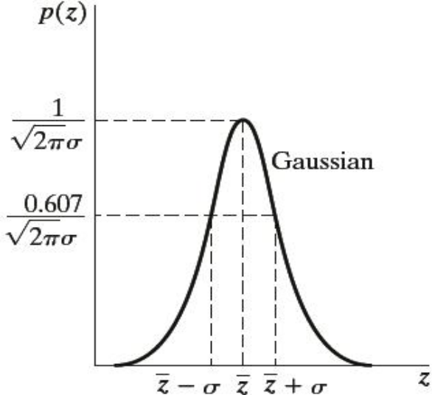
PDF of Gaussian Noise
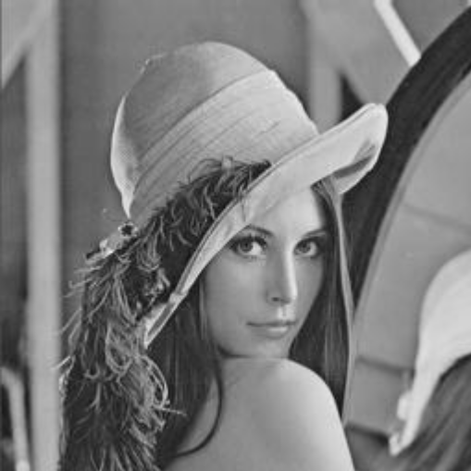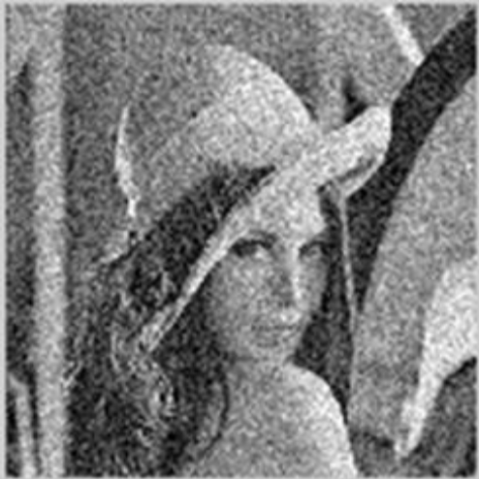
Image containing Gaussian Noise

2. Impulse Noise:
The Impulse noise is also known as Salt & Pepper noise or Spike noise. It is caused by malfunctioning pixels in camera sensors, faulty memory locations in hardware, or transmission in a noisy channel [1]. It is always Independent and uncorrelated to image pixels. Its two types are the salt-and-pepper noise and the random-valued noise. In salt and pepper type of noise, the noisy pixels takes either salt value (gray level -225) or pepper value (grey level -0) and it appears as black and white spots on the images In case of random valued impulse noise, noise can take any gray level value from zero to 225. In this case also noise is randomly distributed over the entire image and probability of occurrence of any gray level value as noise will be same [5].
Reasons for Salt and Pepper Noise:
1) Due to failure of memory cells or wrong working of sensor cells of camera.
2) Due to synchronization errors while transmitting image over media [18].

The PDF of Impulse noise is shown in following equation and figure :
p(z)={𝑝𝑎 𝑓𝑜𝑟 𝑧=𝑎
𝑝𝑏 𝑓𝑜𝑟 𝑧=𝑏
0 𝑜𝑡ℎ𝑒𝑟𝑤𝑖𝑠𝑒
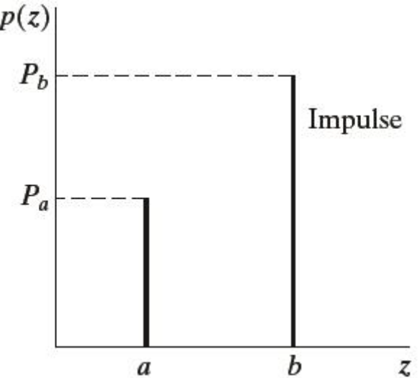
PDF of Impulse (Salt & pepper) Noise

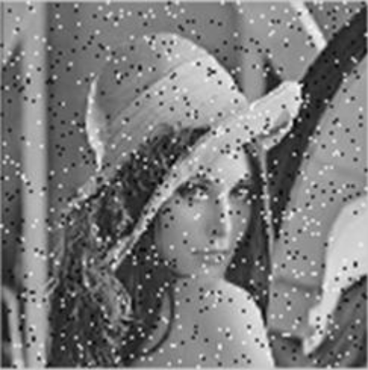
Image containing Impulse Noise

3. Speckle Noise :
Speckle noise is a granular noise. This noise generally degrades Synthetic Aperture Radar (SAR) images to large extent. This noise is generally caused due to random ups and downs in the signal coming back from an object that is smaller than a single image-processing element. It is also caused by consistent processing of backscattered signals from a no of distributed targets. This noise also increases the mean grey level of affecting image. This noise creates a lot of difficulty in interpreting the image. [20].
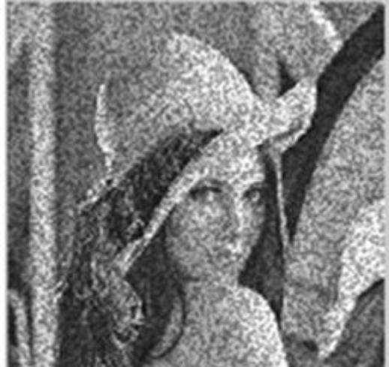
Image Containing Speckle Noise

4. Poisson Noise:
Poisson noise is also known as Photon noise. It arises when number of photons sensed by the sensor is not sufficient to provide detectable statistical information [16]. This noise has root mean square value proportional to square root intensity of the image. Different pixels are suffered by independent noise values. The photon noise and other sensor based noise corrupt the signal at different proportions [15]. The PDF of Poisson Noise is shown in following equation and figure:

𝑝(𝑥)=𝑒^−𝜆𝜆^𝑥/ 𝑥! 𝑓𝑜𝑟 𝜆 > 0 and x=0,1,2 ...

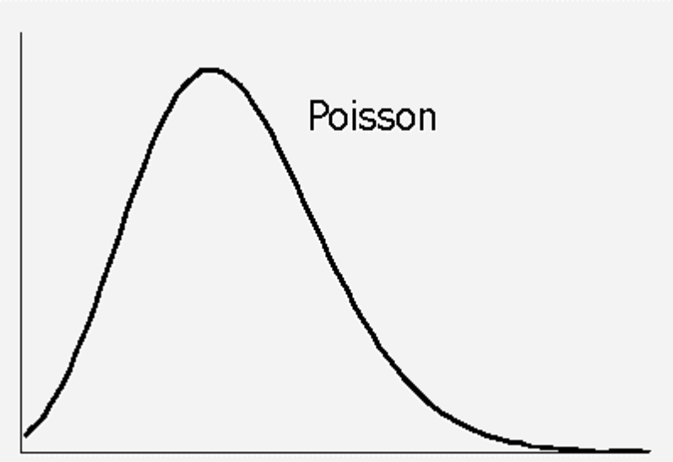
PDF of Poisson Noise

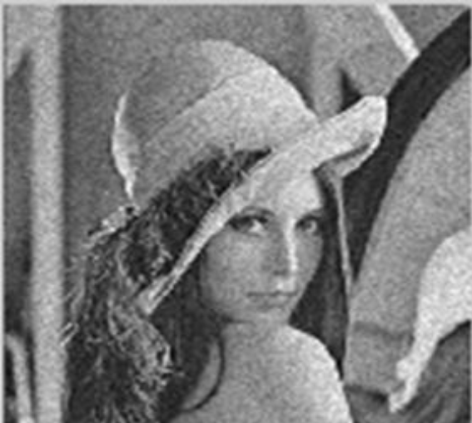
Image containing Poisson Noise

5. Uniform Noise:
The Uniform noise caused by quantizing the pixels of image to a number of distinct levels is known as Quantization noise. It has approximately uniform distribution. In this type of noise, the level of the gray values of the noise is uniformly distributed over a specified range. It can be used to create any type of noise distribution. This type of noise is mostly used to evaluate the performance of image restoration algorithms. This noise provides the most neutral or unbiased noise [10]. The PDF, mean and variance of Uniform Noise is shown below:
(𝑧)={1/(𝑏−𝑎), 𝑖𝑓 𝑎 ≤ 𝑧 ≤𝑏
0, ℎ𝑒𝑟𝑤𝑖𝑠𝑒
𝜇=(𝑎+𝑏)/2
𝜎2=(𝑏−𝑎)^2/12
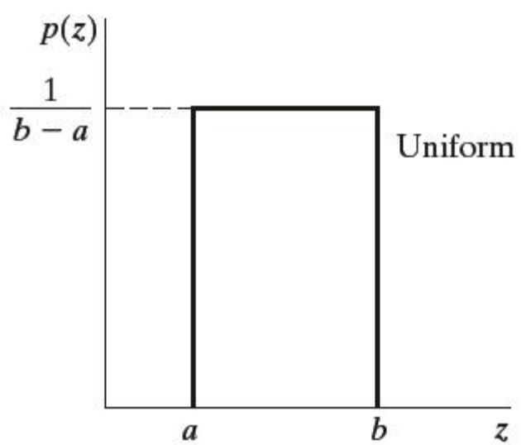
PDF of uniform noise

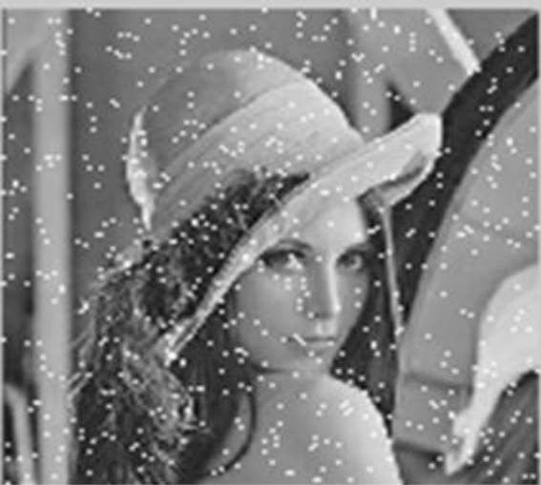
Uniform Noise present in an Image

6. Rayleigh Noise :
Radar range and velocity images typically contain noise that can be modelled by the Rayleigh distribution [18]. The PDF, mean and variance of Rayleigh Noise is given below:
(𝑧)={2/𝑏(𝑧−𝑎)𝑒^−(𝑧−𝑎)^2/𝑏 𝑓𝑜𝑟 𝑧 ≥ 𝑎
- 𝑓𝑜𝑟 𝑧<𝑎

𝜇 = 𝑎 + √𝜋𝑏/4
𝜎^2 = (4−𝜇)/4
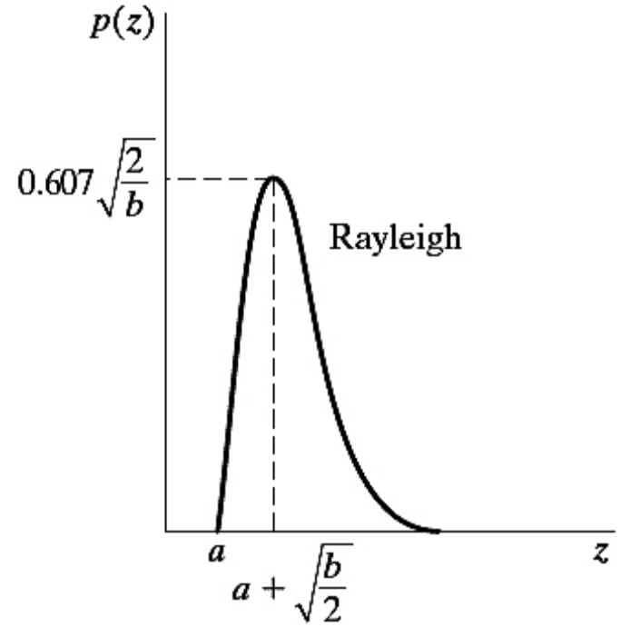
PDF of Rayleigh Noise

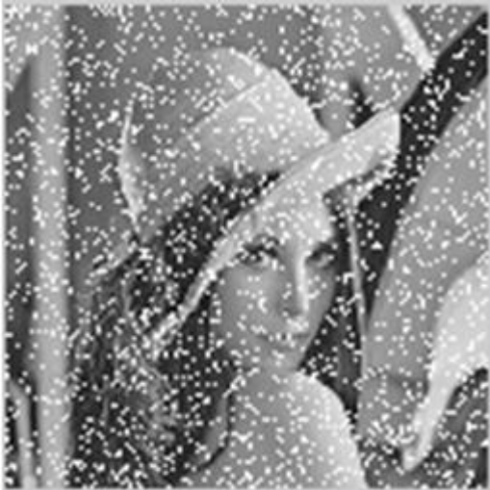
Image containing Rayleigh Noise

7. Gamma Noise :
This type of noise can be obtained by the low-pass filtering of laser based images [18]. The PDF, mean and variance of Gamma Noise is given below:
(𝑥)={𝑎^𝑧𝑧^𝑏−1/(𝑏−1)! 𝑒^−𝑎𝑧, 𝑓𝑜 < 00, 𝑧 ≥ 0
𝜇=𝑏/𝑎
𝜎^2=𝑏/𝑎^2
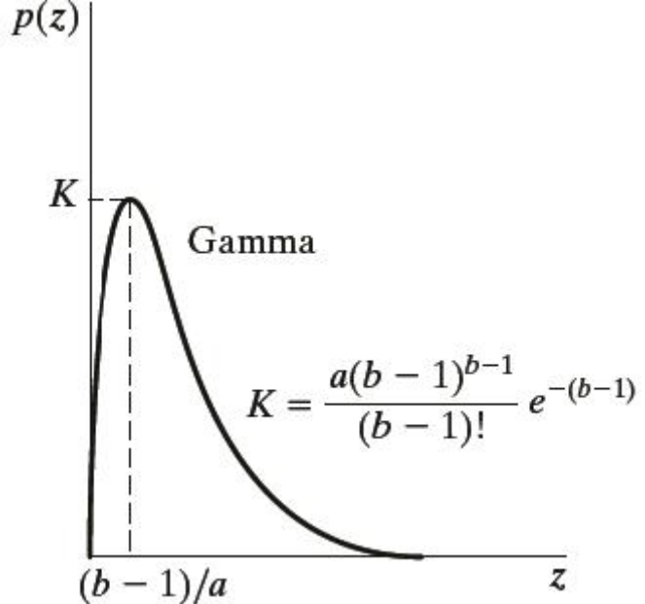
PDF of Gamma noise

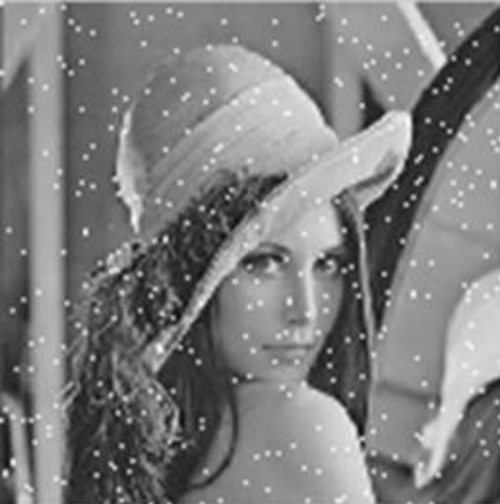
Image containing Gamma Noise

IMAGE DENOISING TECHNIQUES :
There are different Image de-noising techniques developed so far each having its own advantages and limitation. One should choose the technique according to the type and amount of noise present in the image. One should also consider the other factors like performance in de-noising the image, computational time, and computational cost.
De-noising can be done in various domains like Spatial Domain, Frequency Domain and Wavelet Domain. The Spatial domain method is discussed below.

1. Spatial Domain
Here filtering is used for image noise removal. Filtering is a technique in image processing which is used for different tasks like noise reduction, interpolation, and re-sampling. It is mostly used in all image processing systems. The choice of filter depends upon the type and amount of noise present in an image because different filters can remove different types of noise efficiently.

Spatial Domain has following types of filters:

1.1 Linear Filters:
Linear filters are used to remove certain type of noise. Here filtering is generally done by blurring the image. These filters blur the edges and destroy the fine details of an image. They have poor performance in removing signal dependent noise. Gaussian and Averaging filters are commonly used linear filters [8]. They are of following types:

1.1.1 Gaussian Filter:
Gaussian filter is a non-uniform low pass filter. Gaussian filter is used to blur images and remove noise and detail. It does not remove salt & pepper noise effectively [3].

1.1.2 Average Filter:
The output of average filter is simply the average of pixels contained in the neighborhood of filter mask. It calculates the average of all intensities of the neighborhood of the central pixel and replaces the pixel with that average value. It is mostly used in removing irrelevant details from an image. It has a limitation that it blurs the edges of the image [19].

1.2 Non-Linear Filters:
In recent years, a variety of non-linear filters such as median filter, min filter, and max filter have been developed to overcome the shortcoming of linear filter. Non-linear filters exhibit better performance than linear filters [10]. They are discussed below :
1.2.1 Mean Filter:
It is one of the simplest filters among the existing spatial filters. It uses a filter window which is usually square. The filter window replaces the center value in the window with the average mean of all the pixels values in the kernel or window.

1.2.2 Median Filter:
It is also known as order statistics filter. It is most popular and commonly used nonlinear filter. It removes noise by smoothing the images. This filter also lowers the intensity variation between one and other pixels of an image. In this filter, the pixel value of image is replaced with the median value the median value is calculated by first arranging all the pixel values in ascending order and then replaces the pixel being calculated with the middle pixel value. If the neighboring pixel of image which is to be consider, contains and even no of pixels, then it replaces the pixel with average of two middle pixel values. The median filter gives best result when the impulse noise percentage is less than 0.1 It does not perform well in removing high density salt & pepper noise [19]. The mean filter can be represented by the following equation:

𝑓^ (𝑥, 𝑦) = 𝑚𝑒𝑑𝑖𝑎𝑛 {𝑔 (𝑠, 𝑡)} 𝑤ℎ𝑒𝑟𝑒 (𝑠, 𝑡) ∈𝑆𝑥𝑦 (14)

Here S x y corresponds to the set of coordinates in a rectangular sub image window which has center at (x, y). The median filter calculates the median of the corrupted image g(x, y) under the area S x y. Here f^(x, y) represents the restored image.

1.2.3 Min Filter:
Min filter is also known as 0th percentile filter. It replaces the value of pixel by the minimum intensity level of the neighborhood of that pixel.. This filter finds darkest points in an image. It removes salt noise from an image containing salt and pepper noise due to its high intensity value [19]. The min filter can be represented by the following equation:

𝑓^(𝑥,𝑦)=𝑚𝑖𝑛{𝑔(𝑠,𝑡)} 𝑤ℎ𝑒𝑟𝑒 (𝑠,𝑡)∈𝑆𝑥𝑦 (15)

1.2.4 Max Filter:
Max filter is also known as 100th percentile filter. It replaces the value of pixel by the maximum intensity level of the neighborhood of that pixel. This filter finds brightest points in an image. It removes pepper noise from an image containing salt and pepper noise due to its very low intensity value [19].

𝑓^(𝑥,𝑦)=𝑚𝑎𝑥{𝑔(𝑠,𝑡)} 𝑤ℎ𝑒𝑟𝑒 (𝑠,𝑡)∈𝑆𝑥𝑦 (16)

1.3 Adaptive Filters:
These filters work accordingly the statistical characteristics of image inside the filter region defined by the m x n rectangular window. They are more complex and gives better performance than existing spatial filters. The most commonly used spatial filter is adaptive median filter which is discussed below:

1.3.1 Adaptive Median Filter:
It performs well on images containing high density salt & pepper noise. It preserves the details of an image while smoothing non impulse noise. It changes its windows size during its operation depending on the certain conditions [19]. It works in two stages. First it calculates the minimum, maximum and median values of sub image window of the corrupted image. In stage one, it checks whether the calculated median itself is a salt or pepper noise or not. If the median is salt or pepper noise, then it increase the size of sub image window and recalculates the minimum, maximum and median values otherwise it proceeds to stage two. In stage two, it checks whether the selected pixel is a salt or pepper noise or not. If it is salt or pepper noise, then it replaces the selected pixel with previously calculated median otherwise the pixel remains unchanged.

IMPLEMENTATION AND RESULTS
Experiments were carried out on various standard gray scale images of size 256 x 256 which are of jpeg format and are shown in Figure 18. Simulation is performed using mat lab R2013a software.

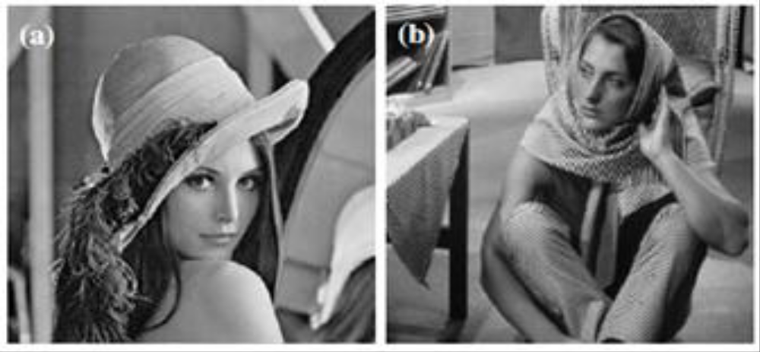
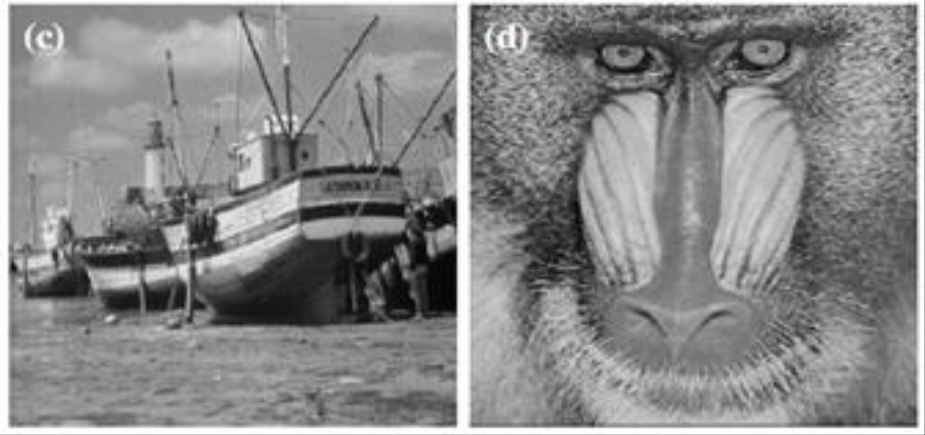
Original Images used for simulation (a) Lena, (b) Barbara, (c) Boat, (d) Baboon

The input images are corrupted by a simulated Gaussian white noise (mean=0, variance=0.01), Salt & Pepper noise (noise density= 0.05), Speckle noise (mean=0, variance=0.04), Poisson noise, Uniform noise (interval [0, 1]), Rayleigh noise (parameters 0,1), Erlangen noise (parameters 2,5). For denoising process, various spatial linear filters which are Gaussian filter (3x3), average filter (3x3) and spatial nonlinear filters which are median filter (3x3), min filter (3x3), max filter (3x3) and adaptive filters which are adaptive median filter (3x3), have been used.
The Quantitative performance of the spatial filters is evaluated through Peak signal to noise ratio (PSNR). It can be defined by following eq.

𝑃𝑆𝑁𝑅=10log10 (2552𝑀𝑆𝐸)

𝑀𝑆𝐸= ΣΣ (𝑟𝑖𝑗−𝑥𝑖𝑗)𝑖𝑀×𝑁

Where r refers to Original image, x denotes the restored image, M x N is the size of processed image.
Table 1 in the Appendix a shows performance of various spatial filters in removing the different types of noise in Lena image, in terms of p s n r. Similarly Tables 2, 3 and 4 corresponds to Barbara, Boat and Baboon image respectively. Figure 16 shows the Lena image corrupted with different noise types and each noisy image filtered using different filters. Similarly Figure 17, 18 and 19 corresponds to Barbara, Boat and Baboon image respectively.

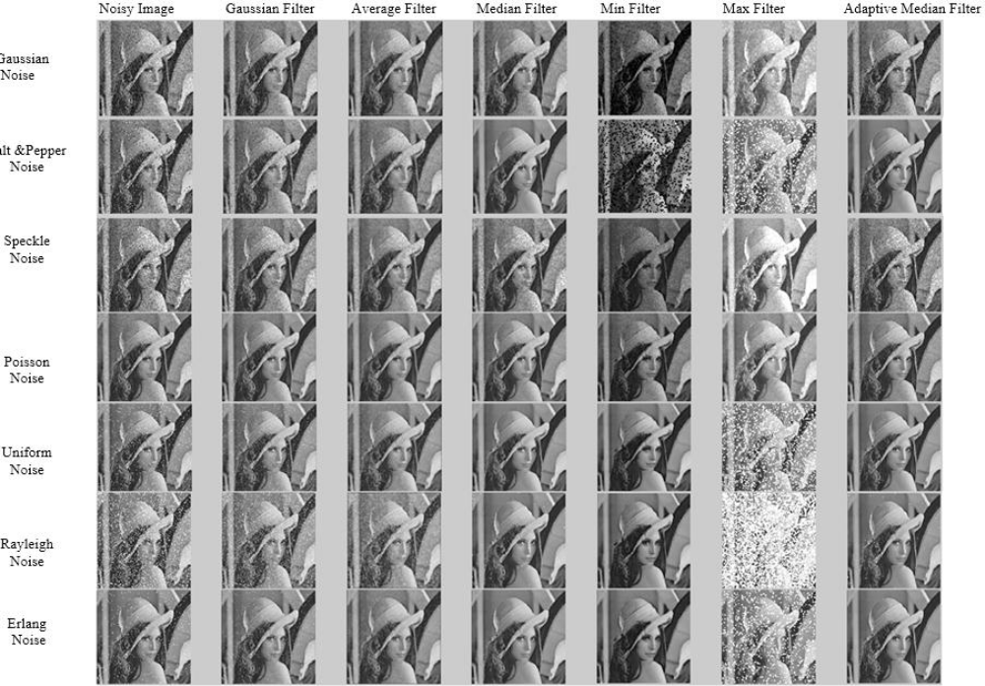Lena image containing various types of noise and filtered by using different spatial filters

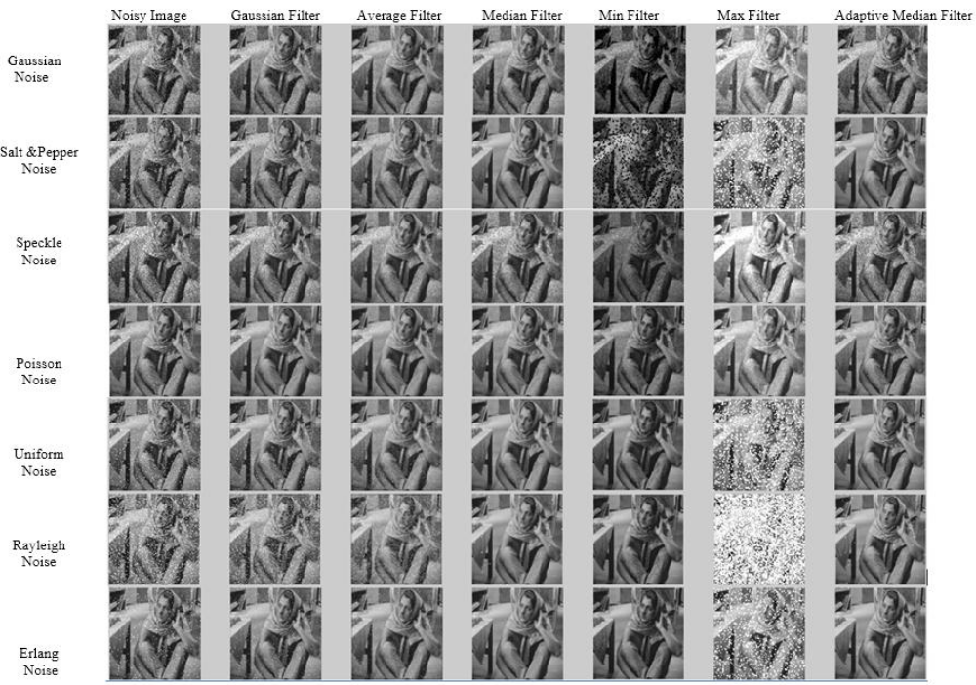
Barbara image containing various types of noise and filtered by different spatial filters.

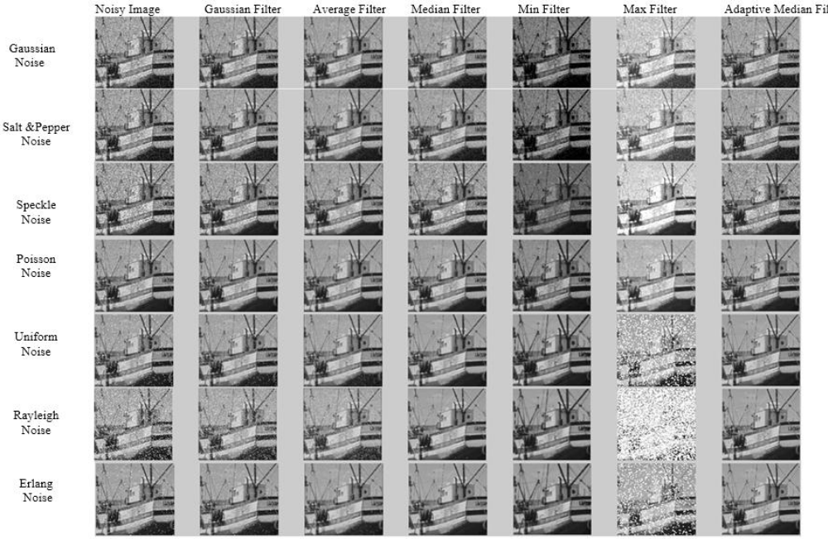Boat image containing various types of noise and filtered by different spatial filters

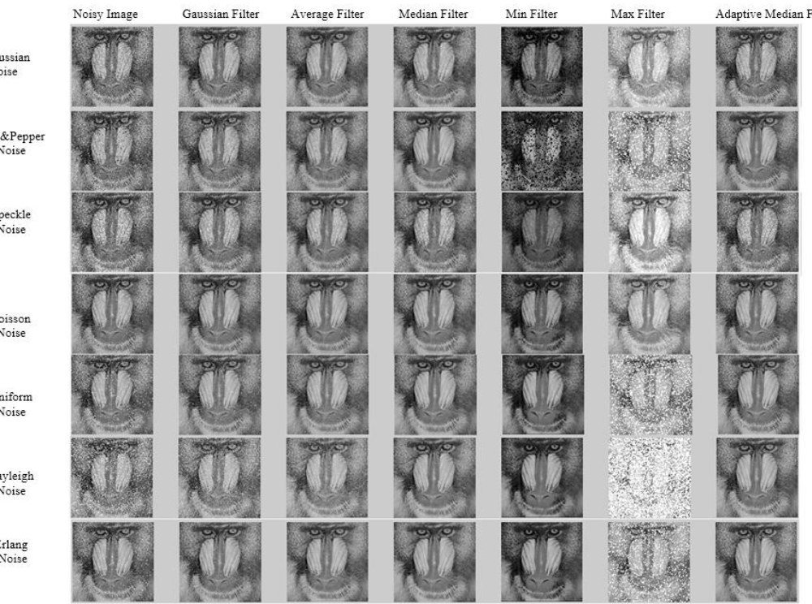 Baboon image containing various types of noise and filtered by different spatial filters

