1) Attendance Report - Done
2) Leave Reports

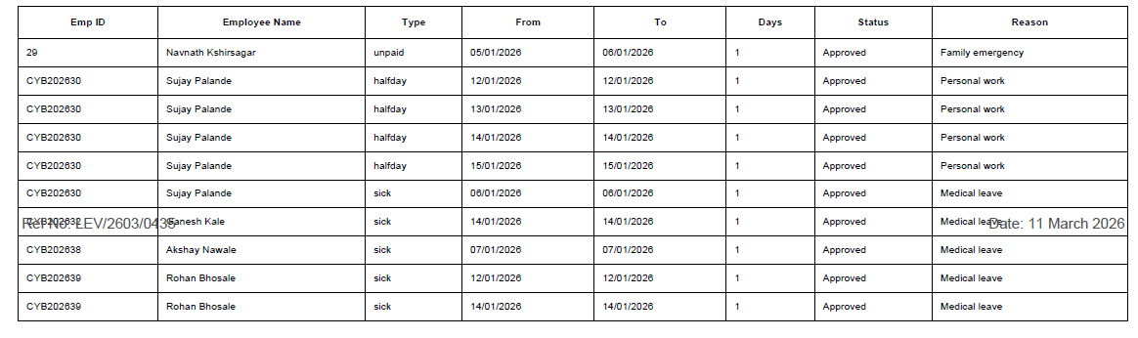
Data and Ref no text occur in between table.(PDF)

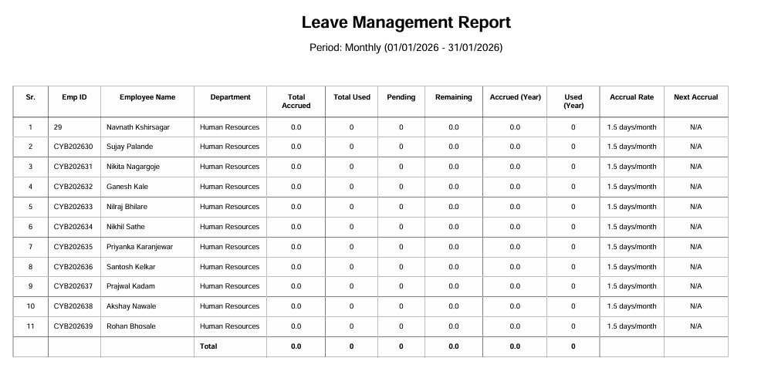

Data mismatch in report

3) Payroll Reports - Done

4) Muster Roll & Wage Register
Muster Roll - Done
Wage Register - Done
5) Leave Register - Form 20 - Done
6) Provident Fund - Done
7) Employees' State Insurance

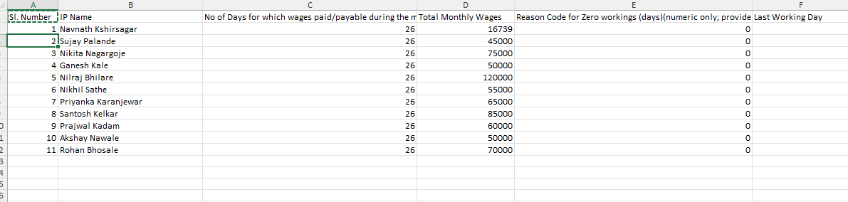

XL report data not matching

8) Professional Tax - Done

9) Maharashtra Labour Welfare Fund

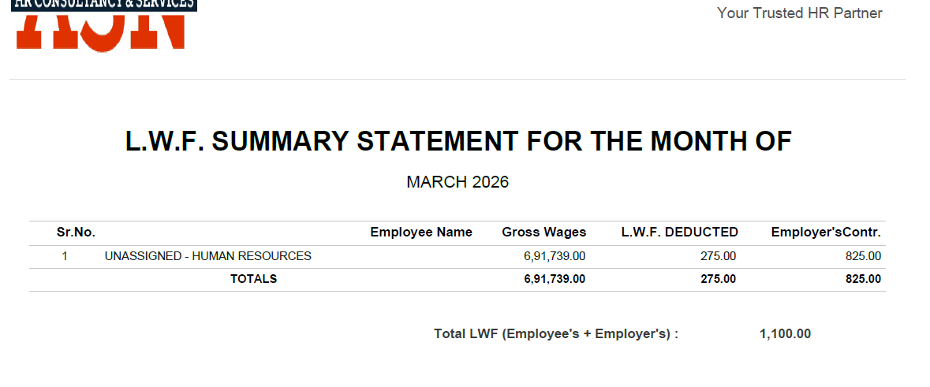

Generate report Employee Name column empty

10) Bonus Reports
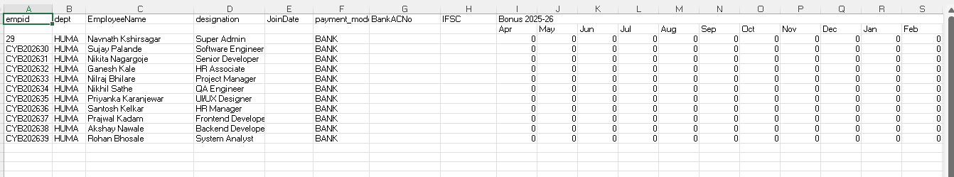

In XL Report - IFSC code and Bank Account no remain blank

12) Payroll Management
Salary-> Payroll Processing (It must change Payment tracking as Done/ Complited)

13) Attendance Management
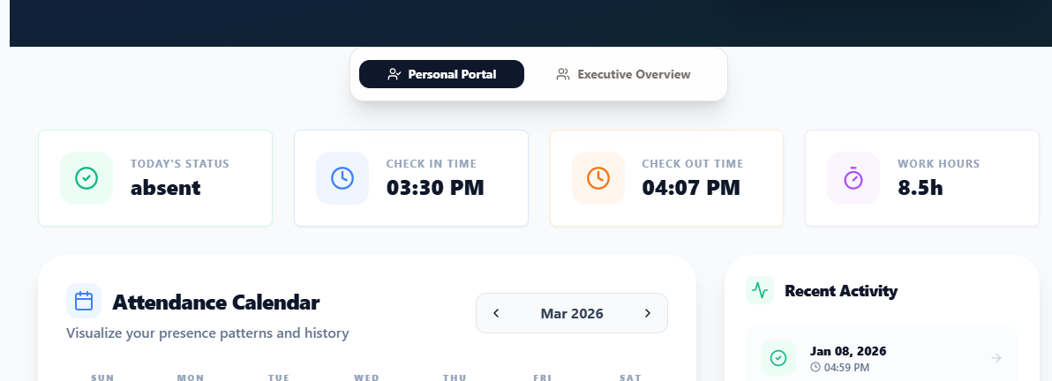

Here work hours not calculate properly.

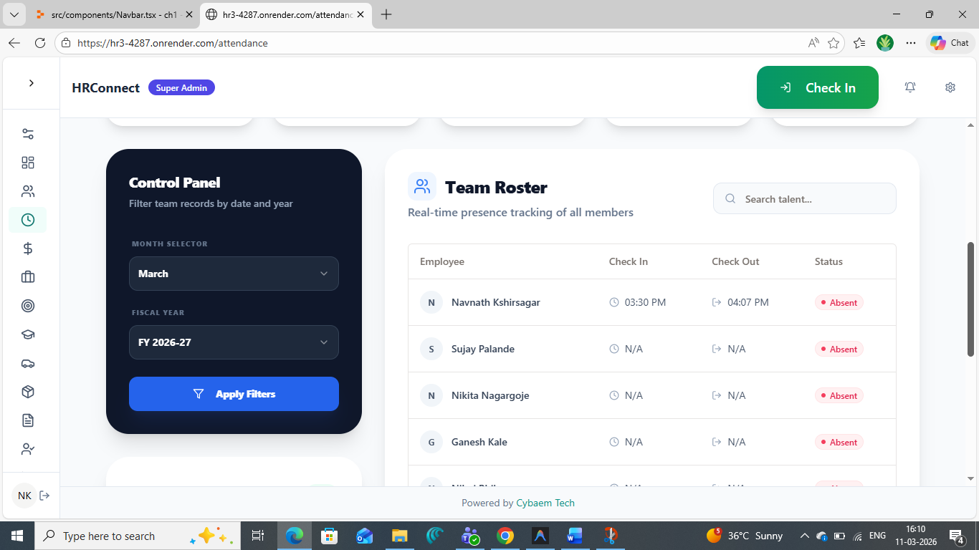

Apply Filter btn not working

