Project Name: NYKAA

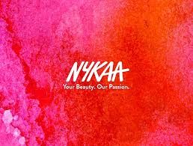

Overview:

Nykaa is an Indian E-Commerce website. It sells beauty, wellness and fashion products. Nykaa prides itself on offering a comprehensive selection of cosmetics, skincare, fragrances, bath and body, luxury and wellness products for women and men.

Home Page:

*Categories

*Brands

*Nykaa Fashion

*Search Bar

*Account

*Cart

*Trending

*Offers

*Footer(Company Description, Help, Quick Links, Top Categories)

Main Page:

*Filters:

Based on-(Brand, Price, Discount, Avg Customer Rating, Preference, Gender, Conscious, Formulation)

*Product Image

(Product Description, Rating, Discount, Gift)

Shopping Cart:

*List of Items in Cart

*Total Cost

Payment:

*Delivery Address Section

*Mobile Number

*Discount Coupon if any

*Payment Method-(COD, UPI, Credit Card, Net Banking)

Technologies Used:

**Frontend:**

*HTML

*CSS  
*Javascript

*Bootstrap

*React

**Backend:**

*Nodejs, expressjs

**Database:**

*Mongodb