Evaluating the Robustness of Lightweight Machine Learning Models to Label Noise

Garima
Dept. of Computer Science & Engineering Chitkara University
Punjab, India
garima313.be22@chitkara.edu.in
Gurnoor Dhaliwal
Dept. of Computer Science & Engineering Chitkara University
Punjab, India
gurnoor344.be22@chitkara.edu.in
Gagan Deep
Dept. of Computer Science & Engineering Chitkara University
Punjab, India
gagandeep310.be22@chitkara.edu.in

Divesh Gupta
Dept. of Computer Science & Engineering Chitkara University
Punjab, India
divesh291.be22@chitkara.edu.in
Dr. Shikha Tuteja*
Associate Professor
Dept. of Computer Science & Engineering Chitkara University
Punjab, India shikha.1290@chitkara.edu.in

Abstract—Label noise is a common issue in real-world datasets and can significantly degrade the performance of models. This study finds out the robustness of six classical machine learning models—Logistic Regression, Decision Tree, Random Forest, Support Vector Machine (SVM), K-Nearest Neighbors (KNN), and LightGBM—under two types of label noise: symmetric and asymmetric. Experiments are conducted on two datasets, namely Breast Cancer Wisconsin and Adult Income, to evaluate the generalizability of model behaviour. We add noise only to the training data at different levels (0%, 10%, 20%, and 30%), while evaluation is performed on clean test data with Accuracy and F1-score metrics.
Results show that symmetric noise leads to significantly higher performance degradation compared to asymmetric noise across all models. Out of the tested models, SVM demonstrates strong and consistent robustness across most settings, while Decision Tree exhibits the highest sensitivity to label corruption. Additionally, F1-score is observed to be more sensitive to noise than accuracy in imbalanced datasets such as Adult Income. The results highlight why it’s important to pick noise-robust models and appropriate evaluation metrics in real-world scenarios where data quality cannot be guaranteed.

Keywords - Label noise, machine learning robustness, symmetric noise, asymmetric noise, SVM, LightGBM, Decision Tree, noisy labels, classification.
- Introduction
Machine learning models rely heavily on the assumption that training data is accurately labeled. However, in real-world scenarios, This assumption is often violated due to errors made during data labeling, ambiguous data instances, automated labeling pipelines, or mismatches in the data collection processes. Such inaccurate or corrupted labels are commonly referred to as label noise [8], and they can weaken the model’s performance and reliability.
Label noise is especially important because it directly affects the learning signal during training. Unlike feature noise, which corrupts input attributes, label noise corrupts the target signal itself [10]. For this reason, models may learn incorrect decision boundaries, which makes the model
perform poorly and unstable predictions. This problem becomes even more important in domains such as healthcare, finance, and decision-support systems, where bad predictions can have serious consequences.
To better understand this problem, label noise is often classified into two major types: symmetric noise and asymmetric noise. In symmetric noise, class labels are randomly flipped with a certain probability, representing uniform corruption across all classes. In comparison, asymmetric noise introduces structured or directional corruption, where labels are changed from one class to another in a planned manner. These two noise settings allow researchers to simulate both random and realistic label corruption scenarios.
While a large body of research has centered on deep learning approaches for dealing with noisy [11], [12], older machine learning models are still widely used, especially for tabular datasets. Classical models such as Logistic Regression, Decision Trees [17], Random Forests [4], Support Vector Machines (SVM) [15], K-Nearest Neighbours (KNN), and gradient boosting models, for example LightGBM [7] is widely used when working with tables of data. However, their robustness under controlled label noise conditions is not always well understood, particularly in a comparative and multi-dataset setting.
In this study, we investigate the robustness of six classic machine learning models with different amounts of symmetric and asymmetric label noise. Experiments are conducted on two benchmark datasets with distinct characteristics: a smaller, clean, numerical dataset (Breast Cancer Wisconsin Diagnostic) and a larger, heterogeneous dataset with combined feature types (Adult Income). This dual-dataset setup enables evaluation of whether robustness patterns are similar across different data category.
To ensure a fair and controlled evaluation, noise is introduced only within training data, while testing is performed on clean, untouched data. Performance is checked using both Accuracy and F1-score, along with extra measures such as relative degradation and variance across folds.
The main contributions of this work are as follows:
- A systematic comparison of six standard machine learning models under controlled symmetric and asymmetric label noise.

- A cross-dataset evaluation demonstrating how robustness differ with dataset characteristics.
- An analysis of performance degradation using both Accuracy and F1-score, highlighting differences among these metrics.
- Identification of models that are consistently robust or highly sensitive to noisy labels.
The findings of this study show practical insights into model selection in noisy environments and underline the importance of robustness analysis in real-world machine learning applications.

LITERATURE REVIEW
Label noise has long been recognized as a serious challenge in supervised classification because corrupted labels distort the learning signal and can reduce generalization performance. Recent survey work shows that noisy-label learning is still a focus of research, with major directions including noise-robust learning, data cleansing, sample selection, and loss correction [9]. Much of this literature focuses on deep learning, but the core issue is broader: when labels are unreliable, learned decision boundaries can turn unstable and evaluation can become misleading.
A common practice in noisy-label research is to evaluate models under controlled synthetic corruption so that degradation can be measured systematically [9], [10], [14]. Two standard label-noise settings are symmetric noise and asymmetric noise [9], [10], [14]. Symmetric noise represents random flipping of class labels, while asymmetric noise represents directional or class-dependent corruption. The difference is important because the two settings stress a classifier differently: symmetric noise weakens the training signal more uniformly, whereas asymmetric noise can mimic realistic annotation bias or one-sided confusion between classes [9], [10], [14].
Another trend visible in the literature is that robustness is commonly talked about in the context of complex deep neural networks, mainly used in computer vision and medical imaging.. Recent literature on noisy-label learning emphasizes methods such as transition-matrix estimation, sample selection, loss correction, data filtering, and confident learning [9], [12], [13], [14]. However, in many tabular-data applications, classical machine learning models are still preferred because they are simpler to train, easier to understand, and more suitable for small or structured datasets. This creates a useful gap for comparative studies that evaluate how traditional classifiers behave under noisy supervision without introducing specialized noise-handling algorithms.
Benchmark dataset choice also matters in robustness research. Using only one dataset can make findings overly dataset-specific, so cross-dataset comparison is often necessary to show the patterns seen are stable [9]. In this work, the Breast Cancer Wisconsin (Diagnostic) dataset and the Adult dataset provide two contrasting test beds. The breast cancer data from Wisconsin contains features computed from digitized images of fine needle aspirates of breast masses [1], while the Adult dataset is a larger tabular dataset with mixed feature types and missing data [2].

Because these datasets differ in size, feature structure, and domain, they are appropriate for examining whether model robustness trends are similar across very different classification settings.
Based on this background, the present study positions itself as a comparative robustness analysis of six typical machine learning models under controlled symmetric and asymmetric label noise throughout two standard UCI datasets. Instead of creating a new noise-correction method, the purpose is to identify which conventional models remain firm, which degrade sharply, and whether baseline accuracy agree with true robustness under noisy training conditions. That shapes the study practically relevant for real tabular-data workflows where label quality cannot be fully guaranteed.

METHODOLOGY

Research Objective
The objective of this study is to evaluate the robustness of conventional machine learning classifiers under controlled label noise conditions. The work looks at how different models perform when incorrect labels are introduced into the training data, whereas the test data remains clean. The study compares model results on different datasets, noise types, and amount of noise using standard classification metrics.

Datasets
Two benchmark tabular classification datasets were used in this work. The Breast Cancer Wisconsin Diagnostic dataset
[1] is relatively small, numerical, and clean, making it suitable for controlled experimentation and debugging of the pipeline. The Adult Income dataset [2] is larger and more heterogeneous, containing a more realistic tabular setting with greater complexity. It was used to validate whether the observed robustness patterns remain consistent on a second dataset. The use of two datasets improves the reliability of the study by reducing the chance that conclusions are specific to only one data distribution.

TABLE I Summary of Datasets Used in the Study

Dataset | Instances | Features | Task Type | Source
Breast Cancer Wisconsin | 569 | 30 | Binary Classification | UCI ML  Repository [1]
Adult Income | 48,842 | 14 | Binary Classification | UCI ML  Repository [2]

Experimental Models
Six classical supervised machine learning models were selected for comparison: Logistic Regression, Decision Tree, Random Forest, Support Vector Machine (SVM), K-Nearest Neighbors (KNN), and LightGBM. These models were chosen because they represent different learning mechanisms, including linear, tree-based, margin-based, instance-based, ensemble, and boosting approaches.

TABLE II Classical Machine Learning Models Used in the Study
Dataset Selection

▼
Model | Category | Working Principle | Reason
Logistic Regression | Linear | Linear boundary via probabilities | Baseline model
Decision Tree | Tree | Hierarchical rule-based splits | Studies split sensitivity
Random Forest | Ensemble | Averaged trees on random subsets | Improves robustness
SVM | Margin | Max-margin hyperplane | Strong tabular performance
KNN | Instance | Nearest neighbor voting | Sensitive to noisy labels
LightGBM | Boosting | Sequential boosted trees | Powerful tabular learner

Preprocessing
▼
Train-Test Split / Stratified Folds
▼
Noise Injection in Training Labels Only

▼
Train 6 Classical ML Models
▼
Evaluate on Clean Test Data
▼
Compute Accuracy and F1-score

▼
Aggregate Results Across Noise Levels and Folds
▼
Robustness Analysis (Relative Drop, Variance, Ranking)

Experimental Pipeline
The complete experimental workflow was designed as a controlled robustness pipeline. The pipeline proceeds through the following steps:
Baseline Training: For each dataset, the original clean dataset was first used to establish a reference performance. The data was split into training and testing sets, and all six models were trained on clean labels. Their baseline Accuracy and F1-score were recorded.
Cross-Validation Setup: To improve reliability and reduce dependence on a single split, 5-fold stratified cross-validation
[3] was used during robustness experiments. Stratification ensured that class proportions were preserved across folds.
Noise Injection: Label noise was introduced only into the training labels. The test labels were kept untouched so that evaluation reflected true generalization under noisy supervision. Symmetric noise randomly flipped a specified percentage of labels, while asymmetric noise flipped labels directionally from one class to another.
Model Training and Evaluation: For each dataset, each noise type, each noise level, and each fold, all six models were trained on the noisy training set and evaluated on the clean test set.
TABLE III Noise Settings and Evaluation Criteria
Component | Setting / Value
Noise Types | Symmetric noise, Asymmetric noise
Noise Rates | 0%, 10%, 20%, 30%
Noise Injection Target | Training labels only
Test Set | Clean and untouched
Validation Strategy | 5-fold stratified cross-validation
Performance Metrics | Accuracy, F1-score
Additional Analysis | Relative degradation, standard deviation, robustness ranking

Fig. 1. Overall workflow of the proposed robustness evaluation framework for classical machine learning models under label noise.

Performance Measures
Accuracy: Accuracy measures the proportion of correctly classified instances among all predictions.
F1-score: F1-score was used as a balanced performance measure because it captures both precision and recall, which is especially useful when class distributions are uneven.
Relative Degradation: To quantify robustness, the drop in performance from the clean baseline was computed as RPD(η) = (M(0) − M(η)) / M(0) × 100%. This shows how strongly each model deteriorates as noise increases.
Standard Deviation Across Folds: The standard deviation of performance across cross-validation folds was used to analyze model stability.

Result Aggregation and Analysis
After all experiments were completed, the raw fold-wise outputs were aggregated into summary tables. For each combination of dataset, noise type, noise level, and model, the mean and standard deviation of both Accuracy and F1-score were computed. Additional analyses examined degradation trends, relative performance drop, robustness ranking of models, comparison between symmetric and asymmetric noise, and model-category-wise robustness patterns.

Reproducibility and Implementation
The experiments were implemented in Python using a notebook-based pipeline. Separate notebooks were maintained for baseline evaluation, noise generation, cross-validation experiments, and analysis plots for each dataset. A fixed random seed was used to improve reproducibility of results.

RESULTS AND DISCUSSION
This section presents the experimental findings obtained from the Breast Cancer Wisconsin and Adult Income datasets under controlled symmetric and asymmetric label noise. The discussion focuses not only on raw performance, but also on

robustness trends, degradation behaviour, and differences between models across datasets. Since the objective of this work is to study robustness rather than only clean-data accuracy, the interpretation emphasizes how performance changes as noise increases.

Baseline Performance on Clean Data
Before introducing noise, all models were evaluated on clean training data to establish a reference point. On the Breast Cancer Wisconsin dataset, baseline performance was uniformly high, indicating that the dataset is relatively well-structured and easier to classify. SVM achieved the strongest baseline performance with a mean accuracy of 97.7% and F1-score of 98.2%, followed closely by Logistic Regression (97.4% / 97.9%) and LightGBM (96.7% / 97.4%). KNN and
Random Forest also performed strongly, with accuracies of 96.3% and 95.4%, respectively, while Decision Tree showed the lowest baseline performance at 91.6% accuracy and 93.4% F1-score.
A different pattern emerged on the Adult Income dataset, where overall performance was lower because of greater data complexity, mixed feature types, and class imbalance. LightGBM achieved the best baseline accuracy of 87.4% with an F1-score of 71.3%, followed by Random Forest at 85.9% accuracy and 67.9% F1-score, and SVM at 84.9% accuracy and 63.5% F1-score. Logistic Regression and KNN showed moderate baseline performance, while Decision Tree again produced the weakest baseline results at 81.4% accuracy and 61.8% F1-score. These results suggest that ensemble- and boosting-based methods are better suited to the Adult dataset, whereas margin-based learning is especially effective on the smaller and cleaner Breast Cancer Wisconsin dataset.
Table IV. Baseline mean accuracy and F1-score at 0% label noise for all models on the Breast Cancer Wisconsin and Adult Income datasets. BC = Breast Cancer Wisconsin. Sym. = Symmetric,
Asym. = Asymmetric

Model | BC Acc. | BC F1 | Adult Acc. | Adult F1
SVM | 97.7% | 98.2% | 84.9% | 63.5%
Logistic Reg. | 97.4% | 97.9% | 82.5% | 55.1%
LightGBM | 96.7% | 97.4% | 87.4% | 71.3%
KNN | 96.3% | 97.1% | 82.9% | 62.1%
Random Forest | 95.4% | 96.4% | 85.9% | 67.9%
Decision Tree | 91.6% | 93.4% | 81.4% | 61.8%

Effect of Symmetric Label Noise
Symmetric noise reduced performance on both datasets, with degradation increasing as the noise rate rose from 0% to 30%. Although all models were affected, the rate of deterioration differed substantially across classifiers.
On the Breast Cancer Wisconsin dataset, SVM was the most robust model under symmetric noise, with a total relative accuracy drop of only 6.5% at 30% noise. Logistic Regression remained the second most stable with a 9.2% relative drop, followed closely by Random Forest at 9.4%. In

contrast, Decision Tree exhibited the strongest degradation with a 26.3% relative drop, confirming that greedy split-based learning is highly sensitive to incorrect labels. LightGBM also degraded substantially at 19.8%, while KNN showed a 16.9% relative drop at the highest noise level.
On the Adult Income dataset, the ranking changed slightly, but the overall pattern remained similar. SVM again emerged as the most robust model under symmetric noise, with only a 1.1% relative accuracy drop at 30% noise. Logistic Regression ranked second at 1.7%, and LightGBM ranked third at 1.9%, which is notable because LightGBM also achieved the best baseline performance on this dataset. Decision Tree remained the weakest model, with a 24.2% relative drop. KNN degraded sharply at 14.8%, while Random Forest showed moderate degradation at 8.5%.
Fig. 2 shows the symmetric degradation curves for the Breast Cancer Wisconsin dataset, and Fig. 3 shows the corresponding curves for the Adult Income dataset. The steeper slopes for Decision Tree and KNN confirm their high sensitivity to random label corruption, while the near-flat curves for SVM and Logistic Regression on the Adult dataset illustrate their strong robustness.
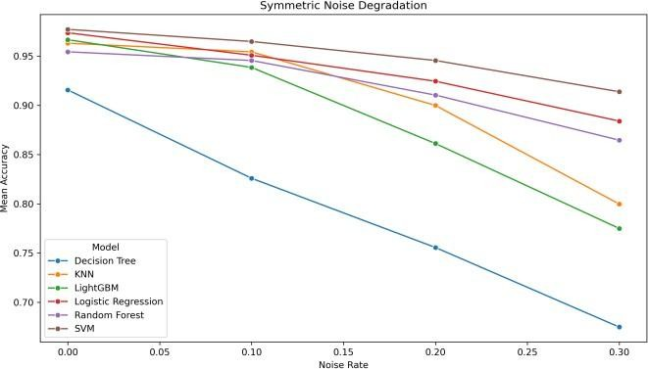
Fig. 2. Accuracy degradation under symmetric noise across noise levels
— Breast Cancer Wisconsin dataset
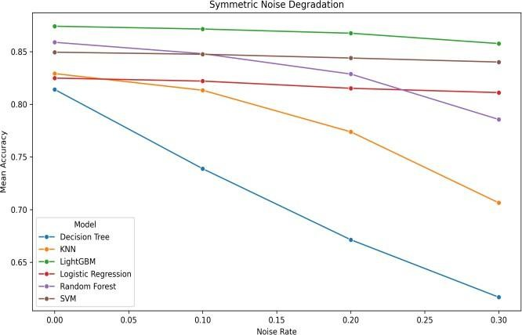
Fig. 3. Accuracy degradation under symmetric noise across noise levels
— Adult Income dataset.
Fig. 4 shows the relative accuracy drop under symmetric noise for the Breast Cancer Wisconsin dataset, while Fig. 5 shows the corresponding trend for the Adult Income dataset. Decision Tree exhibits the highest relative drop in both datasets, confirming its strong sensitivity to label corruption. In contrast, SVM shows the smallest relative drop, especially on the Adult

dataset, indicating better robustness. KNN and LightGBM display moderate degradation, with increasing drops at higher noise levels.
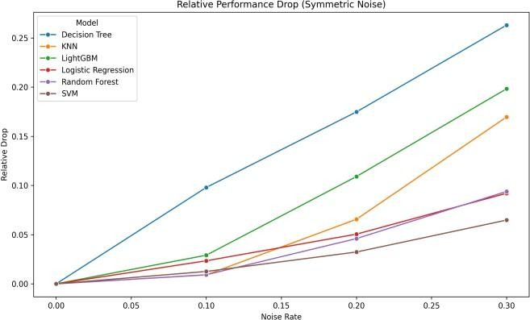
Fig. 4. Relative accuracy drop (%) under symmetric noise — Breast
Cancer Wisconsin dataset
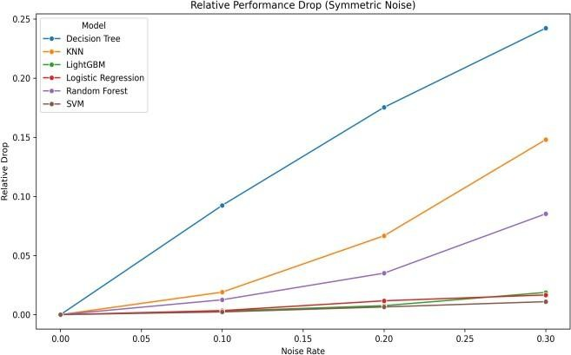
Fig. 5. Relative accuracy drop (%) under symmetric noise — Adult Income dataset.

Effect of Asymmetric Label Noise
Asymmetric noise also reduced performance, but its effect was generally smaller than symmetric noise, especially at lower noise rates. The directional nature of asymmetric corruption preserves part of the class structure, which allows models to partially retain discriminative information even under moderate corruption levels.
On the Breast Cancer Wisconsin dataset, SVM again showed the strongest robustness under asymmetric noise, with a total relative drop of only 3.6% at 30% noise. Random Forest was the next most stable with an 8.8% relative drop, followed by Logistic Regression at 10.8%. Decision Tree remained the most affected model with an 18.3% relative drop. KNN and LightGBM occupied the middle range, with relative drops of 13.0% and 12.9%, respectively.
On the Adult dataset, the behaviour changed notably and produced one of the most interesting findings of the study. Under asymmetric noise, KNN achieved the smallest relative accuracy drop of only 2.0% at 30% noise, making it the most robust model in this specific setting. Decision Tree ranked second at 2.2%, and Random Forest third at 2.4%. In sharp contrast, SVM — which had been strongest under symmetric
noise — became the most affected model under asymmetric corruption on the Adult dataset, with a 5.5% relative drop. Logistic Regression also showed noticeable decline at 3.9%, especially in F1-score.
This reversal demonstrates that a model’s robustness is not a fixed property; it depends on the interaction between model design, data characteristics, and the type of corruption. Asymmetric corruption preserves some local class structure that can still be exploited by neighbourhood-based and tree-based methods on the Adult dataset, whereas globally separating models such as SVM become more affected when one class label is directionally biased.
Fig. 6 and Fig. 7 show the accuracy degradation curves under asymmetric noise for both datasets. The shallower overall slopes compared to symmetric noise confirm that asymmetric corruption is generally less destructive. However, the divergence between models remains clear, especially on Breast Cancer where SVM and Random Forest separate visibly from Decision Tree.
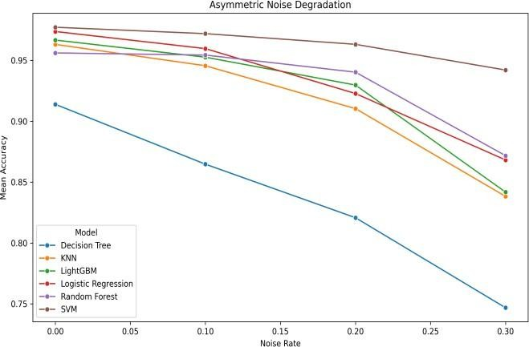
Fig. 6. Accuracy degradation under asymmetric noise across noise levels
— Breast Cancer Wisconsin dataset.
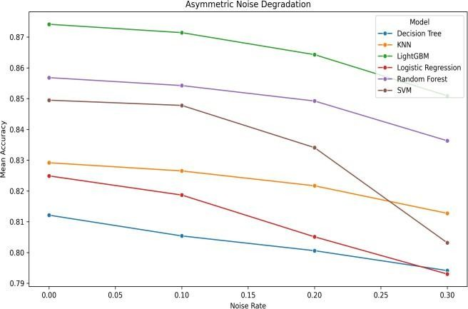
Fig. 7. Accuracy degradation under asymmetric noise across noise levels
— Adult Income dataset.
Fig. 8 and Fig. 9 present the relative performance drop under asymmetric noise. The ranking reversal between SVM and KNN on the Adult dataset is clearly visible in Fig. 9, where KNN achieves the smallest drop and SVM the largest among all models.

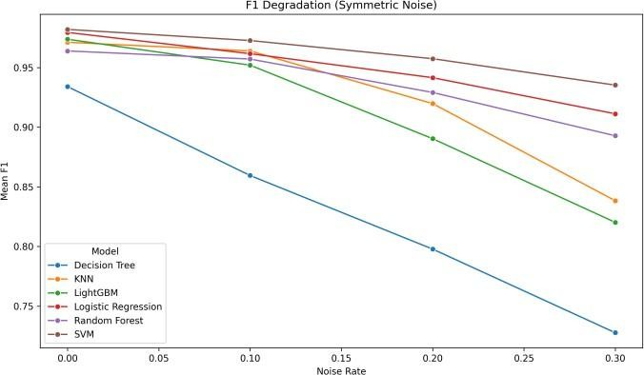

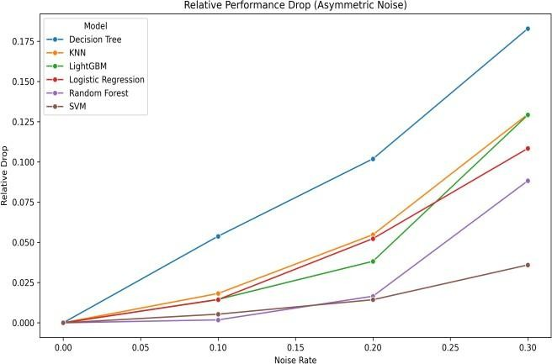
Fig. 8. Relative accuracy drop (%) under asymmetric noise — Breast Cancer Wisconsin dataset.
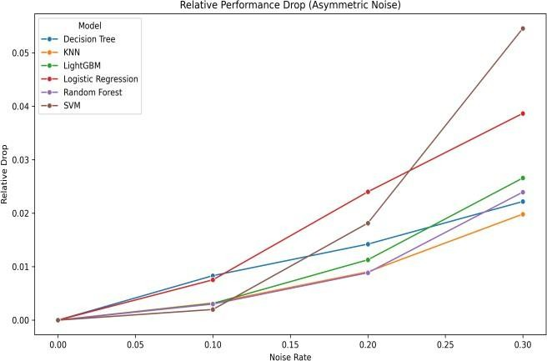
Fig. 9. Relative accuracy drop (%) under asymmetric noise — Adult Income dataset.

Comparative Behaviour of Accuracy and F1-Score
An important observation from the experiments is that accuracy alone does not fully describe the impact of label noise. In several cases, the decline in F1-score was stronger than the decline in accuracy, particularly on the Adult dataset under asymmetric noise. This indicates that models may retain acceptable overall accuracy while suffering from a more severe deterioration in their ability to correctly identify both classes.
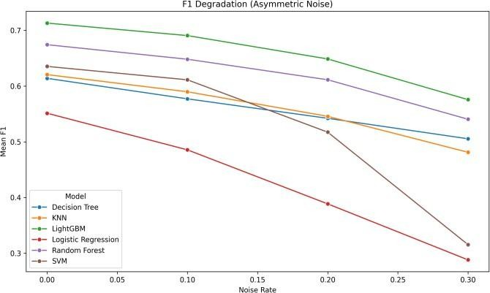
This effect was especially visible for Logistic Regression and SVM on the Adult dataset, where asymmetric noise caused a pronounced collapse in F1-score compared with the corresponding accuracy drop. On the Breast Cancer Wisconsin dataset, both accuracy and F1-score declined together, but the gap between them remained smaller because the dataset is relatively cleaner and balanced.
Fig. 10 and Fig. 10b present the F1-score degradation under symmetric noise for the Breast Cancer Wisconsin and Adult Income datasets, respectively. Similarly, Fig. 11 and Fig. 11b show the F1-score degradation under asymmetric noise for the two datasets. The asymmetric F1 plots show a more severe divergence between models than the corresponding accuracy plots, especially for Logistic Regression and SVM on the Adult dataset. Our empirical findings confirm that F1-score is a more sensitive and informative robustness metric in the presence of class imbalance, and it should accompany accuracy in noisy- label evaluations.
Fig. 10. F1-score degradation under symmetric noise — Breast Cancer Wisconsin dataset.
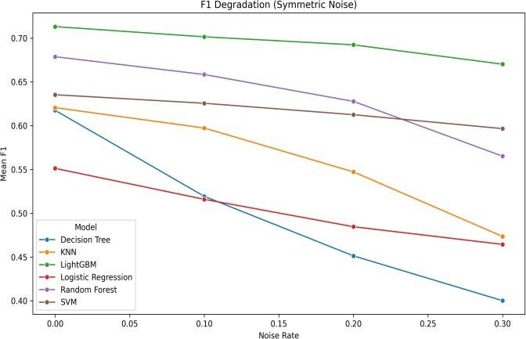
Fig. 10b. F1-score degradation under symmetric noise — Adult Income dataset.
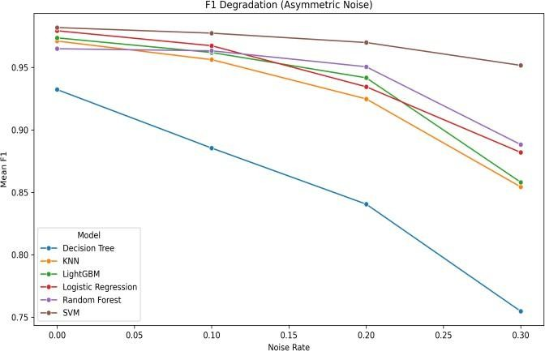
Fig. 11. F1-score degradation under asymmetric noise — Breast Cancer Wisconsin dataset.

Fig. 11b. F1-score degradation under asymmetric noise — Adult Income dataset.

Variance and Stability Across Folds
In addition to mean performance, fold-wise variation provides useful information about robustness. A robust model should not only preserve higher average accuracy, but also remain stable across different train-test partitions of the data.
On the Breast Cancer Wisconsin dataset, standard deviation values were generally higher than on the Adult dataset, which is expected because the smaller dataset size makes each fold more sensitive to local variations in noisy labels. Decision Tree displayed particularly high variability under both noise types, especially at higher symmetric noise levels. KNN and LightGBM also showed increased instability as noise increased. In contrast, SVM and Logistic Regression remained comparatively more stable across most settings.
On the Adult dataset, standard deviations were much smaller overall, reflecting the stabilizing effect of the larger sample size. Even so, the same broad pattern remained: Decision Tree and KNN were less stable when noise increased, whereas LightGBM, SVM, and Logistic Regression remained comparatively consistent. Random Forest also showed moderate stability, though generally not at the same level as the most stable models.
Fig. 12 shows mean accuracy with standard deviation bands across noise levels for both symmetric and asymmetric settings. The wider bands around Decision Tree and KNN confirm their greater instability, while the tighter bands around SVM and Logistic Regression reinforce their more consistent behaviour.
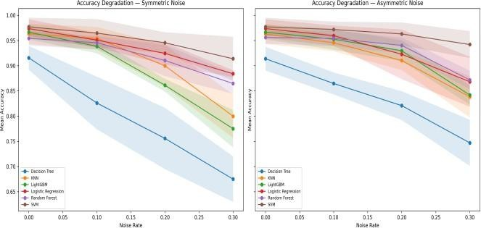
Fig. 12. Mean accuracy with ±1 standard deviation bands across noise levels and models.

Cross-Dataset Comparison
Comparing the two datasets reveals several meaningful and consistent patterns. First, baseline performance was much higher on Breast Cancer than on Adult, confirming that robustness must be interpreted relative to dataset difficulty. A model that performs extremely well on a clean, structured dataset may show more modest results on a larger, imbalanced real-world dataset.
Second, Decision Tree was consistently the weakest model in terms of robustness across both datasets and both noise types. This consistency across very different data domains and corruption settings strengthens confidence in the result and suggests that single-tree learning is inherently vulnerable to corrupted supervision.
Third, SVM was the most robust model on the Breast Cancer dataset and also the strongest performer under symmetric noise on the Adult dataset, demonstrating that margin-based learning provides strong resistance to random corruption. However, its weaker relative ranking under asymmetric noise on the Adult dataset shows that robustness is noise-type dependent rather than universal.
Fourth, LightGBM and Random Forest were strong all-round performers, especially on the Adult dataset. LightGBM achieved the best clean baseline there and remained among the stronger models under both noise types, though its advantage over SVM under symmetric noise is notable given LightGBM’s lower relative drop rank on Adult. Random Forest maintained solid robustness, consistently outperforming Decision Tree. Finally, KNN displayed dataset- and noise-specific behaviour: not among the strongest under symmetric noise, but the most robust under asymmetric noise on the Adult dataset.

Table V. Combined comparison of best baseline, best symmetric robustness, best asymmetric robustness, worst model, and strongest F1 collapse across both datasets. Rel. drop = relative accuracy drop at 30% noise.

Criterion | Breast Cancer | Adult Income | Pattern
Best Acc. | SVM (97.7) | LGBM (87.4) | Data-dependent
Best Sym. | SVM (6.5↓) | SVM (1.1↓) | Consistent
Best Asym. | SVM (3.6↓) | KNN (2.0↓) | Noise-dependent
Worst | Decision Tree | Decision Tree | Consistent
F1 Drop | Decision Tree | LR / SVM | Asym. noise

Fig. 13 and 13b present the robustness ranking bar chart for both noise types, summarizing the mean relative drop across all noise levels for each model. Fig. 14 and 14b present the relative drop heatmap across both noise types and all noise levels, enabling simultaneous comparison of all model-noise-level combinations.
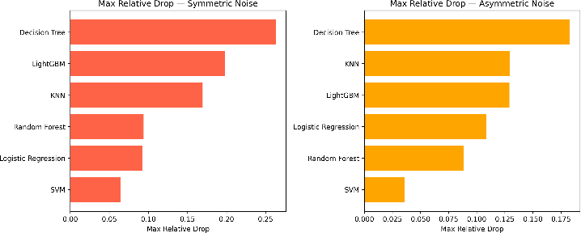
Fig. 13. Robustness ranking of all models by maximum relative accuracy drop at the highest noise level (30%) under symmetric (left) and asymmetric (right) noise - Breast Cancer Wisconsin.
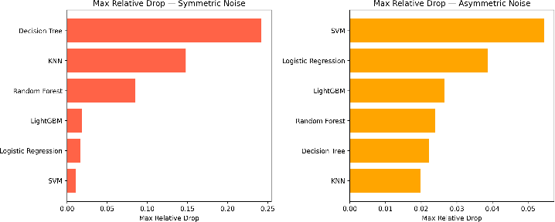

Fig. 13b. Robustness ranking of all models by maximum relative accuracy drop at the highest noise level (30%) under symmetric (left) and asymmetric (right) noise – Adult Income Dataset

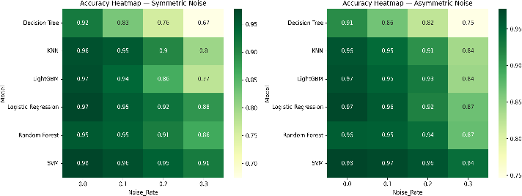

Fig. 14. Accuracy heatmap across all models and noise levels for symmetric (left) and asymmetric (right) noise - Breast Cancer Wisconsin.
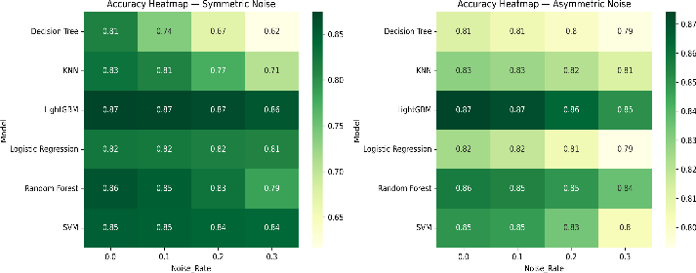

Fig. 14. Accuracy heatmap across all models and noise levels for symmetric (left) and asymmetric (right) noise – Adult Income Dataset
Fig. 15 and 15b show the degradation slope analysis, where steeper bars indicate faster accuracy decline per unit increase in noise rate. Fig. 16 and 16b show the degradation slope analysis, where steeper slopes indicate faster performance decline as noise increases.
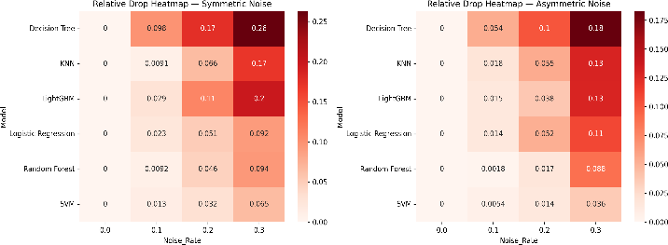
Fig. 15. Relative accuracy drop heatmap for all models and noise levels under both noise types - Breast Cancer Wisconsin.
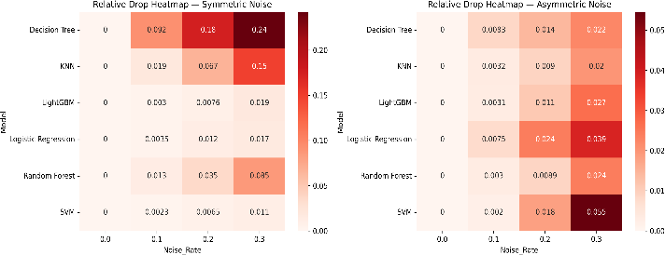
Fig. 15b. Relative accuracy drop heatmap for all models and noise levels under both noise types – Adult Income Dataset.
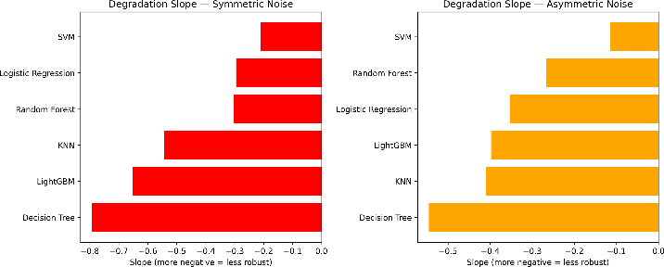
Fig. 16. Degradation slope (linear regression of accuracy on noise rate) for all models under symmetric (left) and asymmetric (right) noise - Breast Cancer Wisconsin.

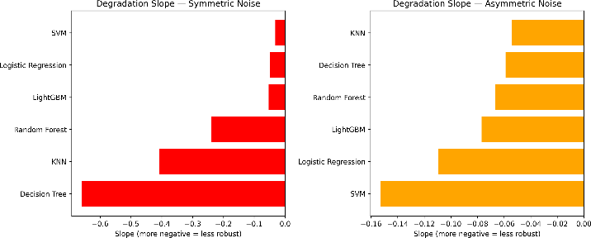
Fig. 16b. Degradation slope (linear regression of accuracy on noise rate) for all models under symmetric (left) and asymmetric (right) noise – Adult Income Dataset

Fig. 17 and Fig. 18 group models by their learning paradigm category and show mean accuracy trends under increasing noise rates, separately for each dataset. On the Breast Cancer Wisconsin dataset, the margin-based category (SVM) consistently shows the flattest degradation curve under both noise types. The tree-based category (Decision Tree) shows the steepest decline. Ensemble and boosting categories fall between these extremes, confirming that aggregation provides partial but not complete protection against label corruption.
On the Adult dataset, the category pattern shifts under asymmetric noise: the instance-based category (KNN) becomes the most stable, overtaking the margin-based category. This cross-dataset divergence reinforces the conclusion that no single learning paradigm is universally most robust; the interaction between model design, data structure, and noise type determines

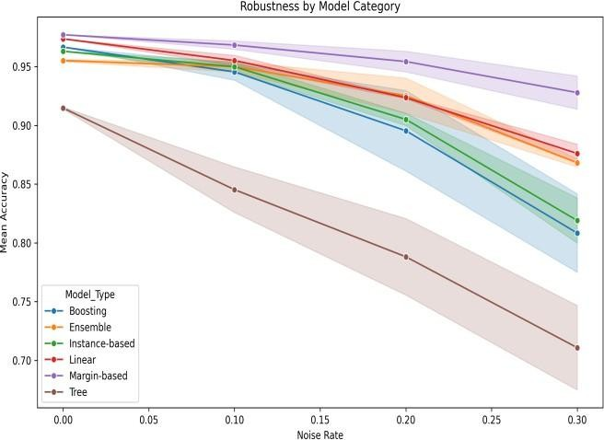
the observed behaviour.
Fig. 17. Mean accuracy by model category across increasing noise rates
— Breast Cancer Wisconsin dataset.
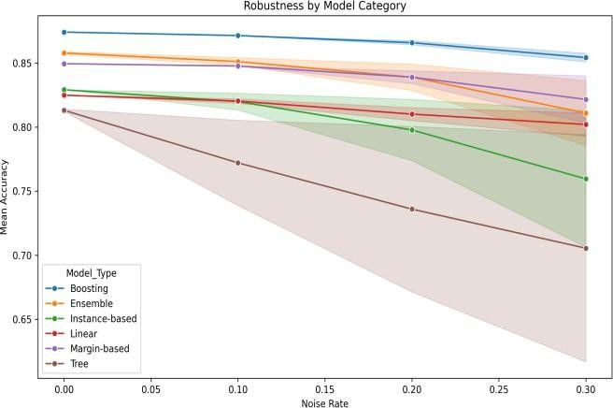
Fig. 18. Mean accuracy by model category across increasing noise rates
— Adult Income dataset.

Fig. 19 presents the bar chart comparing model accuracy at the highest noise level (30%) across both noise types and both datasets. This visualization highlights the absolute performance remaining after strong corruption, complementing the relative drop analysis.
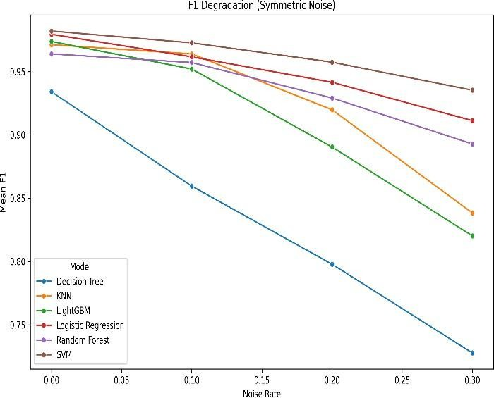

Fig. 19. Mean F1-score degradation under symmetric label noise across increasing noise rates — Breast Cancer Wisconsin dataset.
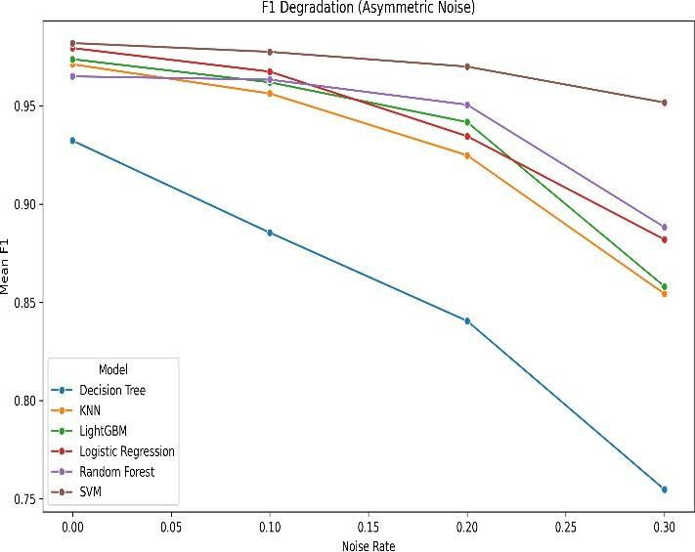

Fig. 20. Mean F1-score degradation under asymmetric label noise across increasing noise rates — Adult Income Dataset
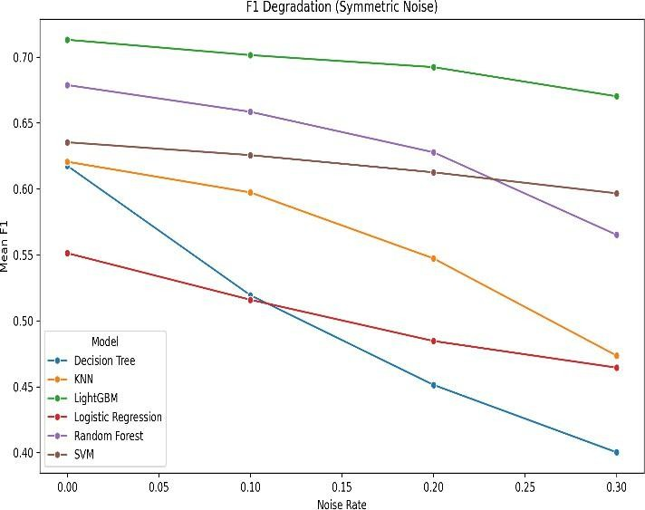
Fig. 21. Mean F1-score degradation under symmetric label noise across increasing noise rates — Adult Income dataset.

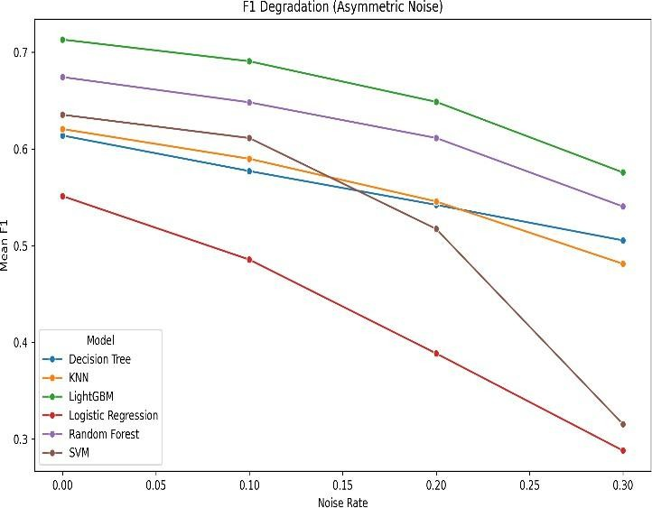

Fig. 22. Mean F1-score degradation under asymmetric label noise across increasing noise rates — Adult Income dataset.

Discussion with Respect to Research Questions
RQ1 — How do classical machine learning models behave under label noise? All models degrade as noise increases, but the magnitude of degradation differs substantially across models and datasets. Tree-based and instance-based methods are generally more sensitive, while margin-based and ensemble methods are more robust. The results show that no model is immune to label noise, but some are significantly more tolerant than others.
RQ2 — What is the difference between symmetric and asymmetric noise? Symmetric noise is consistently more damaging than asymmetric noise for most models and on both datasets. This is because symmetric flipping corrupts labels in all directions, eliminating more of the class structure. However, asymmetric corruption can still produce severe decline in some models, particularly in F1-score on the Adult dataset. The reversal of robustness rankings under asymmetric noise on the Adult dataset is a key finding that highlights the interaction between noise type and model design.
RQ3 — Are robustness patterns consistent across datasets? Partially. Some trends are consistent across both datasets, such as the poor robustness of Decision Tree and the strong robustness of SVM under symmetric noise. However, the best-performing model under asymmetric noise changes between datasets (SVM on Breast Cancer, KNN on Adult), indicating that robustness conclusions drawn from a single dataset may not generalize. Cross-dataset evaluation is therefore essential in robustness studies.

Key Takeaways from the Results
  - Clean-data accuracy does not imply robustness. LightGBM achieved the best baseline on Adult but ranked lower than SVM in symmetric robustness.
  - Symmetric noise is more destructive. It produced consistently higher relative drops than asymmetric noise across all models and both datasets.

  - SVM is the most robust under symmetric corruption. It ranked first on both datasets under symmetric noise, with only 6.5% and 1.1% relative drops at 30% noise.
  - Decision Tree is consistently the least robust. It showed the largest relative drops on both datasets under both noise types, with drops exceeding 24%.
  - Robustness is noise-type- and dataset-dependent. The KNN reversal on Adult under asymmetric noise shows that robustness rankings are not universal.
  - F1-score reveals hidden degradation. Particularly on the imbalanced Adult dataset, F1-score collapsed more severely than accuracy, making it an essential complementary metric.
Taken together, these results demonstrate that robustness analysis is essential before deploying a model in real-world settings where label quality cannot be guaranteed. A classifier that appears best on clean data may not remain the best once label corruption is introduced, and the choice of evaluation metric matters for accurately measuring that degradation.

I. CONCLUSION AND FUTURE SCOPE
This study examined the robustness of six classical machine learning models under controlled label noise on two benchmark tabular datasets, namely the Breast Cancer Wisconsin Diagnostic dataset and the Adult Income dataset. The experiments were conducted using symmetric and asymmetric label noise at multiple corruption levels, while evaluation was always performed on clean test data. The main goal was to understand how performance changes when the quality of training labels deteriorates.
The results show that label noise consistently reduces model performance, but the degree of degradation strongly depends on the model, dataset, and type of noise. Across both datasets, symmetric noise was generally more damaging than asymmetric noise, indicating that random label corruption disrupts the learning process more severely than directional mislabelling. This pattern remained visible in both accuracy and F1-score trends.
Another important finding is that clean-data performance does not always imply robustness under noisy supervision. On the Breast Cancer Wisconsin dataset, SVM achieved the strongest overall robustness and retained high performance even at higher noise levels. On the Adult dataset, LightGBM produced the best clean baseline, while SVM remained the strongest under symmetric noise. However, under asymmetric noise on the Adult dataset, KNN showed the smallest relative degradation. These observations confirm that robustness is context-dependent and that no single classifier is universally best for all label corruption settings.
The study also showed that Decision Tree was the most vulnerable model across most settings. Its performance dropped sharply under both symmetric and asymmetric noise,
and its variability across folds was also comparatively high. In contrast, ensemble and margin-based methods were generally more stable. Random Forest and LightGBM maintained competitive robustness in many cases, while SVM demonstrated especially strong resistance to random corruption.
The analysis further revealed that F1-score often exposed performance deterioration more clearly than accuracy, particularly on the Adult dataset, where some models showed moderate accuracy decline but substantial F1 collapse. This highlights the importance of using multiple evaluation measures in noisy-label studies.

Table VI summarizes the main cross-dataset robustness patterns observed in the study. It shows that best clean-data performance does not necessarily imply best robustness under label noise. Across both datasets, SVM remained the strongest model under symmetric noise, whereas the most robust model under asymmetric noise varied by dataset.
Decision Tree was consistently the least robust model. In addition, the difference between accuracy and F1-score was more pronounced on the Adult dataset, indicating that F1-score captured the impact of noisy supervision more clearly under class imbalance.

Table VI. Combined cross-dataset comparison showing best baseline, best robustness under each noise type, worst model, and F1 collapse pattern.
Rel. drop = relative accuracy drop at 30% noise.

Criterion | Breast Cancer | Adult Income | Pattern
Best Baseline Accuracy | SVM (97.7%) | LightGBM (87.4%) | Dataset-dependent
Best Sym. Robustness | SVM (6.5% rel.  drop) | SVM (1.1% rel.  drop) | Consistent: SVM
Best Asym. Robustness | SVM (3.6% rel.  drop) | KNN (2.0% rel.  drop) | Noise-type dependent
Least Robustness | Decision Tree (26.3%) | Decision Tree (24.2%) | Consistent: DT worst
Strongest F1 Collapse | Decision Tree | Logistic Reg. / SVM | Asym. noise on Adult
Overall, the findings answer the research objective clearly: classical machine learning models do not respond equally to noisy labels, and robustness depends on the interaction between learning mechanism, dataset characteristics, and corruption type. Therefore, robustness evaluation should be considered an essential part of model selection when training labels may be imperfect.

A. Future Scope
This work can be extended in several meaningful directions. First, more benchmark datasets can be added so that the conclusions become stronger and more generalizable across domains. Second, additional noise mechanisms can be studied, such as class-dependent noise, instance-dependent noise, or real annotation uncertainty, which better reflect practical data collection scenarios.

Third, the study can be expanded beyond classical machine learning models to include deep learning approaches and noise-aware training methods. Fourth, advanced robustness techniques such as loss correction, sample reweighting, confident learning, or noise filtering may be incorporated to compare standard learning with explicit noise-handling strategies.
Finally, future work may include statistical significance testing and more detailed theoretical interpretation of why specific models remain more stable than others under different corruption settings. In summary, this work provides a clear experimental foundation for understanding label-noise robustness in classical machine learning and can serve as a base for more advanced and application-oriented research in noisy supervised learning.

REFERENCES
- W. Wolberg, O. Mangasarian, N. Street, and W. Street. "Breast Cancer Wisconsin (Diagnostic)," UCI Machine Learning Repository, 1993. [Online]. Available: https://doi.org/10.24432/C5DW2B.
- B. Becker and R. Kohavi. "Adult," UCI Machine Learning Repository, 1996. [Online]. Available: https://doi.org/10.24432/C5XW20.
- C. M. Bishop, Pattern Recognition and Machine Learning. New York, NY, USA: Springer, 2006.
- L. Breiman, “Random forests,” Machine Learning, vol.
45, no. 1, pp. 5–32, 2001.
- V. N. Vapnik, Statistical Learning Theory. New York, NY, USA: Wiley, 1998.
- J. H. Friedman, “Greedy function approximation: A gradient boosting machine,” Annals of Statistics, vol. 29, no. 5, pp. 1189–1232, 2001.
- G. Ke et al., “LightGBM: A highly efficient gradient boosting decision tree,” in Proc. NeurIPS, 2017, pp. 3146–3154.
- D. Angluin and P. Laird, “Learning from noisy examples,” Machine Learning, vol. 2, no. 4, pp. 343–
370, 1988.
- B. Frenay and M. Verleysen, “Classification in the presence of label noise: A survey,” IEEE Trans. Neural Netw. Learn. Syst., vol. 25, no. 5, pp. 845–869, 2014.
- X. Zhu and X. Wu, “Class noise vs. attribute noise: A quantitative study,” Artificial Intelligence Review, vol. 22, pp. 177–210, 2004.
- S. Rolnick et al., “Deep learning is robust to massive label noise,” arXiv preprint arXiv:1705.10694, 2017.
- J. Patrini et al., “Making deep neural networks robust to label noise: A loss correction approach,” in Proc. CVPR, 2017, pp. 1944–1952.
- C. Northcutt, T. Wu, and I. Chuang, “Confident learning: Estimating uncertainty in dataset labels,” J. Artificial Intelligence Research, vol. 70, pp. 1373–1411, 2021.
- N. Natarajan et al., “Learning with noisy labels,” in Proc. NeurIPS, 2013, pp. 1196–1204.
- C. Cortes and V. Vapnik, “Support-vector networks,” Machine Learning, vol. 20, no. 3, pp. 273–297, 1995.
- E. Fix and J. L. Hodges, “Discriminatory analysis: Nonparametric discrimination: Consistency properties,” USAF School of Aviation Medicine, Project 21-49-004, Report No. 4, 1951.
- L. Rokach, “Decision trees: A survey,” Data Mining and Knowledge Discovery, vol. 14, no. 1, pp. 1–26, 2006.

