Evaluating the Robustness of Lightweight Machine Learning Models to Label Noise

Garima  Dept. of Computer Science & Engineering  Chitkara University  Punjab, India  garima313.be22@chitkara.edu.in | Gurnoor Dhaliwal  Dept. of Computer Science & Engineering  Chitkara University  Punjab, India  gurnoor344.be22@chitkara.edu.in | Gagan Deep  Dept. of Computer Science & Engineering  Chitkara University  Punjab, India  gagandeep310.be22@chitkara.edu.in

Divesh Gupta  Dept. of Computer Science & Engineering  Chitkara University  Punjab, India  divesh291.be22@chitkara.edu.in | Dr. Shikha Tuteja*  Assosiate Professor  Dept. of Computer Science & Engineering  Chitkara University  Punjab, India  shikha.1290@chitkara.edu.in

Abstract—Label noise is a common issue in real-world datasets and can significantly degrade the performance of machine learning models. This study investigates the robustness of six classical machine learning models— Logistic Regression, Decision Tree, Random Forest, Support Vector Machine (SVM), K-Nearest Neighbors (KNN), and LightGBM—under two types of label noise: symmetric and asymmetric. Experiments are conducted on two datasets, namely Breast Cancer Wisconsin and Adult Income, to evaluate the generalizability of model behavior. Noise is injected only into the training data at varying levels (0%, 10%, 20%, and 30%), while evaluation is performed on clean test data using Accuracy and F1-score metrics.
Results show that symmetric noise leads to significantly higher performance degradation compared to asymmetric noise across all models. Among the evaluated models, SVM demonstrates strong and consistent robustness across most settings, while Decision Tree exhibits the highest sensitivity to label corruption. Additionally, F1-score is observed to be more sensitive to noise than accuracy, particularly in imbalanced datasets such as Adult Income. The findings highlight the importance of selecting noise-robust models and appropriate evaluation metrics in real-world scenarios where data quality cannot be guaranteed.
Keywords - Label noise, machine learning robustness, symmetric noise, asymmetric noise, SVM, LightGBM, Decision Tree, noisy labels, classification.

Introduction
Machine learning models rely heavily on the assumption that training data is accurately labeled. However, in real-world scenarios, this assumption is often violated due to human annotation errors, ambiguous data instances, automated labeling pipelines, or inconsistencies in data collection processes. Such incorrect or corrupted labels are commonly referred to as label noise [8], and they can significantly degrade model performance and reliability.
The presence of label noise is particularly critical because it directly affects the learning signal during training. Unlike feature noise, which corrupts input attributes, label noise corrupts the target signal itself [10]. As a result,
models may learn incorrect decision boundaries, leading to poor generalization and unstable predictions. This issue becomes even more important in domains such as healthcare, finance, and decision-support systems, where incorrect predictions can have serious consequences.
To systematically study this problem, label noise is typically categorized into two major types: symmetric noise and asymmetric noise. In symmetric noise, class labels are randomly flipped with a certain probability, representing uniform corruption across all classes. In contrast, asymmetric noise introduces structured or directional corruption, where labels are flipped from one class to another in a controlled manner. These two noise settings allow researchers to simulate both random and realistic label corruption scenarios.
While a large body of research has focused on deep learning approaches for handling noisy labels [11], [12], classical machine learning models remain widely used, especially for tabular datasets. Classical models such as Logistic Regression, Decision Trees [17], Random Forests [4], Support Vector Machines (SVM) [15], K-Nearest Neighbours (KNN), and gradient boosting methods such as LightGBM [7] remain widely used in tabular-data settings. However, their robustness under controlled label noise conditions is not always well understood, particularly in a comparative and multi-dataset setting.
In this study, we investigate the robustness of six classical machine learning models under varying levels of symmetric and asymmetric label noise. Experiments are conducted on two benchmark datasets with distinct characteristics: a smaller, clean, numerical dataset (Breast Cancer Wisconsin Diagnostic) and a larger, heterogeneous dataset with mixed feature types (Adult Income). This dual-dataset setup enables evaluation of whether robustness patterns are consistent across different data domains.
To ensure a fair and controlled evaluation, noise is introduced only in the training data, while testing is performed on clean, untouched data. Performance is evaluated using both Accuracy and F1-score, along with additional metrics such as relative degradation and variance across folds.

The main contributions of this work are as follows:
- A systematic comparison of six classical machine learning models under controlled symmetric and asymmetric label noise.
- A cross-dataset evaluation demonstrating how robustness varies with dataset characteristics.
- An analysis of performance degradation using both Accuracy and F1-score, highlighting differences between these metrics.
- Identification of models that are consistently robust or highly sensitive to noisy labels.
The findings of this study provide practical insights into model selection in noisy environments and emphasize the importance of robustness analysis in real-world machine learning applications.

LITERATURE REVIEW
For decades, label noise has posed serious problems in supervised classification tasks because incorrect labels interfere with model training and reduce generalization performance. Studies published recently indicate ongoing interest in handling noisy labels, exploring strategies such as robust training methods, filtering mislabelled instances, selecting reliable samples, and adjusting objective functions [9]. Even though many current approaches centre on neural networks, the core difficulty applies broadly across machine learning. If labelling errors exist, models may learn unstable decision boundaries, and reported test outcomes can become misleading.
One typical method in studies of label noise involves evaluating models using artificially introduced errors, allowing researchers to observe how accuracy drops under controlled conditions [9], [10], [14]. Among these setups, two appear most frequently: one where mistakes occur randomly across categories, and another where they follow structured patterns tied to class types. When labels shift without preference among groups, model training becomes less reliable overall. However, when mislabelling follows patterns—such as confusion between similar classes—the effect mimics real-world inconsistencies like human annotation bias or overlap between related classes [9], [10], [14]. These differences influence how algorithms respond during learning, as structured errors affect models differently than random ones.
Looking at past research, the focus on robustness tends to center on deep neural networks, particularly within fields such as medical imaging and visual recognition. Recent work has explored approaches including confident learning, data filtering, loss adjustment, sample selection, and transition-matrix estimation [9], [12], [13], [14]. Still, classical machine learning methods remain common when working with tabular data. Their appeal lies in straightforward training, easier interpretation, and suitability for structured datasets. Because of this, relatively fewer studies examine how standard classification algorithms perform under noisy labels, especially without using specialized noise-handling techniques.
Dataset selection also plays an important role when evaluating robustness. Relying on a single dataset risks making conclusions too dependent on a specific data distribution, so cross-dataset comparison becomes necessary to identify stable patterns [9]. In this work, the Breast Cancer Wisconsin (Diagnostic) dataset and the Adult dataset are

chosen as contrasting cases. The Breast Cancer dataset contains features derived from digitized biopsy images of breast tissue [1], while the Adult dataset is larger, more heterogeneous, and includes mixed feature types with some missing values [2].
Since these datasets differ in scale, structure, and domain, they allow examination of whether robustness patterns remain consistent across different classification settings. From this perspective, the present study focuses on comparing six classical machine learning models under controlled symmetric and asymmetric label noise using two standard UCI datasets. Rather than introducing a new noise-handling method, the aim is to identify which models remain stable, which degrade significantly, and whether high baseline accuracy truly reflects robustness under noisy training conditions. Such insights are especially relevant in practical tabular-data scenarios where perfect labelling cannot be guaranteed.
- METHODOLOGY

Research Objective
This research aims to assess how well traditional machine learning classifiers withstand artificially induced label errors during training. With test sets kept accurate, attention turns to shifts in model behavior as flawed labels enter the learning phase. Performance unfolds through comparisons involving diverse data collections, varying forms of mislabeling, and differing degrees of corruption, measured by common classification criteria.

Datasets
One reason for using multiple datasets is to examine whether findings remain consistent across different settings. The Breast Cancer Wisconsin Diagnostic dataset is relatively small, numerical, and clean, which makes it suitable for careful and controlled experimentation. While simpler, it helps in validating the pipeline and observing behavior clearly. In contrast, the Adult Income dataset is larger and more complex, with mixed feature types that better reflect real-world conditions. Because of this, it provides a more challenging setting to evaluate whether observed patterns still hold. When similar results are observed across both datasets, it increases confidence that the findings are not limited to a single data distribution.
TABLE I Summary of Datasets Used in the Study
Dataset | Instances | Features | Task Type | Source
Breast Cancer Wisconsin | 569 | 30 | Binary Classification | UCI ML  Repository [1]
Adult Income | 48,842 | 14 | Binary Classification | UCI ML  Repository [2]

Experimental Models
Six classical supervised machine learning models were selected for comparison: Logistic Regression, Decision Tree, Random Forest, Support Vector Machine (SVM), K-Nearest Neighbors (KNN), and LightGBM. These models were chosen because they represent different learning mechanisms, including linear, tree-based, margin-based, instance-based, ensemble, and boosting approaches.
TABLE II Classical Machine Learning Models Used in the Study

Model | Category | Working Principle | Reason
Logistic Regression | Linear | Linear boundary via probabilities | Baseline model
Decision Tree | Tree | Hierarchical rule- based splits | Studies split sensitivity
Random Forest | Ensemble | Averaged trees on random subsets | Improves robustness
SVM | Margin | Max-margin hyperplane | Strong tabular performance
KNN | Instance | Nearest neighbor voting | Sensitive to noisy labels
LightGBM | Boosting | Sequential boosted trees | Powerful tabular learner

Dataset Selection
▼
Preprocessing
▼
Train-Test Split / Stratified Folds
▼
Noise Injection in Training Labels Only

▼
Train 6 Classical ML Models
▼
Evaluate on Clean Test Data
▼
Compute Accuracy and F1-score

Experimental Pipeline
From the start, testing followed a fixed pattern so each model faced the same level of label noise during observation. Consistency stayed central throughout every run, with behaviour tracking focused on shifts caused by changes in label quality alone.
Baseline Training: First, every dataset stayed exactly as it came — no changes made. It was split into training and testing sets. Six models were trained using correct labels only. Performance was captured using prediction accuracy and balance across outcomes, which became the reference point for later stages.
Cross-Validation Setup: Instead of one random split, the method used five chunks of data while keeping class proportions steady. Each split reflected the overall class mix, helping results stay stable across different runs.
Noise Injection: Errors were introduced only in the training data, while test data remained clean. Labels were flipped randomly in symmetric cases, and directionally between specific classes in asymmetric cases. The amount of noise depended on the selected level.
Model Training and Evaluation: For each dataset, noise type, noise level, and split, all six models were trained on noisy data and evaluated on clean test data. This was repeated consistently to observe performance changes as noise increased.
TABLE III Noise Settings and Evaluation Criteria
Component | Setting / Value
Noise Types | Symmetric noise, Asymmetric noise
Noise Rates | 0%, 10%, 20%, 30%
Noise Injection Target | Training labels only
Test Set | Clean and untouched
Validation Strategy | 5-fold stratified cross-validation
Performance Metrics | Accuracy, F1-score
Additional Analysis | Relative degradation, standard deviation, robustness ranking

▼
Aggregate Results Across Noise Levels and Folds
▼
Robustness Analysis (Relative Drop, Variance, Ranking)
Fig. 1. Overall workflow of the proposed robustness evaluation framework for classical machine learning models under label noise.

Performance Measures
When guesses line up with what really happens, they boost the accuracy number. That figure shows the share of correct predictions out of all predictions made, giving an overall picture of performance.
F1-score steps in when things get lopsided, merging precision with recall to give a clearer picture. Uneven groups tilt the scales — accuracy alone can miss important details.
Noise changes how well models work. A number called RPD(η) tracks the shift by comparing performance under noise with the clean baseline. As distortion increases, performance drops, showing how each model deteriorates.
Stability is checked by looking at differences across folds. Standard deviation shows how much results shift when data is split in different ways.
- Result Aggregation and Analysis
After testing finishes, results from every fold are combined into summary tables. Averages for Accuracy and F1-score are reported for each setup — along with their variation.
Performance changes under noise are then examined. Some systems weaken faster than others. Differences also appear between symmetric and asymmetric noise, as well as across different model types.

Reproducibility and Implementation
Tests are run in Python using notebook-style setups. Separate notebooks handle baseline checks, noise generation, cross-validation, and analysis.
A fixed starting point for randomness ensures results stay consistent across runs.

RESULTS AND DISCUSSION
Results come from tests using two sets: one about breast cancer, another about income levels, both checked under symmetric and asymmetric label noise. Attention goes beyond just scores — patterns in stability matter, along with how sharply results drop when noise rises, and how each model behaves differently across these cases. Because the aim

aim here is understanding resistance to errors, not peak precision, the view centres on shifts in outcomes as messier data enters the picture.

Baseline Performance on Clean Data
First up, each model ran on clean training data prior to introducing noise. The Breast Cancer Wisconsin dataset performed well overall, hinting at good structure and distinct signals. At the peak stood SVM, hitting 97.7% in average accuracy and a 98.2% F1-score. Close after was Logistic Regression — accuracy measured 97.4%, its F1 settled at 97.9%. Just below appeared LightGBM: accuracy marked 96.7%, along with an F1 of 97.4%.
KNN held its ground, along with Random Forest, with accuracies of 96.3% and 95.4%, respectively. Trailing behind, Decision Tree landed at 91.6% correct predictions, paired with an F1-score of 93.4%.
Adult Income data proved harder to handle. Performance slipped because of higher complexity, mixed features, and class imbalance. Leading was LightGBM — 87.4% accuracy, F1 at 71.3%. Right after followed Random Forest (85.9% / 67.9%). Not far back stood SVM with 84.9% accuracy and 63.5% F1-score. Logistic Regression and KNN showed moderate performance. Trailing again was Decision Tree — 81.4% accuracy and 61.8% F1-score.
Fewer errors appeared when ensemble-based models handled the Adult dataset, while margin-based methods performed better on the cleaner Breast Cancer Wisconsin dataset.

Table IV. Baseline mean accuracy and F1-score at 0% label noise for all models on the Breast Cancer Wisconsin and Adult Income datasets. BC = Breast Cancer Wisconsin. Sym. = Symmetric,
Asym. = Asymmetric

Model | BC Acc. | BC F1 | Adult Acc. | Adult F1
SVM | 97.7% | 98.2% | 84.9% | 63.5%
Logistic Reg. | 97.4% | 97.9% | 82.5% | 55.1%
LightGBM | 96.7% | 97.4% | 87.4% | 71.3%
KNN | 96.3% | 97.1% | 82.9% | 62.1%
Random Forest | 95.4% | 96.4% | 85.9% | 67.9%
Decision Tree | 91.6% | 93.4% | 81.4% | 61.8%

Effect of Symmetric Label Noise
Performance dipped under symmetric noise across both datasets. As noise increased from 0% to 30%, performance degradation became more noticeable. However, models did not deteriorate at the same rate.
SVM handled symmetric noise best on the Breast Cancer Wisconsin dataset, with only a 6.5% relative accuracy drop at 30% noise. Logistic Regression followed with a 9.2% drop, and Random Forest with 9.4%. Decision Tree showed the highest degradation at 26.3%, indicating high sensitivity to incorrect labels. LightGBM dropped by 19.8%, while KNN showed a 16.9% decline at the highest noise level.
A slight change in ranking appeared on the Adult Income dataset, though the overall pattern remained similar. SVM

again remained the most robust, with only a 1.1% relative drop at 30% noise. Logistic Regression followed at 1.7%, and LightGBM at 1.9%, notable since it had the best baseline performance. Decision Tree remained the weakest, with a 24.2% drop. KNN showed a 14.8% decline, while Random Forest dropped by 8.5%.
Figure 2 shows the degradation curves for the Breast Cancer Wisconsin dataset, while Figure 3 shows the same for the Adult Income dataset. Decision Tree and KNN show steep declines, indicating high sensitivity to random label noise. In contrast, SVM and Logistic Regression show relatively stable curves on the Adult dataset, indicating stronger robustness.
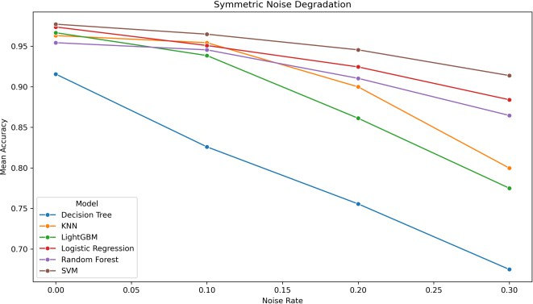
.

Fig. 2. Accuracy degradation under symmetric noise across noise levels
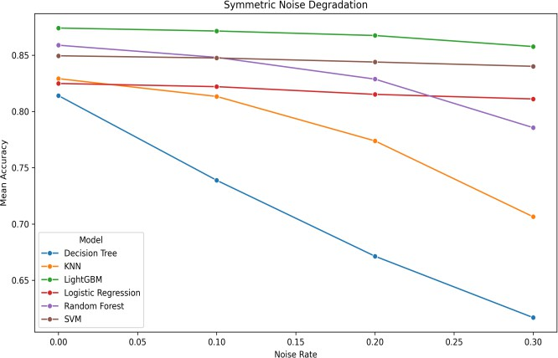
— Breast Cancer Wisconsin dataset

Fig. 3. Accuracy degradation under symmetric noise across noise levels
— Adult Income dataset.

Fig. 4 shows the relative accuracy drop under symmetric noise for the Breast Cancer Wisconsin dataset, while Fig. 5 shows the corresponding trend for the Adult Income dataset. Decision Tree exhibits the highest relative drop in both datasets, confirming its strong sensitivity to label corruption. In contrast, SVM shows the smallest relative drop, especially on the Adult dataset, indicating
better robustness. KNN and LightGBM display moderate degradation, with increasing drops at higher noise levels.

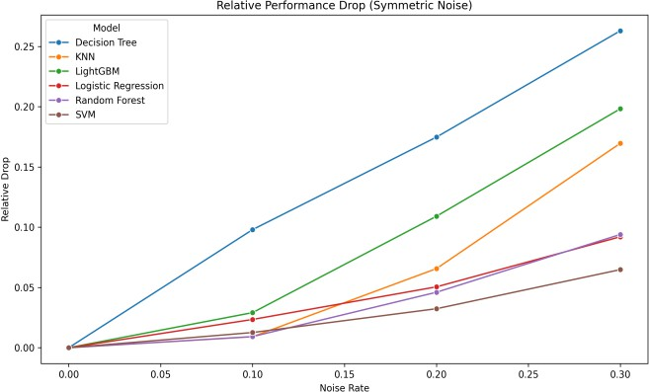

Fig. 4. Relative accuracy drop (%) under symmetric noise — Breast
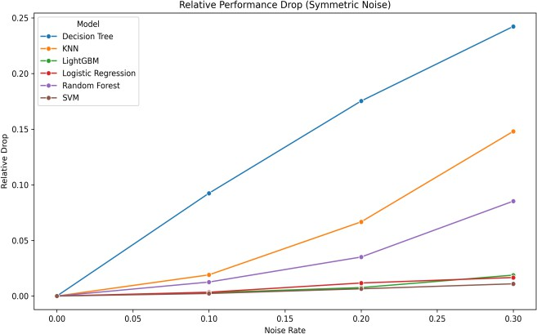
Cancer Wisconsin dataset
Fig. 5. Relative accuracy drop (%) under symmetric noise — Adult Income dataset.

Effect of Asymmetric Label Noise
Asymmetric Performance dipped with asymmetric noise too, yet the impact stayed milder compared to symmetric distortion — particularly at lower noise levels. Because the damage leans one way, some category patterns survive, letting systems still tell differences apart without collapsing completely amid scattered faults.
SVM held up best on the Breast Cancer Wisconsin data when faced with uneven noise — just a 3.6% dip at 30% noise level. Behind it, Random Forest slipped less than others, showing an 8.8% fall in performance. Logistic Regression trailed slightly further back, dropping 10.8%. The biggest hit went to Decision Tree, which lost 18.3% of its edge. In between, KNN dipped by 13.0%; close behind, LightGBM fell 12.9%.
With the Adult data, things shifted clearly, revealing a standout result. When noise tilted one way, KNN slipped least — just 2.0% down at 30% interference, topping all models here. Right behind came Decision Tree, falling by 2.2%; then Random Forest, dropping 2.4%. But SVM? It had led during balanced disruption, yet now became one of the more affected models.
SVM showed the largest drop on the Adult dataset under asymmetric noise, with a 5.5% decrease.

Not far behind, Logistic Regression slipped too, dipping 3.9%, mostly seen in its F1-score.
This flip shows how a model's strength isn’t set in stone — it shifts depending on how the architecture meets the data traits and corruption kind. Because certain local patterns stay intact under uneven distortion, techniques relying on proximity or splits manage to keep working fairly well on the Adult set.
But approaches like SVM, which draw broad dividing lines, stumble more once labels lean one way.
Fig. 6 and Fig. 7 show the accuracy degradation curves under asymmetric noise for both datasets. The shallower overall slopes compared to symmetric noise confirm that asymmetric corruption is generally less destructive. However, the divergence between models remains clear, especially on Breast Cancer where SVM and Random Forest separate visibly from Decision Tree.
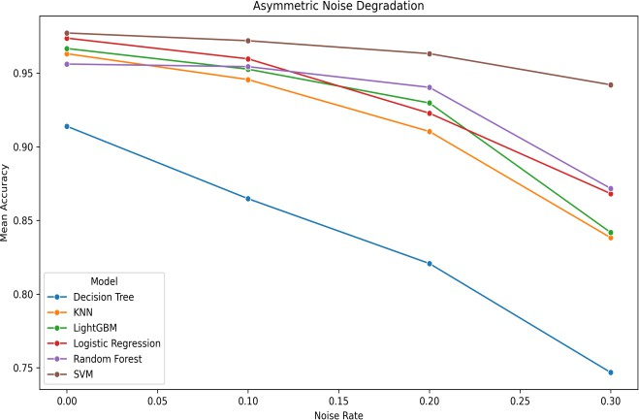
Fig. 6. Accuracy degradation under asymmetric noise across noise levels
— Breast Cancer Wisconsin dataset.
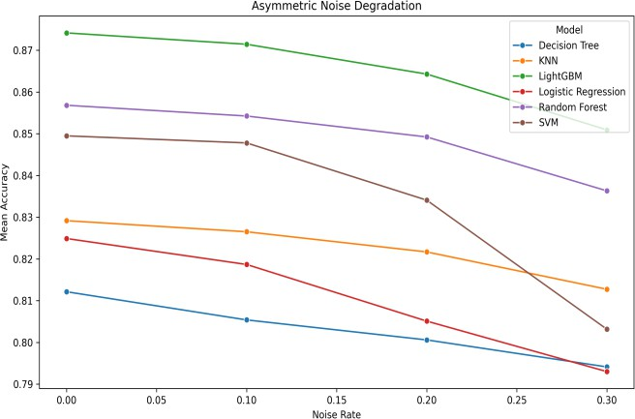
Fig. 7. Accuracy degradation under asymmetric noise across noise levels
— Adult Income dataset.
Fig. 8 and Fig. 9 present the relative performance drop under asymmetric noise. The ranking reversal between SVM and KNN on the Adult dataset is clearly visible in Fig. 9, where KNN achieves the smallest drop and SVM the largest among all models.

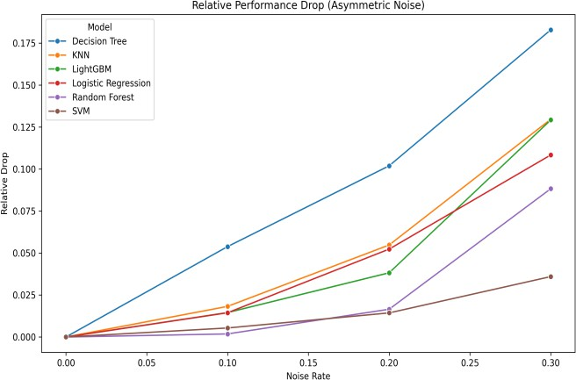
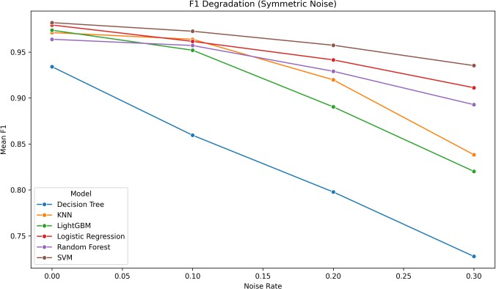

Fig. 8. Relative accuracy drop (%) under asymmetric noise — Breast
Cancer Wisconsin dataset.

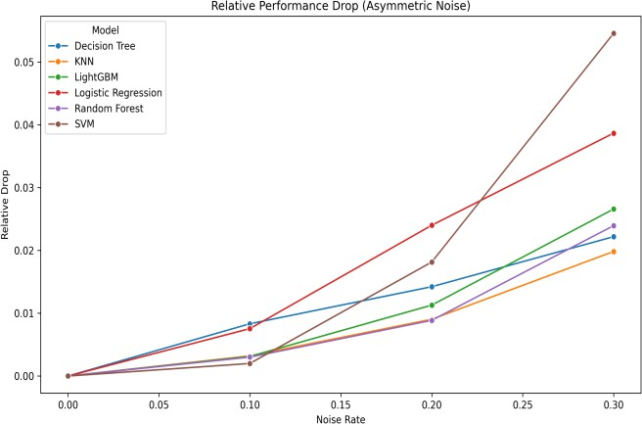
Fig. 9. Relative accuracy drop (%) under asymmetric noise — Adult Income dataset.

Comparative Behaviour of Accuracy and F1-Score
Test results show that accuracy alone can miss some effects of mislabeled data. When label errors occur, the F1-score often drops more than accuracy — this becomes clear in the Adult dataset under asymmetric noise. Uneven labeling can hide deeper issues, where class-level performance drops even when overall accuracy still looks stable.
F1-scores for Logistic Regression and SVM dropped more sharply than accuracy under asymmetric noise in the Adult dataset, even though the overall pattern was similar. On the other hand, the Breast Cancer Wisconsin results showed nearly equal reductions in both measures. The gap was smaller there, likely because the dataset is more balanced and less affected by noise.
Fig. 10 and Fig. 10b present the F1-score degradation under symmetric noise for the Breast Cancer Wisconsin and Adult Income datasets, respectively. Similarly, Fig. 11 and Fig. 11b show the F1-score degradation under asymmetric noise for the two datasets. The asymmetric F1 plots show a more severe divergence between models than the corresponding accuracy plots, especially for Logistic Regression and SVM on the Adult dataset. Our empirical findings confirm that F1-score is a more sensitive and informative robustness metric in the presence of class imbalance, and it should accompany accuracy in noisy- label evaluations.
Fig. 10. F1-score degradation under symmetric noise — Breast Cancer Wisconsin dataset.
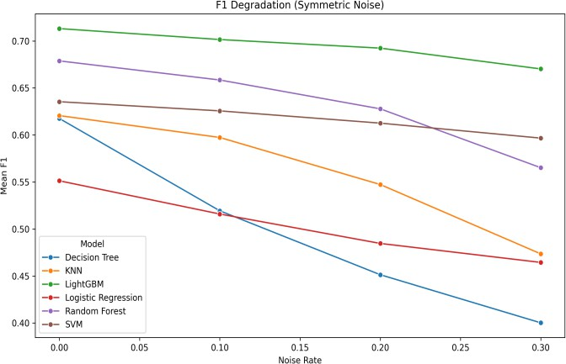
Fig. 10b. F1-score degradation under symmetric noise — Adult Income dataset.
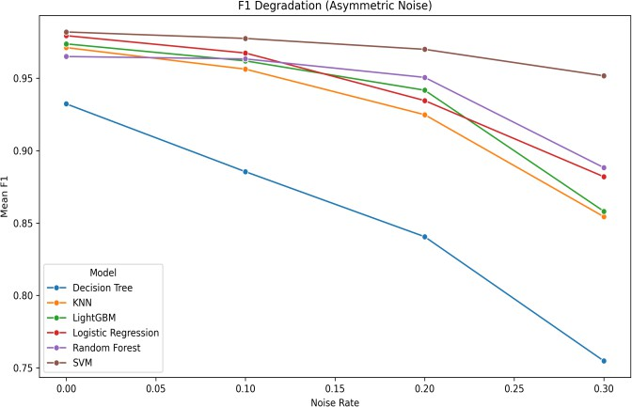
Fig. 11. F1-score degradation under asymmetric noise — Breast Cancer Wisconsin dataset.
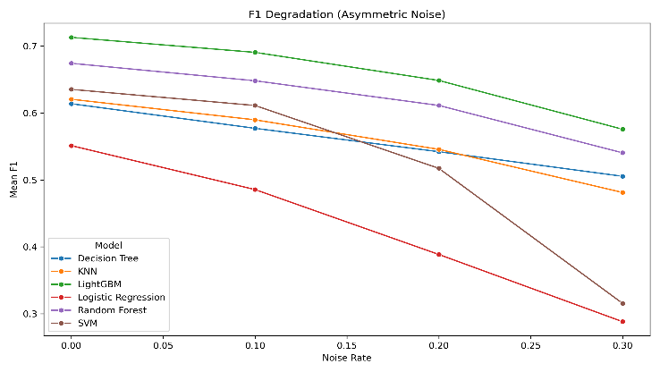
Fig. 11b. F1-score degradation under asymmetric noise — Adult Income dataset.

Variance and Stability Across Folds
What a model does on average matters less when its behavior swings wildly between splits. Stability across folds often tells more than just one high score ever could. Through each partition tested, consistency becomes the quiet signal of strength. Rather than chasing top numbers alone, watching how tightly results cluster reveals deeper truth. When changes in training subsets barely shift outcomes, that is where trust grows. Larger swings popped up in the Breast Cancer Wisconsin data compared to Adult - that tracks, since fewer samples mean folds react more sharply when labels get messy.
When noise climbed, Decision Tree wobbled a lot, no matter the kind of scramble tossed in. KNN and LightGBM didn’t hold steady either, their results shifting wider as things got noisier. But SVM? It stayed calm through most storms. So did Logistic Regression, holding its ground while others swayed. Still, the bigger group made results steadier across the board on the Adult set. Noise hit some harder - Decision Tree and KNN wobbled more as it grew. Meanwhile, LightGBM, SVM, along with Logistic Regression held their ground fairly well. Random Forest didn’t swing wildly either, yet usually trailed behind those top performers. Small shifts aside, the general shape stayed clear.
Fig. 12 shows mean accuracy with standard deviation bands across noise levels for both symmetric and asymmetric settings. The wider bands around Decision Tree and KNN confirm their greater instability, while the tighter bands around SVM and Logistic Regression reinforce their more consistent behaviour.
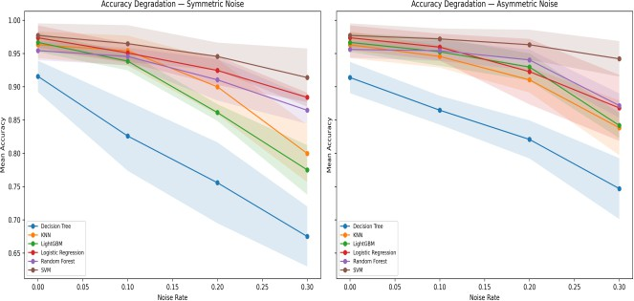
Fig. 12. Mean accuracy with ±1 standard deviation bands across noise levels and models.

Cross-Dataset Comparison
Comparing Looking at both sets shows clear trends. Right away, scores started stronger for Breast Cancer compared to Adult, showing how hard a dataset affects what we expect. When data is neat and small, high accuracy happens easier. Big messy collections tend to lower those numbers, even if the method works fine elsewhere.
Besides, the Decision Tree kept underperforming — no matter the dataset or kind of noise messing up the labels. That it stumbled every time, even when conditions changed a lot, makes the finding harder to dismiss. It hints that relying on just one tree might be risky whenever training data gets dirty.
Midway through, SVM stood out on the Breast Cancer data, plus handled symmetric noise best among models when tested on Adult data — proof that wide-margin training fights off scrambled labels well. Yet down the line, its slip in

rank with asymmetric noise on Adult hints protection isn’t automatic across all error kinds.
Then again, LightGBM plus Random Forest handled tasks well across the board, particularly with the Adult data. Even when noise came into play, LightGBM kept pace near the top for both kinds, while starting strongest in clean conditions — its edge over SVM stood out under symmetric errors because it slipped less than others on Adult. Meanwhile, Random Forest held up reliably, always doing better than a single Decision Tree.
On another note, KNN acted differently depending on the situation — not leading during symmetric disruption, yet standing tallest when asymmetry hit the Adult set. When noise hits unevenly on the Adult set, things shift — KNN, built around individual cases, holds up best now, edging past models shaped by decision margins. That gap across datasets shows one clear thing: strength depends less on approach alone, more on how method, data shape, and corruption type play together.

Table V. Combined comparison of best baseline, best symmetric robustness, best asymmetric robustness, worst model, and strongest F1 collapse across both datasets. Rel. drop = relative accuracy drop at 30% noise.

Criterion | Breast Cancer | Adult Income | Pattern
Best Acc. | SVM (97.7) | LGBM (87.4) | Data-dependent
Best Sym. | SVM (6.5↓) | SVM (1.1↓) | Consistent
Best Asym. | SVM (3.6↓) | KNN (2.0↓) | Noise-dependent
Worst | Decision Tree | Decision Tree | Consistent
F1 Drop | Decision Tree | LR / SVM | Asym. noise

Fig. 13 and 13b present the robustness ranking bar chart for both noise types, summarizing the mean relative drop across all noise levels for each model. Fig. 14 and 14b present the relative drop heatmap across both noise types and all noise levels, enabling simultaneous comparison of all model-noise-level combinations.
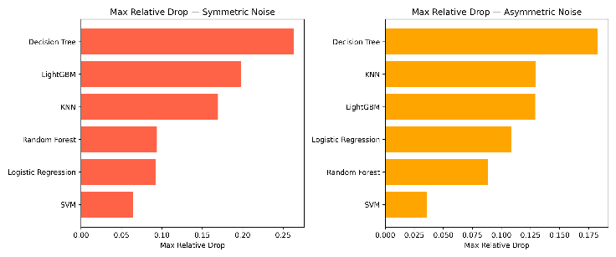
Fig. 13. Robustness ranking of all models by maximum relative accuracy drop at the highest noise level (30%) under symmetric (left) and asymmetric (right) noise - Breast Cancer Wisconsin.
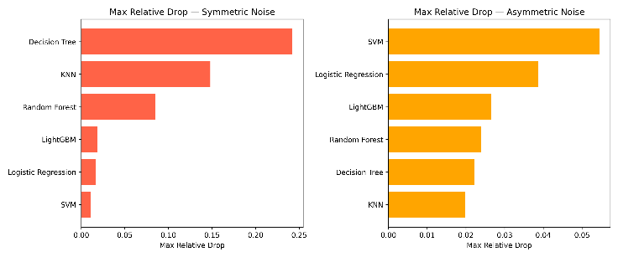
Fig. 13b. Robustness ranking of all models by maximum relative accuracy drop at the highest noise level (30%) under symmetric (left) and asymmetric (right) noise – Adult Income Dataset

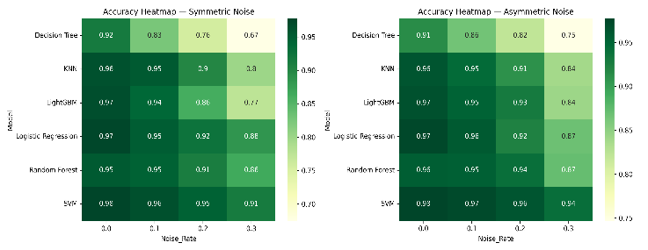Fig. 14. Accuracy heatmap across all models and noise levels for symmetric (left) and asymmetric (right) noise - Breast Cancer Wisconsin.
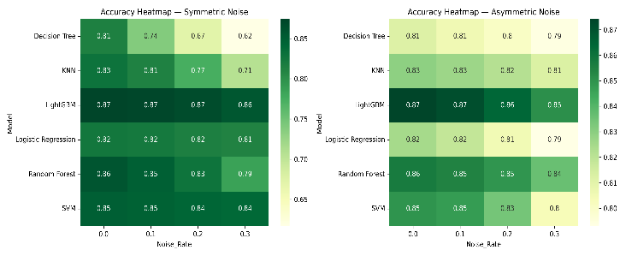
Fig. 14. Accuracy heatmap across all models and noise levels for symmetric (left) and asymmetric (right) noise – Adult Income Dataset
Fig. 15 and 15b show the degradation slope analysis, where steeper bars indicate faster accuracy decline per unit increase in noise rate. Fig. 16 and 16b show the degradation slope analysis, where steeper slopes indicate faster performance decline as noise increases.
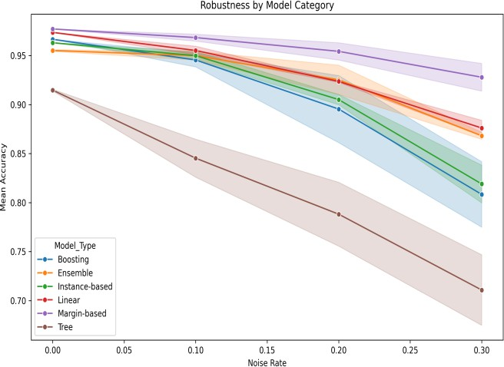
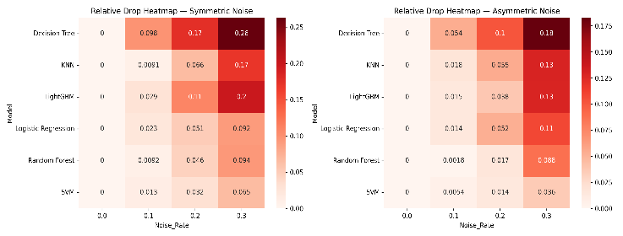
Fig. 15. Relative accuracy drop heatmap for all models and noise levels under both noise types - Breast Cancer Wisconsin.
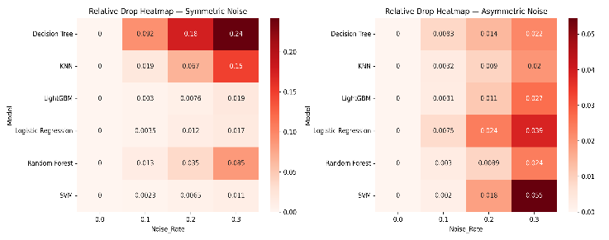
Fig. 15b. Relative accuracy drop heatmap for all models and noise levels under both noise types – Adult Income Dataset.
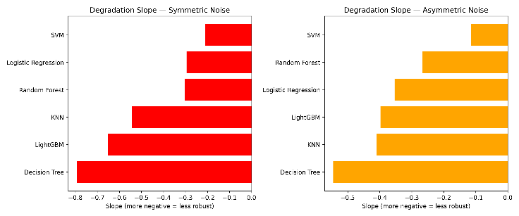
Fig. 16. Degradation slope (linear regression of accuracy on noise rate) for all models under symmetric (left) and asymmetric (right) noise - Breast Cancer Wisconsin.

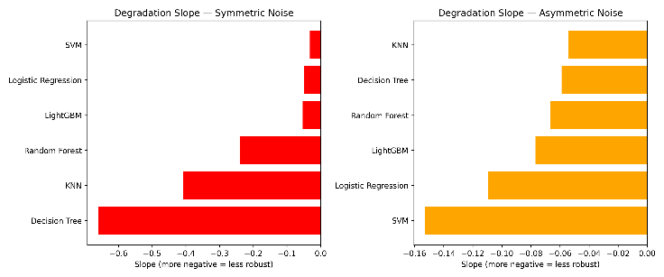
Fig. 16b. Degradation slope (linear regression of accuracy on noise rate) for all models under symmetric (left) and asymmetric (right) noise – Adult Income Dataset

Despite rising noise levels, SVM maintains stable performance on the Breast Cancer Wisconsin data under both noise types. Moving away from clean labels, Decision Trees lose accuracy most rapidly among all groups. Grouped by training approach, Figure 17 and Figure 18 display mean accuracy trends under increasing noise for each dataset.
Between those two lie ensemble methods, whose results suggest combining models helps — yet cannot fully resist damage from incorrect labels. Notably, boosting follows a similar middle path, neither collapsing nor remaining fully stable.
In the Adult dataset, patterns across categories change under asymmetric noise. KNN — an instance-based method — shows the least degradation, overtaking margin-based models. Its performance stands out where others decline.
From one dataset to another, results differ enough to challenge generalizations. No single learning approach remains consistently most robust. What emerges depends on how model design interacts with data structure and noise type.
Fig. 17. Mean accuracy by model category across increasing noise rates
— Breast Cancer Wisconsin dataset.
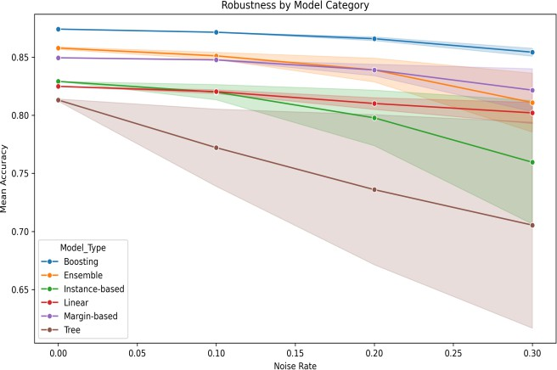

Fig. 18. Mean accuracy by model category across increasing noise rates
— Adult Income dataset.

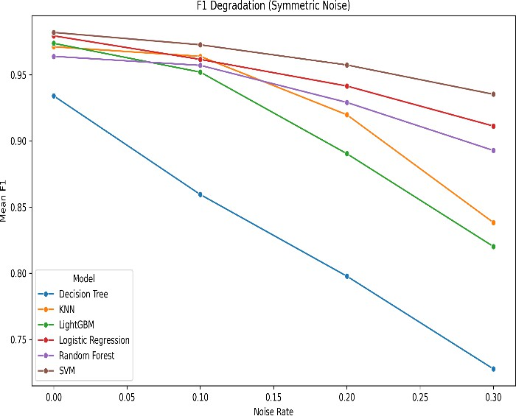
Fig. 19 presents the bar chart comparing model accuracy at the highest noise level (30%) across both noise types and both datasets. This visualization highlights the absolute performance remaining after strong corruption, complementing the relative drop analysis.

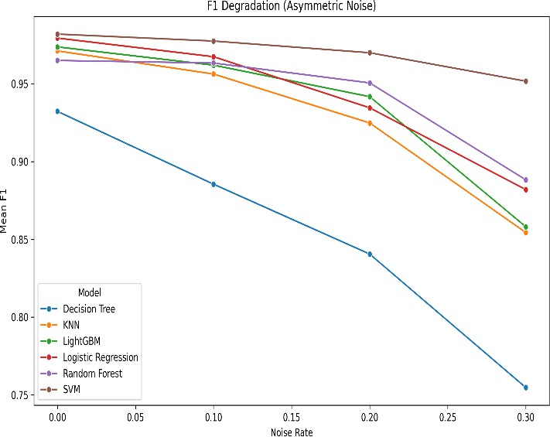
Fig. 19. Mean F1-score degradation under symmetric label noise across increasing noise rates — Breast Cancer Wisconsin dataset.

Fig. 20. Mean F1-score degradation under asymmetric label noise across increasing noise rates — Adult Income Dataset

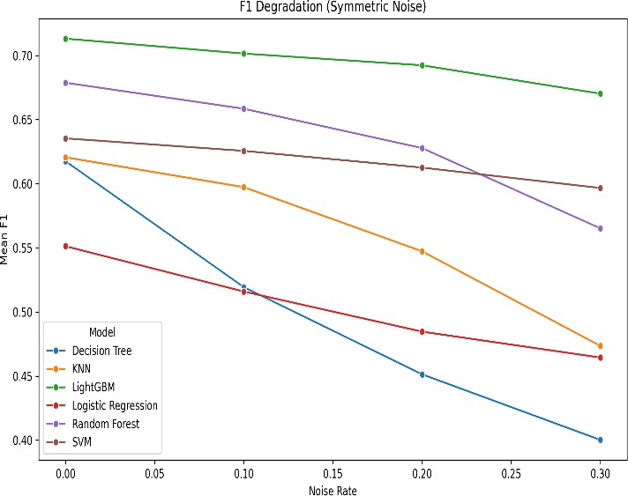
Fig. 21. Mean F1-score degradation under symmetric label noise across increasing noise rates — Adult Income dataset.

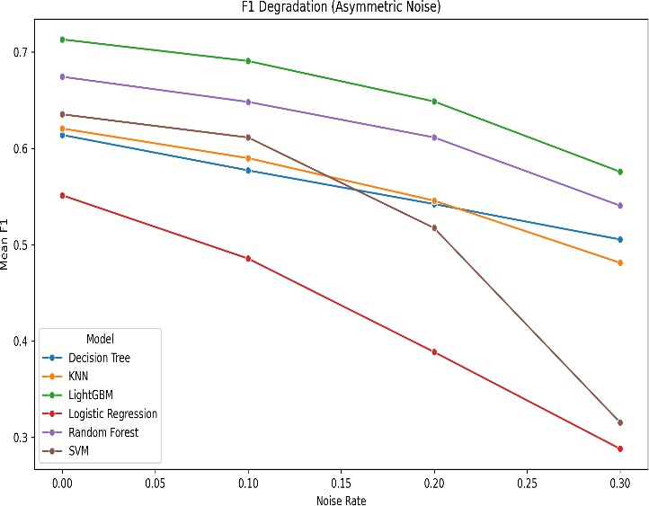
Fig. 22. Mean F1-score degradation under asymmetric label noise across increasing noise rates — Adult Income dataset.

Discussion with Respect to Research Questions
RQ1 — How do classical machine learning models behave under label noise? When labels become noisy, classical machine learning models perform worse — yet the extent varies widely depending on both the algorithm and the dataset. Though performance drops for every method, certain types falter faster than others. Decision trees and nearest neighbor approaches tend to react sharply to inaccuracies in labeling. In contrast, support vector machines and boosted ensembles hold up better under similar conditions. Despite differences, none escape impact entirely; resilience exists on a spectrum, not as absolute protection.
RQ2 — What is the difference between symmetric and asymmetric noise? When comparing symmetric against asymmetric noise, one observes differing impacts across learning systems. Across multiple architectures and datasets, symmetric label distortion tends to degrade performance more severely. Such symmetry introduces errors without preference, disrupting categorical patterns extensively. In contrast, asymmetric perturbation maintains certain structural cues, though notable deterioration still appears — especially in specific models on the Adult dataset. A shift in robustness ranking emerges under such skewed conditions. This change shows how error configuration influences model behavior.
RQ3 — Are robustness patterns consistent across datasets? Now here — RQ3 asks whether robustness patterns stay the same across different datasets. The answer leans toward yes, but only partially. Certain behaviors repeat: Decision Trees tend to struggle regardless of dataset, while SVM holds steady under symmetric noise. Yet outcomes shift under asymmetric noise; one setting favors SVM, another favors KNN instead. Because performance changes with context, drawing broad conclusions from just one dataset is risky. Hence, testing across multiple datasets becomes necessary.

Key Takeaways from the Results
- Clean-data accuracy fails to guarantee resilience. Though LightGBM led on Adult in standard tests, its standing dropped below SVM when symmetric robustness was measured.

- What stands out is how symmetric noise causes greater damage. Across every model and on both datasets, it led to larger performance declines compared to asymmetric noise.
- Under symmetric noise, SVM performs best. First place on each dataset under symmetric noise. Just a 6.5% dip here, 1.1% there — both at 30%. Performance holds steady.
- Decision Tree performs worst overall. Under each condition — across both datasets and noise types — it suffered declines bigger than 24%, standing out through steep performance loss. Its instability becomes clear when conditions shift slightly.
- Robustness depends on noise type and dataset. KNN shows a reversal on Adult under asymmetric noise, performing better in that setting. What holds strong in one case shifts in another, proving rankings are not universal.
- F1-score exposes issues that stay unseen. On the imbalanced Adult data, while accuracy drops, the F1-score drops more sharply — highlighting its critical role alongside standard measures.
Looking at all findings, it becomes clear: checking how well models handle messy labels is crucial before using them outside controlled environments. When errors appear in training labels, top-performing classifiers on perfect data often lose their edge. Which way you measure performance affects how clearly you see that drop-off.

CONCLUSION AND FUTURE SCOPE
Looking into how six traditional machine learning methods hold up, this work tested their behavior when trained on noisy labels from two well-known tabular datasets — the Breast Cancer Wisconsin Diagnostic and the Adult Income dataset. With label errors introduced in both symmetric and asymmetric ways across several noise levels, each model was evaluated using clean test data. Instead of focusing on peak results, attention turned toward shifts in performance as training labels became less reliable. Performance trends emerged not through ideal conditions but by observing how models degrade under noise.
Performance drops when labels are noisy, yet how much it falls depends heavily on the model, dataset, and noise type. On both datasets, performance declined more under symmetric noise compared to asymmetric noise, suggesting random errors disrupt learning more than directional ones. Trends in both accuracy and F1-score reflected this behavior clearly. Though effects varied, one thing remained consistent — the nature of noise influenced the outcome.
Strong performance on clean data does not guarantee robustness under noisy labels. The Breast Cancer Wisconsin dataset showed SVM handling corruption better than others, maintaining high performance even as noise increased. On the Adult dataset, LightGBM led under clean conditions, while SVM performed best under symmetric noise. Under asymmetric noise on the Adult dataset, the

performance patterns shifted again, with KNN showing the smallest drop in performance. These results indicate that robustness depends on context, and no single model performs best in all cases.
A closer look revealed that Decision Tree struggled more than others in nearly every setting. Under both symmetric and asymmetric noise, its performance dropped sharply, and variability across runs remained comparatively high. In contrast, ensemble-based and margin-based methods showed more stable behavior. Random Forest and LightGBM maintained consistent performance across several conditions, while SVM showed strong resistance to random noise.
The analysis also showed that F1-score often captured performance degradation more clearly than accuracy, especially on the Adult dataset. Some models showed only moderate drops in accuracy but significant declines in F1-score. This highlights the importance of using multiple evaluation metrics when studying the effects of label noise.
Looking at Table VI reveals how different models handle label noise across datasets. Best results on clean data do not always mean strong resistance to corrupted labels. Under symmetric noise, SVM consistently outperformed others across both datasets. When facing asymmetric noise, however, top robustness depended on the dataset. The pattern shifts — it does not stay fixed across conditions.
Not surprisingly, Decision Tree showed the weakest performance across tests. What stood out, though, was how much wider the gap became between accuracy and F1-score on the Adult dataset — suggesting F1-score revealed the impact of noise more clearly under class imbalance.

Table VI. Combined cross-dataset comparison showing best baseline, best robustness under each noise type, worst model, and F1 collapse pattern. Rel. drop = relative accuracy drop at 30% noise.

Criterion | Breast Cancer | Adult Income | Pattern
Best Baseline Accuracy | SVM (97.7%) | LightGBM (87.4%) | Dataset- dependent
Best Sym. Robustness | SVM (6.5% rel.  drop) | SVM (1.1% rel.  drop) | Consistent: SVM
Best Asym. Robustness | SVM (3.6% rel.  drop) | KNN (2.0% rel.  drop) | Noise-type dependent
Least Robustness | Decision Tree (26.3%) | Decision Tree (24.2%) | Consistent: DT worst
Strongest F1 Collapse | Decision Tree | Logistic Reg. / SVM | Asym. noise on Adult
The results meet the study’s goal: traditional machine learning methods react differently to incorrect labels, depending on how they learn, what data they face, and how noise patterns influence outcomes. For that reason, testing resilience matters just as much as performance when choosing models for real-world use with flawed annotations.

A. Future Scope
One way forward involves including extra benchmark datasets, helping broaden the reach of the findings across fields. Another path opens by exploring different types of noise — like class-dependent or instance-based distortions — as these mirror actual conditions in data gathering more closely.

Real-world labeling inconsistencies could also shape future tests, pushing methods through tougher, more realistic challenges.
Looking ahead, research might shift toward deep learning frameworks instead of sticking solely to traditional algorithms, while also testing ways that account for data imperfections during training. Methods like adjusting loss functions, prioritizing certain samples, refining label confidence, or removing noisy entries could enter the workflow — offering a clearer contrast between basic training routines and those designed to manage inaccuracies directly.
Later studies could also explore statistical tests along with deeper analysis into why certain models resist noise better across varied conditions. Taken together, the current findings offer solid ground for studying how traditional algorithms handle incorrect labels, opening paths toward practical advances in learning from flawed data.

REFERENCES
- W. Wolberg, O. Mangasarian, N. Street, and W. Street. "Breast Cancer Wisconsin (Diagnostic)," UCI Machine Learning Repository, 1993. [Online]. Available: https://doi.org/10.24432/C5DW2B.
- B. Becker and R. Kohavi. "Adult," UCI Machine Learning Repository, 1996. [Online]. Available: https://doi.org/10.24432/C5XW20.
- C. M. Bishop, Pattern Recognition and Machine Learning. New York, NY, USA: Springer, 2006.
- L. Breiman, “Random forests,” Machine Learning, vol. 45, no. 1, pp. 5–32, 2001.
- V. N. Vapnik, Statistical Learning Theory. New York, NY, USA: Wiley, 1998.
- J. H. Friedman, “Greedy function approximation: A gradient boosting machine,” Annals of Statistics, vol. 29, no. 5, pp. 1189–1232, 2001.
- G. Ke et al., “LightGBM: A highly efficient gradient boosting decision tree,” in Proc. NeurIPS, 2017, pp. 3146–3154.
- D. Angluin and P. Laird, “Learning from noisy examples,” Machine Learning, vol. 2, no. 4, pp. 343–370, 1988.
- B. Frenay and M. Verleysen, “Classification in the presence of label noise: A survey,” IEEE Trans. Neural Netw. Learn. Syst., vol. 25, no. 5, pp. 845–869, 2014.
- X. Zhu and X. Wu, “Class noise vs. attribute noise: A quantitative study,” Artificial Intelligence Review, vol. 22, pp. 177–210, 2004.
- S. Rolnick et al., “Deep learning is robust to massive label noise,” arXiv preprint arXiv:1705.10694, 2017.
- J. Patrini et al., “Making deep neural networks robust to label noise: A loss correction approach,” in Proc. CVPR, 2017, pp. 1944–1952.
- C. Northcutt, T. Wu, and I. Chuang, “Confident learning: Estimating uncertainty in dataset labels,” J. Artificial Intelligence Research, vol. 70, pp. 1373–1411, 2021.
- N. Natarajan et al., “Learning with noisy labels,” in Proc. NeurIPS, 2013, pp. 1196–1204.

- C. Cortes and V. Vapnik, “Support-vector networks,” Machine Learning, vol. 20, no. 3, pp. 273–297, 1995.
- E. Fix and J. L. Hodges, “Discriminatory analysis: Nonparametric discrimination: Consistency properties,” USAF School of Aviation Medicine, Project 21-49-004, Report No. 4, 1951.
- L. Rokach, “Decision trees: A survey,” Data Mining and Knowledge Discovery, vol. 14, no. 1, pp. 1–26, 2006.

