# Axonometric Projection

Axonometric projection is a parallel projection technique used to create a pictorial drawing of an object by rotating the object along one or more of its axes relative to the plane of projection (or the picture plane). Axonometric projection is one of the four principal projection techniques: multiview, axonometric, oblique and perspective projection (Figure-1). In multi view, axonometric, and oblique projections, the observer is theoretically infinitely far away from the projection plane. In addition, the lines of sight are parallel to each other and perpendicular to the plane of projection. The main difference between a multiview drawing and an axonometric drawing are that, in a multiview, only two dimensions of an object are visible in each view and hence more than one view is required to define the object. In an axonometric drawing, the object is rotated about an axis to show all three dimensions, and only one view is required.

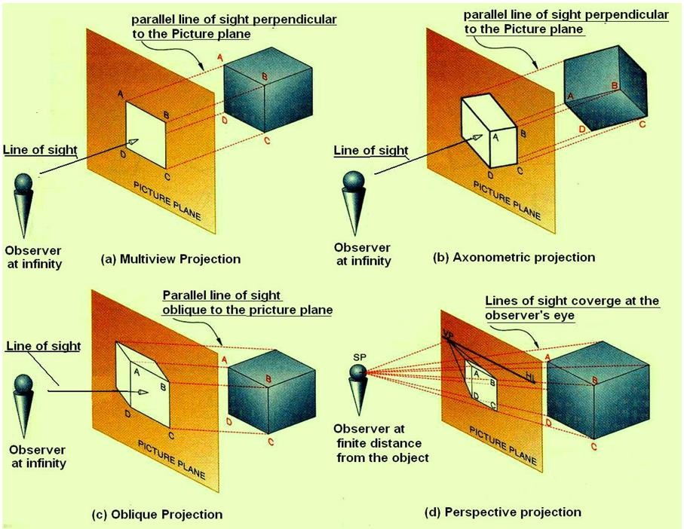Figure 1. illustrates the four principle projection techniques.

Isometric projection is a type of pictorial projection in which the dimensions along the three axes of the solid are shown in one view.

It is one of the three types of axonometric projection.

In axonometric drawing, one axis of space is shown vertical and depending on the exact angle at which the view deviates from the orthogonal, axonometric projections are generally three types: (a) trimetric projection, (b) dimetric projection, and (c) isometric projection.. This is illustrated in figure 2.

1. In trimetric projection, the direction of viewing is such that all of the three axes of space appear unequally foreshortened. The scale along each of the three axes and the angles among them are determined separately as dictated by the angle of viewing. Trimetric perspective is seldom/rarely used
2. In dimetric projection, the direction of viewing is such that two of the three axes of space appear equally shortened, of which the attendant scale and angles of presentation are determined according to the angle of viewing; the scale of the third direction (vertical) is determined separately. When two of the three angles are equal, the drawing is classified as a dimetric projection. Dimetric drawings are less pleasing to the eye, but are easier to produce than trimetric drawings
3. In isometric projection, the most commonly used form of axonometric projection in engineering drawing. Here all three angles are equal. The isometric is the least pleasing to the eye, but is the easiest to draw and dimension.

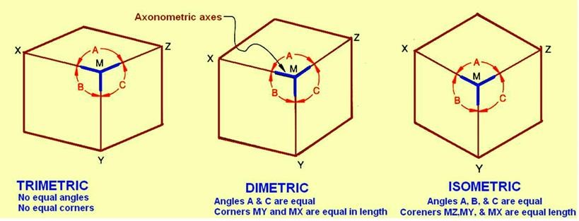Figure 2. Shows the three types of axinometric drawing. The angles determine the type of axinometric drawing.

# Isometric Axonometric Projections

An isometric projection is a true representation of the isometric view of an object. An isometric view of an object is created by rotating the object 45° about a vertical axis, then tilting the object (see figure 3, in this case, a cube) forward until the body diagonal (AB) appears as a point in the front view. The angle the cube is tilted forward is 35° 16’. The 3 axes that meet at A, B form equal angles of 120° and are called the isometric axes. Each edge of the cube is parallel to one of the isometric axes. Line parallel to one of the legs of the isometric axis is an isometric line. Planes of the cube faces & all planes parallel to them are isometric planes

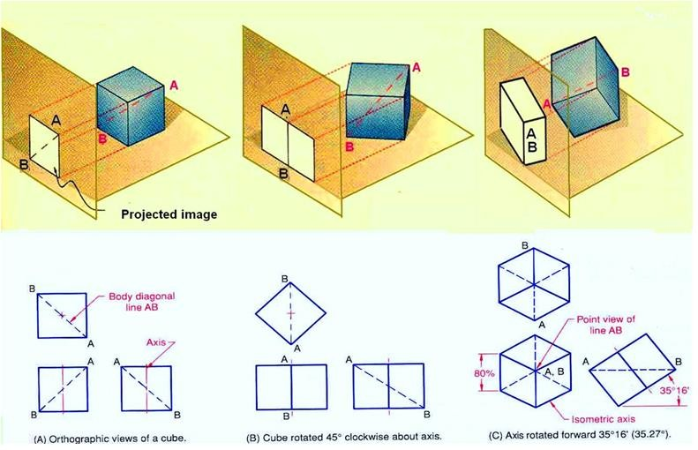

Figure 3. Rotation of the object with respect to the projection plane result in isometric projection.

The forward tilt of the cube causes the edges and planes of the cube to become shortened as it is projected onto the picture plane. The lengths of the projected lines are equal to the cosine of 35° 16’, or 0.81647 times the true length. In other words, the projected lengths are approximately 80% of the true lengths. A drawing produced using a scale of 0.816 is called an isometric projection and is a true representation of the object. However, if the drawing is produced using full scale, it is called an isometric drawing, which is the same proportion as an isometric projection, but is larger by a factor of 1.23 to 1. Figure 4. Illustrates the isometric projection and isometric drawing. Isometric drawings are almost always preferred over isometric projection for engineering drawings, because they are easier to produce. An isometric drawing is an axonometric pictorial drawing for which the angle between each axis equals 120° and the scale used is full scale.