**Introduction**

**What is Visual Science?**

**Vision science** is the scientific study of [vision](https://en.wikipedia.org/wiki/Visual_perception" \o "Visual perception). Researchers in vision science can be called **vision scientists**, especially if their research spans some of the science's many disciplines.

Vision science encompasses all studies of vision, such as how [human](https://en.wikipedia.org/wiki/Human" \o "Human) and [non-human](https://en.wikipedia.org/wiki/Non-human" \o "Non-human) [organisms](https://en.wikipedia.org/wiki/Organism" \o "Organism) process visual information, how conscious [visual perception](https://en.wikipedia.org/wiki/Visual_perception" \o "Visual perception) works in humans, how to exploit visual [perception](https://en.wikipedia.org/wiki/Perception" \o "Perception) for effective communication, and how artificial systems can do the same tasks.

**Types of Engineering Drawing**

An engineering drawing is a subcategory of technical drawings. The purpose is to convey all the information necessary for manufacturing a product or a part.

Engineering drawings use standardized language and symbols. This makes understanding the drawings simple with little to no personal interpretation possibilities.

An engineering drawing is a type of [technical drawing](https://en.wikipedia.org/wiki/Technical_drawing" \o "Technical drawing) that is used to convey information about an object. A common use is to specify the geometry necessary for the construction of a component and is called a detail drawing. Usually, a number of drawings are necessary to completely specify even a simple component. The drawings are linked together by a master drawing or assembly drawing which gives the drawing numbers of the subsequent detailed components, quantities required, construction materials and possibly 3D images that can be used to locate individual items. Although mostly consisting of pictographic representations, [abbreviations and symbols](https://en.wikipedia.org/wiki/Engineering_drawing_abbreviations_and_symbols" \o "Engineering drawing abbreviations and symbols) are used for brevity and additional textual explanations may also be provided to convey the necessary information.

The process of producing engineering drawings is often referred to as [technical drawing](https://en.wikipedia.org/wiki/Technical_drawing" \o "Technical drawing) or drafting (draughting). Drawings typically contain [multiple views](https://en.wikipedia.org/wiki/Multiview_projection" \o "Multiview projection) of a component, although additional scratch views may be added of details for further explanation. Only the information that is a requirement is typically specified. Key information such as dimensions is usually only specified in one place on a drawing, avoiding redundancy and the possibility of inconsistency. Suitable [tolerances](https://en.wikipedia.org/wiki/Engineering_tolerance" \o "Engineering tolerance) are given for critical dimensions to allow the component to be manufactured and function. More detailed [production drawings](https://en.wikipedia.org/wiki/Production_drawing" \o "Production drawing) may be produced based on the information given in an engineering drawing. Drawings have an information box or title block containing who drew the drawing, who approved it, units of dimensions, meaning of views, the title of the drawing and the drawing number.

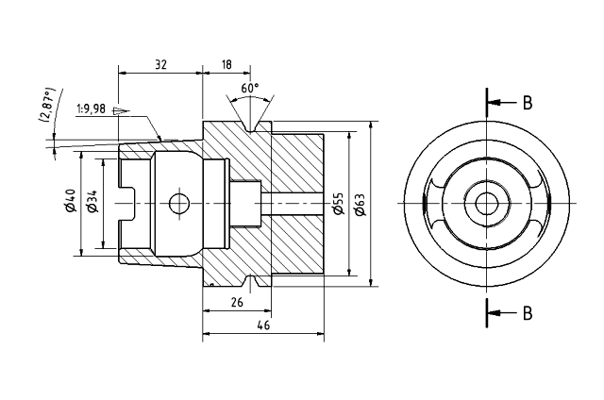

**Introduction to drawing equipment and use of instruments**

In engineering drawing, engineering related objects like buildings, walls, electrical fittings, pipes, machines etc. are represented with specifications like size, shape, materials etc.

Several engineering drawing software with more accuracy are available. But, drawing on paper is still being used in some areas and for small constructions.

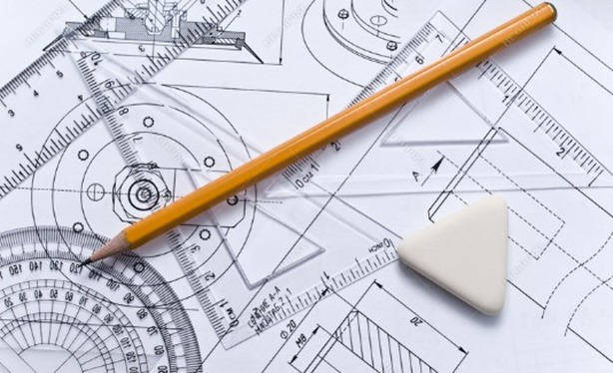

## **Importance of Engineering Drawing**

Drawing plays vital role in the engineering and construction works. The drawing requires no language any one can read it. So, drawings of other countries structures can also be studied easily.

The drawing improves the imagination and new inventions can be developed. The estimate for the project can be done using the details provided in the drawing.

The structure can be analyzed completely before construction by using drawing. So, every engineering construction department especially civil engineering requires drawing to start a project.

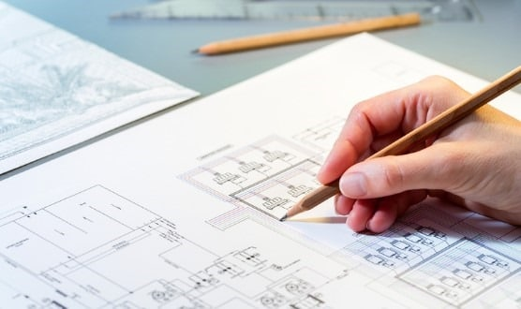

## **Instruments Used in Engineering Drawing**

The instruments used in engineering drawing are:

1. Drawing sheet
2. Drawing board
3. Mini drafter
4. T square
5. Compass
6. Divider
7. Set squares
8. Clinograph
9. Protractor
10. French curves
11. Templates
12. Pencils
13. Eraser

### **Drawing Sheet**

Drawing sheet is a white paper on which an object is drawn which is available in various sizes. The sheet used for engineering should be of good quality. It should be white in color with uniform thickness with must resist the easy torn of paper. The surface of sheet must be smooth.

**Various sizes of drawing sheets recommended by Indian standards are listed below.**

|  |  |
| --- | --- |
| **Drawing Sheet Type** | **Dimensions (Length X Width) (mm)** |
| **A0** | 841 X 1189 |
| **A1** | 594 X 841 |
| **A2** | 420 X 594 |
| **A3** | 297 X 420 |
| **A4** | 210 X 297 |
| **A5** | 148 X 210 |

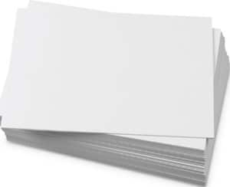

### **Drawing Board**

Drawing board is generally made of soft wood and it is in rectangular shape. It is used to support drawing sheet, so, the size of board is made according the size of the drawing sheet.

The wood portions are joined by tongue and grove type joint to prevent cracks. At the edge of board, straight ebony edge is provided for the T-square usage.

Different types of drawing boards and their sizes according to IS classification are listed below.

|  |  |
| --- | --- |
| **Type of Drawing Board** | **Length X Width X Thickness (mm)** |
| **D0** | 1500 X 1000 X 25 |
| **D1** | 1000 X 700 X 25 |
| **D2** | 700 X 500 X 15 |
| **D3** | 500 X 350 X 15 |

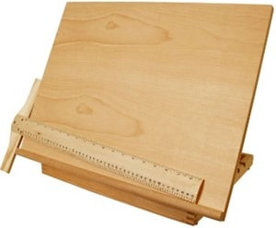

### **Mini Drafter**

Mini drafter is an instrument which can be used for multiple functions in drawing. It contains two arms which is adjustable to required angle and at the end of the lower arm a scale set is attached.

The scale set contains two scales connected perpendicular to each which cannot be separated. This instrument is fixed to the drawing board at one edge with the help of screw provided for the drafter.

Mini drafter is used for drawing horizontal lines, vertical lines, inclined lines, angles, parallel lines, perpendicular lines etc.

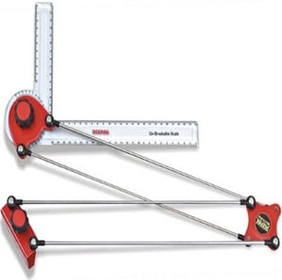

### **T-Square**

T square is used to draw horizontal and vertical lines on drawing sheet. It made of wood or plastic and in T shape. The vertical part of T is called as blade and horizontal part of T is called as head.

The edge of head is uniform level and attached to the edge of the board. The working edge is used to draw lines anywhere on the sheet by moving the instrument top to bottom.

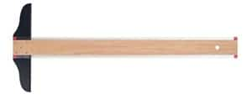

### **Compass**

Compass is used to draw an arc or circle with known dimensions on engineering drawing. It is generally made of steel and consists two legs. One leg contains needle at the bottom and other leg contains a ring in which a pencil is placed.

The needle tip is placed at the respected point and pencil tip is adjusted to the height at least 1mm just above the tip of the needle. The gap is nothing but the paper thickness.

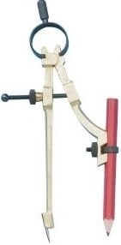

### **Divider**

The divider looks like a compass, but the difference is the two legs of divider are provided with needles. This is used to divide a line or curve into equal parts. It is also used to check the measurements.

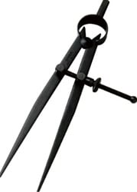

### **Set Squares**

Set squares are used to draw lines with an angle between them. In most of the structures, 30, 45, 60 and 90-degree lines are most common. So, set squares make the work easier for this type of drawings.

Generally, set squares are of two types. One is 45 degree set square and another one is called as 30 – 60 degree set square. Both are required in the drawing. 45 set square has a side of 25 cm while 30-60 set square has 25 cm length on one side.

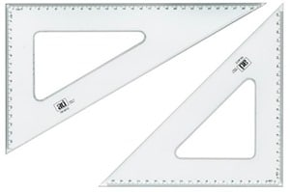

### **Clinograph**

Clinograph is an instrument used to draw parallel lines to the inclined lines. It contains one adjustable wing or strip which can be adjusted to required angle. So, it can be termed as adjustable set square.

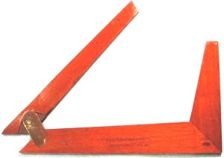

### **Protractor**

Protractor is used to draw and measure the angles of lines in the drawing. It is transparent and made of plastic. It is in the shape of semi-circle, and the edge of semi-circle part consists reading with one-degree accuracy.

The bottom line joins the 0o to the 180o. The center of this bottom line is marked as “O” or “C” from which the angles are measured.

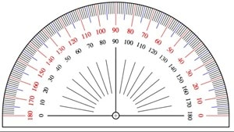

### **French Curves**

French curves are made of plastic and they are in irregular shapes. Sometimes the drawing requires irregular curves or shapes or arcs which cannot be drawn using compass. In that case French curves are suitable.

Generally French curves are more suitable for small curves and for long curves splines are used.

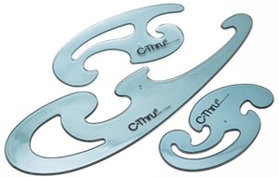

### **Drawing Templates**

Templates are nothing but plastic or wooden boards which contains spaces of several shapes or letters. Non-dimensional shapes or variety font letters are drawn by using templates which makes drawing easier and perfect.

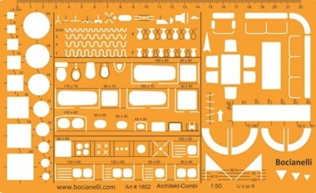

### **Pencils**

Pencil is used to draw on the paper. Any type of pencil is not suitable for drawing. There are some limitations, the drawing appearance should be very neat and understandable.

Every line of the drawing should indicate its importance. It depends upon the hardness of pencil.

Based on the hardness quality pencils are classified into 18 grades and they are

|  |  |
| --- | --- |
| **Grade of Pencil** | **Hardness of Pencil** |
| **9H** | Hardest |
| **6H, 5H, 4H** | Extremely Hard |
| **3H** | Very hard |
| **2H** | Hard |
| **H** | Moderately hard |
| **F** | Firm |
| **HB** | Medium hard |
| **B** | Moderately soft and black |
| **2B** | Soft and black |
| **3B** | Very soft and black |
| **4B, 5B, 6B** | Very soft and very black |
| **7B** | Softest |

Out of the above 18 grades of pencils, following grades are used in engineering drawings.

|  |  |
| --- | --- |
| **Grade of Pencil** | **Used to Draw** |
| **3H** | Construction lines |
| **2H** | Dimension lines, center lines, sectional lines, hidden lines |
| **H** | Object lines, lettering |
| **HB** | Dimensioning, boundary lines |

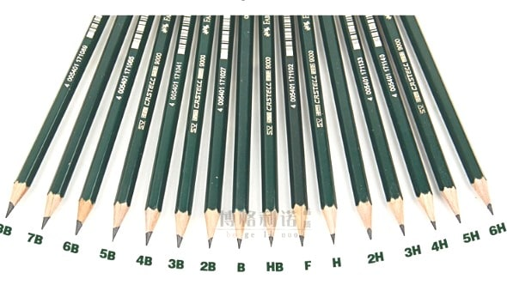

### **Eraser**

Eraser is used to remove the lines or spots which drawn by mistake or with wrong measurements. The eraser used should be of good quality and soft. It should not damage the paper while erasing.



### **Paper Holders**

When the drawing sheet is placed on the board it may not be in fixed position. To fix the drawing sheet to the board paper holders are used.

Generally used paper holders are thumb pins, spring clips, stick tapes etc. Care should be taken while removing the clips or tapes otherwise the sheet may tore.

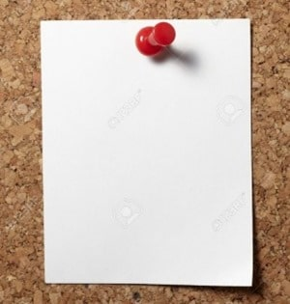

**Symbols and Conventions in Drawing Practice**

## Dimensions

*Dimensions should be shown as follows:*

*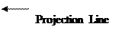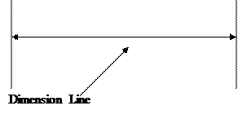*

*The conventions relating to dimensions are as follows:*

* State dimensions once only.
* Place in the most appropriate view.
* Keep related dimensions on the same view.
* Select the functional dimensions.
* Avoid redundant dimensions.

## Letters  and Numbers

*All drawings require some form of lettering and numbers. The principles to remember are:*

* They should be legible and clear – especially numbers, as they often have to be read on their own.
* They should be of a suitable size and not less than 3mm tall.  Title blocks and relative information are usually larger.
* They should be correctly spaced and positioned.  Notes and captions should be placed so that they can be read in the same direction as in the title block.  In other worlds it should not be necessary to turn a drawing on its side to read the information.
* Notes should be grouped together and not spread over the drawing.
* Underlining is not recommended.

## Borders  and Title Blocks

One of the most important features of any drawing is the border and title block.  The border (or margin) is a line which follows the outer edge of the drawing and is usually 10 or 20mm inside it.  This margin is very important because everything inside it forms part of any contract.  
The ‘Title Block’ is locked within the boarder and contains information such as:

* Project title – i.e. New Community School.
* The subject – i.e. Hot and Cold Water Services.
* The date of the original drawing.
* Dates of any revisions.
* Job Number.
* Drawing Number.
* Scale.
* The name of the person who drew up the drawing.
* Name of architects, consultant engineers or surveyors.

*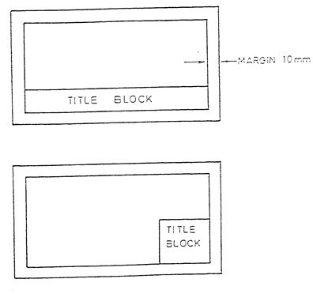*

## Scales

A scale can be used to increase the detail of a small object or to accurately represent a large object on a smaller piece of paper.  The majority of scaled work done in the construction industry is to reduce objects to a smaller more suitable size that will fit on a sheet of paper.  
The list below shows the scales used in BS 1192:

* Block Plans 1:2500 – These show the outlines of buildings and may also indicate roads, railway lines or rivers.
* Site Plans: Between 1:500 and 1:2500 – Although often drawn at the same scale as the block plan site plans only give details relevant to the actual project.  These details could relate to landscaping arrangements or show underground drainage pipe-work.
* General Location Drawings 1:200 or 1:100 – These drawings can show pipe runs within the building and the location of radiators and sanitary fixtures.
* When details of boiler houses or plant rooms are given the scale may increase to 1:50.  This enables greater detail to be shown.
* Where particular detail is necessary the scale could be as high as 1:20 or 1:10.  This could be in the case of a bracket or support for a piece of equipment.

*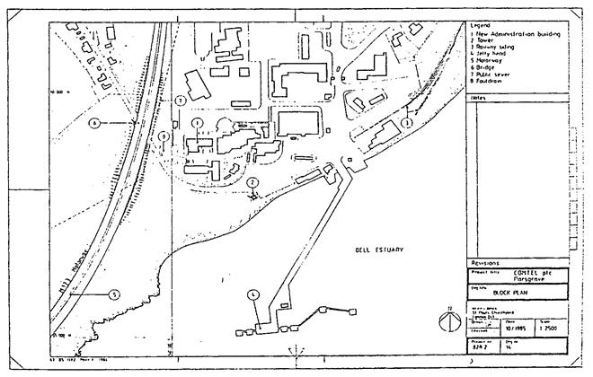*

*Here is a drawing of Block Plan originally drawn at 1:2500 but printed not to scale (NTS).*

## Scale Rulers

*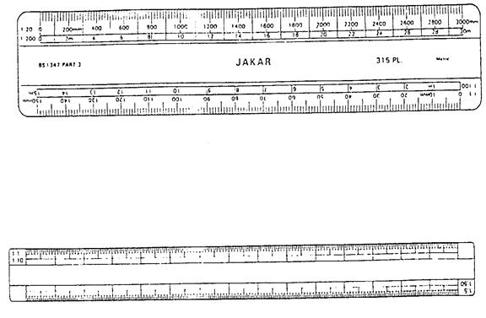*

*As already stated, the scale of the drawing will be indicated in the block.  To take measurements from such a drawing a ‘Scale Rule’ is used.  Scale rules are usually manufactured from plastic and have several scales indicated on the ends as shown below.*

**Abbreviations for Pipe Rises/Drops**

|  |  |
| --- | --- |
| TA | To Above |
| FB | From Below |
| RTA | Rise To Above |
| DTB | Drop To Below |

To identify individual services some of the following abbreviations may be used.

**Service Abbreviations**

|  |  |
| --- | --- |
| MWS | Mains Water Services |
| DW | Drinking Water |
| CWF | Cold Water Flow |
| CWS | Cold Water Service |
| HWSF | Hot Water Service Flow |
| HWSR | Hot Water Service Return |
| HWSVP | Hot Water Service Vent Pipe |
| FF | Fire Fighting Services |
| HRS | Hose Reel Service |
| CA | Compressed Air |
| F&R | Flow and Return |

**Engineering Drawing: Types of Lines and their Use**

Certain features on a Engineering Drawing requires specific ways of indication. For example, holes require center lines to identify the center and show that it is round. Hidden detail are shown with a certain line type to avoid confusion with visible edges.

|  |  |
| --- | --- |
| Line | Description |
| IMG_256 | Continuous Thick Line |
| IMG_257 | Continuous Thin Line |
| IMG_258 | Continuous Thin Freehand Line |
| IMG_259 | Continuous Thin Zigzag Line |
| IMG_260 | Thick or Thin Dashed Line |
| IMG_261 | Thin Chain Line |
| IMG_262 | Thin Chain Line with Thick ends |
| IMG_263 | Thick Chain Line |
| IMG_264 | Thin Chain Double Dashed Line |

### Continuous Thick Line

The continuous thick line is used to show visible outlines or edges of a component or assembly. This line may be made thin if the drawing is congested and allot of lines are so close to each other that the clarity of the drawing is negatively influenced.

### Continuous Thin Line

The continuous thin line is the most frequently used line type on Engineering Drawings. These lines are solid and has no break in them. Here is the list of cases where the continuous thin line will be used:

* Imaginary lines of intersection
* Dimension line
* Projection lines
* Leader lines
* Hatching
* Outlines of revolved sections
* Short center lines (as opposed to the chain line)
* Bending lines

### Continuous Thin Freehand Line

Freehand lines shows breaks or cuts in parts or assemblies. The edge of the partial or interrupted view is indicated with a freehand line.

### Continuous Thin Zigzag Line

The Continuous Thin Zigzag Line shows a break line. If a part needs to be shortened with a break for ease of visibility, a break can be made using this line. \*Remember, any dimensions spanning over the break needs to have a dimension break indicated on the dimension line also.

### Thick or Thin Dashed Line

The Dashed Line is used to indicate hidden details like hidden outlines and hidden edges. The dashed line may be either thick or thin, but only one type (thick or thin) should be used on a single drawing or set of drawings.

### Thin Chain Line

The Thin Chain Line is used to indicate center lines, the lines of symmetry and also trajectories. Often this line is used as a point of reference on engineering drawings.

### Thin Chain Line with Thick ends

Sectional cutting planes are indicated with a Thin Chain Line with Thick ends. This helps to identify the plane in which the part or assembly is cut. If the cut line is on more than one plane, the change in direction should also be indicated with thicker ends.

### Thick Chain Line

A Thick Chain Line is used to indicate special requirements on a surface. This line does not form part of the geometry of the part, but is rather used to identify the surface

**Thin Chain Double Dashed Line**

The Thin Chain Double Dashed Line is used to show adjacent components. This is especially useful when the component has a reference to the existing components.  
It is also used to show alternative or extreme positions. On drawings where bends are indicated, these lines are used to show the initial outlines before forming or bending.  
One can also use this line to indicate parts or components situated in front of the cutting plane, to give reference to the part shown.

**BIS Codes**

* BIS(Board of Indian Standards SP 46: 2003)definesdimension as a numerical value expressed in appropriateunits of measurement and indicated graphically on technicaldrawings with lines, symbols and notes.
* Units of Measurement:The most commonly used unit forlength is themillimetre. Incivil engineering and architecturaldrawing,inch or footis often used as a unit of length. Anglesare shown in degrees.
* Symbolsare incorporated to indicatespecific geometry wherever necessary.Notesare provided to givespecification of a particularfeatureor to givespecific informationnecessary during themanufacturing of the object.

