**Projection of points**

****Objectives****

To Draw the projections of a point in the four quadrants. To Identify the position of the point in different quadrants.

****Notation****

To obtain the projections of points in space, standard notations are followed:

1. The actual points in space are denoted by capital letters A, B, C, D, etc.,

2. The front views are denoted by the corresponding lowercase letters with dashes like a', b', c', d', etc., and their top views are denoted by the corresponding lowercase letters like a, b, c, d, etc.

3. Projectors are always drawn as continuous thin lines using a 2H pencil.

4. The visible points are drawn with a H pencil.

5. Lettering is always drawn with a HB pencil. Projection of a Point in the I-Quadrant

****Point A is 20 mm above the HP and 30 mm in front of the VP****

1. Draw the reference line XY and name it as VP and HP respectively above and below the XY line.

2. Draw a line perpendicular to XY.

3. On the perpendicular line mark a point a 30 mm below XY. (Top view)

4. On the perpendicular line mark a point a' 20 mm above XY. (Front view)

5. Erase the unwanted lines.

6. The points a and a' are the projections of the point A in the I- quadrant.

[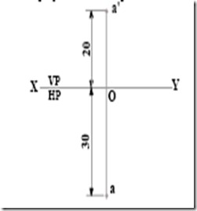](http://lh5.ggpht.com/-zodAqa2WmAI/Tx7GdlxMcHI/AAAAAAAABe0/Lp0tmpxJZUg/s1600-h/clip_image001%5B6%5D.png)

****Projection of a Point in the II-Quadrant****

****Point B is 25 mm above the HP and 35mm behind the VP.****

1. Draw the reference line XY and name it as VP and HP respectively above and below the XY line.

2. Draw a line perpendicular to XY.

3. On the perpendicular line mark a point b 35mm above XY.(Top view)

4. On the perpendicular line mark a point b' 25mm above XY.(Front view)

5. Erase the unwanted lines.

6. The points b' and b are the projections of the point B in the II quadrant.

[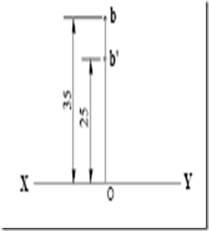](http://lh3.ggpht.com/-AmXkg_YxMRU/Tx7Ggq_er1I/AAAAAAAABfI/h2RoAxwUTrY/s1600-h/clip_image002%5B7%5D.png)

****Projection of a Point in the III-Quadrant****

****Point C 35 mm below the HP and 25 behind the VP.****

1. Draw the reference line XY and name it as VP and HP respectively above and below the XY line.

2. Draw a line perpendicular to XY.

3. On the perpendicular line mark a point ‘c’ 25mm above XY. .(Top view)

4. On the perpendicular line mark a point ‘c'’ 35mm below XY. .(Front view)

5. Erase the unwanted lines.

6. The points c and c' are the projections of the point C in the III- quadrant.

|  |  |
| --- | --- |
| |  | | --- | | [clip_image003](http://lh3.ggpht.com/-fbNcfIKYEvs/Tx7Gma93usI/AAAAAAAABfc/ert3QjsyC5M/s1600-h/clip_image003%5B9%5D.png) | |

****Projection of a Point in the IV-Quadrant****

****Point D 30mm below the HP and 40 mm in front of the VP.****

1. Draw the reference line XY and name it as VP and HP respectively above and below the XY line.

2. Draw a line perpendicular to XY.

3. On the perpendicular line mark a point ‘d’ 40mm below XY.(Top view)

4. On the perpendicular line mark a point ‘d'’ 30mm below XY.(Front view)

5. Erase the unwanted lines.

6. The points d and d' are the projections of the point D in the IV- Quadrant.

[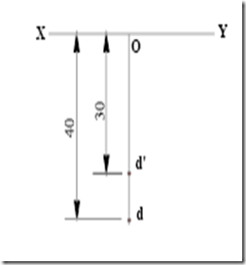](http://lh4.ggpht.com/-EgDfhXB8Plk/Tx7GpXBApmI/AAAAAAAABfw/n2QsrLgnMVg/s1600-h/clip_image004%5B7%5D.png)