**Projection of points**

****Objectives****

To Draw the projections of a point in the four quadrants. To Identify the position of the point in different quadrants.

****Notation****

To obtain the projections of points in space, standard notations are followed:

1. The actual points in space are denoted by capital letters A, B, C, D, etc.,

2. The front views are denoted by the corresponding lowercase letters with dashes like a', b', c', d', etc., and their top views are denoted by the corresponding lowercase letters like a, b, c, d, etc.

3. Projectors are always drawn as continuous thin lines using a 2H pencil.

4. The visible points are drawn with a H pencil.

5. Lettering is always drawn with a HB pencil. Projection of a Point in the I-Quadrant

****Point A is 20 mm above the HP and 30 mm in front of the VP****

1. Draw the reference line XY and name it as VP and HP respectively above and below the XY line.

2. Draw a line perpendicular to XY.

3. On the perpendicular line mark a point a 30 mm below XY. (Top view)

4. On the perpendicular line mark a point a' 20 mm above XY. (Front view)

5. Erase the unwanted lines.

6. The points a and a' are the projections of the point A in the I- quadrant.

[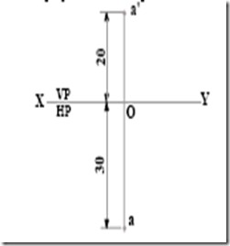](http://lh5.ggpht.com/-zodAqa2WmAI/Tx7GdlxMcHI/AAAAAAAABe0/Lp0tmpxJZUg/s1600-h/clip_image001%5b6%5d.png)

****Projection of a Point in the II-Quadrant****

****Point B is 25 mm above the HP and 35mm behind the VP.****

1. Draw the reference line XY and name it as VP and HP respectively above and below the XY line.

2. Draw a line perpendicular to XY.

3. On the perpendicular line mark a point b 35mm above XY.(Top view)

4. On the perpendicular line mark a point b' 25mm above XY.(Front view)

5. Erase the unwanted lines.

6. The points b' and b are the projections of the point B in the II quadrant.

[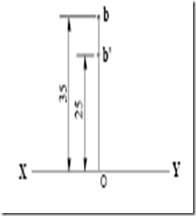](http://lh3.ggpht.com/-AmXkg_YxMRU/Tx7Ggq_er1I/AAAAAAAABfI/h2RoAxwUTrY/s1600-h/clip_image002%5b7%5d.png)

****Projection of a Point in the III-Quadrant****

****Point C 35 mm below the HP and 25 behind the VP.****

1. Draw the reference line XY and name it as VP and HP respectively above and below the XY line.

2. Draw a line perpendicular to XY.

3. On the perpendicular line mark a point ‘c’ 25mm above XY. .(Top view)

4. On the perpendicular line mark a point ‘c'’ 35mm below XY. .(Front view)

5. Erase the unwanted lines.

6. The points c and c' are the projections of the point C in the III- quadrant.

|  |  |
| --- | --- |
| |  | | --- | | [clip_image003](http://lh3.ggpht.com/-fbNcfIKYEvs/Tx7Gma93usI/AAAAAAAABfc/ert3QjsyC5M/s1600-h/clip_image003%5b9%5d.png) | |

****Projection of a Point in the IV-Quadrant****

****Point D 30mm below the HP and 40 mm in front of the VP.****

1. Draw the reference line XY and name it as VP and HP respectively above and below the XY line.

2. Draw a line perpendicular to XY.

3. On the perpendicular line mark a point ‘d’ 40mm below XY.(Top view)

4. On the perpendicular line mark a point ‘d'’ 30mm below XY.(Front view)

5. Erase the unwanted lines.

6. The points d and d' are the projections of the point D in the IV- Quadrant.

[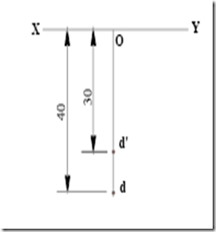](http://lh4.ggpht.com/-EgDfhXB8Plk/Tx7GpXBApmI/AAAAAAAABfw/n2QsrLgnMVg/s1600-h/clip_image004%5b7%5d.png)

**What is Auxiliary Planes?**

**Auxiliary Plane**The plane which we draw to get the true shape of the inclined [surface](https://civiljungle.com/resurface-concrete/) ( often parallel to Principal Plane ) is an auxiliary plane.

Simply, the plane other than the Principal Plane ( **i.e. Horizontal Plane, Vertical Plane or Perpendicular Plane**) is called Auxiliary Plane.

Often one of the six principal views does not completely describe an object. This is justifiable when there are inclined or oblique planes or features on an object. For these special cases, a special [orthographic](https://civiljungle.com/principale-of-plane-table/) view called an auxiliary view is required to be created.

## **Types of Auxiliary Plane**

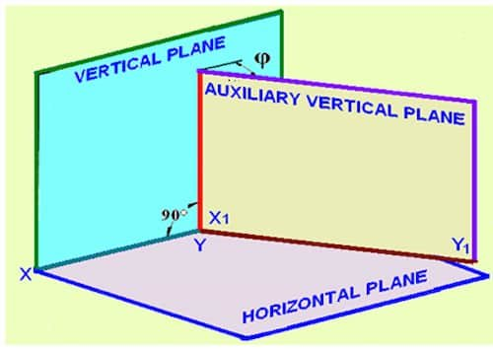

**Types of Auxiliary Plane there are two types. Which is as follows.**

1. Auxiliary Vertical Plane
2. Auxiliary Inclined Plane

### **1. Auxiliary Vertical Plane**

The plane which is perpendicular to a horizontal plane and inclined to the vertical plane is called an auxiliary vertical plane. This plane gives auxiliary front view.

### **2. Auxiliary Inclined Plane**

The plane which is perpendicular to the vertical plane and inclined to the horizontal plane is called an auxiliary inclined plane. This plane gives auxiliary top view.

**Projection of point on Auxiliary Planes:**

Point P is situated in the first quadrant at a height m above HP. An auxiliary vertical plane AVP is set up perpendicular to HP and inclined at Φ to VP. The point P is projected on VP, HP and AVP.   
As shown in figure 3, p' is the projection on VP, p is the projection on HP and P1' is the  projection on AVP.   
Since point is at a height m above HP, both p' and p1’ are at a height m above the XY and X1Y1 lines, respectively.

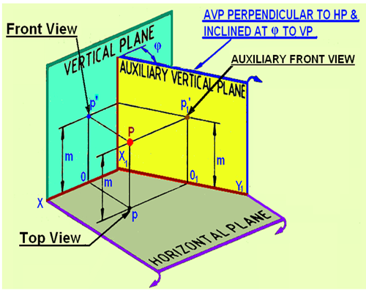

HP is rotated by 90 degree to bring it in plane of VP (figure 4(a) . Subsequently, the AVP is rotated about the X1Y1  line (figure 4(b),  such that it becomes in-plane with that of both HP and *VP.*

[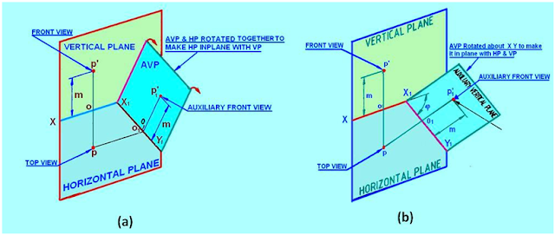](http://1.bp.blogspot.com/-McV2vBpcntA/VXeoUPS5OdI/AAAAAAAAArE/736zqKgaEOA/s1600/4.png)

        Figure 4. The rotation of (a) HP and (b) AVP to make HP and AVP in plane with VP.