**Theory of Projections**

**Projection theory**

In engineering, 3-dimensonal objects and structures are represented graphically on a 2-dimensional media. The act of obtaining the image of an object is termed “projection”.  The image obtained by projection is known as a “view”.  A simple projection system is shown in figure 1.

All projection theory are based on two variables:

* Line of sight
* Plane of projection.

**Plane of Projection**

A plane of projection (i.e, an image or picture plane) is an imaginary flat plane upon which the image created by the line of sight is projected.  The image is produced by connecting the points where the lines of sight pierce the projection plane. In effect, 3-D object is transformed into a 2-D representation, also called projections. The paper or computer screen on which a drawing is created is a plane of projection.

[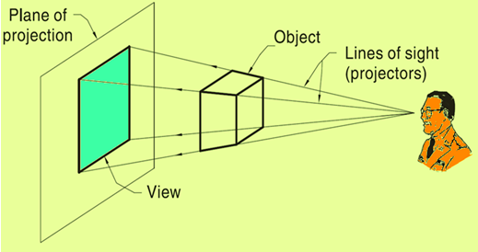](http://2.bp.blogspot.com/-87y8vYuKmAc/VXAMHoz0lOI/AAAAAAAAAjw/34lt-af7guw/s1600/1.png)

**Projection Methods**

Projection methods are very important techniques in engineering drawing.

Two projection methods used are:

* Perspective and
* Parallel

the observer is assumed to be stationed at finite distance from the object. The height of the buildings appears to be reducing as we move away from the observer.  In perspective projection, all lines of sight start at a single point and is schematically shown in figure.

[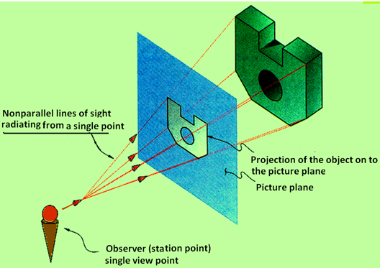](http://4.bp.blogspot.com/-78zU7C6SfiA/VXAMO4G_aQI/AAAAAAAAAkY/Kee0bJbFsRg/s1600/2.png)

In parallel projection, all lines of sight are parallel and is schematically represented in figure. 4. The observer is assumed to be stationed at infinite distance from the object.

[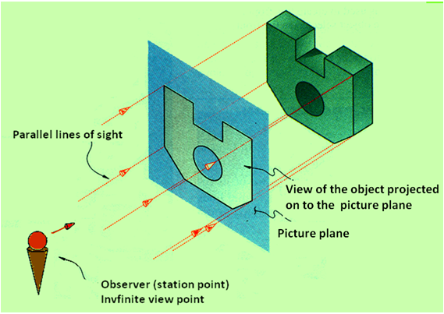](http://1.bp.blogspot.com/-Hf11LxQEhPA/VXAMPVFiYVI/AAAAAAAAAkw/ZVPCCu83FYc/s1600/3.png)

**Parallel vs Perspective Projection**

**Parallel projection**

* Distance from the observer to the object is infinite projection lines are parallel – object is positioned at infinity.
* Less realistic but easier to draw.

**Perspective projection**

* ·    Distance from the observer to the object is finite and the object is viewed from a single point – projectors are not parallel.
* ·    Perspective projections mimic what the human eyes see, however, they are difficult to draw.

**Orthographic Projection**

Orthographic projection is a parallel projection technique in which the plane of projection is perpendicular to the parallel line of sight. Orthographic projection technique can produce either pictorial drawings that show all three dimensions of an object in one view or multi-views that show only two dimensions of an object in a single view. These views are shown in figure

[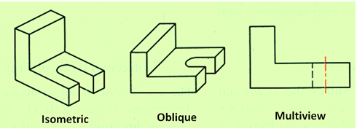](http://1.bp.blogspot.com/-OKnzCFGr6q4/VXAMP_7SOpI/AAAAAAAAAk8/Jg8VhlV2PU8/s1600/4.png)

**Transparent viewing box**

Assume that the object is placed in a transparent box, the faces of which are orthogonal to each other, as shown in figure .  Here we view the object faces normal to the three planes of the transparent box.

[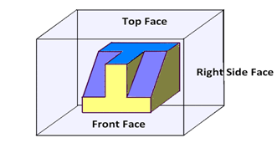](http://2.bp.blogspot.com/-cOYGolH5gfk/VXAMP44JpfI/AAAAAAAAAk4/ZegCczMwhfE/s1600/5.png)

When the viewing planes are parallel to these principal planes, we obtain the Orthographic views

The picture we obtain when the line of sight is projected on to each plane is called as the respective view of the object. The image obtained on the projection planes , i.e., on the top face, Front Face, and Right side face  are respectively the  Top View, Front view and Right side view of the object and is shown in figure

[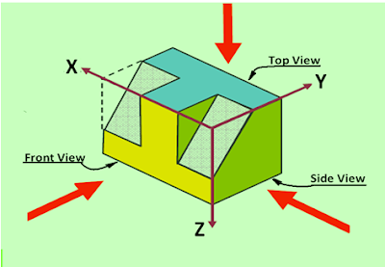](http://4.bp.blogspot.com/-xcUNofFtlp8/VXAMQl3DfxI/AAAAAAAAAlA/8grFHH-hyuE/s1600/6.png)

**Multi-view Projection**

In an orthographic projection, the object is oriented in such a way that only two of its dimensions are shown. The dimensions obtained are the true dimensions of the object .

**Frontal plane of projection**

Frontal plane of projection is the plane onto which the Front View (FV) of the multi-view drawing is projected.  
Figure illustrates the method of obtaining the Front view of an object. Front view of an object shows the width and height dimensions.

[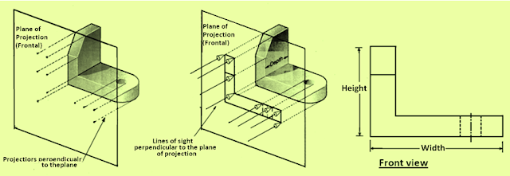](http://4.bp.blogspot.com/-2kWun-IXsDE/VXAMRCze2PI/AAAAAAAAAlQ/R-tteG2IChs/s1600/7.png)

**Horizontal plane of projection**

Horizontal plane of projection is the plane onto which the Top View of the multi-view drawing is projected and is shown in  Figure . The Top view of an object shows the width and depth dimensions of the object.

[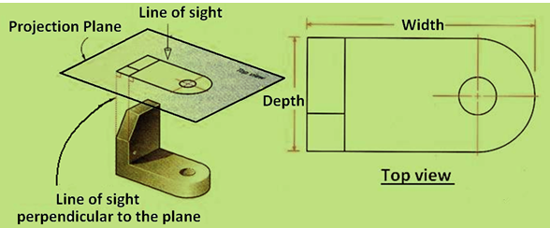](http://2.bp.blogspot.com/-zBAYp4e6G4o/VXAMSCx2e_I/AAAAAAAAAlU/RJFhSKBFhfw/s1600/8.png)

**Profile plane of projection**

In multi-view drawings, the right side view is the standard side view used and is illustrated in figure.  The right side view of an object shows the depth and the height dimensions. The right side view is projected onto the profile plane of projection, which is a plane that is parallel to the right side of the object.

[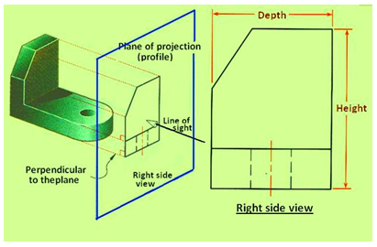](http://2.bp.blogspot.com/-QWmW-PIBDuY/VXAMSBZHDVI/AAAAAAAAAlY/f5YEeZ1_4mE/s1600/9.png)

**Orientation of views from projection planes**

Multi-view drawings gives the complete description of an object. For conveying the complete information, all the three views, i.e., the Front view, Top view and side view of the object is required. To obtain all the technical information, at least two out of the three views are required.  It is also necessary to position the three views in a particular order. Top view is always positioned and aligned with the front view, and side view is always positioned to the side of the Front view and aligned with the front view. The positions of each view is shown in figure 11. Depending on whether 1st angle or 3rd angle projection techniques are used, the top view and Front view will be interchanged. Also the position of the side view will be either towards the Right or left of the Front view.

[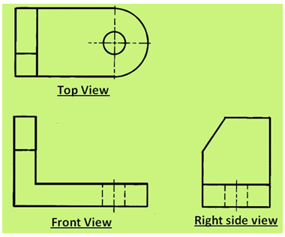](http://3.bp.blogspot.com/-3v8NcBkbQps/VXAMHCFV2DI/AAAAAAAAAj0/M4Si1yoisxI/s1600/10.png)

**Six Principal views**

The plane of projection can be oriented to produce an infinite number of views of an object.  However, some views are more important than others.  These principal views are the six mutually perpendicular views that are produced by six mutually perpendicular planes of projection and is shown in figure  Imagine suspending an object in a glass box with major surfaces of the object positioned so that they are parallel to the sides of the box, six sides of the box become projection planes, showing the six views – front, top, left, right, bottom and rear.

Object is suspended in a glass box producing six principal views: each view is perpendicular to and aligned with the adjacent views.

[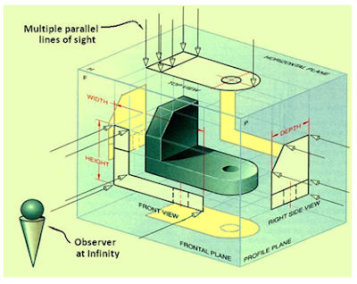](http://3.bp.blogspot.com/-lQIVgjUHNXo/VXAMIKN55rI/AAAAAAAAAkE/i3HN6CF0_fE/s1600/11.png)

The glass box is now slowly unfolded as shown in figure. After complete unfolding  of the box on to a single plane, we get the six views of the object in a single plane as shown in figure. The top, front and bottom views are all aligned vertically and share the same width dimension where as the rear, left side, front and right side views are all aligned horizontally and share the same height dimension.

[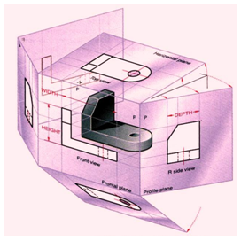](http://4.bp.blogspot.com/-f8-9iHLHLsY/VXAMIt6kLkI/AAAAAAAAAkI/UKhH_mJJOC8/s1600/12.png)

[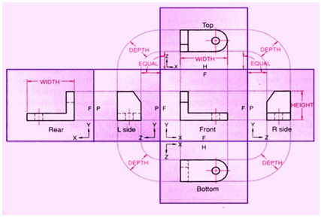](http://4.bp.blogspot.com/-y2ZGzm8mgu8/VXAMJpDlL6I/AAAAAAAAAkQ/v5ZUUE_EMj8/s1600/13.png)

**Conventional view placement**  
The three-view multi-view drawing is the standard used in engineering and technology, because many times the other three principal views are mirror images and do not add to the knowledge about the object.  Figure shows the  standard views used in a three-view drawing i.e.,  the top, front and the right side views

[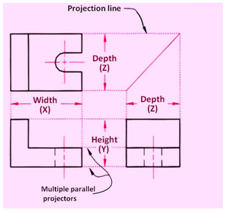](http://3.bp.blogspot.com/-wWu0EBCSh8c/VXAMO25hF0I/AAAAAAAAAkc/dwPWhJ6J9Hk/s1600/14.png)

The width dimensions are aligned between the front and top views, using vertical projection lines. The height dimensions are aligned between the front and the profile views, using horizontal projection lines.  Because of the relative positioning of the three views, the depth dimension cannot be aligned using projection lines. Instead, the depth dimension is measured in either the top or right side view.