**Basic Network Tools**

**hostname:** This is the simplest of all TCP/IP commands. It simply displays the name of your computer.

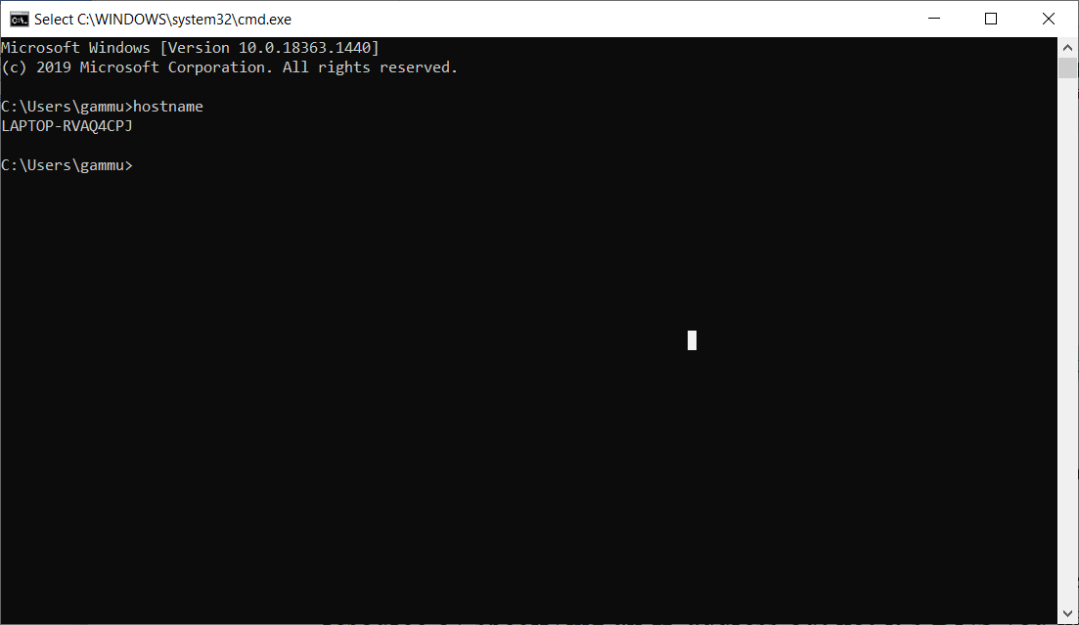

**ipconfig:** The ipconfig command displays information about the host (the computer your sitting at)computer TCP/IP configuration.

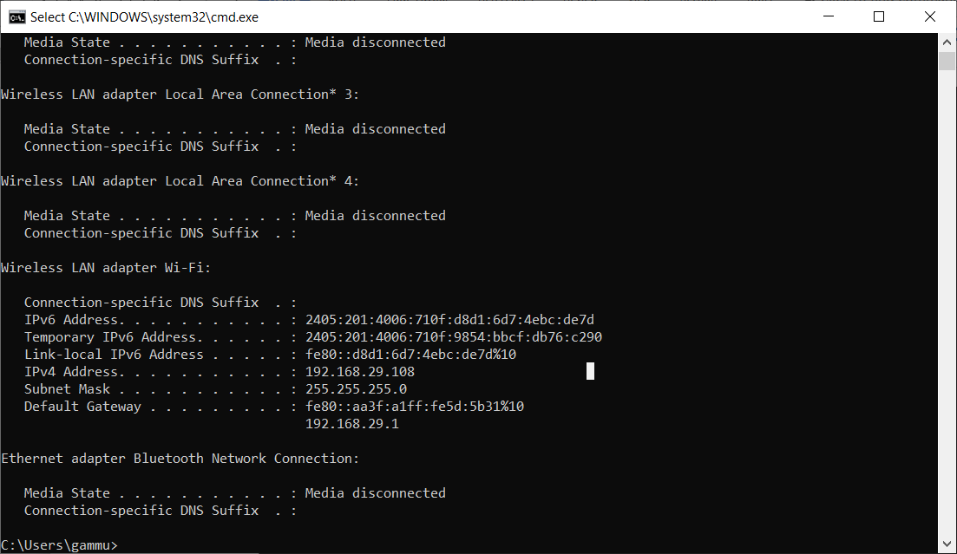

**nslookup:** followed by the domain name will display the “A Record” (IP Address) of the domain. Use this command to find the address record for a domain. It queries to domain name servers and get the details.

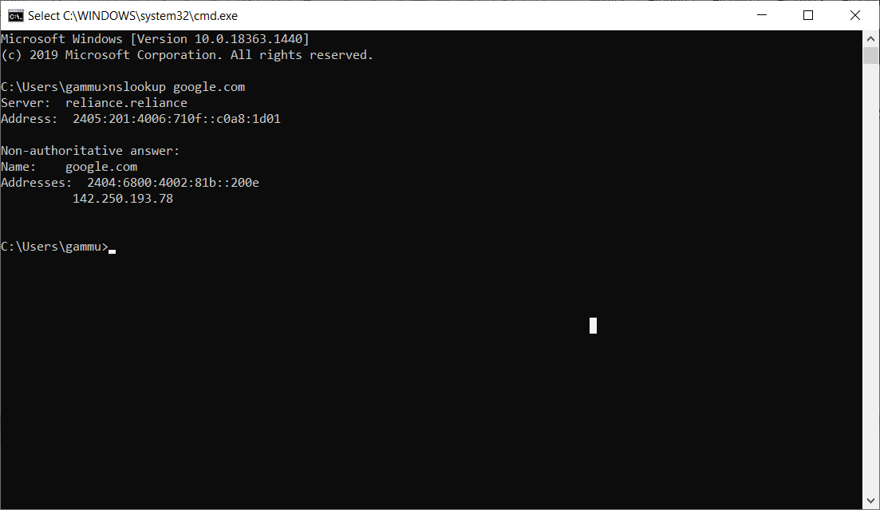

**ping:** Ping is the most basic TCP/IP command, and it’s the same as placing a phone call to your best friend. You pick up your telephone and dial a number, expecting your best friend to reply with “Hello” on the other end. Computers make phone calls to each other over a network by using a Ping command. The Ping commands main purpose is to place a phone call to another computer on the network, and request an answer. Ping has 2 options it can use to place a phone call to another computer on the network. It can use the computers name or IP address.

ping is the primary TCP/IP command used to troubleshoot connectivity, reachability, and name resolution. Used without parameters, this command displays Help content. You can also use this command to test both the computer name and the IP address of the computer.

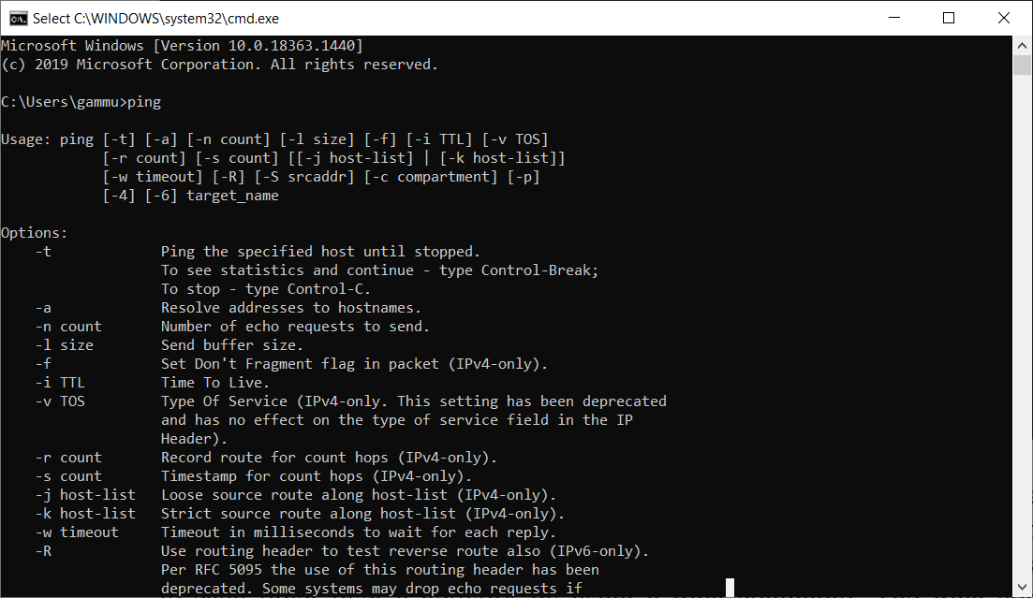

**tracert:** The tracert command displays a list of all the routers that a packet has to go through to get from the computer where tracert is run to any other computer on the internet.

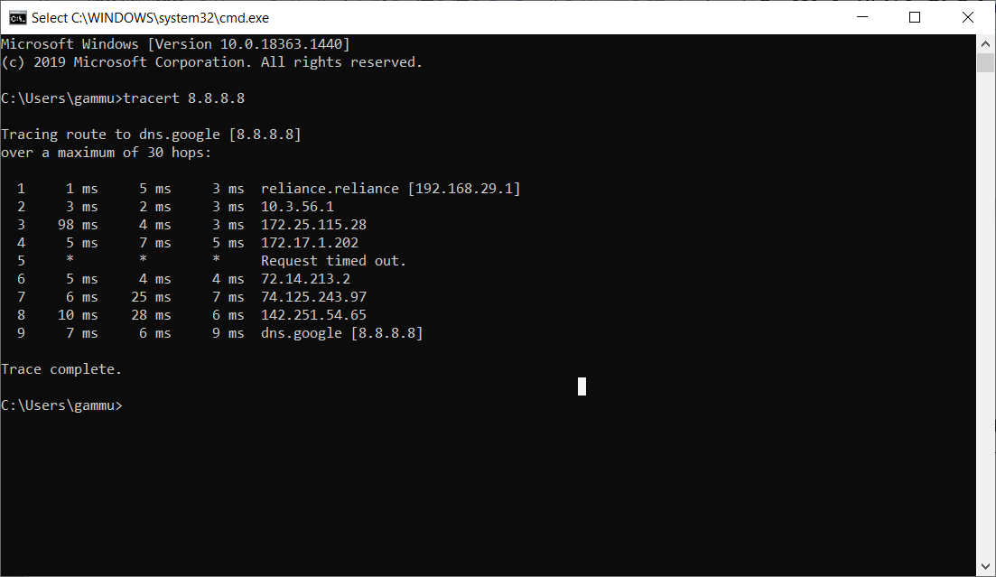

## **Traceroute**

If you are curious as to what path your requests are taking, as well as how long it takes to get from point A to point B (as well as intermediary stops), you can use the Traceroute tool. This can help you with things like:

* Determining if there’s a specific server (or node) that is slow or unreachable
* Figuring out who hosts a specific resource and where the host is located
* Checking the reachability of your site



**Whois**

This one is an oldy, but a goody. Sometimes we want to know who owns a domain name or a range of public IP space. Whois allows us to do this with ease. Whois will give us details about who has registered a particular domain name and often includes contact details for the registrar.

Syntax: whois -v example.com

**Speed Test**

Getting to know your bandwidth. If you stream a lot of Netflix at home, you’ll be familiar with the little spinning circle that lets you know that the video is buffering. Oftentimes, this is due to a lack of bandwidth when your roommate is also streaming the latest DOTA match on Twitch. Websites like Speedtest.net help us to determine how much bandwidth we have in and out of our Network.

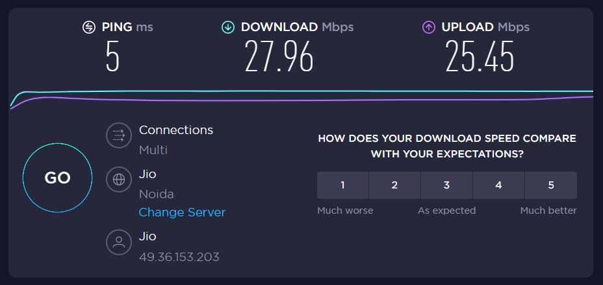

**How http works - A basic idea?**

**What is HTTP?**

HTTP is the abbreviation for hypertext transfer protocol. This is the main method by which the data of web pages are transferred over a network. Web pages are stored on servers, which are then served to the client computer as the user accesses them.

The resulting network of these connections creates the world wide web as we know it today. Without HTTP, the world wide web (WWW) as we know it would not exist.

There is one major issue with an HTTP connection — the data that is transferred over an HTTP connection is not encrypted, so you run the risk of third-party attackers stealing the information. Any information transmitted over this network via HTTP is not private, so any credit card data and sensitive information should not be submitted if you are on an HTTP page.

**How HTTP works?**

The following diagram shows a very basic architecture of a web application and depicts where HTTP sits:

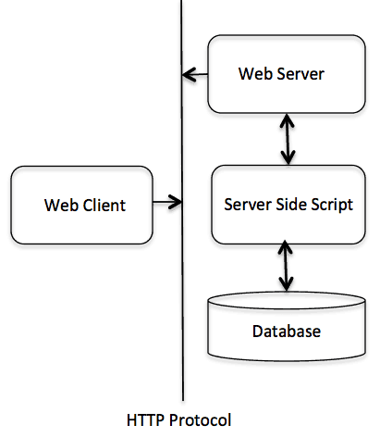

The HTTP protocol is a request/response protocol based on the client/server based architecture where web browsers, robots and search engines, etc. act like HTTP clients, and the Web server acts as a server.

Client

The HTTP client sends a request to the server in the form of a request method, URI, and protocol version, followed by a MIME(Multipurpose Internet Mail Extensions)-like message containing request modifiers, client information, and possible body content over a TCP/IP connection.

Server

The HTTP server responds with a status line, including the message's protocol version and a success or error code, followed by a MIME-like message containing server information, entity meta information, and possible entity-body content.

