**Cloud and Its Types**

"The cloud" refers to servers that are accessed over the Internet, and the software and databases that run on those servers. Cloud servers are located in data centers all over the world. By using cloud computing, users and companies don't have to manage physical servers themselves or run software applications on their own machines.

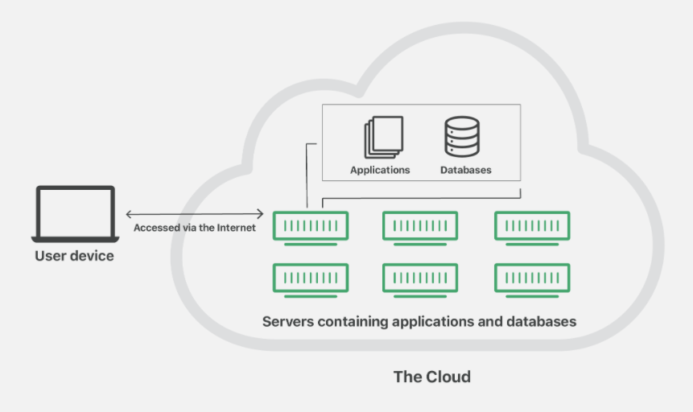

The cloud enables users to access the same files and applications from almost any device, because the computing and storage takes place on servers in a data center, instead of locally on the user device. This is why a user can log into their Instagram account on a new phone after their old phone breaks and still find their old account in place, with all their photos, videos, and conversation history. It works the same way with cloud email providers like Gmail or Microsoft Office 365, and with cloud storage providers like Dropbox or Google Drive.

For businesses, switching to cloud computing removes some IT costs and overhead: for instance, they no longer need to update and maintain their own servers, as the cloud vendor they are using will do that. This especially makes an impact for small businesses that may not have been able to afford their own internal infrastructure but can outsource their infrastructure needs affordably via the cloud. The cloud can also make it easier for companies to operate internationally, because employees and customers can access the same files and applica-tions from any location.

## **How does cloud computing work?**

Cloud computing is possible because of a technology called virtualization. Virtualization allows for the creation of a simulated, digital-only "virtual" computer that behaves as if it were a physical computer with its own hardware. The technical term for such a computer is virtual machine. When properly implemented, virtual machines on the same host machine are sandboxed from one another, so they don't interact with each other at all, and the files and applications from one virtual machine aren't visible to the other virtual machines even though they're on the same physical machine.

Virtual machines also make more efficient use of the hardware hosting them. By running many virtual machines at once, one server becomes many servers, and a data center becomes a whole host of data centers, able to serve many organizations. Thus, cloud providers can offer the use of their servers to far more customers at once than they would be able to otherwise, and they can do so at a low cost.

Even if individual servers go down, cloud servers in general should be always online and always available. Cloud vendors generally back up their services on multiple machines and across multiple regions.

Users access cloud services either through a browser or through an app, connecting to the cloud over the Internet – that is, through many interconnected networks – regardless of what device they're using.

## **Types of Cloud Computing**

There are three main types of cloud computing – public cloud, private cloud, and hybrid cloud computing. Let’s go deep to understand the types of cloud computing.

### **Public Cloud**

A public cloud is a platform that uses the standard cloud computing model to make resources, such as virtual machines (VMs), applications, or storage, available to users remotely. Public cloud services may be free or offered through a variety of subscription or on-demand pricing schemes, including a pay-per-usage model.

Some public cloud examples include those offered by Amazon, Microsoft, or Google. These companies provide both services and infrastructure, which are shared by all customers. Public clouds typically have massive amounts of available space, good data upload speed, higher bandwidth, which translates into easy scalability. A public cloud is often recommended for software development and collaborative projects. Companies can design their applications to be portable so that a project that is tested in the public cloud can be moved to the private cloud for production. Most cloud providers package their computing resources as part of a service. Public cloud examples range from access to a completely virtualized infrastructure that provides little more than raw processing power and storage (Infrastructure as a Service, or IaaS) to specialized software programs that are easy to implement and use (Software as a Service, or SaaS).

#### **Pros of a Public Cloud**

* Easy scalability
* Cost-effective
* Highly reliable
* Easy to manage

#### **Cons of a Public Cloud**

* Not considered the safest option for sensitive data

### **Private Cloud**

Private clouds usually reside behind a firewall and are utilized by a single organization. A completely on-premises cloud may be the preferred solution for businesses with very tight regulatory requirements, though private clouds implemented through a co-location provider are gaining in popularity. Authorized users can access, utilize, and store data in the private cloud from anywhere, just like they could with a public cloud. The difference is that no one else can access or utilize those computing resources. Private cloud solutions offer both security and control, but these benefits come at a cost. The company that owns the cloud is responsible for both software and infrastructure, making this a less economical model than the public cloud.

#### **Pros of a Private Cloud**

* High level of security
* Great control on server
* Easy Customizable

#### **Cons of a Private Cloud**

* Harder to access data from remote locations
* Requires IT expertise

### **Hybrid Cloud**

Hybrid clouds combine public clouds with private clouds. They are designed to allow the two platforms to interact seamlessly, with data and applications moving seamlessly from one to the other.   
The primary advantage of a hybrid cloud model is its ability to provide the scalable computing power of a public cloud with the security and control of a private cloud. Data can be stored safely behind the firewalls and encryption protocols of the private cloud, then moved securely into a public cloud environment when needed. This is especially helpful in the age of big data analytics when industries like healthcare must adhere to strict data privacy regulations while also using sophisticated algorithms powered by artificial intelligence (AI) to derive actionable insights from huge masses of unstructured data.

There are two commonly used types of hybrid cloud architecture. Cloud bursting uses a private cloud as its primary cloud, storing data and housing proprietary applications in a secure environment. When service demands increase, however, the private cloud’s infrastructure may not have the capacity to keep up. That is where the public cloud comes in. A cloud bursting model uses the public cloud’s computing resources to supplement the private cloud, allowing the company to handle increased traffic without having to purchase new servers or other infrastructure.

The second type of hybrid cloud model also runs most applications and houses data in a private cloud environment but outsources non-critical applications to a public cloud provider. This arrangement is common for organizations that need to access specialized development tools (like Adobe Creative Cloud), basic productivity software (like Microsoft Office 365), or CRM platforms (like Salesforce). Multi-cloud architecture is often deployed here, incorporating multiple cloud service providers to meet a variety of unique organizational needs.

#### **Pros of a Hybrid Cloud**

* Highly flexible and scalable
* Cost-effective
* Enhanced security features

#### **Cons of a Hybrid Cloud**

* As used in both private and public clouds, the communications in network level may be conflicted