**CSMA/CA**

This method was developed to decrease the chances of collisions when two or more stations start sending their signals over the datalink layer. Carrier Sense multiple access requires that each station **first check the state of the medium** before sending.

### Carrier Sense Multiple Access with Collision Avoidance (CSMA/CA) –

The basic idea behind CSMA/CA is that the station should be able to receive while transmitting to detect a collision from different stations. In wired networks, if a collision has occurred then the energy of received signal almost doubles and the station can sense the possibility of collision. In case of wireless networks, most of the energy is used for transmission and the energy of received signal increases by only 5-10% if a collision occurs. It can’t be used by the station to sense collision. Therefore **CSMA/CA has been specially designed for wireless networks**.

These are three types of strategies:

* **InterFrame Space (IFS) –** When a station finds the channel busy, it waits for a period of time called IFS time. IFS can also be used to define the priority of a station or a frame. Higher the IFS lower is the priority.
* **Contention Window –** It is the amount of time divided into slots.A station which is ready to send frames chooses random number of slots as **wait time**.
* **Acknowledgements –** The positive acknowledgements and time-out timer can help guarantee a successful transmission of the frame.

**Process**

The algorithm of CSMA/CA is:

* When a frame is ready, the transmitting station checks whether the channel is idle or busy.
* If the channel is busy, the station waits until the channel becomes idle.
* If the channel is idle, the station waits for an Inter-frame gap (IFG) amount of time and then sends the frame.
* After sending the frame, it sets a timer.
* The station then waits for acknowledgement from the receiver. If it receives the acknowledgement before expiry of timer, it marks a successful transmission.
* Otherwise, it waits for a back-off time period and restarts the algorithm.

The entire process for collision avoidance can be explained as follows:

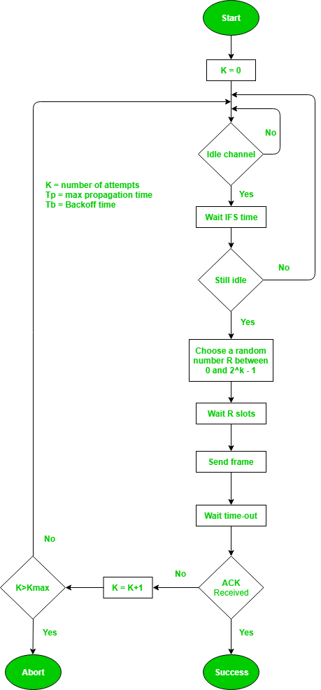

**Error Detection and Correction**

## What is Error?

Error is a condition when the output information does not match with the input information. During transmission, digital signals suffer from noise that can introduce errors in the binary bits travelling from one system to other. That means a 0 bit may change to 1 or a 1 bit may change to 0.

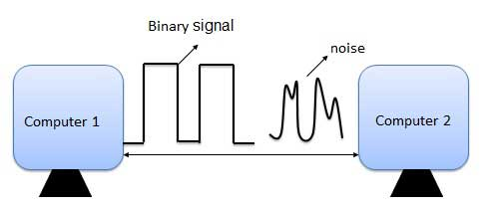

## Error-Detecting codes

Whenever a message is transmitted, it may get scrambled by noise or data may get corrupted. To avoid this, we use error-detecting codes which are additional data added to a given digital message to help us detect if an error occurred during transmission of the message. A simple example of error-detecting code is **parity check**.

## Error-Correcting codes

Along with error-detecting code, we can also pass some data to figure out the original message from the corrupt message that we received. This type of code is called an error-correcting code. Error-correcting codes also deploy the same strategy as error-detecting codes but additionally, such codes also detect the exact location of the corrupt bit.

In error-correcting codes, parity check has a simple way to detect errors along with a sophisticated mechanism to determine the corrupt bit location. Once the corrupt bit is located, its value is reverted (from 0 to 1 or 1 to 0) to get the original message.

## How to Detect and Correct Errors?

To detect and correct the errors, additional bits are added to the data bits at the time of transmission.

The additional bits are called **parity bits**. They allow detection or correction of the errors.

The data bits along with the parity bits form a **code word**.

## Parity Checking of Error Detection

It is the simplest technique for detecting and correcting errors. The MSB of an 8-bits word is used as the parity bit and the remaining 7 bits are used as data or message bits. The parity of 8-bits transmitted word can be either even parity or odd parity.

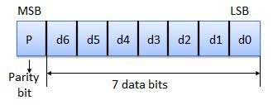

**Even parity** -- Even parity means the number of 1's in the given word including the parity bit should be even (2,4,6,....).

**Odd parity** -- Odd parity means the number of 1's in the given word including the parity bit should be odd (1,3,5,....).

## Use of Parity Bit

The parity bit can be set to 0 and 1 depending on the type of the parity required.

For even parity, this bit is set to 1 or 0 such that the no. of "1 bits" in the entire word is even. Shown in fig. (a).

For odd parity, this bit is set to 1 or 0 such that the no. of "1 bits" in the entire word is odd. Shown in fig. (b).

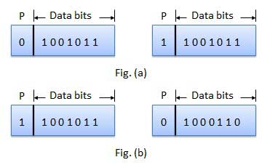

## How Does Error Detection Take Place?

Parity checking at the receiver can detect the presence of an error if the parity of the receiver signal is different from the expected parity. That means, if it is known that the parity of the transmitted signal is always going to be "even" and if the received signal has an odd parity, then the receiver can conclude that the received signal is not correct. If an error is detected, then the receiver will ignore the received byte and request for retransmission of the same byte to the transmitter.

