**Internet of Things (IoT)**

The Internet of Things (IoT) describes the network of physical objects:- “things”- that are embedded with sensors, software, and other technologies for the purpose of connecting and exchanging data with other devices and systems over the internet.

That includes an extraordinary number of objects of all shapes and sizes – from [smart microwaves](https://www.youtube.com/watch?v=1u4Mwn6BQyo), which automatically cook your food for the right length of time, to [self-driving cars](https://www.youtube.com/watch?v=K564rXrlZbc), whose complex sensors detect objects in their path, to wearable [fitness devices](https://www.ibm.com/blogs/internet-of-things/watson-iot-sports/) that measure your heart rate and the number of steps you’ve taken that day, then use that information to suggest exercise plans tailored to you. There are even [connected footballs](http://www.wilson.com/en-us/explore/football/wx.html) that can track how far and fast they are thrown and record those statistics via an app for future training purposes.

The Internet of Things is the concept of connecting any device (so long as it has an on/off switch) to the Internet and to other connected devices. The IoT is a giant network of connected things and people – all of which collect and share data about the way they are used and about the environment around them.

## **How does it work?**

Devices and objects with built in sensors are connected to an [Internet of Things platform](http://www.ibm.com/internet-of-things/), which integrates data from the different devices and applies analytics to share the most valuable information with applications built to address specific needs.

These powerful IoT platforms can pinpoint exactly what information is useful and what can safely be ignored. This information can be used to detect patterns, make recommendations, and detect possible problems before they occur.

**Devices that can form IoT**

Internet of Things (IoT) devices support the expansion of internet connection beyond the usual standard devices like computers, laptops, smartphones etc.

These IoT devices are purely integrated with high definition technology which makes it possible for them to communicate or interact over the internet smoothly and can also be managed and controlled remotely when required.

## **Introduction Of IoT Devices**

It is a matter of fact today that a number of IoT products have a huge number of humans on this planet.

Approximately there are around 7.62 billion humans on our planet, but to your surprise, by the year 2021 with an increasing graph of IoT devices, there may be around 20 billion IoT smart devices up and running with an increase in the demand of 5g network.

**Enlisted below are the top Internet of Things devices that are used all over the world:**

### **1) Google Home Voice Controller**

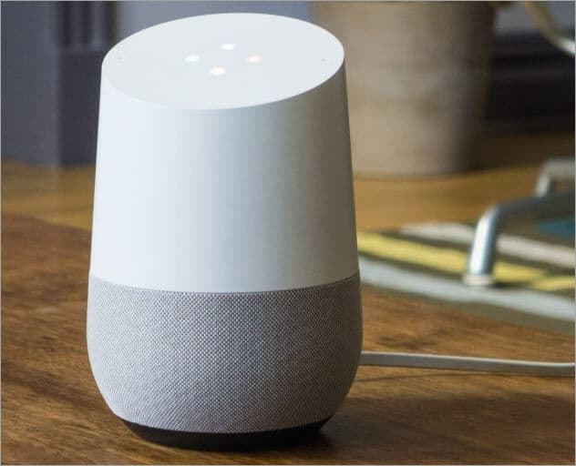

Google Home Voice Controller is a smart IoT device which allows the user to enjoy features like media, alarms, lights, thermostats, control the volume and much more functions just by their voice.

Cost: US $ 130

**Top Features:**

* Google home allows a user to listen to media.
* Let’s the user to control TV and speakers.
* It is capable of managing timers and alarms.
* It can remotely handle the volume and home lights as well.
* It helps the user to plan their day and get things done automatically.

### 2) Amazon Echo Plus Voice Controller

[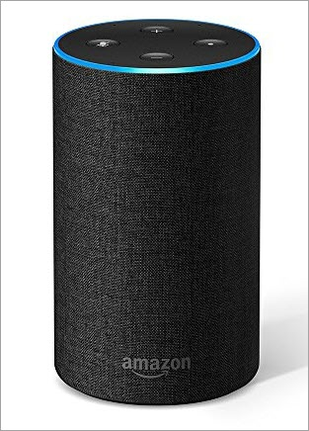](https://geni.us/SDGK0)

Amazon Echo Plus voice controller is a popular and reliable IoT device. It is capable to run songs, do phone calls, set timers and alarms, ask questions, provide information, check the weather, manage to-do & shopping lists, manage house instruments, and several other things.

****Cost:**** US $ 99.99

****Top Features:****

* Amazon Echo can play songs, connect to external speakers or headphones.
* It is capable of making calls and messaging on voice command.
* Amazon Echo has around 6-7 microphones, good technical specification and sound cancellation. It is capable of hearing your voice from all the directions even when songs are played.
* Controls compatible smart home devices including lights, plugs, and more.

### 3) Amazon Dash Button

[](https://geni.us/xfAqF)

Amazon Dash Button is basically a device that gets connected over internet Wi-Fi and makes sure that the user does not lack important household items like soft drinks, grocery material, medical and personal care, kids and any pet items ever again.

If a user wants to fully utilize the Dash Button, then the user must be an Amazon Prime member.

****Cost:**** US $ 4.99

**Top Features:**

* It allows the user to order products quickly and there is no need to recall the message again and it also helps to reduce the time frame for searching the required product by the user.
* Amazon Dash Button also allows the user to reorder from popular brands – like Bounty, Tide, Cottonelle, Glad, Clorox etc.
* It does not accept fresh order if the prior order is not complete unless the user allows multiple orders.

It is a good and reliable IoT product that is developed for making the user’s lifestyle simple and easy.

### **4) August Doorbell Cam**

[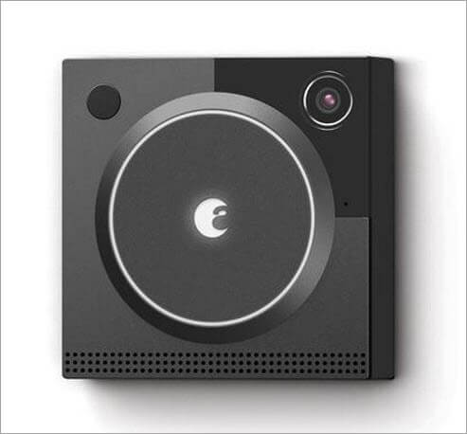](https://geni.us/BojdS)

August Doorbell Cam is an effective IoT innovation. August Doorbell Cam allows you to answer your door from anywhere or remote location. It constantly checks your doors and also captures motion changes in your doorstep.

****Cost:**** US $ 199

**Top Features:**

* Doorbell Cam pairs with all August Smart Locks to easily let guests into your home.
* The integrated floodlight delivers clear, full-color HD video even full-color.
* It constantly monitors your doorstep and will click the moments leading up to a motion alert.
* Free 24 hour video recording.
* It comes with a speedy and hassle-free installation process.

**5) August Smart Lock**

[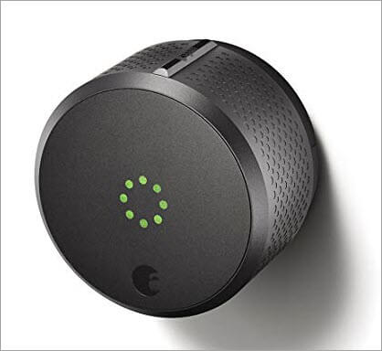](https://geni.us/wHQNTeD)

August Smart Lock has proven to be a reliable security IoT device. It allows the user to manage their doors from any location hassle-free. It helps the user to keep thieves away and family in your home.

****Cost:**** US $ 220

**Top Features:**

* Allows the user to know about each and every person coming and going into your home.
* Provides unlimited digital keys and no fear of stolen key.
* It gives the status updates of your door as it is properly closed or not.
* It has a good auto-unlock feature and as soon as the user arrives near the door it opens automatically.
* Easy installation and is compatible with most standard single cylinder deadbolts.

# 5 challenges and risks still facing the Internet of Things

[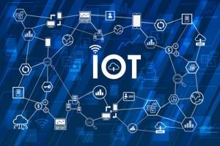](https://www.iot-now.com/2020/06/03/103228-5-challenges-still-facing-the-internet-of-things/)

The [Internet of Things](https://www.iot-now.com/2019/07/07/97056-what-is-iot/) (IoT) has quickly become a huge part of how people live, communicate and do business. All around the world, web-enabled devices are turning our world into a more switched-on place to live.

From security challenges to the perils of high customer expectations, these five factors are big concerns for the growth and development of the Internet of Things. Overcoming them will be the key to creating true lasting productivity and prosperity through these incredible technologies.

### 1. ****Security****

In cybersecurity terms, IoT devices greatly expand the “attack surface,” or the amount of potential areas for cybercriminals to penetrate a secure network.

Cybercriminals don’t have to crack an IoT device’s [plastic enclosure](https://www.polycase.com/plastic-enclosures) to access sensitive materials. They can simply finesse their way in through one of the many security vulnerabilities that are found throughout the IoT. Many IoT devices have default passwords left unchanged, unpatched software and other major security vulnerabilities.

### ****2. Regulation****

Another common characteristic of technological innovations is that government regulation often takes a long time to catch up with the current state of technology. With the rapid evolution that’s happening every day in IoT, the government is taking its time in catching up and businesses are often left without crucial information they need to make decisions.

The [lack of strong IoT regulations](https://www.iot-now.com/2017/04/21/60903-iot-lack-standards-becoming-threat/" \t "https://www.iot-now.com/2020/06/03/103228-5-challenges-still-facing-the-internet-of-things/_blank) is a big part of why the IoT remains a severe security risk, and the problem is likely to get worse as the potential attack surface expands to include ever more crucial devices. When medical devices, cars and children’s toys are all connected to the Internet, it’s not hard to imagine many potential disaster scenarios unfolding in the absence of sufficient regulation.

Quality control in IoT can be particularly tricky from a regulatory perspective. With huge numbers of IoT devices now being imported from countries like China that have different standards of quality and security, many experts are calling for strong and universal security standards for IoT technology.

### 3. ****Compatibility****

New waves of technology often feature a large stable of competitors jockeying for market share, and IoT is certainly no exception. This can be good news, since competition creates increased choices for consumers, but it can also create frustrating compatibility issues.

Continued compatibility for IoT devices also depends upon users keeping their devices updated and patched, which, as we’ve just discussed, can be pretty difficult. When IoT devices that have to talk to each other are running different software versions, all kinds of performance issues and security vulnerabilities can result. That’s a big part of why it’s so important that IoT consumers keep their devices patched and up to date.

### 4. ****Bandwidth****

Connectivity is a bigger challenge to the IoT than you might expect. As the size of the IoT market grows exponentially, some experts are concerned that bandwidth-intensive IoT applications such as video streaming will soon struggle for space on the IoT’s current server-client model.

That’s because the server-client model uses a centralised server to authenticate and direct traffic on IoT networks. However, as more and more devices begin to connect to these networks, they often struggle to bear the load.

### 5. ****Customer expectations****

It’s often said that it’s better to under-promise and over-deliver. Many IoT manufacturers have learned this the hard way, with [IoT start-ups failing often and leaving bewildered customers in their wake](https://medium.com/@virgil.utopia/the-silent-extinction-of-iot-startups-767c08773c9a). When customer expectations and product reality don’t match, the results can be system failures, orphaned technologies and lost productivity.

With such strong competition in the IoT market, customers whose expectations aren’t met won’t hesitate to go elsewhere. Businesses looking to enter this competitive and innovative sector should be prepared for a market that never sits still and customers who always want a smoother and more advanced experience.