**Types of Networks by Component Roles**

**and**

**based on Communication Channel**

In general, a [computer](https://ecomputernotes.com/fundamental/introduction-to-computer/what-is-computer) network composed of one or more servers, workstations, network interface cards, active and passive hub, routers, bridges, gateways, modem, software components like network operating systems, and other application software. The following components widely used for the construction of networks.

Server It is the most powerful [computer](https://ecomputernotes.com/fundamental/introduction-to-computer/what-is-computer) in the network. In a local area network, usually, a powerful microcomputer or a super microcomputer with the power of a [minicomputer](https://ecomputernotes.com/fundamental/introduction-to-computer/minicomputer) is used as a server. There are two types of servers typically employed in a local area network. They are dedicated servers and non-dedicated servers.

In a dedicated server, the server computer performs the functions and services of the whole network. It helps to run user applications efficiently and increases the overall system cost. Users cannot run their applications directly in a dedicated server. It provides e-mail service, sharing of multiple hard disks, and sharing of other resources and faster response time. For more extensive networks with a heavy load, dedicated servers usually employed.

In a non-dedicated server, apart from the role of a network controller, a server also acts as an individual workstation — the server equipped with a prodigious [memory](https://ecomputernotes.com/fundamental/input-output-and-memory/memory" \o "memory). Network operations demand only a portion of server [memory](https://ecomputernotes.com/fundamental/input-output-and-memory/memory" \o "memory). The remaining portion of the memory may use for the user applications. Under light load conditions, it is advisable to use a non-dedicated server. Some servers can operate on both modes, according to the requirement of the user.

**Network Devices**

Hardware devices that are used to connect computers, printers, fax machines and other electronic devices to a network are called network devices. These devices transfer data in a fast, secure and correct way over same or different networks. Network devices may be inter-network or intra-network. Some devices are installed on the device, like NIC card or RJ45 connector, whereas some are part of the network, like router, switch, etc.

**Network Interface Card (NIC)**

A network interface card (NIC) is a hardware component without which a computer cannot be connected over a network. It is a circuit board installed in a computer that provides a dedicated network connection to the computer. It is also called network interface controller, network adapter or LAN adapter.

**Types of NIC Cards**

NIC cards are of two types:

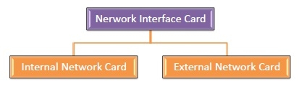

**Internal Network Cards**

In internal networks cards, motherboard has a slot for the network card where it can be inserted. It requires network cables to provide network access. Internal network cards are of two types. The first type uses Peripheral Component Interconnect (PCI) connection, while the second type uses Industry Standard Architecture (ISA).

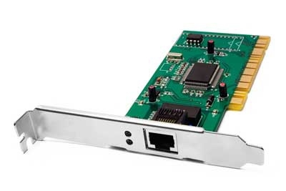

**External Network Cards**

In desktops and laptops that do not have an internal NIC, external NICs are used. External network cards are of two types: Wireless and USB based. Wireless network card needs to be inserted into the motherboard, however no network cable is required to connect to the network. They are useful while traveling or accessing a wireless signal.

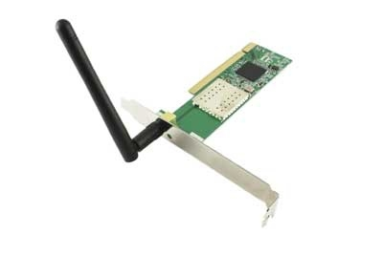

## **RJ45 Connector**

RJ45 is the acronym for Registered Jack 45. RJ45 connector is an 8-pin jack used by devices to physically connect to Ethernet based local area networks (LANs). Ethernet is a technology that defines protocols for establishing a LAN. The cable used for Ethernet LANs are twisted pair ones and have RJ45 connector pins at both ends. These pins go into the corresponding socket on devices and connect the device to the network.

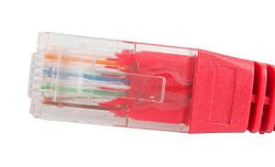

## **Router**

A router is a network layer hardware device that transmits data from one LAN to another if both networks support the same set of protocols. So a router is typically connected to at least two LANs and the internet service provider (ISP). It receives its data in the form of packets, which are data frames with their destination address added. Router also strengthens the signals before transmitting them. That is why it is also called repeater.

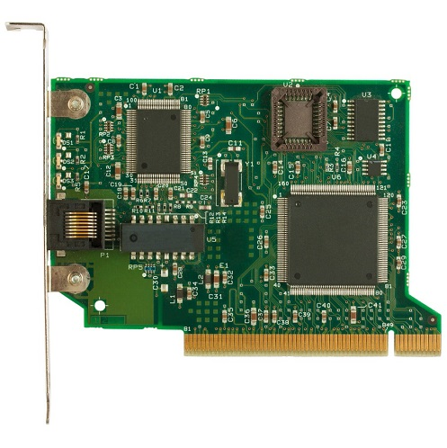

## **Routing Table**

A router reads its routing table to decide the best available route the packet can take to reach its destination quickly and accurately. The routing table may be of these two types −

Static − In a static routing table the routes are fed manually. So it is suitable only for very small networks that have maximum two to three routers.

Dynamic − In a dynamic routing table, the router communicates with other routers through protocols to determine which routes are free. This is suited for larger networks where manual feeding may not be feasible due to large number of routers.

## **Switch**

Switch is a network device that connects other devices to Ethernet networks through twisted pair cables. It uses packet switching technique to receive, store and forward data packets on the network. The switch maintains a list of network addresses of all the devices connected to it.

On receiving a packet, it checks the destination address and transmits the packet to the correct port. Before forwarding, the packets are checked for collision and other network errors. The data is transmitted in full duplex mode

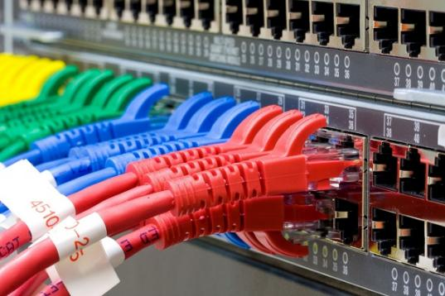

Data transmission speed in switches can be double that of other network devices like hubs used for networking. This is because switch shares its maximum speed with all the devices connected to it. This helps in maintaining network speed even during high traffic. In fact, higher data speeds are achieved on networks through use of multiple switches.

## **Gateway**

Gateway is a network device used to connect two or more dissimilar networks. In networking parlance, networks that use different protocols are dissimilar networks. A gateway usually is a computer with multiple NICs connected to different networks. A gateway can also be configured completely using software. As networks connect to a different network through gateways, these gateways are usually hosts or end points of the network.

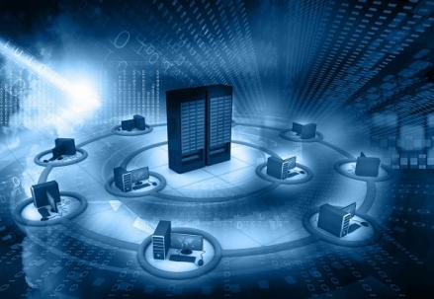

Gateway uses packet switching technique to transmit data from one network to another. In this way it is similar to a router, the only difference being router can transmit data only over networks that use same protocols.

## **Wi-Fi Card**

Wi-Fi is the acronym for wireless fidelity. Wi-Fi technology is used to achieve wireless connection to any network. Wi-Fi card is a card used to connect any device to the local network wirelessly. The physical area of the network which provides internet access through Wi-Fi is called Wi-Fi hotspot. Hotspots can be set up at home, office or any public space. Hotspots themselves are connected to the network through wires.

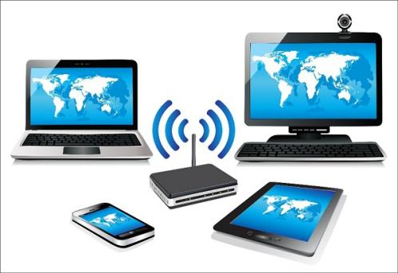

A Wi-Fi card is used to add capabilities like teleconferencing, downloading digital camera images, video chat, etc. to old devices. Modern devices come with their in-built wireless network adapter.