**Software Engineering**

**Introduction of Software Engineering:**

Software is a program or set of programs containing instructions which provide desired functionality . And Engineering is the processes of designing and building something that serves a particular purpose and find a cost effective solution to problems.

***Software Engineering****is a systematic approach to the design, development, operation, and maintenance of a software system.*

**Dual Role of Software:**

**1. As a product**

* It delivers the computing potential across network of Hardware.
* It enables the Hardware to deliver the expected functionality.
* It acts as information transformer because it produces, manages, acquires, modifies, displays, or transmits information.

**2. As a vehicle for delivering a product**

* It provides system functionality (e.g., payroll system)
* It controls other software (e.g., an operating system)
* It helps build other software (e.g., software tools)

**Objectives of Software Engineering:** 

1. **Maintainability –**   
   It should be feasible for the software to evolve to meet changing requirements.
2. **Efficiency –**  
   The software should not make wasteful use of computing devices such as memory ,processor cycles etc..
3. **Correctness –**   
   A software product is correct, if the different requirements as specified in the SRS(Software Requirements Specification) document have been correctly implemented.
4. **Reusability –**   
   A software product has good reusability, if the different modules of the product can easily be reused to develop new products.
5. **Testability –**   
   Here software facilitates both the establishment of test criteria and the evaluation of the software with respect to those criteria.
6. **Reliability –**   
   It is an attribute of software quality. The extent to which a program can be expected to perform its desired function, over an arbitrary time period.
7. **Portability –**   
   In this case, software can be transferred from one computer system or environment to another.
8. **Adaptability –**   
   In this case, software allows differing system constraints and user needs to be satisfied by making changes to the software.
9. **Interoperability**– Capability of 2 or more functional units to process data cooperatively.

**Program vs Software Product:** 

* A program is a set of instructions which is given to a computer in order to achieve a specific task whereas a software is when a program is made available for commercial business and is properly documented along with its licensing. Software=Program+documentation+licensing.
* A program is one of the stages involved in the development of the software, whereas a software development usually follows a life cycle, which involves the feasibility study of the project, requirement gathering, development of a prototype, system design, coding and testing.

**Software Crisis**

**Software Crisis** is a term used in computer science for the difficulty of writing useful and efficient computer programs in the required time .software crisis was due to using same workforce, same methods, same tools even though rapidly increasing in software demand, complexity of software and software challenges. With increase in the complexity of software, many software problems arise because existing methods were insufficient.

If we will use same workforce, same methods and same tools after fast increasing in software demand, software complexity and software challenges, then there arise some problems like software budget problem, software efficiency problem, software quality problem, software managing and delivering problem etc. This condition is called software crisis.

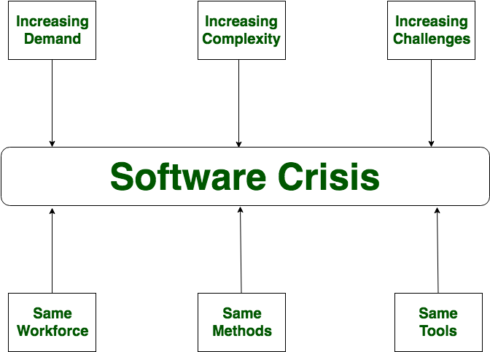

**Causes of Software Crisis:**

* The cost of owning and maintaining software was as expensive as developing the software
* At that time Projects was running over-time
* At that time Software was very inefficient
* The quality of software was low quality
* Software often did not meet requirements
* The average software project overshoots its schedule by half
* At that time Software was never delivered

**Solution of Software Crisis:**

There is no single solution to the crisis.one possible solution of software crisis is *Software Engineering* because software engineering is a systematic, disciplined and quantifiable approach. For preventing software crisis, there are some guidelines:

* Reduction in software over-budget
* The quality of software must be high
* Less time needed for software project
* Experience working team member on software project
* Software must be delivered

# **Software Process & Characteristics:**

The process that deals with the technical and management issues of software development is called a software process. A software development project must have at least development activities and project management activities. The fundamental objectives of a process are the same as that of software engineering (after all, the process is the main vehicle of satisfying the software engineering objectives), viz. optimality and scalability.

Optimality means that the process should be able to produce high-quality software at low cost, and scalability means that it should also be applicable for large software projects. To achieve these objectives, a process should have some properties. Predictability of a process determines how accurately the outcome of following a process in a project can be predicted before the project is completed. Predictability can be considered a fundamental property of any process, In fact, if a process is not predictable, it is of limited use.

One of the important objectives of the development project should be to produce software that is easy to maintain. And the process should be such that it ensures this maintainability. Testing consumes the most resources during development. Underestimating the testing effort often causes the planners to allocate insufficient resources for testing, which, in turn, results in unreliable software or schedule slippage.

The goal of the process should not be to reduce the effort of design and coding, but to reduce the cost of maintenance. Both testing and maintenance depend heavily on the design and coding of software, and these costs can be considerably reduced if the software is designed and coded to make testing and maintenance easier. Hence, during the early phases of the development process the prime issues should be “can it be easily tested” and “can it be easily modified”. Errors can occur at any stage during development.

However error detection and correction should be a continuous process that is done throughout software development. Detecting errors soon after they have been introduced is clearly an objective that should be supported by the process. A process is also not a static entity.

As the productivity (and hence the cost of a project) and quality are determined largely by the process to satisfy the engineering objectives of quality improvement and cost reduction, the software process must be improved. Having process improvement as a basic goal of the software process implies that the software process used is such that is supports its improvement.

**Software Life Cycle Models:**

Software Development Life Cycle (SDLC) is a framework that defines the steps involved in the development of software at each phase. It covers the detailed plan for building, deploying and maintaining the software.

SDLC defines the complete cycle of development i.e. all the tasks involved in planning, creating, testing, and deploying a Software Product.

[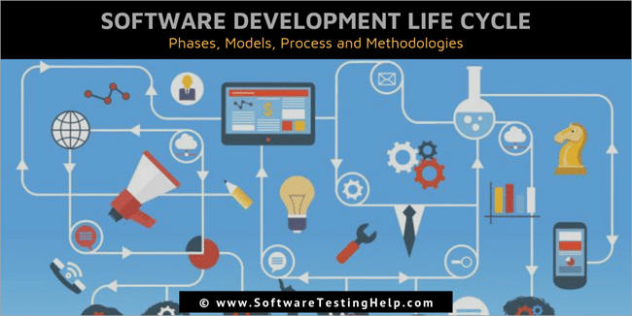](https://www.softwaretestinghelp.com/wp-content/qa/uploads/2019/01/Software-Development-Life-Cycle-SDLC.png)

## **Software Development Life Cycle Process**

SDLC is a process which defines the various stages involved in the development of software for delivering a high-quality product. SDLC stages cover the complete life cycle of a software i.e. from inception to retirement of the product.

Adhering to the SDLC process leads to the development of the software in a systematic and disciplined manner.

****Purpose:****

Purpose of SDLC is to deliver a high-quality product which is as per the customer’s requirement.

SDLC has defined its phases as, Requirement gathering, Designing, Coding, Testing, and Maintenance. It is important to adhere to the phases to provide the Product in a systematic manner.

****For Example,**** A software has to be developed and a team is divided to work on a feature of the product and is allowed to work as they want. One of the developers decides to design first whereas the other decides to code first and the other on the documentation part.

This will lead to project failure because of which it is necessary to have a good knowledge and understanding among the team members to deliver an expected product.

## **SDLC Cycle**

SDLC Cycle represents the process of developing software.

****Below is the diagrammatic representation of the SDLC cycle:****

[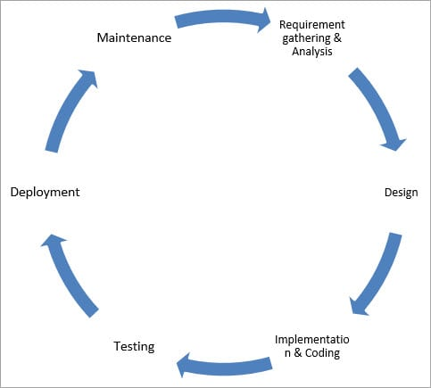](https://www.softwaretestinghelp.com/wp-content/qa/uploads/2018/04/SDLC-Cycle.jpg)

## **SDLC Phases**

****Given below are the various phases:****

* Requirement gathering and analysis
* Design
* Implementation or coding
* Testing
* Deployment
* Maintenance

### #1) Requirement Gathering and Analysis

During this phase, all the relevant information is collected from the customer to develop a product as per their expectation. Any ambiguities must be resolved in this phase only.

Business analyst and Project Manager set up a meeting with the customer to gather all the information like what the customer wants to build, who will be the end-user, what is the purpose of the product. Before building a product a core understanding or knowledge of the product is very important.

****For Example,**** A customer wants to have an application which involves money transactions. In this case, the requirement has to be clear like what kind of transactions will be done, how it will be done, in which currency it will be done, etc.

Once the requirement gathering is done, an analysis is done to check the feasibility of the development of a product. In case of any ambiguity, a call is set up for further discussion.

Once the requirement is clearly understood, the SRS (Software Requirement Specification) document is created. This document should be thoroughly understood by the developers and also should be reviewed by the customer for future reference.

### #2) Design

In this phase, the requirement gathered in the SRS document is used as an input and software architecture that is used for implementing system development is derived.

### #3) Implementation or Coding

Implementation/Coding starts once the developer gets the Design document. The Software design is translated into source code. All the components of the software are implemented in this phase.

### #4) Testing

Testing starts once the coding is complete and the modules are released for testing. In this phase, the developed software is tested thoroughly and any defects found are assigned to developers to get them fixed.

Retesting, regression testing is done until the point at which the software is as per the customer’s expectation. Testers refer SRS document to make sure that the software is as per the customer’s standard.

### #5) Deployment

Once the product is tested, it is deployed in the production environment or first [UAT (User Acceptance testing)](https://www.softwaretestinghelp.com/what-is-user-acceptance-testing-uat/) is done depending on the customer expectation.

In the case of UAT, a replica of the production environment is created and the customer along with the developers does the testing. If the customer finds the application as expected, then sign off is provided by the customer to go live.

### #6) Maintenance

After the deployment of a product on the production environment, maintenance of the product i.e. if any issue comes up and needs to be fixed or any enhancement is to be done is taken care by the developers.

## **Software Development Life Cycle Models**

A software life cycle model is a descriptive representation of the software development cycle. SDLC models might have a different approach but the basic phases and activity remain the same for all the models.

### #1) Waterfall Model

[Waterfall model](https://www.softwaretestinghelp.com/what-is-sdlc-waterfall-model/) is the very first model that is used in SDLC. It is also known as the linear sequential model.

In this model, the outcome of one phase is the input for the next phase. Development of the next phase starts only when the previous phase is complete.

* First, Requirement gathering and analysis is done. Once the requirement is freeze then only the System Design can start. Herein, the SRS document created is the output for the Requirement phase and it acts as an input for the System Design.
* In System Design Software architecture and Design, documents which act as an input for the next phase are created i.e. Implementation and coding.
* In the Implementation phase, coding is done and the software developed is the input for the next phase i.e. testing.
* In the testing phase, the developed code is tested thoroughly to detect the defects in the software. Defects are logged into the defect tracking tool and are retested once fixed. Bug logging, Retest, Regression testing goes on until the time the software is in go-live state.
* In the Deployment phase, the developed code is moved into production after the sign off is given by the customer.
* Any issues in the production environment are resolved by the developers which come under maintenance.

[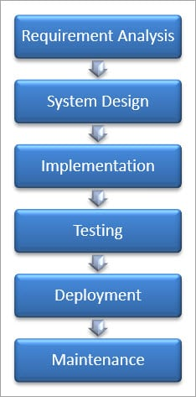](https://www.softwaretestinghelp.com/wp-content/qa/uploads/2018/04/Waterfall-Model-1.jpg)

****Advantages of the Waterfall Model:****

* Waterfall model is the simple model which can be easily understood and is the one in which all the phases are done step by step.
* Deliverables of each phase are well defined, and this leads to no complexity and makes the project easily manageable.

****Disadvantages of Waterfall model:****

* Waterfall model is time-consuming & cannot be used in the short duration projects as in this model a new phase cannot be started until the ongoing phase is completed.
* Waterfall model cannot be used for the projects which have uncertain requirement or wherein the requirement keeps on changing as this model expects the requirement to be clear in the requirement gathering and analysis phase itself and any change in the later stages would lead to cost higher as the changes would be required in all the phases.

### #2) V-Shaped Model

[V- Model](https://www.softwaretestinghelp.com/what-is-stlc-v-model/) is also known as Verification and Validation Model. In this model Verification & Validation goes hand in hand i.e. development and testing goes parallel. V model and waterfall model are the same except that the test planning and testing start at an early stage in V-Model.

[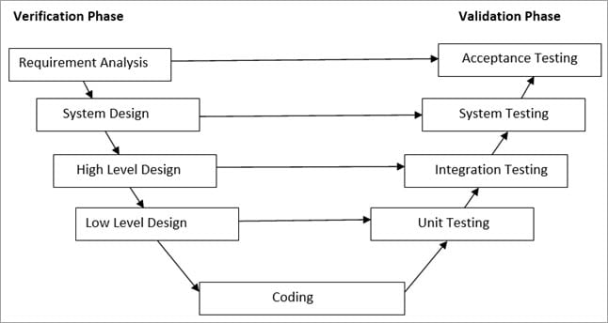](https://www.softwaretestinghelp.com/wp-content/qa/uploads/2018/04/V-Shaped-Model.jpg)

****a) Verification Phase:****

****(i) Requirement Analysis:****

In this phase, all the required information is gathered & analyzed. Verification activities include reviewing the requirements.

****(ii) System Design:****

Once the requirement is clear, a system is designed i.e. architecture, components of the product are created and documented in a design document.

****(iii) High-Level Design:****

High-level design defines the architecture/design of modules. It defines the functionality between the two modules.

****(iv) Low-Level Design:****

Low-level Design defines the architecture/design of individual components.

****(v) Coding:****

Code development is done in this phase.

****b) Validation Phase:****

****(i) Unit Testing:****

[Unit testing](https://www.softwaretestinghelp.com/unit-testing/) is performed using the unit test cases that are designed and is done in the Low-level design phase. Unit testing is performed by the developer itself. It is performed on individual components which lead to early defect detection.

**(ii) Integration Testing:**

[Integration testing](https://www.softwaretestinghelp.com/what-is-integration-testing/) is performed using integration test cases in High-level Design phase. Integration testing is the testing that is done on integrated modules. It is performed by testers.

**(iii) System Testing:**

[System testing](https://www.softwaretestinghelp.com/system-testing/) is performed in the System Design phase. In this phase, the complete system is tested i.e. the entire system functionality is tested.

****(iv) Acceptance Testing:****

Acceptance testing is associated with the Requirement Analysis phase and is done in the customer’s environment.

****Advantages of V – Model:****

* It is a simple and easily understandable model.
* V –model approach is good for smaller projects wherein the requirement is defined and it freezes in the early stage.
* It is a systematic and disciplined model which results in a high-quality product.

****Disadvantages of V-Model:****

* V-shaped model is not good for ongoing projects.
* Requirement change at the later stage would cost too high.

### #3) Prototype Model

The prototype model is a model in which the prototype is developed prior to the actual software.

Prototype models have limited functional capabilities and inefficient performance when compared to the actual software. Dummy functions are used to create prototypes. This is a valuable mechanism for understanding the customers’ needs.

Software prototypes are built prior to the actual software to get valuable feedback from the customer. Feedbacks are implemented and the prototype is again reviewed by the customer for any change. This process goes on until the model is accepted by the customer.

[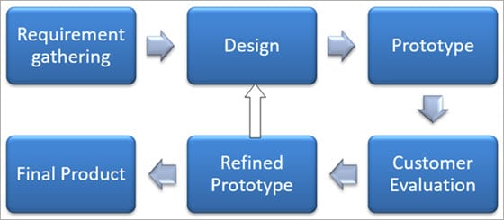](https://www.softwaretestinghelp.com/wp-content/qa/uploads/2018/04/Prototype-Model.jpg)

Once the requirement gathering is done, the quick design is created and the prototype which is presented to the customer for evaluation is built.

Customer feedback and the refined requirement is used to modify the prototype and is again presented to the customer for evaluation. Once the customer approves the prototype, it is used as a requirement for building the actual software. The actual software is build using the Waterfall model approach.

****Advantages of Prototype Model:****

* Prototype model reduces the cost and time of development as the defects are found much earlier.
* Missing feature or functionality or a change in requirement can be identified in the evaluation phase and can be implemented in the refined prototype.
* Involvement of a customer from the initial stage reduces any confusion in the requirement or understanding of any functionality.

****Disadvantages of Prototype Model:****

* Since the customer is involved in every phase, the customer can change the requirement of the end product which increases the complexity of the scope and may increase the delivery time of the product.

### #4) Spiral Model

[The Spiral Model](https://www.softwaretestinghelp.com/spiral-model-what-is-sdlc-spiral-model/) includes iterative and prototype approach.

Spiral model phases are followed in the iterations. The loops in the model represent the phase of the SDLC process i.e. the innermost loop is of requirement gathering & analysis which follows the Planning, Risk analysis, development, and evaluation. Next loop is Designing followed by Implementation & then testing.

****Spiral Model has four phases:****

* Planning
* Risk Analysis
* Engineering
* Evaluation

[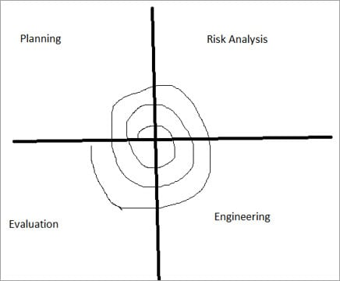](https://www.softwaretestinghelp.com/wp-content/qa/uploads/2018/04/Spiral-Model.jpg)

****(i) Planning:****

The planning phase includes requirement gathering wherein all the required information is gathered from the customer and is documented. Software requirement specification document is created for the next phase.

****(ii) Risk Analysis:****

In this phase, the best solution is selected for the risks involved and analysis is done by building the prototype.

****For Example****, the risk involved in accessing the data from a remote database can be that the data access rate might be too slow. The risk can be resolved by building a prototype of the data access subsystem.

****(iii) Engineering:****

Once the risk analysis is done, coding and testing are done.

****(iv) Evaluation:****

Customer evaluates the developed system and plans for the next iteration.

****Advantages of Spiral Model:****

* Risk Analysis is done extensively using the prototype models.
* Any enhancement or change in the functionality can be done in the next iteration.

****Disadvantages of Spiral Model:****

* The spiral model is best suited for large projects only.
* The cost can be high as it might take a large number of iterations which can lead to high time to reach the final product.

### #5) Iterative Incremental Model

The iterative incremental model divides the product into small chunks.

****For Example****, Feature to be developed in the iteration is decided and implemented. Each iteration goes through the phases namely Requirement Analysis, Designing, Coding, and Testing. Detailed planning is not required in iterations.

Once the iteration is completed, a product is verified and is delivered to the customer for their evaluation and feedback. Customer’s feedback is implemented in the next iteration along with the newly added feature.

Hence, the product increments in terms of features and once the iterations are completed the final build holds all the features of the product.

****Phases of Iterative & Incremental Development Model:****

* Inception phase
* Elaboration Phase
* Construction Phase
* Transition Phase

****(i) Inception Phase:****

Inception phase includes the requirement and scope of the Project.

****(ii) Elaboration Phase:****

In the elaboration phase, the working architecture of a product is delivered which covers the risk identified in the inception phase and also fulfills the non-functional requirements.

****(iii) Construction Phase:****

In the Construction phase, the architecture is filled in with the code which is ready to be deployed and is created through analysis, designing, implementation, and testing of the functional requirement.

****(iv) Transition Phase:****

In the Transition Phase, the product is deployed in the Production environment.

****Advantages of Iterative & Incremental Model:****

* Any change in the requirement can be easily done and would not cost as there is a scope of incorporating the new requirement in the next iteration.
* Risk is analyzed & identified in the iterations.
* Defects are detected at an early stage.
* As the product is divided into smaller chunks it is easy to manage the product.

****Disadvantages**** ****of Iterative & Incremental Model:****

* Complete requirement and understanding of a product are required to break down and build incrementally.

### #6) Big Bang Model

Big Bang Model does not have any defined process. Money and efforts are put together as the input and output come as a developed product which might be or might not be the same as what the customer needs.

Big Bang Model does not require much planning and scheduling. The developer does the requirement analysis & coding and develops the product as per his understanding. This model is used for small projects only. There is no testing team and no formal testing is done, and this could be a cause for the failure of the project.

****Advantages**** ****of Big Bang Model:****

* It’s a very simple Model.
* Less Planning and scheduling is required.
* The developer has the flexibility to build the software of their own.

****Disadvantages of the Big Bang Model:****

* Big Bang models cannot be used for large, ongoing & complex projects.
* High risk and uncertainty.

### #7) Agile Model

Agile Model is a combination of the Iterative and incremental model. This model focuses more on flexibility while developing a product rather than on the requirement.

In Agile, a product is broken into small incremental builds. It is not developed as a complete product in one go. Each build increments in terms of features. The next build is built on previous functionality.

In agile iterations are termed as sprints. Each sprint lasts for2-4 weeks. At the end of each sprint, the product owner verifies the product and after his approval, it is delivered to the customer.

Customer feedback is taken for improvement and his suggestions and enhancement are worked on in the next sprint. Testing is done in each sprint to minimize the risk of any failures.

[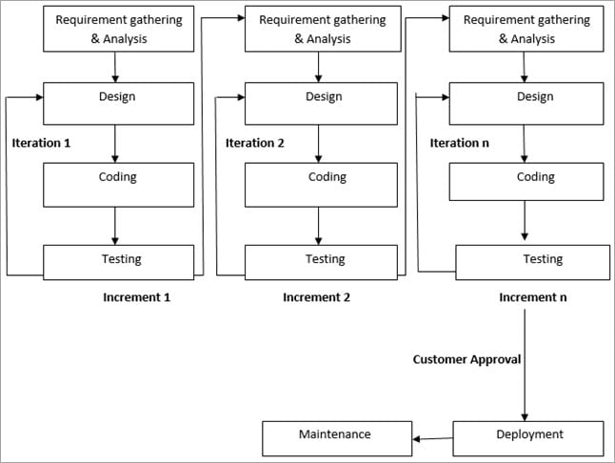](https://www.softwaretestinghelp.com/wp-content/qa/uploads/2018/04/Agile-Model.jpg)

****Advantages of Agile Model:****

* It allows more flexibility to adapt to the changes.
* The new feature can be added easily.
* Customer satisfaction as the feedback and suggestions are taken at every stage.

****Disadvantages:****

* Lack of documentation.
* Agile needs experienced and highly skilled resources.
* If a customer is not clear about how exactly they want the product to be, then the project would fail.