# Software Project Planning

A Software Project is the complete methodology of programming advancement from requirement gathering to testing and support, completed by the execution procedures, in a specified period to achieve intended software product.

## Need of Software Project Management

Software development is a sort of all new streams in world business, and there's next to no involvement in structure programming items. Most programming items are customized to accommodate customer's necessities. The most significant is that the underlying technology changes and advances so generally and rapidly that experience of one element may not be connected to the other one. All such business and ecological imperatives bring risk in software development; hence, it is fundamental to manage software projects efficiently.

## Software Project Manager

Software manager is responsible for planning and scheduling project development. They manage the work to ensure that it is completed to the required standard. They monitor the progress to check that the event is on time and within budget. The project planning must incorporate the major issues like size & cost estimation scheduling, project monitoring, personnel selection evaluation & risk management. To plan a successful software project, we must understand:

* Scope of work to be completed
* Risk analysis
* The resources mandatory
* The project to be accomplished
* Record of being followed

Software Project planning starts before technical work start. The various steps of planning activities are:

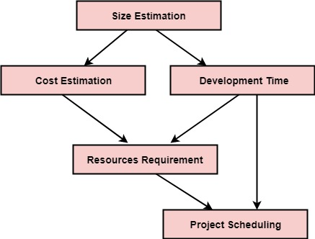

The size is the crucial parameter for the estimation of other activities. Resources requirement are required based on cost and development time. Project schedule may prove to be very useful for controlling and monitoring the progress of the project. This is dependent on resources & development time.

# Software Cost Estimation

For any new software project, it is necessary to know how much it will cost to develop and how much development time will it take. These estimates are needed before development is initiated, but how is this done? Several estimation procedures have been developed and are having the following attributes in common.

1. Project scope must be established in advanced.
2. Software metrics are used as a support from which evaluation is made.
3. The project is broken into small PCs which are estimated individually.  
   To achieve true cost & schedule estimate, several option arise.
4. Delay estimation
5. Used symbol decomposition techniques to generate project cost and schedule estimates.
6. Acquire one or more automated estimation tools.

## Uses of Cost Estimation

1. During the planning stage, one needs to choose how many engineers are required for the project and to develop a schedule.
2. In monitoring the project's progress, one needs to access whether the project is progressing according to the procedure and takes corrective action, if necessary.

## Cost Estimation Models

A model may be static or dynamic. In a static model, a single variable is taken as a key element for calculating cost and time. In a dynamic model, all variable are interdependent, and there is no basic variable.

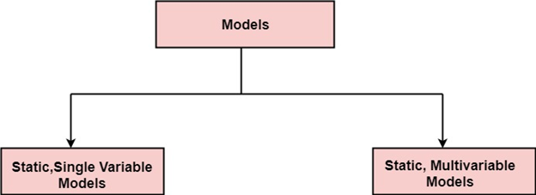

Static, Single Variable Models: When a model makes use of single variables to calculate desired values such as cost, time, efforts, etc. is said to be a single variable model. The most common equation is:

                                C=aLb

Where    C = Costs  
                L= size  
                a and b are constants

The Software Engineering Laboratory established a model called SEL model, for estimating its software production. This model is an example of the static, single variable model.

                E=1.4L0.93  
                DOC=30.4L0.90  
                D=4.6L0.26

Where    E= Efforts (Person Per Month)  
                DOC=Documentation (Number of Pages)  
                D = Duration (D, in months)  
                L = Number of Lines per code

Static, Multi variable Models: These models are based on method (1), they depend on several variables describing various aspects of the software development environment. In some model, several variables are needed to describe the software development process, and selected equation combined these variables to give the estimate of time & cost. These models are called multi variable models.

WALSTON and FELIX develop the models at IBM provide the following equation gives a relationship between lines of source code and effort:

**E=5.2L0.91**

In the same manner duration of development is given by

**D=4.1L0.36**

The productivity index uses 29 variables which are found to be highly correlated productivity as follows:

IMG_257

Where **Wi** is the weight factor for the **ith**variable and **Xi={-1,0,+1}** the estimator gives **Xi** one of the values **-1, 0 or +1** depending on the variable decreases, has no effect or increases the productivity.

# **COCOMO Model**

Boehm proposed COCOMO (Constructive Cost Estimation Model) in 1981. COCOMO is one of the most generally used software estimation models in the world. COCOMO predicts the efforts and schedule of a software product based on the size of the software.

The necessary steps in this model are:

1. Get an initial estimate of the development effort from evaluation of thousands of delivered lines of source code (KDLOC).
2. Determine a set of 15 multiplying factors from various attributes of the project.
3. Calculate the effort estimate by multiplying the initial estimate with all the multiplying factors i.e., multiply the values in step1 and step2.

The initial estimate (also called nominal estimate) is determined by an equation of the form used in the static single variable models, using KDLOC as the measure of the size. To determine the initial effort Ei in person-months the equation used is of the type is shown below

                Ei=a\*(KDLOC)b

The value of the constant a and b are depends on the project type.

In COCOMO, projects are categorized into three types:

1. Organic
2. Semidetached
3. Embedded
4. Organic: A development project can be treated of the organic type, if the project deals with developing a well-understood application program, the size of the development team is reasonably small, and the team members are experienced in developing similar methods of projects. Examples of this type of projects are simple business systems, simple inventory management systems, and data processing systems.

2. Semidetached: A development project can be treated with semidetached type if the development consists of a mixture of experienced and inexperienced staff. Team members may have finite experience in related systems but may be unfamiliar with some aspects of the order being developed. Example of Semidetached system includes developing a new operating system (OS), a Database Management System (DBMS), and complex inventory management system.

3. Embedded: A development project is treated to be of an embedded type, if the software being developed is strongly coupled to complex hardware, or if the stringent regulations on the operational method exist. For Example: ATM, Air Traffic control.

For three product categories, Bohem provides a different set of expression to predict effort (in a unit of person month)and development time from the size of estimation in KLOC(Kilo Line of code) efforts estimation takes into account the productivity loss due to holidays, weekly off, coffee breaks, etc.

According to Boehm, software cost estimation should be done through three stages:

1. Basic Model
2. Intermediate Model
3. Detailed Model

1. Basic COCOMO Model: The basic COCOMO model provide an accurate size of the project parameters. The following expressions give the basic COCOMO estimation model:

                Effort=a1\*(KLOC) a2 PM  
                Tdev=b1\*(efforts)b2 Months

Where

KLOC is the estimated size of the software product indicate in Kilo Lines of Code,

a1,a2,b1,b2 are constants for each group of software products,

Tdev is the estimated time to develop the software, expressed in months,

Effort is the total effort required to develop the software product, expressed in person months (PMs).

Estimation of development effort

For the three classes of software products, the formulas for estimating the effort based on the code size are shown below:

Organic: Effort = 2.4(KLOC) 1.05 PM

Semi-detached: Effort = 3.0(KLOC) 1.12 PM

Embedded: Effort = 3.6(KLOC) 1.20 PM

Estimation of development time

For the three classes of software products, the formulas for estimating the development time based on the effort are given below:

Organic: Tdev = 2.5(Effort) 0.38 Months

Semi-detached: Tdev = 2.5(Effort) 0.35 Months

Embedded: Tdev = 2.5(Effort) 0.32 Months

Some insight into the basic COCOMO model can be obtained by plotting the estimated characteristics for different software sizes. Fig shows a plot of estimated effort versus product size. From fig, we can observe that the effort is somewhat superliner in the size of the software product. Thus, the effort required to develop a product increases very rapidly with project size.

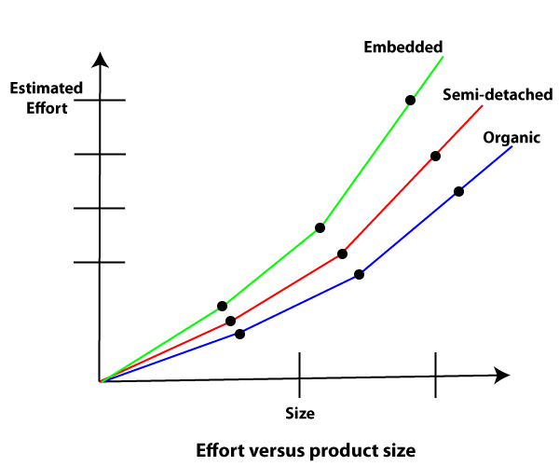

The development time versus the product size in KLOC is plotted in fig. From fig it can be observed that the development time is a sub linear function of the size of the product, i.e. when the size of the product increases by two times, the time to develop the product does not double but rises moderately. This can be explained by the fact that for larger products, a larger number of activities which can be carried out concurrently can be identified. The parallel activities can be carried out simultaneously by the engineers. This reduces the time to complete the project. Further, from fig, it can be observed that the development time is roughly the same for all three categories of products. For example, a 60 KLOC program can be developed in approximately 18 months, regardless of whether it is of organic, semidetached, or embedded type.

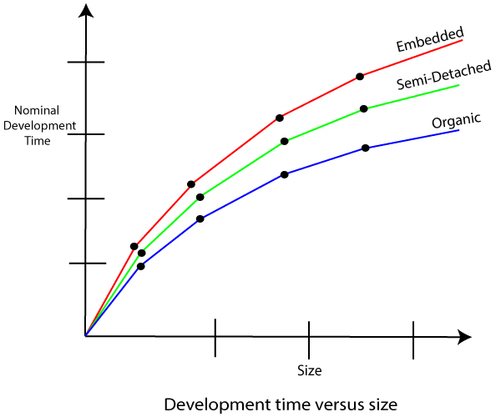

From the effort estimation, the project cost can be obtained by multiplying the required effort by the manpower cost per month. But, implicit in this project cost computation is the assumption that the entire project cost is incurred on account of the manpower cost alone. In addition to manpower cost, a project would incur costs due to hardware and software required for the project and the company overheads for administration, office space, etc.

It is important to note that the effort and the duration estimations obtained using the COCOMO model are called a nominal effort estimate and nominal duration estimate. The term nominal implies that if anyone tries to complete the project in a time shorter than the estimated duration, then the cost will increase drastically. But, if anyone completes the project over a longer period of time than the estimated, then there is almost no decrease in the estimated cost value.

Example1: Suppose a project was estimated to be 400 KLOC. Calculate the effort and development time for each of the three model i.e., organic, semi-detached & embedded.

Solution: The basic COCOMO equation takes the form:

                Effort=a1\*(KLOC) a2 PM  
                Tdev=b1\*(efforts)b2 Months  
                Estimated Size of project= 400 KLOC

(i)Organic Mode

                E = 2.4 \* (400)1.05 = 1295.31 PM  
                D = 2.5 \* (1295.31)0.38=38.07 PM

(ii)Semidetached Mode

                E = 3.0 \* (400)1.12=2462.79 PM  
                D = 2.5 \* (2462.79)0.35=38.45 PM

(iii) Embedded Mode

                E = 3.6 \* (400)1.20 = 4772.81 PM  
                D = 2.5 \* (4772.8)0.32 = 38 PM

2. Intermediate Model: The basic Cocomo model considers that the effort is only a function of the number of lines of code and some constants calculated according to the various software systems. The intermediate COCOMO model recognizes these facts and refines the initial estimates obtained through the basic COCOMO model by using a set of 15 cost drivers based on various attributes of software engineering.

Classification of Cost Drivers and their attributes:

Product attributes -

* Required software reliability extent
* Size of the application database
* The complexity of the product

Hardware attributes -

* Run-time performance constraints
* Memory constraints
* The volatility of the virtual machine environment
* Required turnabout time

Personnel attributes -

* Analyst capability
* Software engineering capability
* Applications experience
* Virtual machine experience
* Programming language experience

Project attributes -

* Use of software tools
* Application of software engineering methods
* Required development schedule

Intermediate COCOMO equation:

                E=ai (KLOC) bi\*EAF  
                D=ci (E)di

|  |  |  |  |  |
| --- | --- | --- | --- | --- |
| Project | ai | bi | ci | di |
| Organic | 2.4 | 1.05 | 2.5 | 0.38 |
| Semidetached | 3.0 | 1.12 | 2.5 | 0.35 |
| Embedded | 3.6 | 1.20 | 2.5 | 0.32 |

Coefficients for intermediate COCOMO

3. Detailed COCOMO Model:Detailed COCOMO incorporates all qualities of the standard version with an assessment of the cost driver?s effect on each method of the software engineering process. The detailed model uses various effort multipliers for each cost driver property. In detailed cocomo, the whole software is differentiated into multiple modules, and then we apply COCOMO in various modules to estimate effort and then sum the effort.

The Six phases of detailed COCOMO are:

1. Planning and requirements
2. System structure
3. Complete structure
4. Module code and test
5. Integration and test
6. Cost Constructive model

The effort is determined as a function of program estimate, and a set of cost drivers are given according to every phase of the software life cycle.

# What is Risk?

"Tomorrow problems are today's risk." Hence, a clear definition of a "risk" is a problem that could cause some loss or threaten the progress of the project, but which has not happened yet.

These potential issues might harm cost, schedule or technical success of the project and the quality of our software device, or project team morale.

Risk Management is the system of identifying addressing and eliminating these problems before they can damage the project.

We need to differentiate risks, as potential issues, from the current problems of the project.

Different methods are required to address these two kinds of issues.

For example, staff storage, because we have not been able to select people with the right technical skills is a current problem, but the threat of our technical persons being hired away by the competition is a risk.

## Risk Management

A software project can be concerned with a large variety of risks. In order to be adept to systematically identify the significant risks which might affect a software project, it is essential to classify risks into different classes. The project manager can then check which risks from each class are relevant to the project.

There are three main classifications of risks which can affect a software project:

1. Project risks
2. Technical risks
3. Business risks

**1. Project risks:** Project risks concern differ forms of budgetary, schedule, personnel, resource, and customer-related problems. A vital project risk is schedule slippage. Since the software is intangible, it is very tough to monitor and control a software project. It is very tough to control something which cannot be identified. For any manufacturing program, such as the manufacturing of cars, the plan executive can recognize the product taking shape.

**2. Technical risks:** Technical risks concern potential method, implementation, interfacing, testing, and maintenance issue. It also consists of an ambiguous specification, incomplete specification, changing specification, technical uncertainty, and technical obsolescence. Most technical risks appear due to the development team's insufficient knowledge about the project.

**3. Business risks:** This type of risks contain risks of building an excellent product that no one need, losing budgetary or personnel commitments, etc.

**Other risk categories**

1. **Known risks:** Those risks that can be uncovered after careful assessment of the project program, the business and technical environment in which the plan is being developed, and more reliable data sources (e.g., unrealistic delivery date)
2. **Predictable risks:** Those risks that are hypothesized from previous project experience (e.g., past turnover)
3. **Unpredictable risks:** Those risks that can and do occur, but are extremely tough to identify in advance.

## Principle of Risk Management

1. **Global Perspective:** In this, we review the bigger system description, design, and implementation. We look at the chance and the impact the risk is going to have.
2. **Take a forward-looking view:** Consider the threat which may appear in the future and create future plans for directing the next events.
3. **Open Communication:** This is to allow the free flow of communications between the client and the team members so that they have certainty about the risks.
4. **Integrated management:** In this method risk management is made an integral part of project management.
5. **Continuous process:** In this phase, the risks are tracked continuously throughout the risk management paradigm.