**2D TRANSFORMATION**

**OBJECTIVE:** TO APPLY THE BASIC 2D TRANSFORMATIONS SUCH AS TRANSLATION, SCALING, ROTATION, SHEARING AND REFLECTION FOR A GIVEN 2D OBJECT.

**THEORY:** We have to perform 2D transformations on 2D objects. Here we perform transformation on a line segment.

The 2D transformations are:

1. Translation
2. Scaling
3. Rotation
4. Reflection
5. Shear
6. **Translation**

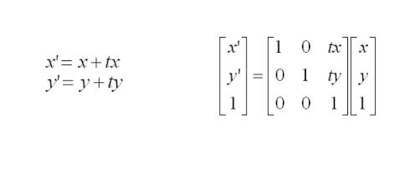

2D translation matrix is:





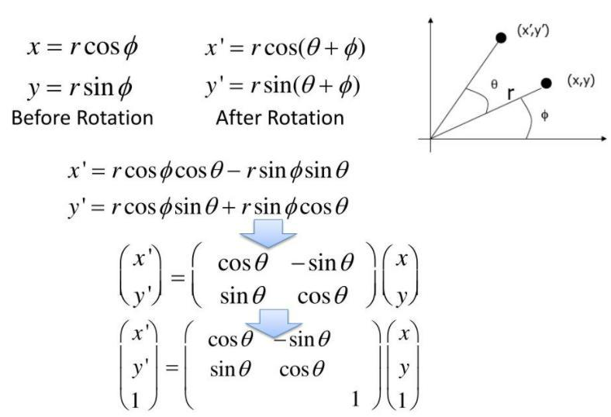

1. **Rotation**

2D Rotation is matrix with rotation angle Theta in CCW is

**3. Scaling**

The 2D scaling equations in matrix form is given by

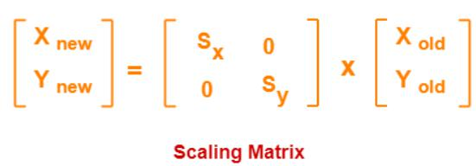

1. **Reflection**

The 2D reflection equations in matrix form is given by

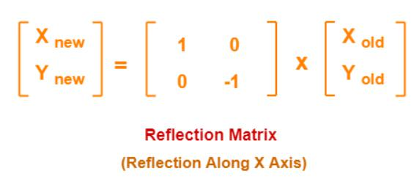

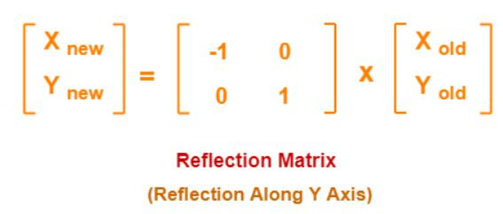

**5. Shearing**

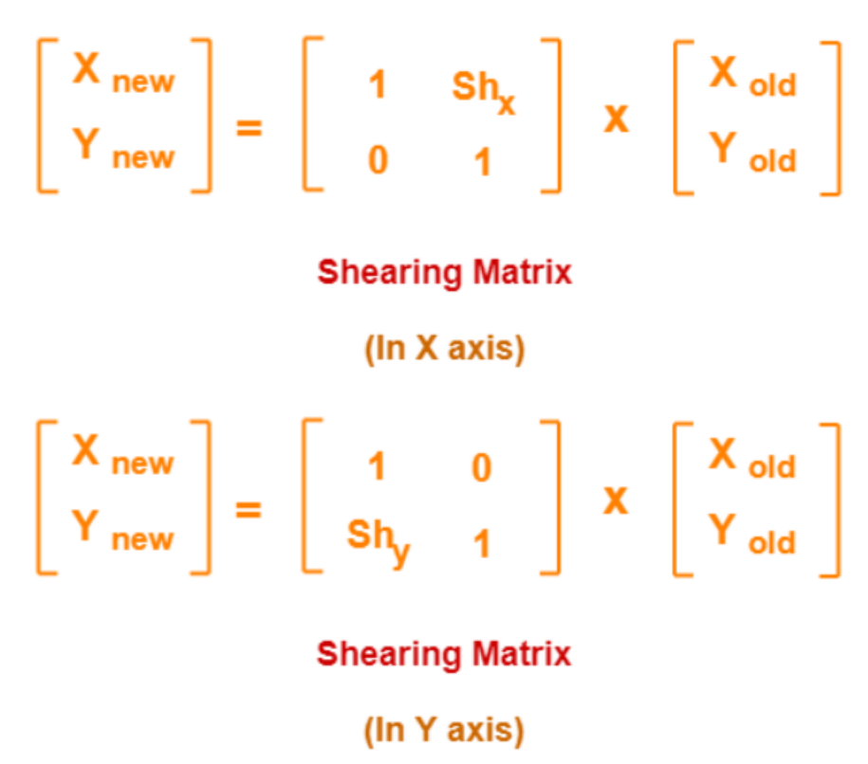The 2D shearing equations in matrix form is given by

**PROGRAM:**

#include<iostream> #include<graphics.h> #include<math.h> using namespace std; int main()

{

int gd=DETECT,gm,s; initgraph(&gd,&gm,(char*)"");

cout<<"1.Translation\n2.Rotation\n3.Scaling\n4.Reflection\n5.Shearing "<<endl; cout<<"Selection:";

cin>>s; switch(s)

{

case 1:

{ int x1=250,y1=200,x2=350,y2=250;

int tx=60,ty=60;

cout<<"Rectangle before translation"<<endl; setcolor(3);

rectangle(x1,y1,x2,y2); setcolor(4);

cout<<"Rectangle after translation"<<endl; rectangle(x1+tx,y1+ty,x2+tx,y2+ty); getch();

break;

}

case 2:

{ long x1=250,y1=200,x2=350,y2=250;

double a;

cout<<"Rectangle with rotation"<<endl; setcolor(3);

rectangle(x1,y1,x2,y2); cout<<"Angle of rotation:"; cin>>a;

a=(a*3.14)/180;

long xr=x1+((x2-x1)*cos(a)-(y2-y1)*sin(a));

long yr=y1+((x2-x1)*sin(a)+(y2-y1)*cos(a)); setcolor(2);

rectangle(x1,y1,xr,yr); getch();

break;

}

case 3:

{

int x1=50,y1=50,x2=75,y2=75,y=4,x=4;

cout<<"Before scaling"<<endl; setcolor(3); rectangle(x1,y1,x2,y2); cout<<"After scaling"<<endl; setcolor(10); rectangle(x1*x,y1*y,x2*x,y2*y); getch();

break;

}

case 4:

{

int x1=250,y1=350,x2=600,y2=350,x3=350,y3=400;

cout<<"triangle before reflection"<<endl; setcolor(3);

line(x1,y1,x2,y2);

line(x1,y1,x3,y3);

line(x2,y2,x3,y3);

cout<<"triangle after reflection"<<endl; setcolor(5);

line(x1,-y1+500,x2,-y2+500); line(x1,-y1+500,x3,-y3+500); line(x2,-y2+500,x3,-y3+500);

getch(); break;

}

case 5:

{

int x1=400,y1=100,x2=600,y2=100,x3=400,y3=200,x4=600,y4=200,shx=2;

cout<<"Before shearing of rectangle"<<endl; setcolor(3);

line(x1,y1,x2,y2);

line(x1,y1,x3,y3);

line(x3,y3,x4,y4);

line(x2,y2,x4,y4);

cout<<"After shearing of rectangle"<<endl; x1=x1+shx*y1;

x2=x2+shx*y2; x3=x3+shx*y3; x4=x4+shx*y4; setcolor(13); line(x1,y1,x2,y2);

line(x1,y1,x3,y3);

line(x3,y3,x4,y4);

line(x2,y2,x4,y4); getch();

}

default:

{

cout<<"Invalid Selection"<<endl; break;

}

}

closegraph(); return 0;

}

**OUTPUTS:**

