ASSIGNMENT-1

Question1) Explain the difference between frontend, backend, and full-stack development with suitable real-world examples.
Answer1) Frontend development deals with the part of a website that users see and interact with, like buttons, pages, and forms. Backend development handles the server-side logic, database, and requests behind the scenes. Full-stack development involves both frontend and backend. For example, in an online shopping website, the product page is frontend, order processing is backend, and a developer handling both is a full-stack developer.

Question2) Create a simple diagram showing how the client-server model works in web architecture.
CLIENT
(Web Browser)
|
| Request
↓
SERVER
(Web Server)

|
| Request / Data
↓
DATABASE

|
| Response / Data
↓
SERVER

|
| Response
↓
CLIENT
(Web Browser)
Client sends a request to the server. The server processes it, communicates with the database if needed, and sends the response back to the client.

Question3) Describe how a browser requests and displays a web page from a web server.
Answer3) A browser sends a request to the web server for a webpage. The server processes the request and sends the required HTML, CSS, JavaScript, and other files back to the browser. The browser then interprets these files and displays the webpage to the user.

Question4) Identify and list the tools required to set up a web development environment. Explain the purpose of each.
Answer4) The main tools required are a code editor like VS Code for writing code, a web browser like Chrome for testing webpages, Git for version control, Node.js and npm for running JavaScript and managing packages, and a terminal/command prompt for running commands and development tools. For frontend development, tools like React can also be used to build interactive web applications.

Question5) Explain what a web server is and give examples of commonly used servers.
Answer5) A web server is software or a computer that receives requests from clients (browsers) and sends web pages or other resources in response. Common examples include Apache, Nginx, Microsoft IIS, and Node.js.

Question6) Define the roles of a frontend developer, backend developer, and database administrator in a project.
Answer6) A frontend developer creates the user interface and user interactions, a backend developer handles server-side logic, APIs, and application functionality, while a database administrator (DBA) manages the database, including storing, securing, organizing, and maintaining data.

Question7) Install VS Code and configure it for HTML, CSS, and JavaScript development. Take a screenshot of the setup.
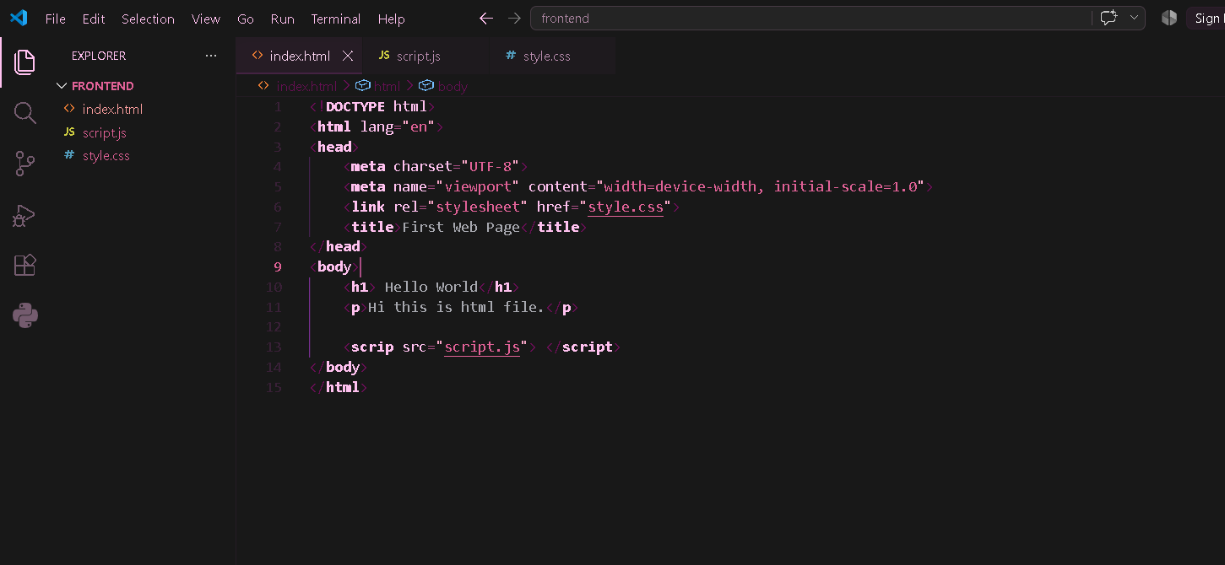

Question8) Explain the difference between static and dynamic websites. Provide an example of each.
Answer8) A static website shows fixed content that changes only when the developer updates the code, e.g., a simple portfolio website. A dynamic website generates or updates content based on user interaction or database data, e.g., Instagram or Amazon.

Question9) Research and list five web browsers. Explain how rendering engines differ between them.
Answer9) Five popular web browsers are Google Chrome, Microsoft Edge, Mozilla Firefox, Apple Safari, and Opera. Chrome, Edge, and Opera mainly use the Blink rendering engine, Firefox uses Gecko, and Safari uses WebKit. These engines differ in how they process HTML, CSS, and JavaScript to display web pages.

Question10) Draw a labeled diagram showing the basic web architecture flow — client, server, database, and APIs.
BASIC WEB ARCHITECTURE

CLIENT
(Web Browser)
|
| HTTP Request
↓
API

INTERFACE
|
↓
SERVER
Application
Logic
|
|
|
| Query / Data
↓
DATABASE

|
| Data / Result
↓
SERVER

|
| HTTP Response
↓
CLIENT
(Web Browser)

