CDAC-Mumbai

Subject: Pattern Challenge in Java

Date: 04-09-2024 Total Marks:10

Time duration: 40 Min. Batch: August-24

Q1. Write a Java program to print a hollow pyramid pattern using asterisks (\*) and spaces.

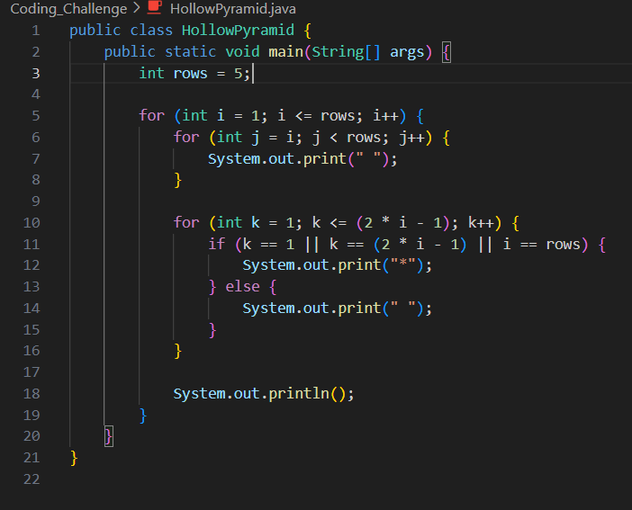

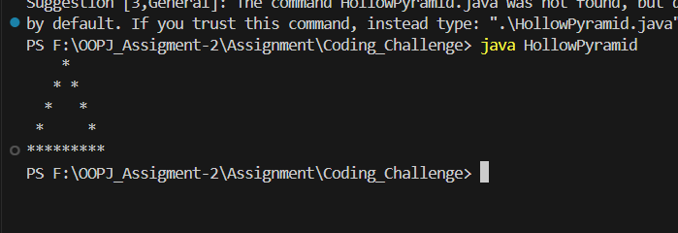

Q2. Write a Java program to print a hollow inverted pyramid pattern using asterisks (\*) and

spaces.

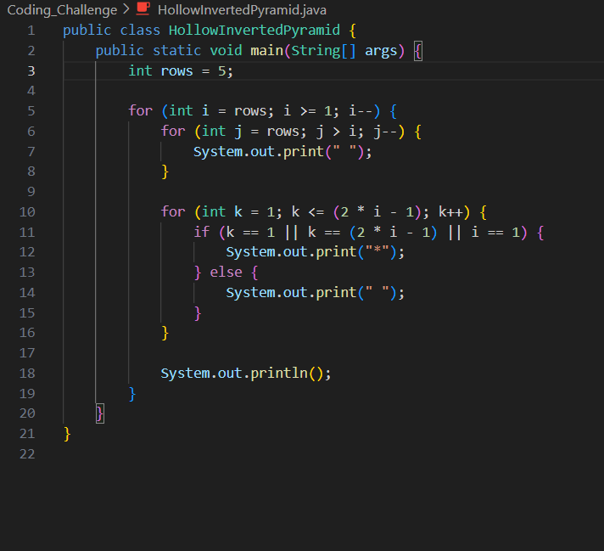

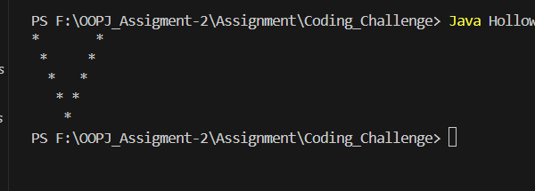

Q3. Write a Java program to print a pyramid pattern of alphabets, starting from 'A', using

spaces.

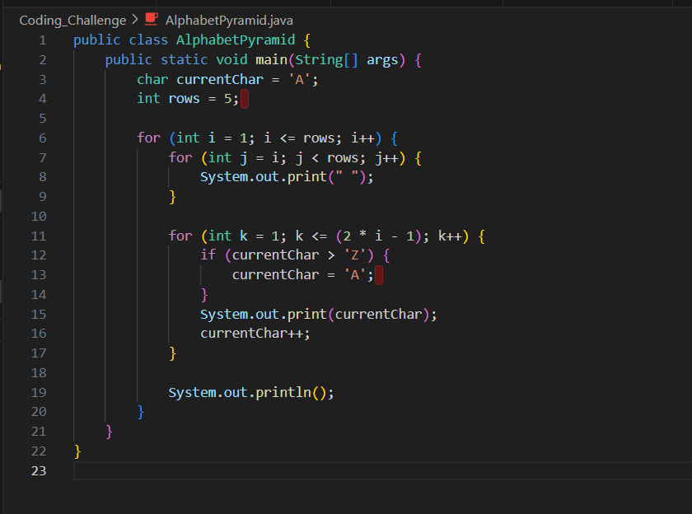

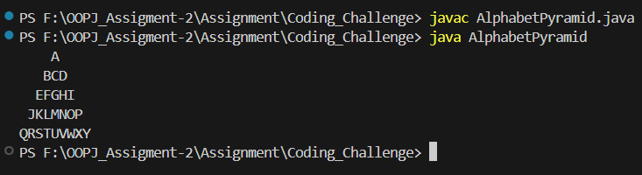

Q4. Write a Java program to print a hollow right triangle pattern using numbers and spaces.

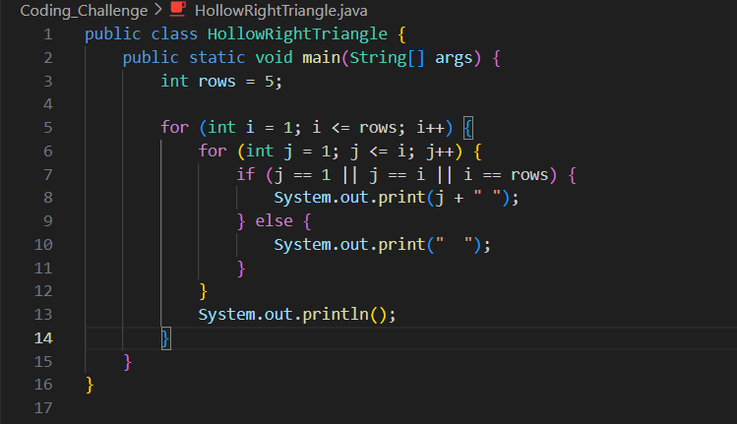

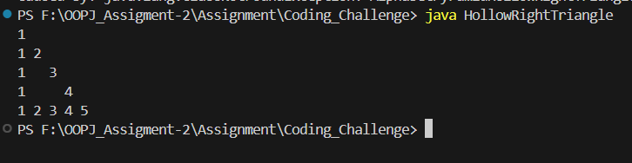

Q5. Write a Java program to print a Palindrome Number Pyramid.

