EasyAI v1.1.0 — User Manual
EasyAI is a Windows desktop app for making AI pictures, videos and better prompts without touching a node editor. Pick a style, type what you want, choose a shape, press Create — EasyAI drives ComfyUI (the engine that does the actual generation) behind the scenes. It’s aimed at people who want the results ComfyUI can produce without learning ComfyUI itself.
EasyAI actually comes as three separate programs that share the same look and settings language:
- EasyAI — the day-to-day app: Image, Video, Prompt Helper, Queue and Read a prompt tabs. This is what most people run.
- EasyAI Setup — a one-time (or occasional) installer/updater that downloads ComfyUI and the specific models and add-ons EasyAI’s workflows need, or updates a ComfyUI you already have. Run this before EasyAI if you don’t already have ComfyUI installed.
- EasyAI Studio — a publishing tool for people who maintain or add workflows to EasyAI. Most users will never need to open this.
This manual covers all three.

Installation & Requirements
- Operating system: Windows only.
- Graphics card: an NVIDIA graphics card is required. EasyAI’s workflows were built and tested on a 16 GB card.
- ComfyUI: EasyAI does not include ComfyUI itself. Either point EasyAI’s Settings at a ComfyUI install you already have, or run EasyAI Setup first to download one for you (a tested version, currently ComfyUI 0.37.0).
- Disk space for downloads (via EasyAI Setup): roughly 76 GB for the Image group of models, 138 GB for Video, and 5 GB for Prompt Helper. You don’t need all three — choose only the groups you want.

Running the prebuilt version (recommended for most people)
If you downloaded EasyAI.exe and EasyAI Setup.exe from the Releases page, nothing else needs installing — no Python required. Keep the .exe files in a folder you can write to (not inside Program Files), because EasyAI keeps its settings, workflows and results in folders right next to the program.
- Run EasyAI Setup.exe first if you don’t already have ComfyUI.
- Once that finishes, run EasyAI.exe.

Running from source (technical users)
pip install -r requirements.txt
python EasyAI.py
Double-clicking EasyAI.bat does the same thing automatically: it finds Python, installs the required libraries the first time only, then always starts the app without a console window. EasyAISetup.bat and EasyAI Studio.bat start the other two programs the same way. Python 3.10 or newer is required when running from source; EasyAI.bat checks this and links to the Python download page if your version is missing or too old.

First-Run Setup
The very first time you start EasyAI, before you can create anything, you will see a short welcome message.
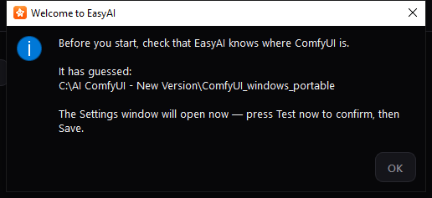
It tells you that EasyAI has guessed where your ComfyUI folder is, and that it’s about to open Settings so you can check that guess. Press OK to continue — Settings opens automatically right after.
This message only appears once. After you close it, EasyAI remembers that first run is done, whether or not you changed anything in Settings.

Feature Walkthrough

Settings
Settings is where you tell EasyAI where ComfyUI lives, where your workflows and results are stored, and set a few generation defaults and the app language. You can open it any time from File → Settings… (or Ctrl+,), not just on first run.
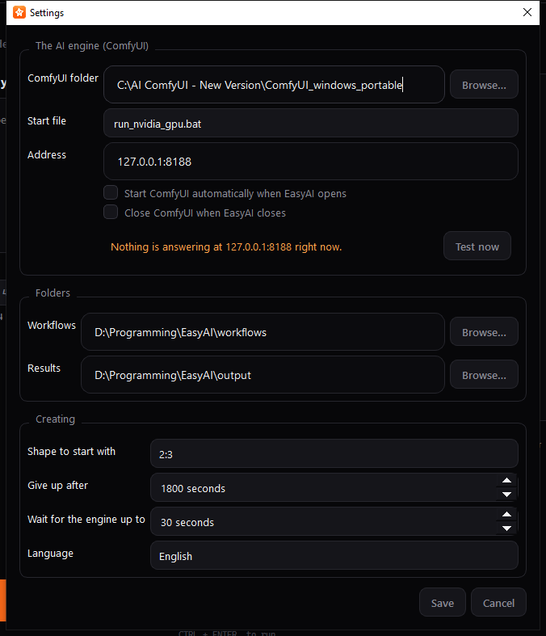
The AI engine (ComfyUI) section:
- ComfyUI folder — type or Browse… to the folder ComfyUI is installed in.
- Start file — a dropdown of every launcher file EasyAI found in that folder; pick the one that starts ComfyUI on your machine.
- Address — the host:port ComfyUI answers on. The default, 127.0.0.1:8188, is correct for almost everyone.
- Two checkboxes: Start ComfyUI automatically when EasyAI opens, and Close ComfyUI when EasyAI closes (this only ever closes a ComfyUI that EasyAI itself started — one you started by hand is left alone).
- A status line and a Test now button let you check right away whether EasyAI can talk to ComfyUI at the settings you’ve entered. In the screenshot above no ComfyUI was running, so it reads “Nothing is answering at 127.0.0.1:8188” — once ComfyUI is reachable this line turns green and reads “ComfyUI is answering at …”.
Folders section: where Workflows and Results are stored. Both default to folders sitting right next to EasyAI itself, so you can move or copy the whole EasyAI folder and it keeps using its own workflows/results.
Creating section: a default Shape to start with, how long to wait before giving up on a stuck generation (“Give up after”) or a slow ComfyUI launch (“Wait for the engine up to”), and a Language dropdown (English, 繁體中文, 简体中文). Changing the language takes effect the moment you press Save — no restart needed.
Press Save to keep your changes, or Cancel to discard them. If you change the ComfyUI folder, start file, address, or workflow folder, EasyAI re-checks the engine and reloads your workflow list automatically.

Startup Splash
If ComfyUI isn’t already running when EasyAI starts, you’ll briefly see a progress screen while EasyAI looks for it (and, if “Start ComfyUI automatically” is on, starts it for you).
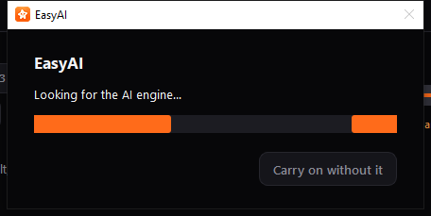
It shows an indeterminate progress bar and a status line. If you don’t want to wait, press Carry on without it — the main window opens right away, though you won’t be able to create anything until the engine connects. If ComfyUI genuinely fails to start, EasyAI tells you it’s still fine for browsing but not for creating.
If ComfyUI is already running and answering when you start EasyAI, this screen is skipped entirely.

Main Window
This is the app’s home screen: an engine status strip, five tabs, a menu bar, and a status bar.
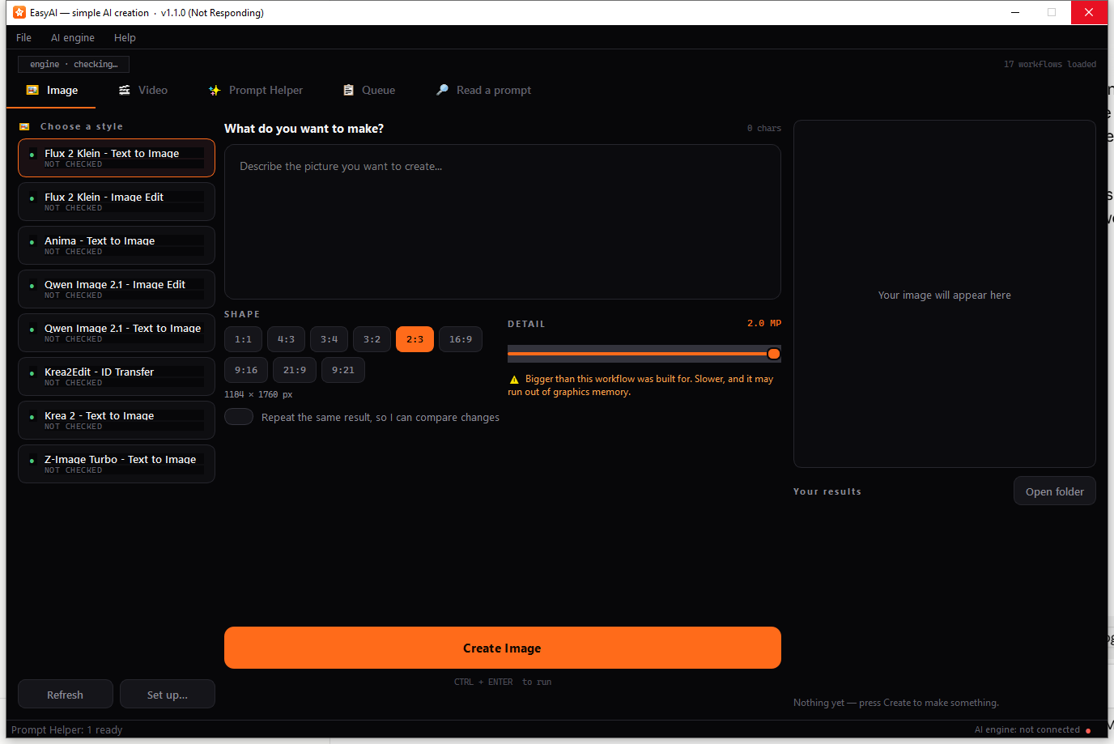
- The strip above the tabs shows whether the engine is live (engine live · 127.0.0.1:8188) or down (engine down · …), plus how many workflows are loaded.
- The tab bar runs: Image, Video, Prompt Helper, Queue, and Read a prompt.
- The bottom status bar shows VRAM usage once the engine is running, plus a coloured dot and “AI engine: running/not running” text.
- The File menu holds Open the workflows folder, Open the results folder, Settings…, and Quit.
- The AI engine menu holds Check it is running (F5), Start it now, and Reload workflows (Ctrl+R).
- The Help menu holds “How do I add a workflow?” and “About EasyAI”.
Handy shortcuts: Ctrl+Enter runs Create on whichever tab is in front, Ctrl+, opens Settings, F5 checks the engine, Ctrl+R reloads workflows.
EasyAI remembers the window’s size and position between sessions. When you close the window, if anything is still in the Queue, EasyAI asks first (see the Queue section below) before shutting anything down.

Image tab
Pick a workflow (“style”) on the left, describe what you want in the middle, and watch the result appear on the right.
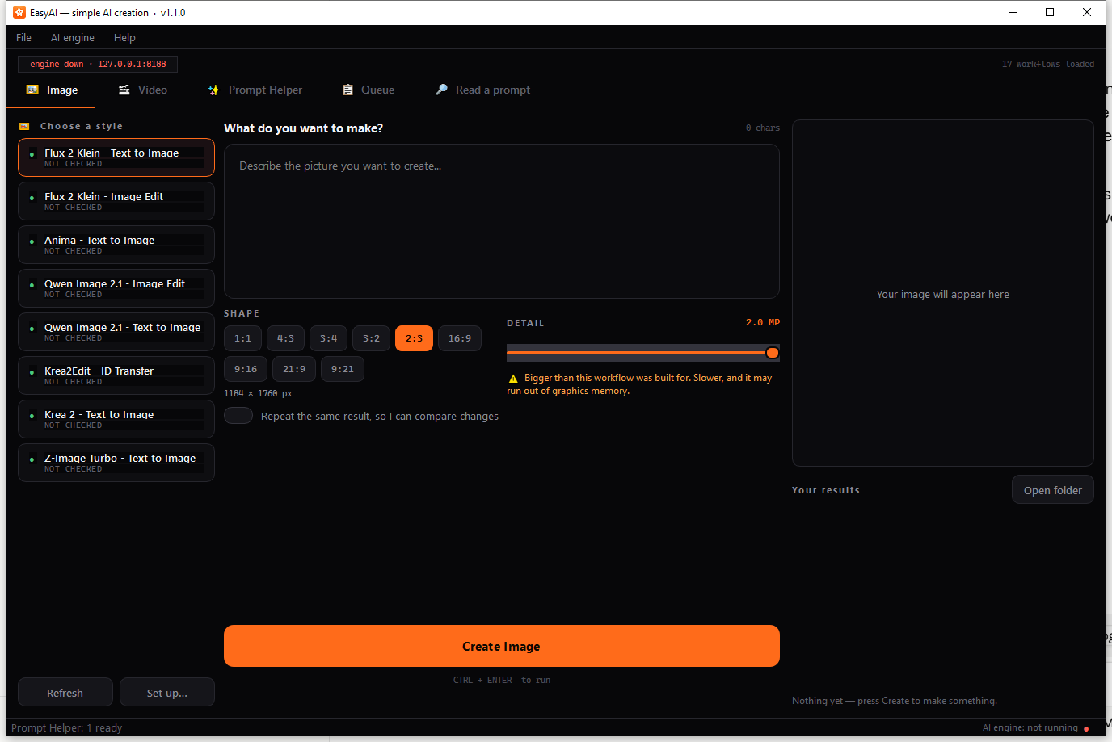
- Choose a style (left column) — scroll the list of workflow cards. Each shows a coloured status dot: green means ready, amber means it needs checking, red means something (an add-on or model) is missing. Use Refresh after adding new workflow files, and Set up… to correct how EasyAI has guessed a workflow works (see the Manifest Editor section below). Right-click a workflow for Rename…, Set up…, or Show the file; double-clicking a workflow also renames it.
- Describe it (middle column) — type your prompt in the box at the top; a live character counter tracks its length. Some workflows disable the prompt box entirely if they don’t take one.
- Negative prompt — for workflows that support it, a second box labelled NEGATIVE PROMPT appears, often pre-filled with useful default text. Leave it as-is to use that default, edit it to change it, or clear it to send no negative prompt at all.
- Attach files — workflows that need a picture, audio or video to work from show labelled drop zones; click or drag a file in. Only a few slots show at once, with the rest reachable by scrolling, so even a workflow with many file slots stays usable.
- Reference pictures that grow one at a time — some workflows (built on Qwen Image 2.1) can take up to 10 reference pictures. EasyAI only shows you Reference 1 at first; as soon as you fill it, Reference 2 appears, and so on, up to 10. If you remove a picture partway through the list, the remaining ones shift up so there’s never a gap.
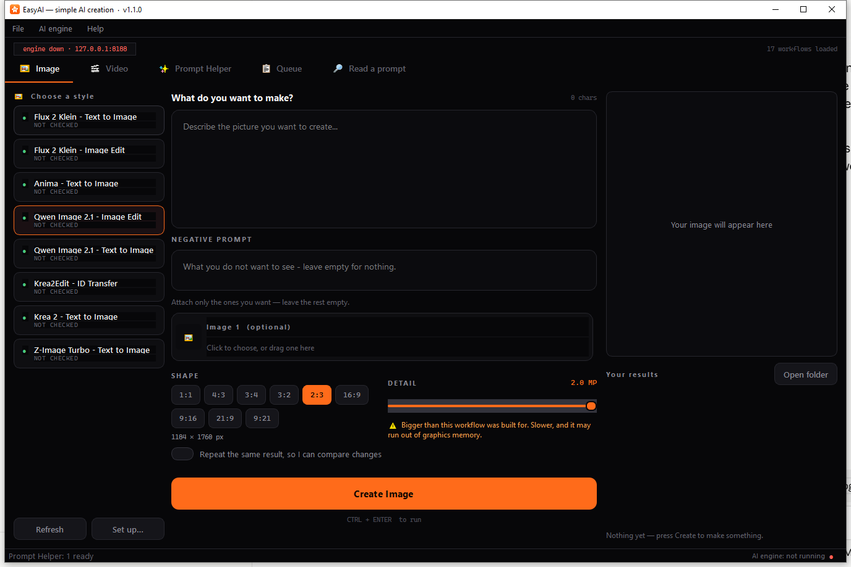
6. Model picker — when a workflow’s model folder contains more than one file of the same type (for example several checkpoints of the same family), a MODEL dropdown appears so you can pick which one to use; the workflow’s own default is marked “(in the workflow)”. This only shows up when there’s a genuine choice to make. 7. Shape, Detail, batch — a row of shape chips (e.g. square, portrait, landscape — whatever the workflow supports), a Detail slider controlling output resolution/quality (with a warning above a certain level, since higher detail uses more graphics memory), and a “How many” count for workflows that support batches. 8. Two optional switches: “Let the AI improve my wording first” (turns on an automatic prompt-enhancer for workflows that have one) and “Repeat the same result, so I can compare changes” (locks the random seed so you can compare small changes fairly). 9. At the bottom, always visible even while you scroll the rest of the column: the Create Image button, a Stop button (once something is running), a “CTRL + ENTER to run” hint, a progress bar, and a status line that, after a run finishes, shows elapsed time, file size, count, seed, and any notes. 10. Right column — a live preview of the image as it generates, and a Results gallery of everything you’ve made this session, with an Open folder button and double-click-to-view.
If you press Create while the engine isn’t running, EasyAI warns you and points you to Settings. If a required file is missing, EasyAI tells you exactly what’s needed before sending anything.

Video tab
Works the same way as the Image tab, with two differences: a Length control (in seconds, with the resulting frame count shown underneath, and a caution above 8 seconds about graphics-memory use) replaces the still-image size choice for length, and the results preview shows the finished video’s first frame — both in the live preview pane and in the gallery thumbnails — so you can tell several takes apart at a glance. Double-click a result to open the actual video in your normal video player.
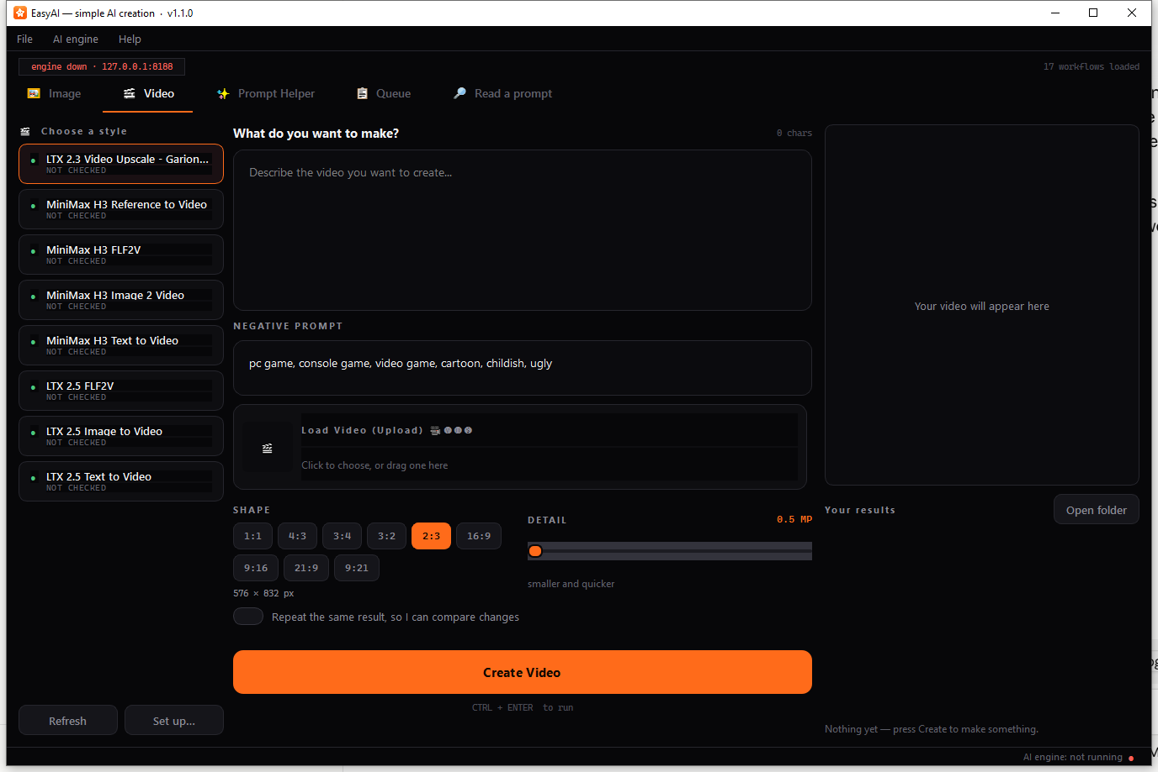
The Detail warning threshold is lower on Video than on Image, since a higher setting costs graphics memory once per frame rather than once per image.

Prompt Helper tab
Use this tab when you want AI help turning a rough idea into a fuller prompt, rather than to generate a picture or video directly.
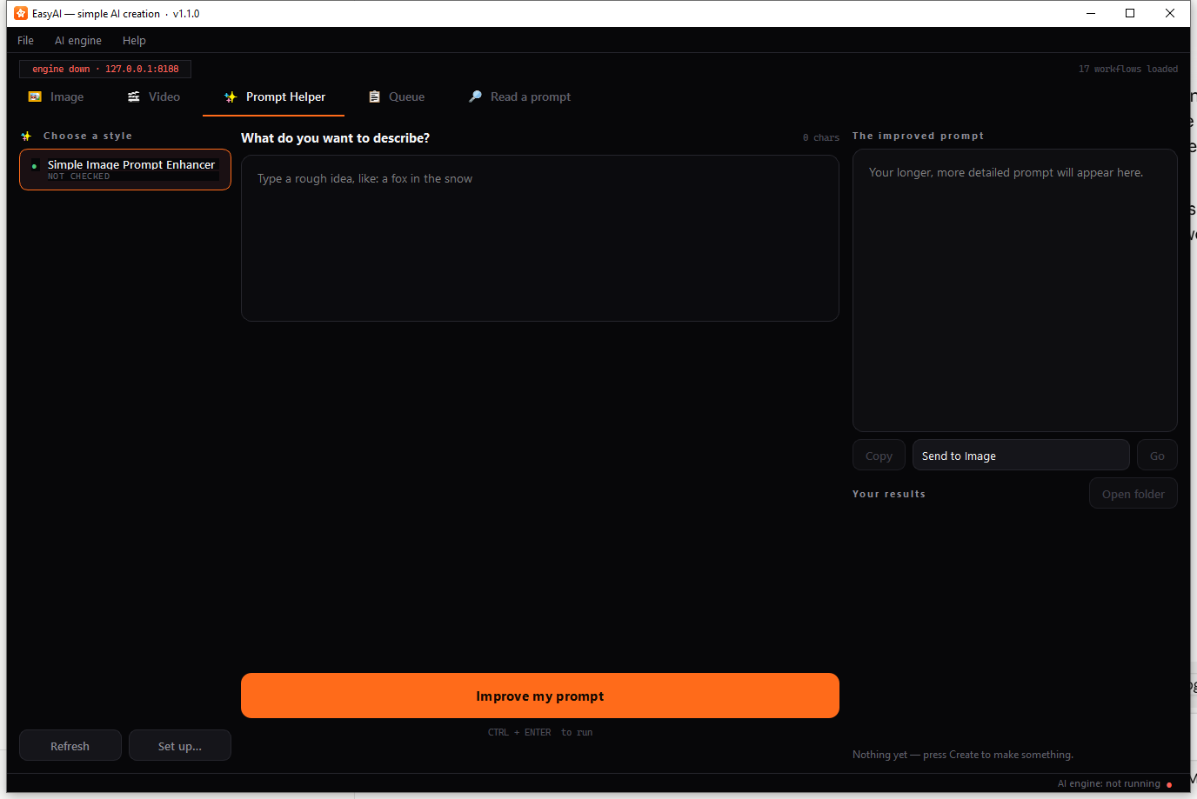
Type your rough idea and press Improve my prompt. Instead of a picture preview, this tab shows:
- THE IMPROVED PROMPT — a read-only box with the result.
- Copy — copies the text.
- A “Send to Image/Video” dropdown plus Go — drops the improved prompt straight into the chosen tab’s prompt box and switches you there.
- A history list of everything you’ve generated with Prompt Helper before, which you can click to reload.
Every result is also saved to a text file automatically, so nothing is lost even after you close EasyAI.

Queue tab
Every press of Create — on any of the three Generate tabs — adds a job here rather than running immediately. Because there’s one GPU, jobs run one at a time in order.
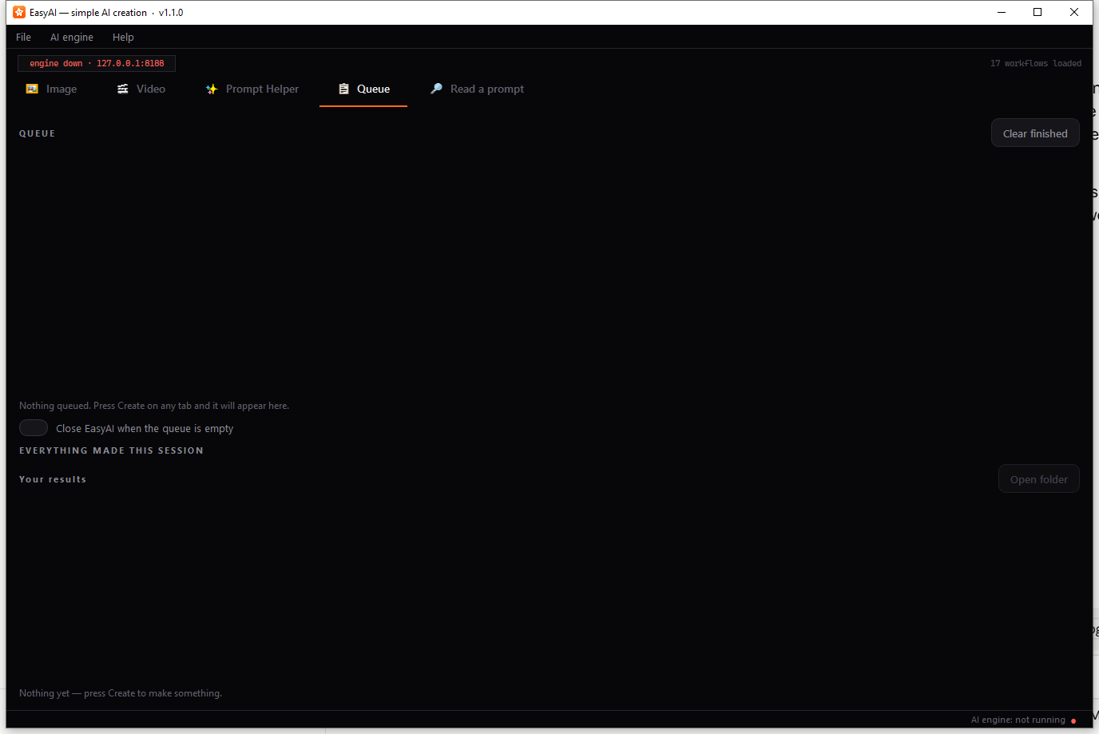
The screenshot above shows the empty state you’ll see before anything has been queued: “Nothing queued. Press Create on any tab and it will appear here.” Once jobs are queued, this screen instead shows:
- A running count (“1 running · N waiting”).
- One row per job, showing its state (waiting, running, done, failed, or cancelled), which tab it came from, the workflow name, a short summary, a progress bar while it runs, and a cancel button.
- Clear finished to tidy up completed rows.
- “Close EasyAI when the queue is empty” — a switch that, combined with “Close ComfyUI when EasyAI closes” in Settings, lets you queue up a batch of jobs, walk away, and have both EasyAI and ComfyUI shut down on their own once everything’s done. This switch resets to off every time you start EasyAI, so it never surprises you on a night you forgot it was set.
- A gallery of everything made in the current session, below the queue list.
When the queue does empty out with “Close when empty” turned on, EasyAI shows a message saying everything is finished and counts down 20 seconds, with Stay open (the default) and Close now buttons. Choosing Stay open turns the switch back off so you won’t be asked again next time.
If you try to close EasyAI while jobs are still running or waiting, EasyAI stops you with a warning naming how many are in progress, offering Keep working (switches you to the Queue tab) or Cancel everything and close.

Read a prompt tab
Use this to recover the prompt that made an existing picture or video — useful when you’ve forgotten what you typed, or you’re curious how someone else’s image was made. It works even with ComfyUI closed.
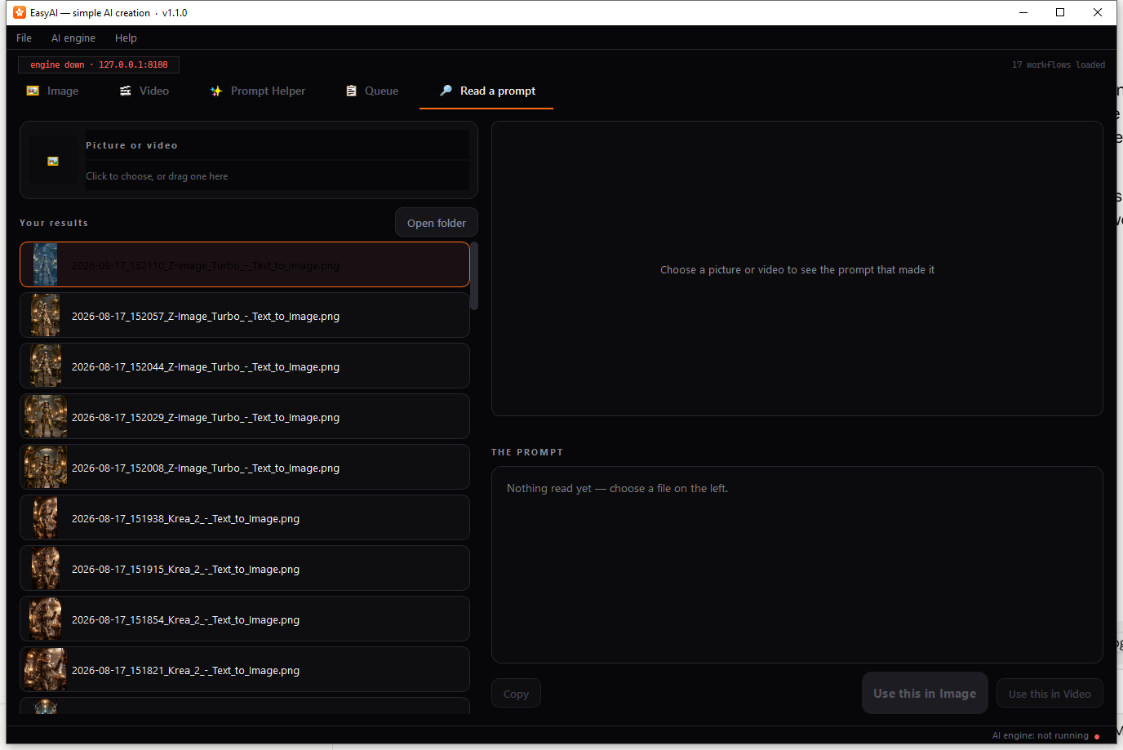
Drag a picture or video onto the drop zone on the left, or click it to browse for one — or pick one from the results gallery underneath it, which lists recent files from all three output folders (Image, Video, Prompt Helper).
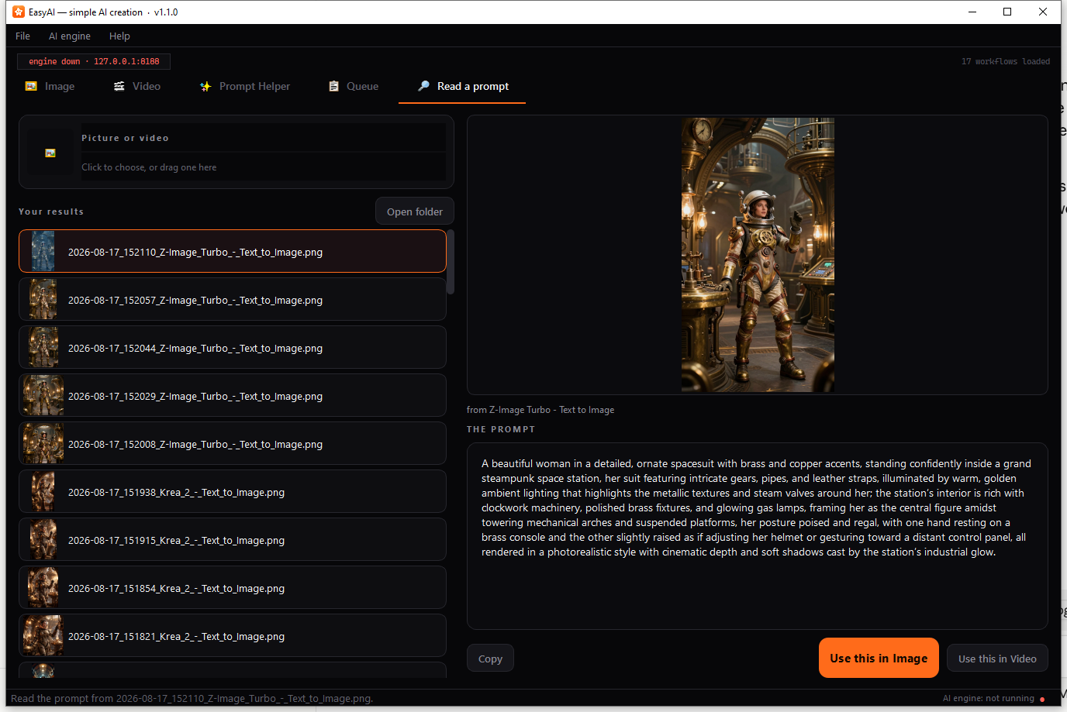
Once a file is chosen, the right side shows a preview and, if a prompt could be found embedded in the file, “THE PROMPT” with the recovered text, plus Copy, Use this in Image, and Use this in Video buttons. Above the prompt box, a short line tells you where the text came from:
- “from ” — EasyAI matched the file to one of your own workflows.
- “best guess — this workflow is not one of yours” (shown in an amber warning colour) — the file wasn’t made with any workflow EasyAI recognises, so it’s showing its best guess at the prompt anyway.
If the file has no prompt embedded at all — common for pictures that have been re-saved, sent through a messaging app, or downloaded from most websites — you’ll see “This file does not carry a prompt…” and the Copy/Use buttons stay disabled. If the file has since been deleted, EasyAI tells you “That file is no longer there.”
This tab refreshes its list every time you open it, so new results and newly added workflows show up without restarting EasyAI.

Set up… (Manifest Editor)
EasyAI guesses, automatically, which parts of a workflow’s internal node graph correspond to the prompt, negative prompt, shape, seed, length, and so on. The Manifest Editor lets you correct those guesses by hand, without editing any files directly.
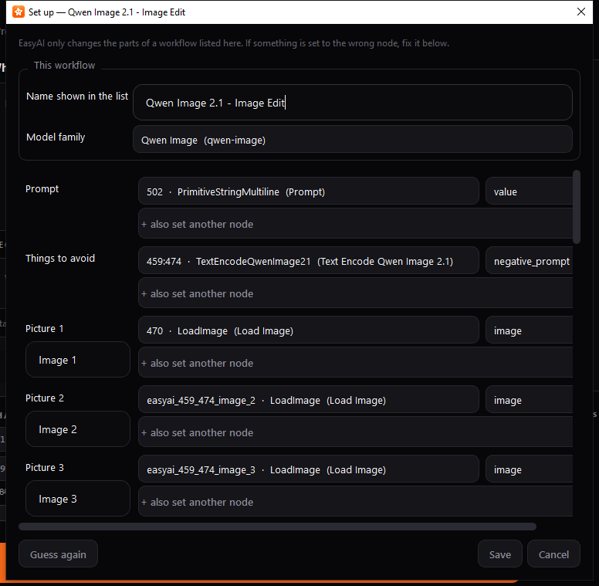
Open it via the Set up… button on a Generate tab, right-click a workflow and choose Set up…, or when a workflow is flagged “CHECK SET UP” in the workflow list.
- Name shown in the list — rename the workflow as it appears to you.
- Model family — leave as “Work it out automatically”, or pick a specific engine if EasyAI guessed wrong; this decides which set of shapes is offered.
- One row per setting (Prompt, Negative prompt, Width, Height, Seed, and so on, plus a row for each file slot) — each lets you pick which node and input in the graph that setting should control.
- Save keeps your changes and marks the workflow as manually configured (so it won’t be silently re-guessed later). Guess again re-runs the automatic detection (discarding your edits in this dialog, until you press Save). Cancel closes without saving.
Your corrections are stored in a small file next to the workflow and are kept even if you later re-export the same workflow from ComfyUI.

Rename dialog
A simple way to give a workflow a friendlier name than its file name.
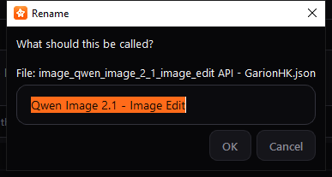
Open it with F2 on a selected workflow, by double-clicking a workflow, or via right-click → Rename…. Type the new name and press OK. Clearing the name entirely reverts to using the file name.

Help → How do I add a workflow?
A quick in-app reminder of the steps for adding a new workflow: export it from ComfyUI using Export (API), save it into the right folder, then press Refresh.
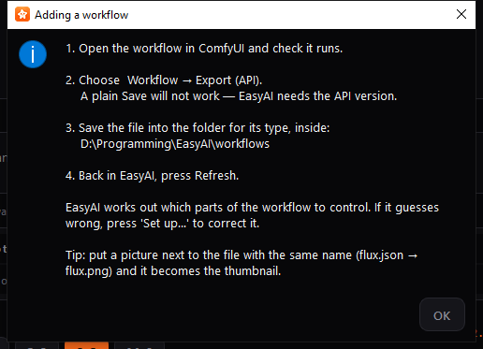
The message names your actual current workflow folder, taken from Settings.

Help → About EasyAI
Shows the app version and a reminder of where your workflows and results are currently stored.
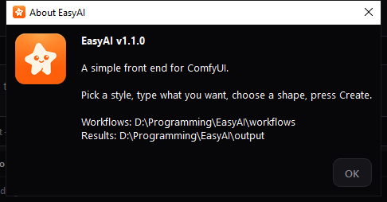

EasyAI Setup
Run this program to install ComfyUI and the models/add-ons EasyAI’s workflows need, or to update a ComfyUI you already have. It’s one long scrollable screen, meant to be read top to bottom.
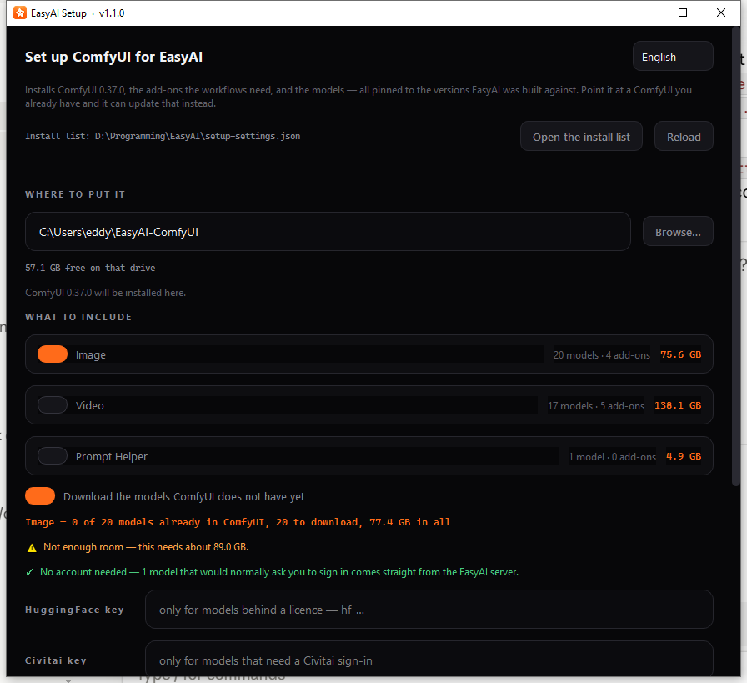
- Pick a Language at the top right if needed.
- Read the blurb naming which ComfyUI version will be installed.
- The install list row shows where the list of things to install comes from — either built into Setup, or a setup-settings.json file next to it that you can open, edit and reload (see Settings Reference below for what’s in it).
- WHERE TO PUT IT — choose a destination folder (defaults to ~/EasyAI-ComfyUI); a free-disk-space readout appears alongside it.
- Once a folder is chosen, a line appears telling you what Setup found there:
  - An empty folder: “ComfyUI {version} will be installed here.”
  - A folder that already matches: “✓ ComfyUI {version} is already here, with EasyAI’s add-ons at their tested versions” — nothing to do.
  - An existing but older/newer/mismatched ComfyUI: a message naming both versions, together with a switch to update it to the tested version (or to change it back down, if the found copy is newer). This switch defaults on for an older install and off for a newer one, but only the first time — after that, your own choice is remembered.
- WHAT TO INCLUDE — one card per group of models/add-ons (Image, Video, Prompt Helper), each a simple on/off switch showing how many models and add-ons it includes and its total download size.
- “Download the models ComfyUI does not have yet” — on by default; models ComfyUI already has are never re-downloaded. Turn this off to install or update just ComfyUI and its add-ons, without any models.
- A running total line tells you how much will actually be downloaded, followed by a free-space readout and any warnings — for example, not enough disk space, or models with no automatic download link (which you’d need to copy in yourself), or models that need a HuggingFace or Civitai account.
- If any gated models are needed, HuggingFace key and Civitai key fields let you paste in an access key for the current run only — nothing is saved to disk.
- Press Install. A confirmation dialog first states the exact download size, destination, and plan. A Stop button appears while installing (it finishes the current file, then stops); a progress bar, current file/speed/ETA, and a scrolling log show progress.
Installing is resumable — if it’s interrupted, running Setup again picks up where it left off, including part-finished downloads. When it finishes, it tells you EasyAI is already configured to use the new ComfyUI, or, if it couldn’t update EasyAI’s settings itself, gives you the exact folder path to paste into EasyAI’s own Settings.

EasyAI Studio
Studio is a maintainer/publishing tool, not something a day-to-day EasyAI user needs. It has a navigation rail on the left and a page area on the right, rather than a single top-to-bottom flow like Setup.

Add a workflow
Package an already-working ComfyUI workflow so EasyAI Setup can install its models for everyone else.
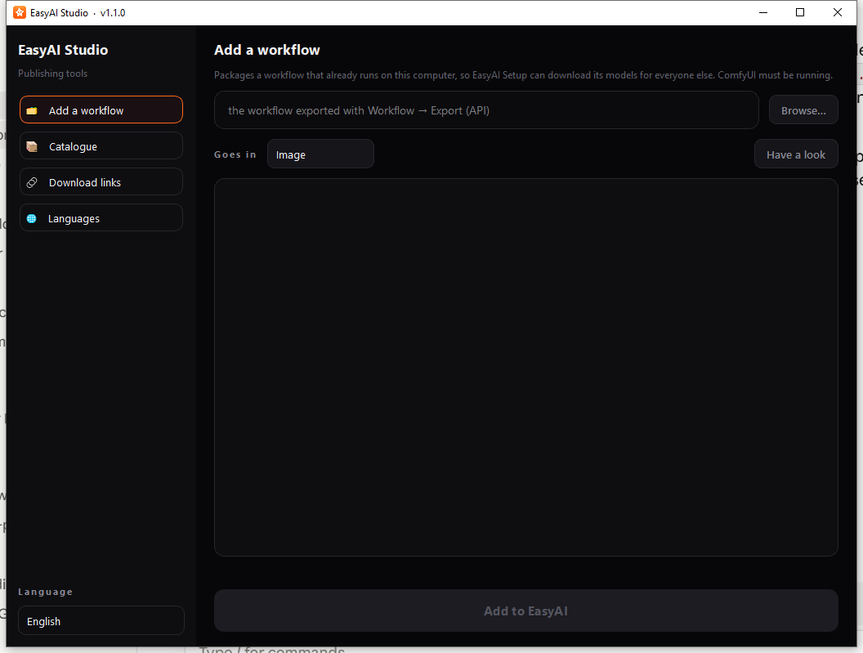
Browse to a workflow .json file, confirm which group it belongs in (Image, Video, or Prompt Helper — guessed automatically from the filename but always changeable), and press Have a look. This requires a running ComfyUI, since only the live engine can say which folder each model belongs in. The report shows the node count, what EasyAI can drive, every model found and its download-link status, and any add-ons needed. Once the report says the workflow can safely be added, press Add to EasyAI.

Catalogue
Rebuilds the master install list that EasyAI Setup uses, based on what’s installed on this machine.
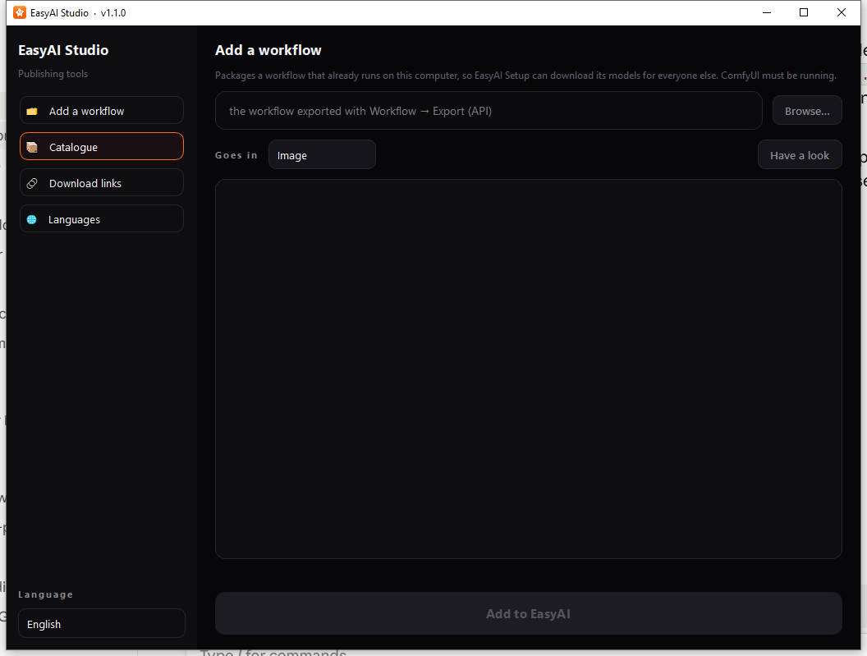
Update folders and mirrors does a lighter refresh; Rebuild everything does a full rebuild (requires a running ComfyUI). A summary line and scrolling log show progress and results.

Download links
Checks that every model’s download link still works and still serves the right file.
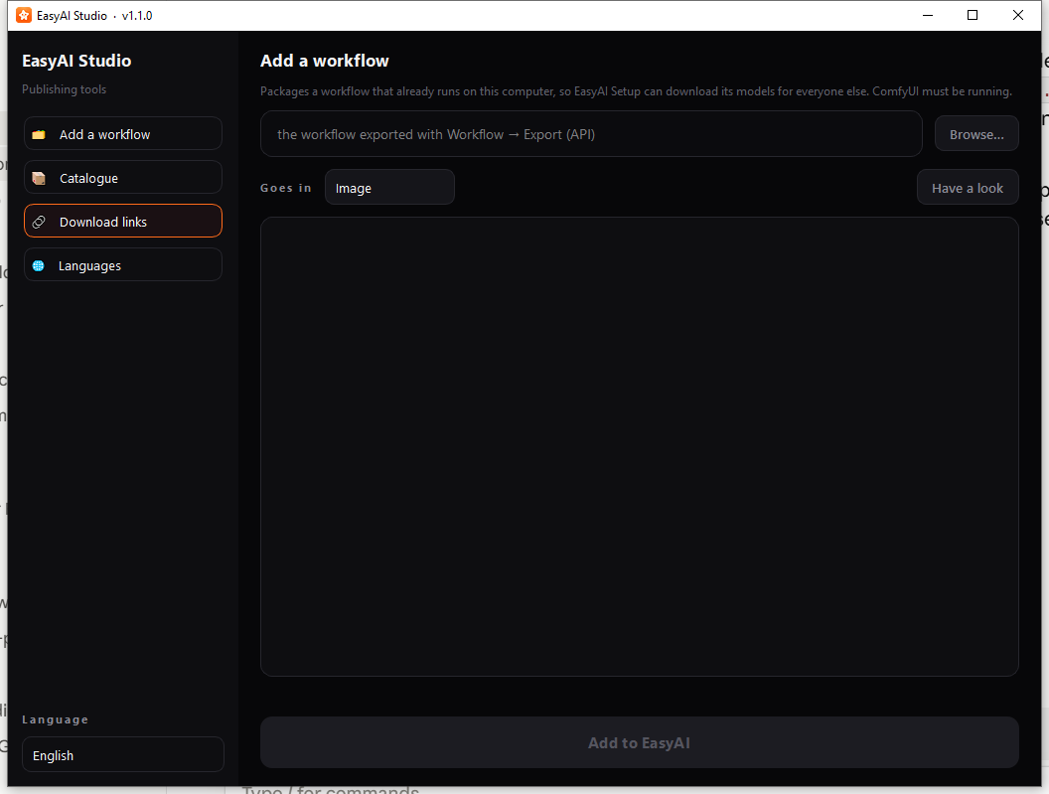
Check the original sources verifies links against their original providers; Check my mirror checks the maintainer’s own mirror server instead. A summary line shows how many links need checking, are mirrored, or need an account.

Languages
Finds text that’s been added to the programs since the translation files were last updated, for 繁體中文 and 简体中文.
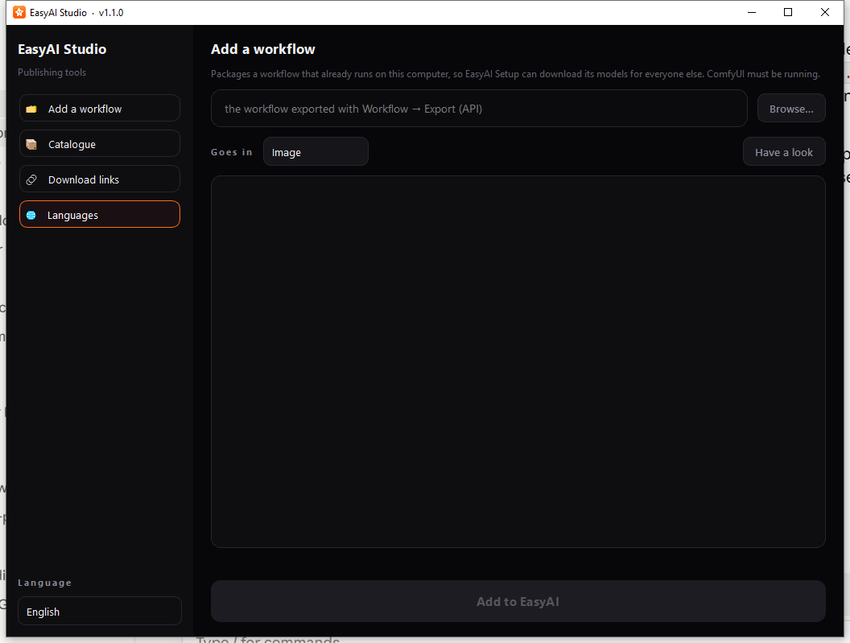
What is missing? reports what needs translating without changing anything. Add new text to the language files adds the new entries with empty values, ready for a translator to fill in.

Settings Reference
All settings live in settings.json, kept beside EasyAI (or beside the built .exe). You should not normally need to edit this file by hand — use the Settings dialog instead — but this table explains every value in it.
Setting | What it does | Default
ComfyUI folder | Folder where ComfyUI is installed. | C:\AI ComfyUI - New Version\ComfyUI_windows_portable
Start file | Which file inside that folder starts ComfyUI. | run_nvidia_gpu.bat
Address | Address EasyAI talks to ComfyUI on. | 127.0.0.1:8188
Start ComfyUI automatically | Whether EasyAI starts ComfyUI itself if nothing answers. | On
Wait for the engine up to | How long to wait for ComfyUI to start before giving up. | 300 seconds
Give up after | How long a single generation may run before EasyAI gives up on it. | 1800 seconds
Close ComfyUI when EasyAI closes | If EasyAI started ComfyUI, close it again on exit. Never closes a ComfyUI started some other way. | On
Close EasyAI when the queue is empty | Queue tab switch; auto-closes EasyAI once nothing is left queued. Always resets to off at the start of every session. | Off
Workflows folder | Folder holding your workflow files. | workflows folder beside EasyAI
Results folder | Folder generated files are saved into. | output folder beside EasyAI
Shape to start with | Shape chip pre-selected when you pick a workflow. | 2:3
Repeat the same result (seed lock) | Whether “repeat the same result” starts ticked. | Off
Model choice | Remembered alternate model per workflow (Model picker), without changing the workflow file itself. | (none)
How many (batch count) | Default value of the batch-count box. | 1
Let the AI improve my wording first | Default state of the prompt-enhancer switch. | On
Image Detail | Remembered Detail value for the Image tab. | 1.0 MP
Video Detail | Remembered Detail value for the Video tab. | 0.5 MP
Image Detail warning level | Detail value above which the Image tab warns about memory use. | 1.5 MP
Video Detail warning level | Same, for Video (lower, since video pays the cost per frame). | 1.0 MP
Video length | Length box’s starting value. | 5 seconds
Video length range | Minimum/maximum of the Length box. | 2–15 seconds
Video length warning level | Above this, the Length control shows a memory caution. | 8 seconds
Language | Which language the app displays in. | English
Window size/position | Remembered between sessions. | (none)
First-run done | Whether the first-run welcome/Settings flow has already been shown. | Off
Each workflow also keeps its own small settings file alongside it (created automatically the first time the workflow loads, and never overwritten afterward), storing its display name, model family, and all of the Manifest Editor’s node/input bindings — so your corrections in Set up… always survive re-exporting the same workflow later.

EasyAI Setup’s install list (setup-settings.json)
The first time you run EasyAI Setup, it writes an editable setup- settings.json file beside itself, and reads that instead of its built-in list from then on. You can open it (via Setup’s Open the install list button) to customize:
- Where models and workflows get installed.
- Which specific models are included, and where each one downloads from.
- Which workflows are included in each group.
If this file goes out of date compared to a newer version of Setup, an untouched file is quietly replaced; an edited one is kept, with a warning telling you what’s missing and an offer to switch to the current list (keeping your old file as a backup).

Troubleshooting
- A workflow’s status dot is amber or red. This is the first place to look. Green with “READY · ” means all good. Amber (“CHECK SET UP” or “NOT CHECKED”) means EasyAI guessed the workflow’s setup and wants you to confirm it in Set up…, or hasn’t checked yet. Red (“MISSING ADD-ON” / “MISSING MODEL”) names the exact file that’s missing from your ComfyUI install — install it (via EasyAI Setup, or by hand) and press Refresh. Red “NEEDS RE-EXPORT” means the file isn’t a valid ComfyUI API export — a plain “Save” in ComfyUI is not enough; you must use ComfyUI’s Workflow → Export (API) option.
- The engine pill or status-bar dot says “down”/“not running”. Check this first if Create isn’t working. Try AI engine → Check it is running (F5), or AI engine → Start it now, or open Settings and press Test now.
- No VRAM readout in the status bar. This only appears once the engine is running and reporting a graphics device — it isn’t a fault by itself, but its absence usually means the engine isn’t connected yet.
- “ComfyUI closed straight away.” Usually means something is wrong with the ComfyUI install itself. Try running the start file directly (outside EasyAI) to see the actual error message.
- “The AI engine did not start within N seconds.” ComfyUI took longer to start than the “Wait for the engine up to” setting allows — either wait longer by raising that value in Settings, or check that ComfyUI can start on its own.
- “EasyAI cannot reach ComfyUI” when pressing Create. The engine isn’t running or isn’t reachable at the configured address — check Settings.
- “Almost there” dialog. A required file input is empty; the dialog lists exactly which ones. Attach the missing files and press Create again.
- “The workflow finished but produced no text.” (Prompt Helper only) — the underlying workflow needs a node that outputs text (a Preview Any or Show Text node); without one there’s nothing for EasyAI to read back.
- “This file does not carry a prompt…” on Read a prompt. The file has lost its embedded prompt data — this commonly happens after re-saving, sending through a messaging app, or downloading from most websites. There is no way to recover the prompt from a file like this.
- “best guess” label on Read a prompt. Shown in an amber warning colour when the file can’t be matched to one of your own workflows — EasyAI is still showing you a recovered prompt, but can’t be fully sure it picked the right text box out of the file’s embedded data.
- A reference-picture slot disappeared when you removed a picture in the middle of the list. This is expected — the remaining pictures shift up so there’s never a gap, since the workflow numbers them by position.
- A generated file’s size doesn’t exactly match the shape you chose. Some engines (the LTX family) round both dimensions down to the nearest multiple of 64 after computing the size, so the final file can be very slightly smaller than the shape chip’s label suggested. This is normal.
- Turning off “Let the AI improve my wording first” changes nothing visible right away, but the workflow behaves differently. This switch actually rewires the workflow’s internal graph to skip the enhancer entirely (rather than just hiding a setting), so the language model for that step never loads — this is expected behaviour, not a bug.
- “Close EasyAI when the queue is empty” was on yesterday but is off today. This is deliberate — the switch is a session-only convenience and always resets to off each time you start EasyAI, so it can’t cause an unexpected auto-close later.
- EasyAI won’t close while jobs are queued. This is a safety feature — choose Keep working to go back to the Queue tab, or Cancel everything and close if you really want to stop now.
- “Close ComfyUI when EasyAI closes” didn’t close a ComfyUI I started by hand. This is expected — EasyAI only ever closes a ComfyUI process that it itself launched, never one you started manually or on another machine.
- EasyAI Setup’s update seems cautious. That’s by design: it never overwrites your own edits, keeps a backup of the previous state, and automatically restores a replaced add-on if its new version fails to install.
- EasyAI guessed the wrong ComfyUI folder on first run. This is why the first-run welcome message exists — press Test now in Settings after changing the folder to confirm EasyAI can actually reach ComfyUI there before relying on it.

Needs Confirmation
The following items could not be verified against the running app or exact source text in time for this manual, and are flagged here rather than guessed:
- Exact wording of several error messages: “ComfyUI closed straight away.”, “The workflow finished but produced no text.”, “The AI engine finished but produced no files.”, and the precise NEEDS RE-EXPORT explanation text.
- Exactly where the current language selection is stored (it’s kept separately from the main settings file so all three programs agree, but the precise file/location wasn’t confirmed).
- Whether a dark/light theme setting is genuinely user-facing anywhere, or purely internal — no toggle for it was found in Settings, Setup, or Studio, despite a theme value existing in the settings file.
- The practical minimum graphics-card memory (VRAM) needed — the stated requirement is “an NVIDIA graphics card,” tested on 16 GB, but no lower bound is enforced or documented elsewhere.
- The exact wording and full behaviour of EasyAI Setup’s licence/key screen for gated models (HuggingFace/Civitai), particularly around whether any licence text gets saved into the install folder.
- The Model picker screen, and the Reference 2+ reveal behaviour, and EasyAI Setup’s “found an existing ComfyUI here” update-switch screen could not be captured as screenshots for this manual (each needs a real ComfyUI models folder or install to demonstrate) — described here from the design outline only.

