ICS3U Software Design Name Zhang, Garland

Program Name:
Tetris Marathon

Explain how your game will work. Assume that I don’t know how to play your game. Be sure to describe how all input will be received and all output will be displayed.
Tetris Marathon is a one-player game. A 10 x 22 grid will appear on the screen. A 4-block variation, called a tetromino, is generated at the top of the grid and drops one grid square per second( initial speed ) towards the bottom of the grid. The user will interact with the game by controlling the placement and position of the tetromino through the interaction with the keyboard( e.g; arrow keys ). To gain points, the user must occupy an entire row with blocks of any assortment of tetrominoes. This will clear the line, shift every block on top downwards, and increment points value by one.

Difficulty is based off of drop speed of the tetromino and changes when a milestone of points is reached( for every five lines cleared, increase speed by 75 milliseconds ). The game ends when the user stacks to the top of the screen. This game cannot be won, only prolonged.

Input will be received by the user’s interactions with the tetromino (arrow keys & other keys). Input will also be received by user inputting their name. A random generator will be used to identify which type of tetromino will be displayed next. High scores as well as the username will be inputted to a file for future reference. High scores will also be displayed.

Screen Designs: Print this document and sketch key screens. (Introduction, main game, special cases, game over, etc)

Tetris Marathon  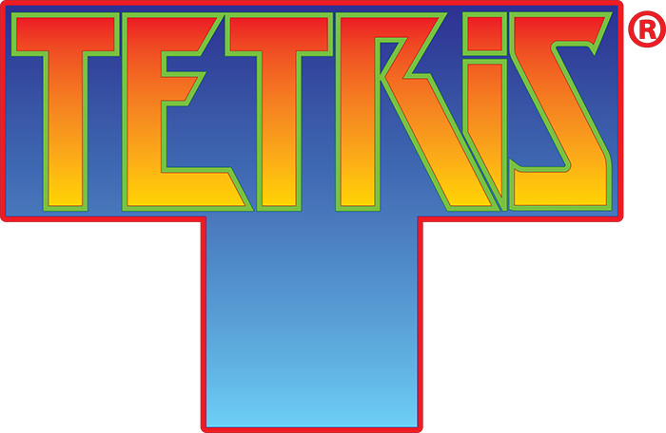 |  | Instructions  - Clear lines to earn points  Rotate 90° clockwise  Move left 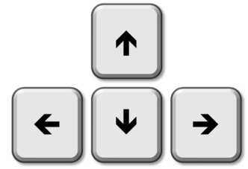Move right  Drop tetrominoe by one pixel    Quick drop
Gameplay  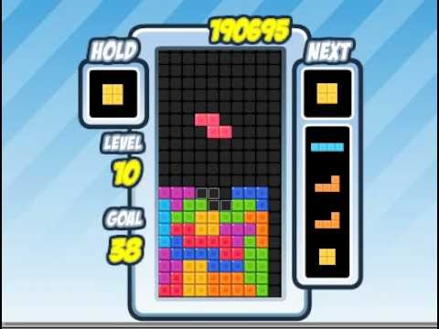 |  | GAME OVER    High scores  .  .  .  Play Again?
ICS3CU Software Design Name Zhang, Garland

Data Structures Used:

Arrays: grid : 1..10, 1..22 of Boolean – to keep track of which grid square is true( filled by a tetromino )
Tetromino : 1..4, 1..4 of Boolean – to create a 4-block variation where each block is marked as true in the array
holdTetromino : holds the tetromino. Consider as a pointer to a tetromino

Strings: username : Stores first and last name of user
Highscores : Stores high score including username and placement. String is built when getting input from file.

Files Used:

drawImages.t - Where images are drawn and called to use
Tetromino.t – Where tetromino is created and manipulated to move
UserMove.t – Where user will interact with the game through keyboard commands
MyGlobalVars.t – Where global variables are stored
Grid.t – Where grid is created
Includes.t – Includes all files to main file
IntroScreen.t – Introduction to game screen
InstructionsScreen.t - Where instructions are given to the user
DescriptionScreen.t – Where description of game is given
GameScreen.t - Where game will be played
Scoreboard.t - Where scores and level data are shown to user during the game play
PauseScreen.t - Where game is paused
GameOverScreen.t - Where high scores are displayed and allows user to submit name into high score chart
GUI.class – Retrieve GUI interface for user interaction with buttons. This includes the play button, instructions button, and other miscellaneous buttons

Images – pauseImg.gif, battleKeys.gif, gameOver.gif, tetrisBG.gif, tetrisDemo.gif, TetrisLogo.gif
Sounds – clearLineSound.wav, dropSound.wav, jeopardyMusic.mp3, gameOver.mp3, tetrisMusic.mp3, tada.wav
Text – HighScore.txt, Description.txt

Predefined OOT Units Used:

Font – To modify text that display titles, username, and score

Mouse – To click on buttons ( play button, instructions button, etc. )

Keyboard – User interaction with game by manipulating tetromino using arrow keys and space bar

Windows – Open windows to play game

Main Program Steps:

- Display title screen
- Provide the user with the option to click on instructions button
  - If true, then go to instructions screen( change display )
  - Else if user presses on play button, go to game screen( change display to game display )
- Tetris Marathon step-step build
  - Draw the grid onto the screen
  - Randomly choose one of seven tetromino variations
  - Draw tetrominoe onto the middle top of the screen
  - Keep track of any keyboard interaction
    - If left arrow key is pressed, shift tetromino left by one grid square
    - Else if right arrow key is pressed, shift tetromino right by one grid square
    - Else if up arrow key is pressed, rotate tetromino 90° clockwise by manipulating tetromino array
    - Else if down arrow key is pressed, shift tetromino down by one grid square
    - If no interaction is present, delay 1000 milliseconds
  - Shift tetromino down automatically by one grid square
  - Check if tetromino comes in contact with any other previous tetromino( refer to the Boolean returned from the 2D grid array. If grid( i, j ) is true, then previous block from tetromino is present in that current block. ).
  - Check if tetromino is at the bottom of grid to stop automatic shift down.
  - Check grid if any line in the grid is true. If so, clear the line by changing each square in the grid to false and shift everything above down by one grid square. Increment points value by one.
  - In five point intervals, increase drop speed of tetromino by 75 milliseconds.
  - If tetromino is dropped at the top of the grid, and no other tetrominoes can be generated at the top, record score and input to a high score file. Exit user to the Game Over screen.
  - Else, continue looping through steps b to j.
- Display game over screen
  - Display GAME OVER image
  - Display high score chart
- Display option to play again, or exit

