ICS3CU Software Proposal Name Zhang, Garland

Program Name:
Tetris ( Marathon style )

Explain how your game will work. Do not assume that I have played your game. Be sure to describe how all input will be received and all output will be displayed.
Tetris Marathon is a one-player game. A 10 x 22 grid will appear on the screen. A 4-block variation, called a tetrominoe, is generated at the top of the grid and drops one pixel per second towards the bottom. The user will control the placement and position of the tetrominoe by using the arrow keys ( left & right ) to shift pixel position on the grid and up arrow key to rotate tetrominoe 90° clockwise. To gain points, the user must occupy an entire row with blocks of any assortment of tetrominoes. This will clear the line and shift every block on top downwards.

Difficulty is based off of drop speed of the tetrominoe and changes when a milestone of points is reached. The game ends when the user stacks to the top of the screen. This game cannot be won, only prolonged.

Input will be received by the user’s interactions with the tetrominoe (arrow keys & other keys). A random generator will be used to identify which type of tetrominoe will be displayed next. High scores and username will be also be inputted to a file for future reference.

Screen Designs: Print this document and sketch key screens. (Introduction, main game, special cases, game over, etc)

Tetris Marathon  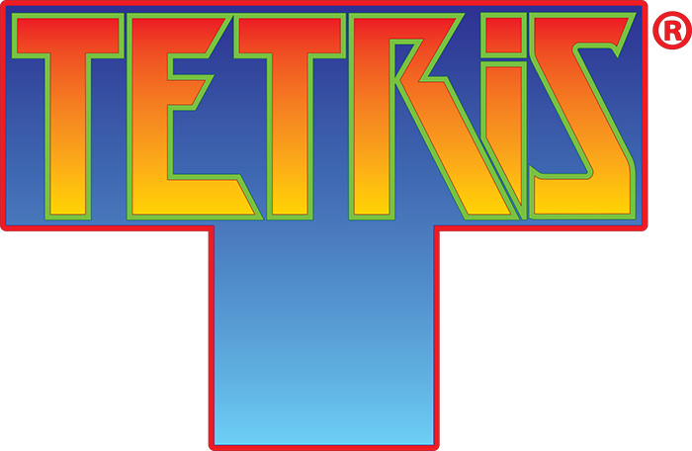 |  | Instructions  - Clear lines to earn points  Rotate 90° clockwise  Move left 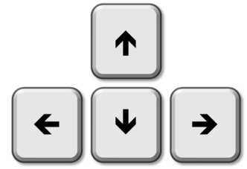Move right  Drop tetrominoe by one pixel    Quick drop
Gameplay  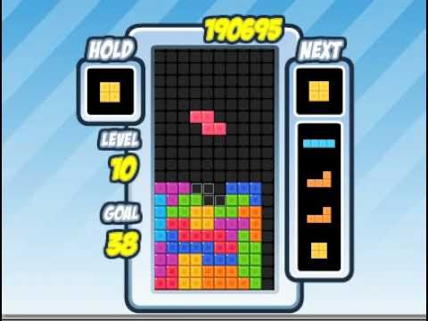 |  | GAME OVER    Play Again?

