Міністерство освіти і науки України
Національний технічний університет України
«Київський політехнічний інститут імені Ігоря Сікорського»
Факультет інформатики та обчислювальної техніки
Кафедра обчислювальної техніки

Лабораторна робота №4
з дисципліни
«Об’єктно-орієнтоване програмування»
на тему
«Вдосконалення структури коду графічного редактора об’єктів»

Виконав: Перевірив:
студент групи ІМ-53 Рекечинський Дмитро Олександрович
Бунтовський Денис Сергійович
Номер в списку - 3

Київ 2026

Завдання
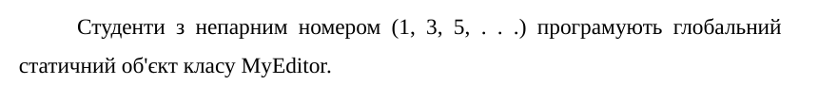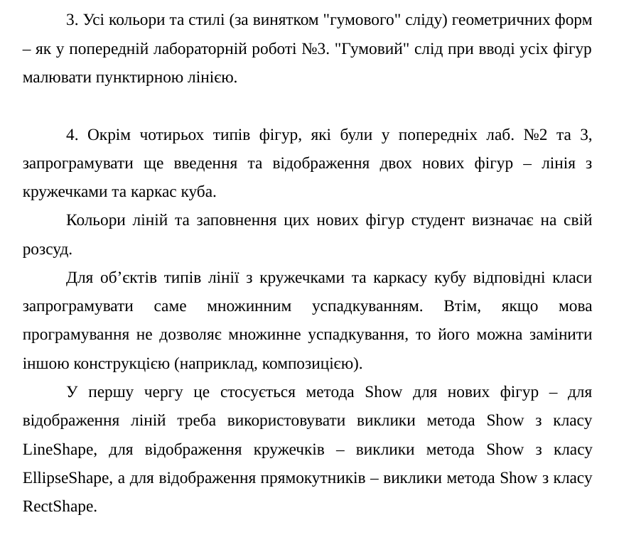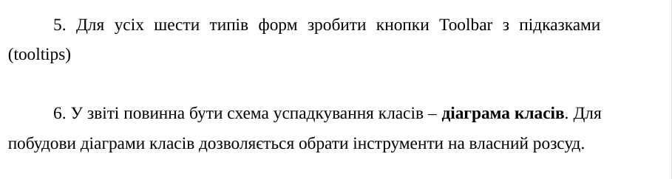
Лістинг коду
main.cpp
#ifndef UNICODE
#define UNICODE
#endif

#include <windows.h>
#include <windowsx.h> // Required for GET_X_LPARAM and GET_Y_LPARAM
#include <commctrl.h>

// Link Common Controls library
#pragma comment(lib, "comctl32.lib")
#define WIN32_LEAN_AND_MEAN
#include "shapes/shape.h"
#include "shapes/elipse.h"
#include "shapes/vec2.h"
#include "create.h"
#include "paint_window.h"

PaintWindow myWindow;

int WINAPI WinMain(HINSTANCE hInstance, HINSTANCE hPrevInstance, LPSTR pCmdLine, int nCmdShow) {

if (!myWindow.Create(L"Лаба4", WS_OVERLAPPEDWINDOW, 0, 100, 100, 800, 600)) {
return 0;
}

myWindow.Show(nCmdShow);

// Цикл обробки повідомлень
MSG msg = {};
while (GetMessage(&msg, nullptr, 0, 0)) {
TranslateMessage(&msg);
DispatchMessage(&msg);
}

return 0;
}
create.h
#include "shapes/shape.h"
#ifndef _CREATE_H_
#define _CREATE_H_
Shape* CreateShapeObject(Vector2 vec1, Vector2 vec2, int shape_id);
HICON CreateIconFromBitmap(HBITMAP hBitmap, COLORREF transparentColor);
HICON LoadIconFromFile(const wchar_t* filePath, int width, int height);

#endif
create.cpp
#include "create.h"
#include "shapes/dot.h"
#include "shapes/line.h"
#include "shapes/rect.h"
#include "shapes/elipse.h"
#include "shapes/circled_line.h"
#include "shapes/cube.h"
#include "shapes/shape.h"
#include "windows.h"
Shape* CreateShapeObject(Vector2 vec1, Vector2 vec2, int shape_id){
Shape* shape;
Vector2 delta = Vector2{vec2.x - vec1.x, vec2.y - vec1.y};
switch (shape_id) {
case 2: shape = new Dot(vec1); break;
case 3: shape = new Line(vec1, vec2); break;
case 4: shape = new Rect(vec1, delta); break;
case 5: shape = new Elipse(vec1, vec2); break;
case 6: shape = new CircledLine(vec1,vec2); break;
case 7: shape = new Cube(vec1,Vector2{0,0}); break;
}
return shape;
}
HICON CreateIconFromBitmap(HBITMAP hBitmap, COLORREF transparentColor) {
BITMAP bm;
GetObject(hBitmap, sizeof(BITMAP), &bm);

// 1. Create a monochrome mask bitmap for transparency
// (If the pixel matches transparentColor, it's transparent; otherwise opaque)
HDC hDC = GetDC(NULL);
HDC hMemDC = CreateCompatibleDC(hDC);
HDC hMaskDC = CreateCompatibleDC(hDC);

// Create the color and mask bitmaps
HBITMAP hOldBmp = (HBITMAP)SelectObject(hMemDC, hBitmap);

// Create monochrome mask (1 bit per pixel)
HBITMAP hMaskBmp = CreateBitmap(bm.bmWidth, bm.bmHeight, 1, 1, NULL);
HBITMAP hOldMaskBmp = (HBITMAP)SelectObject(hMaskDC, hMaskBmp);

// Set background color to the transparent color for mask generation
COLORREF oldBkColor = SetBkColor(hMemDC, transparentColor);

// Copy bits: pixels matching transparentColor become white (transparent), others black (opaque)
BitBlt(hMaskDC, 0, 0, bm.bmWidth, bm.bmHeight, hMemDC, 0, 0, SRCCOPY);

// Clean up DC selections
SetBkColor(hMemDC, oldBkColor);
SelectObject(hMemDC, hOldBmp);
SelectObject(hMaskDC, hOldMaskBmp);
DeleteDC(hMemDC);
DeleteDC(hMaskDC);
ReleaseDC(NULL, hDC);

// 2. Populate the ICONINFO structure
ICONINFO iconInfo = {};
iconInfo.fIcon = TRUE; // TRUE for icon, FALSE for cursor
iconInfo.xHotspot = 0;
iconInfo.yHotspot = 0;
iconInfo.hbmMask = hMaskBmp; // The transparency mask
iconInfo.hbmColor = hBitmap; // The actual color bitmap

// 3. Create the icon
HICON hIcon = CreateIconIndirect(&iconInfo);

// Clean up the mask bitmap (CreateIconIndirect makes a copy of the bitmaps)
DeleteObject(hMaskBmp);

return hIcon;
}
HICON LoadIconFromFile(const wchar_t* filePath, int width, int height) {
// 1. Load the bitmap from an external file
HBITMAP hBmp = (HBITMAP)LoadImageW(
NULL,
filePath,
IMAGE_BITMAP,
width,
height,
LR_LOADFROMFILE | LR_CREATEDIBSECTION
);

if (!hBmp) return NULL;

// 2. Convert to icon (using Magenta RGB(255, 0, 255) as the transparent color, for example)
HICON hIcon = CreateIconFromBitmap(hBmp, RGB(255, 0, 255));

// You can delete the source HBITMAP now if you no longer need it independently
DeleteObject(hBmp);

return hIcon;
}
vec2.h
#ifndef _VEC2_H_
#define _VEC2_H_

struct Vector2{
int x;
int y;
};
#endif
shape.h
#ifndef _SHAPE_H_
#define _SHAPE_H_

#include <windows.h>
#include "vec2.h"

class Shape{
public:
Shape() = default;
virtual ~Shape() = default;
virtual void draw(HDC hdc) = 0;
virtual void preview_draw(HDC hdc) = 0;
virtual void set_second(Vector2 value) = 0;
};

#endif

rect.h
#ifndef _RECT_H_
#define _RECT_H_

#include "shape.h"
#include "vec2.h"

#include <windows.h>

//black contour no fill

class Rect : public virtual Shape{
public:
Rect(Vector2 center, Vector2 delta) : center(center), delta(delta){};
~Rect() = default;
void draw(HDC hdc) override;
void preview_draw(HDC hdc) override;
void set_second(Vector2 value) override;
protected:
Vector2 center;
Vector2 delta;
private:

};

#endif

rect.cpp
#include <windows.h>
#include "rect.h"

void Rect::draw(HDC hdc){
HBRUSH hNullBrush = (HBRUSH)GetStockObject(NULL_BRUSH);
HBRUSH hOldBrush = (HBRUSH)SelectObject(hdc, hNullBrush);
Rectangle(hdc, center.x,center.y,center.x+delta.x,center.y+delta.y);
SelectObject(hdc, hOldBrush);
DeleteObject(hNullBrush);

}

void Rect::preview_draw(HDC hdc){
HBRUSH hNullBrush = (HBRUSH)GetStockObject(NULL_BRUSH);
HBRUSH hOldBrush = (HBRUSH)SelectObject(hdc, hNullBrush);
HPEN hBlackPen = CreatePen(PS_DASH, 1, RGB(0, 0, 0));
HPEN hOldPen = (HPEN)SelectObject(hdc, hBlackPen);
Rectangle(hdc, center.x,center.y,center.x+delta.x,center.y+delta.y);
SelectObject(hdc, hOldBrush);
SelectObject(hdc,hOldPen);
DeleteObject(hNullBrush);
DeleteObject(hBlackPen);

}

void Rect::set_second(Vector2 value){
delta=Vector2{value.x-center.x,value.y-center.y};
}
line.h
#ifndef _LINE_H_
#define _LINE_H_

#include "shape.h"
#include "vec2.h"
#include <windows.h>

class Line : public virtual Shape{
public:
Line(Vector2 start, Vector2 end) : start(start), end(end){};
~Line() = default;
void draw(HDC hdc) override;
void preview_draw(HDC hdc) override;
void set_second(Vector2 value) override;
Vector2 start;
Vector2 end;
private:

};

#endif

line.cpp
#include <windows.h>
#include "line.h"

void Line::draw(HDC hdc){
MoveToEx(hdc, start.x, start.y, NULL); // Set starting point
LineTo(hdc, end.x, end.y); // Draw line to
}

void Line::preview_draw(HDC hdc){
MoveToEx(hdc, start.x, start.y, NULL); // Set starting point

HBRUSH hBlueBrush = (HBRUSH)GetStockObject(NULL_BRUSH);
HBRUSH hOldBrush = (HBRUSH)SelectObject(hdc, hBlueBrush);
HPEN hBlackPen = CreatePen(PS_DASH, 1, RGB(0, 0, 0));
HPEN hOldPen = (HPEN)SelectObject(hdc, hBlackPen);

LineTo(hdc, end.x, end.y);

SelectObject(hdc, hOldBrush);
SelectObject(hdc,hOldPen);
DeleteObject(hBlackPen);
DeleteObject(hBlueBrush);

// Draw line to
}

void Line::set_second(Vector2 value){
end= value;
}
elipse.h
#ifndef _ELIPSE_H_
#define _ELIPSE_H_

#include "shape.h"
#include "vec2.h"
#include <windows.h>

class Elipse : public virtual Shape{
public:
Elipse(Vector2 corner1, Vector2 corner2) : corner1(corner1), corner2(corner2){};
~Elipse() = default;
void draw(HDC hdc) override;
void preview_draw(HDC hdc) override;
void set_second(Vector2 value) override;
Vector2 corner1;
Vector2 corner2;
private:

};

#endif

elipse.cpp
#include <windows.h>
#include "elipse.h"

void Elipse::draw(HDC hdc){
HBRUSH hBlueBrush = CreateSolidBrush(RGB(247, 2, 170));
HBRUSH hOldBrush = (HBRUSH)SelectObject(hdc, hBlueBrush);
HPEN hBlackPen = CreatePen(PS_SOLID, 3, RGB(0, 0, 0));
HPEN hOldPen = (HPEN)SelectObject(hdc, hBlackPen);
Vector2 delta = Vector2{corner1.x-corner2.x,corner1.y-corner2.y};
Ellipse(hdc,corner1.x-delta.x,corner1.y-delta.y,corner1.x+delta.x,corner1.y+delta.y);

SelectObject(hdc, hOldBrush);
SelectObject(hdc,hOldPen);
DeleteObject(hBlackPen);
DeleteObject(hBlueBrush);
}

void Elipse::preview_draw(HDC hdc){
HBRUSH hBlueBrush = (HBRUSH)GetStockObject(NULL_BRUSH);
HBRUSH hOldBrush = (HBRUSH)SelectObject(hdc, hBlueBrush);
HPEN hBlackPen = CreatePen(PS_DASH, 1, RGB(0, 0, 0));
HPEN hOldPen = (HPEN)SelectObject(hdc, hBlackPen);
Vector2 delta = Vector2{corner1.x-corner2.x,corner1.y-corner2.y};
Ellipse(hdc,corner1.x-delta.x,corner1.y-delta.y,corner1.x+delta.x,corner1.y+delta.y);

SelectObject(hdc, hOldBrush);
SelectObject(hdc,hOldPen);
DeleteObject(hBlackPen);
DeleteObject(hBlueBrush);
}

void Elipse::set_second(Vector2 value){
corner2 = value;
}
dot.h
#ifndef _DOT_H_
#define _DOT_H_

#include "shape.h"
#include "vec2.h"
#include <windows.h>

class Dot : public Shape{
public:
Dot(Vector2 position) : position(position){};
~Dot() override = default;
void draw(HDC hdc) override;
void preview_draw(HDC hdc) override;
void set_second(Vector2 value) override;
private:
Vector2 position;
};

#endif

dot.cpp
#include <windows.h>
#include "dot.h"

void Dot::draw(HDC hdc){
SetPixel(hdc, position.x, position.y, RGB(0, 0, 0));
}

void Dot::preview_draw(HDC hdc){
SetPixel(hdc, position.x, position.y, RGB(0, 0, 0));
}
void Dot::set_second(Vector2 value){}
cube.h
#pragma once

#include "line.h"
#include "rect.h"
#include "vec2.h"
#include <windows.h>

#define BACKPLANE_OFFSET_X 0.3
#define BACKPLANE_OFFSET_Y 0.4

class Cube : public Rect, public Line{
public:
Cube(Vector2 start, Vector2 end): Shape(), Rect(start,end), Line(start,end){}
void draw(HDC hdc);

void preview_draw(HDC hdc);

void set_second(Vector2 value);
};
cube.cpp
#include <cmath>
#include <algorithm>
#include "cube.h"

void Cube::draw(HDC hdc){
// 1. Save original bounding box coordinates (corner and offset)
Vector2 cache_start = Rect::center;
Vector2 cache_end = Rect::delta;

int total_width = cache_end.x;
int total_height = cache_end.y;

// 2. Calculate the backplane offset in pixels
int offset_x = (int)(total_width * BACKPLANE_OFFSET_X);
int offset_y = (int)(total_height * BACKPLANE_OFFSET_Y);

// 3. Correct rectangle sizing: Fit both rects inside the total dragged bounds
int cube_width = total_width - offset_x;
int cube_height = total_height - offset_y;

// 4. Draw Front Rectangle
Rect::center = cache_start;
Rect::delta = Vector2{cube_width, cube_height};
Rect::draw(hdc);

Vector2 cache_cube1_start = Rect::center;
Vector2 cache_cube1_end = Vector2{Rect::center.x + Rect::delta.x, Rect::center.y + Rect::delta.y};

// 5. Draw Back Rectangle (shifted by offset, matching front size)
int back_start_x = cache_start.x + offset_x;
int back_start_y = cache_start.y + offset_y;

Rect::center = Vector2{back_start_x, back_start_y};
Rect::delta = Vector2{cube_width, cube_height};
Rect::draw(hdc);

Vector2 cache_cube2_start = Rect::center;
Vector2 cache_cube2_end = Vector2{Rect::center.x + Rect::delta.x, Rect::center.y + Rect::delta.y};

// 6. Connect corresponding corners with Lines
Line::start = Vector2{cache_cube1_start.x, cache_cube1_end.y};
Line::end = Vector2{cache_cube2_start.x, cache_cube2_end.y};
Line::draw(hdc);

Line::start = cache_cube1_end;
Line::end = cache_cube2_end;
Line::draw(hdc);

Line::start = Vector2{cache_cube1_end.x, cache_cube1_start.y};
Line::end = Vector2{cache_cube2_end.x, cache_cube2_start.y};
Line::draw(hdc);

Line::start = cache_cube1_start;
Line::end = cache_cube2_start;
Line::draw(hdc);

// 7. Restore original Rect state
Rect::center = cache_start;
Rect::delta = cache_end;
}

void Cube::preview_draw(HDC hdc){
draw(hdc);
}

void Cube::set_second(Vector2 value){
Rect::set_second(value);
Line::set_second(value);
}
circled_line.h
#pragma once

#include "line.h"
#include "elipse.h"
#include "vec2.h"
#include <windows.h>

#define CIRCLE_RADIUS 10

class CircledLine : public Line, public Elipse{
public:
CircledLine(Vector2 start, Vector2 end) : Shape(), Line(start,end), Elipse(start,end){} //doesn't matter as circles need config every time;
void draw(HDC hdc);

void preview_draw(HDC hdc);

void set_second(Vector2 value);
};
circled_line.cpp
#include "circled_line.h"

void CircledLine::draw(HDC hdc){
Line::draw(hdc);
Elipse::corner1 = Vector2{Line::start.x, Line::start.y};
Elipse::corner2 = Vector2{Line::start.x+CIRCLE_RADIUS, Line::start.y+CIRCLE_RADIUS};
Elipse::draw(hdc);
Elipse::corner1 = Vector2{Line::end.x, Line::end.y};
Elipse::corner2 = Vector2{Line::end.x+CIRCLE_RADIUS, Line::end.y+CIRCLE_RADIUS};
Elipse::draw(hdc);

}

void CircledLine::preview_draw(HDC hdc){
HBRUSH hBlueBrush = (HBRUSH)GetStockObject(NULL_BRUSH);
HBRUSH hOldBrush = (HBRUSH)SelectObject(hdc, hBlueBrush);
HPEN hBlackPen = CreatePen(PS_DASH, 1, RGB(0, 0, 0));
HPEN hOldPen = (HPEN)SelectObject(hdc, hBlackPen);

//draw
Line::preview_draw(hdc);
Elipse::corner1 = Vector2{Line::start.x, Line::start.y};
Elipse::corner2 = Vector2{Line::start.x+CIRCLE_RADIUS, Line::start.y+CIRCLE_RADIUS};
Elipse::preview_draw(hdc);
Elipse::corner1 = Vector2{Line::end.x, Line::end.y};
Elipse::corner2 = Vector2{Line::end.x+CIRCLE_RADIUS, Line::end.y + CIRCLE_RADIUS};
Elipse::preview_draw(hdc);

SelectObject(hdc, hOldBrush);
SelectObject(hdc,hOldPen);
DeleteObject(hBlackPen);
DeleteObject(hBlueBrush);
}

void CircledLine::set_second(Vector2 value){
Line::set_second(value);
}
Діаграма класів
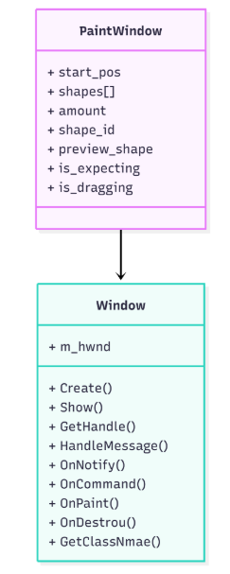
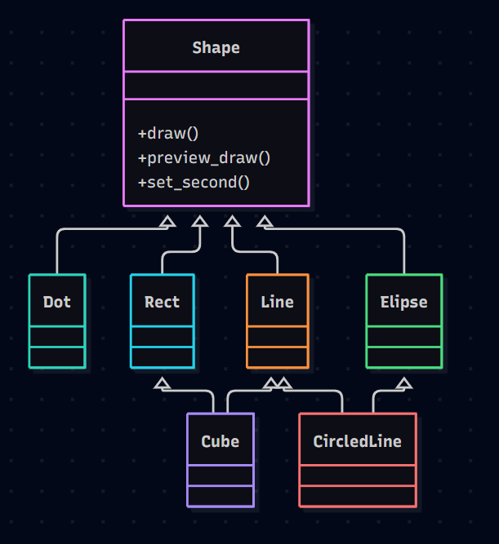
Скріншоти
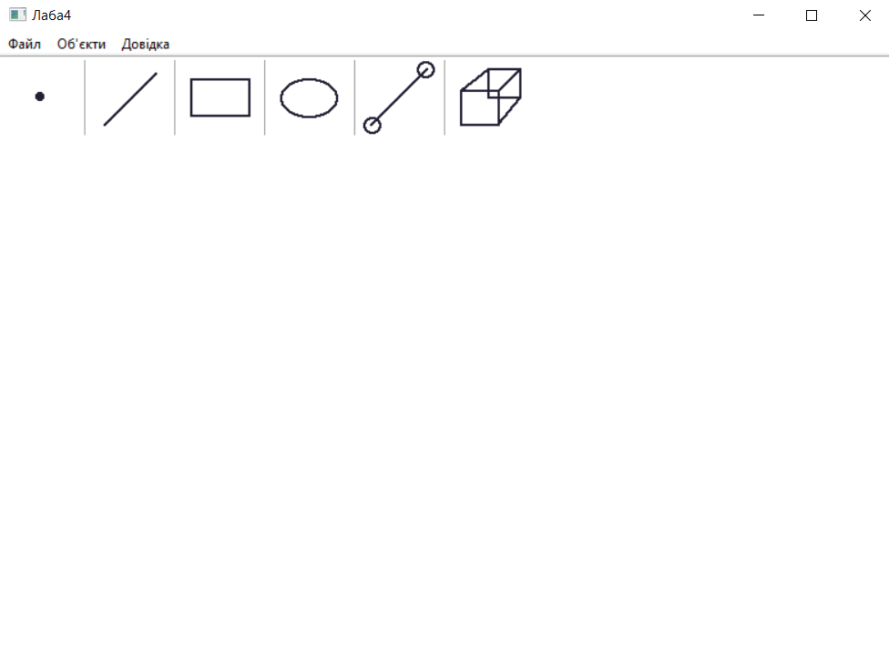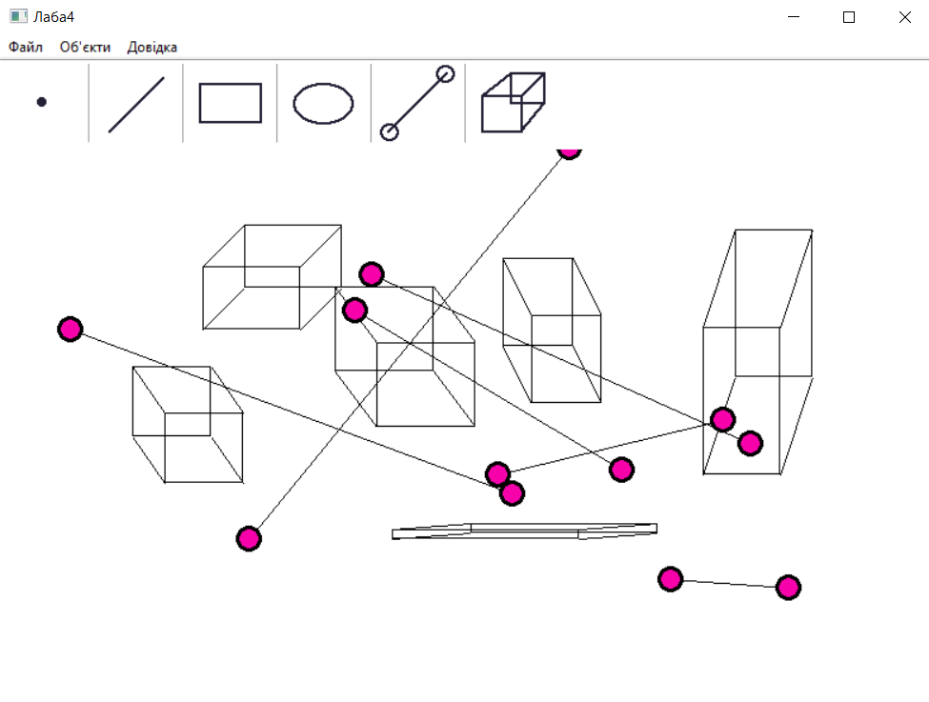
Висновок
В результаті лабораторної роботи я розширив функціонал графічного редактора новими фігурами, використовуючи принципи множинного наслідування. Я дізнався і практично використав принципи множинного наслідування.

