Міністерство освіти і науки України
Національний технічний університет України
«Київський політехнічний інститут імені Ігоря Сікорського»
Факультет інформатики та обчислювальної техніки
Кафедра обчислювальної техніки

Лабораторна робота №5
з дисципліни
«Об’єктно-орієнтоване програмування»
на тему
«Розробка багатовіконного інтерфейсу користувача для графічного редактора об’єктів»

Виконав: Перевірив:
студент групи ІМ-53 Рекечинський Дмитро Олександрович
Бунтовський Денис Сергійович
Номер в списку - 3

Київ 2026
Завдання
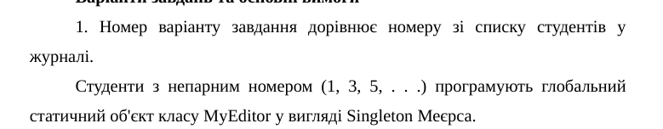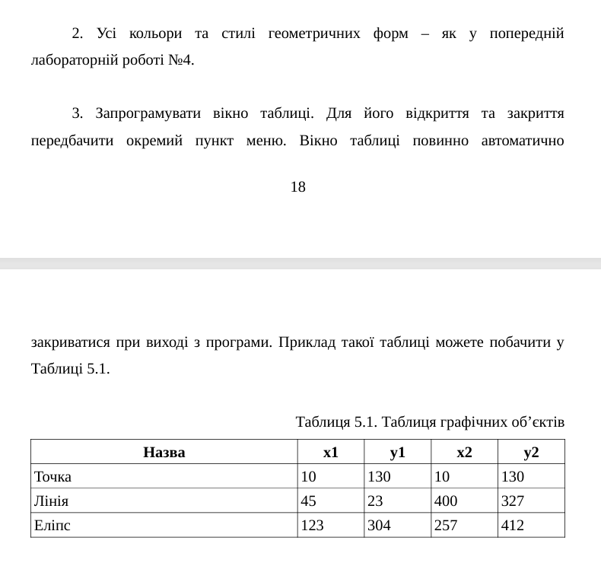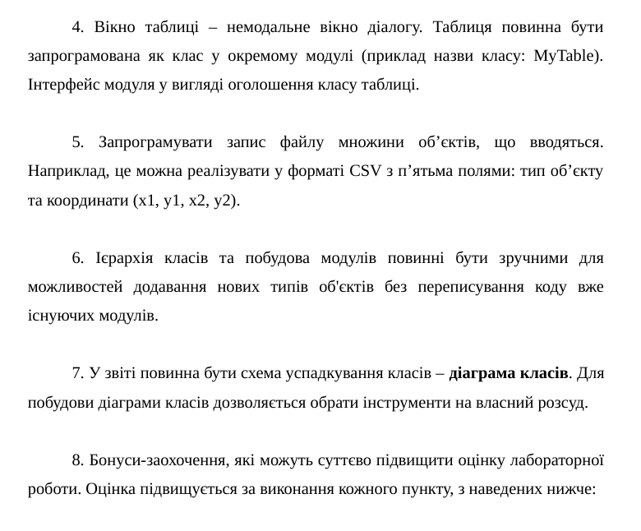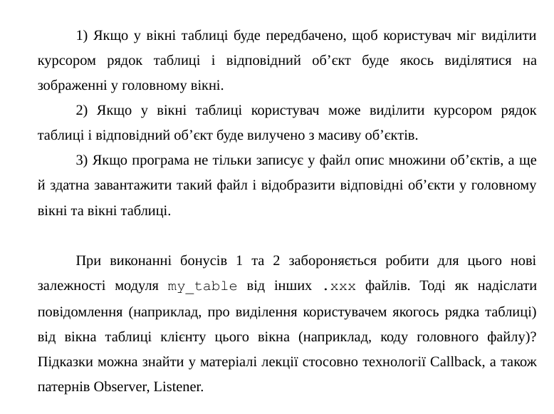
Лістинг коду

main.cpp
#ifndef UNICODE
#define UNICODE
#endif

#include <windows.h>
#include <windowsx.h> // Required for GET_X_LPARAM and GET_Y_LPARAM
#include <commctrl.h>

// Link Common Controls library
#pragma comment(lib, "comctl32.lib")
#define WIN32_LEAN_AND_MEAN
#include "shapes/shape.h"
#include "shapes/elipse.h"
#include "shapes/vec2.h"
#include "create.h"
#include "windows/paint_window.h"
#include "windows/table.h"

PaintWindow& myWindow = PaintWindow::getInstance();

int WINAPI WinMain(HINSTANCE hInstance, HINSTANCE hPrevInstance, LPSTR pCmdLine, int nCmdShow) {

if (!myWindow.Create(L"Лаба4", WS_OVERLAPPEDWINDOW, 0, 100, 100, 800, 600)) {
return 0;
}

myWindow.Show(nCmdShow);

// Цикл обробки повідомлень
MSG msg = {};
while (GetMessage(&msg, nullptr, 0, 0)) {

TranslateMessage(&msg);
DispatchMessage(&msg);
}

return 0;
}
create.h
#include "shapes/shape.h"
#ifndef _CREATE_H_
#define _CREATE_H_
Shape* CreateShapeObject(Vector2 vec1, Vector2 vec2, int shape_id);
HICON CreateIconFromBitmap(HBITMAP hBitmap, COLORREF transparentColor);
HICON LoadIconFromFile(const wchar_t* filePath, int width, int height);

#endif
create.cpp
#include "create.h"
#include "shapes/dot.h"
#include "shapes/line.h"
#include "shapes/rect.h"
#include "shapes/elipse.h"
#include "shapes/circled_line.h"
#include "shapes/cube.h"
#include "shapes/shape.h"
#include "windows.h"
Shape* CreateShapeObject(Vector2 vec1, Vector2 vec2, int shape_id){
Shape* shape;
Vector2 delta = Vector2{vec2.x - vec1.x, vec2.y - vec1.y};
switch (shape_id) {
case 2: shape = new Dot(vec1); break;
case 3: shape = new Line(vec1, vec2); break;
case 4: shape = new Rect(vec1, delta); break;
case 5: shape = new Elipse(vec1, vec2); break;
case 6: shape = new CircledLine(vec1,vec2); break;
case 7: shape = new Cube(vec1,Vector2{0,0}); break;
}
return shape;
}
HICON CreateIconFromBitmap(HBITMAP hBitmap, COLORREF transparentColor) {
BITMAP bm;
GetObject(hBitmap, sizeof(BITMAP), &bm);

// 1. Create a monochrome mask bitmap for transparency
// (If the pixel matches transparentColor, it's transparent; otherwise opaque)
HDC hDC = GetDC(NULL);
HDC hMemDC = CreateCompatibleDC(hDC);
HDC hMaskDC = CreateCompatibleDC(hDC);

// Create the color and mask bitmaps
HBITMAP hOldBmp = (HBITMAP)SelectObject(hMemDC, hBitmap);

// Create monochrome mask (1 bit per pixel)
HBITMAP hMaskBmp = CreateBitmap(bm.bmWidth, bm.bmHeight, 1, 1, NULL);
HBITMAP hOldMaskBmp = (HBITMAP)SelectObject(hMaskDC, hMaskBmp);

// Set background color to the transparent color for mask generation
COLORREF oldBkColor = SetBkColor(hMemDC, transparentColor);

// Copy bits: pixels matching transparentColor become white (transparent), others black (opaque)
BitBlt(hMaskDC, 0, 0, bm.bmWidth, bm.bmHeight, hMemDC, 0, 0, SRCCOPY);

// Clean up DC selections
SetBkColor(hMemDC, oldBkColor);
SelectObject(hMemDC, hOldBmp);
SelectObject(hMaskDC, hOldMaskBmp);
DeleteDC(hMemDC);
DeleteDC(hMaskDC);
ReleaseDC(NULL, hDC);

// 2. Populate the ICONINFO structure
ICONINFO iconInfo = {};
iconInfo.fIcon = TRUE; // TRUE for icon, FALSE for cursor
iconInfo.xHotspot = 0;
iconInfo.yHotspot = 0;
iconInfo.hbmMask = hMaskBmp; // The transparency mask
iconInfo.hbmColor = hBitmap; // The actual color bitmap

// 3. Create the icon
HICON hIcon = CreateIconIndirect(&iconInfo);

// Clean up the mask bitmap (CreateIconIndirect makes a copy of the bitmaps)
DeleteObject(hMaskBmp);

return hIcon;
}
HICON LoadIconFromFile(const wchar_t* filePath, int width, int height) {
// 1. Load the bitmap from an external file
HBITMAP hBmp = (HBITMAP)LoadImageW(
NULL,
filePath,
IMAGE_BITMAP,
width,
height,
LR_LOADFROMFILE | LR_CREATEDIBSECTION
);

if (!hBmp) return NULL;

// 2. Convert to icon (using Magenta RGB(255, 0, 255) as the transparent color, for example)
HICON hIcon = CreateIconFromBitmap(hBmp, RGB(255, 0, 255));

// You can delete the source HBITMAP now if you no longer need it independently
DeleteObject(hBmp);

return hIcon;
}
window.h
#ifndef _WINDOW_H_
#define _WINDOW_H_

#include <windows.h>
#include <commctrl.h>

class Window {
public:
Window();
virtual ~Window();

// Метод створення вікна
virtual bool Create(PCWSTR title, DWORD style, DWORD exStyle = 0,
int x = CW_USEDEFAULT, int y = CW_USEDEFAULT,
int width = CW_USEDEFAULT, int height = CW_USEDEFAULT,
HWND parent = nullptr, HMENU menu = nullptr);

void Show(int cmdShow = SW_SHOW);

HWND GetHandle() const { return m_hwnd; }

protected:
// Головний диспетчер повідомлень класу
virtual LRESULT HandleMessage(UINT msg, WPARAM wParam, LPARAM lParam);

// Обробник повідомлення WM_NOTIFY (Метод-член класу)
virtual LRESULT OnNotify(int controlId, NMHDR* pNotificationHeader);

// Обробник команд (кнопки, меню тощо)
virtual LRESULT OnCommand(int id, int eventCode, HWND controlHandle);

// Обробник малювання
virtual void OnPaint();

// Обробник закриття/знищення вікна
virtual void OnDestroy();

virtual PCWSTR GetClassName() const;

HWND m_hwnd;

private:
// Внутрішній статичний метод-місток для зв'язку WinAPI та C++ об'єкта
static LRESULT CALLBACK StaticWndProc(HWND hwnd, UINT msg, WPARAM wParam, LPARAM lParam);
};

#endif // _WINDOW_H_
window.cpp
#include "window.h"

Window::Window() : m_hwnd(nullptr) {}

Window::~Window() {
if (m_hwnd && IsWindow(m_hwnd)) {
DestroyWindow(m_hwnd);
}
}

bool Window::Create(PCWSTR title, DWORD style, DWORD exStyle,
int x, int y, int width, int height,
HWND parent, HMENU menu)
{
WNDCLASS wc = {};
wc.lpfnWndProc = Window::StaticWndProc; // Використовуємо внутрішній приватний місток
wc.hInstance = GetModuleHandle(nullptr);
wc.lpszClassName = GetClassName();
wc.hbrBackground = (HBRUSH)(COLOR_WINDOW + 1);
wc.hCursor = LoadCursor(nullptr, IDC_ARROW);

RegisterClass(&wc);

m_hwnd = CreateWindowEx(
exStyle, GetClassName(), title, style,
x, y, width, height,
parent, menu, GetModuleHandle(nullptr),
this // Передаємо 'this' як параметр створення (lpParam)
);

return m_hwnd != nullptr;
}

void Window::Show(int cmdShow) {
ShowWindow(m_hwnd, cmdShow);
UpdateWindow(m_hwnd);
}

LRESULT Window::HandleMessage(UINT msg, WPARAM wParam, LPARAM lParam) {
switch (msg) {
case WM_NOTIFY:
// Виклик обробника OnNotify як функції-члена
return OnNotify((int)wParam, reinterpret_cast<NMHDR*>(lParam));

case WM_COMMAND:
return OnCommand(LOWORD(wParam), HIWORD(wParam), (HWND)lParam);

case WM_PAINT:
OnPaint();
return 0;

case WM_DESTROY:
OnDestroy();
return 0;
}
return DefWindowProc(m_hwnd, msg, wParam, lParam);
}

LRESULT Window::OnNotify(int controlId, NMHDR* pNotificationHeader) {
// Базова реалізація (можна перевизначити у похідних класах)
return 0;
}

LRESULT Window::OnCommand(int id, int eventCode, HWND controlHandle) {
return 0;
}

void Window::OnPaint() {
PAINTSTRUCT ps;
HDC hdc = BeginPaint(m_hwnd, &ps);
EndPaint(m_hwnd, &ps);
}

void Window::OnDestroy() {
PostQuitMessage(0);
}

PCWSTR Window::GetClassName() const {
return L"BaseWindowClass";
}

LRESULT CALLBACK Window::StaticWndProc(HWND hwnd, UINT msg, WPARAM wParam, LPARAM lParam) {
Window* pThis = nullptr;

if (msg == WM_NCCREATE) {
// Отримуємо вказівник на екземпляр класу 'this', який ми передали в CreateWindowEx
CREATESTRUCT* pCreate = reinterpret_cast<CREATESTRUCT*>(lParam);
pThis = reinterpret_cast<Window*>(pCreate->lpCreateParams);

// Зберігаємо вказівник у внутрішній пам'яті самого вікна WinAPI
SetWindowLongPtr(hwnd, GWLP_USERDATA, reinterpret_cast<LONG_PTR>(pThis));
pThis->m_hwnd = hwnd;
} else {
// Отримуємо збережений вказівник 'this' для всіх наступних повідомлень
pThis = reinterpret_cast<Window*>(GetWindowLongPtr(hwnd, GWLP_USERDATA));
}

if (pThis) {
return pThis->HandleMessage(msg, wParam, lParam);
}

return DefWindowProc(hwnd, msg, wParam, lParam);
}
paint_window.h
#ifndef _PAINT_WINDOW_H_
#define _PAINT_WINDOW_H_

#include "window.h"
#include "table.h"
#include "../shapes/shape.h"
#include "../create.h"

#define BUTTON_AMOUNT 6
#define MENU_FILE 1
#define MENU_DOT 2
#define MENU_LINE 3
#define MENU_RECT 4
#define MENU_ELIPSE 5
#define MENU_CIRCLED_LINE 6
#define MENU_CUBE 7
#define MENU_ABOUT 8
#define TOOL_DOT 9
#define TOOL_LINE 10
#define TOOL_RECT 11
#define TOOL_ELIPSE 12
#define TOOL_CIRCLED_LINE 13
#define TOOL_CUBE 14
#define TOOL_BAR 15
#define MENU_TABLE 16
#define MENU_SAVE 17
#define MENU_LOAD 18

class PaintWindow : public Window {
public:
PaintWindow(const PaintWindow&) = delete;
PaintWindow& operator=(const PaintWindow&) = delete;
~PaintWindow() override;

bool Create(PCWSTR title, DWORD style, DWORD exStyle = 0,
int x = CW_USEDEFAULT, int y = CW_USEDEFAULT,
int width = CW_USEDEFAULT, int height = CW_USEDEFAULT,
HWND parent = nullptr, HMENU menu = nullptr) override;

void DeleteShape(int index);
void SelectShape(int index);
void UnselectAll();

static PaintWindow& getInstance();

protected:
PCWSTR GetClassName() const override;

LRESULT OnNotify(int controlId, NMHDR* pNotificationHeader) override;

// Перевизначення обробника команд
LRESULT OnCommand(int id, int eventCode, HWND controlHandle) override;

LRESULT HandleMessage(UINT msg, WPARAM wParam, LPARAM lParam) override;

void OnPaint() override;

private:
PaintWindow() = default;

HICON icons[6] = {};
Vector2 start_pos;
Shape* shapes[104];
int amount = 0;
int shape_id = 0;
Shape* preview_shape = nullptr;
bool is_expecting = false;
bool is_dragging = false;

Table table;
};

#endif // _PAINT_WINDOW_H_

paint_window.cpp
#include "paint_window.h"
#include <windowsx.h> // GET_X_LPARAM / GET_Y_LPARAM
#include <iostream>
#include <commdlg.h>
#include <string>
#include "../shapes/dot.h"
#include "../shapes/line.h"
#include "../shapes/rect.h"
#include "../shapes/elipse.h"
#include "../shapes/cube.h"
#include "../shapes/circled_line.h"

struct FileElement{
std::wstring name;
int x1;
int x2;
int y1;
int y2;
};

bool WriteTextFile(const std::wstring& path, const std::wstring& text) {
// wstring -> UTF-8 bytes
int need = WideCharToMultiByte(CP_UTF8, 0, text.c_str(), (int)text.size(),
nullptr, 0, nullptr, nullptr);
std::string utf8(need, '\0');
if (need > 0) {
WideCharToMultiByte(CP_UTF8, 0, text.c_str(), (int)text.size(),
&utf8[0], need, nullptr, nullptr);
}

HANDLE h = CreateFileW(path.c_str(), GENERIC_WRITE, 0, nullptr,
CREATE_ALWAYS, FILE_ATTRIBUTE_NORMAL, nullptr);
if (h == INVALID_HANDLE_VALUE) return false;

// UTF-8 BOM so Notepad and Excel recognize the encoding (optional, my reader handles both)
const unsigned char bom[] = { 0xEF, 0xBB, 0xBF };
DWORD written = 0;
BOOL ok = WriteFile(h, bom, sizeof(bom), &written, nullptr);

if (ok && !utf8.empty()) {
ok = WriteFile(h, utf8.data(), (DWORD)utf8.size(), &written, nullptr)
&& written == utf8.size();
}
CloseHandle(h);
return ok;
}
bool PickSavePath(HWND owner, std::wstring& outPath) {
wchar_t path[MAX_PATH] = L"";

OPENFILENAMEW ofn = {};
ofn.lStructSize = sizeof(ofn);
ofn.hwndOwner = owner;
ofn.lpstrFilter = L"Text (*.txt)\0*.txt\0All files (*.*)\0*.*\0";
ofn.lpstrFile = path;
ofn.nMaxFile = MAX_PATH;
ofn.lpstrDefExt = L"txt"; // appended if the user types a name without an extension
ofn.Flags = OFN_OVERWRITEPROMPT | OFN_PATHMUSTEXIST | OFN_NOCHANGEDIR;

if (!GetSaveFileNameW(&ofn)) return false;
outPath = path;
return true;
}
bool ReadFileBytes(const std::wstring& path, std::vector<unsigned char>& out) {
HANDLE h = CreateFileW(path.c_str(), GENERIC_READ, FILE_SHARE_READ, nullptr,
OPEN_EXISTING, FILE_ATTRIBUTE_NORMAL, nullptr);
if (h == INVALID_HANDLE_VALUE) return false;

LARGE_INTEGER size;
if (!GetFileSizeEx(h, &size) || size.QuadPart > 0xFFFFFFFFLL) { // keep it simple: < 4 GB
CloseHandle(h);
return false;
}

out.resize((size_t)size.QuadPart);
DWORD bytesRead = 0;
BOOL ok = out.empty() || ReadFile(h, out.data(), (DWORD)out.size(), &bytesRead, nullptr);
CloseHandle(h);
return ok && bytesRead == out.size();
}
bool PickFile(HWND owner, std::wstring& outPath) {
wchar_t path[MAX_PATH] = L"";

OPENFILENAMEW ofn = {};
ofn.lStructSize = sizeof(ofn);
ofn.hwndOwner = owner;
ofn.lpstrFilter = L"Text (*.txt)\0*.txt\0All files (*.*)\0*.*\0"; // pairs of "label\0pattern\0"
ofn.lpstrFile = path;
ofn.nMaxFile = MAX_PATH;
ofn.Flags = OFN_FILEMUSTEXIST | OFN_PATHMUSTEXIST | OFN_NOCHANGEDIR;

if (!GetOpenFileNameW(&ofn)) return false; // user pressed Cancel (or an error occurred)
outPath = path;
return true;
}
static bool Convert(UINT codePage, DWORD flags, const char* s, int len, std::wstring& out) {
int need = MultiByteToWideChar(codePage, flags, s, len, nullptr, 0);
if (need <= 0) return false;
out.resize(need);
MultiByteToWideChar(codePage, flags, s, len, &out[0], need);
return true;
}
std::wstring BytesToWString(const std::vector<unsigned char>& bytes) {
const unsigned char* p = bytes.data();
size_t n = bytes.size();
if (n == 0) return L"";

// UTF-16 LE with BOM (what Windows Notepad calls "Unicode")
if (n >= 2 && p[0] == 0xFF && p[1] == 0xFE) {
return std::wstring((const wchar_t*)(p + 2), (n - 2) / 2);
}

// UTF-8, with or without BOM
size_t skip = (n >= 3 && p[0] == 0xEF && p[1] == 0xBB && p[2] == 0xBF) ? 3 : 0;
std::wstring result;
if (Convert(CP_UTF8, MB_ERR_INVALID_CHARS, (const char*)p + skip, (int)(n - skip), result)) {
return result;
}

// Not valid UTF-8: assume the system ANSI code page (e.g. cp1251 on a Ukrainian system)
Convert(CP_ACP, 0, (const char*)p, (int)n, result);
return result;
}

PaintWindow::~PaintWindow() {
for (int i = 0; i < 6; i++) {
DestroyIcon(icons[i]);
}
}

bool ParseCSV(std::vector<FileElement>& result, std::wstring& text){
std::wstring buffer;
FileElement el;
int filled = 0;

for(auto c : text){
if(c == ','){
switch (filled)
{
case 0:
el.name = buffer;
break;
case 1:
el.x1 = stoi(buffer);
break;
case 2:
el.y1 = stoi(buffer);
break;
case 3:
el.x2 = stoi(buffer);
break;
case 4:
el.y2 = stoi(buffer);
break;
default:
break;
}
filled+=1;
buffer = L"";
}else if(c == '\r'){}
else if(c == '\n'){
result.push_back(el);
filled = 0;
}
else{
buffer += c;
}
}

}

PaintWindow& PaintWindow::getInstance() {
static PaintWindow instance;
return instance;
}

void PaintWindow::DeleteShape(int id){
//drag everything down 1
for(int i = id; i < amount; i++){
if(i+1 < amount){
shapes[i] = shapes[i+1];
}
}
amount-=1;
InvalidateRect(m_hwnd,NULL,TRUE);
}
void PaintWindow::SelectShape(int id){
for (size_t i = 0; i < amount; i++)
{
if(i==id){
shapes[i]->is_selected = true;
}
else{
shapes[i]->is_selected = false;
}
}
InvalidateRect(m_hwnd,NULL,TRUE);

}
void PaintWindow::UnselectAll(){
for(int i = 0; i < amount; i++){
shapes[i]->is_selected = false;
}
InvalidateRect(m_hwnd,NULL,TRUE);
}

void on_table_select(int row){
PaintWindow& win = PaintWindow::getInstance();
win.SelectShape(row);
}

void on_table_delete(int row){
PaintWindow& win = PaintWindow::getInstance();
win.DeleteShape(row);

}
void on_table_close(){
std::cout << "Callback close!" << std::endl;
PaintWindow& win = PaintWindow::getInstance();
win.UnselectAll();
}

bool PaintWindow::Create(PCWSTR title, DWORD style, DWORD exStyle,
int x, int y, int width, int height,
HWND parent, HMENU menu)
{
table.SetupCallbacks(on_table_select,on_table_delete, on_table_close);
//load icons
icons[0] = LoadIconFromFile(L".\\icons\\ellipse.bmp", 64, 64);
icons[1] = LoadIconFromFile(L".\\icons\\ellipse.bmp", 64, 64);
icons[2] = LoadIconFromFile(L".\\icons\\ellipse.bmp", 64, 64);
icons[3] = LoadIconFromFile(L".\\icons\\ellipse.bmp", 64, 64);
icons[4] = LoadIconFromFile(L".\\icons\\ellipse.bmp", 64, 64);
icons[5] = LoadIconFromFile(L".\\icons\\ellipse.bmp", 64, 64);

//building menu
HMENU hMenu = CreateMenu();
//AppendMenuW(hMenu, MF_STRING, MENU_FILE, L"Файл");
HMENU hFileMenu = CreatePopupMenu();
AppendMenuW(hFileMenu, MF_STRING, MENU_SAVE, L"Зберегти");
AppendMenuW(hFileMenu, MF_STRING, MENU_LOAD, L"Відкрити");
AppendMenuW(hMenu, MF_POPUP, (UINT_PTR)hFileMenu, L"Меню");
HMENU hActionMenu = CreatePopupMenu();
AppendMenuW(hActionMenu, MF_STRING, MENU_DOT, L"Крапка");
AppendMenuW(hActionMenu, MF_STRING, MENU_LINE, L"Лінія");
AppendMenuW(hActionMenu, MF_STRING, MENU_RECT, L"Прямокутник");
AppendMenuW(hActionMenu, MF_STRING, MENU_ELIPSE, L"Еліпс");
AppendMenuW(hActionMenu, MF_STRING, MENU_CIRCLED_LINE, L"Круголінія");
AppendMenuW(hActionMenu, MF_STRING, MENU_CUBE, L"Куб");
AppendMenuW(hMenu, MF_POPUP, (UINT_PTR)hActionMenu, L"Об'єкти");
AppendMenuW(hMenu, MF_STRING, MENU_ABOUT, L"Довідка");
AppendMenuW(hMenu, MF_STRING, MENU_TABLE, L"Таблиця");
if (!Window::Create(title, style, exStyle, x, y, width, height, parent, hMenu)) { return false; }

// 1. Initialize Common Controls
INITCOMMONCONTROLSEX icex = { 0 };
icex.dwSize = sizeof(INITCOMMONCONTROLSEX);
icex.dwICC = ICC_BAR_CLASSES;
InitCommonControlsEx(&icex);

// 2. Create Toolbar Window
HWND hToolbar = CreateWindowExW(
0,
TOOLBARCLASSNAMEW,
NULL,
WS_CHILD | WS_VISIBLE | TBSTYLE_FLAT | TBSTYLE_TOOLTIPS,
0, 0, 0, 0,
m_hwnd,
(HMENU)TOOL_BAR,
GetModuleHandle(NULL),
NULL
);

if (!hToolbar) return false;

// Send size structure for compatibility
SendMessageW(hToolbar, TB_BUTTONSTRUCTSIZE, (WPARAM)sizeof(TBBUTTON), 0);

HIMAGELIST hMyImageList = ImageList_Create(64, 64, ILC_COLOR32 | ILC_MASK, 5, 0);

HBITMAP hCustomBmp = (HBITMAP)LoadImageW(
NULL,
L"icons\\icons.bmp", // A strip of images placed side-by-side
IMAGE_BITMAP,
0, 0,
LR_LOADFROMFILE | LR_CREATEDIBSECTION
);

if (hCustomBmp) {
// Add the bitmap to the image list.
// RGB(255, 0, 255) is Magenta, which acts as the transparent color mask.
ImageList_AddMasked(hMyImageList, hCustomBmp, RGB(255, 0, 255));

// Clean up the raw bitmap handle (ImageList makes its own copy)
DeleteObject(hCustomBmp);
}
SendMessageW(hToolbar, TB_SETIMAGELIST, 0, (LPARAM)hMyImageList);

// 4. Define Toolbar Buttons
TBBUTTON tbb[11] = { 0 };

// Button 1: Dot
tbb[0].iBitmap = 2;
tbb[0].idCommand = TOOL_DOT;
tbb[0].fsState = TBSTATE_ENABLED;
tbb[0].fsStyle = BTNS_BUTTON;

// Separator
tbb[1].fsStyle = BTNS_SEP;

// Button 2: Line
tbb[2].iBitmap = 3;
tbb[2].idCommand = TOOL_LINE;
tbb[2].fsState = TBSTATE_ENABLED;
tbb[2].fsStyle = BTNS_BUTTON;

// Separator
tbb[3].fsStyle = BTNS_SEP;

// Button 3: Rect
tbb[4].iBitmap = 1;
tbb[4].idCommand = TOOL_RECT;
tbb[4].fsState = TBSTATE_ENABLED;
tbb[4].fsStyle = BTNS_BUTTON;

// Separator
tbb[5].fsStyle = BTNS_SEP;

// Button 3: Elipse
tbb[6].iBitmap = 0;
tbb[6].idCommand = TOOL_ELIPSE;
tbb[6].fsState = TBSTATE_ENABLED;
tbb[6].fsStyle = BTNS_BUTTON;

// Separator
tbb[7].fsStyle = BTNS_SEP;

// Button 3: CircledLine
tbb[8].iBitmap = 5;
tbb[8].idCommand = TOOL_CIRCLED_LINE;
tbb[8].fsState = TBSTATE_ENABLED;
tbb[8].fsStyle = BTNS_BUTTON;

// Separator
tbb[9].fsStyle = BTNS_SEP;

// Button 3: CircledLine
tbb[10].iBitmap = 4;
tbb[10].idCommand = TOOL_CUBE;
tbb[10].fsState = TBSTATE_ENABLED;
tbb[10].fsStyle = BTNS_BUTTON;

// 5. Add Buttons to Toolbar & Auto-size
SendMessageW(hToolbar, TB_ADDBUTTONS, sizeof(tbb) / sizeof(TBBUTTON), (LPARAM)&tbb);
SendMessageW(hToolbar, TB_AUTOSIZE, 0, 0);

return true;
}

PCWSTR PaintWindow::GetClassName() const {
return L"PaintWindowClass";
}

LRESULT PaintWindow::OnNotify(int controlId, NMHDR* pNotificationHeader) {
// Check for Tooltip Request
if (pNotificationHeader->code == TTN_GETDISPINFOW) {
LPNMTTDISPINFOW pTTDI = (LPNMTTDISPINFOW)pNotificationHeader;

// pTTDI->hdr.idFrom contains the ID of the toolbar button (e.g. TOOL_DOT)
switch (pTTDI->hdr.idFrom) {
case TOOL_DOT:
pTTDI->lpszText = (LPWSTR)L"Намалювати крапку";
break;
case TOOL_LINE:
pTTDI->lpszText = (LPWSTR)L"Намалювати лінію";
break;
case TOOL_RECT:
pTTDI->lpszText = (LPWSTR)L"Намалювати прямокутник";
break;
case TOOL_ELIPSE:
pTTDI->lpszText = (LPWSTR)L"Намалювати еліпс";
break;
case TOOL_CUBE:
pTTDI->lpszText = (LPWSTR)L"Намалювати куб";
break;
case TOOL_CIRCLED_LINE:
pTTDI->lpszText = (LPWSTR)L"Намалювати круголінію";
break;
default:
pTTDI->lpszText = (LPWSTR)L"";
break;
}
return 0;
}

return Window::OnNotify(controlId, pNotificationHeader);
}

LRESULT PaintWindow::OnCommand(int id, int eventCode, HWND controlHandle) {
if (eventCode == BN_CLICKED) {
switch (id) {
case MENU_SAVE:{
std::wstring save_path;
bool result = PickSavePath(m_hwnd,save_path);
if(result){
std::wstring text_to_write;
for(int i = 0; i< amount; i++){
text_to_write += shapes[i]->name();
text_to_write += L",";
auto data = shapes[i]->get_data();
text_to_write += std::to_wstring(data.first.x) + L"," +std::to_wstring(data.first.y) + L"," + std::to_wstring(data.second.x) + L","+std::to_wstring(data.second.y) + L",\r\n";
}
bool result = WriteTextFile(save_path, text_to_write);

}
break;
}
case MENU_LOAD:{
std::wstring load_path;
bool result = PickFile(m_hwnd, load_path);
if(result){
std::vector<unsigned char> bytes;
bool result = ReadFileBytes(load_path, bytes);
if(result){
std::wstring file_contents = BytesToWString(bytes);
std::vector<FileElement> data_rows;
ParseCSV(data_rows, file_contents);
amount = 0;
for(auto el : data_rows){
if(el.name == L"Прямокутник"){
shapes[amount] = new Rect(Vector2{el.x1, el.y1}, Vector2{el.x2, el.y2});
}else if(el.name == L"Лінія"){
shapes[amount] = new Line(Vector2{el.x1, el.y1}, Vector2{el.x2, el.y2});
}else if(el.name == L"Еліпс"){
shapes[amount] = new Elipse(Vector2{el.x1, el.y1}, Vector2{el.x2, el.y2});
}else if(el.name == L"Точка"){
shapes[amount] = new Dot(Vector2{el.x1, el.y1});
}else if(el.name == L"Куб"){
shapes[amount] = new Cube(Vector2{el.x1, el.y1}, Vector2{el.x2, el.y2});
}else{
shapes[amount] = new CircledLine(Vector2{el.x1, el.y1}, Vector2{el.x2, el.y2});
}
amount+=1;
}
}
}
InvalidateRect(m_hwnd,NULL,TRUE);
break;
}
case MENU_TABLE:
table.SetData(shapes, amount);
table.Open(L"Таблиця", 600, 300, m_hwnd);
break;
case MENU_DOT:
case MENU_ELIPSE:
case MENU_LINE:
case MENU_RECT:
case MENU_CIRCLED_LINE:
case MENU_CUBE:
is_expecting = true;
shape_id = id;
InvalidateRect(m_hwnd, NULL, TRUE);
break;
case TOOL_DOT:
case TOOL_ELIPSE:
case TOOL_LINE:
case TOOL_RECT:
case TOOL_CIRCLED_LINE:
case TOOL_CUBE:
is_expecting = true;
shape_id = id - BUTTON_AMOUNT - 1;
InvalidateRect(m_hwnd, NULL, TRUE);
break;
}
}

return Window::OnCommand(id, eventCode, controlHandle);
}

LRESULT PaintWindow::HandleMessage(UINT msg, WPARAM wParam, LPARAM lParam) {
switch (msg) {
case WM_LBUTTONDOWN: {
if (shape_id == 0) return 0;
int xPos = GET_X_LPARAM(lParam);
int yPos = GET_Y_LPARAM(lParam);
start_pos = Vector2{xPos, yPos};
preview_shape = CreateShapeObject(Vector2{xPos, yPos}, Vector2{xPos, yPos}, shape_id);
is_dragging = true;
SetCapture(m_hwnd);
InvalidateRect(m_hwnd, NULL, TRUE);
return 0;
}
case WM_MOUSEMOVE: {
// 2. TRACK: Only record movement if currently in a drag state
if (is_dragging) {
Vector2 pos;
pos.x = GET_X_LPARAM(lParam);
pos.y = GET_Y_LPARAM(lParam);

preview_shape->set_second(pos);

// Example: Trigger a window repaint to show a selection box or line
InvalidateRect(m_hwnd, NULL, TRUE);
}
return 0;
}
case WM_LBUTTONUP: {
// 3. FINISH: End tracking when button is released
if (is_dragging) {
is_dragging = false;
is_expecting = false;

// Always release capture when finished
ReleaseCapture();

// Final position when released
int endX = GET_X_LPARAM(lParam);
int endY = GET_Y_LPARAM(lParam);

//delete preview_shape;
//preview_shape = nullptr;

//shapes[amount] = CreateShapeObject(start_pos,Vector2{endX,endY},shape_id);
shapes[amount] = preview_shape;
preview_shape = nullptr;
amount += 1;
// Perform final action (e.g., commit selection, drop object)

InvalidateRect(m_hwnd, NULL, TRUE);

table.SetData(shapes, amount);
if(table.IsOpen()){
table.RebuildControls();
} }
return 0;
}
}
return Window::HandleMessage(msg, wParam, lParam);
}

void PaintWindow::OnPaint() {
PAINTSTRUCT ps;
HDC hdc = BeginPaint(m_hwnd, &ps);
for (int i = 0; i < amount; i++) {
shapes[i]->draw(hdc);
}
if (preview_shape != nullptr) {
preview_shape->preview_draw(hdc);
}
EndPaint(m_hwnd, &ps);
}

dialogue_window.h
#ifndef _DIALOGUE_WINDOW_H_
#define _DIALOGUE_WINDOW_H_

#include "window.h"
#include <vector>

class DialogueWindow : public Window {
public:
void RebuildControls();
DialogueWindow();
~DialogueWindow() override;

// Створює вікно. Стилі WS_POPUP | WS_CAPTION | WS_SYSMENU додаються автоматично,
// 'parent' використовується як власник (owner).
bool Create(PCWSTR title, DWORD style, DWORD exStyle = 0,
int x = CW_USEDEFAULT, int y = CW_USEDEFAULT,
int width = CW_USEDEFAULT, int height = CW_USEDEFAULT,
HWND parent = nullptr, HMENU menu = nullptr) override;

// розмір задається для клієнтської області,
// вікно центрується відносно власника і одразу показується.
bool Open(PCWSTR title, int clientWidth, int clientHeight, HWND owner = nullptr);

void Close();
bool IsOpen() const;
HWND GetOwner() const { return m_owner; }

// Передає повідомлення всім відкритим діалогам (Tab, Enter, Esc...).
// Повертає true, якщо повідомлення оброблено і його не треба диспетчеризувати далі.
static bool IsDialogueMessage(MSG* msg);

protected:
// Викликається з WM_CREATE: тут похідні класи створюють свої елементи керування.
virtual void OnCreateControls();

// Викликається після знищення вікна (WM_DESTROY).
virtual void OnClosed();

// Створює дочірній елемент керування зі стандартним шрифтом.
HWND AddControl(PCWSTR className, PCWSTR text, DWORD style,
int x, int y, int width, int height, int id);

PCWSTR GetClassName() const override;
LRESULT HandleMessage(UINT msg, WPARAM wParam, LPARAM lParam) override;
LRESULT OnCommand(int id, int eventCode, HWND controlHandle) override;
void OnDestroy() override;

private:
HWND m_owner;
static std::vector<DialogueWindow*> s_dialogues;
};

#endif // _DIALOGUE_WINDOW_H_

dialogue_window.cpp
#include "dialogue_window.h"
#include <algorithm>

std::vector<DialogueWindow*> DialogueWindow::s_dialogues;

DialogueWindow::DialogueWindow() : m_owner(nullptr) {}

DialogueWindow::~DialogueWindow() {
// Знищуємо вікно поки об'єкт ще є DialogueWindow, щоб WM_DESTROY
// потрапив у наш OnDestroy (а не в базовий, який викликає PostQuitMessage).
if (m_hwnd && IsWindow(m_hwnd)) {
DestroyWindow(m_hwnd);
}
s_dialogues.erase(std::remove(s_dialogues.begin(), s_dialogues.end(), this),
s_dialogues.end());
}

bool DialogueWindow::Create(PCWSTR title, DWORD style, DWORD exStyle,
int x, int y, int width, int height,
HWND parent, HMENU menu)
{
m_owner = parent;
style |= WS_POPUP | WS_CAPTION | WS_SYSMENU;
exStyle |= WS_EX_CONTROLPARENT;

if (!Window::Create(title, style, exStyle, x, y, width, height, parent, menu)) {
return false;
}

if (std::find(s_dialogues.begin(), s_dialogues.end(), this) == s_dialogues.end()) {
s_dialogues.push_back(this);
}
return true;
}

bool DialogueWindow::Open(PCWSTR title, int clientWidth, int clientHeight, HWND owner) {
const DWORD style = WS_POPUP | WS_CAPTION | WS_SYSMENU;
const DWORD exStyle = WS_EX_DLGMODALFRAME;

// Перераховуємо розмір клієнтської області у розмір усього вікна
RECT rc = { 0, 0, clientWidth, clientHeight };
AdjustWindowRectEx(&rc, style, FALSE, exStyle);
int w = rc.right - rc.left;
int h = rc.bottom - rc.top;

int x = CW_USEDEFAULT;
int y = CW_USEDEFAULT;
if (owner) {
RECT o;
GetWindowRect(owner, &o);
x = o.left + ((o.right - o.left) - w) / 2;
y = o.top + ((o.bottom - o.top) - h) / 2;
}

if (!Create(title, style, exStyle, x, y, w, h, owner, nullptr)) {
return false;
}
Show();
return true;
}

void DialogueWindow::Close() {
if (m_hwnd && IsWindow(m_hwnd)) {
DestroyWindow(m_hwnd);
}
}

bool DialogueWindow::IsOpen() const {
return m_hwnd && IsWindow(m_hwnd);
}

bool DialogueWindow::IsDialogueMessage(MSG* msg) {
// Копія списку: діалог може закритись (і видалити себе зі списку) під час обробки
std::vector<DialogueWindow*> copy = s_dialogues;
for (DialogueWindow* d : copy) {
if (d->IsOpen() && IsDialogMessageW(d->m_hwnd, msg)) {
return true;
}
}
return false;
}

void DialogueWindow::OnCreateControls() {
// За замовчуванням порожньо — перевизначається у похідних класах
}

void DialogueWindow::OnClosed() {
// За замовчуванням порожньо
}

void DialogueWindow::RebuildControls() {
if (!IsOpen()) return;

SendMessageW(m_hwnd, WM_SETREDRAW, FALSE, 0); // no flicker while rebuilding

// Destroy every direct child; their own children go with them
while (HWND child = GetWindow(m_hwnd, GW_CHILD)) {
DestroyWindow(child);
}

OnCreateControls();

SendMessageW(m_hwnd, WM_SETREDRAW, TRUE, 0);
RedrawWindow(m_hwnd, nullptr, nullptr,
RDW_ERASE | RDW_INVALIDATE | RDW_ALLCHILDREN | RDW_UPDATENOW);
}

HWND DialogueWindow::AddControl(PCWSTR className, PCWSTR text, DWORD style,
int x, int y, int width, int height, int id)
{
HWND h = CreateWindowExW(
0, className, text, WS_CHILD | WS_VISIBLE | style,
x, y, width, height,
m_hwnd, (HMENU)(INT_PTR)id, GetModuleHandle(nullptr), nullptr
);
if (h) {
SendMessageW(h, WM_SETFONT, (WPARAM)GetStockObject(DEFAULT_GUI_FONT), TRUE);
}
return h;
}

PCWSTR DialogueWindow::GetClassName() const {
return L"DialogueWindowClass";
}

LRESULT DialogueWindow::HandleMessage(UINT msg, WPARAM wParam, LPARAM lParam) {
switch (msg) {
case WM_CREATE:
OnCreateControls();
return 0;

case WM_NCDESTROY: {
// Останнє повідомлення вікна: після нього дескриптор недійсний
LRESULT result = DefWindowProcW(m_hwnd, msg, wParam, lParam);
m_hwnd = nullptr;
return result;
}
}
return Window::HandleMessage(msg, wParam, lParam);
}

LRESULT DialogueWindow::OnCommand(int id, int eventCode, HWND controlHandle) {
// Esc у IsDialogMessage надсилає WM_COMMAND з IDCANCEL
if (id == IDCANCEL) {
Close();
return 0;
}
return Window::OnCommand(id, eventCode, controlHandle);
}

void DialogueWindow::OnDestroy() {
// Без PostQuitMessage — закриття діалогу не має завершувати програму
s_dialogues.erase(std::remove(s_dialogues.begin(), s_dialogues.end(), this),
s_dialogues.end());
OnClosed();
}
table.h
#pragma once

#include "dialogue_window.h"
#include "../shapes/shape.h"

class Table : public DialogueWindow{
protected:

void OnCreateControls() override;
LRESULT OnCommand(int id, int code, HWND h) override;
LRESULT HandleMessage(UINT msg, WPARAM wParam, LPARAM lParam) override;

public:

void SetData(Shape** arr, int size);

void SetupCallbacks(void (*on_select)(int row), void (*on_delete)(int row), void (*on_close)()){
m_on_select = on_select;
m_on_delete = on_delete;
m_on_close = on_close;
}

private:
Shape** m_arr;
int m_size;
void (*m_on_select)(int row);
void (*m_on_delete)(int row);
void (*m_on_close)();
};

table.cpp
#include "table.h"
#include <string>

#define IDC_TABLE 200

void Table::OnCreateControls() {
INITCOMMONCONTROLSEX icex = { sizeof(icex), ICC_LISTVIEW_CLASSES };
InitCommonControlsEx(&icex);

HWND lv = AddControl(WC_LISTVIEWW, L"", LVS_REPORT | LVS_SINGLESEL | WS_BORDER | WS_TABSTOP,
10, 10, 500, 200, IDC_TABLE);
ListView_SetExtendedListViewStyle(lv, LVS_EX_FULLROWSELECT | LVS_EX_GRIDLINES);

// Columns
LVCOLUMNW col = {};
col.mask = LVCF_TEXT | LVCF_WIDTH;
col.cx = 120; col.pszText = (LPWSTR)L"Фігура"; ListView_InsertColumn(lv, 0, &col);
col.cx = 80; col.pszText = (LPWSTR)L"X1"; ListView_InsertColumn(lv, 1, &col);
col.cx = 80; col.pszText = (LPWSTR)L"Y1"; ListView_InsertColumn(lv, 2, &col);
col.cx = 80; col.pszText = (LPWSTR)L"X2"; ListView_InsertColumn(lv, 3, &col);
col.cx = 80; col.pszText = (LPWSTR)L"Y2"; ListView_InsertColumn(lv, 4, &col);

for(int i = m_size-1; i >= 0; i--){
// A row
LVITEMW item = {};
item.mask = LVIF_TEXT;
item.iItem = 0;
item.pszText = (LPWSTR)m_arr[i]->name();
ListView_InsertItem(lv, &item);
// sets column 0

ListView_SetItemText(lv, 0, 1, (LPWSTR)std::to_wstring(m_arr[i]->get_data().first.x).c_str()); // column 1
ListView_SetItemText(lv, 0, 2, (LPWSTR)std::to_wstring(m_arr[i]->get_data().first.y).c_str()); // column 2
ListView_SetItemText(lv, 0, 3, (LPWSTR)std::to_wstring(m_arr[i]->get_data().second.x).c_str()); // column 3
ListView_SetItemText(lv, 0, 4, (LPWSTR)std::to_wstring(m_arr[i]->get_data().second.y).c_str()); //4
}

AddControl(L"BUTTON", L"OK", BS_DEFPUSHBUTTON | WS_TABSTOP, 50, 250, 70, 26, IDOK);
AddControl(L"BUTTON", L"Скасувати", BS_PUSHBUTTON | WS_TABSTOP, 130, 250, 80, 26, IDCANCEL);
}

LRESULT Table::OnCommand(int id, int code, HWND h){
if (id == IDOK) {
if(m_on_close){
m_on_close();
}
Close();
return 0;
}
return DialogueWindow::OnCommand(id, code, h);
}

void Table::SetData(Shape** arr, int size){
m_arr = arr;
m_size = size;
}

LRESULT Table::HandleMessage(UINT msg, WPARAM wParam, LPARAM lParam) {
switch(msg){
case WM_NOTIFY:{
LPNMHDR pnmh = (LPNMHDR)lParam;
if (pnmh->idFrom == IDC_TABLE){
if (pnmh->code == NM_CLICK){
LPNMITEMACTIVATE pnmItem = (LPNMITEMACTIVATE)lParam;
int rowIndex = pnmItem->iItem; // Row index (-1 if clicked on empty space)

if (rowIndex != -1){
m_on_select(rowIndex);
}
}
else if (pnmh->code == NM_RCLICK){
LPNMITEMACTIVATE pnmItem = (LPNMITEMACTIVATE)lParam;
int rowIndex = pnmItem->iItem;

if (rowIndex != -1)
{
m_size-=1;
m_on_delete(rowIndex);
RebuildControls();
}
}
}

}
}
return DialogueWindow::HandleMessage(msg, wParam, lParam);
}
shape.h
#ifndef _SHAPE_H_
#define _SHAPE_H_

#include <windows.h>
#include "vec2.h"
#include <utility>

class Shape{
public:
Shape() = default;
virtual ~Shape() = default;
virtual void draw(HDC hdc) = 0;
virtual void preview_draw(HDC hdc) = 0;
virtual void set_second(Vector2 value) = 0;
virtual std::pair<Vector2, Vector2> get_data() = 0;
virtual PCWSTR name() const = 0;
bool is_selected = false;

};

#endif

rect.h
#ifndef _RECT_H_
#define _RECT_H_

#include "shape.h"
#include "vec2.h"

#include <windows.h>

//black contour no fill

class Rect : public virtual Shape{
public:
Rect(Vector2 center, Vector2 delta) : center(center), delta(delta){};
~Rect() = default;
void draw(HDC hdc) override;
void preview_draw(HDC hdc) override;
void set_second(Vector2 value) override;
std::pair<Vector2, Vector2> get_data() override;
PCWSTR name() const override { return L"Прямокутник"; }
protected:
Vector2 center;
Vector2 delta;
private:

};
rect.cpp
#include <windows.h>
#include "rect.h"

void Rect::draw(HDC hdc){
if(is_selected){
HBRUSH hNullBrush = (HBRUSH)GetStockObject(NULL_BRUSH);
HBRUSH hOldBrush = (HBRUSH)SelectObject(hdc, hNullBrush);
HPEN hBluePen = CreatePen(PS_SOLID, 1, RGB(0, 20, 255));
HPEN hOldPen = (HPEN)SelectObject(hdc, hBluePen);
Rectangle(hdc, center.x,center.y,center.x+delta.x,center.y+delta.y);
SelectObject(hdc, hOldBrush);
SelectObject(hdc, hOldPen);
DeleteObject(hNullBrush);
DeleteObject(hBluePen);
return;
}
HBRUSH hNullBrush = (HBRUSH)GetStockObject(NULL_BRUSH);
HBRUSH hOldBrush = (HBRUSH)SelectObject(hdc, hNullBrush);
Rectangle(hdc, center.x,center.y,center.x+delta.x,center.y+delta.y);
SelectObject(hdc, hOldBrush);
DeleteObject(hNullBrush);

}

void Rect::preview_draw(HDC hdc){
HBRUSH hNullBrush = (HBRUSH)GetStockObject(NULL_BRUSH);
HBRUSH hOldBrush = (HBRUSH)SelectObject(hdc, hNullBrush);
HPEN hBlackPen = CreatePen(PS_DASH, 1, RGB(0, 0, 0));
HPEN hOldPen = (HPEN)SelectObject(hdc, hBlackPen);
Rectangle(hdc, center.x,center.y,center.x+delta.x,center.y+delta.y);
SelectObject(hdc, hOldBrush);
SelectObject(hdc,hOldPen);
DeleteObject(hNullBrush);
DeleteObject(hBlackPen);

}

void Rect::set_second(Vector2 value){
delta=Vector2{value.x-center.x,value.y-center.y};
}

std::pair<Vector2, Vector2> Rect::get_data(){
return std::make_pair(center, delta);
}

line.h
#ifndef _LINE_H_
#define _LINE_H_

#include "shape.h"
#include "vec2.h"
#include <windows.h>

class Line : public virtual Shape{
public:
Line(Vector2 start, Vector2 end) : start(start), end(end){};
~Line() = default;
void draw(HDC hdc) override;
void preview_draw(HDC hdc) override;
void set_second(Vector2 value) override;
std::pair<Vector2, Vector2> get_data() override;
Vector2 start;
Vector2 end;
PCWSTR name() const override { return L"Лінія"; }
private:

};

#endif

line.cpp
#include <windows.h>
#include "line.h"

void Line::draw(HDC hdc){
if(is_selected){
HBRUSH hNullBrush = (HBRUSH)GetStockObject(NULL_BRUSH);
HBRUSH hOldBrush = (HBRUSH)SelectObject(hdc, hNullBrush);
HPEN hBluePen = CreatePen(PS_SOLID, 1, RGB(0, 20, 255));
HPEN hOldPen = (HPEN)SelectObject(hdc, hBluePen);
MoveToEx(hdc, start.x, start.y, NULL); // Set starting point
LineTo(hdc, end.x, end.y);
SelectObject(hdc, hOldBrush);
SelectObject(hdc, hOldPen);
DeleteObject(hNullBrush);
DeleteObject(hBluePen);
return;
}
MoveToEx(hdc, start.x, start.y, NULL); // Set starting point
LineTo(hdc, end.x, end.y); // Draw line to
}

void Line::preview_draw(HDC hdc){
MoveToEx(hdc, start.x, start.y, NULL); // Set starting point

HBRUSH hBlueBrush = (HBRUSH)GetStockObject(NULL_BRUSH);
HBRUSH hOldBrush = (HBRUSH)SelectObject(hdc, hBlueBrush);
HPEN hBlackPen = CreatePen(PS_DASH, 1, RGB(0, 0, 0));
HPEN hOldPen = (HPEN)SelectObject(hdc, hBlackPen);

LineTo(hdc, end.x, end.y);

SelectObject(hdc, hOldBrush);
SelectObject(hdc,hOldPen);
DeleteObject(hBlackPen);
DeleteObject(hBlueBrush);

// Draw line to
}

void Line::set_second(Vector2 value){
end= value;
}

std::pair<Vector2, Vector2> Line::get_data(){
return std::make_pair(start, end);
}

ellipse.h
#ifndef _ELIPSE_H_
#define _ELIPSE_H_

#include "shape.h"
#include "vec2.h"
#include <windows.h>

class Elipse : public virtual Shape{
public:
Elipse(Vector2 corner1, Vector2 corner2) : corner1(corner1), corner2(corner2){};
~Elipse() = default;
void draw(HDC hdc) override;
void preview_draw(HDC hdc) override;
void set_second(Vector2 value) override;
std::pair<Vector2, Vector2> get_data() override;
Vector2 corner1;
Vector2 corner2;
PCWSTR name() const override { return L"Еліпс"; }
private:

};

#endif

elipse.cpp
#include <windows.h>
#include "elipse.h"

void Elipse::draw(HDC hdc){

HBRUSH hBlueBrush;
HPEN hBlackPen;
if(is_selected){
hBlueBrush = (HBRUSH)GetStockObject(NULL_BRUSH);
hBlackPen = CreatePen(PS_SOLID, 1, RGB(0, 20, 255));
}else{
hBlueBrush = CreateSolidBrush(RGB(247, 2, 170));
hBlackPen = CreatePen(PS_SOLID, 3, RGB(0, 0, 0));
}
HBRUSH hOldBrush = (HBRUSH)SelectObject(hdc, hBlueBrush);

HPEN hOldPen = (HPEN)SelectObject(hdc, hBlackPen);
Vector2 delta = Vector2{corner1.x-corner2.x,corner1.y-corner2.y};
Ellipse(hdc,corner1.x-delta.x,corner1.y-delta.y,corner1.x+delta.x,corner1.y+delta.y);

SelectObject(hdc, hOldBrush);
SelectObject(hdc,hOldPen);
DeleteObject(hBlackPen);
DeleteObject(hBlueBrush);
}

void Elipse::preview_draw(HDC hdc){
HBRUSH hBlueBrush = (HBRUSH)GetStockObject(NULL_BRUSH);
HBRUSH hOldBrush = (HBRUSH)SelectObject(hdc, hBlueBrush);
HPEN hBlackPen = CreatePen(PS_DASH, 1, RGB(0, 0, 0));
HPEN hOldPen = (HPEN)SelectObject(hdc, hBlackPen);
Vector2 delta = Vector2{corner1.x-corner2.x,corner1.y-corner2.y};
Ellipse(hdc,corner1.x-delta.x,corner1.y-delta.y,corner1.x+delta.x,corner1.y+delta.y);

SelectObject(hdc, hOldBrush);
SelectObject(hdc,hOldPen);
DeleteObject(hBlackPen);
DeleteObject(hBlueBrush);
}

void Elipse::set_second(Vector2 value){
corner2 = value;
}

std::pair<Vector2, Vector2> Elipse::get_data(){
return std::make_pair(corner1, corner2);
}

dot.h
#ifndef _DOT_H_
#define _DOT_H_

#include "shape.h"
#include "vec2.h"
#include <windows.h>

class Dot : public Shape{
public:
Dot(Vector2 position) : position(position){};
~Dot() override = default;
void draw(HDC hdc) override;
void preview_draw(HDC hdc) override;
void set_second(Vector2 value) override;
std::pair<Vector2, Vector2> get_data() override;
PCWSTR name() const override { return L"Точка"; }
private:
Vector2 position;
};

#endif

dot.cpp
#include <windows.h>
#include "dot.h"

void Dot::draw(HDC hdc){
if(is_selected){
SetPixel(hdc, position.x, position.y, RGB(0, 20, 255));
}
else{
SetPixel(hdc, position.x, position.y, RGB(0, 0, 0));
}

}

void Dot::preview_draw(HDC hdc){
SetPixel(hdc, position.x, position.y, RGB(0, 0, 0));
}
void Dot::set_second(Vector2 value){}

std::pair<Vector2, Vector2> Dot::get_data(){
return std::make_pair(position, position);
}

cube.h
#pragma once

#include "line.h"
#include "rect.h"
#include "vec2.h"
#include <windows.h>

#define BACKPLANE_OFFSET_X 0.3
#define BACKPLANE_OFFSET_Y 0.4

class Cube : public Rect, public Line{
public:
Cube(Vector2 start, Vector2 end): Shape(), Rect(start,end), Line(start,end){}
void draw(HDC hdc);

void preview_draw(HDC hdc);

void set_second(Vector2 value);

std::pair<Vector2, Vector2> get_data() override;
PCWSTR name() const override { return L"Куб"; }
};
cube.cpp
#include <cmath>
#include <algorithm>
#include "cube.h"

void Cube::draw(HDC hdc){
Rect::is_selected = is_selected;
Line::is_selected = is_selected;
// 1. Save original bounding box coordinates (corner and offset)
Vector2 cache_start = Rect::center;
Vector2 cache_end = Rect::delta;

int total_width = cache_end.x;
int total_height = cache_end.y;

// 2. Calculate the backplane offset in pixels
int offset_x = (int)(total_width * BACKPLANE_OFFSET_X);
int offset_y = (int)(total_height * BACKPLANE_OFFSET_Y);

// 3. Correct rectangle sizing: Fit both rects inside the total dragged bounds
int cube_width = total_width - offset_x;
int cube_height = total_height - offset_y;

// 4. Draw Front Rectangle
Rect::center = cache_start;
Rect::delta = Vector2{cube_width, cube_height};
Rect::draw(hdc);

Vector2 cache_cube1_start = Rect::center;
Vector2 cache_cube1_end = Vector2{Rect::center.x + Rect::delta.x, Rect::center.y + Rect::delta.y};

// 5. Draw Back Rectangle (shifted by offset, matching front size)
int back_start_x = cache_start.x + offset_x;
int back_start_y = cache_start.y + offset_y;

Rect::center = Vector2{back_start_x, back_start_y};
Rect::delta = Vector2{cube_width, cube_height};
Rect::draw(hdc);

Vector2 cache_cube2_start = Rect::center;
Vector2 cache_cube2_end = Vector2{Rect::center.x + Rect::delta.x, Rect::center.y + Rect::delta.y};

// 6. Connect corresponding corners with Lines
Line::start = Vector2{cache_cube1_start.x, cache_cube1_end.y};
Line::end = Vector2{cache_cube2_start.x, cache_cube2_end.y};
Line::draw(hdc);

Line::start = cache_cube1_end;
Line::end = cache_cube2_end;
Line::draw(hdc);

Line::start = Vector2{cache_cube1_end.x, cache_cube1_start.y};
Line::end = Vector2{cache_cube2_end.x, cache_cube2_start.y};
Line::draw(hdc);

Line::start = cache_cube1_start;
Line::end = cache_cube2_start;
Line::draw(hdc);

// 7. Restore original Rect state
Rect::center = cache_start;
Rect::delta = cache_end;
}

void Cube::preview_draw(HDC hdc){
draw(hdc);
}

void Cube::set_second(Vector2 value){
Rect::set_second(value);
Line::set_second(value);
}

std::pair<Vector2, Vector2> Cube::get_data(){
return std::make_pair(Rect::center, Rect::delta);
}
circled_line.h
#pragma once

#include "line.h"
#include "elipse.h"
#include "vec2.h"
#include <windows.h>

#define CIRCLE_RADIUS 10

class CircledLine : public Line, public Elipse{
public:
CircledLine(Vector2 start, Vector2 end) : Shape(), Line(start,end), Elipse(start,end){} //doesn't matter as circles need config every time;
void draw(HDC hdc);

void preview_draw(HDC hdc);

void set_second(Vector2 value);

std::pair<Vector2, Vector2> get_data() override;

PCWSTR name() const override { return L"Круголінія"; }
};
circled_line.cpp
#include "circled_line.h"

void CircledLine::draw(HDC hdc){
Line::draw(hdc);
Elipse::corner1 = Vector2{Line::start.x, Line::start.y};
Elipse::corner2 = Vector2{Line::start.x+CIRCLE_RADIUS, Line::start.y+CIRCLE_RADIUS};
Elipse::draw(hdc);
Elipse::corner1 = Vector2{Line::end.x, Line::end.y};
Elipse::corner2 = Vector2{Line::end.x+CIRCLE_RADIUS, Line::end.y+CIRCLE_RADIUS};
Elipse::draw(hdc);

}

void CircledLine::preview_draw(HDC hdc){
Elipse::is_selected = is_selected;
Line::is_selected = is_selected;
HBRUSH hBlueBrush = (HBRUSH)GetStockObject(NULL_BRUSH);
HBRUSH hOldBrush = (HBRUSH)SelectObject(hdc, hBlueBrush);
HPEN hBlackPen = CreatePen(PS_DASH, 1, RGB(0, 0, 0));
HPEN hOldPen = (HPEN)SelectObject(hdc, hBlackPen);

//draw
Line::preview_draw(hdc);
Elipse::corner1 = Vector2{Line::start.x, Line::start.y};
Elipse::corner2 = Vector2{Line::start.x+CIRCLE_RADIUS, Line::start.y+CIRCLE_RADIUS};
Elipse::preview_draw(hdc);
Elipse::corner1 = Vector2{Line::end.x, Line::end.y};
Elipse::corner2 = Vector2{Line::end.x+CIRCLE_RADIUS, Line::end.y + CIRCLE_RADIUS};
Elipse::preview_draw(hdc);

SelectObject(hdc, hOldBrush);
SelectObject(hdc,hOldPen);
DeleteObject(hBlackPen);
DeleteObject(hBlueBrush);
}

void CircledLine::set_second(Vector2 value){
Line::set_second(value);
}

std::pair<Vector2, Vector2> CircledLine::get_data(){
return std::make_pair(Line::start, Line::end);
}

Схема класів

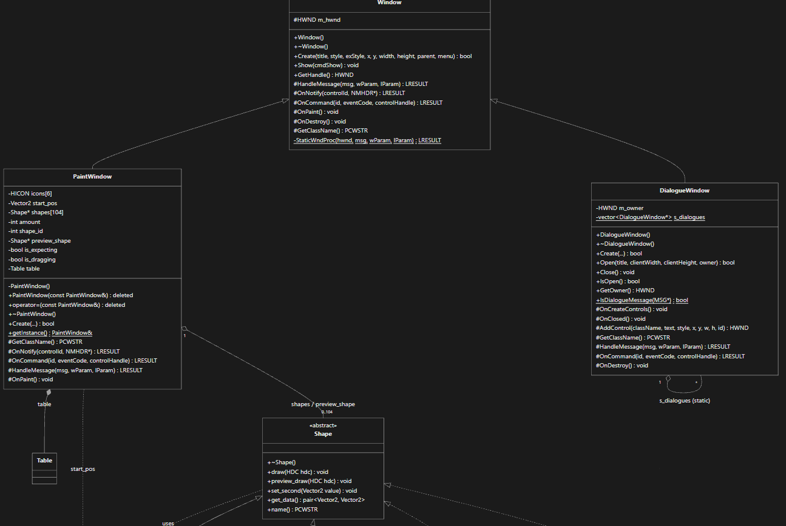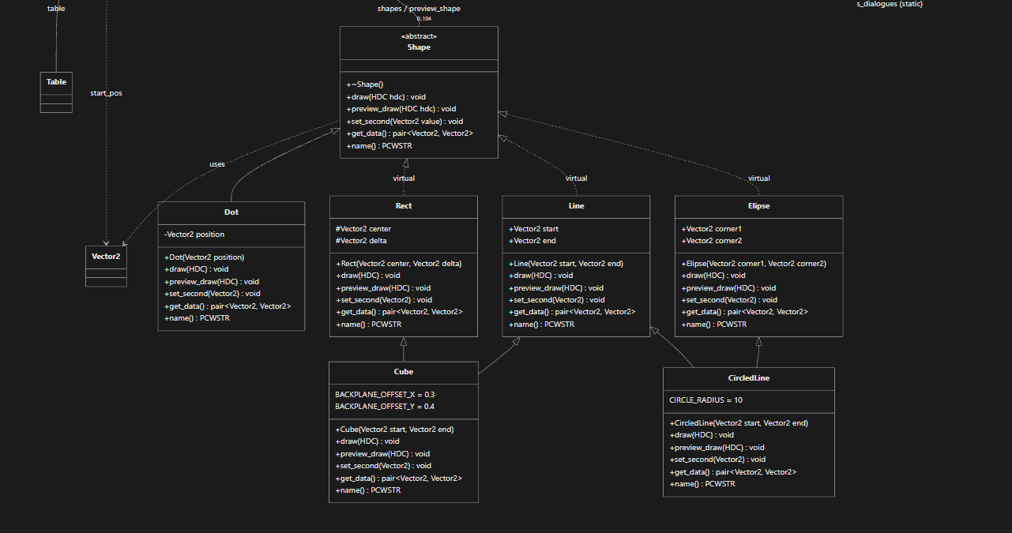
Скріншоти
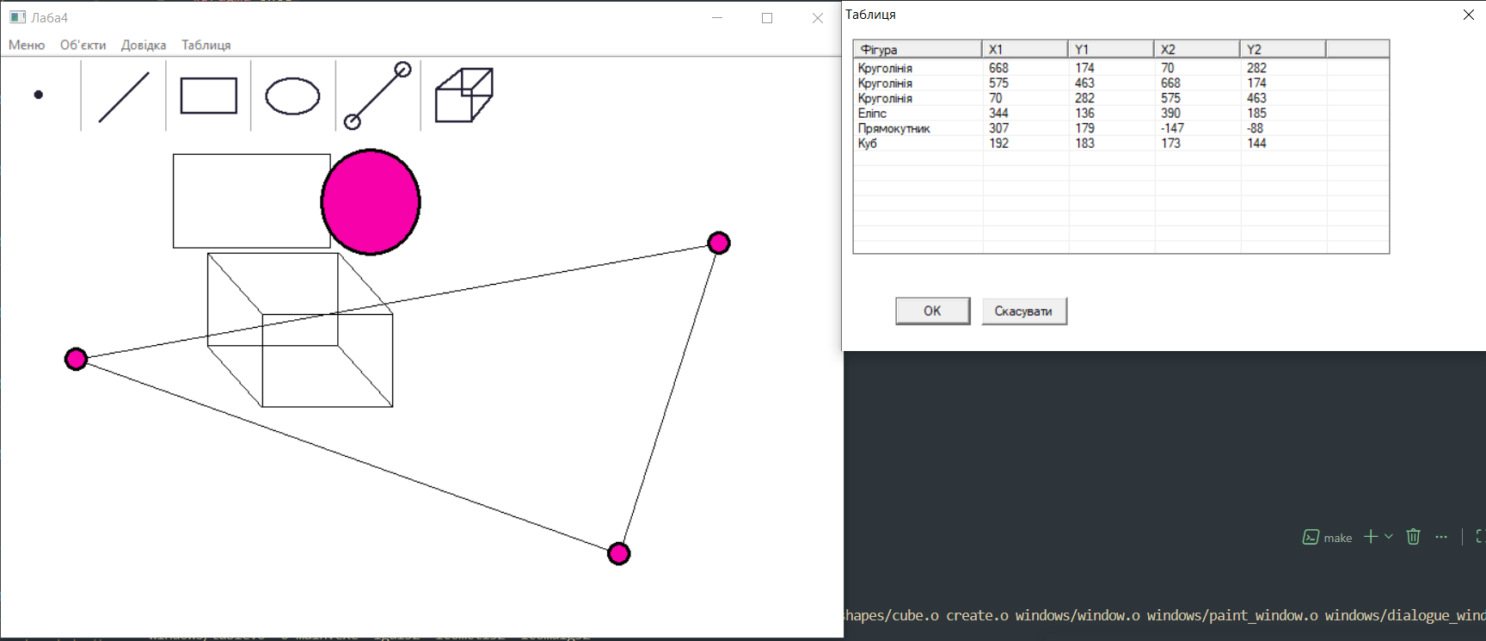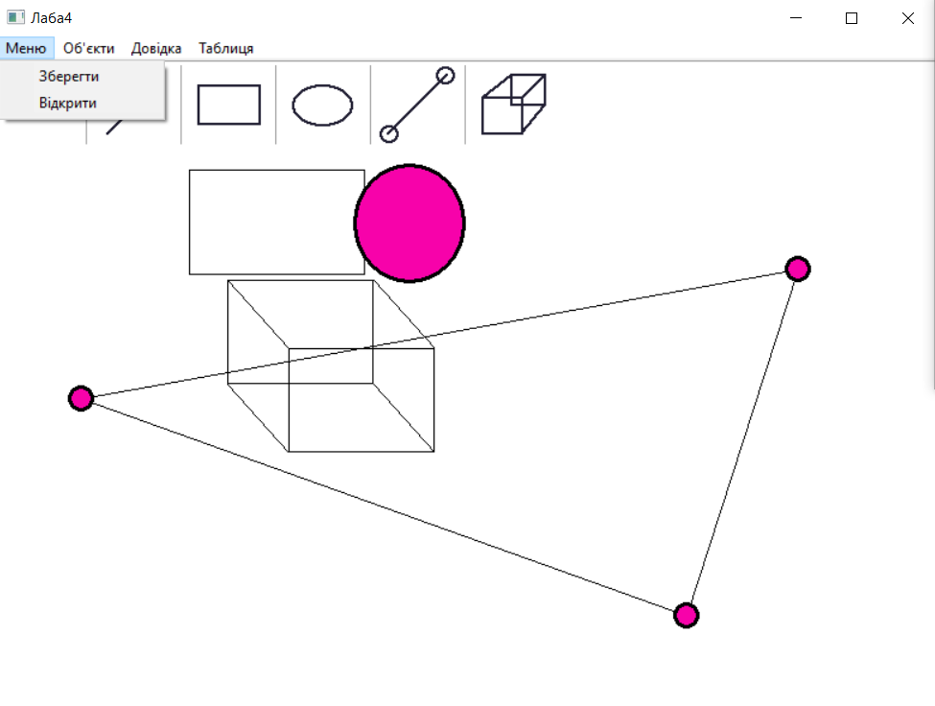
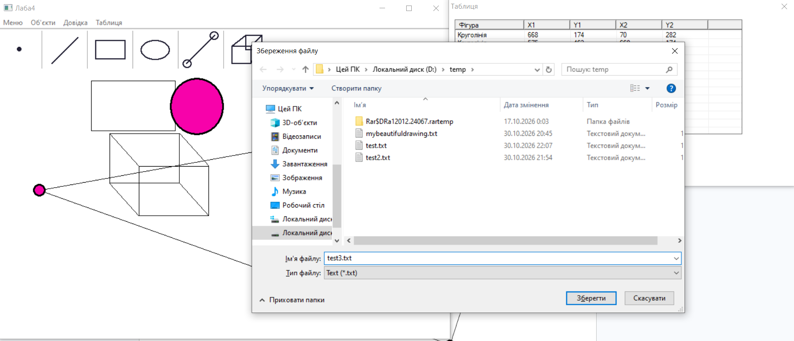
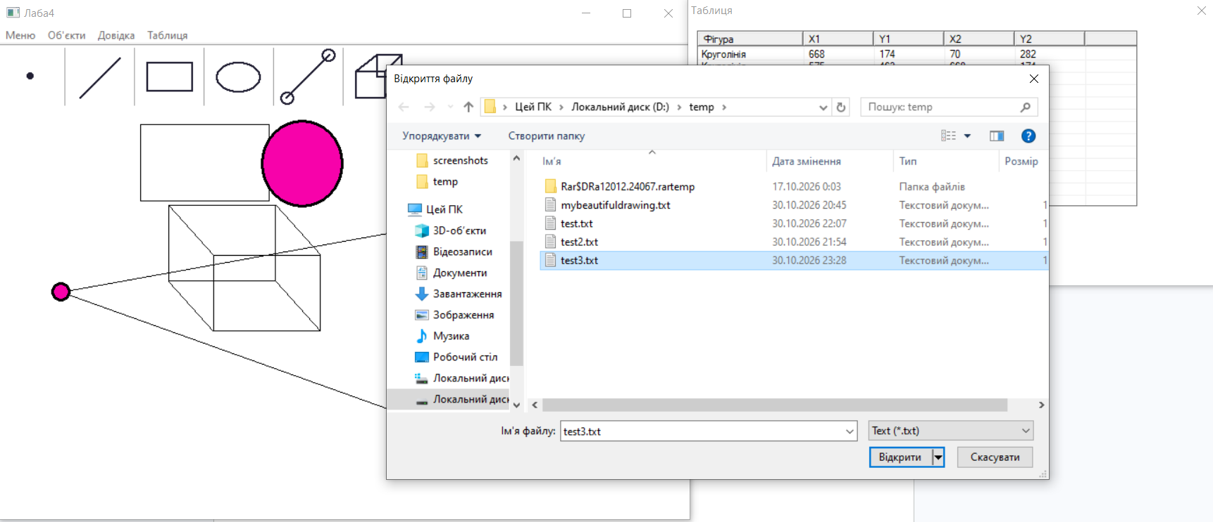
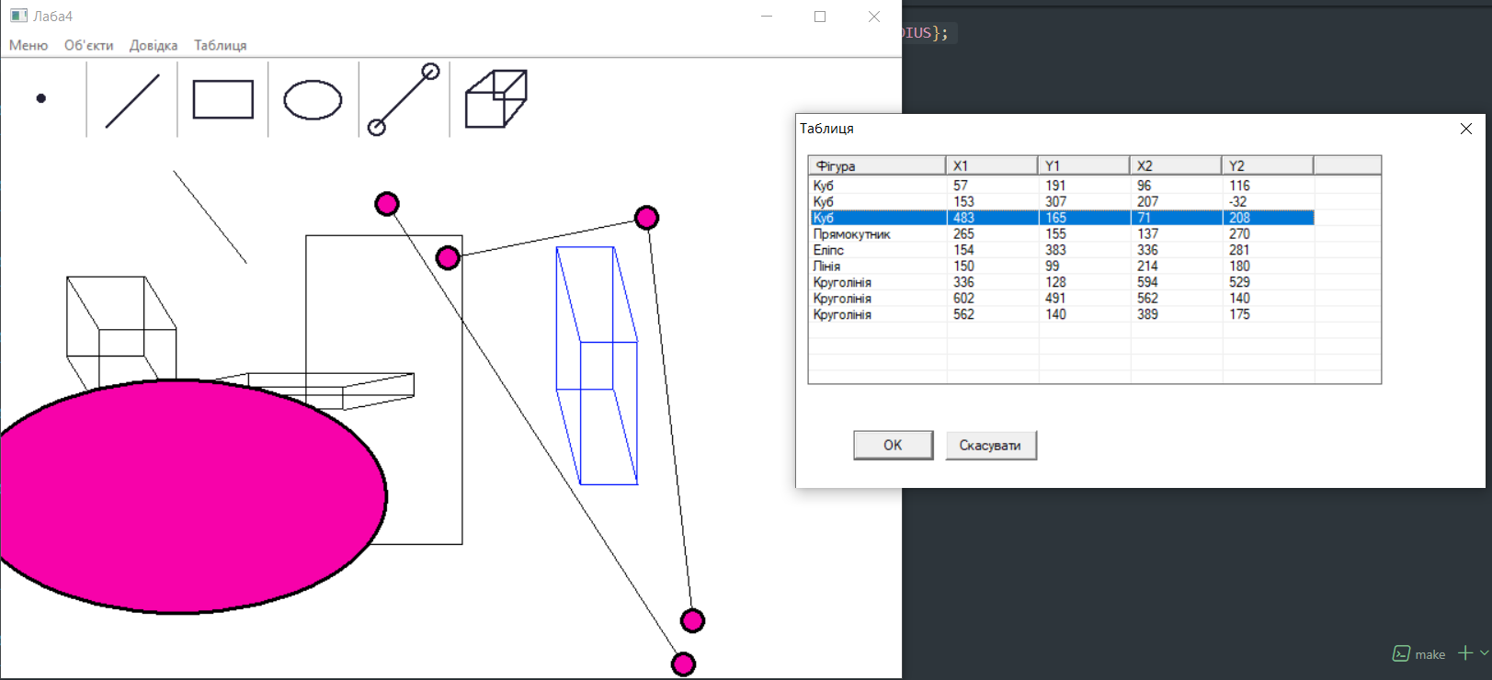
Висновок

В результаті виконання лабораторної роботи я розширив функціонал базового класу Window для роботи з немодальними діалоговими вікнами. За допомогою цього класу я імплементував вивід

