**ONLINE ART GALLERY**

*A PROJECT REPORT*

*Submitted by*

**T.HARSHINI**

**(Reg No : 22MCA012)**

**MASTERS**

**IN**

**COMPUTER APPLICATIONS**

**Subject Name: PHP Programming**

**Subject Code: 21CA1913**

**ABSTRACT**

Online Art Gallery is an online application, which is used to manage all information related to art works available, famous artists, types of arts, all art styles, price, orders, customer and the time required for delivering the arts. Artist can register through online for being a member in the art gallery and each artist can upload the digital copy of their art work under the respective categories. They can also host their art work for fixed price. Customer can also register through online and they can browse art works that are arranged in different categories. The Online Art Gallery is updated daily, so the user can view and buy the latest collection of arts from anywhere in the state. Each customer and artist can view and update their account information. Each artist can view and update their artworks uploaded. An artist can set the price for their artwork. We add ₹100 as commission on the price quoted by artist. Each customer has the right to purchase an art work using the integrated payment gateway. After valid payment the art work will be shipped within 15 days. Each artist view, update and delete their artworks.

This project is designed with front-end HTML, CSS, JavaScript, Bootstrap and backend with PHP.

**INTRODUCTION**

Art of any kind is worth being experienced by more than just the creator. A method for this to transpire is usually developed by galleries, which organize art exhibitions and auctions at a given date and place. This also unfortunately means that customers and visitors must be present at the venue in order to admire the original works of art, which must be put on display.

Often, during the run of the exhibition, customers find themselves edging towards admiring an artwork so much that they wish to acquire it. For this to take place, they must first contact the manager of the gallery, ask whether it is on sale or not, then follow the complex procedure further to finally purchase the work.

At such a situation, automating the entire process, from exhibiting to selling art, can be done with the help of an Online Art Gallery System. An Online Art Gallery System is an online website that exhibits, sells and collects art works and art pieces. The core purpose of an Online Art System is to allow customers to explore their artistic hobbies and interests simply at home, without the trouble of having to travel back.

**CHARACTERITICS**

* **USER MODULE:**
* **Customer**

The Customer can sign up with their details and then login with the username and password. The Customer after logging in should be able to view various pieces of artwork provided by artist in the gallery. The Customer should be able to cart and pay for artworks they would like to possess through the payments module. Customer can view their profile as well as they can view the order details that the customer can purchase. Through this customer can view the status of the order.

* **Artist**

The Artist can sign up with their details and then login with the username and password. The Artist after logging in should be able to upload new artworks and they can view, update and delete the artworks uploaded. After uploading each artwork the bill is calculated and displayed. Artist can also view the profile.

* **ORGANIZER MODULE**

The admin can login with the username and password. After logging in, the admin should be able to view and update the all artworks uploaded, artist payment, customers orders details, and remove the customers, feedback, artist bank account details and artist.

**EXISTING SYSTEM AND PROPOSED SYSTEM**

**EXISTING SYTEM**

In the existing system, the art galleries are only managed by manually. A method for this to transpire is usually developed by galleries, which organize art exhibitions and auctions at a given date and place. This also unfortunately means that customers and visitors must be present at the venue in order to admire the original works of art, which must be put on display. For this to take place, they must first contact the manager of the gallery, ask whether it is on sale or not, then follow the complex procedure further to finally purchase the work. It has lack of security of data and needs more manual calculations. Day to day work is managed manually to view particular product information or product orders, features, price, and product specification we need to go through all the entered and view the details under respective categories which consume time.

**DISADVANTAGES:**

* It has time consuming process.
* More man power.
* Needs manual calculations.
* Not easy to search particular record.
* Less convenient.

**PROPOSED SYSTEM**

Online Art Gallery System will automate the entire process, from exhibiting to selling and buying art. An Online Art Gallery System is an online website that exhibits, sells and collects art works. The core purpose of an Online Art System is to allow customers to explore their artistic hobbies and interests simply at home, without the trouble of having to travel back.

The proposed system can overcome all the limitations of the existing system. This website helps the end users to search their arts and paintings and they can place order for the selected pieces. It facilitates the artists to create their profile on this system and keep track of their art works and also upload their new artworks in the digital form. They will be able to see which of their paintings have been placed. The artworks would be categorized into different types of art.

User and artists can send a message to the admin. User and artists can also edit their profile and photos.

**ADVANTAGES:**

* Security of data.
* Reduce the manual work.
* Proper control of the higher officials.
* Greater efficiency, User friendly and interactive.
* Better service.
* Not time consuming.
* Automatically the records are stored.
* It make easier to search

**FLOW DIAGRAM**

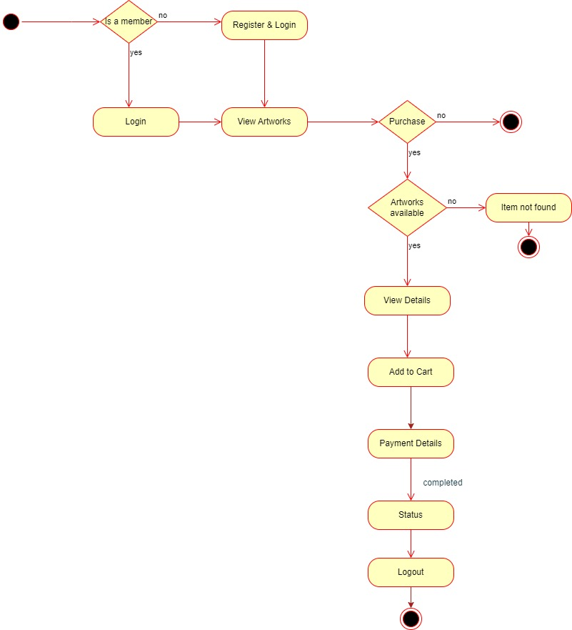

**WORKING ENVIRONMENT**

**XAMPP:**

XAMPP is one of the widely used cross-platform web servers, which helps developers to create and test their programs on a local web server. It was developed by the **Apache Friends**, and its native source code can be revised or modified by the audience. It consists of **Apache HTTP Server, MariaDB, and interpreter** for the different programming languages like PHP and Perl. XAMPP is an abbreviation where X stands for Cross-Platform, A stands for Apache, M stands for MYSQL, and the Ps stand for PHP and Perl, respectively. It is an open-source package of web solutions.

* **XAMPP Control Panel:** It is a panel that helps to operate and regulate upon other components of the XAMPP. Version 3.2.1 is the most recent update.
* **phpMyAdmin:** It is a tool used for dealing with MariaDB. Its version 4.0.4 is currently being used in XAMPP. Administration of DBMS is its main role.
* **PHP:** It is the backend scripting language primarily used for web development. PHP allows users to create dynamic websites and applications. It can be installed on every platform and supports a variety of database management systems. It was implemented using C language. PHP stands for **Hypertext Processor**.
* **Apache:** It is an HTTP a cross-platform web server. It is used worldwide for delivering web content. The server application has made free for installation and used for the community of developers under the aegis of Apache Software Foundation. The remote server of Apache delivers the requested files, images, and other documents to the user.

**SAMPLE SCREENSHOTS**

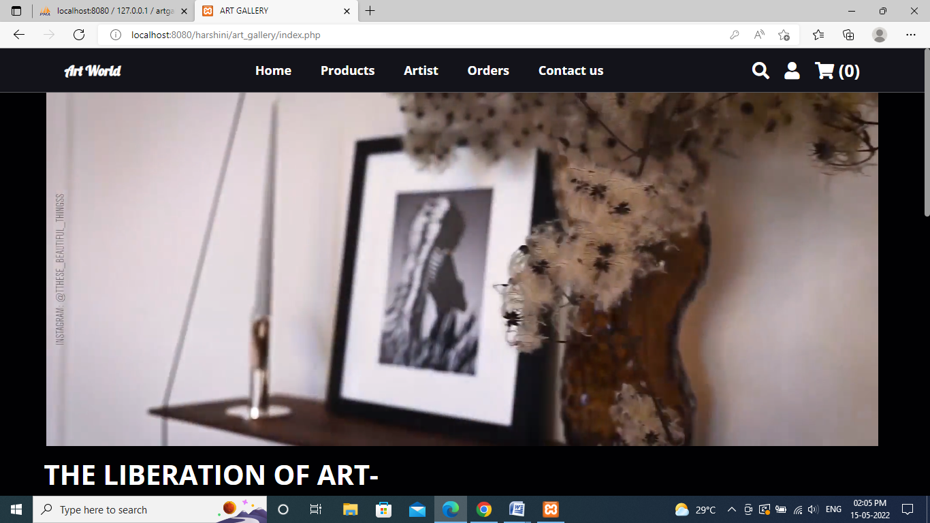

**Figure 1: Home Screen**

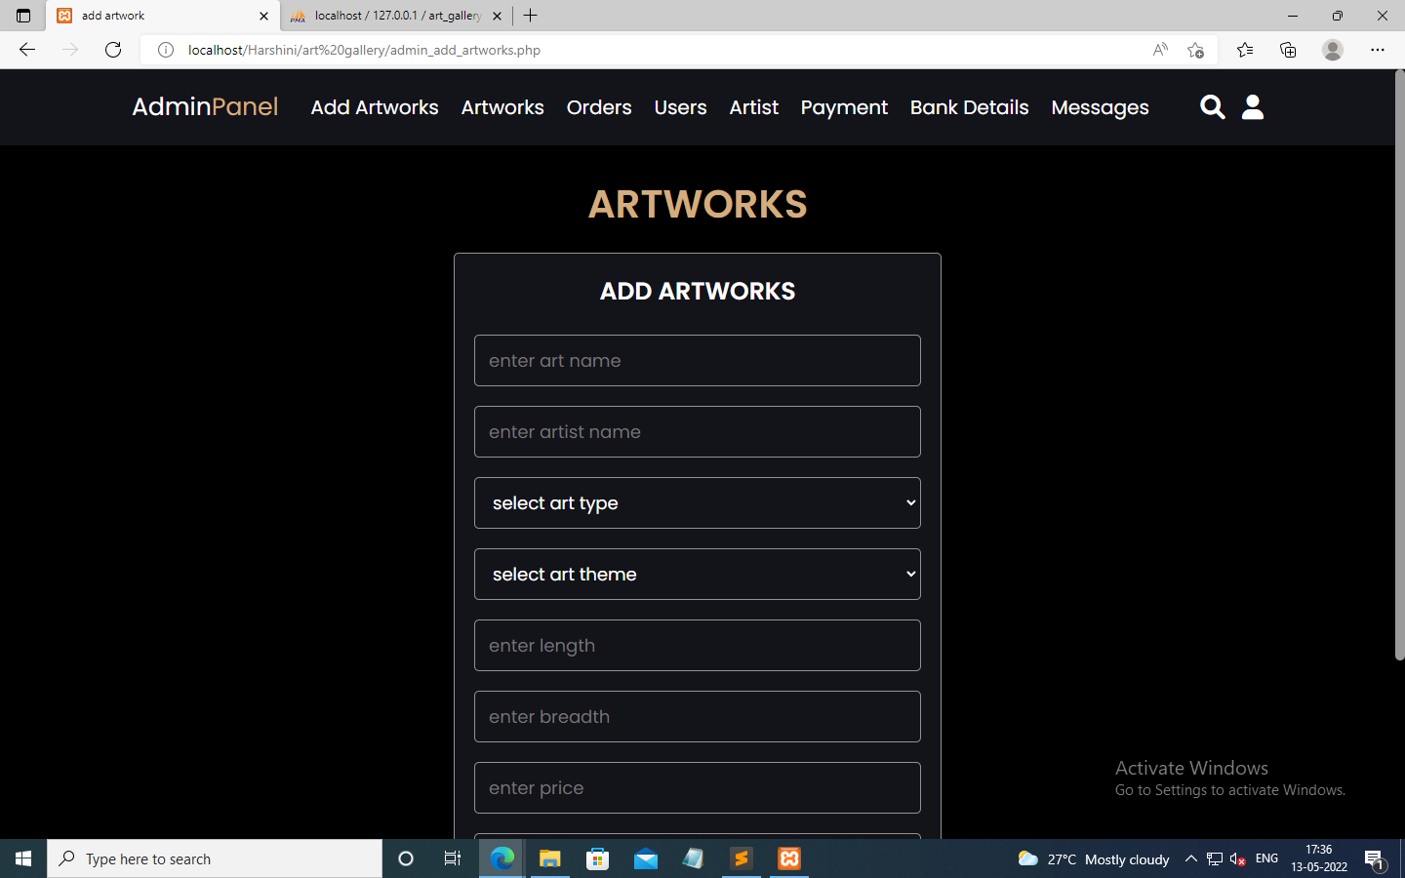

**Figure 2: Artist add artworks form**

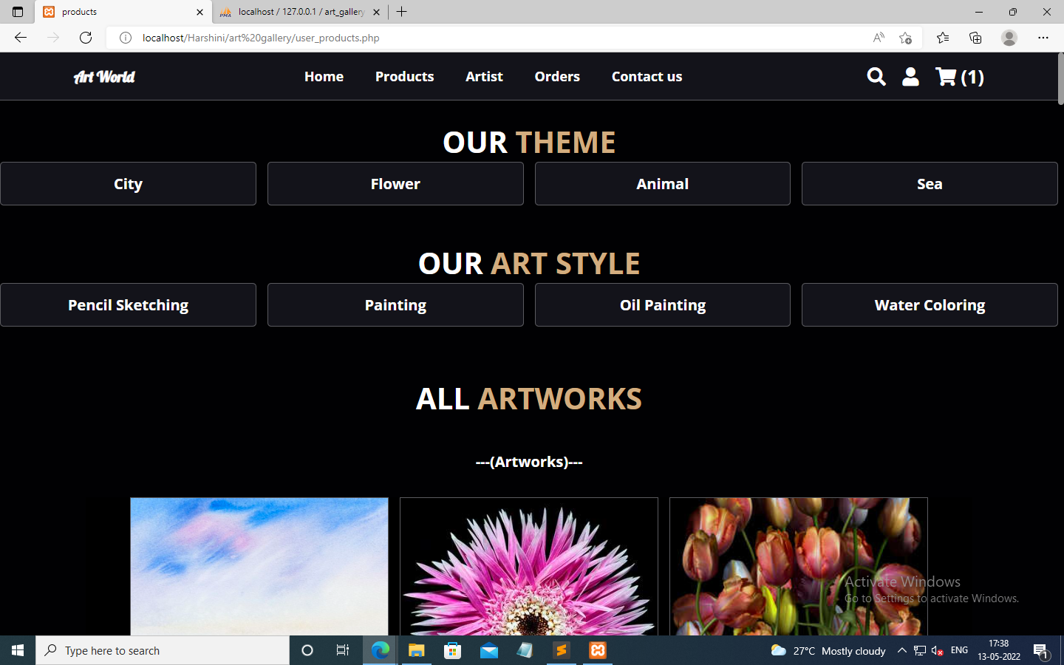

**Figure 3: All Artworks**

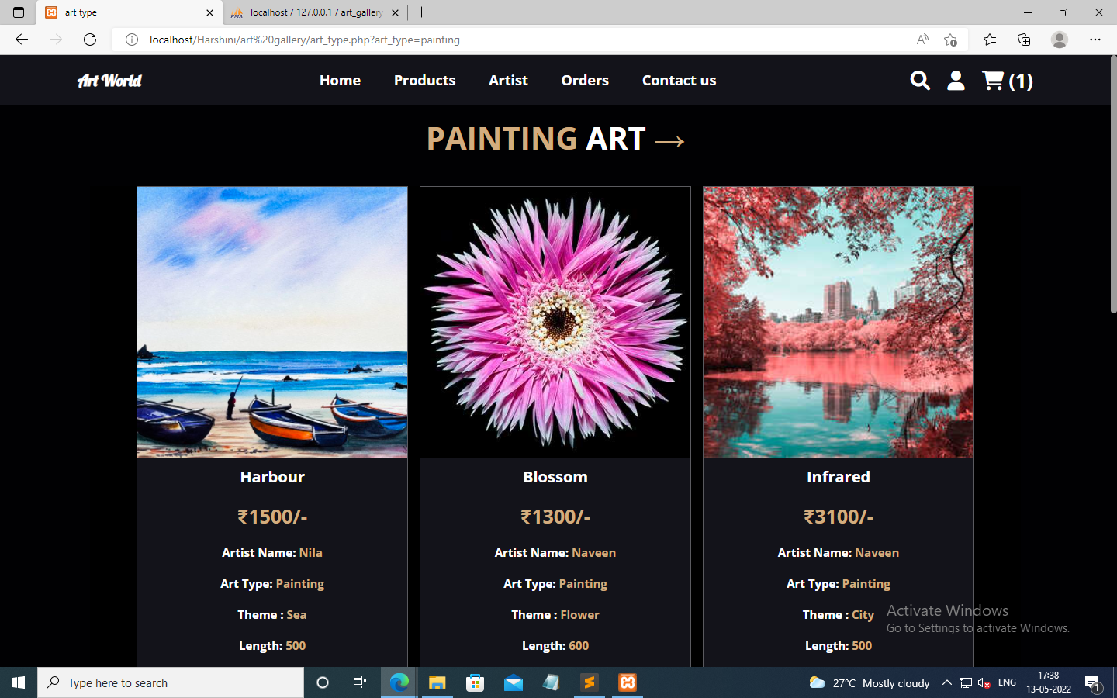

**Figure 4: Customer’s view artworks by art styles**

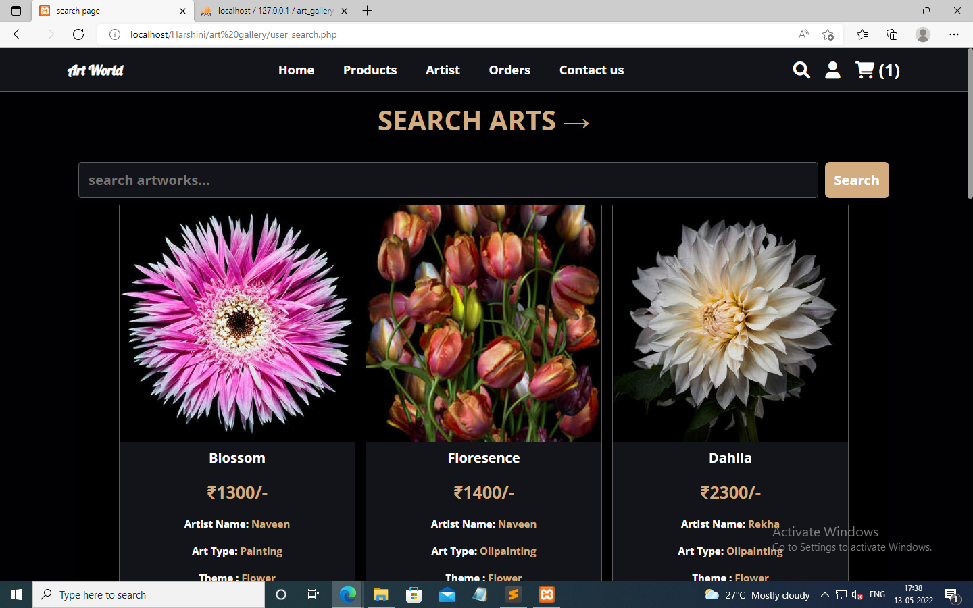

**Figure 5: Search Artworks**

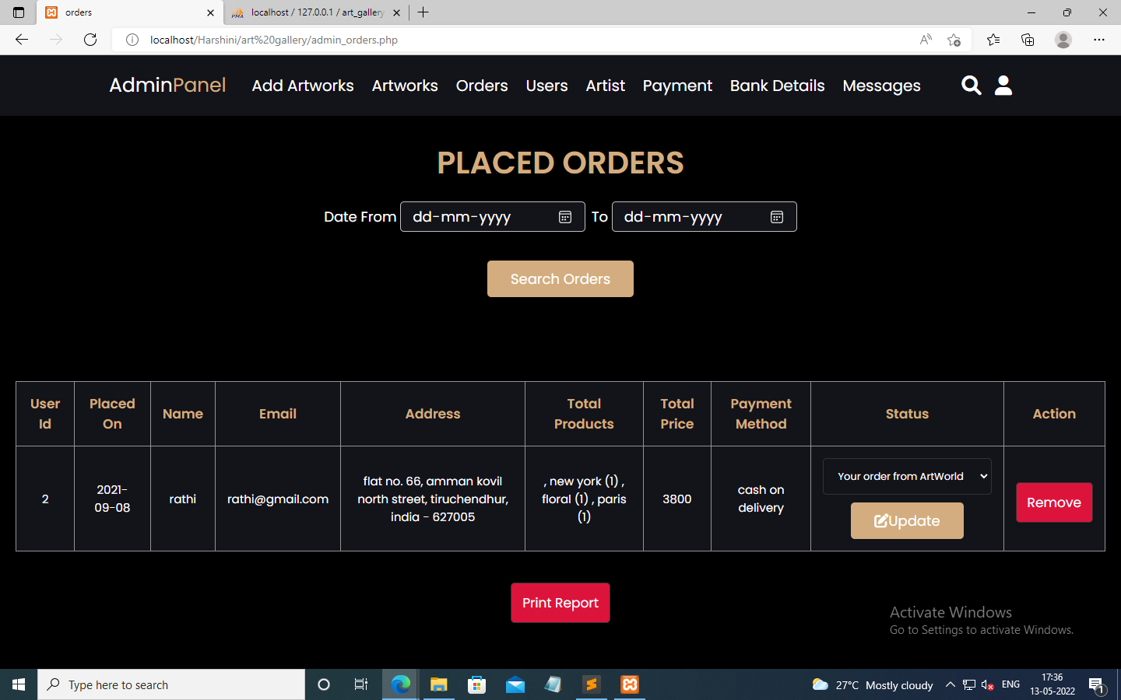

**Figure 6: Admin view and search orders page**

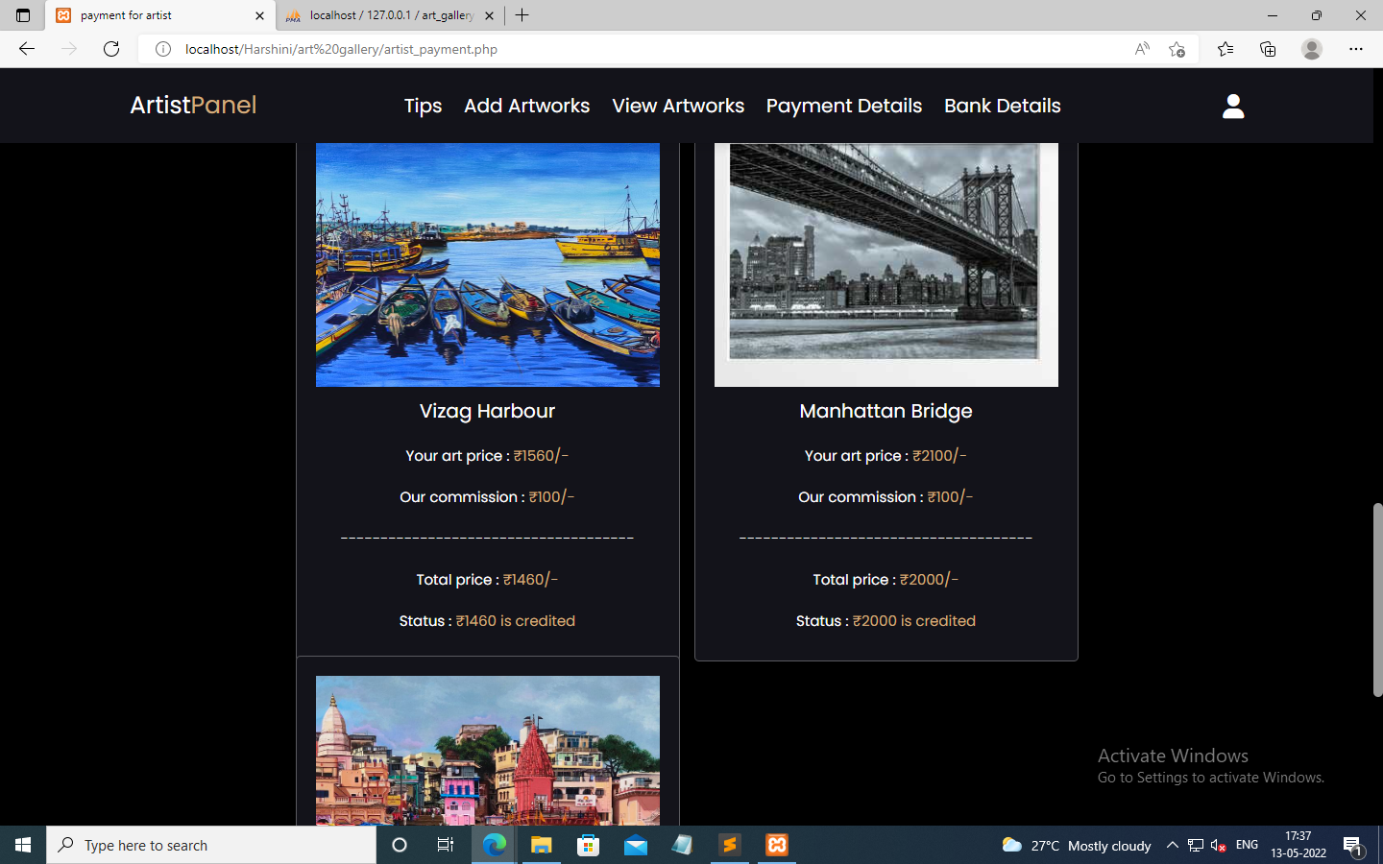

**Figure 7: Artist Bill page**

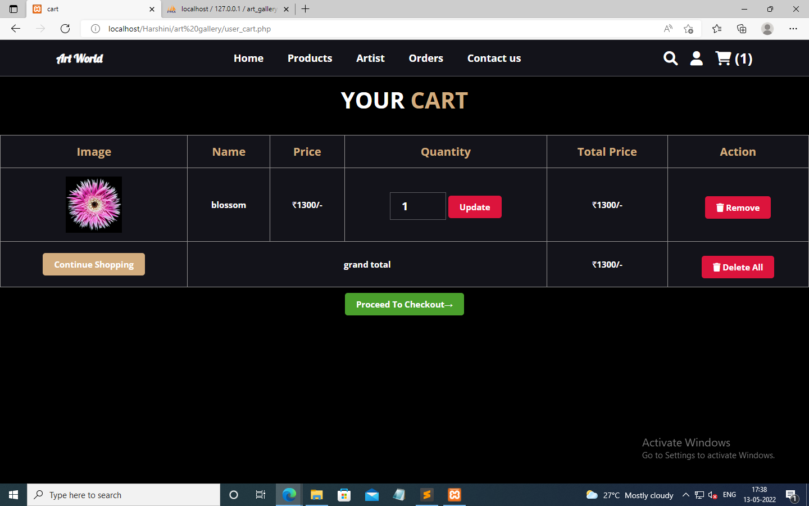

**Figure 8: Customer cart items**



**Figure 9: Customer search artworks**

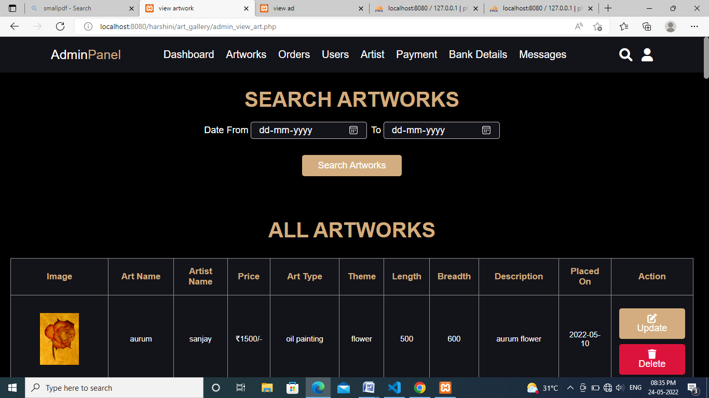

**Figure 10: Admin view, search, update and delete artworks**

**CONCLUSION**

The Online Art Gallery will manage the user’s details by which user role can login to the art gallery. As well as, the artist details can be maintained for login to upload new artworks. The gallery will have different artist displaying their artwork. It provides the various types of artworks based on theme of art, type of an art and artist. There is a database which is maintained by the Admin in which all the information of customer and artist with complete data are stored. Customer and artist details stored in database and it can be viewable by the admin. By Online Art Gallery many people can purchase the artwork without trouble. It decreases the cost of travel, easy for searching artworks so that the time is consumed for the user and purchasing process. It also allows the possibility of queries to obtain information for various surveys. It is very easy to use and it is very less time consuming.

**FUTURE ENHANCEMENT**

Online Art Gallery has covered all the requirements. In future, this project can be added the following procedures:

* The admin portal can also send email notifications to the customer about new artworks uploaded and status of the purchase.
* I will host the platform on online servers to make it accessible worldwide.
* Implement a rating system for artwork.
* Online payment can be implemented.
* Implemented as a mobile application.

**REFERENCE**

**Book Reference:**

* “PHP in a Nutshell” by Paul Hudson.
* “PHP5/MySql Programming for the absolute beginner” by Andy Harris, Thomas Course Technology
* **Robin Nixon**. Learning PHP, MySql and Javascript.

**Web Reference:**

* <https://www.w3schools.com>
* https://www.tutorialspoint.com
* <https://www.javatpoint.com>