**Connecting the Wires:** First, the microcontroller should be attached to the featherboard, and the ECG sensor has to connect to the featherboard using 3 wires. The wires should be connected as shown below. To power the device and collect data, both usb cables should be connected to a computer. Next, attach the ECG sensors to the body as shown below.

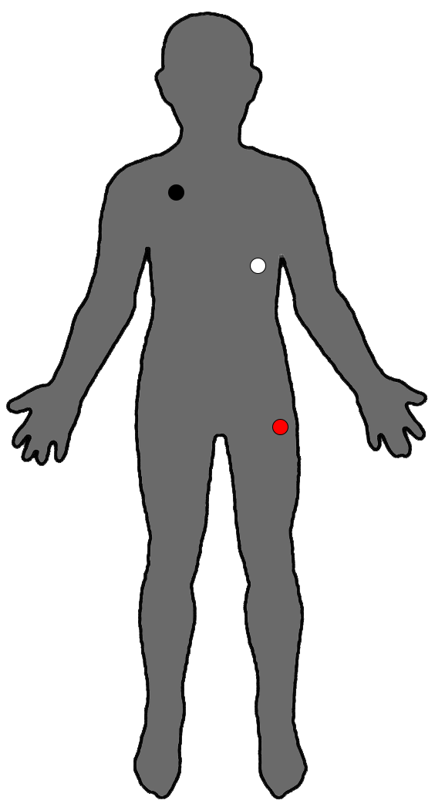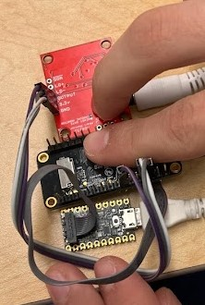

**Collecting the data:** We used PuTTY to collect the data. Below are the settings we used for PuTTY, the connection port is machine specific and should be changed from “3”. This can be found in device manager on Windows machines.

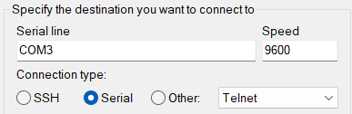

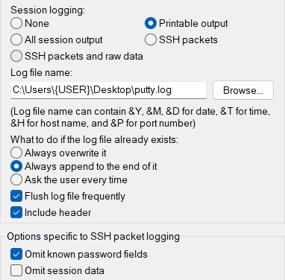

Additionally, in the “log file name” section, {USER} should be changed to the name of the user.

The data collected should be in 1 minute segments.

**Interpreting the data:**

*The code is implemented in MATLAB, although it could be transferred over, for the sake of this document everything is expected to be done via the latest version of MATLAB.

The code takes 10 second segments of the data and averages every segment’s heart rate and heart rate variability (HRV) and puts each segment in a matrix. For example, for a trial that ran at the recommended sixty seconds the variable “dynamic_RMSSD” will be a 1x10 matrix. Where 1x2 will be the first ten second segment, 1x2 will be the second 10 second segment, and so on.

The following will give detailed information on all the actions needed to do for the user to interpret the ECG data.

*i)* Move the text document into the appropriate folder where your MATLAB code exists.

*ii)* At line 3 of the MATLAB code, after enter the name of YOUR SPECIFIC FILE into the colored excerpt: noisyECG = load(‘tylerexcecise.txt’);

*iii)* Click “Run”

*iv)* Move to the “command window” and scroll to see the variables “dynamic_RMSSD” (your HRV) and “dynamic_heart_rate”.



