EAGLE Project: Circuit Design and Fabrication

Author: Garrett Barton

(Student ID: 896822887)

Submitted On: 20170217

Submitted To: Mr. John Scalzo

**Abstract:** The assignment was to create a modified version of an example signal amplifier circuit utilizing EAGLE and then take the necessary stepped in order to physically implement it, without actually doing so. The main purpose of this task is to allow real life learning of the process of creating circuits and secondarily to prepare students for senior design.

1. **Introduction**

This board fulfils the requirements to create a modified circuit of an example signal amplifier. The only requirements were to create this circuit and make it as small as was reasonable. All parts were chosen such that they could be obtained from digikey.com (in order to simplify ordering) and could be ordered as single units in order to not have excess.

1. **Figures**

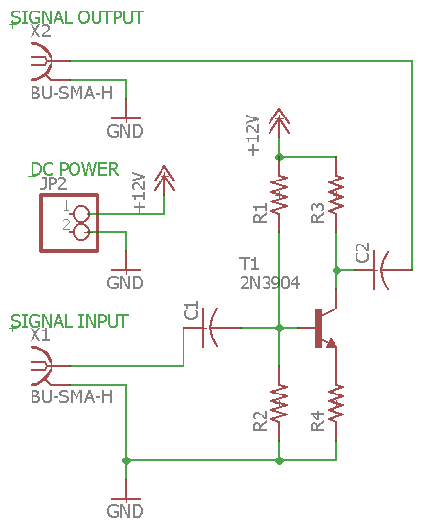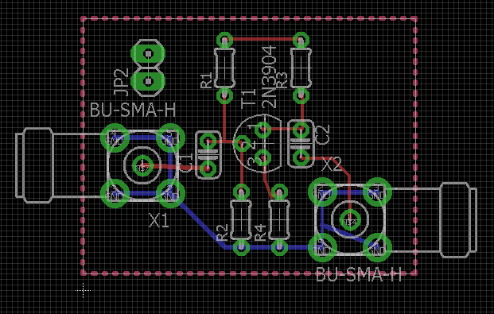

The schematic (left) file and board file (right) are the rendered models. The board measures in at 30.5 mm by 23.5 mm, 1.200787 in by 0.9251969 in (${716.75 mm}^{2},1.11 {in}^{2})$.

1. **Design and Fabrication**

In designing the schematic file the model was rendered as close to the original circuit as possible in order to be easily be recognized and worked with. The board file was made to appear nearly identical to the schematic file, again for ease of work and understanding.

**Parts**

* The transistor was chosen to be a NPN3904 per requirements of design. The transistor is obtained from Fairchild/ON Semiconductor at $0.18 each. It is lead free/RoHS bipolar transistor NPN 40V 200mA 300MHz 625mW through hole TO-92-3. [Digi-Key Part Number: 2N3904FS-ND, Manufacture part number: 2N3904BU]
* The resistors (x4) are ceramic, axial 1 kΩ ± 10% (1W) from Ohmite at $1.54 each in bulk packaging. These resistors are moisture resistant and pulse withstanding and offer an operating temperature range from -40⁰C ~ 220⁰C. [Digi-Key Part Number: OX102KE-ND, Manufacturer part number: OX102KE]
* The capacitors (x2) are 1µF ± 10% 6.3V lead free, surface mount Ceramic capacitor X5R 0402 from Taiyo Yuden at $0.10 each. This device operate at -55⁰ C ~ 85⁰ C. [Digi-Key Part Number: 587-1231-6-ND, Manufacture part number: JMK105BJ105KV-F]
* The coaxial connectors are sourced from Amphenol RF SMA Connectors at $7.80 each. It is a SMA connector jack, female socket 50 Ohm through hole, right angle solder. [Digi-Key Part Number: ACX1232-ND, Manufacture part number: 132136]
* The DC power jack is a power barrel connector jack, through hole right angle from Conec. It is rated for 24V/5A and is unshielded. The price for under 10 units is $0.73. [Digi-Key Part Number: 626-1968-ND, Manufacture part number: 33DCJ-0202-A]

1. **Summary**

This task was successful in both its primary and secondary target objectives. The processes of creating, modeling, and preparing to fabricate the circuit designed were learned.

