LipidMatch Flow Instructions

Video tutorials are available at:

<https://www.youtube.com/playlist?list=PLZtU6nmcTb5kAOHAPjtpWXwyjfpDnaB2M>

Yang Li

yliweb@ufl.edu

Jeremy Koelmel

jeremkoelmel@gmail.com

1) Dependencies: (most windows computers will already have the two dependencies below installed, so try running first and if a warning comes up about these dependencies you can install them free)

Microsoft .NET (Developed using Ver 4.7.2)

Java 64-bit version

2) Change .raw (or other vendor format) file names:

You can change your vendor formatted files to the right naming convention manually (or during data-acquisition) or using the tool that comes with LipidMatch Flow (see link for tutorial):

<https://youtu.be/eIpdhDnhh9I>

All file names should end in _Neg.raw or _Pos.raw, depending on the polarity.

All ion fragmentation data should have AIF somewhere in the name

Data-dependent are targeted MS/MS files should have "ddMS2" somewhere in the name

Blanks, for blank filtration (for example extraction blanks) should have "blank" somewhere in the file name

Files which are representative of all samples (eg. pooled samples) and can be processed to determine which features to target in all samples, should have "target" somewhere in the file name.

Length of the file names of MS/MS (ddMS2 or AIF) should not be longer than 23 characters. It is OK if full scan data used for feature detection is over 23 characters.

3) Input Files:

Double click LipidMatch_Batch.exe to open the GUI interface.

You should have at least one MS/MS file per polarity (AIF or ddMS2)

Atleast 3 blanks and 1 file with "target" in their name for each polarity

You can run only a single polarity if desired

After uploading files and choosing project name and working directory the start button should no longer be grayed out

Select start.

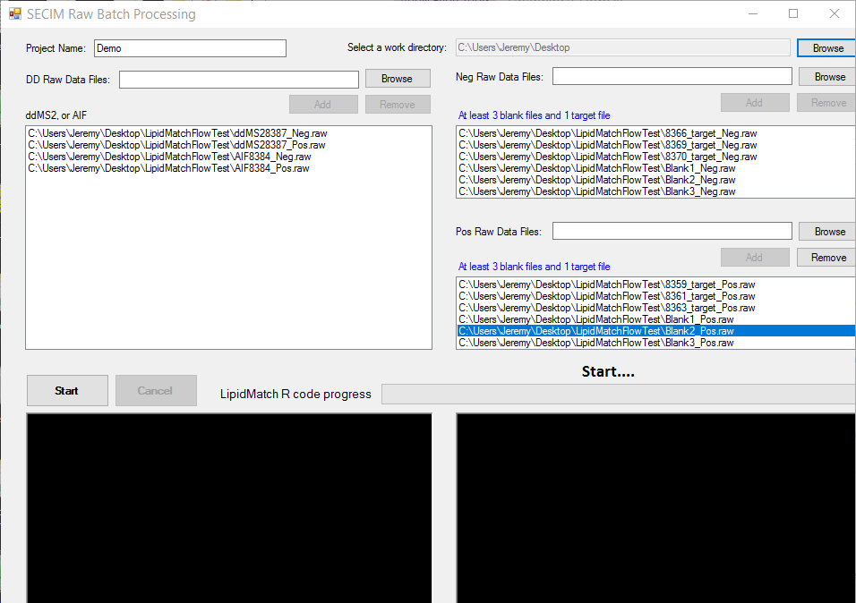

4) Interpreting results:

You will get multiple files outputted in the working directory you selected in the previous step; these include the converted .raw files to .mzXML and the MZmine files in the Temp_Work folder which is generated, and the LipidMatch output files in the LipidMatch_Run directory. Your final data with each feature's *m/z*, retention time, intensities across samples, and lipid annotation(s) will be in the LipidMatch_Run directory saved as Pos_IDed.csv and Neg_IDed.csv. You will also have Neg_MolecularSpecies.csv, Pos_MolecularSpecies.csv, and PosNeg_MolecularSpecies.csv. The latter contains one feature for each lipid molecular species and combines positive and negative mode data, this is the file you will most likely want for further statistics, etc.

Appended in the column labeled ID of PosNeg_MolecularSpecies.csv contains lipid annotations or multiple lipid annotations per feature separated by “I”.

* There are currently 4 identity markers:
  + 1_[ID] represents confirmation by ddMS2
  + 2_[ID] represents confirmation by AIF
  + 3_[ID] represent ddMS2 by class
  + 4_[ID] represents confirmation by exact mass.
* The order for multiple confirmations is based on summed fragment intensity.
* The data files in the folder “…Neg/Confirmed/”, “…Pos/Confirmed/”, and “…PosByClass/Confirmed/” can be used to better determine confidence and the most abundant lipids defining a specific feature (these tables contain fragment intensities, retention times at max intensity, experimental and actual mass of fragments, number of scans containing fragments, etc.).

MZmine project files can be found in the Temp_Work folder (use the most recently saved files for negative and positive mode). These files can be open in MZmine and the gap-filled table can be double clicked to manually investigate the quality of peak picking.