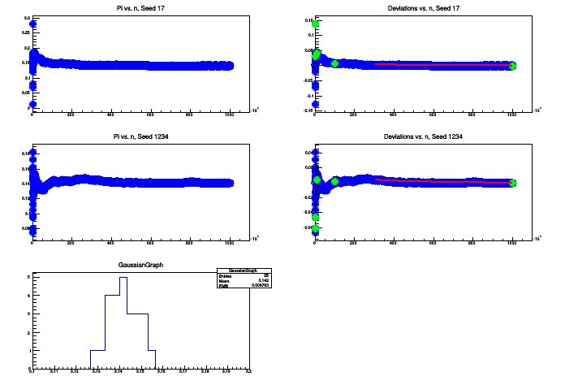

for 100 tries, pi = 3.17111 +- 0.148834
for 1000 tries, pi = 3.14898 +- 0.0489559
for 10000 tries, pi = 3.14196 +- 0.0184883
for 100000 tries, pi = 3.14194 +- 0.00690196
for 1e+06 tries, pi = 3.14123 +- 0.0014317
FCN=3.67024e-31 FROM HESSE STATUS=NOT POSDEF 12 CALLS 41 TOTAL
EDM=7.33314e-31 STRATEGY= 1 ERR MATRIX NOT POS-DEF
EXT PARAMETER APPROXIMATE STEP FIRST
NO. NAME VALUE ERROR SIZE DERIVATIVE
1 a -5.17633e-03 2.26485e-02 4.94320e-07 8.46299e-13
2 b 4.82367e+00 2.26485e+01 2.79630e-05 8.46299e-16
FCN=0 FROM HESSE STATUS=NOT POSDEF 10 CALLS 39 TOTAL
EDM=4.59249e-29 STRATEGY= 1 ERR MATRIX NOT POS-DEF
EXT PARAMETER APPROXIMATE STEP FIRST
NO. NAME VALUE ERROR SIZE DERIVATIVE
1 a -5.18433e-03 2.26485e-02 6.99074e-07 0.00000e+00
2 b 4.81567e+00 2.26485e+01 1.39815e-04 -4.23154e-16
root [2] Info in <TCanvas::Print>: png file /home/garrett/work/phys6802/PiPlots.png has been created
FCN=1.64621 FROM MIGRAD STATUS=CONVERGED 63 CALLS 64 TOTAL
EDM=7.61448e-08 STRATEGY= 1 ERROR MATRIX ACCURATE
EXT PARAMETER STEP FIRST
NO. NAME VALUE ERROR SIZE DERIVATIVE
1 Constant 4.27040e+00 1.16744e+00 7.01782e-04 5.64476e-05
2 Mean 3.14238e+00 1.86782e-03 1.49841e-06 -7.17264e-02
3 Sigma 7.64735e-03 1.80598e-03 4.98504e-05 5.20246e-03

