
Bachelor of Engineering (Software Engineering) – BH120
OENG1183 Engineering & IT Capstone Project

Capstone Final Report
FinVision: A Solution for Automated Financial Data Processing and Investment Recommendations

Student team | Kitto
Student name & ID | Nguyen Dinh Viet – s3927291  Doan Huu Quoc – s3927776  Vo Hoang Phuc – s3926761  Phan Trong Nguyen – s3927189
Academic supervisors | Dr. Tran Duc Linh  Dr. Pham Chi Thanh  Dr. Tran Nhat Quang
Company | RMIT SSET

Contents
1 Executive Summary 4
2 Project background and Problem Statement 4
3 Literature review and Market research 6
3.1 Financial Platforms and Market Tools 6
3.2 Model Architectures for Stock Prediction 6
3.3 Hybrid Techniques: Decomposition and Optimisation 7
3.4 Explainability and Sentiment Integration 8
4 Solution Design 9
4.1 Project Refinement 9
4.1.1 Scope of Work 9
4.1.2 Performance Metrics Refinement 10
4.2 Detailed System Design 10
4.2.1 Stock prediction 11
4.2.2 Sentiment analysis 14
4.2.3 Web platform 15
5 Result analyses and Discussion 19
5.1 Key results & accomplishments 19
5.1.1 Stock prediction 19
5.1.2 Sentiment analysis 19
5.1.3 Web application 20
5.2 Results analysis 20
5.2.1 Result analysis of Sentiment Analysis Performance 20
5.2.2 Result analysis of Stock Trend Prediction Performance 21
5.3 Discussion of Project Issues & Limitations 23
5.3.1 The Scalability and Cost Dilemma 23
5.3.2 Mismatched Data Latency and Inflexible Forecast Horizon 23
5.3.3 The Risk of Model Performance Degradation (Model Drift) 23
5.3.4 Suboptimal Model Formulation & Lack of Actionability 8
5.4 Recommendations for Future Work 10
5.4.1 Implement a Tiered Hybrid Model Architecture 12
5.4.2 Integrate Real-Time Data and Flexible Forecast Horizons 12
5.4.3 Build and Deploy an MLOps Pipeline 17
5.4.4 Transition to a Binary Classification Framework for Enhanced Performance and Actionability 18
6 Summary and Reflection 24
7 References 26
8 Appendices 27

List of Figures
Figure 1. LSTM Architecture 7
Figure 2. Aquila optimiser (part 1) 8
Figure 3. Solution design diagram 10
Figure 4: Stock prediction pipeline 11
Figure 5. Sentiment analysis pipeline 14
Figure 6. Kitto agent architecture 19
Figure 7. Sentiment analysis pipeline’s results 20
Figure 8. AAPL prediction result on LSTM model 21
Figure 9. LSTM learning curve for AAPL 21
Figure 10. Prediction imbalance of NVDA on LSTM model 22
Figure 11. Transformer learning curve 22
Figure 12. Common architectures used for stock price prediction 27
Figure 13. Aquila optimiser based idea (part 2) 27
Figure 14. Diagram of Aquila optimiser 28
Figure 15. XAI reasoning on OHLCV dataset based on SHAP (part 1) 29
Figure 16. XAI reasoning for OHLCV dataset based on SHAP (part 2) 30
Figure 17. XAI reasoning on OHLCV dataset based on SHAP (part 30 31
Figure 18. Agentic AI screen of Kitto web platform 32
Figure 19. Market page of Kitto web platform 32
Figure 20. Portfolio management page of Kitto web platform (part 1) 33
Figure 21. Portfolio management page of Kitto web platform (part 2) 33
Figure 22. Portfolio management page of Kitto web platform (part 3) 34
Figure 23. XAI page of Kitto web platform 34
Figure 24. Cost management page of Kitto web platform 35
Figure 25. User management page of Kitto web platform 35
Figure 26. User management page of Kitto web platform (part 2) 36
Figure 27. Landing page of Kitto web platform 36
Figure 28. Landing page of Kitto web platform (part 2) 37
Figure 29. Landing page of Kitto web platform (part 3) 37
Figure 30. Landing page of Kitto web platform (part 4) 38

List of Tables
Table 1. Models comparison 8
Table 2. Performance Evaluation 10
Table 3. Final LSTM Pipeline Configuration (Derived from A.O) 12
Table 4. Final Transformer configuration (Derived from A.O) 12
Table 5. Investment Goal Default Metrics 17
Table 6. Risk Tolerance Calibration Units 18

Table 1. Models’ comparison 8
Table 2. Performance Evaluation 10
Table 3. Final LSTM Pipeline Configuration (Derived from A.O) 12
Table 4. Final Transformer configuration (Derived from A.O) 12
Table 5. Investment Goal Default Metrics 17
Table 6. Risk Tolerance Calibration Units 18

Executive Summary
In today’s increasingly complex financial markets, investors face significant challenges when interpreting the vast amounts of data available and forecasting stock price movements with confidence [1]. Although global market participation has risen rapidly, particularly among retail investors, this growth has not been accompanied by tools or expertise that make financial data easier to understand [2]. Specially, market behaviour is influenced by a wide range of factors, including macroeconomic conditions, geopolitical events, and investor sentiment, making reliable forecasting even more difficult [3][4]. Traditional approaches, such as technical chart analysis and fundamental ratio evaluation, often prove inadequate because they cannot capture the non-linear patterns and sudden shifts that define modern markets. As a result, there is increasing demand for advanced, data-driven analytics that can adapt quickly and respond in real time [4].
FinVision is a platform designed to address these challenges by improving the accuracy, clarity, and transparency of financial analysis and investment decision-making. The system brings together several techniques into a single pipeline, reflecting the way experienced analysts combine diverse sources of information. To begin with, FinVision collects key financial metrics (KPIs) from the Alpha Vantage API. These indicators are then processed using rule-based filters aligned with user preferences, allowing the system to screen companies against chosen criteria and highlight those that meet important performance thresholds. In addition, the platform incorporates a sentiment analysis module that evaluates financial news articles related to specific stocks. Rather than relying on static models, FinVision uses the Google Gemini Large Language Model (LLM) to summarise and classify sentiment in a financial context. This enables the system to capture prevailing market sentiment and emerging developments, producing clear sentiment labels that add valuable context to quantitative data. Building on these foundations, FinVision’s predictive engine applies well-established machine learning (ML) and deep learning (DL) models, including Long Short-Term Memory (LSTM) networks, Transformer-based models, and Support Vector Machines (SVMs). These models make use of open, high, low, close, and volume (OHLCV) data, technical indicators, as well as sentiment labels to forecast price movements. By comparing a range of models, the system can either select the most effective one or combine them in an ensemble to strengthen predictions. In addition, FinVision also incorporates an explainable artificial intelligence (AI) component, using SHapley Additive exPlanations (SHAP) and Layer Integrated Gradients (LIG), to ensure that the reasoning behind each forecast is clear to users. This emphasis on interpretability helps build trust and confidence in the system’s outputs.
The significance of this project lies in its complete end-to-end pipeline and in the practical techniques it applies to financial analytics. Specifically, FinVision integrates sentiment with traditional market data, thereby providing predictions that are labelled with context and easier to interpret. Moreover, it applies Multivariate Empirical Mode Decomposition (MEMD) during preprocessing, a method that decomposes complex time series into component signals for cleaner analysis and still rarely applied in stock prediction [5]. To further improve performance, the system also tested against the Aquila Optimiser and Genetic Algorithm, both bio-inspired approaches to hyperparameter tuning [5], which allow it to identify effective model settings more systematically. Finally, the platform has been validated extensively across all S&P 500 tickers, demonstrating its reliability and generalisability across a wide variety of companies and market conditions.
In summary, FinVision provides a comprehensive AI-based pipeline that not only improves predictive accuracy but also prioritises transparency and generalisability. Together, these qualities make FinVision not only a practical tool for investors, but also an insightful contribution to academic research in the growing field of financial technology.

Project background and Problem Statement
In recent years, stock markets worldwide have experienced a significant increase in participation from individual investors. A growing number of people are now taking greater responsibility for their financial decisions, viewing investment as a pathway to achieving long-term goals and generating returns that exceed those of traditional savings. This group is already substantial and continues to expand rapidly. For example, more than 100 million people now use stock trading applications each year, with usage increasing at an annual rate of approximately 20% [6]. Similar developments are evident in emerging markets as well. In Vietnam, for instance, a survey reported that half of respondents had entered the stock market within the previous year [2]. Although this expansion in access represents progress in terms of financial inclusion, it also highlights significant challenges. Many of these new investors lack the knowledge and skills needed to interpret complex market data effectively. According to the OECD’s 2024 programme for retail investors, only 48% of new investors could correctly answer a question on diversification, and among 18 to 24-year-olds this figure fell to just 42% [7]. These findings make clear that while more people are participating in financial markets, preparedness has not advanced at the same pace [2]. This imbalance has created an urgent need for decision-support tools that can guide non-experts through complex financial environments and help them build confidence in their strategies.
At the same time, financial markets themselves are becoming more complex and harder to predict. Stock prices are driven not only by company fundamentals and macroeconomic indicators but also by geopolitical tensions, regulatory announcements, and sudden shifts in public sentiment [3][4]. These overlapping factors can trigger abrupt and non-linear dynamics, undermining traditional assumptions of smooth and stable price movements [8]. Forecasting methods that rely solely on historical data or static ratios often prove insufficient when relationships are unstable or when information flows from many sources at once. Reviews of forecasting practice confirm that classical, single-source approaches underperform in such conditions [9]. For less experienced investors, this complexity can turn the abundance of information into noise, making decisions even harder.
In response, a recent studies point to the benefits of combining different sources of information. Research published in 2024 and 2025 highlights a clear shift towards integrated approaches that use both numerical data (such as price and volume) and qualitative data (such as sentiment from news or social media) [9], [10]. Such approaches provide a more complete picture of market behaviour. Sentiment signals have been shown to anticipate or contextualise turning points around critical events such as earnings announcements or policy changes, moments where historical patterns often prove unreliable [10]. Early experiments with multimodal systems also show that combining text with price data can improve stability, particularly when one data source is weak or noisy [11]. The academic implication is straightforward: decision-support for contemporary markets must integrate diverse evidence streams rather than extrapolate from price data alone.
Nevertheless, two obstacles continue to restrict the usefulness of advanced analytics for most investors. The first is generalisability. Many models are developed and tested on narrow datasets or specific episodes, which means that their performance can deteriorate when applied to new sectors, regions, or market conditions. Studies note risks of overfitting, sensitivity to parameter choices, and a lack of broad validation, limiting the reliability of results beyond carefully selected test cases [12], [13]. This limitation is particularly problematic for retail investors with diversified portfolios, as they need decision-support that works consistently across a wide range of assets.
The second obstacle is interpretability. Even when accuracy improves, many models function as “black boxes” offering forecasts without explaining the reasons behind them. This lack of transparency has long been cited as a key barrier to the adoption of AI in finance. A 2024 review in Artificial Intelligence Review shows that investors and regulators alike are reluctant to act on opaque outputs, while evidence increasingly suggests that transparent explanations significantly improve trust and enable better risk management [14]. In practice, investors want to know why a prediction is made, for example, whether it is based on macroeconomic data, sector news, or unusual trading patterns, before they will rely on it.
This gap between the complexity of markets and the support available to non-experts is further illustrated by the contrast between institutional and retail platforms. Institutional systems such as Bloomberg Terminal or Refinitiv Eikon deliver sophisticated analytics and real-time data, but they remain prohibitively expensive, difficult to operate, and often opaque in how they generate insights. By contrast, retail-oriented tools such as Yahoo Finance or TradingView are accessible and user-friendly but provide only limited analytical depth, typically surfacing simplified indicators without meaningful context. Consequently, there is a twofold shortfall. On the practical side, investors lack reliable, transparent, and generalisable support. On the academic side, research has yet to produce validated frameworks that integrate different types of evidence and remain interpretable at market scale.
It is also important to be realistic about limits. Even sophisticated methods face problems such as nonstationary, sudden structural breaks, and market feedback from algorithmic trading [8], [13]. For this reason, decision-support systems should not aim to provide perfect forecasts. Instead, they should focus on context and risk awareness. Recent studies are moving in this direction, combining predictive components with tools that show what is driving a recommendation and validating results across different regimes, not just in-sample averages [14], [13]. These designs improve oversight, support investor learning, and match regulatory expectations for transparency.
The motivation for addressing this shortfall is therefore both practical and academic. Practically, retail investors would benefit from tools that organise and contextualise information, linking market movements to news sentiment or sector-level developments. This would reduce reactive behaviour and encourage decisions that align with long-term objectives. Research shows that adding sentiment cues to numerical trends improves the detection of narrative-driven shifts, particularly during event periods when behaviour is strongly influenced by external news [10]. Moreover, transparent explanations of why a signal matter allow investors to calibrate their level of confidence and avoid excessive trading. Evidence on explainability confirms that rationales not only reduce perceived risk but also increase willingness to adopt AI-supported insights [14].
From an academic standpoint, the value is equally strong. A framework that integrates diverse inputs, prioritises interpretability, and is validated across a broad universe would fill well-documented gaps in replicability and external validity [12], [13]. It would also meet repeated calls for approaches that are accurate, generalisable, and understandable in wider contexts [9]. By bringing together time-series analysis, sentiment research, and explainable AI, such a framework would offer both theoretical progress and real-world utility.
The importance of addressing these challenges is significant. For retail investors, an integrated and explainable system would help them manage news-driven volatility, avoid reliance on speculation or social media, and maintain stronger diversification [6], [7]. For advisors and regulators, such systems would improve auditability and reduce risks from opaque models [15], [16]. For academics, developing and testing a framework at market scale would answer long-standing concerns about narrow evaluation and reproducibility [9], [17].
In summary, the issue is not the availability of financial data but rather the absence of integrated and transparent decision-support that connects historical patterns, up to date sentiment, and portfolio breadth. This background shows why such integration is urgently required: the steady inflow of retail investors with uneven levels of financial literacy, the growing influence of sentiment-driven price shifts, and the continuing shortcomings of existing tools and research approaches. A solution that combines sentiment analysis, prioritises interpretability, and ensures generalisability across broad markets, such as the S&P 500, would generate insights that are accurate in testing and actionable in practice. In this context, the project highlights its significance both as a response to immediate investor needs and as a step forward in academic research, laying the groundwork for more informed, transparent, and fair participation in global markets.

Literature review and Market research

Financial Platforms and Market Tools
The financial analytics ecosystem today is characterised by a bifurcation between institutional-grade platforms and consumer-facing solutions. At the institutional end, platforms such as Bloomberg Terminal, Refinitiv Eikon, and FactSet remain dominant. These systems deliver real-time market feeds, integrated financial news, and sophisticated modelling capabilities. Their comprehensiveness has made them indispensable for portfolio managers, traders, and analysts in major financial institutions. However, these advantages come with significant drawbacks: subscription costs often run into tens of thousands of dollars annually, and the steep learning curves make them accessible only to highly trained professionals. Moreover, while some of these platforms have begun integrating AI-driven insights, such features are frequently proprietary and opaque, providing little methodological transparency or interpretability to the end user.
On the consumer-facing side, retail investors frequently rely on platforms such as Alpha Vantage, Twelve Data, and Polygon.io, which provide free or low-cost access to stock charts, financial metrics, and community-driven insights. While these services democratize market access, their analytical capabilities are limited. AI functions, where available, are typically simplified and lack methodological clarity, undermining their reliability for serious investment decision-making.
A parallel ecosystem of financial data APIs, including Yahoo Finance, TradingView, and Google Finance, caters to developers and researchers by offering raw OHLCV feeds, technical indicators, and historical datasets. These APIs provide flexibility for custom applications but demand significant development effort and technical expertise to build usable systems. For many non-technical investors, this gap translates into a lack of usable, explainable decision-support systems.
In recent years, a few fintech startups have emerged, seeking to leverage AI for specific subtasks within the investment pipeline. Accern, for example, applies natural language processing (NLP) to deliver real-time sentiment and event detection; Kavout produces machine learning-driven “Kai Scores” that rank stocks; and Boosted.ai provides AI-assisted stock screening and risk management. Although these products demonstrate innovation in sentiment analysis and portfolio optimization, they often operate as “black boxes”, offering limited transparency into their predictive logic.
Academic tools such as FinBERT further illustrate this point: while FinBERT has achieved strong performance in financial sentiment classification, its standalone application does not provide a complete or interpretable investment pipeline [18]. Similarly, although LLMs like GPT and Gemini have demonstrated strong performance in sentiment analysis and text summarisation, their integration into broader forecasting pipelines is still in its infancy.
Taken together, this review of existing platforms reveals two major gaps. First, scalable and interpretable prediction systems remain scarce. Institutional systems provide power but lack transparency, while retail tools provide accessibility but lack depth. Second, integration between multimodal signals-numerical OHLCV features, technical indicators, and qualitative sentiment-remains limited. The motivation for FinVision arises precisely from these gaps: to deliver advanced yet interpretable AI-based financial forecasting at a scale suitable for retail investors.

Model Architectures for Stock Prediction
Financial forecasting has historically been dominated by statistical approaches such as ARIMA and GARCH, which are effective in modelling autoregressive dynamics and volatility clustering but struggle to handle the nonlinearities of modern financial markets [19]. These limitations prompted the adoption of machine learning, and later deep learning, which expanded the modelling toolkit with the capacity to capture nonlinear dependencies in financial time series [19].
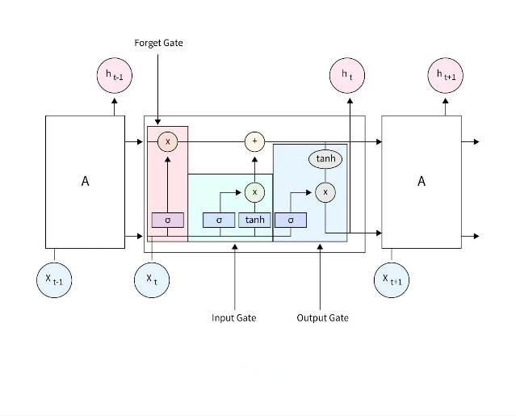
Among deep learning models, Recurrent Neural Networks (RNNs) networks have been widely used in stock price forecasting tasks. RNNs are designed to handle sequential data by passing information from one timestep to the next, enabling the network to develop an internal memory of past events. However, RNNs often suffer from vanishing gradients, which limit their ability to capture long-term dependencies [20]. As a result, LSTMs were developed to address this challenge. They extend the RNN design by adding memory cells and gating mechanisms that regulate how information is stored, updated, or discarded over time. The three gates, forget, input, and output, allow the network to preserve critical signals while filtering out irrelevant noise. This selective retention makes LSTMs highly effective for financial time series, where short-term volatility and long-term momentum must both be considered. Empirical studies confirm that LSTMs consistently outperform traditional models and simple RNNs in financial forecasting tasks, especially for single-ticker or medium-horizon predictions [19].
Figure 1. LSTM Architecture
Despite their strengths, LSTMs have inherent scalability issues in multi-stock or high-frequency environments. Because they process sequences step by step, training across hundreds of tickers or for long horizons becomes computationally expensive. This bottleneck has led researchers to explore newer architectures better suited to parallel computation.
Transformers address these challenges by replacing recurrence with a self-attention mechanism. Instead of relying on sequential hidden states, Transformers learn relationships between all positions in a sequence simultaneously. This allows them to capture long-range dependencies more effectively and to scale across modern parallel hardware such as GPUs. Unlike LSTMs, which struggle when forecasting long horizons or large universes of stocks, Transformers maintain accuracy even in extended sequences while training more efficiently at scale [20].
However, Transformers also have trade-offs. Comparative studies show that while they deliver superior accuracy, achieving lower Mean Absolute Error (MAE) and Mean Squared Error (MSE), they consume significantly more memory and require longer training times [20]. For example, in a study across IT consulting firms, LSTM achieved an MAE of approximately 7.15 million on Capgemini stock, while RNN performed slightly better at 6.35 million. The Transformer model reduced MAE dramatically to 2.99 million, but training time increased from about 21 seconds (LSTM) to 95 seconds (Transformer), and memory usage rose between 5 and 37 MB [20]. Similar patterns were observed on Infosys stock data, where the Transformer achieved an MAE of 0.29 million compared to 0.58 million for both LSTM and RNN [20]. These results underscore the trade-off between accuracy and computational efficiency.
Beyond baseline comparisons, recent research has introduced domain-specific adaptations of Transformers for finance. Chen et al. [21] proposed multi-iTR, applying a multi-task learning framework to stock forecasting. By sharing a Transformer encoder across multiple stocks and using stock-specific decoders, the model captures both market dynamics and individual ticker behaviour. Results show that multi-iTR outperformed state-of-the-art baselines, achieving the highest accuracy on 66% of stocks for 5-day forecasts and 69% for 10-day forecasts, surpassing PatchTST on 81% of tested stocks [21].
These innovations reflect a broader shift in financial forecasting research. While LSTMs remain effective for capturing sequential patterns in smaller-scale or single-ticker contexts, Transformers, and especially their specialised variants like multi-iTR, are better equipped for modern challenges: scaling to hundreds of assets, integrating multi-modal data, and modeling complex dependencies across time and features. The trajectory of research thus points toward increasingly flexible and scalable architectures that move beyond single-source OHLCV inputs to combine price, technical, sentiment, and even cross-asset information [18].

Hybrid Techniques: Decomposition and Optimisation
Even the most advanced architecture requires robust preprocessing and optimisation strategies. Financial time series are noisy and non-stationary, often containing overlapping cycles and volatility shocks. These characteristics make it difficult for deep learning models to distinguish genuine patterns from random fluctuations. To address this challenge, decomposition techniques such as Multivariate Empirical Mode Decomposition (MEMD) have been widely applied.
MEMD decomposes multivariate signals into a set of Intrinsic Mode Functions (IMFs), each representing oscillations at different frequencies [5]. Unlike fixed-basis transformations (e.g., Fourier or wavelets), MEMD is adaptive and data-driven, meaning the decomposition is shaped by the actual signal rather than predetermined functions. This property makes MEMD well-suited for financial markets, where data patterns are irregular and influenced by sudden exogenous shocks.
By breaking down the original OHLCV series into IMFs, MEMD provides a hierarchy of components: low-frequency modes often capture long-term market trends, while high-frequency modes reflect short-term volatility and noise. When these IMFs are fed into a forecasting model such as LSTM, the network can focus on cleaner, more interpretable sub-signals instead of attempting to learn from raw, noisy data. This decomposition improves learning stability, reduces overfitting, and allows models to better generalize to unseen conditions.

While decomposition enhances input quality, optimisation determines how effectively the model parameters converge. The Aquila Optimizer (AO) is a recently proposed metaheuristic inspired by the hunting strategies of eagles [5]. AO alternates between exploration (searching broadly across the solution space to avoid premature convergence) and exploitation (refining solutions near promising regions), striking a balance between global search and local tuning. Unlike gradient-based optimisers such as Adam or stochastic gradient descent, AO does not rely on gradient information, making it more robust to the non-convex landscapes typical of deep learning models.
Figure 2. Aquila optimiser (part 1)
Ge [5] demonstrated the effectiveness of combining MEMD with AO in a hybrid MEMD-AO-LSTM framework. In this setup, MEMD first decomposes OHLCV data into IMFs, serving as structured inputs to the LSTM. The Aquila Optimizer then fine-tunes the hyperparameters of the LSTM, such as the number of hidden units, learning rate, and batch size, ensuring that the network converges to a configuration that maximises predictive accuracy. This two-stage enhancement directly addresses two common weaknesses in stock prediction: noisy inputs and poorly tuned models.
The results were striking. The MEMD-AO-LSTM model achieved an RMSE of 27.12, MAE of 19.43, and R² of 0.992 on the S&P 500 and CSI 300 indices, outperforming baseline LSTMs and even other hybrid models [5]. Beyond accuracy, the approach showed robustness under exogenous shocks, maintaining performance during the COVID-19 pandemic and periods of geopolitical uncertainty. This resilience highlights a critical advantage: MEMD-AO frameworks are not only accurate under normal market conditions but also adaptable to crisis periods when volatility spikes.
Table 1. Models’ comparison
Model | Strengths | Limitations | Scalability Strategy
RNN | Fast training, low memory use | Poor handling of long dependencies | Per-ticker feasible, limited depth
LSTM | Captures medium-term dependencies, robust gating | Sequential, slower than RNN | One model per ticker (500+ models)
Transformer | Long-range dependencies, parallelizable | High memory and computing cost | Possible, but resource-intensive
Multi-iTR | Multi-task, scalable across many tickers | Architectural complexity | Shared encoder across tickers
MEMD–AO–LSTM | Noise reduction (MEMD), robust tuning (AO) | Still sequential, per-ticker scaling. MEMD and AO require longer training time | One model per ticker, rolling retrain

Explainability and Sentiment Integration
Accuracy alone is insufficient for financial adoption; explainability and sentiment integration are equally critical. Many AI models in finance are criticised as “black boxes,” making it difficult for investors to trust predictions or regulators to approve their use. As its core, sentiment has long been recognised as a driver of market behaviour. Early classification approaches used Naive Bayes or SVMs, but financial-domain deep learning models such as FinBERT have since demonstrated superior performance in extracting sentiment from financial news [18]. However, FinBERT faces constraints, including limited handling of long documents and weak temporal context.
Recent literature has explored hybrid approaches that leverage LLMs to enhance sentiment modelling. Chen and Kawashima proposed a sentiment-aware Transformer, where LLMs generate “formulaic alphas” combining OHLCV data and sentiment features [18]. These alphas act as structured, interpretable signals, mitigating alpha decay and improving both accuracy and transparency. Furthermore, explainability frameworks further enhance adoption. Tools such as SHAP (Shapley Additive Explanations) and LIME (Local Interpretable Model-Agnostic Explanations) attribute predictions to specific features, bridging the gap between complex models and user trust. By combining explainable sentiment integration with robust predictive models, FinVision provides investors not only with forecasts but also with rationales, addressing both performance and interpretability.

Solution Design
FinVision was conceived as a comprehensive, AI-driven platform with a clear mission: to empower a diverse range of users, from individual retail investors to junior financial analysts and market enthusiasts, with sophisticated tools for financial analysis and investment. The core philosophy was to democratise access to advanced financial intelligence by simplifying complex data processing, offering insightful portfolio management tools, and ensuring that all AI-driven recommendations were understandable. The platform’s architecture was designed around the principles of modularity, scalability, and user-centricity, delivered through an intuitive web interface.

Project Refinement

Scope of Work
Initially, FinVision was envisioned with an end-to-end feature set. Our original plan of the project included four core modules: automated collection of key metrics from reliable sources, market sentiment analysis powered by the Gemini model, an AI stock recommendation engine using time-series models, and a user-friendly web interface to tie it all together. In addition, a custom web crawling system, was also planned to supply data for sentiment analysis. This scope aimed to cover the entire investment analysis lifecycle, from raw data to actionable insight. As the project progressed, the team made several strategic refinements to navigate practical, technical, and financial challenges. These decisions were crucial for focusing resources on high-impact areas and ensuring the delivery of a robust and viable product.
- Data Acquisition Strategy: The plan to build a proprietary web crawler was de-scoped upon realising the immense engineering effort required not just for development, but for long-term maintenance against constantly evolving anti-scraping technologies. This, coupled with the ethical and legal complexities of web scraping, led the team to pivot towards more reliable and standardised financial data APIs.
- Real-Time Data Deferral: The implementation of real-time stock data visualisation, while valuable, was deferred. This decision was made due to the significant subscription costs required for reliable, low-latency API access, which exceeded the project’s budget.
- Sentiment Analysis Architecture: The decision to replace the FinBERT model with Google’s Gemini LLM was driven by a strategic opportunity to leapfrog in capability. While FinBERT is effective, the rapid advancements in LLMs presented a chance to achieve a significantly higher degree of accuracy and contextual understanding. Gemini’s ability to interpret nuance, sarcasm, and complex sentence structures in financial news, thing that specialised models can struggle with, was a compelling advantage. This pivot was a proactive choice to enhance the quality and reliability of a core system input, justifying the integration effort.
- Predictive Model Benchmarking: The initial idea of exploring a wide range of models was refined to a more scientific and focused approach. Instead of a broad but potentially shallow survey, the team chose to conduct a rigorous benchmark comparison between established baseline models (LSTM, Random Forest) and state-of-the-art Transformer architectures. This approach allowed for a deeper investigation into which model type truly performs best on financial time-series data when subjected to methodical processes like data decomposition and hyperparameter optimization, yielding more valuable and defensible insights.
- Company Filtering Mechanism: The methodology for company filtering during portfolio creation was enhanced to improve its robustness. The initial concept of a simple, one-to-one KPI matching system, which could fail to return any matching companies, was replaced. The system was upgraded to utilise a K-Means clustering approach, where user preferences define a centroid. Companies are then ranked based on their Euclidean distance to this centroid, ensuring that a relevant and ranked list of investment options is always provided.
- Generalisation and Forecasting Scope: The initial goal to cover the entire S&P 500 with sentiment-enhanced predictions was found to be computationally and financially unsustainable. The cost of running the advanced Gemini LLM pipeline on news for 500 companies continuously was immense. Therefore, a hybrid strategy was adopted as an intelligent compromise. By focusing the expensive sentiment analysis on a small, representative set of 10 stocks, the project could demonstrate the model’s full potential. Meanwhile, training on a larger set of 400 stocks using only historical data ensured the model’s broader applicability, balancing deep, innovative analysis with practical scalability.
- Agentic AI: Recognising the undeniable rise of agentic AI and the growing prevalence of AI-powered tools, our team KITTO has strategically expanded the scope of this project to introduce KITTO Agent, a speech-to-speech agentic AI that allows users to interact with the platform directly through natural speech. With this advancement, users are no longer limited to traditional interfaces but can instead engage in conversations that make the system more accessible and intuitive. The agent is designed to be able to call internal APIs, including those for sentiment prediction, sentiment analysis and portfolios retrieval, in response to user requests, thereby enabling a more personalised access to critical insights. Ultimately, this extension reflects our vision of positioning Kitto as both a cutting-edge financial analysis tool and a conversational assistant that adapts to the evolving needs of investors.

Performance Metrics Refinement
To align with the refined scope, the project’s success criteria were solidified into clear, measurable targets. These final metrics defined the “definition of done” and guided the final evaluation of the platform.
Table 2. Performance Evaluation
Project Component | Metric | Final Target Value | Note
Sentiment Analysis | Classification Accuracy | Around 80% | The target was increased from an initial 70% following promising results with the Gemini LLM pipeline.
Stock Price Trend Classification | Classification Accuracy | Around 60% | Assessed via back testing the model on a defined historical dataset of S&P 500 stocks.
Explainable AI (XAI) | Explanation Generation | Functional Demonstration | Success is defined by the system’s ability to produce understandable outputs on the dashboard that are logically linked to model recommendations.
System Usability | UI/UX | All UI/UX feedback is resolved. | Ensures the UI is intuitive and free from significant performance issues under expected test conditions.
Feature Completion | Functional Completeness | 100% | All essential functionalities outlined in the final system design are implemented and fully operational.

Detailed System Design
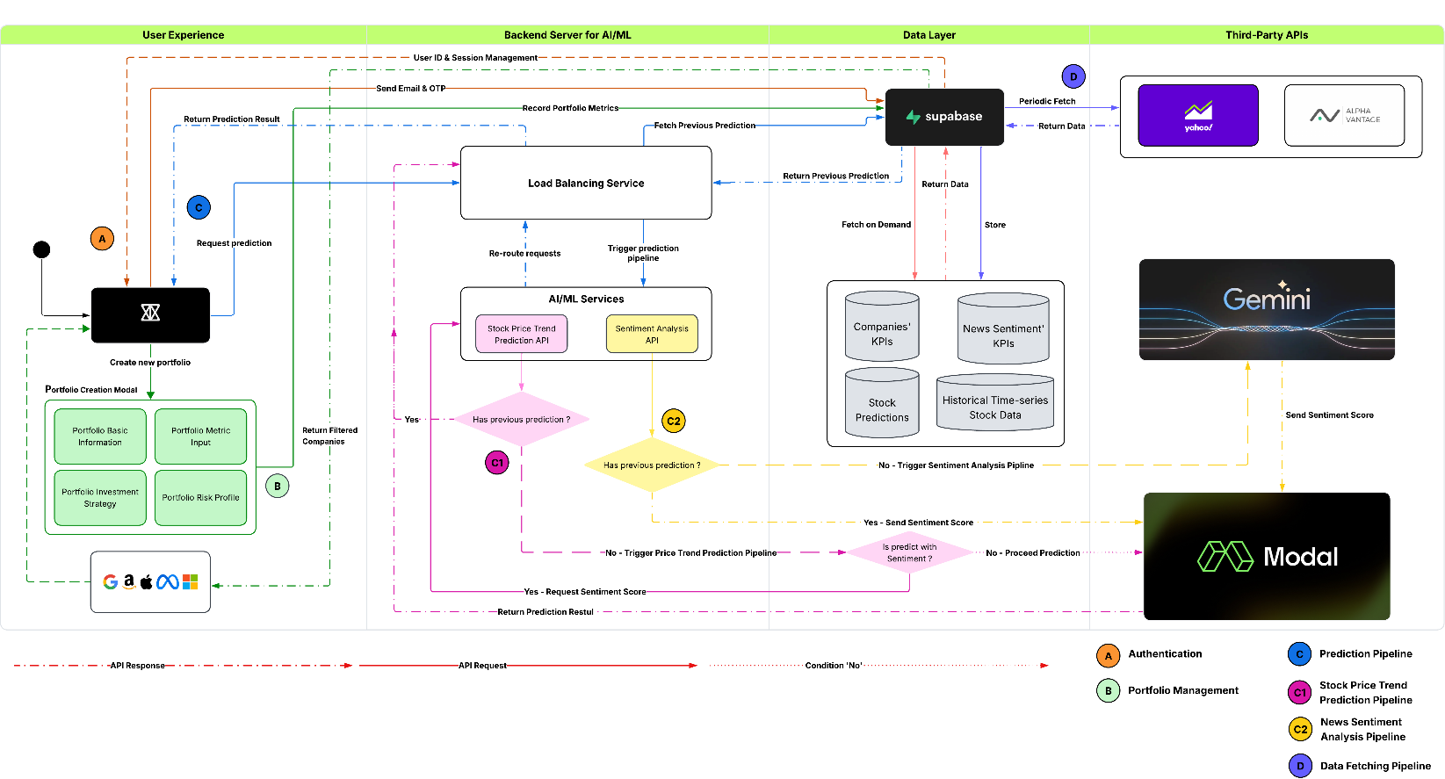
Figure 3. Solution design diagram

Stock prediction
The stock recommendation system is implemented as a modular architecture with a pipeline-based workflow that supports both training and inference. The design emphasizes reproducibility and scalability, while allowing for independent modelling of individual stocks. Instead of treating all assets under a single unified framework, the system deliberately trains a separate model per ticker, enabling rapid retraining on rolling windows and ensuring that the unique dynamics of each asset are captured without interference from unrelated securities.

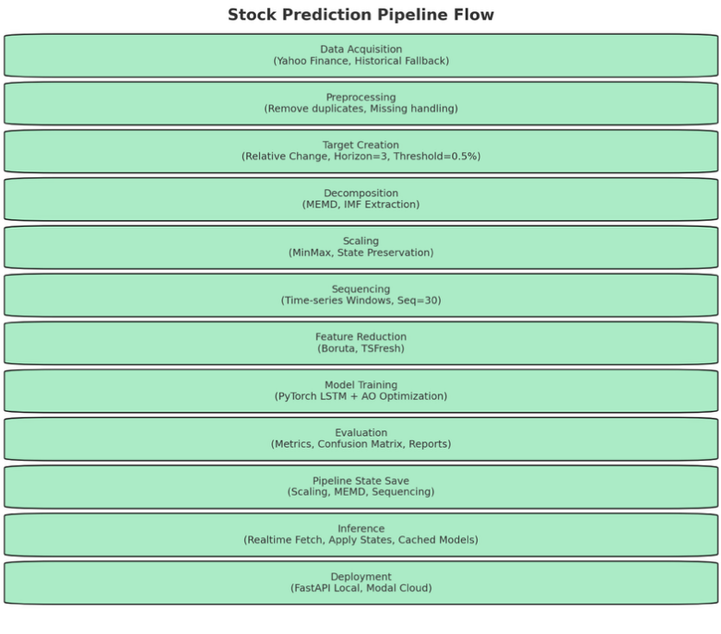
Data Processing and Feature Engineering
The first stage of the system is devoted to preparing raw market data into structured form. Historical OHLCV data serves as the foundation, but to mitigate the impact of market noise, it is passed through MEMD. This method decomposes each time series into IMFs that isolate patterns at different frequency levels, thereby separating long-term cycles from high-frequency volatility. MEMD is parameterised with configurable settings such as direction vectors and maximum decomposition levels, and its implementation ensures efficiency when applied to multiple tickers simultaneously.
Once decomposition is complete, the resulting features are normalised using MinMax scaling. Importantly, the scaling parameters are preserved as state objects so that the exact same transformations can be reapplied during inference. The cleaned and scaled data is then segmented into fixed length rolling windows, typically thirty days long, forming the temporal context for prediction. Labels are then generated by comparing price movements over a configurable horizon, most commonly three days, with thresholds set to distinguish bearish, neutral, and bullish outcomes. This formulation frames the forecasting task as a three-class classification problem, emphasising directional signals that are actionable for trading decisions.
Figure 4. Stock prediction pipeline

Model Architecture and Training
The predictive core of the stock recommendation system is structured around a modular architecture that separates preprocessing, model definition, training, and evaluation. This modularity is achieved through facade interfaces, which encapsulate tasks such as preprocessing, decomposition, sequencing, target creation, hyperparameter tuning, and evaluation. By abstracting these stages, the system maintains reproducibility across experiments and facilitates extensibility when adding new models or feature-processing methods.
At the preprocessing level, raw OHLCV data is standardised and decomposed into structured features. The Data Preprocessing Facade applies Min-Max scaling with persistence of transformation parameters, ensuring that the same scaling applied during training is reapplied at inference. Noise in the market data is reduced using the Data Decomposition Facade, which implements MEMD. It decomposes OHLCV signals into IMFs that isolate cyclical patterns at different frequencies, thereby enabling the learning models to focus on clearer and more interpretable sub-signals.
Once features are prepared, the Data Sequencing Facade converts them into rolling windows of fixed length, specifically 30 days. Each window represents a temporal context for the prediction of future market direction. Labels are then generated by the Target Creation Facade, which uses relative percentage change over a configurable horizon (three trading days in the current implementation). Predictions are classified into three categories, bearish, neutral, and bullish, based on a ±0.5% threshold. This formulation transforms the problem into a multi-class classification task that emphasises directionality rather than exact price prediction.
The core model used in production is the PyTorch-based LSTM, defined in a two-layer stacked configuration with dropout regularisation. LSTMs are particularly suited for this application because of their gating mechanisms, which allow them to retain relevant information over long sequences while filtering out noise. Each ticker is modeled independently, resulting in approximately 500 separate models for the S&P 500. This per-ticker strategy increases the number of models to manage, but it allows each network to specialize in the dynamics of an individual stock and supports rapid retraining on rolling windows as new data becomes available.
To optimize model performance, hyperparameters such as hidden units, learning rate, and dropout are tuned via the Hyperparameter Tuning Facade, which employs the AO. AO is incorporated as an optional metaheuristic search method, complementing the baseline Adam optimiser. Training is performed with a 70/15/15 split for train, validation, and test data, using cross-entropy loss. Early stopping with a minimum delta of 1e-3 prevents overfitting, and device selection is automated across CPU, GPU, or Apple MPS.
Table 3. Final LSTM Pipeline Configuration (Derived from A.O)
Component | Configuration Value
Input Features | OHLCV + Sentiment score
Decomposition Method | Multivariate Empirical Mode Decomposition
MEMD Parameters | ndir_min=64, min_sifts=3, max_imfs=6
Sequence Length | 30 trading days
Target Horizon | 3 trading days ahead
Classification Threshold | ±0.5% relative change
Model Core | Two-layer LSTM (PyTorch)
Hidden Units | 64 (per LSTM layer, configurable)
Regularization | Dropout between LSTM layers
Loss Function | Cross-entropy
Optimizer | Adam
Hyperparameter Tuning | Aquila Optimizer (AO) via HyperParamFacade
Training/Validation/Test | 70% / 15% / 15%
Early Stopping | Patience with min_delta=1e-3
Hardware Utilization | CPU / GPU / Apple MPS (auto-selected)
Alongside the LSTM pipeline, the system also supports a Transformer-based architecture as an experimental alternative. This model is integrated into the same facade-based pipeline, allowing it to use the identical preprocessing, decomposition, sequencing, and target creation procedures. By maintaining compatibility with the established abstractions, the Transformer can be benchmarked directly against the LSTM under identical conditions.
Each Transformer is trained on a per-ticker basis, mirroring the LSTM setup. This design choice reflects the limited number of input features (OHLCV and MEMD components), which do not necessitate the high-capacity multi-ticker frameworks such as Multi-iTR. Instead, a simplified Transformer is employed, optimized for training efficiency across hundreds of individual stock models.
The input consists of 30-day rolling windows of decomposed OHLCV features. Each sequence is projected into an embedding space of configurable dimensionality (default 64), with sinusoidal positional encodings added to preserve temporal ordering. The encoder is composed of stacked self-attention layers, each including multi-head attention and feed-forward blocks with residual connections and normalization. Dropout regularisation is also applied mitigate overfitting.
The model outputs probability distributions over the three target classes, bearish, neutral, and bullish, consistent with the labeling strategy used in the LSTM pipeline. Training uses cross-entropy loss with a 70/15/15 split for train, validation, and test data. Adam is the default optimiser, though hyperparameters such as the number of attention heads, hidden size, and encoder depth can be tuned via the Hyperparameter Tuning Facade.
Compared to the LSTM, the Transformer demonstrates greater capacity for capturing long-range dependencies, but at the cost of higher memory and compute requirements. The simplified configuration, using fewer layers and moderate embedding sizes, was adopted to balance predictive performance with the need to manage potentially 500 per-ticker models.
Table 4. Final Transformer configuration (Derived from A.O)
Component | Configuration Value
Input Features | OHLCV + Sentiment score
Sequence Length | 30 trading days
Embedding Dimension | 64 (configurable)
Positional Encoding | Sine–cosine
Attention Heads | 2–4 (configurable)
Encoder Layers | 2–3 (lightweight for per-ticker use)
Regularization | Dropout (0.2–0.3)
Loss Function | Cross-entropy
Optimizer | Adam
Hyperparameter Tuning | Supported via HyperParamFacade
Training/Validation/Test | 70% / 15% / 15%
Early Stopping | Enabled, min_delta=1e-3
Hardware Utilization | CPU / GPU / Apple MPS (auto-selected)
Input Features | OHLCV + MEMD components
Sequence Length | 30 trading days
Embedding Dimension | 64 (configurable)
By supporting both LSTM and Transformer within the same modular framework, the system ensures flexibility for experimentation. While the MEMD–AO–LSTM remains the production-ready choice due to its efficiency and robustness, the Transformer provides a scalable research alternative that highlights the potential benefits of attention mechanisms in financial forecasting

Inference and State Management
The inference pipeline is engineered to ensure that predictions remain fully consistent with the transformations applied during training. This reproducibility is achieved through the Pipeline State module, which serializes and restores every preprocessing component. Scaling parameters, MEMD decomposition settings, and windowing configurations are all stored as state objects at training time and reapplied during inference. As a result, incoming live data undergoes identical transformations, eliminating the risk of data leakage or inconsistencies between training and production environments.
The Inference Engine orchestrates the end-to-end process. Incoming OHLCV data is first acquired through the Yahoo Finance API, with a built-in fallback mechanism to cached historical datasets when live feeds are unavailable. This dual approach ensures continuous operability even under unstable network or API conditions. Once data is retrieved, the engine applies the preserved scaling transformations, decomposes features via MEMD if enabled, and reshapes them into rolling windows consistent with the training pipeline. Each ticker-specific model, stored as a PyTorch state dictionary, is loaded into memory on demand. To minimise latency for repeated queries, the system implements per-ticker model caching, where once a model is loaded, it remains active for subsequent requests. Predictions are generated as probability distributions across the three directional classes, bearish, neutral, and bullish. These probabilities are returned alongside confidence scores, providing transparency into prediction certainty. Importantly, inference is designed to be stateless: every request is independent, relying solely on serialised pipeline states and cached models. This allows for horizontal scaling, since multiple workers can serve requests in parallel without sharing session information.
The system also incorporates logging and evaluation hooks during inference. Every prediction, along with its input window and model version, can be recorded, creating a complete audit trail for back testing or regulatory review. This feature enhances traceability, ensuring that recommendations can always be traced back to the exact data, preprocessing states, and model instance that produced them.

Deployment architecture
For local development and testing, the system runs through a FastAPI-based server implemented in Python, hosted locally. This interface exposes endpoints for data submission, prediction, and health checks, enabling rapid debugging and experimentation. Because it directly connects to local models and state files, the team can validate updates to preprocessing, decomposition, or model weights without requiring cloud resources.
For production deployment, the system leverages Modal’s serverless infrastructure. Modal provides an elastic, cloud-native environment where inference workers are automatically provisioned and scaled according to request load. Each worker is stateless and lightweight, designed to boot rapidly, load the relevant ticker model from persistent storage, and serve predictions before terminating or returning to an idle state. This model ensures cost efficiency while retaining the ability to handle peak loads across hundreds of tickers.
Performance optimisation is achieved through caching and modularisation. When a ticker is first requested, its model is loaded and cached, significantly reducing response time for subsequent requests. The caching system operates independently per worker, enabling parallelism across distributed inference servers. Since the pipeline is designed stateless, Modal can spin up any number of concurrent workers, each applying identical pipeline states, ensuring consistency at scale. The APIs return standardised JSON responses that include predicted labels, class probabilities, and metadata describing the applied preprocessing states and model identifiers. This format ensures downstream applications can parse results easily and interpret them in the context of the underlying transformations.
Together, these deployment strategies allow seamless transition from research to production. Local servers provide the flexibility for iterative development, while Modal’s cloud-based infrastructure ensures scalability and reliability under real-world conditions. The architecture combines the transparency of detailed metadata with the robustness of stateless design, supporting both performance and interpretability.

Explainable AI (XAI) Integration
To validate feature selection and provide interpretability, the system incorporates explainable AI techniques during model evaluation. SHAP (Shapley Additive Explanations) and Integrated Gradients were applied to trained models to attribute predictive importance to individual input features. Analysis consistently showed that the basic OHLCV indicators were the most influential variables driving model predictions. This finding aligns with prior financial forecasting literature, confirming that OHLCV serves as a stable and reliable foundation for trend prediction tasks (Figure 15, 16, 17).
The use of XAI not only supports transparency but also justifies the system’s design choice to prioritise OHLCV features in model training, ensuring that the pipeline remains both interpretable and grounded in empirically validated predictors.

Sentiment analysis
In contemporary financial markets, sentiment has become a powerful force that frequently dictates short term price movements. A single tweet, regulatory announcement or company press release can trigger unexpected fluctuations, leading to both sudden gains and sharp losses. Recognising this undeniable dynamic, our team designed and implemented a Sentiment Analysis Pipeline to ensure that the Kitto platform is not only technically rigorous but also responsive to the contextual drivers of the market.
The purpose of this pipeline is twofold. First, it provides an accurate daily sentiment score that is directly integrated into the stock price prediction pipeline, allowing our models to remain sensitive to the prevailing mood of the market. Second, it offers detailed and reliable financial report summarisation and sentiment analysis, enabling both the system and its users to quickly interpret the likely impact of financial disclosures without the need for manual review. This dual capability ensures that Kitto is robust against sudden market movements while also equipping users with accessible insights.
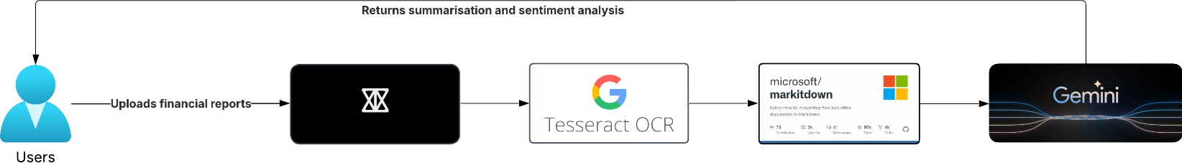
Figure 5. Sentiment analysis pipeline
From a technical standpoint, the pipeline was implemented in two distinct but complementary components. The news-based sentiment pipeline focuses on external market signals. All relevant news articles, including titles, links and sentiment scores, are sourced primarily from the End of Day Historical Data (EODHD) API, with Alpha Vantage integrated as an alternative provider to guarantee continuity. Given the transient nature of financial news, only articles from March 2022 onwards are collected, ensuring that the dataset remains current and applicable to modern market conditions. For each tracked stock, daily news items are retrieved, processed and stored. The sentiment scores derived from these news articles are then used as an additional feature column to the stock price prediction pipeline, thereby creating sentiment aware forecasting models. Meanwhile, the same news items are displayed on the platform’s arket page, where users may view up to date articles and follow direct links to the original sources. In this way, the pipeline benefits both the predictive modelling process and the end user experience, creating a system that is technically robust and practically informative.
The financial report sentiment pipeline, by contrast, deals with structured corporate disclosures and is deliberately designed to minimise external bias. Here, the data is drawn directly from the reports themselves rather than from secondary news commentary. Users can upload financial reports in a wide range of formats, including PDF, Word and image-based documents. To ensure consistency, an optical character recognition (OCR) stage is applied to scanned or image-based files, converting them into raw text. This raw text is then passed through MarkItDown, which normalises the content into markdown format, a representation that is both lightweight and efficient for processing by LLMs. The normalised content, together with our constructed system prompts, is sent to the Gemini API, returning a structured summary of the report alongside a sentiment evaluation. This process delivers a concise yet comprehensive understanding of the report’s implications, saving users considerable time and effort. For efficiency reasons, and given the high volume of reports processed, the analysed data is stored in the system’s database with a retention period of three days, after which it is removed to optimise memory usage without compromising user access to recent results.
In conclusion, the sentiment analysis pipeline significantly enhances both the resilience and usability of the Kitto platform. By combining daily sentiment scores from market news with on demand financial report analysis, it ensures that the system does not rely exclusively on technical indicators but is instead informed by the broader market environment.

Web platform
The central access point for all features of our system is the web platform, named Kitto. It is designed as the primary hub through which users interact with every component of the solution, ranging from predictive models to sentiment analysis and portfolio management. The platform serves as a channel that translates complex processes into an accessible and intuitive experience. In doing so, it reduces the cognitive burden placed on users, ensuring that the full breadth of the system’s capabilities can be utilised without requiring specialist knowledge or lengthy onboarding.
From a design perspective, the web platform has been guided extensively by established principles of human–computer interaction, particularly the Nielsen ten heuristics for usability. Wherever possible, these principles have been implemented directly into the interface. For example, the number of options presented at any one time is deliberately limited to reduce decision fatigue and lower cognitive load. Similarly, multi-theme support has been incorporated, allowing users to select between themes according to personal preference, which improves comfort and accessibility. The avoidance of unnecessary animations or visual effects reflects a further design decision to accommodate users who may be sensitive to distraction, such as those with attention-related symptoms. Moreover, the platform also embodies the principles of modern, minimal and aesthetic design. Each interface element is crafted to convey a single, clear function rather than overloading the user with excessive information. Text displayed on screen is deliberately free from jargon wherever a simpler equivalent exists, the aim being to improve comprehension without diluting technical accuracy. Responsive design is also supported via Tailwind CSS breakpoints, allowing the platform to adapt seamlessly to different devices. This adaptability is essential given the increasing diversity of user devices and the expectation that modern platforms should operate consistently across all of them. The overall result is an environment that is professional, modern and accessible to a broad range of users, irrespective of their level of financial or technical expertise.
Finally, to maintain relevance and ensure that the platform continues to feel contemporary, the team has engaged in regular design research sessions. Sources of inspiration include well-established platforms, and design showcases such as Dribble and Pinterest, offering valuable insight into current trends in interface design. These sessions not only ensured that the platform remained visually appealing but also helped to reinforce the principle that functionality alone is insufficient for user adoption but rather usability and accessibility that fit to the needs of its users.
On the technical side, the platform is divided into four submodules, each responsible for a distinct aspect of functionality. This modular approach allows the system to remain scalable, maintainable and easier to extend in future iterations.

Core Web System
The Core Web System was designed as the backbone of the platform, providing the structural and functional base upon which all other features depend. In developing this module, the team prioritised technologies that could deliver high performance, long-term maintainability and seamless integration across the full stack. Each decision was guided by the principle of selecting tools that were not only technically strong but also widely recognised, thereby ensuring both current reliability and future extensibility.
The decision to build on Next.js was central to this design. As a React-based environment, Next.js supports both client-side and server-side rendering, giving the flexibility to optimise performance where required. Server-side rendering was adopted to reduce initial load times and to improve responsiveness, qualities that are particularly important in financial applications where users expect near real-time performance and stability. Next.js also integrates frontend and backend development within a single environment, simplifying the overall architecture and reducing the need for multiple frameworks. This in turn lowers complexity, improves collaboration and supports the delivery of a modern and performant system.
For styling, the team selected Tailwind CSS version 4. The design rationale here was its utility approach, significantly speeding up development while maintaining consistency and readability. Unlike traditional CSS frameworks, Tailwind allows styles to be applied directly within the component structure, making it easier to enforce the platform’s design principles. This choice also supports responsive layouts through predefined breakpoints, ensuring the platform adapts smoothly to mobile devices, tablets and wide monitors.
For data management at the frontend level, the team employed TanStack Query. This library was chosen for its dual capability as both a caching layer and a global state management tool, eliminating the need for additional state libraries such as Redux. By caching API responses, it reduces redundant calls to the database, conserving resources and improving responsiveness. Its ability to centralise state management further simplified the overall architecture, reducing complexity and making the platform more efficient.
Furthermore, the runtime environment is powered by Bun, selected over traditional alternatives such as npm and Yarn due to its superior performance. Bun offers faster package resolution and shorter build times, accelerating the development process and enabling quicker iterations. In an Agile development environment, this efficiency proved especially valuable, allowing the team to deliver improvements rapidly without compromising system stability.
For data storage, Supabase was selected to provide a robust yet flexible solution. Built on PostgreSQL, Supabase combines the reliability of a mature relational database with modern developer-oriented features such as real-time engine, built-in authentication and a user-friendly dashboard. Its compatibility with SQL ensures that future migration or scaling remains possible, avoiding vendor lock-in. To manage schema definition and migrations, Drizzle ORM was used in conjunction with the PostgreSQL library, chosen for its ability to enforce type safety, simplify schema management and maintain consistency between development and production environments.
The backend is also implemented using Next.js, with server components and file-based routing used to define RESTful APIs. REST was selected because of its simplicity, wide adoption and ease of integration. This enforces that the platform’s APIs remain straightforward to understand, extend and maintain, both by the current team and by future developers. As a result, to manage communication across the platform, two distinct layers were implemented. The API Service class was designed to handle requests between the frontend and backend systems, including communication with the Python-based services. The API Proxy Handler, by contrast, was reserved for server-side communication within or between servers, reducing latency and ensuring secure and efficient exchanges that do not require client involvement.
AI features, such as integration with the Google Gemini API, were implemented using the Vercel AI SDK. This choice was made because the SDK abstracts much of the complexity of working with large language models, provides native support for streaming outputs and integrates seamlessly with the Next.js environment. Finally, the platform is hosted on Vercel, which was selected for its optimised support for Next.js, automated deployment pipelines and scalable serverless infrastructure. Hosting on Vercel reduced operational overhead while ensuring that the platform remains reliable, performant and capable of adapting to demand.
In summary, the Core Web System reflects a deliberate and coherent design strategy. Each technology was chosen not in isolation but as part of an integrated solution that prioritises usability, scalability and maintainability. The combination of Next.js, Tailwind CSS, Bun, Supabase and Vercel ensures that the system is modern, efficient and well positioned to support the growth and evolution of the Kitto platform.

Stock Market View
The Market View was designed as the common interface through which users can explore up-to-date and historical stock data, alongside relevant news and sentimental information. The guiding principle behind this module was to present complex financial data in a format that is both familiar and intuitive, while at the same time ensuring performance and scalability. To achieve this, the design drew inspiration from widely used crypto trading platforms such as OKX and Binance, adopting familiar layouts and presentation styles. This approach was deliberately chosen to improve user recognition and reduce onboarding time, as many users already have experience with similar trading applications.
At the core of this page lies the charting functionality, implemented using TradingView. TradingView was selected because it is widely recognised as an industry-leading charting library, offering professional-grade visualisations and extensive support for financial data. By leveraging TradingView, the team avoided the significant overhead of building a custom charting solution while providing users with best-in-class charting capabilities. To maintain clarity and reduce unnecessary complexity, the platform currently supports two chart types: the Candlestick chart and the Line chart. These were selected because they represent the most common and widely understood formats for financial analysis, ensuring accessibility for both new and experienced investors.
In an essence, the data displayed in this page, including both historical stock prices and news, is sourced from the database and cached for efficiency. However, because of the large volume of data transmitted, particular attention was paid to performance optimisation and scalability. Two mechanisms were designed and implemented to address these challenges. The first is a lazy loading mechanism, whereby stock data is only fetched when it is required. Specifically, the system loads data for stocks currently visible on the user’s screen, and additional data is fetched on demand as the user scrolls using Intersection Observer API. Once retrieved, this data is cached on the client side using TanStack Query, allowing instant retrieval the next time it is requested. This design ensures that resources are not wasted on unused data while simultaneously improving responsiveness for repeated interactions. The second is a load balancing mechanism, building upon Supabase’s underlying architecture. In general, Supabase automatically distributes network traffic across multiple instances, but to further optimise this, the team implemented a queuing system that regulates API calls. This queuing mechanism requests in an efficient manner, preventing server overload and maintaining performance even during peak hours.
Together, these design choices allow Market View to balance functionality with efficiency. By combining a familiar interface inspired by popular trading applications, professional-grade charting through TradingView, and robust performance mechanisms, the module provides a market exploration tool that is both powerful and accessible.

Portfolio Management
The Portfolio Management module was designed to provide users with a structured, guided way to construct and manage their investment strategies. Its feature is called Portfolio Wizard, an interactive form that supports the creation of new portfolios by walking users through two key steps. The first step involves entering basic information that differentiates one portfolio from another. The second step is more critical: users must select their investment goals and risk tolerance, both of which directly influence the configuration of the portfolio’s key metrics.
Key Portfolio Metrics
Each portfolio is uniquely defined by an identifier, a name and five performance metrics. These metrics were carefully chosen to reflect both valuation and risk-return characteristics, ensuring that the portfolios produced are realistic and comparable across a wide universe of companies.
- Price-to-Earnings (P/E) Ratio: Represents the valuation of a company relative to its earnings. A higher P/E ratio often suggests higher growth expectations, whereas a lower ratio indicates undervaluation or slower growth.
- Operating Margin (TTM): Reflects profitability by showing what proportion of revenue remains after covering operating costs. Companies with higher operating margins are generally considered more financially stable.
- Quarterly Revenue Growth (YoY): Measures the annual growth in revenue for a given quarter compared with the same quarter the previous year. This captures the company’s growth trajectory.
- Beta: Indicates the volatility of a company’s stock relative to the market. A higher beta implies greater risk and potential reward, while a lower beta indicates stability.
- Dividend Yield: Shows the annual dividends paid by a company as a percentage of its share price, representing income returned to shareholders.
These five metrics were selected because, in combination, they capture valuation, profitability, growth, risk and income, key considerations for investors with differing strategies.
Investment Goal Defaults
The first step of portfolio construction assigns default values to the five metrics according to the selected investment goal. These values were chosen to mirror the typical financial profile of companies aligned with each strategy.
Table 5. Investment Goal Default Metrics
Goal | P/E Ratio | Operating Margin (TTM) | Quarterly Revenue Growth (YoY) | Beta | Dividend Yield
Growth | 35 | 0.16 | 0.35 | 1.25 | 0.5%
Income | 16 | 0.22 | 0.06 | 0.85 | 4.5%
Balanced | 20 | 0.18 | 0.15 | 1.00 | 2.0%
Speculative | 60 | 0.10 | 0.50 | 1.60 | 0.3%
The reasoning behind these values is as follows:
- Growth: Adopt a high P/E ratio of 35 to reflect investor willingness to pay more for future potential. Revenue growth of 35% and beta of 1.25 capture the expansion and volatility associated with growth companies, while dividend yield remains low (0.5%) as profits are reinvested.
- Income: Focus on stability, with a lower P/E ratio of 16 and higher operating margin (0.22). Dividend yield is set high at 4.5%, reflecting reliable income distribution. A beta of 0.85 further aligns with lower volatility.
- Balanced: Sit between the two, with moderate valuation (P/E 20), growth (15%) and dividend yield (2.0%), alongside average market volatility (beta 1.0).
- Speculative: Follow very high valuation (P/E 60), strong revenue growth (50%) and extreme volatility (beta 1.60). Margins are thin (0.10), and dividend yield is minimal (0.3%), consistent with early-stage companies.

Risk Calibration
This step applies multipliers that adjust the default metrics according to the user’s chosen risk tolerance. This ensures that portfolios not only reflect the selected strategy but also adapt to the investor’s appetite for risk.
Table 6. Risk Tolerance Calibration Units
Risk Tolerance | P/E Ratio | Operating Margin (TTM) | Quarterly Revenue Growth (YoY) | Beta | Dividend Yield
Conservative | 0.85 | 1.10 | 0.85 | 0.90 | 1.15
Moderate | 1.00 | 1.00 | 1.00 | 1.00 | 1.00
Aggressive | 1.20 | 0.90 | 1.20 | 1.15 | 0.85
The reasoning behind these values is as follows:
- Conservative: Favour lower valuations (0.85 multiplier on P/E), higher stability (1.10 multiplier on margins), reduced volatility (0.90 multiplier on beta) and stronger income streams (1.15 multiplier on dividend yield).
- Moderate: Accept the defaults with no adjustments.
- Aggressive investors tolerate higher valuations (1.20 multiplier on P/E), accept lower margins (0.90 multiplier), pursue higher growth (1.20 multiplier on revenue growth) and accept greater volatility (1.15 multiplier on beta), while reducing emphasis on dividends (0.85 multiplier).
Portfolio Construction with K-Means
After the portfolio metrics are finalised, the system utilises the K-means clustering algorithm to identify companies that best match the portfolio’s profile. The portfolio metrics themselves act as a centroid, and the Euclidean distance is calculated between the portfolio metrics and each company’s metrics. As a result, companies are then ranked by proximity to the centroid, with closer matches considered stronger candidates. Compared with the older method of threshold-based filtering, where companies had to pass all five conditions within strict bounds, K-means offers a more flexible approach. To elaborate, threshold filtering risks producing no matches if companies fail even one condition, leaving users without results. By contrast, K-means guarantees a ranked list of candidates, reflecting varying degrees of suitability. This ranking mirrors the real-world investment process, where trade-offs between growth, risk and income are expected rather than eliminated.
In summary, the Portfolio Management module combines user-driven configuration with quantitative analysis. By grounding portfolios in financial metrics, calibrating them to risk preferences and matching them through clustering, the system ensures that users receive personalised, data-driven recommendations that remain consistent with investment logic.

Kitto Agentic AI
Kitto’s Agent is an audio-native conversational assistant designed to provide seamless, low-latency interaction with the platform. It is powered by Google’s Gemini Live 2.5 Flash model, selected for its ability to handle continuous audio input and output streams over a single websocket. Unlike traditional request–response models, Gemini Live provides real-time speech-to-speech generation, which was critical in creating a fluid and natural user experience.
In general, the implementation of the agent began as a fork of Google’s live-api-web-console repository. This open-source project was chosen as the base because it provided stable websocket handling, session lifecycle management, and reliable audio capture and playback primitives. By forking, we were able to reuse the proven core for transport and speech processing, while completely rebuilding the UI layer in Next.js and React to match Kitto’s design system. The result was a system that combines hardened infrastructure with consistent and modern user experience.
A defining feature of the agent is the AGENTS.md specification, acting as its behavioural contract. This document encodes system context, scope of responsibility, refusal templates, domain guardrails and example prompts. It clearly instructs the model to focus only on finance and trading, to decline unrelated queries politely, to explain within the constraints of Kitto’s static-data design, and to use visualisations or tool calls when appropriate. By storing this as a version-controlled file, we ensured that behaviour remains reproducible and auditable. Changes to the assistant’s behaviour are made declaratively by editing AGENTS.md rather than hardcoding logic, simplifying governance and evaluation.
The assistant’s intelligence is extended through tool calling, giving it controlled access to Kitto’s internal APIs. Each tool is declared with a name, a short description, and a parameter schema. When the model determines that additional data is needed, such as fetching a prediction, listing portfolio holdings, or retrieving matching companies, it issues a structured tool call. A dedicated dispatcher validates the arguments against the schema, injects the user’s authentication context, and routes the request to the appropriate backend service. Responses are normalised and streamed back into the live session so that the conversation can continue with fresh data. This design ensures that the model cannot invent new capabilities and can only interact with whitelisted, schema-defined tools. Additionally, the assistant can also surface visual insights. When a chart is relevant, it emits a Vega-Lite specification as a JSON string. The client then uses Vega-Embed to render the chart within a dialogue window, giving users immediate access to visual explanations of numerical results. This supports intuitive understanding of predictions, portfolio performance or market movements without requiring manual chart building.
These choices were made deliberately over simpler alternatives. For example, static text-only assistants lack the immediacy and accessibility of speech; threshold-based access to APIs would risk brittle or insecure behaviour; and manual chart construction would impose cognitive overhead on users. Instead, by combining Gemini Live for real-time dialogue, AGENTS.md for explicit governance, a secure dispatcher for tool calls, and Altair/Vega-Lite for visualisation, Kitto’s Agent extends the platform into a conversational analyst. It allows users to request insights by voice, ensures the right APIs are invoked securely, and presents results as speech, text or charts, all within one coherent interaction loop.

Figure 6. Kitto agent architecture

Result analyses and Discussion

Key results & accomplishments
Our FinVision project had successfully transitioned from an ambitious concept to a tangible, functional platform by adhering to a refined scope and focusing on high-impact deliverables. The key accomplishments are organised by the project’s core components.

Stock prediction
The primary achievement within this component was the successful implementation and rigorous benchmarking of multiple predictive models for stock price trend classification.
- Successful Model Benchmarking: A complete pipeline was established to compare baseline models against a more advanced Transformer-based architecture. This process included state-of-the-art procedures such as time-series data decomposition and systematic hyperparameter optimisation, ensuring a fair and robust evaluation.
- Achievement of Performance Target: The Transformer-based model, particularly when enriched with sentiment data for the 10 focus stocks, successfully achieved the project’s target with 63% classification accuracy on a 3-day prediction horizon. While baseline models performed closer to 53-55%, the Transformer’s superior performance validated its selection and demonstrated the tangible value of integrating advanced architectures.
- Implementation of the Hybrid Data Strategy: A key accomplishment was the operationalisation of the two-tiered forecasting strategy. The system successfully trains a highly nuanced model for 10 selected stocks using costly sentimental data, while simultaneously training a more general model for an additional 400 stocks using historical data alone. This demonstrates a novel approach to balancing analytical depth with computational and financial feasibility.

Sentiment analysis
The sentiment analysis module evolved into one of the project’s most innovative and successful components, exceeding our original expectations.
- Advanced LLM Pipeline Implementation: The project successfully pivoted from the planned FinBERT model to a more powerful pipeline leveraging Google’s Gemini LLM. This involved designing and implementing a system capable of preprocessing financial news articles, crafting effective prompts for the LLM, and parsing its nuanced outputs into structured sentiment labels (e.g., positive, negative, neutral, with a confidence score).
- Exceeding Accuracy Target: Our pipeline achieved a classification accuracy of approximately 82% with Gemini 2.5 flash-lite and 83% with Gemini 2.0 model when evaluated against a manually curated and labelled dataset of financial news headlines. This surpassed the initial 70% target and even the revised 80% goal, providing a high-fidelity data source for the predictive models.
- Demonstrated Nuance and Contextual Understanding: The LLM’s output proved superior in interpreting complex financial language, including forward-looking statements, conditional phrasing, and market sarcasm, which simpler models often misclassify. This accomplishment ensures that the sentiment data fed into the prediction engine is not just accurate, but qualitatively rich.

Web application
The web application was successfully developed as the central hub of the FinVision platform, achieving all functional and usability goals outlined in the refined project scope.
- Full Functional Completeness: All essential functionalities defined in the final system design were implemented and are fully operational. This includes user authentication, a central dashboard for market overviews, detailed stock analysis pages with historical data visualizations, and the portfolio creation module. A particularly noteworthy achievement is the integration of an AI agentic bot, a key innovation that provides a dynamic, conversational interface. Our agentic AI serves as a conversational data retrieval tool, allowing users to interact with the platform’s backend services using natural language. For instance, users can ask the bot directly for a stock’s trend prediction or other key metrics, receiving immediate answers without needing to manually search for the information.
- Robust and User-Centric Company Filtering: The innovative K-Means clustering mechanism for company filtering was successfully implemented. The system allows users to define their ideal investment profile through KPIs, which then serves as a centroid to rank companies by relevance. This approach guarantees that users always receive a useful, ranked list of investment options, representing a significant improvement over the initial concept.
- Intuitive and Responsive User Interface: The final UI is modern, responsive, and intuitive. A dedicated phase of user testing and feedback integration was completed, resulting in the resolution of all identified UI/UX issues. The platform provides performant user experience under expected test conditions, meeting the project’s usability criteria.

Results analysis
The quantitative outcomes of the FinVision project serve as a powerful validation of its architectural design, strategic pivots, and core hypothesis. Our two headline results - 83% accuracy in sentiment analysis and 63% accuracy in stock trend prediction - are not merely successful metrics; they are interconnected achievements that tell a compelling story about the platform’s capabilities and potential.

Result analysis of Sentiment Analysis Performance
The sentiment analysis of financial news is one of the cornerstones of this project’s success and has profound implications for the entire system.
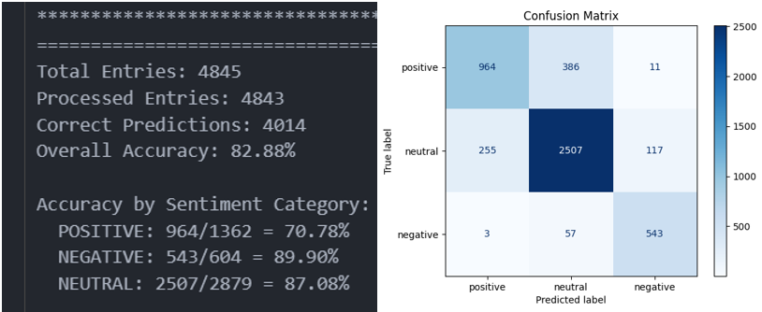
Figure 7. Sentiment analysis pipeline’s results

With an accuracy of nearly 83% across 4,843 processed entries, the model demonstrates a strong ability to correctly classify the sentiment of financial texts. This high-level metric confirms that the strategic decision to use a sophisticated LLM pipeline was successful. The sentiment data generated by this module is a high-fidelity, reliable input for the downstream stock trend prediction engine, which is critical for the success of the entire FinVision platform. The breakdown of accuracy by category provides crucial insights into the model’s specific behaviors:
- Negative Sentiment (Accuracy: 89.90%): This is the model’s strongest category. Its exceptional ability to correctly identify negative news is arguably the most valuable characteristic for a financial tool. Negative financial news often contains strong, unambiguous keywords (e.g., “loss,” “downgrade,” “plunged,” “failed”), which the model detects with very high precision. From a risk management perspective, this is an outstanding result, as it ensures users are reliably alerted to potentially adverse information.
- Neutral Sentiment (Accuracy: 87.08%): The model also performs excellently in identifying neutral text. This is significant because a vast amount of financial reporting is factual and devoid of strong sentiment. The model’s ability to correctly filter out this “noise” and label it as neutral prevents the system from overreacting to non-events.
- Positive Sentiment (Accuracy: 70.78%): This is the area with the most noticeable room for improvement. While still well above a random chance, the lower accuracy for the “Positive” class suggests the model finds positive financial language more challenging to interpret. This is because positive sentiment can be expressed more subtly, using forward-looking statements, conditional language or jargon that can be ambiguous without deeper context.
In addition, our confusion matrix provides a visual and quantitative breakdown of the model’s errors, allowing us to understand how things get wrong.
- The Primary Source of Error: The most significant misclassification pattern is clearly visible: 386 instances of “True Positive” were incorrectly predicted as “Neutral”. This single error type accounts for a large portion of the mistakes and directly explains the lower accuracy for the Positive class. This suggests the model when faced with a subtly positive or ambiguous statement, it tends to default to a “Neutral” classification rather than risk a false positive.
- Strong Separation Between Extremes: A key strength revealed by the matrix is the model’s excellent ability to distinguish between strong positive and strong negative signals.
  - Only 11 “Positive” news were misclassified as “Negative”.
  - Only 3 “Negative” news were misclassified as “Positive”.
- Neutral Class as a “Catch-All”: The “Predicted Neutral” column shows that it catches errors from both the “Positive” (386) and “Negative” (57) classes. This reinforces the idea that “Neutral” label acts as the model’s default classification when the sentiment is not strong enough to meet its internal threshold for a positive or negative label.

Result analysis of Stock Trend Prediction Performance
The evaluation of the prediction module was conducted on a three-class classification problem defined by the relative percentage change method. A ±0.5% threshold determined whether a sequence was labelled as bearish, neutral, or bullish, with predictions extending three trading days ahead. Input features consisted of OHLCV data decomposed through MEMD, windowed into 30-day sequences, and modeled using a two-layer LSTM with 32 hidden units and dropout regularization.
- Class Distribution: Analysis of the label distribution showed that the neutral class dominated the dataset, representing approximately 26% of samples, while bullish and bearish classes accounted for 37% each, which has been done to avoid class imbalance. Temporal analysis confirmed that class imbalance varied with market conditions: bullish dominance in upward-trending periods contrasted with neutral dominance during sideways regimes.
- Overall Performance. The LSTM achieved an overall accuracy of 58% on no sentiment score, and about 63% with sentiment score as a separate feature, which are significantly higher than the random baseline of 33.33%. The peak performance for some stock might reach over 70%, such-= as AAPL ticker. In such cases, macro F1-score reached 74%, while weighted F1-score was 77%, reflecting balanced improvements across all classes. Directional accuracy, which excludes neutral cases, was more than 70% on average, underscoring the model’s strength in detecting actionable trends.
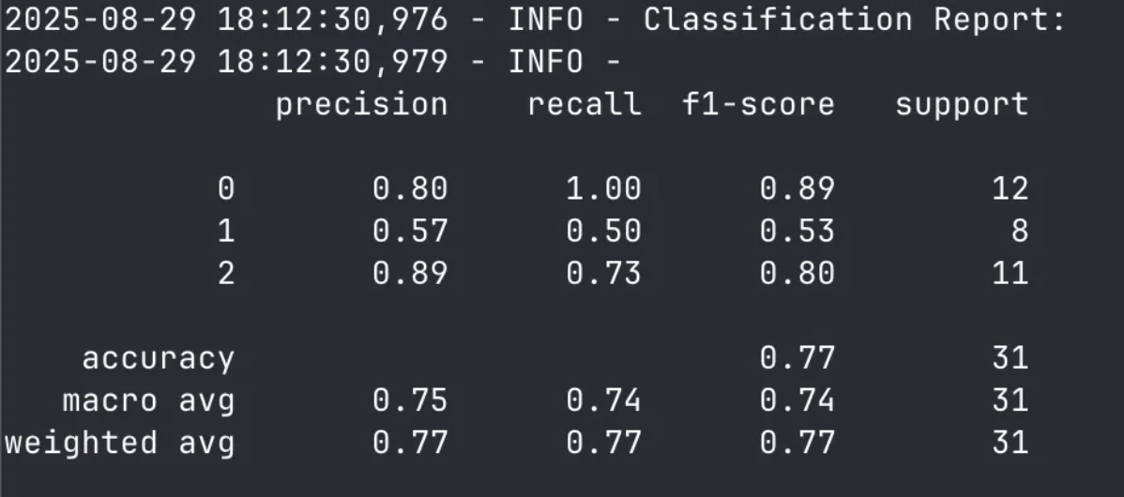
Figure 8. AAPL prediction result on LSTM model
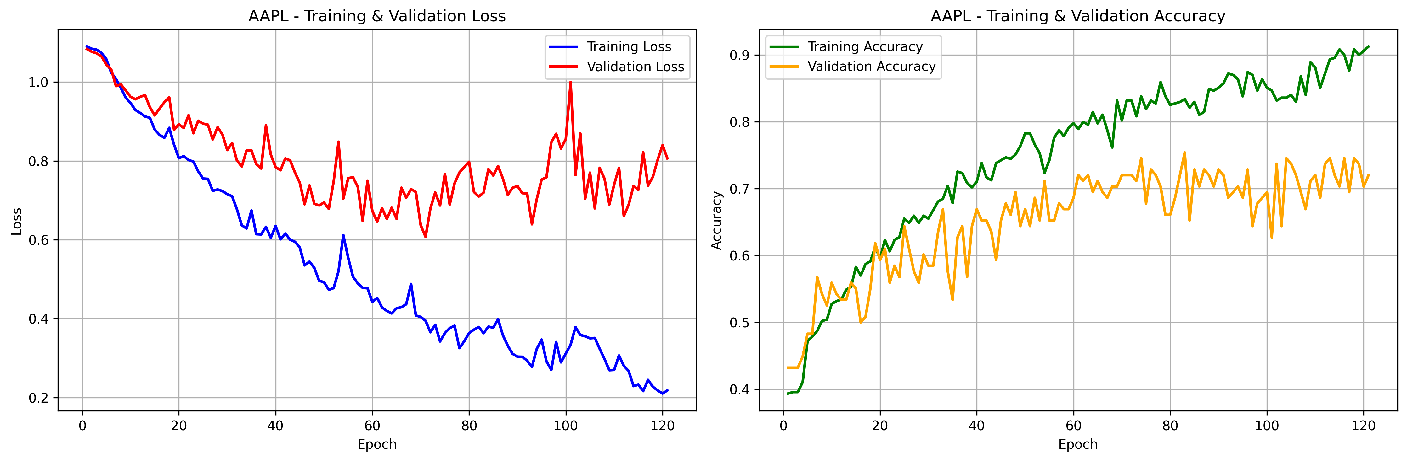
Figure 9. LSTM learning curve for AAPL
The model demonstrated relatively stronger performance in predicting up and down trends. Neutral predictions proved more challenging, as the model occasionally misclassified weak upward or downward moves as neutral, reflecting the intrinsic ambiguity of the class. This is also the issue occurring in some tickers, when the generalized target creation may cause imbalance in distribution, causing the skewed to bearish or bullish behaviour. Certain tickers experience this issue will provide around 40% accuracy, but it is because all the predictions are in bearish or bullish class.
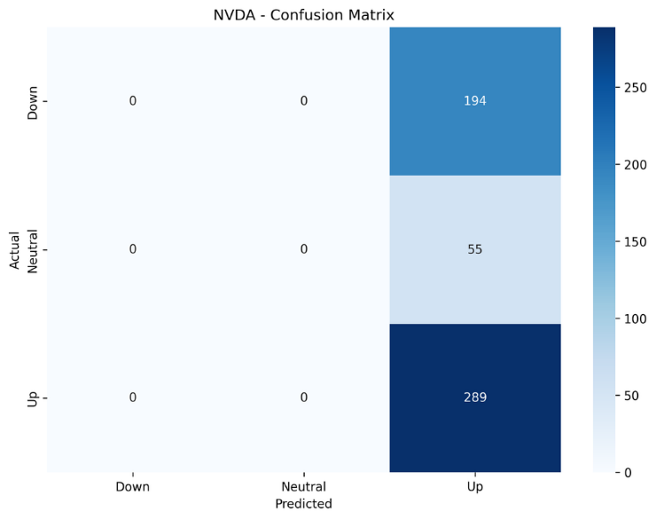
Figure 10. Prediction imbalance of NVDA on LSTM model

On Transformer model, the accuracy is about 58% with the same configuration used in LSTM training pipeline. The learning curves are much smoother, but the epochs required for result is about 400 epochs, causing redundancy in training progress, which take quite a lot of time to train one ticker.
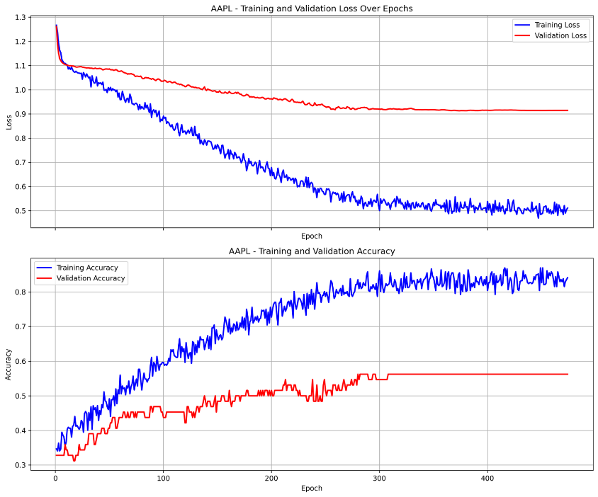
Figure 11. Transformer learning curve
- Threshold and Horizon Sensitivity: Sensitivity experiments with classification thresholds demonstrated that lowering the threshold to 0.3% improved recall of bullish/bearish classes at the cost of higher false signal rates, while raising it to 1.0% produced fewer but more reliable predictions. Comparative analysis of prediction horizons showed that the chosen three-day horizon balanced accuracy and signal usefulness: one-day predictions were more precise but less informative, while five-day horizons suffered from accuracy decay due to compounding uncertainty.
- Comparative Benchmarks: In summary, Transformer with decomposition proves to be effectively achieve the accuracy of about 58% with sentiment score. However, MEMD–AO–LSTM configuration consistently outperformed random guessing at about 63%, with some can reach roughly 77% in class prediction. However, certain issues regarding class imbalance might occur, so proper data handling must be done to avoid this issue when generalizing the pipeline for 500 tickers. The per-ticker LSTM approach adopted here therefore represents a pragmatic balance, trading some accuracy for scalability in a system that manages 500 independent models.

Discussion of Project Issues & Limitations
While the FinVision project successfully achieved its refined objectives and delivered a high-performing prototype, a critical analysis reveals several inherent limitations that must be addressed for the platform to evolve into a commercially viable and scalable product. These issues are not failures of the project but are direct consequences of the strategic trade-offs made to manage scope, budget, and complexity.

The Scalability and Cost Dilemma
The project’s most significant limitation stems from the substantial financial and computational costs associated with its core technology: the reliance on a premium, proprietary LLM like Google’s Gemini.
- Manifestation: The high-performance model, which leverages nuanced sentiment analysis, is only operational for a curated list of 10 stocks. This creates a “two-tiered” system where the platform’s premier feature is unavailable for most of the market. Therefore, this restricts the platform’s utility and creates an inconsistent user experience.
- Strategic Implication: The financial and computational cost of running the Gemini LLM pipeline at scale is prohibitive. Processing and analysing the vast volume of news required to cover the entire S&P 500, let alone the broader market, would lead to unsustainable operational expenses. This presents a direct conflict between the platform’s most powerful feature and its ability to scale.

Mismatched Data Latency and Inflexible Forecast Horizon
The platform’s practical utility for investors is significantly constrained by two interconnected temporal issues that affect the timeliness and relevance of its predictions.
- Manifestation: The platform’s operational limitations are twofold. First, it operates on a delayed data ingestion cycle, rendering it blind to intraday market movements. Second, it employs a rigid 3-day prediction horizon, an inflexible window that fails to meet diverse user needs. To be detailed, this fixed forecast might be too long for tactical traders requiring intraday signals, yet simultaneously too short for strategic swing traders or investors evaluating weekly or longer-term trends. This creates a critical dissonance where immediate, short-term forecasts are generated using non-immediate data, a structure that is misaligned with the requirements of multiple key investor profiles.
- Strategic Implication: This combination severely restricts the platform’s addressable market and utility. The lack of real-time data alienates short-term traders, while the insufficient 3-day forecast window fails to provide value for longer-term investors. This positions FinVision in an awkward middle ground, unable to fully serve any specific trading or investment strategy effectively. The primary risk is a product-market misalignment that limits user adoption and daily engagement. Furthermore, providing short-term guidance based on latent data introduces a significant risk of issuing outdated predictions, which could mislead users and irreparably damage the platform’s credibility and user trust.

The Risk of Model Performance Degradation (Model Drift)
The models were trained and validated on a specific historical dataset. However, financial markets are non-stationary systems, meaning their underlying statistical properties and patterns change over time.
- Manifestation: FinVision project currently lacks an automated Machine Learning Operations (MLOps) framework for monitoring and retraining its models. Over time, the phenomenon known as “model drift” will inevitably occur, where the model’s predictive accuracy degrades as it encounters new market conditions it was not trained on.
- Strategic Implication: Without a system for continuous monitoring and periodic retraining, the impressive 63% accuracy is a perishable achievement. The model’s reliability will decrease, eventually rendering its predictions no better than random chance and eroding user trust.

Suboptimal Model Formulation & Lack of Actionability
- Manifestation: The stock trend model employs a three-class (“Bearish”, “Bullish” and “Neutral”) classification system. The “Neutral” class is inherently ambiguous and difficult for the model to learn, often representing market noise rather than a clear signal. This increases the complexity of the learning task and dilutes the model’s focus on the more critical “Bearish” and “Bullish” trends.
- Strategic Implication: This formulation has two negative impacts. Firstly, it can lead to lower overall model performance on the actionable signals. Secondly, a “Neutral” prediction offers no actionable value to the end-user, as it simply reinforces the default action of “doing nothing”. This makes a portion of the platform’s outputs functionally irrelevant and reduces its value as a decision-support tool.

Recommendations for Future Work
To address these limitations and build upon the project’s success, a multi-faceted strategic roadmap is recommended, focusing on scalability, enhanced functionality, long-term reliability, and user trust.

Implement a Tiered Hybrid Model Architecture
- Proposal: Create a multi-tiered system for sentiment analysis and prediction. For instance:
  - Tier 1 (Premium): Continue to use the high-performance Gemini LLM for a select group of high-interest stocks (e.g., S&P 100) or as a premium, subscription-only feature.
  - Tier 2 (Standard): For broader market coverage (e.g., the rest of the S&P 500), fine-tune a smaller, cost-effective, open-source language model (e.g., FinBERT, Flan-T5, or a quantized Llama model). While its accuracy might be slightly lower than Gemini’s, it would provide a massive improvement over no sentiment data at a fraction of the cost.
  - Tier 3 (Baseline): For all other equities, use the historical-data-only model.
- Benefit: This approach provides a pragmatic path to scalability. It expands the platform’s utility to a much wider range of stocks while managing operational costs and creating a clear monetisation strategy (e.g., a premium subscription).

Integrate Real-Time Data and Flexible Forecast Horizons
- Proposal:
  - Data Integration: Implement a phased integration of live data, starting with automated end-of-day updates and progressing to intraday and eventually real-time data streams as a premium feature.
  - Flexible Horizons: Enhance the user interface to allow users to select their desired prediction window (e.g., intraday, 3-day, 7-day, 30-day), with the model backend being adapted to generate these different forecasts.
- Benefit: This will dramatically broaden the platform’s addressable market to include short-term and long-term investors, significantly increase user engagement, and ensure predictions are timely and relevant, thereby building user trust.

Build and Deploy an MLOps Pipeline
- Proposal: Establish an automated MLOps framework responsible for:
  - Performance Monitoring: Continuously track the models’ predictive accuracy on new, incoming data to detect performance degradation automatically.
  - Automated Retraining: Implement a pipeline that triggers a model retraining process whenever its performance drops below a predefined threshold (e.g., 58% accuracy).
  - Validated Deployment: Create a system for A/B testing newly trained models against the currently deployed version to ensure any new model provides a genuine improvement before it is pushed into production.
- Benefit: This transforms the predictive models from static artifacts into a dynamic system that can be adapted to changing markets.

Transition to a Binary Classification Framework for Enhanced Performance and Actionability
- Proposal: Refactor the model from its current three-class system to a binary (Bearish/Bullish) framework. This involves re-labelling the dataset by defining a volatility threshold to filter out insignificant, “neutral” price movements, and training the model exclusively on strong, directional signals.
- Benefit: This approach is expected to yield two key improvements. First, by presenting the model with a clearer objective and higher-quality training data, it should lead to increased accuracy on the two classes that truly matter. Second, by providing direct, unambiguous, and actionable predictions, it will make the FinVision platform a significantly more valuable and useful tool for investor decision-making.

Summary and Reflection
This section presents recommendations that can guide future development and provide practical insights for similar data-driven initiatives.
Effective Strategies and Successes
In general, agile Scrum methodologies played a significant role in our progress. To elaborate, regular sprint reviews and a clearly documented Way of Working helped the team manage complexity and stay aligned with overall goals. The framework allowed us to adjust scope when new technical findings or resource limits appeared, while keeping the project on track. Sprint retrospectives gave us a reliable way to review workflows, identify bottlenecks, and make quick improvements, which kept the team focused and efficient.
This structure worked hand in hand with a dedicated team culture built on shared ownership and support. We matched roles to individual strengths but also encouraged cross-functional learning across web development, DevOps, and AI/ML. As a result, everyone contributed to technical discussions, which improved code quality and produced stronger final architecture. A clear example of this collaboration was the company filtering mechanism: what began as a simple KPI matcher evolved into a robust K-Means clustering system, directly improving the user experience. As a result, the combination of structured methodology and open collaboration helped us deliver an innovative yet stable solution, while also creating an environment where members felt confident sharing ideas and tackling complex problems together.
Challenges and Lessons Learned
The biggest technical challenge came from the non-stationary nature of financial markets. Because conditions constantly change, historical data often fail to predict future outcomes. This made it difficult to build models that could generalise. We learned that in finance, model accuracy is not rigid but instead fluctuates over time, meaning models require ongoing monitoring and recalibration. Models that performed well in back-testing often struggled in real market conditions, showing the impact of concept drift and market regime. This experience highlighted the need to design models that can adapt rather than relying only on static accuracy scores. Budget and time constraints made the challenge more difficult. Limited funding meant we could not access premium APIs, which reduced the size and quality of our sentiment dataset. With less data, we had to spend more time tuning models to reach acceptable performance, which conflicted with the fixed timeline. These trade-offs revealed how closely resources, data availability, and model viability are connected. They also underlined the importance of setting realistic expectations early in the project. At the same time, these pressures pushed the team to make pragmatic choices, focusing on solutions with the highest impact within our limits.
Key Considerations for Future Work
- Maintain methodological discipline: Scrum offers stability, visibility for stakeholders, and steady progress. Future projects should continue using this structure, while documenting each stage to ensure transparency and adaptability.
- Secure resources before committing: Projects should begin with detailed resource assessment, including a risk register for dependencies. Evaluating API reliability and cost in advance can prevent disruption and keep the scope realistic.
- Allocate time for iterative refinement: AI model development is non-linear and requires space for iteration. A basic MLOps framework for dataset and model versioning, combined with automated retraining and evaluation, can sustain performance as conditions change.
- Promote a culture of shared ownership: Open knowledge sharing and collaboration drive innovation and make teams more resilient. By encouraging joint problem-solving and avoiding knowledge silos, projects can stay maintainable over the long term. A culture of accountability ensures that after handover, future teams inherit not only the system but also the understanding needed to extend and adapt it effectively.

References
[1] W. Lu, J. Li, J. Wang, and L. Qin, “A CNN-BILSTM-AM method for stock price prediction,” Neural Comput. Appl., vol. 33, no. 8, pp. 4741–4753, Apr. 2021, doi: 10.1007/s00521-020-05532-z.
[2] Indochina Research, “Vietnamese Individual Investors 2021,” Indochina Research, Jul. 22, 2021. [Online]. Available: https://indochina-research.com/vietnamese-individual-investors-2021/. Accessed: Apr. 14, 2025.
[3] V. Singh, “Machine Learning Models for Stock Market and Investment Predictions,” Int. J. Enhanc. Res. Manag. Comput. Appl., vol. 12, no. 7, pp. 74–87, Jul. 2023.
[4] H. Ni et al., “Harnessing Earnings Reports for Stock Predictions: A QLoRA-Enhanced LLM Approach,” 2024 6th International Conference on Data-driven Optimization of Complex Systems (DOCS), Hangzhou, China, 2024, pp. 909-915, doi: 10.1109/DOCS63458.2024.10704454
[5] Q. Ge, “Enhancing stock market forecasting: A hybrid model for accurate prediction of S&P 500 and CSI 300 future prices,” Expert Systems With Applications, vol. 260, p. 125380, Sep. 2024.
[6] World Economic Forum, Boston Consulting Group, and Robinhood, 2024 Global Retail Investor Outlook. 2024.
[7] Organisation for Economic Co-operation and Development, Supporting the New Generation of Retail Investors in France, OECD Business and Finance Policy Papers, no. 672, 2024.
[8] Bank for International Settlements, Annual Economic Report 2024. Basel, Switzerland: BIS, 2024.
[9] Vuong PH, Phu LH, Van Nguyen TH, Duy LN, Bao PT, Trinh TD, “A bibliometric literature review of stock price forecasting: From statistical models to deep learning,” Inf., SAGE Publ., 2024.
[10] X. Chen, H. Xie, Z. Li, H. Zhang, X. Tao, and F. L. Wang, “Sentiment analysis for stock market research: A bibliometric study,” Natural Lang. Process. J., vol. 2, Art. 100125, 2025, doi: 10.1016/j.nlp.2025.100125.
[11] J. Qin, “MSMF: Multi-scale multi-modal fusion for enhanced stock market prediction,” arXiv preprint, arXiv:2409.07855 [cs.CE], Sep. 12, 2024, doi: 10.48550/arXiv.2409.07855.
[12] W. Bao, Y. Cao, Y. Yang, H. Che, J. Huang, and S. Wen, “Data-driven stock forecasting models based on neural networks: A review,” Inf. Fusion, vol. 115, Art. 102616, 2025, doi: 10.1016/j.inffus.2024.102616.
[13] M. S. M. Bhuiyan, M. A. Rafi, G. N. Rodrigues, M. N. H. Mir, A. Ishraq, M. F. Mridha, and J. Shin, “Deep learning for algorithmic trading: A systematic review of predictive models and optimization strategies,” Array, vol. 20, Art. 100390, 2025, doi: 10.1016/j.array.2025.100390.
[14] J. Černevičienė, A. Kabašinskas, “Explainable artificial intelligence (XAI) in finance: A systematic literature review,” Artif. Intell. Rev., 2024.
[15] International Organization of Securities Commissions, Artificial Intelligence in Capital Markets: Use Cases, Risks, and Public Policy Considerations. 2025.
[16] European Securities and Markets Authority, Guidance for Firms Using Artificial Intelligence in Retail Investment Services. 2024.
[17] D. Muhammad, I. Ahmed, K. Naveed, and M. Bendechache, “An explainable deep learning approach for stock market trend prediction,” Heliyon, vol. 10, no. 21, Art. e40095, Nov. 15, 2024.
[18] Q. Chen and H. Kawashima, “Sentiment-aware stock price prediction with Transformer and LLM-generated formulaic alpha,” arXiv preprint, arXiv:2508.04975, Aug. 2025.
[19] S. Singh, M. Singh, and S. Attri, “Mapping stock market dynamics: A tripartite neural network approach using modified grid search for stock market prediction,” Expert Systems With Applications, vol. 278, p. 127243, Mar. 2025.
[20] P. U. Rukmana, Asriana, and H. Fakhrurroja, “Application of LSTM, RNN, and Transformer in stock price prediction of information technology companies: A comparative analysis,” in Proc. Int. Conf. on Computer, Control, Informatics and its Applications (IC3INA), Bandung, Indonesia, 2024, pp. 249–254.
[21] Z. Chen, B. Liu, J. Zheng, and P.-G. Ye, “Multi-iTR: A Transformer-based multi-task learning framework for stock closing price prediction,” Preprint, Beijing Institute of Technology, Feb. 2025. [Online]. Available: https://ssrn.com/abstract=5170218

Appendices

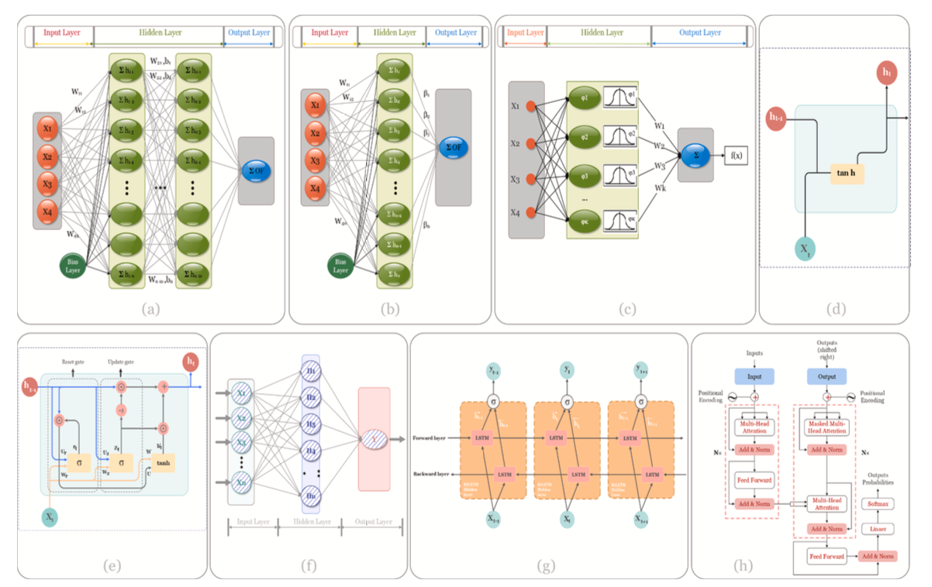
Figure 12. Common architectures used for stock price prediction


Figure 13. Aquila optimiser based idea (part 2)

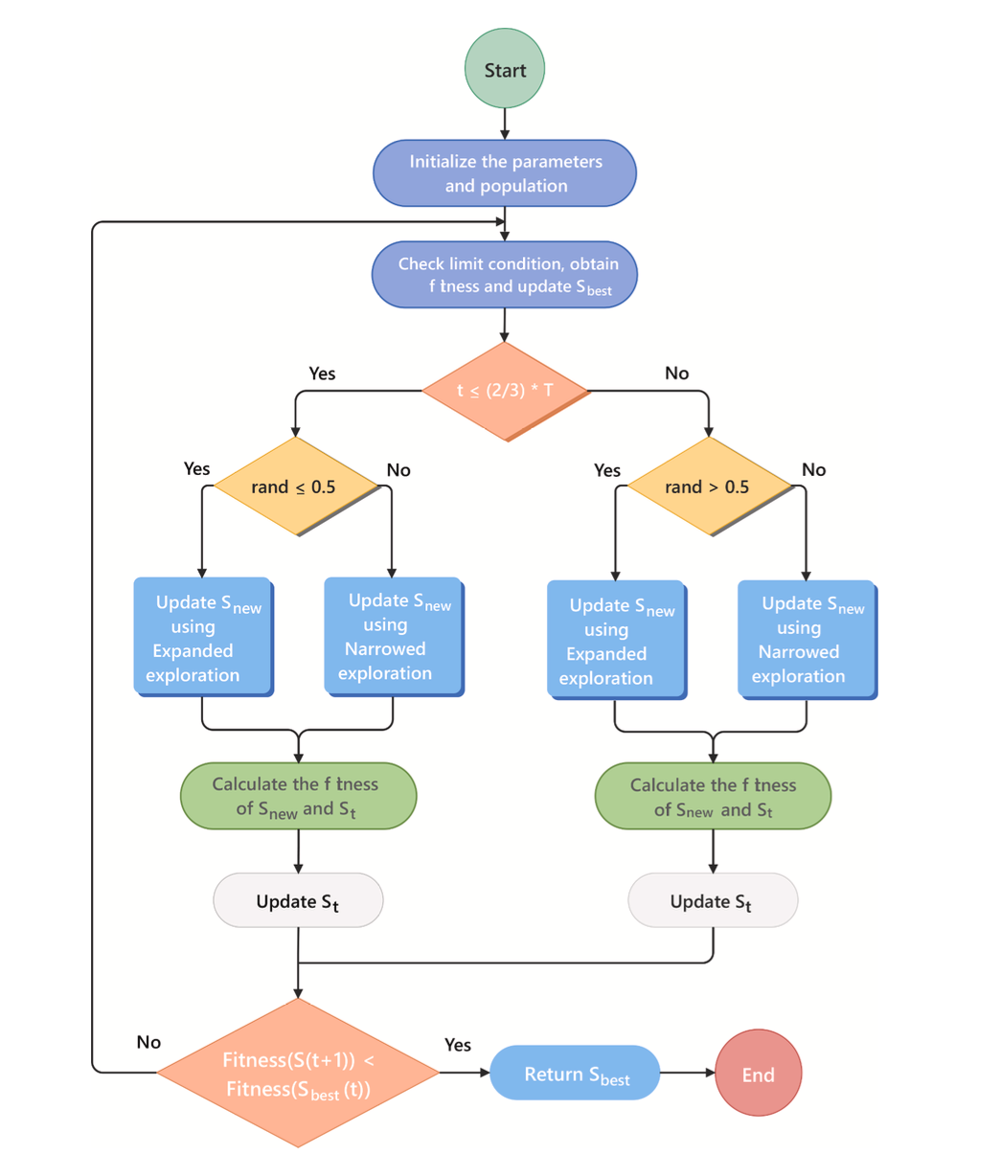
Figure 14. Diagram of Aquila optimiser

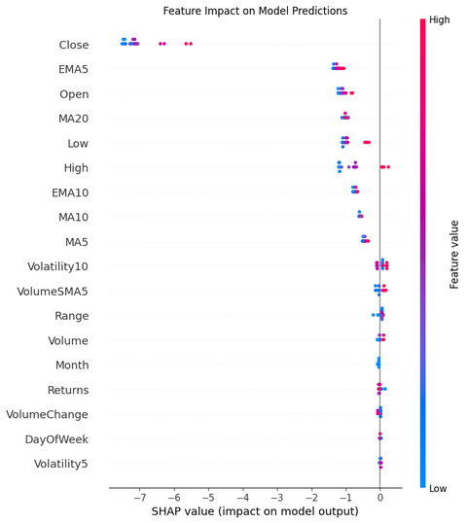
Figure 15: XAI reasoning on OHLCV dataset based on SHAP (part 1)
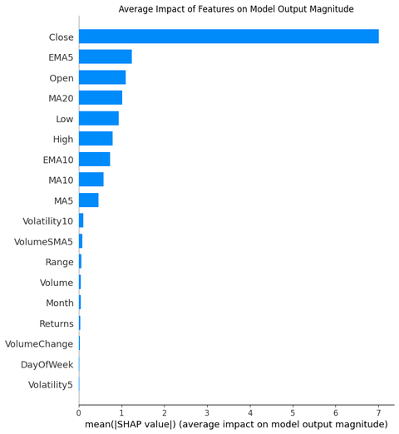
Figure 16: XAI reasoning for OHLCV dataset based on SHAP (part 2)
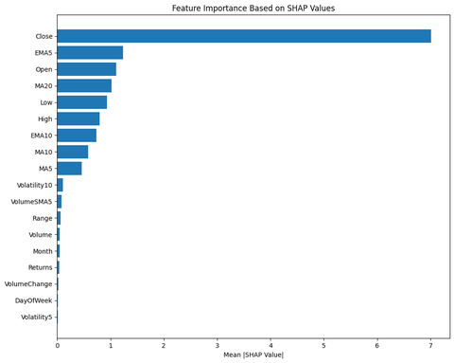
Figure 17: XAI reasoning on OHLCV dataset based on SHAP (part 30


Figure 18. Agentic AI screen of Kitto web platform

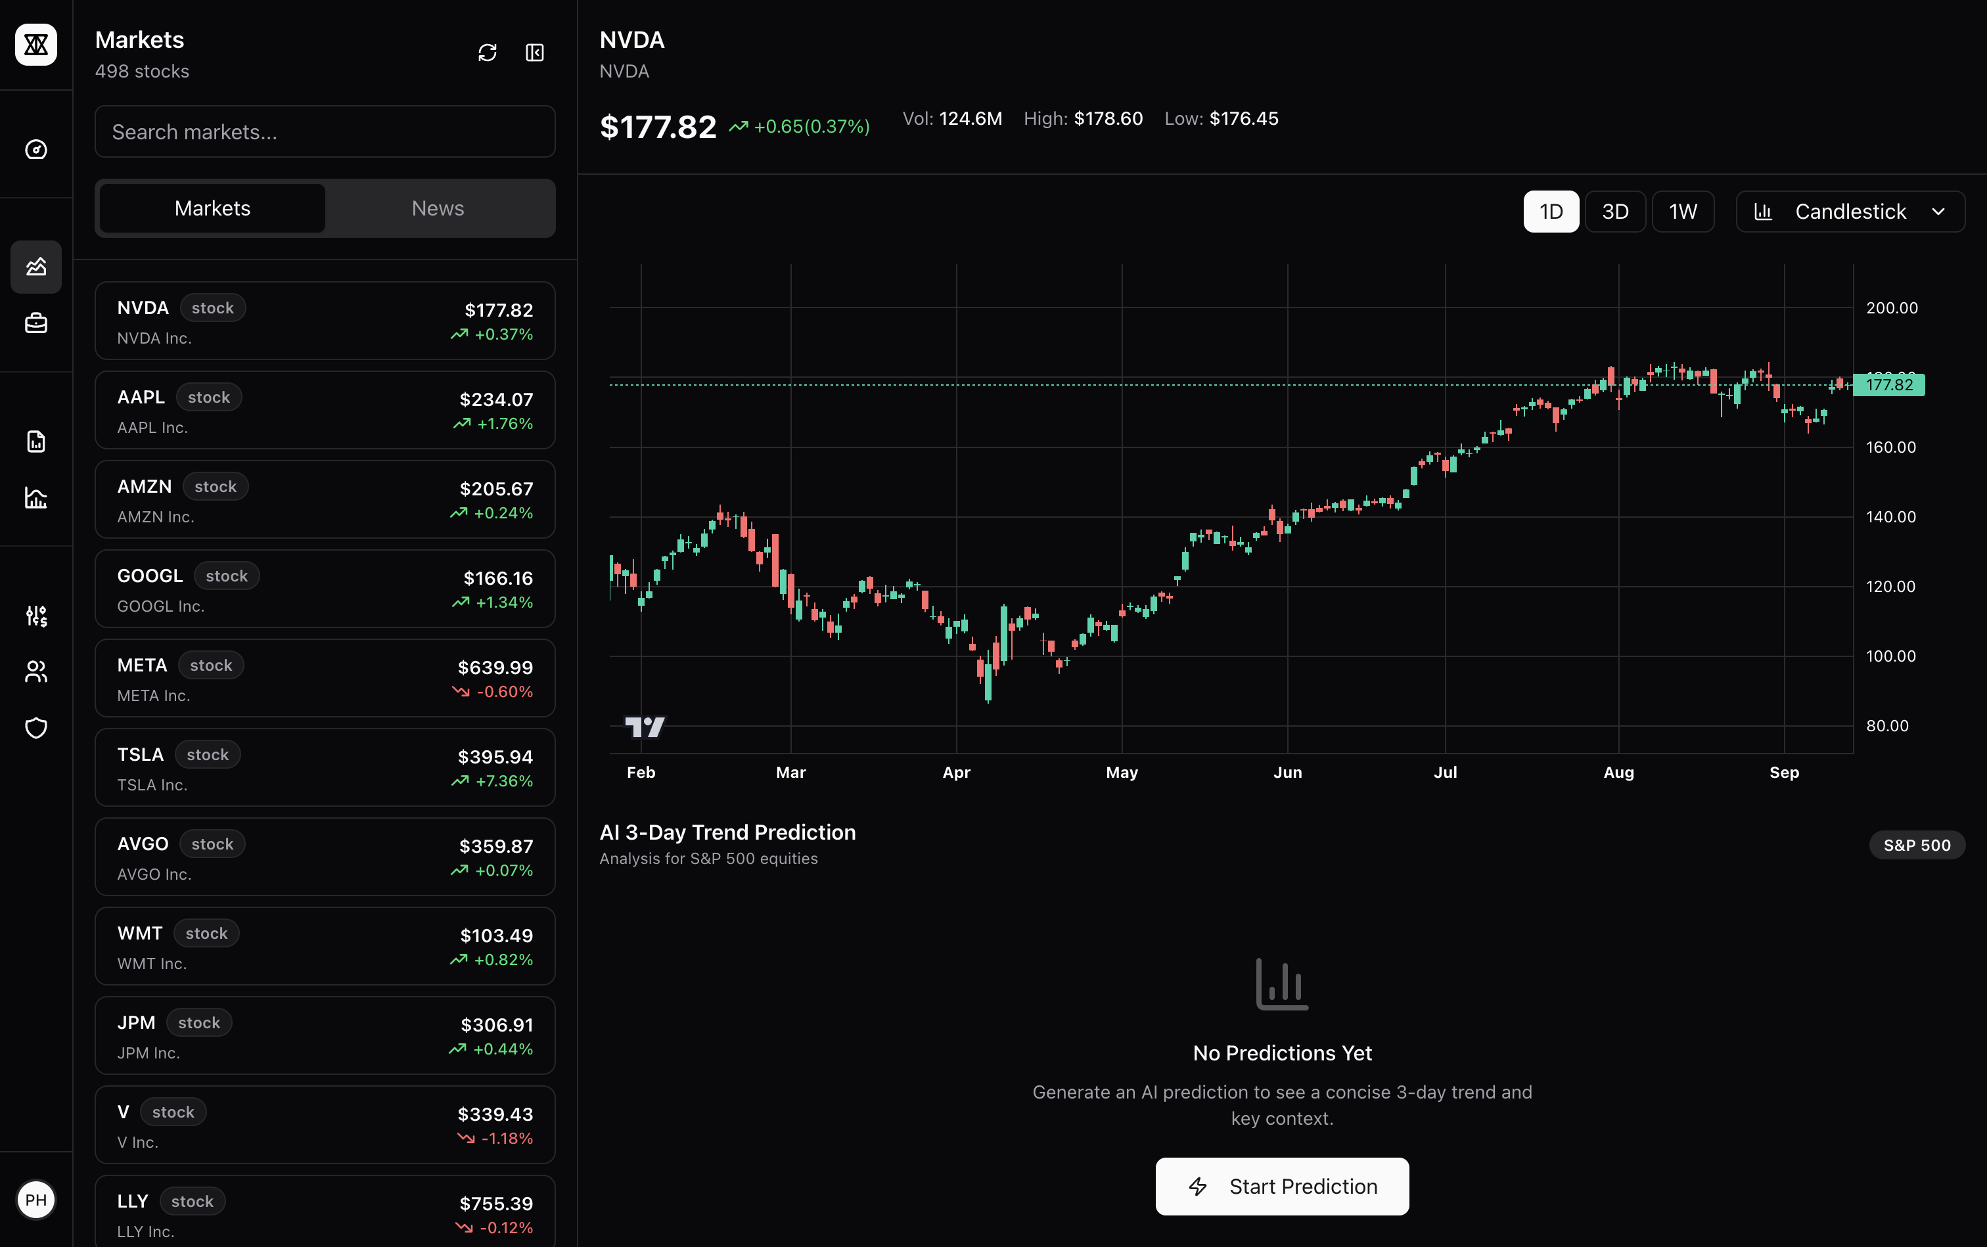
Figure 19. Market page of Kitto web platform
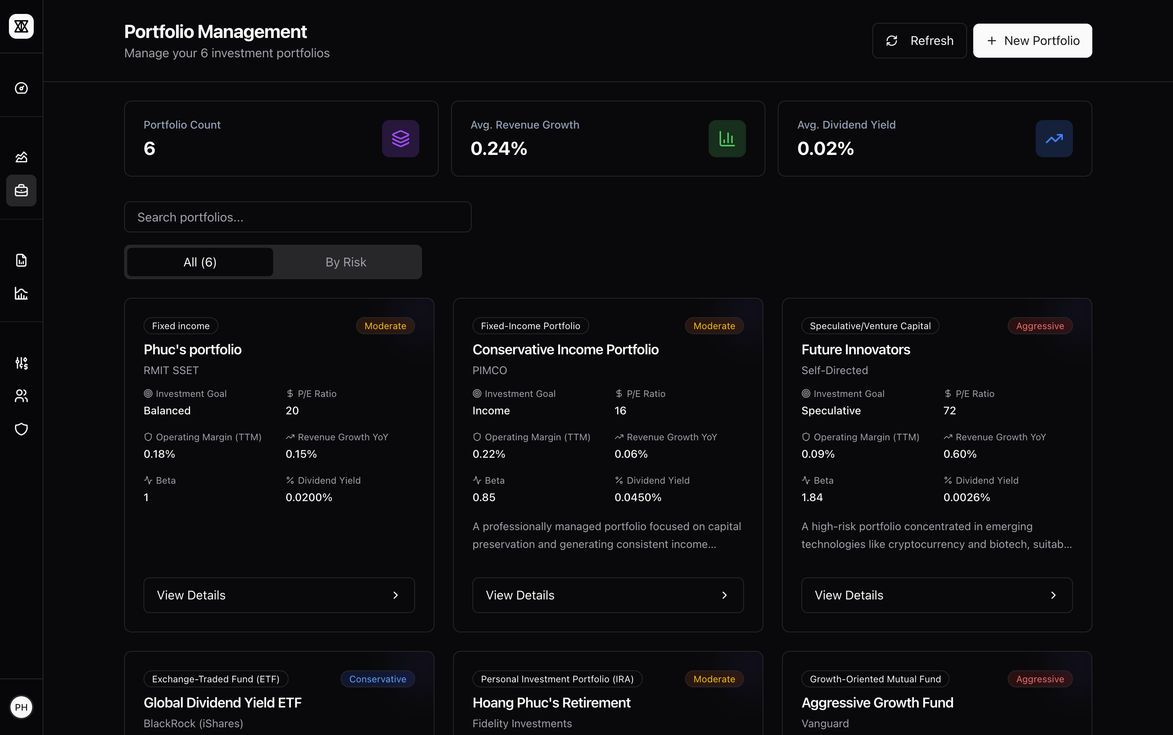
Figure 20. Portfolio management page of Kitto web platform (part 1)

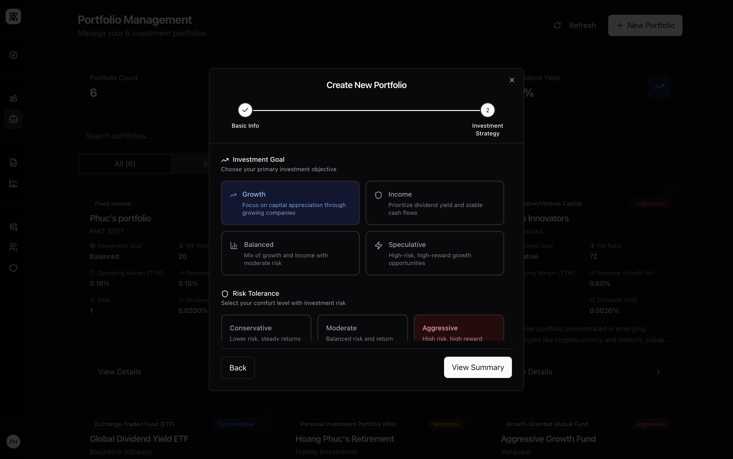
Figure 21. Portfolio management page of Kitto web platform (part 2)
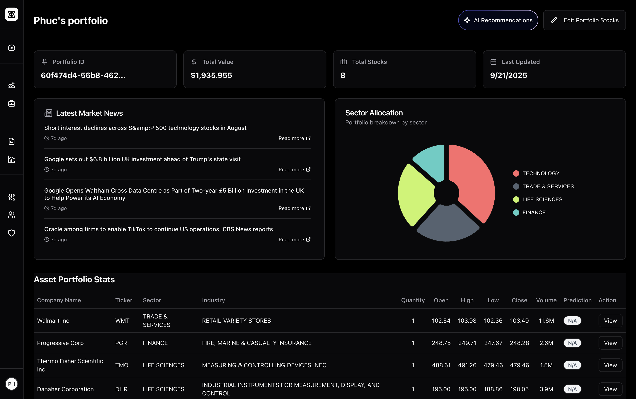
Figure 22. Portfolio management page of Kitto web platform (part 3)

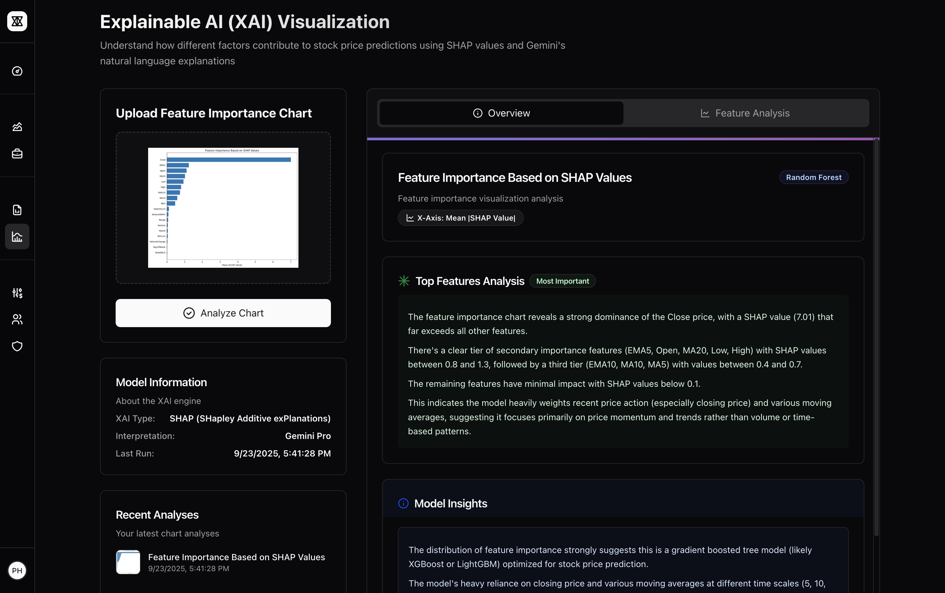
Figure 23. XAI page of Kitto web platform
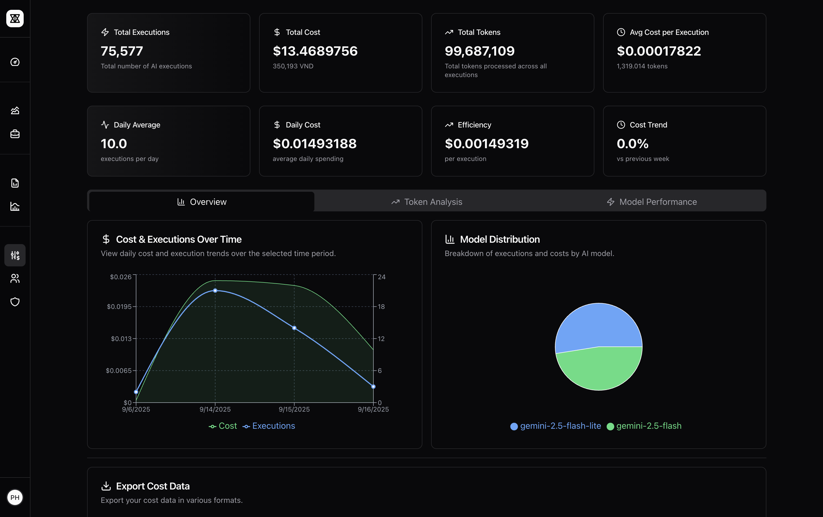
Figure 24. Cost management page of Kitto web platform

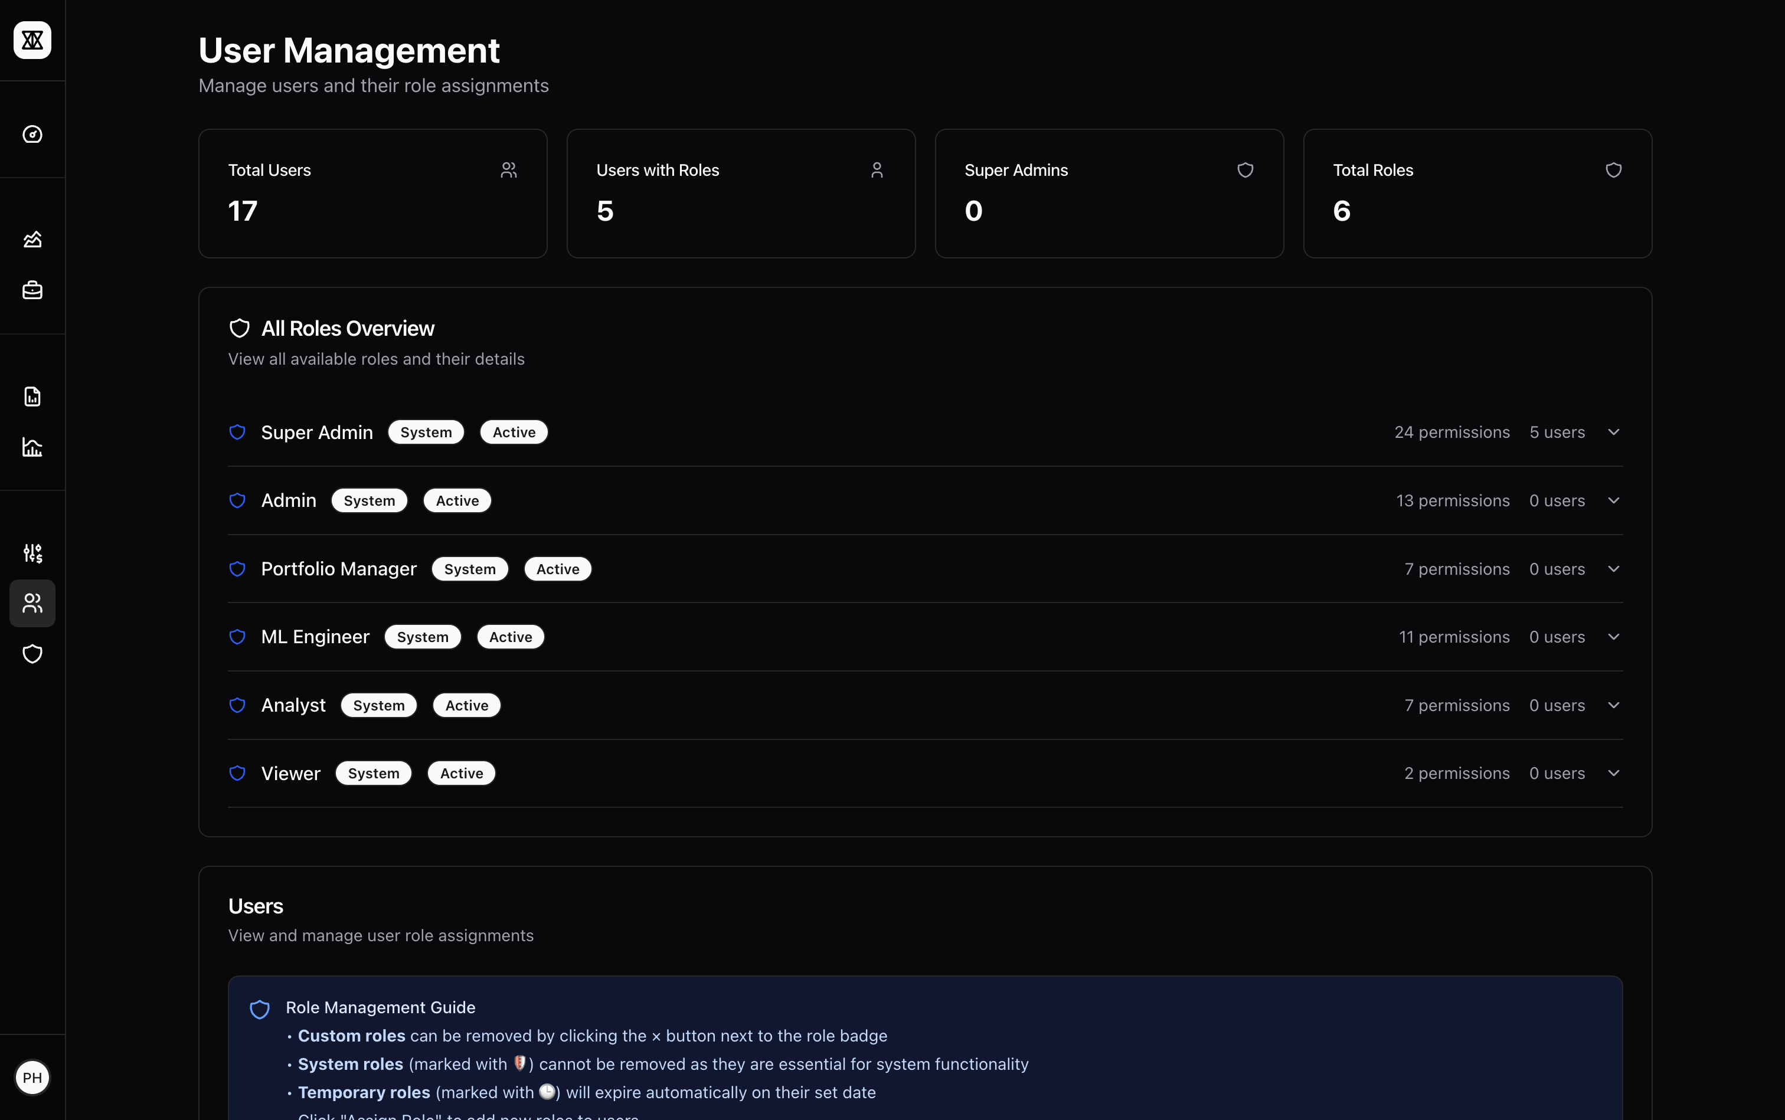
Figure 25. User management page of Kitto web platform
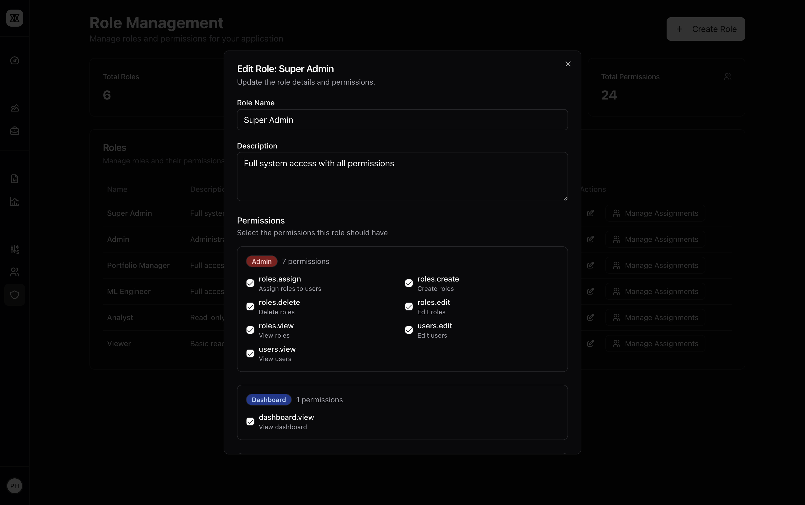
Figure 26. User management page of Kitto web platform (part 2)
\
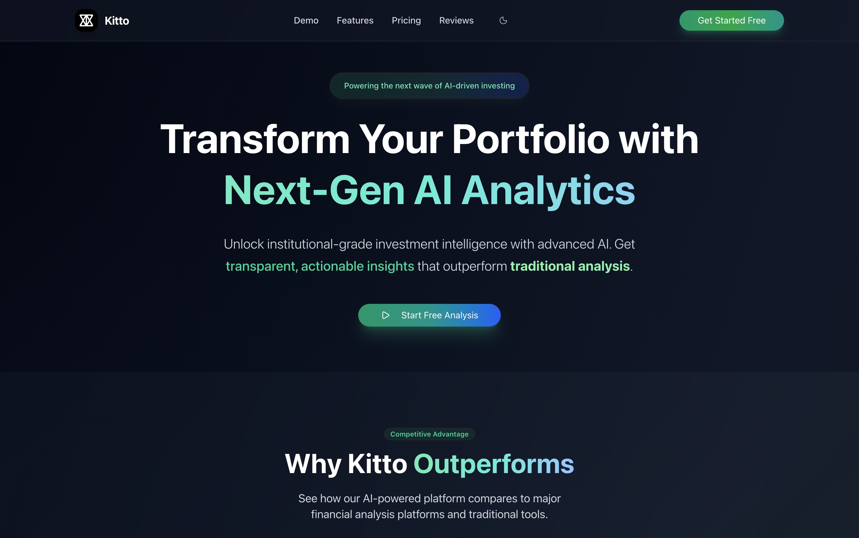
Figure 27. Landing page of Kitto web platform

Figure 28. Landing page of Kitto web platform (part 2)


Figure 29. Landing page of Kitto web platform (part 3)

Figure 30. Landing page of Kitto web platform (part 4)

