Cullen Williams & Garrick Hutcheson
Hassan Ghasemzadeh
CPTS 223
April 16 2018
Homework 9 Report
Problem statement.
The goal of this assignment is to compare the time complexity of lists and vectors.

Algorithm design.
The List and vector implementations of this assignment are fairly similar with most of the major differences being within the standard template implementations. Neither List nor Vector are actually circular in structure, Both rely on checks at the end of the list to return iterators to the beginning of the list or vector. Both List and Vector start an iterator at the beginning of the list and count over N places. The function then deletes whatever is at that space and sets the iterator equal to the element after the element that was deleted. Then it counts over N spaces again, deletes the element and sets the iterator equal to the next item and continues until only one thing is left in the list. In the Vector implementation removing an element requires creating a new vector and copying all the elements over except the one being removed. In the List implementation removing an element just requires pointing the previous element to the element after the element being deleted and vice versa.

Experimental setup.
Machine specification :
Acer v5-313
OS: Ubuntu
Ram: 5.7 GiB
CPU: Intel Celeron 1007U @ 1.50GHz x2
Compiler: Terminal with G++
the experiment entailed running the Josephus game with both lists and vectors. First with increasing values of N and then with increasing values of M.

Data:
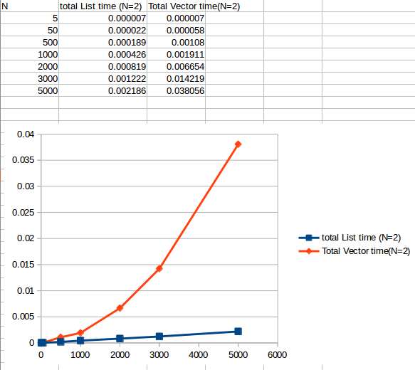
Plot I)
y-axis:
Total elimination time

x ‐ axis:
Initial size of the circle.

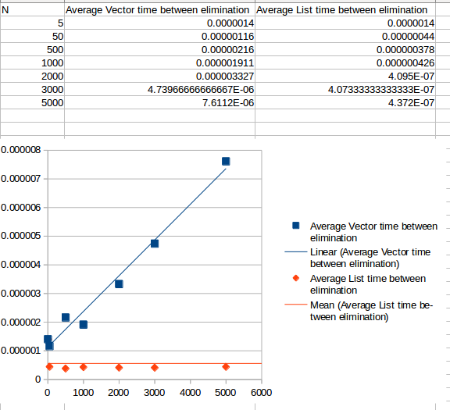

Plot II)
y-axis:
Average elimination time

x ‐ axis:
Initial size of the circle

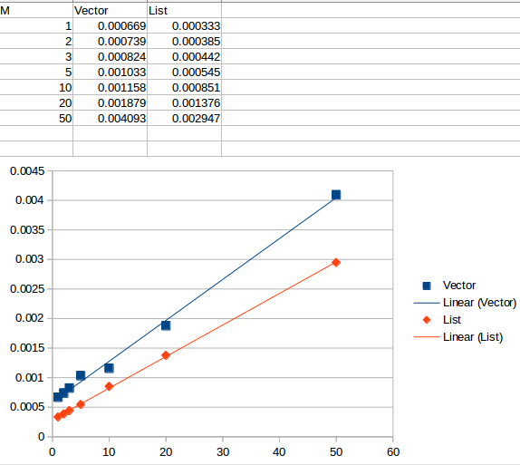

Plot III)
y-axis:
Total elimination time

x ‐ axis:
Number of jumps before elimination.

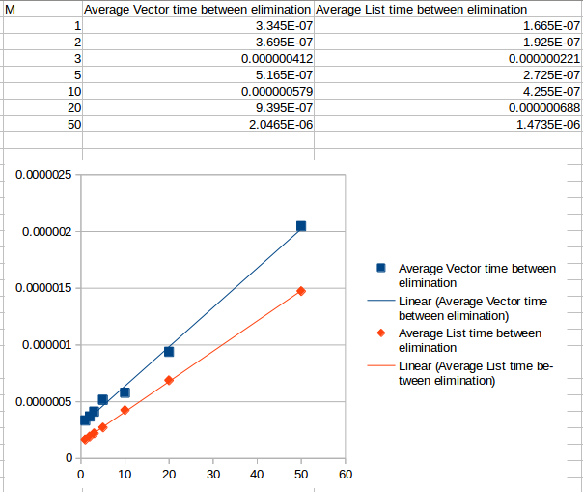
Plot IV)
y-axis:
Average elimination time

x ‐ axis:
Number of jumps before elimination.

Results:
Based on plot one it is easy to see that vector is not the best algorithm to use for this kind of task. For vectors the runtime is dominated by the erase task. As the number of elements increases the vector elimination task takes longer and longer for each element leaving the vector implementation with a O(). The list implementation has a constant time for erasing elements(as shown by Plot 2 )so the runtime is dominated by iterating through the list, leaving a O(N).
Since both my List and Vector functions use iterators to count through the circle increasing the size of M effects both List and vector implementations in the same way. Garrick Hutcheson showed me a better implementation of vector that allows for changing M to not effect the time complexity of the vector implementation.

Discussion:
List performs significantly better than Vectors for this task especially for large lists. For my implementations, the size of the list dominated the time complexity for Vectors and Lists. Even with Lists eliminating in constant time larger lists take longer. When the jump size(M) increased the effect on both lists and vectors was roughly the same. In theory vectors could be implemented such that changing M would not have no effect on the time complexity. My code doesn’t work that way but if it did vector would be better with small lists that have large jump sizes.

